Passive RC Filter Networks
BEng Mechanical & Manufacturing – Part Time
ACDB4002 Electrical & Electronic Principles Coursework
20/4/25
2415273 Laurence (Loz) Browne

Abstract
This report compares the calculated, simulated and real performance of low pass and high pass filters. A filter is a circuit which is capable of passing a specific range of frequencies while blocking others (Scherz, 2016). Low pass and high pass filters are designed to block frequencies below or above (respectively) a certain cutoff.
The theoretical cut off frequency (where the output voltage is 70.7% of the input voltage) was compared to that measured from a Proteus simulation and a physical circuit.
In general, the three figures showed good correlation but accuracy was limited by the reading error in the proteus simulation and component tolerance and breadboard connection method in the physical circuit.

Introduction
The task was to compare the simulated and actual performance of two types of filter circuits. There are several key concepts which are necessary in order to understand the function of the filter circuits.

Filters
Filters are one of two types:
Passive- using passive components which do not require an additional power supply as they store energy from the applied signal in an electrical or magnetic field (Mike Tooley, 2021). Filters using capacitors or inductors fall into this category.
Active- These are filters which use components such as Operation Amplifiers (Op Amps) that are semi-conductor based devices and so modulate a separate power source depending on an input signal.

Resistor Capacitor Filters
The two filters considered here are both passive designs which use only capacitors.

Capacitor Reactance
Capacitor Reactance is given by the following formula:
$$X_{c}=\frac{1}{2πfc}$$
As the frequency is part of the denominator of the fraction it is inversely proportional to the impedance. As such, a capacitor in series with a signal source has the characteristic of having a high impedance to low frequencies and acts to completely block direct current (D.C). As the frequency increases the impedance reduces, so there is less attenuation of the signal. (The Organic Chemistry Tutor, 2020)

Circuit Impedance
The impedance in a circuit is the resultant vector of the Resistance and Reactance. As the filters here do not use inductors, the impedance is if found by applying Pythagoras’ formula to the resistance and capacitive reactance:
$$Z=\sqrt{R^{2}+X_{C}^{2}}$$

Cutoff Frequency/ Half Power Point
A filter is described using its cutoff frequency- the frequency where the output power is attenuated by half. Beyond this frequency the attenuation is greater.
The formula for calculating power is:
$$P={I_{max}}^{2}R$$
Where:
$$P_{cutoff}={\left(0.5I_{max}\right)}^{2}R$$
Therefore:
$$P_{cutoff}=\sqrt{0.5}.I_{max}^{2}R=0.707I_{max}^{2}R$$
As current is proportional to voltage:
$$V_{cutoff}=0.707V_{in}$$
With $V_{in}=5V$ then $V_{cutoff}=0.707V_{in}=3.535V$
Using the formula to calculate signal attenuation in Decibels (dB):
$$dB=20log\left(\frac{V_{out}}{V_{in}}\right)=20log\left(\frac{3.53}{5}\right)=-3dB$$

Low Pass Filters
A low pass filter allows frequencies below a defined cutoff to pass with minimal attenuation of the output voltage. Frequencies beyond this cutoff undergo an attention greater than -3 d.B./ half power. This equates to the output voltage of these frequencies being 70.7% of the input voltage at the cut off and less beyond this.
The RC low pass filter used here resembles a voltage divider circuit but with $R_{2}$ replaced by the capacitor $C_{1}$. In a voltage divider the sizing of $R_{2}$ dictates the proportion of current synced to ground (and therefore voltage seen at the output).
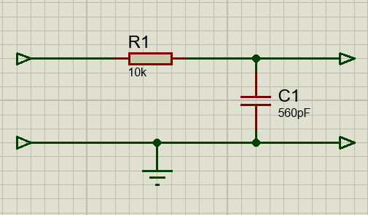
The formula for the output voltage of a voltage divider is:
$$V_{out}=\frac{R_{2}}{R_{1}+R_{2}}.V_{in}$$
As the capacitive reactance is inversely proportional to frequency, replacing $R_{2}$ with a capacitor allows the output voltage to be inversely proportional to frequency and so filter higher values.
This is voltage divider formular is modified for the low pass filter by replacing the denominator (total circuit resistance) with the circuit impedance:
$$V_{out}=\frac{X_{C}}{\sqrt{R_{1}^{2}+X_{C}^{2}}}.V_{in}$$
By calculating the capacitive reactance $X_{C}$ for a given frequency the theoretical (ideal) output voltage can be calculated. This ideal value was compared to the simulated and measured values.
A common use of a low pass filter is in anti-aliasing filters which perform signal conditioning before Analog to Digital Conversion (ADC). An ADC can faithfully sample an analogue signal up to a fixed value, typically just below half it’s sampling frequency. Beyond this a frequency which is a harmonic of a frequency which is within the ADC’s range (e.g. twice the fundamental frequency) could be mistaken (be an alias) for the fundamental.
A low pass filter can remove the frequencies above the ADC sample range and so perform an anti aliasing function.

High Pass Filters
High pass filters are the reverse of the low-pass filter, these attenuate frequencies below the cutoff by at least -3d.B. and allow higher frequencies to pass with minimal attenuation.
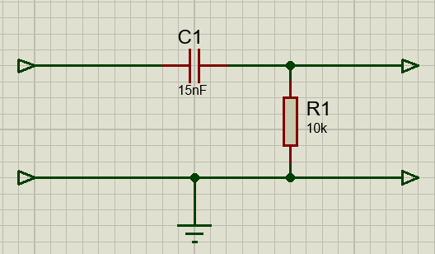
The high pass filter also resembles a voltage divider but with the capacitor in series with the input voltage.
Formula for $V_{out}$:
$$V_{out}=\frac{R_{1}}{\sqrt{R_{1}^{2}+X_{C}^{2}}}.V_{in}$$
This formula was used to calculate the theoretical values for the high pass filter response curve.
As before, the circuit was simulated using Proteus along with measurements taken from a circuit prototyped using a breadboard and through-hole components.
A common use for a high pass filter is in audio circuits where it is used to block the 60Hz hum from the mains circuit (Scherz, 2016).

Response Curves
The characteristics of the filter are illustrated using a response curve which plots the attenuation (Vin/Vout) against frequency. In this report the curve is log-linear with the x axis for log frequency and the y axis for Vout (in a linear scale).

Method & Results

Theoretical Performance
The ideal performance of the filter designs was calculated using the formulas in section 2 with the use of an Excel speadsheet. The figures for each filter were plotted alongside the simulated and measured results.
The calculated cutoff frequency for the low pass filter was 28.4KHz and 1.05KHz for the high pass filter.

Proteus Simulation

Low Pass
The circuit was arranged as below with two oscilloscope channels connected to allow comparison of the input and output waveforms.
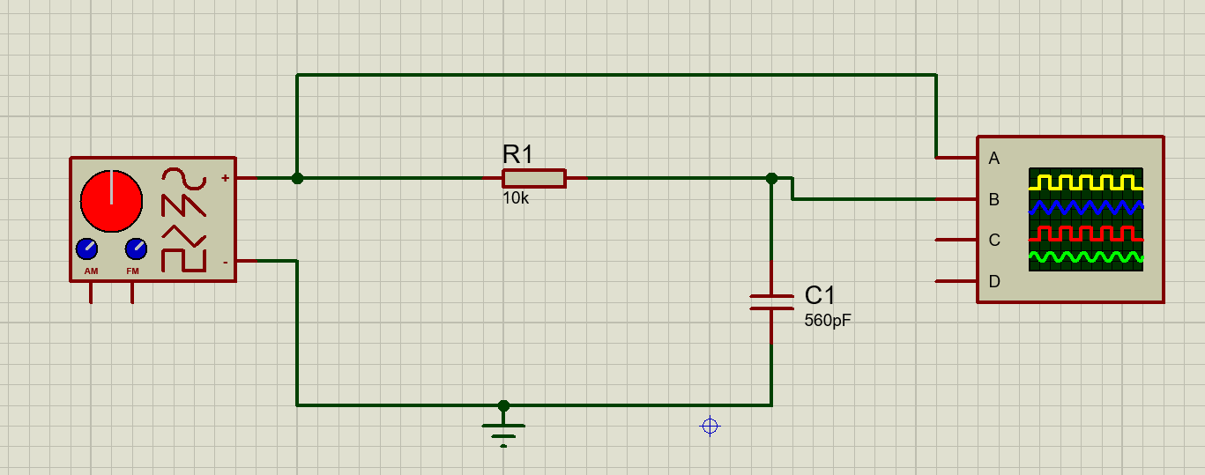
The below screenshot of the Proteus oscilloscope and waveform generator show the attenuation and phase lag on a 40Khz signal. This is above the cutoff frequency which is evident from the peak amplitude being over 1V below the input value.
There is also some phase shift in the output voltage which is a feature of circuits with reactive components.
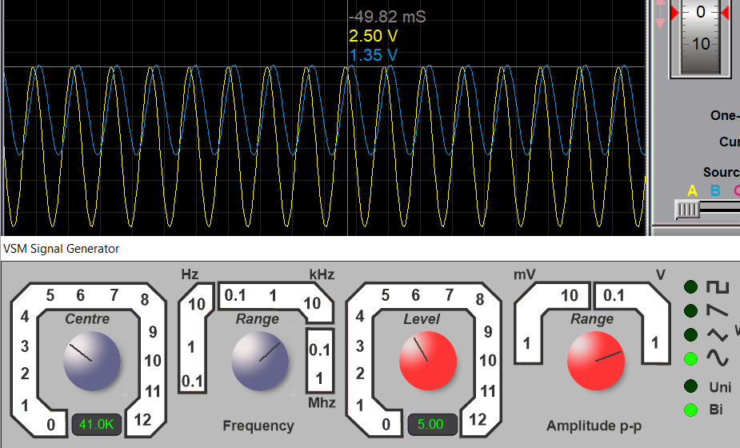
The measured cutoff frequency for the simulated low pass filter was 28KHz.

High Pass
The simulation of the high pass filter was arranged as below in proteus.
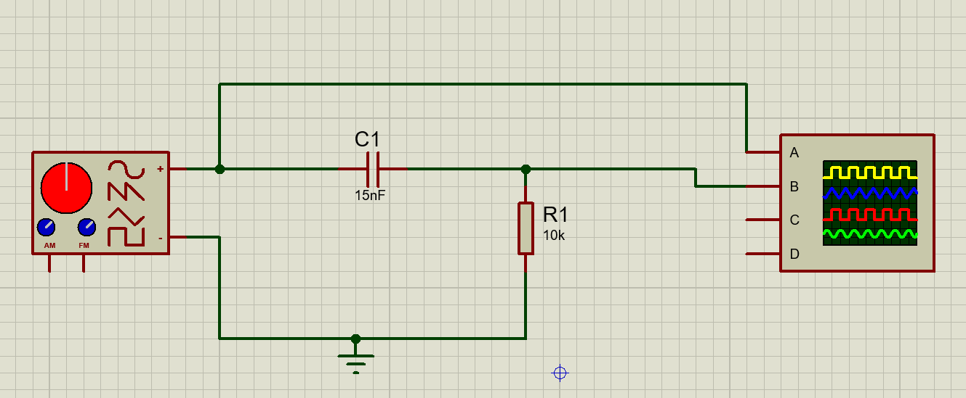
The measured cutoff frequency for the simulated high pass filter was 1.05KHz

Breadboard Circuits

Low Pass
The low pass filter was constructed on breadboard as below. The signal generator was connected to the +’ve & - ‘ve rails. The oscilloscope was connected across the capacitor. The distance between components was kept to a minimum to reduce capacitive and inductive effects.

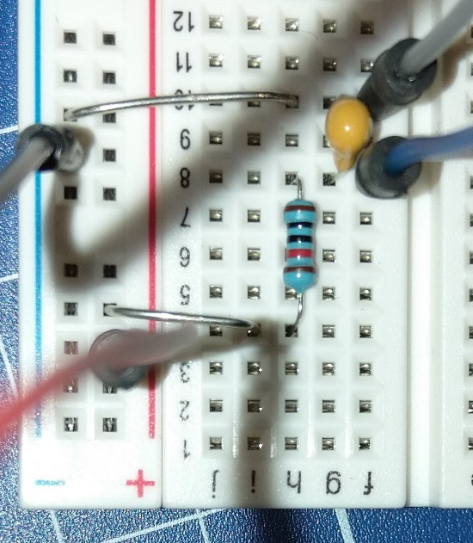
The inbuilt function generator of the oscilloscope was used to generate the input signal.
The peak-to-peak voltage and frequency were read from an automatic measurement function in order to reduce reading error.
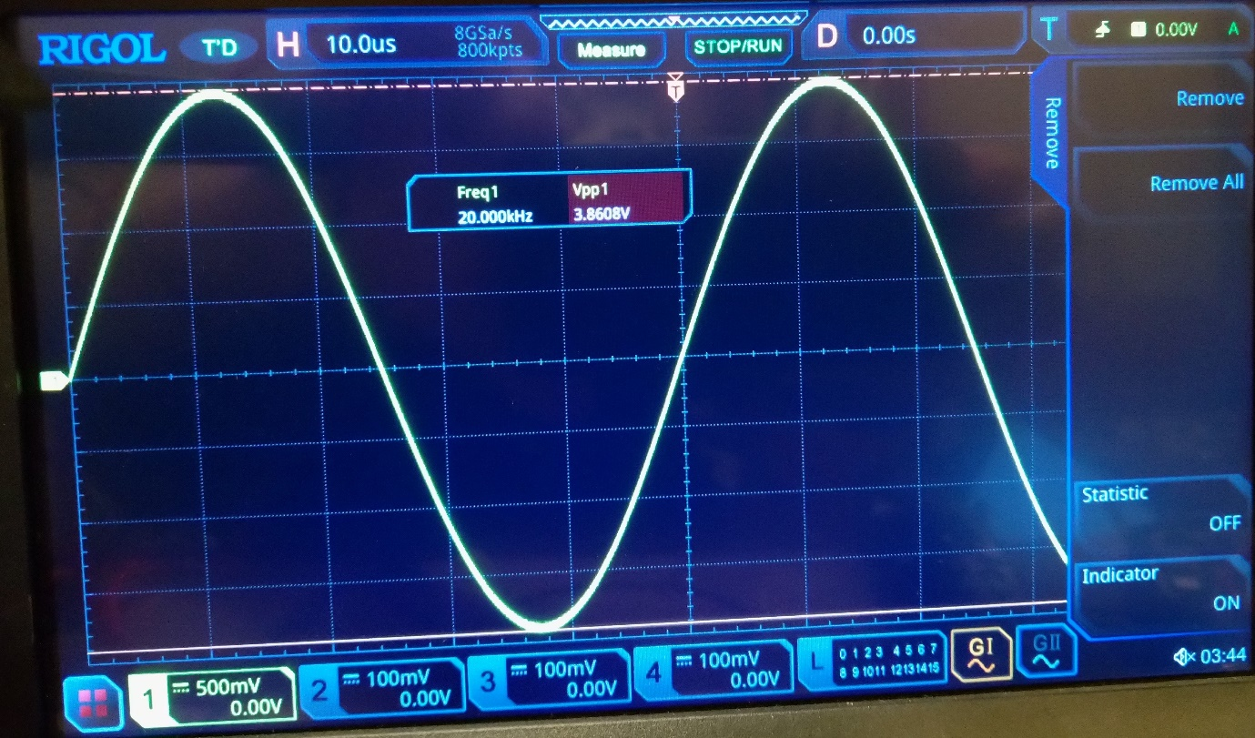
The measured cutoff frequency for the low pass filter circuit was 23.5KHz.

High Pass
The high pass filter circuit was constructed as below.
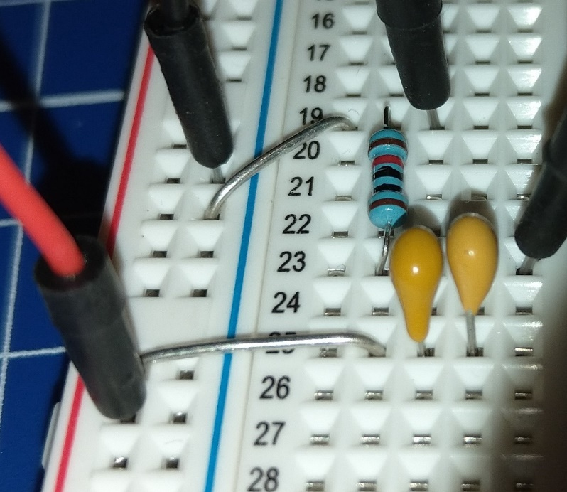
A 15nF capacitor was not available so a 10nF & 4.7nF were connected in parallel. The combined capacitance was measure with a bench multimeter and shown to be 15.13nF.
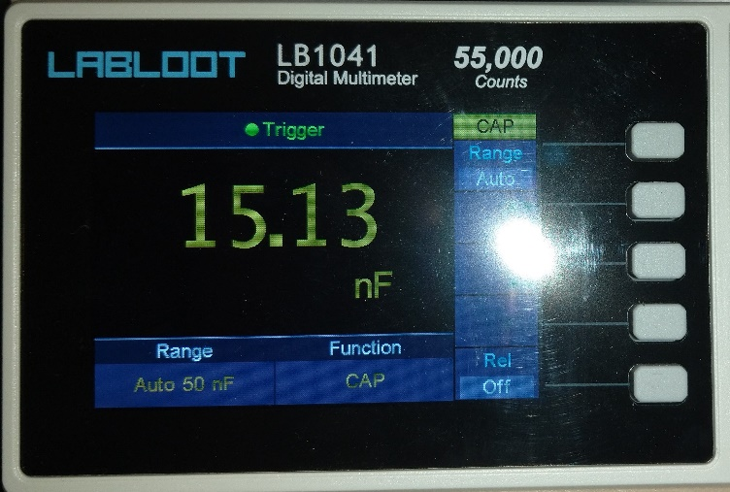
The 10K Ohm resistor was also measured and found to be with in the 5% tolerance.
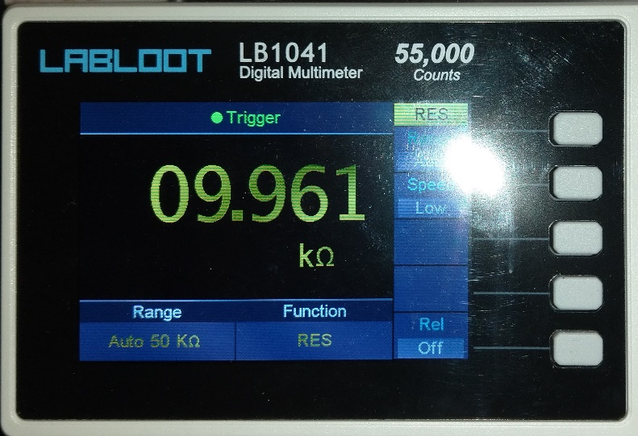
The measured cutoff frequency for the high pass filter circuit was 1095Hz.

Analysis & Discussion
The ideal, simulated and circuit results were plotted against each other on a response curve graph. The cutoff voltage (the -3d.B. point) was superimposed in red.
The cutoff frequency from each method was added as a broken line in the appropriate colour.

Ideal & Simulated Results
The ideal figures for both filters were strongly correlated to the simulated results, the error is likely due to reading error when measuring the simulated waveform on the oscilloscope and manually transposing to the spreadsheet.

Low Pass
The measured results correlate strongly with the other results but with a slightly reduced magnitude which is consistent throughout the frequency range. This loss of power is likely due to losses/ increased resistance in the components due to heating or poor connections in the breadboard.
The cutoff frequency was measured as 28.4KHz as opposed to the ideal 28KHz, this is likely due to losses in the circuit rather than component tolerances due to the consistently reduced output voltage even within the bandwidth where attenuation was minimal.

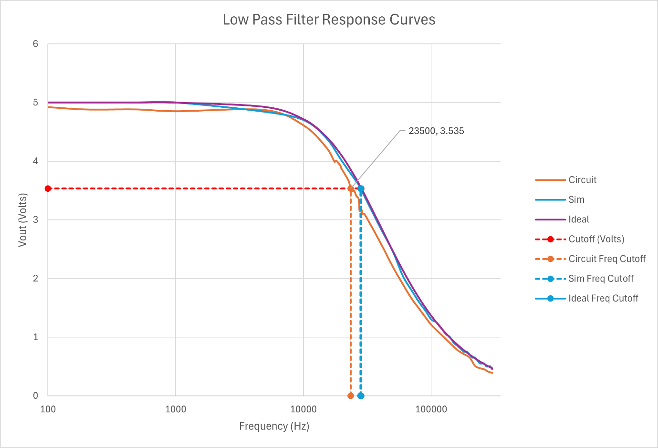

High Pass
The measured results for the high pass filter followed the general trend of the other results but did not follow the same smooth (but diminished) form shown in the low pass filter circuit.
The exception to this is in the region of the cutoff frequency where all results are closely correlated. For the high pass filter the measured cutoff frequency was 1095Hz as opposed to the ideal 1050Hz.
The shape of the curve for the measured results is not as smooth as would be expected (particularly in the higher frequency range) which suggests there may be some interference between components.

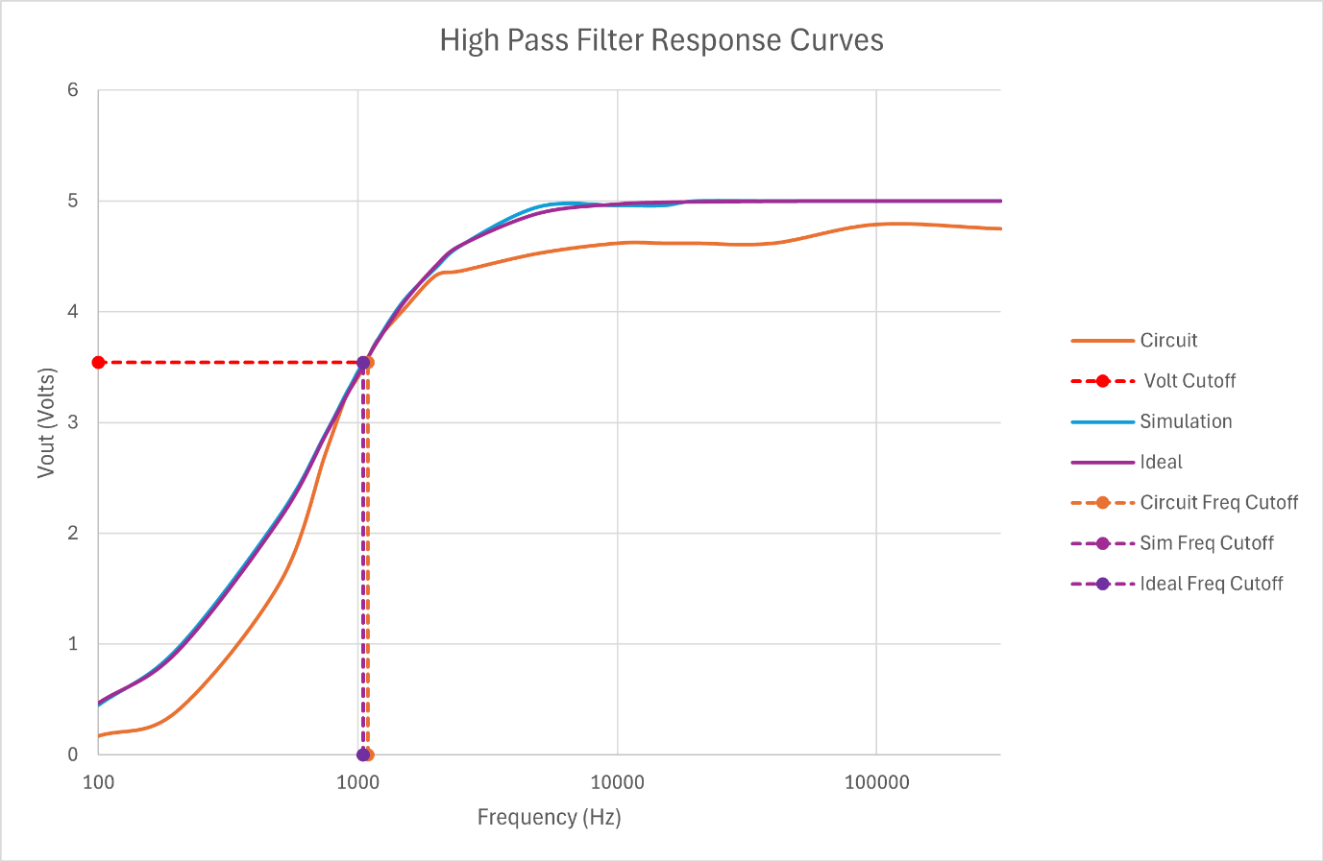

Conclusion
The Proteus software produced results which closely corresponded to the ideal results and the general characteristics of the real-world circuit. This makes it an effective prototyping tool as it removed the need to calculate the individual reactance at each frequency and the resultant attenuation of the output signal.
The main criticism was the crude nature of the oscilloscope in not offering an automatic measurement function and the limited resolution of the function generator.
The circuits created using prototyping breadboard performed adequately considering the numerous potential points of failure when using push-in components. The logical next step would be to use prototyping board which allowed the soldering of components or custom PCB manufacture.
The passive filters gave a smooth transition around the cutoff frequency, an ideal filter would give an instantaneous transition which blocked all frequencies beyond the cutoff. One method of achieving this would be to stack these filters with subsequent filters tuned to have a cutoff slightly beyond the first.

References
Mike Tooley, L. D., 2021. Electrostatics & Capacitors. In: Engineering Science for Foundation Degree & Higher National. Abingdon: Routledge, pp. 325-338.
Scherz, P. a. M. S., 2016. Practical Electronics for Inventors. 4th edn. ed. New York: McGraw-Hill Education.
The Organic Chemistry Tutor, 2020. Low Pass Filters and High Pass Filters - RC and RL Circuits. [Online]
Available at: https://www.youtube.com/watch?v=lagfhNjMuQM
[Accessed 18 March 2025].

