Programming 2
Assignment 1

Name: Daniel Davies
Student Number: 1701603
Course: Software Engineer
Contents
- Introduction
- Problem Solving Approach
  - What is Subdividing a Problem?
  - How to Apply Subdividing?
- Testing
  - Testing Program
  - Fixing Errors
- Implementation
  - Exercise 1
  - Exercise 3
- Conclusion
- References
- Appendix

Introduction
Through out this report a few programming topics will be covered which has a focus on problem solving. The first section a problem solving approach will be looked, this approach will be examined and analysed. The next section a program will be tested and any errors will be fixed. The last section involves creating a connect 4 game and create a number guessing game

Problem Solving Approach
Introduction
In this section of the report a problem solving approach will be analysed and will look at how that approach can be used when writing code. The approach which will be analysed will be subdivide the problem into smaller problems.

What is Subdividing a Problem?
Subdividing problem is when a large problem is broken down into smaller parts and then even smaller parts again if possible. For example if a program is required which needs the user to input 5 names and ages, then add up all the ages, then subdividing would split this into two tasks, these are:
- User inputs 5 names and ages
- Adds the ages up
The first task could then be split into two more tasks, these are:
- Get user to enter 5 names
- Get user to enter 5 ages
As the tasks are broken down more and more the tasks get easier and easier to complete and manage. This is why subdividing is such a powerful tool and should always be used to break down a big project.

How to Apply Subdividing?
It is very important to note that subdividing should not be done while writing the code but should be done on paper or word beforehand. This is because a problem should never be solved while writing the code as it is really ineffective and is a massive waste of time.
To apply subdividing to a problem firstly take the whole problem and break it down into various sub problems and then break those problems down again and again, until the problems are small and easier to solve. For example to create a battleships game it is very challenging but it can be broken down in to easier sub sections, some of these sub sections include:
- Create the grid
- Allow user to plot on the grid
- Create interface for user
- Allow the users to take in turns to turn and hit the opponent
- If all ships are sunk end game
Now the big problem has been broken down into sub problems it is a lot easier to see what needs to be done and potentially see how some these tasks can be completed. For example the “Create Grid” can be done through using a multi-dimensional array.

Benefits of using subdividing
Subdividing is one of the best ways to solve big problems and there are many benefits of using subdividing some of these include:
- Make the problem easier by breaking it down into smaller problems
- Helps makes what is required more clearer (If a loop is required or if function is going to be beneficial)
- Allows planning the project more effective.
- Make it easier to see what needs to be done
- Very good way to solve massive problems as well as smaller problems

Testing
Testing Program
01 | User Enters a valid menu option
Description |  | User enters a valid menu option
 |  | Test Steps :
1 | Ask user to enter a number
2 | Enter the value 1

Response |  | The program should not display any error messages and should continue to allow the user to enter a number
Status |  |  | Date |  |  | Description
Pass |  |  | 28/03/2018 14:24 |  |  | Passed

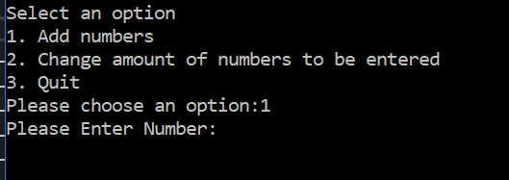

02 | User Enters an invalid menu option
Description |  | User enters invalid values into the options
 |  | Test Steps :
1 | Ask user to enter a number
2 | Enter values A1, 55, AA, ++

Response |  | An error message should display asking the user to input a valid number
Status |  |  | Date |  |  | Description
Pass |  |  | 28/03/2018  14:29 |  |  | Passed

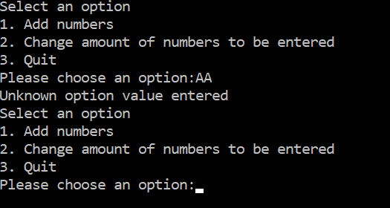

03 | Allow User to input valid number to add them
Description |  | After the user selects option 1 in the menu (add numbers), checking to see if the user is able to input valid numbers to add
 |  | Test Steps :
1 | Ask user to enter a number
2 | User enter valid number

Response |  | The program should not display any error messages and should continue to allow the user to enter a number
Status |  |  | Date |  |  | Description
Pass |  |  | 28/03/2018  14:31 |  |  | Passed

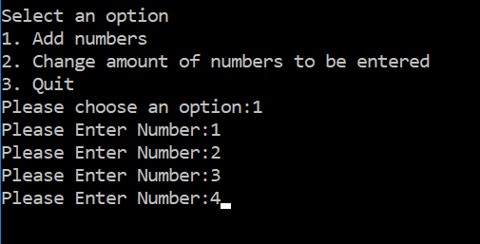

04 | User enter an invalid value when adding number
Description |  | After the user selects option 1 in the menu (add numbers), enter an invalid number
 |  | Test Steps :
1 | Ask user to enter a number
2 | User values A1, AA, ++s

Response |  | The program should not display any error messages and should continue to allow the user to enter a number
Status |  |  | Date |  |  | Description
Fail |  |  | 28/03/2018  14:39 |  |  | It allows the user to enter invalid values

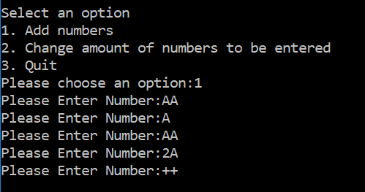

05 | User enter a negative value when adding number
Description |  | After the user selects option 1 in the menu (add numbers), enter an negative number
 |  | Test Steps :
1 | Ask user to enter a number
2 | User enters -1
3 | User enter 2

Response |  | The program should take this number away from the final number
Status |  |  | Date |  |  | Description
Pass |  |  | 28/03/2018  14:42 |  |  | Passed

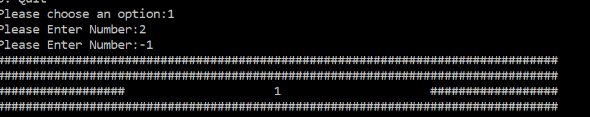

06 | Checking if option 1 works correctly
Description |  | Testing to see if option 1 works correctly
 |  | Test Steps :
1 | Select option 1
2 | User enters 1, 2, 3, 4, 5

Response |  | The program should add up all the numbers
Status |  |  | Date |  |  | Description
Pass |  |  | 28/03/2018  15:25 |  |  | Passed

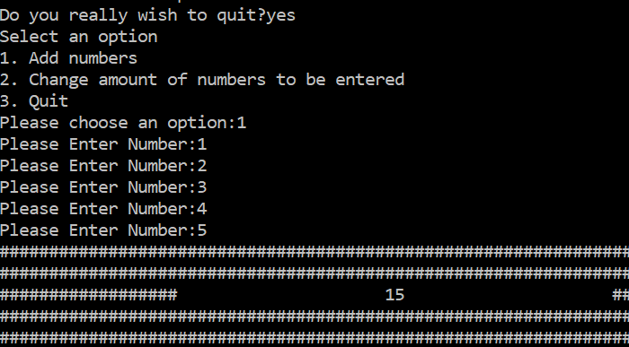

06 | Input a valid number in option 2
Description |  | After the user selects option 2 in the menu, checking to see if the user is able to input valid number
 |  | Test Steps :
1 | Ask user to enter a number
2 | User enter valid number

Response |  | The program should not display any error messages and should continue to allow the user to enter a number
Status |  |  | Date |  |  | Description
Pass |  |  | 28/03/2018  14:49 |  |  | Passed

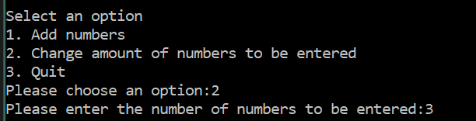

07 | Input a invalid number in option 2
Description |  | After the user selects option 2 in the menu (add numbers), enter an invalid number
 |  | Test Steps :
1 | Ask user to enter a number
2 | User values A1, AA, ++

Response |  | The program should not display any error messages and should continue to allow the user to enter a number
Status |  |  | Date |  |  | Description
Fail |  |  | 28/03/2018  14:50 |  |  | It allows the user to enter invalid values

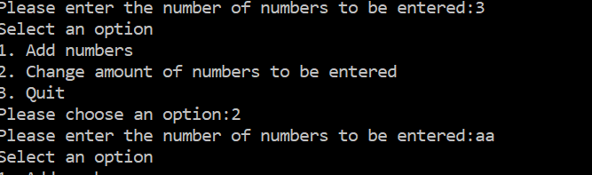

08 | Seeing if option 2 works correctly
Description |  | What ever value the user enters in option 2 should change how many numbers the user can add together.
 |  | Test Steps :
1 | Select option 2
2 | Enter 3
3 | Select option 1
4 | Enter 3 numbers (1, 2, 3)

Response |  | The program should only allow the user to enter 3 numbers when the user adds up their numbers.
Status |  |  | Date |  |  | Description
Pass |  |  | 28/03/2018  14:59 |  |  | Passed

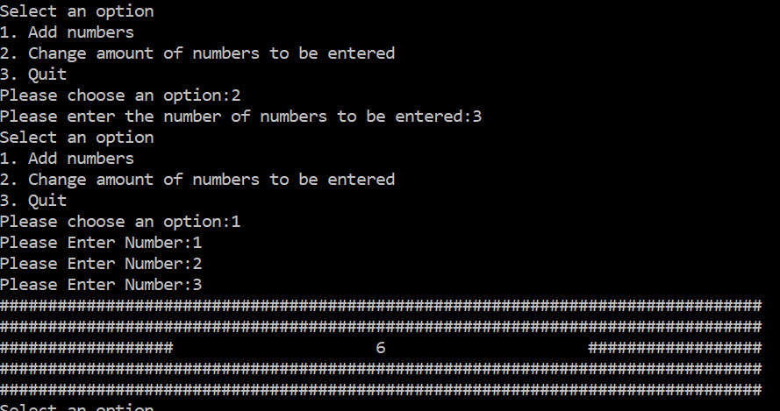

09 | Seeing if the program quits
Description |  | After the user selects option 3, does the program quit when the user enters YES
 |  | Test Steps :
1 | Select option 3
2 | Enter YES

Response |  | The program should allow the user to quit displaying a message which says “Quitting”
Status |  |  | Date |  |  | Description
Pass |  |  | 28/03/2018  15:01 |  |  | Passed

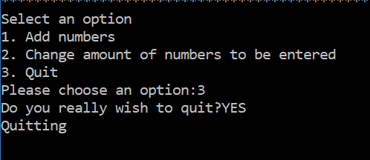

10 | Seeing if the program quits with other values
Description |  | After the user selects option 3, does the program quit when the user enters yes, y and Y
 |  | Test Steps :
1 | Select option 3
2 | Enter yes, y and Y

Response |  | The program should allow the user to quit displaying a message which says “Quitting”
Status |  |  | Date |  |  | Description
Failed |  |  | 28/03/2018  15:05 |  |  | The program did not quit

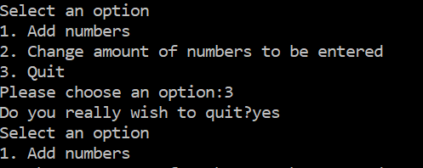

Fixing Errors
Quit Option – When the user selects option three they are then prompted if they would like to quit which then the only way to quit is if the user enters “YES”. This has now been changed so that other values can be inputted so that the user can enter:
- Yes
- yes
- Y
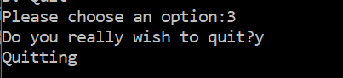
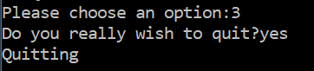
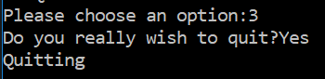
All the inputs working correctly

Text Driven Menu – Currently there is a number driven menu which only works through numbers. However this has been changed to a text driven menu so that the user can enter “one”, “two” or “three”.
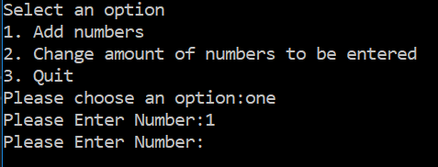
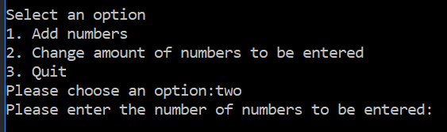
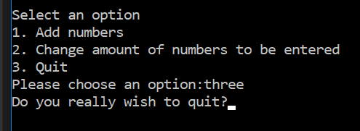
This is the program working correctly, the user enters a the number and the program runs the correct process depending on their selection.
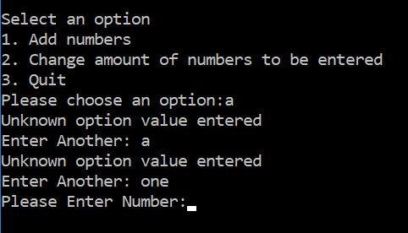
If the user enters an invalid value it will keep one asking for a different value till a valid value has been entered. This means that the menu is fully functional

Fixing the spaces – After the user has entered all the numbers they wish to add, the total is then displayed if the digit is 10 or over then it would make a space which destroys the display. This has now been fixed and the user can enter a value of any size.
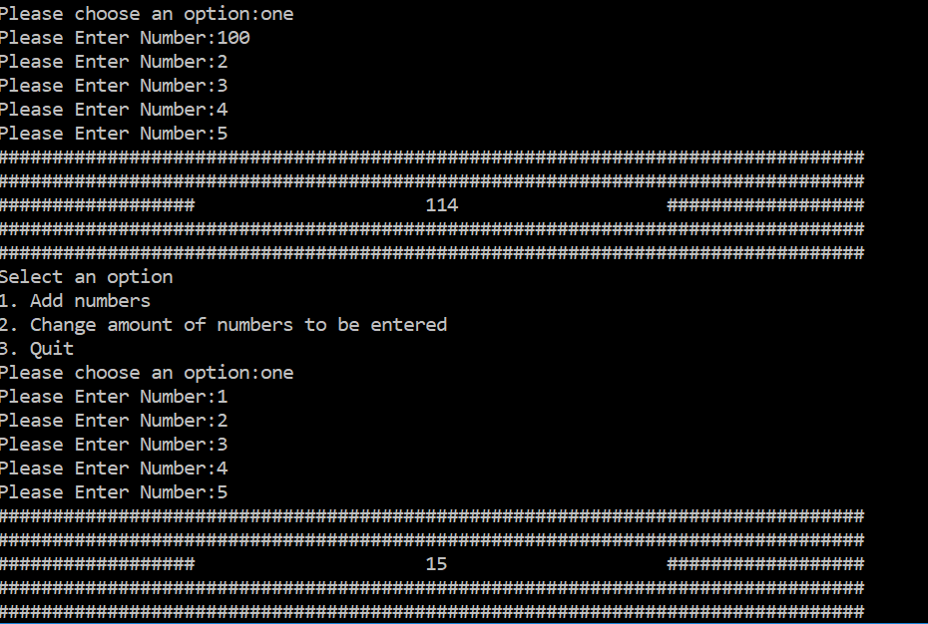
Here there are two different numbers which have been displayed the first being 114(three digit number) and the second being 12(two digit number). However the display is still working correctly and everything is displaying correctly.
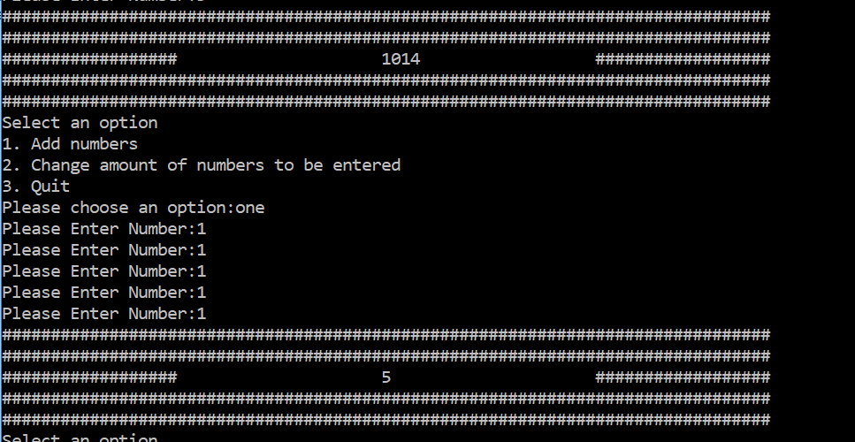
Here are another two different numbers which have been displayed the first being 1014(four digit number) and the second being 5(one digit number). However the display is still working correctly and everything is displaying correctly. This proves that the error has been fixed and everything is working correctly.

Implementation
Exercise 1
This exercise requires a guessing game, a random number was generated from -20 to 20 and the user had 5 guesses to get the number correct while getting various hints saying if the number is within 10, 5, 2 or if the number is a positive or negative number. The user would lose if they made the 5 guesses without getting the random number correct.
The first problem to solve was how was everything going to flow?. With this in mind a list of tasks were made in order what they need to be in the code itself. This list include:
- Generate the random number
- Allow the user to make a guess
- Check if the number was correct
- If its correct end game if incorrect give the user hint
- Repeat step 2, 3, 4, five times
- User loses
With this in mind the first task which was undertaken was the random number. As generating a positive number from any range was easy. The problem was how to generate a negative number. For this a number was generated from 0 – 40 then that number was taken and 20 was subtracted from it.
The next step was to allow the user to make a guess from -20 to 20. For this a simple printf and scanf was done. However the user was able to write other numbers in a the program did not know what to do. For this reason a function was then created which allows the user to scan in a number and there is an if statement which checks to see if the number is a valid number, when there is a valid number the function then returns that number back to the main.
The next step was one of the easiest step and was done through a simple if statement and checked if the playerGuiess variable was equal to the rndNumber variable.
Step four was the hardest step and required a lot of work to figure out the easy part was the end game function and if the statement in step 3 came out true then it would break out of the while loop and display “You Win”. The hard part was telling the user the correct hint, for this task I broke it down into more subtasks to do these were:
- Tell user if number was positive or negative
- Tell user if number within 10
- Tell user if number within 5
- Tell user if number within 2
The easiest of these was to display whether the number was positive or negative so this was done first, it was done through two simple if statements which checked if the rndNumber was a positive or negative number and display it to the user.
The next was to figure out how to check to see if the number was in a certain range, so a function was created which tock the random number put it in loop which max count was passed into the function and added 1 and checked it to the player guess. If this statement came out as turn then it would return 1 otherwise it would return 0.
This number would then be added to a variable called messageCounter which then determined what help message would be displayed. For example if only one of the statements is true then it would mean that the messageCounter would be equal to one which would mean the number is within 10 but not in 5 and 2 which it would then only display “The number is within 10”. However if every statement came out false then the messageCounter would be 0 which would the run the code which tells the user if the number is positive or negative.
The next step was to make repeat step 2, 3 and 4 5 times which was very simple. All that was required was a for loop with the max count set to 5 so that the player gets to make 5 guesses.
The last step was then to tell the user that they have lost which was a simple printf at the end of the for loop.

Easiest Problem to Hardest
- Display “You Win” and You Lose”
- Display “Please select a number”
- Display “That was Incorrect”
- Allow the user to input a number
- Check to see if player guess was the same as random number
  - If number was correct display “You Win”
  - If number was incorrect display “That was incorrect”
  - If that was the players last guess display “You Lose
- Generate the random number
- End game if user has had 5 attempts
- Validation check to see if user entered a valid value
- Tell user if number is positive or negative
- Tell user if number is within 10, 5, 2
- Display only one hint depending on how close the guessed number was to random number.

Testing the Program
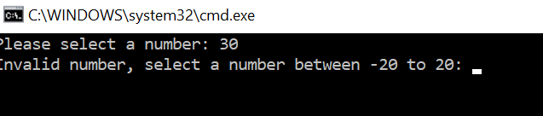
It will not allow the user to enter a number which is above 20 or below -20. A variety of different numbers were tested and this validation function works correctly.

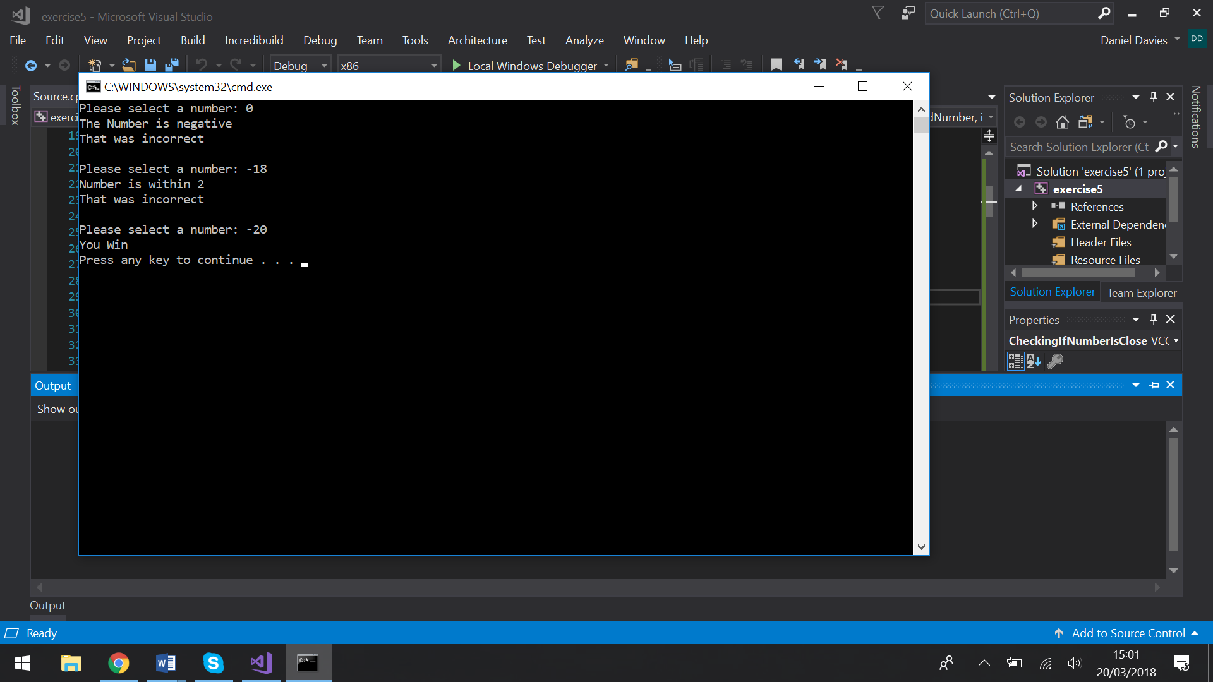
If the user enters the guesses the correct number then a message will come up saying they win.

After the user makes an incorrect guess it will tell the user a correct hint this shows -18 as the guess and it says the number is within 2, which next line -20 is entered which is within 2 of -18.
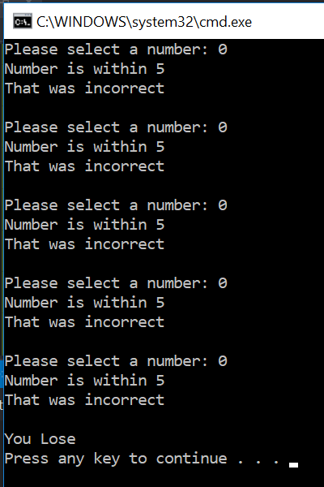
After the user has entered 5 numbers it tell the user that they have lost.

Exercise 3
This exercise requires a connect 4 game, each player takes in turn to place a counter and when one of the players have 4 counters next to each other either horizontal, vertical and diagonal then that play wins and the game ends.
The first problem to solve was how was everything going to flow?. With this in mind a list of tasks were made in order what they need to be in the code itself. This list include:
- Create the grid
- Display the grid and allow the user to enter a column to place the counter.
- Put the counter in the correct column and row
- Update the grid
- Check to see if there are four in a row.
  - If there are end game and display “Player & Wins”
  - If not repeat step 2, 3, 4 and 5.
Taking this list into consideration the first problem to solve is how to create a the grid, for this a multi-dimensional array was created. To create this a counting loop within a counting loop was created. This was the easiest task and as this problem has previously been solved before it was not challenging.
How the grid works
If there is an empty slot with no counter then the value will be set to 0. If player 1 has a counter within the slot then it would have a value of 1 and would display an X in the place. If player 2 has a counter within the slot then it would have a value of 0 and will display an O.
The next problem was to display the grid and allow the user to enter the column of their choice. however within the code the this task was mixed in with step three which was to place the counter in the correct gird. For step two the first problem to solve was how does the program know which player go it is?. For this two variables were created these were player1counter (value was set to 1) and player2counter (value was set to 2) which are used for:
- Setting value within the grid
- Display which players turn it is
- Displaying which user won.
With these variables set in place it is going to be a lot easier setting values into the grid as this can be done through a function and all that needs to be passed in is the player counter and the program will know who’s turn it is.
Now that the program know who is placing the counter within the grid all that is needed is to display the interface. The interface which has been created is that the grid is going to be at the top then underneath it displays what the different counters mean. Under this it says which users go it is which then asks the user to make a choice. There is then a scanf which takes the column choice the user decided.
The next step was to place a counter in the grid depending on what column the user selected, for this the column choice of the user was required. After the column has been inputted by the user then the program will run the function which places the counter in the grid. Within this function a variable has been set called row which has been set to 5, this stands for which row the counter is going to placed in.
The program places the counter by firstly taking the column number which it then goes the row (which has been set to 5) and attempting to place the counter with that row and column, if the value of that slot has been set to 0 then it will change the value depending on the playerCounter. However if there is a value of either 1 or 2 then this means that a value has already been set on this coordinate. The program then takes 1 off the row and does the same check to see if there is a value within the slot. It will carry on doing until it places a counter.
After this code runs and places the counter it then prints out the grid again with the update grid which is step 3. This was the easiest step and only required the function which printed out the grid which was done in step 2.
The next step which was the hardest step required to check if there were four in a row. This was all done within a function and was done through if statements. Within the function the grid, column and row choice was required. To do the checks every different combinaton was looked at, in the following illustrations the X is the player choice and the 0 is what the program checks:
Horizontal and Vertical Checks
X000
0X00
00X0
000X
These were the easiest checks and only required to + and - from the row (Vertical check) or the + and - from the column (Horizontal check). For example for the first horizontal check it would check to see if the three 0 are the same as playerCounter. This means it would add one to column, check to see if the number is the same as playerCounter (this is the first 0), if it is then it will check the next 0 this means it would add 2 to column and check to the playerCounter (This is the second 0). To check the vertical – or + the row instead of the column.

Diagonal Check
0
0
0
X
This was the tricky check as it was not a simple job of just – and + the horizontal or vertical. However it needed to - or + both the horizontal and vertical at the same time to check. Once one vertical side was done just flipping the numbers would work out the opposite diagonal check. For the first to check for the first 0 add 1 to row and add 1 to column, to check the second add 2 to row and add 2 to column.
If none off the if statements came back as true then it would mean that the player has not won which it then lets the next player to have their go. If one of these come back as true this means the one of the players have one which it will then display a message and end the game.

Easiest problem to hardest
- Displayer what the counters means (“X = Player 1” and “0 = Player 2”)
- Display “Player & has won”
- Display which players go it is
- Allow the user to enter a column choice
- Create the grid
- Display the grid
- Validation check to see if user entered a valid column number
- Put the counter in the grid
- Check if user has won vertical or horizontal
- Check if user has won diagonal

Testing the Program
Creating the interface
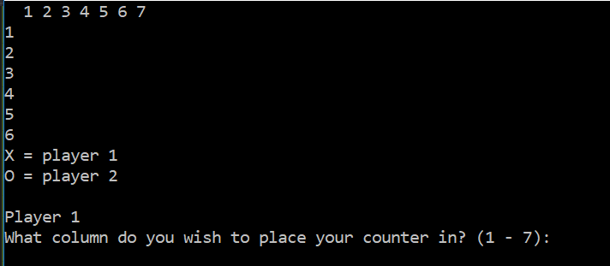
This is the screen it displays when the program is first loaded, the grid is on the top left and below it says which each counter means, as it has just been loaded up there is no counter on the grid. Below that it displays which users go it is and allows the user to enter a number.

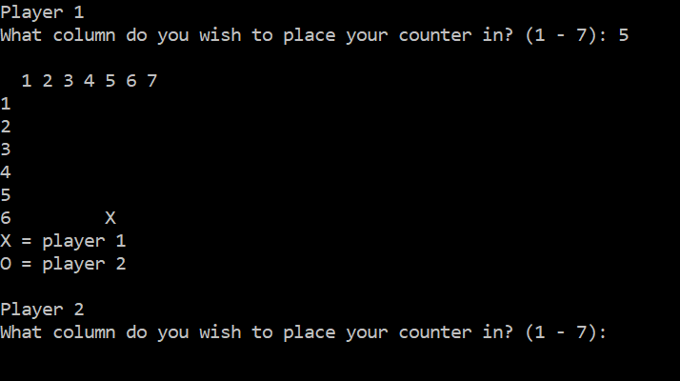
Player 1 has selected to put the counter within column 5 which it then places the counter in the correct column. It then asks player 2 to select a counter. This shows that everything is working so far.
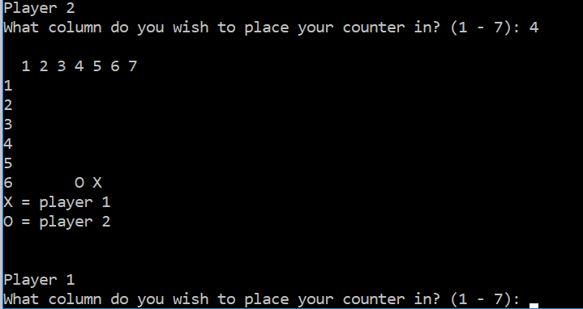
Player 2 selected column 4 which it then placed a counter in column 4. After this it asks player 1 to select a column.
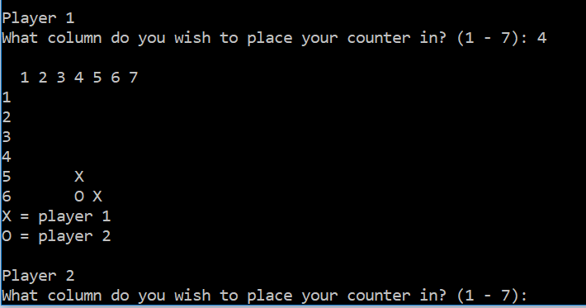
Player 1 also selected column 4 which it then put the counter on top of player 2 counter. This shows that everything is working so far.
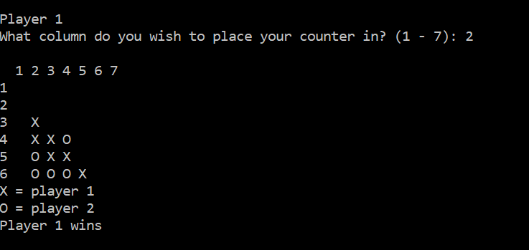
Skipping forward a bit players 1 has four in a row going diagonal left which it has then displayed a message and does not allow the next player to make a move. This shows that everything is working correctly.

Conclusion
To conclude a problem solving approach has been looked, this being sub-dividing problems, this approach has be examined and analysed. The next section has program has been tested and many of the errors has been fixed. The last section involved creating a connect 4 game and create a number guessing game. Both these have been created, tested and explained

References

References

[1] | "Moodle," [Online]. Available: moodle.uwtsd.ac.uk. [Accessed 19 02 2018].
[2] | "Skills You Need," [Online]. Available: https://www.skillsyouneed.com/ips/problem-solving.html. [Accessed 01 03 2018].
[3] | "Wiki," 22 02 2018. [Online]. Available: https://en.wikipedia.org/wiki/Problem_solving. [Accessed 9 02 2018].
[4] | "What Is Problem Solving?," [Online]. Available: https://www.mindtools.com/pages/article/newTMC_00.htm. [Accessed 27 02 2018].

Appendix
Exercise 1
#define _CRT_SECURE_NO_WARNINGS
#include <string>

#include <cstdlib>
#include <time.h>

using namespace std;

//Generate a random number
int rndNumberGen(int maxValue)
{
return rand() % (maxValue);
}

//Checks number within max count
int CheckingIfNumberIsClose(int maxCount, int rndNumber, int playerGuiess)
{
int count = 0;
int same = 0;
int rndNumberCheck = 0;

rndNumberCheck = rndNumber;

//Checking if number is within 10 +
for (count = 0; count < maxCount; count++)
{
rndNumberCheck = rndNumberCheck + 1;

if (rndNumberCheck == playerGuiess)
{
return 1;
}
}

rndNumberCheck = rndNumber;

//Checking if number is within 10 -
for (count = 0; count < maxCount; count++)
{
rndNumberCheck = rndNumberCheck - 1;

if (rndNumberCheck == playerGuiess)
{
return 1;
}
}

return 0;
}

//Display the hint message
void displayHint(int messageCount)
{
if (messageCount == 1)
{
printf("Number is within 10\r\n");
}

if (messageCount == 2)
{
printf("Number is within 5\r\n");
}

if (messageCount == 3)
{
printf("Number is within 2\r\n");
}
}

//Give the user hints
void checkNumber(int playerGuiess, int rndNumber)
{
int count = 0;
int same = 0;
int messageCounter = 0;

int rndNumberCheck = 0;

//Check if the rnd number is within 10
same = CheckingIfNumberIsClose(10, rndNumber, playerGuiess);

messageCounter = messageCounter + same;

//Check if the rnd number is within 5
same = CheckingIfNumberIsClose(5, rndNumber, playerGuiess);

messageCounter = messageCounter + same;

//Check if the rnd number is within 2
same = CheckingIfNumberIsClose(2, rndNumber, playerGuiess);

messageCounter = messageCounter + same;

//Display the hint message
displayHint(messageCounter);

//Checking if number is negative or positive
if (messageCounter == 0)
{
if (rndNumber < 0)
{
printf("The Number is negative\r\n");
}

if (rndNumber >= 0)
{
printf("The Numeber is postive\r\n");
}
}
}

int main(int argc, char** argv)
{
//For creating the random number
time_t theTime;
srand((unsigned)time(&theTime));

//Setting variables
int rndNumber = 0;
int playerGuiess = 0;
int win = 0;

int count;

//creating the random number
rndNumber = rndNumberGen(40);

//Taking the number and taking 20 from it
rndNumber = rndNumber - 20;

//Creating the overall for loop
for (count = 0; count < 5; count++)
{
//Get user to make a guiess
printf("Please select a number: ");
scanf("%i", &playerGuiess);

//Checks to see if the player has won
if (playerGuiess == rndNumber)
{
printf("You Win\r\n");
win = 1;
break;
}

checkNumber(playerGuiess, rndNumber);

//Tell the user there guiess was incorrect
printf("That was incorrect\r\n");

printf("\r\n");
}

if (win != 1)
{
printf("You Lose\r\n");
}

return 0;
}

Exercise 3
#define _CRT_SECURE_NO_WARNINGS
#include <string>

using namespace std;

//Display grid icons
void GridIcons(int iconSelector)
{
if (iconSelector == 0)
{
printf(" ");
}
if (iconSelector == 1)
{
printf("X ");
}
if (iconSelector == 2)
{
printf("O ");
}
}

//Displays the Grid
void DisplayGrid(int grid[5][6])
{
int rowCount;
int colCount;

printf(" 1 2 3 4 5 6 7\r\n");

for (rowCount = 0; rowCount < 6; rowCount++)
{
printf("%i ", rowCount + 1);

for (colCount = 0; colCount < 7; colCount++)
{
GridIcons(grid[rowCount][colCount]);
}

printf("\r\n");
}
}

//Place counter in grid
int PlaceCountGrid(int grid[5][6], int playerChoice, int playerCounter)
{
int quit = 0;
int row = 5;

while (quit == 0)
{
if (grid[row][playerChoice] == 0)
{
grid[row][playerChoice] = playerCounter;
quit = 1;
break;
}

row = row - 1;
}

DisplayGrid(grid);

printf("X = player 1\r\n");
printf("O = player 2\r\n");
return row;
}

//Check if player won
int CheckPlayerWon(int grid[5][6], int playerChoice, int playerCounter, int row)
{
int win = 0;

//Check Vertical Win
if (grid[row + 1][playerChoice] == playerCounter)
{
if (grid[row + 2][playerChoice] == playerCounter)
{
if (grid[row + 3][playerChoice] == playerCounter)
{
win = 1;
}
}
}

if (grid[row - 1][playerChoice] == playerCounter)
{
if (grid[row + 1][playerChoice] == playerCounter)
{
if (grid[row + 2][playerChoice] == playerCounter)
{
win = 1;
}
}
}

if (grid[row - 2][playerChoice] == playerCounter)
{
if (grid[row - 1][playerChoice] == playerCounter)
{
if (grid[row + 1][playerChoice] == playerCounter)
{
win = 1;
}
}
}

if (grid[row - 3][playerChoice] == playerCounter)
{
if (grid[row - 2][playerChoice] == playerCounter)
{
if (grid[row - 1][playerChoice] == playerCounter)
{
win = 1;
}
}
}

//Check Horizontal Win
if (grid[row][playerChoice + 1] == playerCounter)
{
if (grid[row][playerChoice + 2] == playerCounter)
{
if (grid[row][playerChoice + 3] == playerCounter)
{
win = 1;
}
}
}

if (grid[row][playerChoice - 1] == playerCounter)
{
if (grid[row][playerChoice + 1] == playerCounter)
{
if (grid[row][playerChoice + 2] == playerCounter)
{
win = 1;
}
}
}

if (grid[row][playerChoice - 2] == playerCounter)
{
if (grid[row][playerChoice - 1] == playerCounter)
{
if (grid[row][playerChoice + 1] == playerCounter)
{
win = 1;
}
}
}

if (grid[row][playerChoice - 3] == playerCounter)
{
if (grid[row][playerChoice - 2] == playerCounter)
{
if (grid[row][playerChoice - 1] == playerCounter)
{
win = 1;
}
}
}

//Check Diagonal Right Win
if (grid[row - 1][playerChoice + 1] == playerCounter)
{
if (grid[row - 2][playerChoice + 2] == playerCounter)
{
if (grid[row - 3][playerChoice + 3] == playerCounter)
{
win = 1;
}
}
}

if (grid[row + 1][playerChoice - 1] == playerCounter)
{
if (grid[row - 1][playerChoice + 1] == playerCounter)
{
if (grid[row - 2][playerChoice + 2] == playerCounter)
{
win = 1;
}
}
}

if (grid[row + 2][playerChoice - 2] == playerCounter)
{
if (grid[row + 1][playerChoice - 1] == playerCounter)
{
if (grid[row - 1][playerChoice + 1] == playerCounter)
{
win = 1;
}
}
}

if (grid[row + 3][playerChoice - 3] == playerCounter)
{
if (grid[row + 2][playerChoice - 2] == playerCounter)
{
if (grid[row + 1][playerChoice - 1] == playerCounter)
{
win = 1;
}
}
}

//Check Diagonal Left Win
if (grid[row - 1][playerChoice - 1] == playerCounter)
{
if (grid[row - 2][playerChoice - 2] == playerCounter)
{
if (grid[row - 3][playerChoice - 3] == playerCounter)
{
win = 1;
}
}
}

if (grid[row + 1][playerChoice + 1] == playerCounter)
{
if (grid[row - 1][playerChoice - 1] == playerCounter)
{
if (grid[row - 2][playerChoice - 2] == playerCounter)
{
win = 1;
}
}
}

if (grid[row + 2][playerChoice + 2] == playerCounter)
{
if (grid[row + 1][playerChoice + 1] == playerCounter)
{
if (grid[row - 1][playerChoice - 1] == playerCounter)
{
win = 1;
}
}
}

if (grid[row + 3][playerChoice + 3] == playerCounter)
{
if (grid[row + 2][playerChoice + 2] == playerCounter)
{
if (grid[row + 1][playerChoice + 1] == playerCounter)
{
win = 1;
}
}
}

return win;
}

//Player Choice
int PlayerChoice()
{
int columnChoice = 0;
int quit = 0;

printf("What column do you wish to place your counter in? (1 - 7): ");
scanf("%i", &columnChoice);

while (quit == 0)
{
if (columnChoice >= 1 && columnChoice <= 7)
{
columnChoice = columnChoice - 1;
return columnChoice;
}
printf("Invalid Choice Please select another between 1 - 7: ");
scanf("%i", &columnChoice);
}
}

int main(int argc, char** argv)
{
//Setting Variables
int grid[5][6]; //rows-columns
int win = 0;

int columnChoice = 0;
int row = 0;

int player1Counter = 1;
int player2Counter = 2;

int rowCount = 0;
int colCount = 0;

//Creating Grid
for (rowCount = 0; rowCount < 6; rowCount++)
{
for (colCount = 0; colCount < 7; colCount++)
{
grid[rowCount][colCount] = 0;
}
}

//Display Grid
DisplayGrid(grid);
printf("X = player 1\r\n");
printf("O = player 2\r\n");

//Overall While Loop
while (win == 0)
{
printf("\r\n");

//Player 1 go
//Allows user to enter a number
printf("Player %i\r\n", player1Counter);
columnChoice = PlayerChoice();

printf("\r\n");

//Places players one counter on grid
row = PlaceCountGrid(grid, columnChoice, player1Counter);
win = CheckPlayerWon(grid, columnChoice, player1Counter, row);

if (win > 0)
{
printf("Player %i wins\r\n", player1Counter);
break;
}

printf("\r\n");

//Player 2 go
//Allows user to enter a number
printf("Player %i\r\n", player2Counter);
columnChoice = PlayerChoice();

printf("\r\n");

//Places players one counter on grid
row = PlaceCountGrid(grid, columnChoice, player2Counter);
win = CheckPlayerWon(grid, columnChoice, player2Counter, row);

if (win > 0)
{
printf("Player %i wins\r\n", player2Counter);
break;
}

printf("\r\n");
}

return 0;
}

