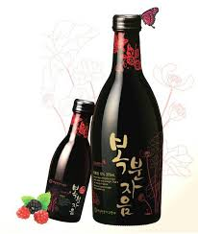
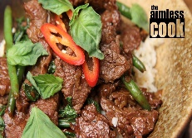

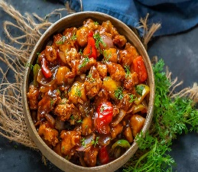

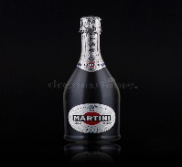
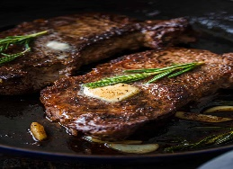
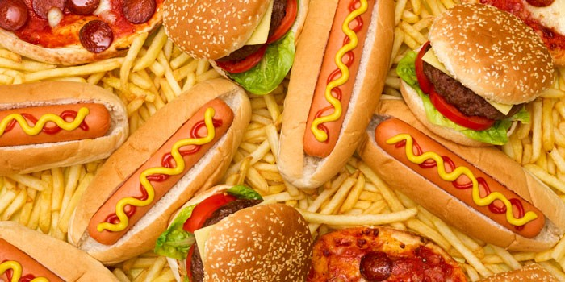
Hu, Q., 2014. A Description of Improvement ideas for a Chinese Restaurant in Finland.
12 PM
To 3 PM

12 PM
To 3 PM

Price- Only £ 12.00
Total Calories:
95 calories
(Kcl Fat- 9.8 gram)
Allergens: Chicken

Parmo

Ginger mango chicken
12 PM
To 3 PM

Price- Only £ 16.00
Total Calories:
151 calories
(Kcl Fat- 11 gram)
Allergens: Chicken

Eat Healthy foods
12 PM
To 3 PM

Price: Only £ 25.00
Total Calories:
253.6 G. (KCL- 75G)
Allergies- Steak

Pan Seared Steak + Steak Meal and Moscato (wine)

Price- Only £ 21.90
Total Calories
330 calories
(Kcl Fat- 14 gram)
Allergens: Beef

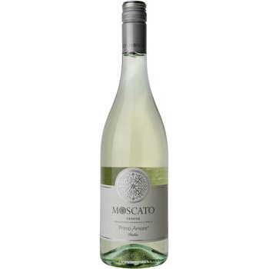
Thai Basil Beff with Respberry Wine
FOOD MENU

Swansea, South Wales
Order by +44 0915124365
WWW.HOTELTRINITY.CO.UK.
Hotel TRINITY
FOOD MENU

