CHAPTER 4

4.1 Chapter overview
This chapter presents the analysis of the researcher’s primary data, namely, respondents’ answers to questions about social media influence within the beauty industry and their buying behaviour towards it, collected through an online questionnaire. This chapter seeks to critically analyse the impact of social media influencers in the beauty industry from a number of different perspectives, opinions, and for different types of people from Swansea. The analysis of each question will be framed within the objectives of the dissertation and discussed concurrently.

Data were collected via an online survey (Google Docs) and transferred to IBM SPSS (v25, IBM Corp) for analysis. Answers to questions were given using Likert scales and multiple-choice answers meaning response data were ordinal (rank order of importance) or nominal (categories without implied ranking) and required non-parametric analyses (Roni et al., 2020). Chi-square tests of independence assessed whether response choices differed between age groups with Cramer’s V calculated to assess effect sizes (a sample size independent measure of the magnitude of the difference between groups) (Thakkar, 2020). Since the number of participants in each age group differed, the percentage of responses for each group were presented in bar charts to accurately portray group differences (Krieg, 2019).

4.2 Results 1 – Participant demographics
4.2.1 Age and gender demographics
165 people responded to the online survey, 89.7% (n=148) female, 9.1% (n=15) male and 1.2% (n=2) transgender male. The majority of respondents were either young (60.6% were 18-24) or older (23.0% were 40+; Figure 4.1). For this reason, the remaining analyses will only consider female responses (to ensure statistically plausible findings) which will be separated into three age groups to prevent small group sizes (18-24 (n=88), 25-39 (n=25) and 40+ (n=35)) by combining the 25-30 (n=14) and 31-39 (n=11) age groups.
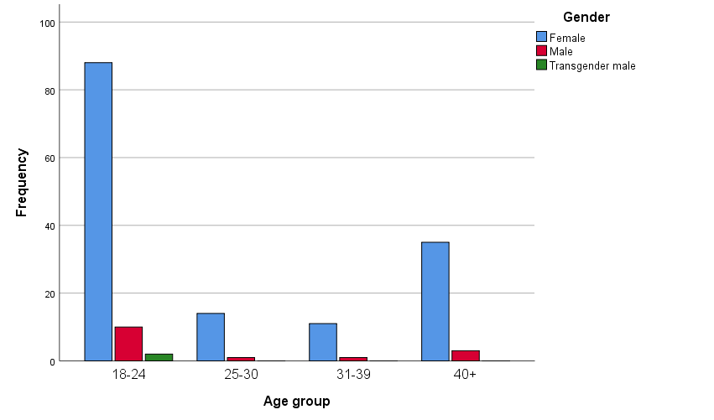
Figure 4.1: Age and gender of survey respondents
A large national survey on addictive behaviours (Andreassen et al., 2017) found that young females were influenced by social media influencers as they typically spent around nine hours a day viewing/watching brand promotion through different social media platforms including Instagram and YouTube. Therefore, separating the female respondents into three age group categories will facilitate assessing whether Andreassen et al.’s (2017) findings are relevant for this sample of Swansea females.
4.3 Results 2 – Buyer behaviour
4.3.1 Choice of where to shop by female age groups
Very few respondents reported only shopping for beauty products online (17.0% of 18-24, 24.0% of 25-39 and 5.7% of 40+; Figure 4.2). Two thirds (68.6%) of women 40+ only shopped instore, compared to 51.1% aged 18-24 and 36.0% aged 25-39 (chi-square = 7.43, df = 4, p = 0.16; Cramer’s V = 0.16).
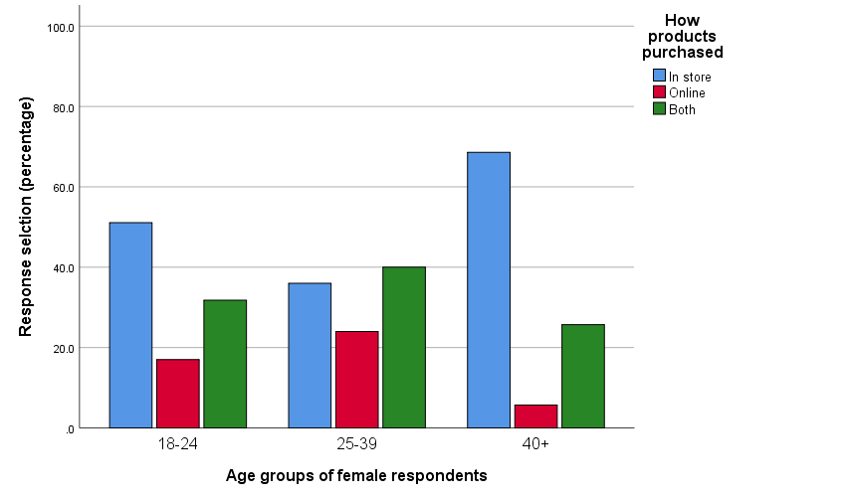
Figure 4.2: Where beauty products were purchased by female survey respondents
Kim et al. (2011) found that typically, people were more inclined to purchase beauty products in store when they hadn’t purchased it before. However, if customers were re-purchasing a product they were loyal to, then there was a higher chance that they purchased online, after searching for an online discount code. Nguyen et al. (2018) added to this suggesting that social media influencers with a large following tended to promote their beauty brands with a discount code, if purchased online. The popularity for in store purchasing found in this study could have many causes although age appeared to be a factor. First time purchases or the trust, or lack of, of both products and social media influencers could have impacted answers. However, many people simply prefer to have a tangible interaction with the product before using them (Boyer et al., 2006).

4.3.2 Frequency of shopping by female age groups
The general trend for purchasing frequency was to purchase less frequently as females got older (chi-square = 12.90, df = 6, p < 0.05; Cramer’s V = 0.21). This was evidenced by the peak purchasing frequency for 18-24 and 25-39 years old as monthly shoppers whereas 40+ women were more likely to purchase every 3 months (Figure 4.3). Further contributory evidence was the fact that weekly purchases of beauty products were only undertaken by 14.8% of 18-24 and 12.0% of 25-39 year olds with no 40+ women reporting this frequency of purchases.
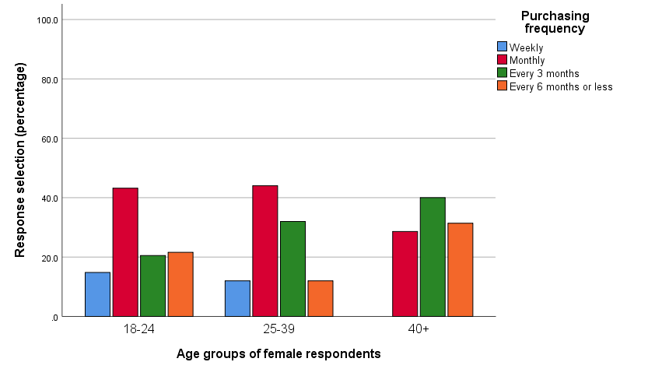
Figure 4.3: Frequency of purchasing beauty products by female survey respondents
Wongleedee (2015) suggested that purchasing frequency would always differ depending on the person, their age, and the product. However, this isn’t too informative since there are a lot of unknowns in this suggestion, such as the influence of relative cost i.e. disposable income may be related to age and hence affect purchasing frequency. Chen et al. (2019) found that 80% of young people aged between 18-34 made at least one online impulse buy during the week after seeing a product promoted in social media channels. This study found that younger women purchased more frequently than older women but this was more likely to be monthly than weekly, which is slightly surprising but Liu et al. (2019) suggests this may be due to bulk buying, as today it’s not unusual to see offers such as “buy one get one free” on beauty products. This is true for many well-known stores selling beauty products, including Boots, Superdrug and Tesco, who very frequently have these types of offer (Lu et al., 2019). This may also be a factor in why the women in this study frequently purchased in-store (Figure 4.2).

4.4 Results 3 – Social media influence on consumers of beauty products
4.4.1 Use of social media by different female age groups
There was a high reported awareness (>85%) of how social media influencers promote beauty products for all age groups ((chi-square = 4.94, df = 4, p = 0.29; Cramer’s V = 0.13; Figure 4.4).
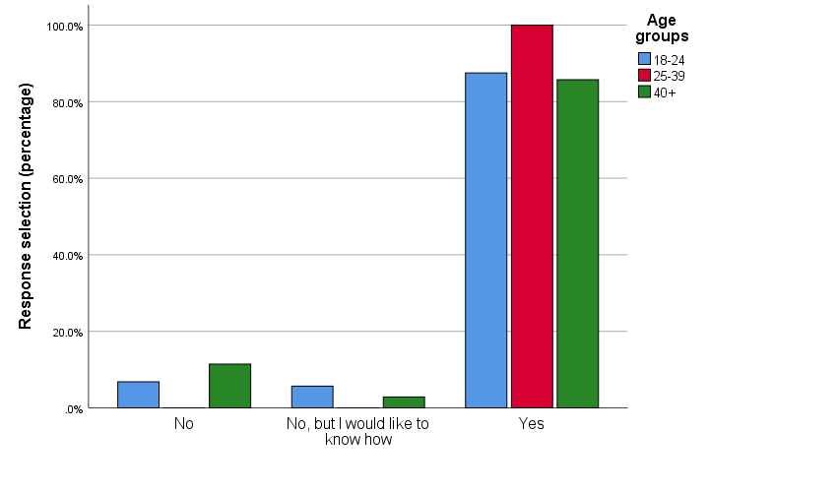
Figure 4.4: Awareness of how social media influencers promote beauty products
From the social media influencer’s point of view, it is extremely important that people are aware of how “they” promote beauty products (De Veirman et al., 2017). Hence, if the respondents hadn’t known how influencers promoted beauty products then it would be likely that they hadn’t been aware of what to look out for (Clark et al., 2013). Since this wasn’t the case the next issue was whether respondents actually took notice of the social media influencers and how they accessed this information e.g. through imagery or video content.

4.4.2 Experience of social media influencers by different female age groups
There was a high reported experience of witnessing social media influencers promoting beauty products (>80%) for all age groups ((chi-square = 4.14, df = 2, p = 0.13; Cramer’s V = 0.17; Figure 4.5).
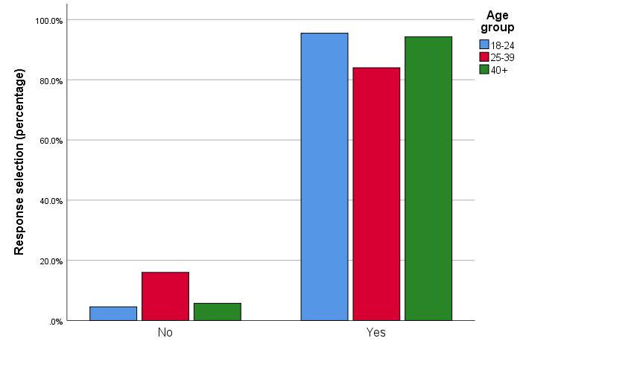
Figure 4.5: Experience of social media influencers promoting beauty products
Syam et al. (2018) found that if a person witnessed a social media influencer promoting a beauty product through any form of digital media, then statistically, there was a 52% chance that the product would be purchased. Artificial intelligence (AI) was deemed to play a significant part in targeting consumers with the content they were likely to be influenced by, based on previous browsing history. Similarly, Singh et al. (2019) described how a consumer viewing a brand’s product being promoted online, provokes AI to efficiently scan through petabytes of data to make sure the same post is advertised on that individual’s social media platforms, effectively enhancing the chance of a sale for that brand. This means there is a high chance that the respondents, who reported experience of witnessing social media influencers promoting beauty products, have purchased a product through the implementation of AI without even realising it (Marchand et al., 2017).

4.4.3 Use of media sources by different female age groups
Digital forms of social media (social media, internet and blogs) were thought to influence beauty product purchases by the younger age groups (18-24 and 25-39) much more than for the 40+ age group ((chi-square = 137.60, df = 14, p <0.001; Cramer’s V = 0.32; Figure 4.6).
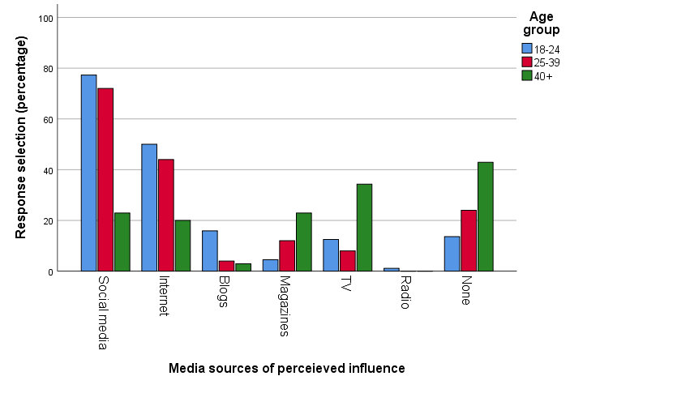
Figure 4.6: Perceived influence of media sources on beauty product purchases by female survey respondents
In contrast the 40+ respondents thought that TV (34.3%) or magazines (22.9%) influenced them more although 22.9% stated that social media had an effect on their purchasing. The proportion of respondents that felt that media sources did not influence their purchasing of beauty products increased from 13.6% in the 18-24 category, to 24.0% in the 25-39 group to 42.9% in the 40+ group.
Coyne et al. (2019) suggests that social media is growing rapidly every day, with people becoming more and more likely to be influenced, as more people are becoming influencers given that all that is needed are a camera and computer, both being commonplace and easy to use. Pöyry et al. (2019) also makes the point that social media platforms allow influencers to portray beauty products through videography and imagery. This means that consumers can be shown how to use products, the impact a product can make, and the influencer can give their, seemingly honest, opinions of the product, to either promote a sale or recommend an alternative they have also used and believes to be better. This approach gives the impression that the influencer is trying to help the consumer select the best product and, if the consumer trusts the influencer, this would appear to be a very powerful sales pitch.

4.4.4 The media sources where females have witnessed social media influencers promoting beauty products by age group
Social media influencers have been witnessed promoting beauty products on YouTube, Instagram, blogs, Snapchat, and Twitter more often by each successively younger age group ((chi-square = 111.00, df = 12, p < 0.001; Cramer’s V = 0.30; Figure 4.7). However, this trend was reversed for Facebook with 74.3% of the 40+ group witnessing influencers on this platform compared to less than half of respondents in the other two groups.
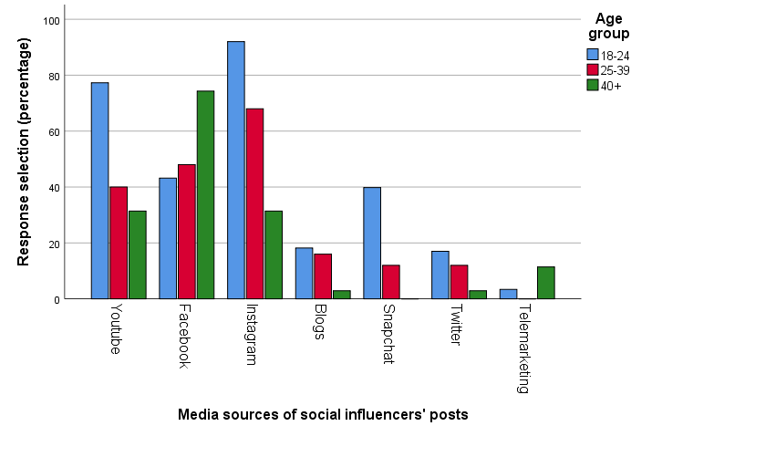
Figure 4.7: Media sources where social media influencers promoting beauty products were witnessed by female survey respondents
Sokolova et al. (2020) reported that YouTube and Instagram were the most popular forms of digital platforms for social media influencers to promote brands, both with a target audience age between 18 and 34. This is in comparison to Facebook, which targets 30-year olds and over, currently with 58.3 million active Facebook accounts for this demographic (Kang et al., 2020). The results from this study seem to support the effectiveness of these media sources efforts to target specific age groups. Similarly, the relatively low impact that blogs had on participants is in accordance with the findings of Nygren et al. (2019) who found that blogs were becoming less common, as 68% of people suggested they weren’t as interesting as content on other platforms.

4.5 Results 4 – The impact of social media influencers on beauty products
4.5.1 The number of social media influencers followed by different female age groups
Females over 40 were far more likely (45.7%) to not follow social media influencers than either 25-39 (24.0%) or 18-24 (5.7%) year olds ((chi-square = 41.63, df = 8, p < 0.001; Cramer’s V = 0.38; Figure 4.8). The following of social influencers tended to be greatest in the younger groups with 59.3% of 18-24 year olds following 6 or more influencers (compared to 56% in the 25-39 and 11.5% in the 40+ age groups).
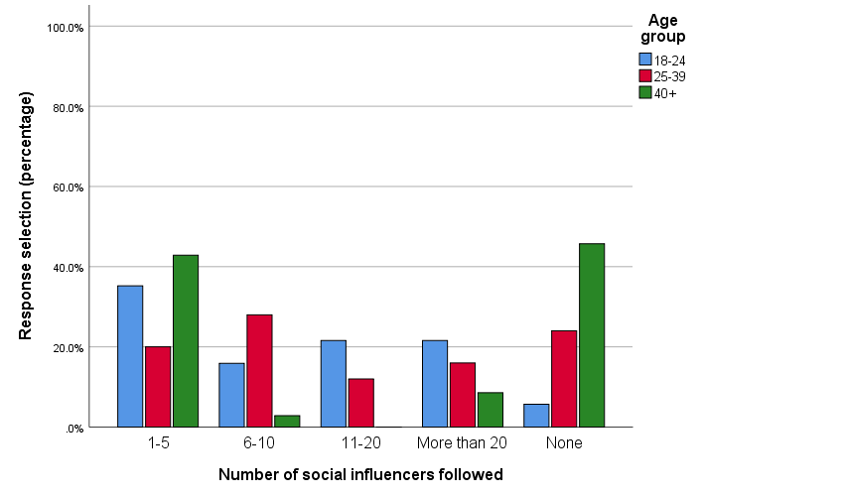
Figure 4.8 Number of social media influencers followed by different female age groups
Hautala (2019) found that individuals, aged between 18-30, could follow five or more social media influencers, determined by their interests and likeability factor. This study has determined that, for females, up to around the age of 40, there was a high percentage of individuals following six or more influencers (58.4%) but this diminished to 11.5% in the 40+ age group. Lokithasan et al. (2019) suggested that individuals followed particular social media influencers for their content and their level of activity, for example, influencers who work with a brand constantly and share information, updates and discounts of that brand were more likely to gain the most followers, whereas irregular posts suggested a lack of followers. However, to put these findings into perspective, Chae (2018) found that 78% of adolescents suggested they were not interested in following influencers as they found them too repetitive. This study found that not following influencers was related to age, 38% (the effect size) of the factors likely to influence this decision attributed to age, but only 5.7% of 18-24 year olds reported not following influencers. Given the large discrepancy with Chae’s (2018) finding it would be interesting to determine what behavioural changes take place between adolescence and adulthood that could explain this difference. However, gender differences should be accounted for in future studies given that this study only had a representative sample of females.

4.5.2 The impact and trust in social media influencers by different female age groups
Females over 40 were far less likely (37.1%) to have purchased products promoted by social media influencers that either 25-39 (68.0%) or 18-24 (65.9%) year olds ((chi-square = 9.51, df = 2, p < 0.01; Cramer’s V = 0.25; Figure 4.9).
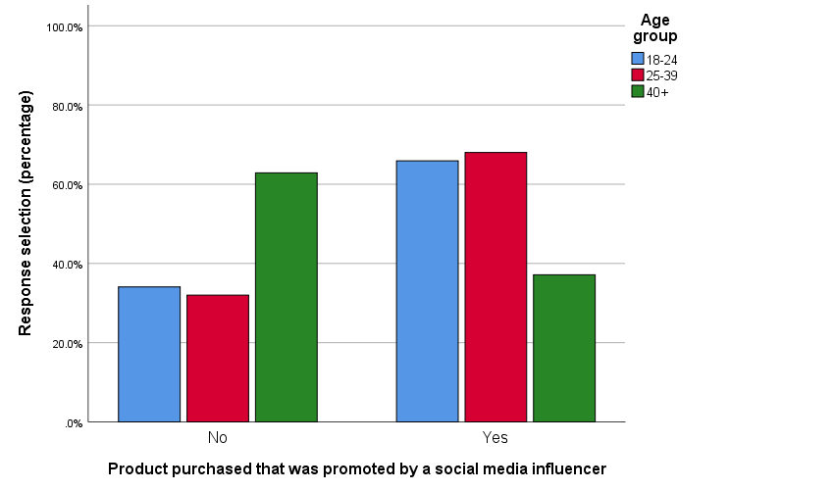
Figure 4.9: Females by age group purchasing products promoted by social media influencers
About 60% of younger women (18-39) tended to purchase products promoted by social media influencers, falling to about 40% for the over 40’s with 25% of the factors likely to influence this decision attributed to age. Social media influencers have specific techniques to promote sales thorough their posts, including persuasive selling and giving their own experience of the product (Smith et al., 2018; Duffy et al., 2017). However, Barhorst et al. (2019) suggested that, more often than not, many influencers didn’t actually try the product before they promoted it, they simply get given a script from the brand with exactly what they had to say. For example, Lauren Goodger, reality star, promoted a beauty weight loss product on her Instagram page, saying she lost three stone using it, however, it was revealed by hidden camera footage sent to the Mail Online (2019) that she hadn’t used the product at all. It would seem, therefore, that not all social media influencers are alike. Perhaps, the older women in this study were more aware of this and this impacted their belief in the influencers, or perhaps it is simply a case that age brings scepticism. As Luoma-aho et al. (2019) suggested, whilst influencers do generate sales, it is not always for the right reasons, as many consumers have been hypnotised into believing a beauty influencer looks the way they do because of this particular product.
Females aged 18-24 were most likely to trust an influencer based on the person (39.8%) or the brand (20.5%). 25-39 year olds, however, were either likely or very likely (36%) or, conversely, not likely (24.0%) to trust an influencer. The 40+ group were most likely to trust an influencer based on the brand (31.4%) or were not likely to trust the influencer (25.7%).
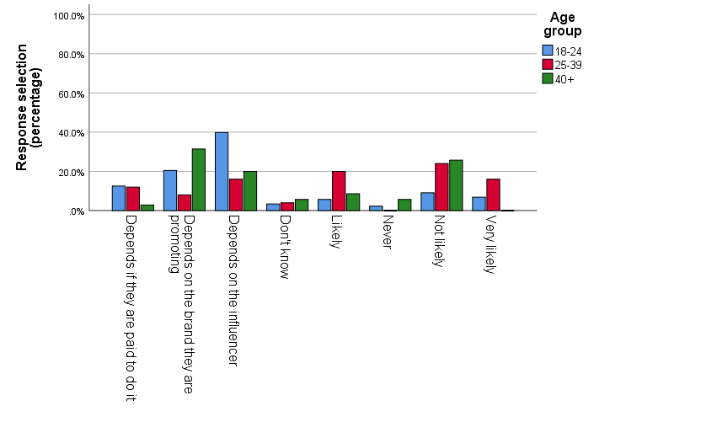
Figure 4.10 Likelihood of trusting social media influencers by female age groups
Hu et al. (2019) suggested that it takes a long time for people to trust social media influencers, especially influencers who either don’t have much content/following or who are not celebrities, as they are not well-known to the audience. On the other hand, Lou et al. (2019) explained that when people did gain trust, it was dependent on both the influencer and the brand, as the interaction between the method of promotion and influencer personality only worked with certain brands. This study allowed respondents to provide multiple answers to the question of why they did, or did not, trust influencers. The findings supported the contention that multiple factors play a role in trusting an influencer including whether they were paid to promote a brand.

4.5.3 Positive influences by social media influencers for different female age groups
Kylie Jenner was the most impactful social media influencer in both 18-24 (40.9%) and 25-39 (40.0%) year old groups; Nikki De Jager (17.0%), Huda Kattan (18.0%) and Jeffree Star (28.4%) had made sizeable impacts on the 18-24 group only. The six social media influencers had not affected purchasing for nearly all 40+ females (94.3%) and nearly half of both 18-24 (37.5%) and 25-39 (44.0%) year old groups.
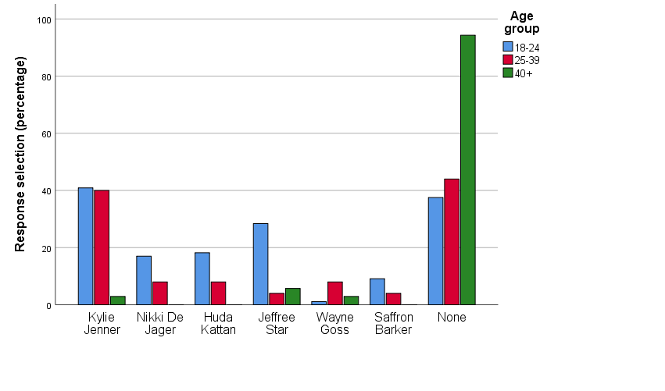
Figure 4.11: Social media influencers followed by female age groups
The social media influencers identified in the questionnaire were chosen for different reasons. Kylie Jenner is the youngest billionaire in the world, largely due to creating her own beauty brand, Kylie Cosmetics, but previously has a large public profile due to her role in the reality television programme “Keeping Up With The Kardashians” (Robehmed, 2018). She was the most recognised of the influencers in this study, although primarily, only for the under 40-year olds. Nikki De Jager was chosen because she has the most followers on YouTube from her beauty channel, currently 13.3 million subscribers (Lutz, 2019). Niki was not followed by any respondents over 40 and twice as many 18-24-year olds as 25-39-year olds.
Huda Kattan was chosen as she is the founder of HudaBeauty.com which is one of the world’s biggest online beauty stores with an annual turn-over of $200 million (Ismail, 2018). Similar to Nikki, Huda was followed by just under 20% of 18-24-year olds but less than half this for 25-39-year olds. Jeffree Star was chosen because he started with nothing and currently has 17.6 million subscribers for his beauty channel, he is also known for being a part of the lesbian, gay, bisexual and transgender (LGBT) community (Homant et al., 2019). Jeffree had a substantial following by the 18-24-year olds in this study (28.4%) but trivial numbers in the other age categories. Whether this has anything to do with his LGBT affiliation is unknown, but the results may be indicative of an increased acceptance of minority groups in the younger age groups. Future studies could seek to determine this.
Wayne Goss was selected due to his age (42) to see if the older participants were influenced by him through his beauty channel on YouTube. The results did not support this hypothesis as only 1 respondent in the 40+ and 2 in the 25-39 age group reported following him. Finally, Saffron Barker, was selected as a British influencer who started with nothing, but now has 2.3 million subscribers on YouTube and regularly gets sent free beauty products from hundreds of brands. She is well known for giving out discount codes for these products very regularly. Similar to Niki and Huda, Saffron was not followed by any respondents over 40 and only 9% of 18-24-year olds in this study followed her.

4.6 Results 5 – Responses to seeing a product promoted by a social media influencer
4.6.1 The response to seeing a product promoted by a social media influencer by different female age groups
Younger age groups were more likely to do further research online or instantly purchase online than older age groups ((chi-square = 27.33, df = 6, p < 0.001; Cramer’s V = 0.30; Figure 4.12). Conversely, older age groups were more likely to try in store before buying or not buy at all than the younger age groups.
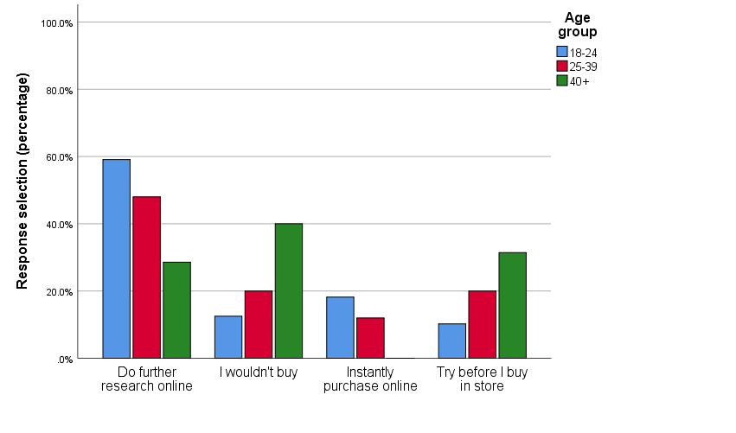
Figure 4.12: Response to seeing a product promoted by a social media influencer by female age groups
Dooley (2016) suggested that people who did further research before buying a product thought more strategically, as they evaluated the quality, price, worth and need factor, whereas people who didn’t, were more likely to be impulse buyers, instantly thinking they needed and wanted it, when in reality, this might not have been the case. The majority of 18-24-year olds and 25-39-year olds in this study reported doing further research in comparison to 28.6% of the 40+ age group. This is, perhaps, a counterintuitive relationship between age and strategic thinking (Dooley, 2016) and perhaps more related to the propensity for younger people to use online search strategies. Li et al. (2019) believed that people, who try before they buy in store, were also more strategic thinkers, as they assessed the product too. This may also have been a consequence of a positive endorsement by a social media influencer, but the person goes into the store to double check the benefits before making the purchase. 31.4% of the 40+ age group reported this type of behaviour suggesting that the idea that the older participants were less strategic was erroneous. Indeed, none of this age group reported instantly purchasing online whereas 12% of 25-39-year olds and 18% of 18-24-year olds did.

4.6.2 Reason for response to seeing a product promoted by a social media influencer by different female age groups
All age groups were more likely to buy a product because they wanted it rather that to support the social media influencer. The tendency for this to be influenced by age group was not significant ((chi-square = 3.11, df = 2, p = 0.21; Cramer’s V = 0.15; Figure 4.13).
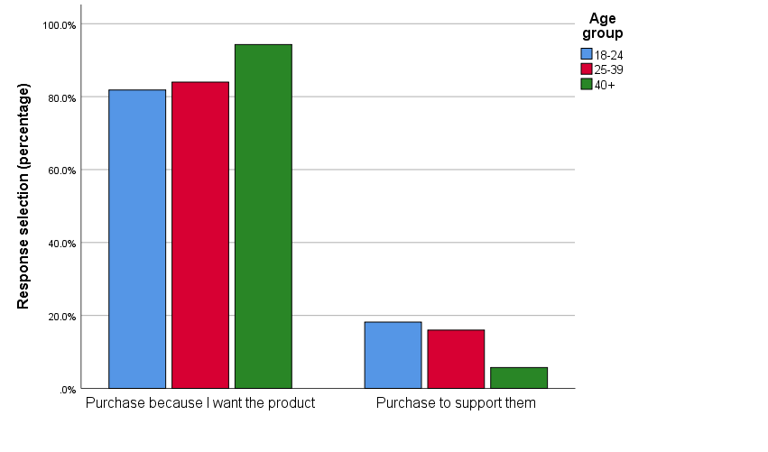
Figure 4.13: Response to seeing a product promoted by a social media influencer by female age groups
McCormick (2016) believed that the younger demographic would make at least one purchase to help support a social media influencer. This is because they are a fan and simply wish to show their appreciation and identity, for example, by buying personalised merchandise to exhibit the influencers name. However, there was little support for this behaviour in this study, as the vast majority reported they purchased items because they wanted them, a reflection of strategic purchasing rather than influencer led. Respondents in this study appeared to know not to spend money on unnecessary products (Iyer et al., 2019), perhaps a reflection of the spending ability of the sample and not necessarily representative of all women.

