
Coaching and Mentoring skills within an organisation
Rina Begum Miah (1812757)

April 9, 2021
university of wales trinity saint david
BMSW6105

Executive summary

This report consists of a critical evaluation of the similarities and differences between coaching and mentoring. In relation, the report states and explains the tangible and intangible benefits of coaching and mentoring to organisations. In addition to this, a critical evaluation of the line manager as a coach and mentor is provided and it also includes an assessment of the necessary skills and behaviours. This report features a critical evaluation of the role of coaching and mentoring in change management and facilitating change. The researcher has included a critical evaluation of their performance as a coach, essentially a reflection of the researcher’s performance as a coach, in the peer coaching exercise. The researcher applied the Gibbs’ reflective cycle and a personal development plan.

Contents

Executive summary

Contents
1.0 Introduction……………………………………………………………………………. 3
2.0 Findings …………………………………………………………………………………. 4-10
3.0 Conclusions ……………………………………………………………………………. 11
4.0 Appendix………………………………………………………………………………….12
5.0 References ………………………………………………………………………………13-15

- Introduction

The purpose of this report is to explain coaching and mentoring and the similarities and differences between them. The report covers the areas of intangible and tangible benefits which both bring to organisations, critical evaluation of line manager as a coach/mentor, including necessary behaviours and skills, critical evaluation of the role of mentoring and coaching in facilitating change and change management and the final area it will cover is a critical evaluation of my own performance in the peer coaching exercise. Coaching and mentoring are essential in organisations as it enhances an organisation’s process and prepare employees for the work they will undertake. Coaching and mentoring are important to employees as it keeps them productive, active and willing to work.

2.0 Findings

Coaching and Mentoring

2.1 Coaching

Coaching is a method which aims to enhance performance and concentrates on now and here instead of the past or future. Coaching unlocks a person’s development to one’s higher level in their own achievement. It helps a person to learn instead of teaching this was stated by the author Clutter, (2011) (Davey, 2017).
Another coaching definition of Gallway, T, 1986 is that it helps one to learn instead of teaching them (Personal coaching 2020). Comparing both of these definition of coaching over the years it seems that it remained same as there is no change.
Example of coaching in practice at Amazon. HR Coach asks and listens to the employee’s issues or problems and the employees ends up solving the issues or problems by themselves which they discussed with the coach by answering question which the coach asked (Amazon.com 2021).

2.1.2 Mentoring

An individual who provides a young person or less knowledgeable individual advice and help for a period of time regarding work or school (Clutterbuck, 2004).
Example of mentoring in an organisation such as Virgin Media in which Virgin Media gives employees the opportunity to concentrate on self-development with guidance, advice and direction from the mentor while the employee is expanding their network across the organisation. The mentor may be any skilled individual from across the organisation, not just based from the same area or function therefore it makes Virgin Media a connected workplace (Virgin Media, 2019).

2.1.3 Differences and similarities between Coaching and Mentoring

The difference between coaching and mentoring is that according to Blakemore, R (2014), coaching helps an individual to identify if they need to grow in person, to reach workplace goals or personal goals or to improve current issues they are facing. A coaching main job is to challenge, assist and encourage instead of teaching, advise or direct. Coaching is made up to help an individual figure out what one needs to do for oneself to enhance and in the procedure, what inspires the individual and what might be stopping them such as prejudices, assumptions, preconceptions and attitudes. On the other hand, according to mindtools article (2021), Mentoring is the relationship connecting two people with the aims of worker and in a personal growth. A person who is “mentor” is normally a skilled individual who shares experience, knowledge and guidance with a less knowledgeable person. The main differences are that coaching is undertaken in a shorter term, measured and structured and concentrates on particular development problems whereas mentoring is long term and is indefinite, not structured and operates as needed and focuses on personal development and career. The similarities of coaching and mentoring is knowledge, commitment and listening (Mattone, 2017).

2.1.4 The tangible/intangible benefits
According to Coonan (2017), the benefits are that it will enhance the productivity and performance of the employees and higher retention, engagement of the employees. Furthermore, it will increase sales, reduce costs and grow revenue for the organisation. Building better relationship with the employees will make employees feel valued and in return they will work harder for the organisation’s aims and objectives. Johnson, (2019) asserted that the benefits of intangible at a workplace will build on relationships of the report and stakeholders, build teamwork, job satisfaction, reduce conflict, lessen turnover and increase workplace commitment. This eventually will lead an organisation to its success.

2.1.5 Non-Directive
Coaching is mainly non-directive this is when a coach has the ability of helping people to review, reflect and problem-solve for themselves. A Coachee produces an answer as that will help them to create strategies that are required in order to lead their own development and learning (Braddell, 2017).

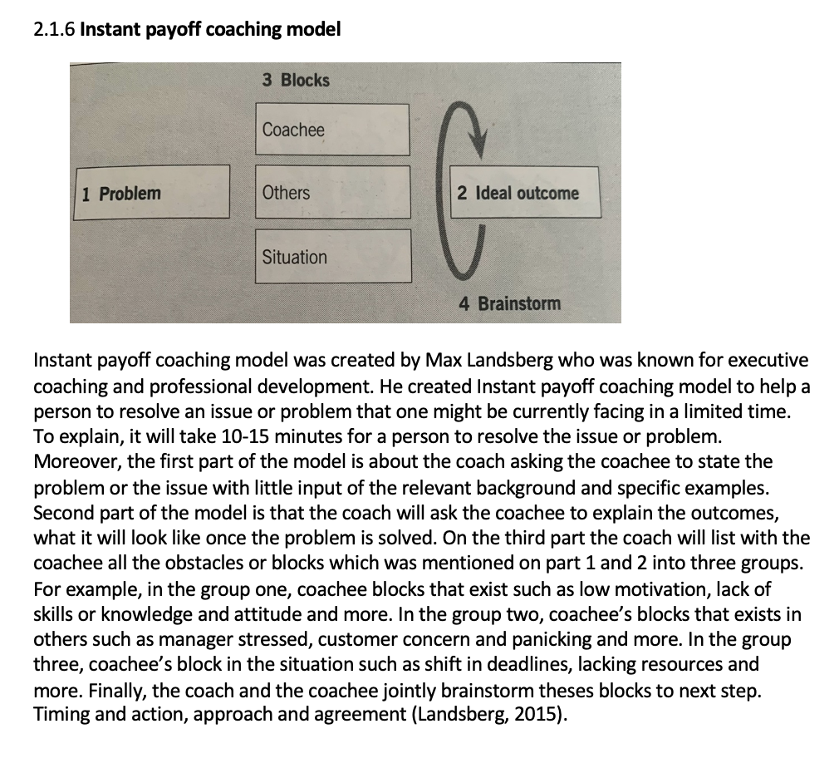

2.1.7 Roles of line-manager

The concept of a line-manager as a coach and mentor consists of many roles and responsibilities including the chance to collaborate to support organisational aims and objectives. It requires a strong positive relationship between managers and members of the team and support them to develop people management skills in order to achieve organisation goals (CIPD, 2020). A line manager’s role as a coach and mentor is to direct and teach employees on how to reach their goals and develop employees that understand the organisational aims and objectives to attain success (Ibarra & Scoular, 2019). In addition, it also includes roles such as managing employees daily and implementing HR and organisational policies (CIPD, 2020).

2.1.8 There are many advantages of a line-manager as a coach. One advantage, according to Walsh (2021), is that coaching improves the relationship between the line manager, as a coach, and the team members which provides organisational benefits. To explain, employees feel like they belong to the organisation therefore this leads to improved performance, reduces conflict, team cohesion and significantly enhances motivation. As the employees have greater engagement, employees are more creative which can further result in improving measures such as profitability. However, there are disadvantages of a line-manager as a coach. Barber of the David Clutterbuck Partnership article (2018) asserted that it could lead to conflicts between the line-manager and employees. To explain, line-manager as a coach being too disciplined could eventually make employees feel that they do not belong to the organisation which then might result in low performance and decreased productivity.

2.1.9 A line-manager as a mentor can derive advantages. According to Joseph (2019), one advantage is that it can help acclimatise a new employee to their job and business. As employees have a line-manager to discuss situations, to ask questions, and learn an organisation’s policy, the mentee is able to become a productive individual in a shorter period of time and are aware that they can request help from mentor if required. For example, if the mentor were to serve in a supervisory capacity or is required to rely on the mentee’s performance of reaching certain objectives, the mentor is ensured that they are trained correctly. Despite, the advantage there are plethora of disadvantages of line-manager as a mentor. One disadvantage, according to Andreas (2021), is that not all line-managers as mentors are fully skilled to guide employees. To explain, if a mentor cannot direct its employees then this can be more harmful than positive to the employee and mentor consequently leading to frustration over time.

2.2.1 The skills and behaviours needed for success as a coach/mentor

There are many skills and behaviours to be a successful mentor or coach. An important skill to the success of a coach is questioning skill. According to Mindtools Ltd (2018), asking the correct questions at the right time helps the coachee to gain a better understanding of themselves. The most common and important for coaching and mentoring is active listening. According to Philips-Jones (2003), active listening is a basic yet vital skill for mentoring and coaching. The other skills one gains are based from the active listening skill. A coach or mentor listens carefully to the individual which shows the individual that their concerns have been acknowledged and understood. Consequently, this leads to an individual feeling accepted by the coach or mentor therefore the trust between both parties is gradually going to build. The coach or mentor demonstrates listening intentionally by executing many observable behaviours. For example, when the coach or mentor has excellent listening skills, they will have the opportunity to use non-verbal body language such as performing facial expressions when appropriate, looking directly in an individual’s eyes, shift body slightly towards individual and nodding one’s head as a way to show understanding.

2.2.2 GDPR 2018-Coaching

GDPR stands for General Data Protection Regulation. The European Union’s new data protection law which had been effectuated in May 2018. The coach should be aware of GDPR 2018 to ensure that there is transparency when collecting coachee’s data. This means that a coachee should have easy access to their data, what the coach does with the coachee’s data and how the coachee can access a copy of the record or delete if they required to. Resultingly, confidentially significantly importance in the coaching relationship (International Coach Academy, 2021).

2.2.3 Change management

The definition of Change management is that change management is a structured method to transitioning a person, groups and organisations to a desired future state from the current state. The approach can be implemented to situations such as instituting a new internal process, downsizing or adding the latest technology. Research on change management reveals that if an organisation were to actively manage change then it would result in the increase of the success rate of these initiatives (Austin 2015).

The organisation change management is important because it will increase growth and success of the organisation. Change management impels the successful application and usage of change in an organisation. Change management enables an organisation’s employees to understand and commit to the change and work productively during it. If there is not effective organisational change management as a result when an organisation transitions it can be difficult and costly as both resources and time will be consumed. Another negative result is that there can be lower employee morale and competent skill development. Indisputably, if there is a lack of effective change management then it can lead an organisation to fail and be unsuccessful (Stobierski 2020)

2.2.4 Internal and External drivers of change management

There are internal and external drivers of change management. The internal drivers which are characterised by factors such as management styles, management policies, processes and practices, procedures and organisational structure. Despite the fact that these factors can be utilised as a tool for enhancing an organisations performance in terms of efficiency and effectiveness which undoubtedly drives change in an organisation, the organisational performance-enhancing factors can become inefficacious as a consequence an organisation’s operations management arrangement becomes inadequate therefore this produces a need for change in an organisation (Mdletye, Coetzee and Ukpere 2014). The external drivers are Economic downturns and challenging trading conditions, Government legislation/initiatives, customer or supplier demands, changing markets, pressure from competitors, mergers and acquisitions. Currently, due to the COVID-19 pandemic it has resulted in many organisations to develop changes in organisation. For example, most organisations had to make changes in their services, products, contracts or expanding their activities and rearrange their platforms (CIPD 2020).

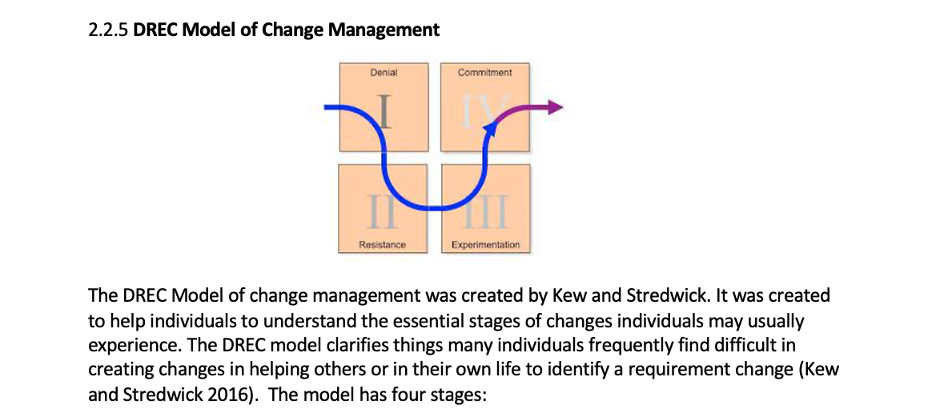

Denial - "I do not have a problem."
Resistance - "Even if I do have a problem, there is nothing I can do about it." In this stage the coach can help the coachee to identify how to solve the problems by asking questions relevant to background and specific objectives. By asking questions to the coachee it can help them identify how they can solve their issues or problems.
Exploration - "Ok, so I do have a problem, what are my options for dealing with it?" In this stage the mentor can help the mentee to deal with the problem by giving opinions and ideas to resolve the problem or issue.
Commitment - "Ok, this is what I am going to do to fix this problem!" In this stage the coach can give regular coaching sessions to see the coachees progress and be updated on the coachees situation. Additionally, the mentor can provide support, guidance and motivate the mentee to fix the problem.

In the stage of Denial and Resistance there is an absence of responsibility or ownership – these factors are generally challenging for most individuals and problems to go through.
In the stage of Exploration an individual undertakes research and goes through the Commitment stage in which the individual takes direct and immediate action in order to solve an issue (Kew and Stredwick 2016). The strength of using coaching and mentoring as a change management tool is that it can engage employees to the change process by allowing and providing the opportunity for employees to be involved in the process. This eventually leads to ownership and engagement and to an organisation success. The weakness of using coaching and mentoring as a change management tool is that change happens for one person at a time and is successful if employees change how they act and think when completing their daily activities (Nevenhoven, 2021).

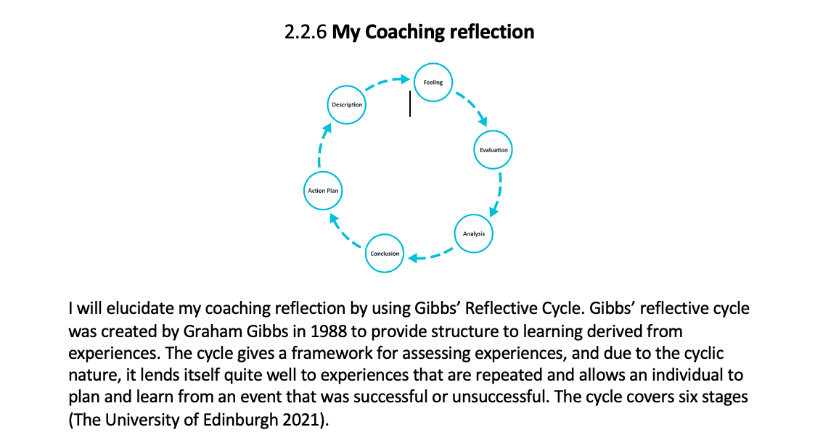

The first stage is ‘Description’ which describes the experiences. To explain, I played the role of a coach by applying the Instant payoff coaching model. The coaching took place on Microsoft teams on the 24th February 2021. At the coaching session the coachee and I were present. I was asking questions and the coachee was answering. The outcome of the coaching session was that the coachee manage to come to a solution to solve her issues which she discussed with me as a coach. My duty was to conduct the role of a coach by using the Instant payoff coaching model and help the coachee to come to a conclusion by herself by answering my question. My aim for the coachee was to work out a solution to solve her issues which she was currently facing by answering the questions that I have asked. The second stage is ‘Feelings’. Which is how one feels about the experience. To explain, what I felt about performing the role of a coach was that I was nervous and unconfident. By using the Instant payoff coaching model made it quite easier when to ask the questions however, I rushed therefore I had to repeat some of the questions for the coachee understand what I was asking. The third stage is ‘Evaluation’. Which is assessing the experience. To explain, the experience was good as I clearly stated the questions and I have listened to the coachee. However, the bad outcome was that I have rushed the questions and went below the time limit, which was set, I could have asked more questions. Overall the coachee was happy to answer all the questions.
The fourth stage is ‘Analysis’ “which is to make sense of the situation”. To explain, as I prepared my question it was easy to remember however due to the fact that I was very nervous I ended up rushing my questions. If I was more confident by practicing more, I would have not rushed the questions by being on time. The fifth stage is ‘Conclusion’ “about what you learned and what you could have done differently”. Presenting as a coach I have learnt that I should be more confident and calmer when asking questions. If I was not nervous, I would have been able to clearly state the questions in order for the coachee to understand. The skills I need to develop to do better in the future is communication and people skills. The final stage is ‘Action’ “plan for how you would deal with similar situations in the future, or general changes you might find appropriate”. If I had to undertake the role of a coach in the future, I would need to join an online coaching course to improve my coaching and abilities. I would do the online communication course to enhance my communication and people skill and with the help of my family by practicing with them (The University of Edinburgh 2021). (Copy of the PDP is located in the appendix, p12).

3.0 Conclusions

Coaching and mentoring are significantly important due to the fact that it develops and helps employees in their organisation and in personal life. Moreover, a line manager as a coach or mentor is of great importance as they will guide employees to reach their objectives which will lead to the success of their organisation. In addition, the Instant Payoff Coaching Model can be utilised by coaches to reveal a coachee’s solution to a problem or issue they are facing which is impeding to perform. Coaching and mentoring fits into the DREC Model of Change Management as it can be used to solve an employee’s issue or problem. Furthermore, it allows organisations to execute a process of change without much difficulty and prepares employees to work with the new change without negatively affecting their ability and productivity. Additionally, the researcher applied the Instant Payoff Coaching Model when undertaking the peer coaching exercise in which the researcher asked questions which lead to the researcher, as a coach, helping a coachee to resolve an issue or problem that they were facing. The Instant Payoff Coaching Model is advantageous because it allows the coach to ask appropriate questions at the correct time. This report clearly shows coaching and mentoring must be used by organisations and change should be managed effectively whilst ensuring employees are satisfied.

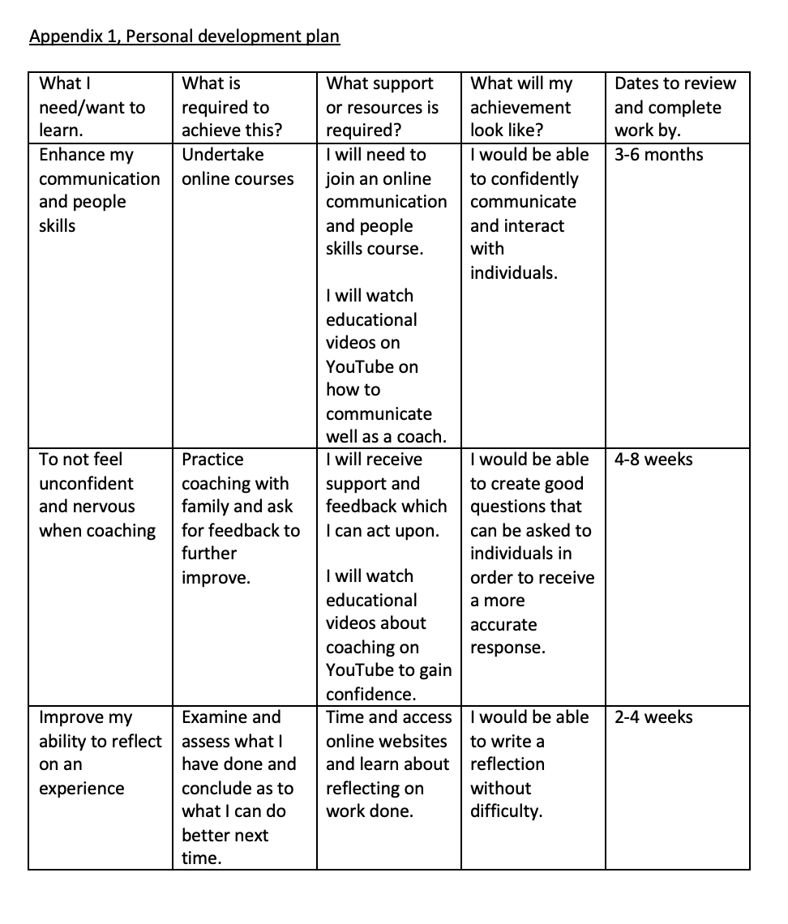
4.0

5.0 Reference list

Andreas (2021) 25 Key Pros & Cons of Mentoring |Environmental Conscience [Online] Available at: https://environmental-conscience.com/mentoring-pros-cons/ (Accessed on 28th March 2021)

Amazon.com (2021) Human Resources – Fulfilment [Online] Available at:
https://www.amazon.jobs/en-gb/team/human-resources-fulfillment (Accessed on 27th March 2021)

Austin, J (2015) Leading Effective Change: A Primer for the HR Professional [Online] Available at: https://www.shrm.org/hr-today/trends-and-forecasting/special-reports-and-expert-views/Documents/Leading-Effective-Change.pdf (Accessed on 1st April 2021)

Barber, A (2018) Line manager, mentor and coach: managing the conflicts and capitalizing on the opportunities| David Clutterbuck Partnership [Online] Available at:
https://davidclutterbuckpartnership.com/line-manager-mentor-and-coach-managing-the-conflicts-and-capitalizing-on-the-opportunities/ (Accessed on 28th March 2021)

Blakemore, R (2014) Coaching vs mentoring - why the difference matters [Online] Available at: https://www.apm.org.uk/blog/coaching-vs-mentoring-why-the-difference-matters/ (Accessed on 19th March 2021)

Braddell, A (2017) Citizens’ Curriculum guide to Non-directive coaching. Leicester. Published by the Learning and Work Institute [ Online] Available at:
https://webcache.googleusercontent.com/search?q=cache:fWlM0ueBicQJ:https://www.itta.uva.nl/upload/files/Coaching_citizen_guide_non-directive_coaching(2).pdf+&cd=14&hl=en&ct=clnk&gl=uk&client=safari (Accessed on 27th March 2021)

CIPD (2020) Change Management [Online] Available at:
https://moodle.uwtsd.ac.uk/pluginfile.php/435124/mod_resource/content/1/CIPD%20Change%20Management%20Factsheet.pdf (Accessed on 3rd April 2021)

CIPD, (2020) Line managers' role in supporting the people profession [Online] Available at:
https://www.cipd.co.uk/knowledge/fundamentals/people/hr/line-managers-factsheet#gref (Accessed on 28th March 2021)

Clutterbuck, D (2004) Everyone needs a mentor, Fostering talent in your organisation 4th edition, London. Chartered Institute of Personnel & Development

Coonan, S (2017) Coaching Works. Here’s Why. [Online] Available at: https://www.td.org/insights/coaching-works-heres-why (Accessed on 23rd March 2021)

Davey, D (2017) Defining Coaching & Mentoring.|Linkedin.com [online] Available at: https://www.linkedin.com/pulse/defining-coaching-mentoring-daz-davey (Accessed on 27th March 2021)
Ibarra, H. & Scoular, A, 2019) The Leader as Coach | Harvard business reviews [Online] Available at: https://hbr.org/2019/11/the-leader-as-coach (Accessed on 28th March 2021)

International Coach Academy (2021) What Coaches Need to Know About the GDPR [Online] Available at: https://coachcampus.com/articles/what-coaches-need-to-know-about-the-gdpr/ (Accessed on 29th March 2021)

Johnson, C (2019) Exploring the Real Impact and Benefits of Coaching [Online] Available at:
https://20-rock.com/exploring-the-real-impact-and-benefits-of-coaching (Accessed on 23rd March 2021)
Joseph, C (2019) Advantages & Disadvantages of Mentoring | Small Business [Online] Available at: https://smallbusiness.chron.com/advantages-disadvantages-mentoring-10888.html (Accessed on 28th March 2021)

Kew, J. Strewick, J. (2016) Kew and Strewick, Human Resources management in a business context (2016) 3rd edition, Page 81, CIPD – Kogan published

Landsberg, M (2015) The Tao of Coaching: Boost your effectiveness at work by inspiring and developing those you. London: Profile Books

Mattone, J (2017) Executive Coaching Definition, Stages, Benefits, Strategies & Results [Online] Available at: https://johnmattone.com/blog/executive-coaching-definition-benefits-strategies-and-results/ (Accessed on 20th March 2021)

Mdletye, Coetzee and Ukpere (2014) Exploring the triggers of Transformational change in the South Africa. Department of correctional service. Vol5, No10, P599. Rome-Italy MCSER Publishing [Online] Available at: https://core.ac.uk/download/pdf/43602879.pdf (Accessed on 1st April 2021)

Mindtools (2021) Mentoring, A Mutually Beneficial Partnership [Online] Available at:
https://mindtools.com/pages/article/newCDV_72.htm (Accessed on 19th March 2021)

Mindtools Ltd (2018) How to coach a manager’s guide to coaching [Online] Available at: https://www.mindtools.com/blog/offers/wp-content/uploads/sites/5/2019/08/How-to-Coach-2018.pdf (Accessed on 29th March 2021)

Nevenhoven, J. (2021) Coaching Employees Through Change| Life Cycle Engineering [Online] Available at: https://www.lce.com/Coaching-Employees-Through-Change-1912.html (Accessed on 5th April 2021)
Personal coaching (2020) A Guide to Coaching & Being Coached [Online] Available at:
https://www.personal-coaching-information.com/definition-of-coaching.html (Accessed on 19th March 2021)

Philips-Jones, Linda (PhD) (2003) Skills for successful mentoring. Grass Valley, The Mentoring group [Online] Available at: https://my.lerner.udel.edu/wp-content/uploads/Skills_for_Sucessful_Mentoring.pdf (Accessed on 29th March 2021)

Stobierski, T (2020) Organizational change management: what it is & why it’s important| Harvard Business School [Online] Available at: https://online.hbs.edu/blog/post/organizational-change-management (Accessed on 1st April 2021)

The University of Edinburgh (2021) Gibbs' Reflective Cycle [Online] Available at:
https://www.ed.ac.uk/reflection/reflectors-toolkit/reflecting-on-experience/gibbs-reflective-cycle (Accessed on 5th April 2021)

Virgin Media (2019) Learning & development, The future of mentoring [Online] Available at:
https://careers.virginmedia.com/feeling-social/stories/the-future-of-mentoring/ (Accessed on 27th March 2021)

Walsh, M FCIPD (2021) What does it mean to coach as a line manager?|CIPD [Online] Available at: https://www.cipd.co.uk/Community/blogs/b/cipd_member_blog/posts/what-does-it-mean-to-coach-as-a-line-manager (Accessed on 28th March 2021)

