Grant Morgan-materials and introduction to manufacturing
Introduction
This report will be on two different types of manufacturing methods. The first method I have chosen to talk about is 3D printing and the 2nd method I have chosen will be electron beam machining I will go into detail about the science behind both these methods and explain to you how they work.
First method 3D printing
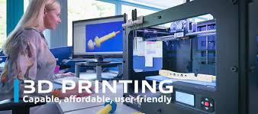
3D printing or additive manufacturing is a process of making three dimensional solid objects from a digital file.
The creation of a 3Dprinted object is achieved using additive processes.in an additive process an object is created by laying down successive layers of materials until the object is created. Each of these layers can be seen as a thinly sliced horizontal cross section of the eventual object.
3D printing is the opposite of subtractive manufacturing which is cutting out/ hollowing out a piece of metal or plastic with for instance a milling machine.
3D printing enables you to produce complex shapes using less materials than traditional manufacturing methods.
How does 3D printing work? It all starts with a 3D model. You create one yourself or download it from a 3D repository. When creating it yourself you can choose to use a 3D scanner, app, haptic device, code or 3D modelling software.
3D modelling software there are many different types of 3D modelling software tools available. Industrial grade software can be easily cost thousands a year per license, but there’s also open source software you can get for free.
You would often be recommended that beginners would use to start tinker cad. Tinker cad is free and works in your browser, you don’t have to install this to your computer, tinker card offers beginners lessons and has a built in feature to get your 3D model printed via a 3D print service.
Now that you have a 3D model, the next step is to prepare the file for your 3D printer, this is called slicing.
Slicing, slicing is dividing a 3D model into hundreds or thousands of horizontal layers and is done with a slicing software.
Some 3D printers have a built in slicer and let you feed the raw, stl, obj or even cad file.
When your file is sliced, it’s ready to be fed to your 3D printer. This can be done via USB, SD or internet. Your sliced 3D model is now ready to be 3D printed layer by layer.
The 3D printing industry has reached a critical mass as those who have yet to integrate additive manufacturing somewhere in their supply chain are now part of an ever shrinking minority. Where 3D printing was only suitable for prototyping and one off manufacturing in the early stages, it is now rapidly transforming into a production technology.
Most of the current demand for 3D printing is industrial in nature. But research forecasts the global 3D printing market to reach $41 billion by 2026.
As it evolves, 3D printing technology is destined to transform almost every major industry and change the way we live, work and play in the future.
3D printing encompasses many forms of technologies and materials as 3D printing is being used in almost all industrial you can think of. It’s important to see it as a cluster of diverse industries with a myriad of different applications.
A few examples:
- Consumer products (eyewear, footwear, design, furniture)
- Industrial products (manufacturing tools, prototypes, functional parts)
- Dental products
- Prosthetics
- Architectural scale models and Marquette’s
- Reconstruction fossils
- Replicating ancient artefacts
- Reconstructing evidence in forensic pathology
- Movie props
Rapid prototyping and rapid manufacturing. Companies have used 3D printers in their design process to create prototypes since the late 70s .using 3D printers for these purposes is called rapid prototyping.
Why use 3D printer for it in short its fast and relatively cheap .from idea to 3D model to holding a prototype in your hands is a matter of days instead of weeks .iterations are easier and cheaper to make and you don’t need expensive moulds or tools.
Besides rapid prototyping, 3D printing is also used for rapid manufacturing. Rapid manufacturing is a new method of manufacturing where businesses use 3D printers for short run / small batch custom manufacturing.
Types of 3D printing
There are several ways to 3D print. All these technologies are additive, differing mainly in the way layers are built to create an object.
Some methods use melting or softening materials to exclude layers. Others cure a photo reactive resin with a UV laser or another similar light source layer by layer. To be more precise since 2010 the American society for testing and materials (ASTM) group developed a set of standards that classify the additive manufacturing process into categories according to standard terminology for additive manufacturing technologies. These processes are:
- Vat photo polymerisation
- Stereo lithography
- Digital light processing
- Continuous liquid interface production
- Material jetting
- Binder jetting
- Material extrusion
- Fused deposition modelling
- Fused filament fabrication
- Powder bed fusion
- Multi jet fusion
- Selective laser sintering
- Direct metal laser sintering
- Sheet lamination
- Directed energy deposition

What materials can be used? Six types of materials can be used in additive manufacturing: plastics, metals, concrete, ceramics, paper and certain edibles e.g. chocolate. Materials are often produced in wire feedstock aka 3D printer filament, powder form or liquid resin. All previously described 3D printing techniques, cover the use of these materials, although polymers are most commonly used and some additive techniques lend themselves towards the use of certain materials over others.
Positive and negative effects of 3D printing
Positive
Manufacturing options: it can only be limited by your imagination
Rapid prototyping: products can manoeuvre more quickly from the design stages to prototype.
Cost reduction: 3D printing has become less expensive and printing on site cuts out the middle man expense
More jobs: there will be an increase of engineers to design products and fabricators to develop and produce printers and they will also need technicians to maintain, use and repair 3D printers.
Safety issues: there is less chance of you getting hurt using a 3D printer than you would by manually constructing a prototype?

Negative
Fewer manufacturing jobs: we reduce the need for individuals and their craftsmanship. This reduction in workforce is a disadvantage which will have a large effect on the economy and others.
Limited materials: currently, 3D printers can only manufacture products out of metals, ceramics, resin and plastics. This is somewhat limiting factor.
Dangerous items: even though most people would use this to enhance their lives there are people out there if this got into the wrong hands may do illegal or harmful things like example make guns.
Size: currently 3D printers are facing a roadblock with size. So far they can only produce small products. People are researching bigger machines, but for now they can only produce small objects.

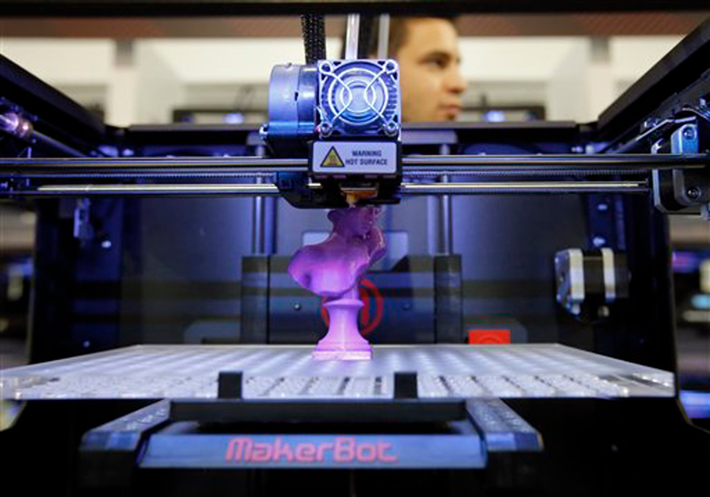

2nd method electron beam machining
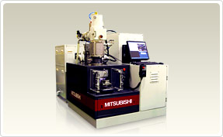
Electron beam machining is the process in which high velocity electrons are concentrated in a narrow beam and then directed towards the work piece for machining. When this high velocity electron strikes the work piece, it melts and vaporizes the material from the work piece.
In an electron beam machining, the electrons strike the work piece with a high velocity. As the electrons strike the work piece, the kinetic energy of the electrons change into heat energy. The heat energy so produced is used to melt and vaporize the materials from w/p. the whole process takes place in a vaccum.vacuum environment is used to prevent the contamination and avoid collision of electrons with air molecules. If the electrons collide with the air molecules, it will lose its kinetic energy.

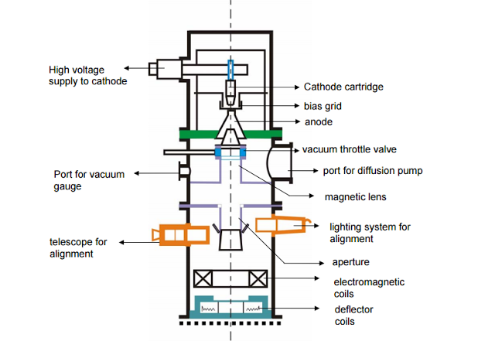
Various equipment can be used in EBM machines are
Cathode: the cathode is negatively charged and it is used to produce electrons.
Annular bias grid: it is present next to the cathode. Annular bias grid, it is positively charged. Annular anode attracts the beam of electron towards it and gradually the velocity of the electron increases. As the electron beam leave the anode section, its velocity becomes half of the velocity of light.
Anode: it is placed after the annular bias grid. It is positively charged. Annular anode attracts the beam of electron towards it and gradually the velocity of the electron increases .as the electron beam leave the anode section, its velocity becomes half of the velocity of light.
Magnetic lenses: the magnetic lenses reduce the divergence of electron beam and shapes them. It allows only convergent electrons to pass and captures the low energy divergent electrons from fringes. It improves the quality of the beam.
Electromagnetic lens: it helps the electron beam to focus on the desired spot.
Defector coil: the defector coil carefully guides the high velocity electron beam to a desired location on the work piece and improves the shape of the holes.
Working of the electron beam machine, in the EBM, first the electron is generated by the cathode and an annular biased grid does not allows the electron to diverge. From the annular bias grid, the electron produced by the cathode is attracted towards the anode and gradually it velocity increases. As the electron beam leaves the anode section, its velocity reaches to half of the velocity of the light. After that, it passes to the series of magnetic lenses. The magnetic lenses allows only convergent beam to pass through it and captures the divergent beam from the fringes. And then a high quality electron beam is made to pass through the electromagnetic lens and defector coils. The electromagnetic lens focuses the electron beam to desired spot on the work piece. The deflector carefully guides the beam to the desired locations and improves the shape hole.
The electron beam machine is operated in pulse mode and this is achieved by the biasing annular biased grid.
The beam current can be as low as 1 amp.
The pulse duration achieved in the EBM machine is 50ꭒs to 15ms.
The energy possessed by the pulse is 100j/pulse.
It utilizes voltage in the range of 150kv to 200kv. And this voltage is used to accelerate electrons to about 2000, 000km/s
Advantages of this
- It can produce bolts of small sizes
- High accuracy and better surface finishes
- Almost all types of materials can be machined
- Highly reactive metals such as AL and MG can be machined easily
- As it does not apply any mechanical cutting force on the work piece, so cost of work holding and fixtures is reduced
Disadvantages
- High equipment cost
- Low metal removal rate
- High skilled operator is required
- High power consumption
- Not applicable to produce perfectly cylindrical deep holes

Part 2 of the assignment
For the 2nd part of the assignment we was asked to research a group of materials, have decided to do it on memory materials / polymers.
So what is memory materials?
As implied in the name, these are materials who have a memory of their shape.specifacally, they are able to return to their original shape after they have been deformed in some way. They can return to their original shape when a particular stimulus is applied. This stimulus may be heat or light, for example.
This ability is known as the shape memory effect (SME) and can occur in alloys known as shape memory alloys (SMAs) and in polymers.in shape memory polymers (SMPs), but is also possible in shape memory hybrids (SMHs).
These materials all belong to a wider set of smart materials, also known as intelligent or responsive materials, that have one or more properties that are affected in a controlled manner by some external stimuli.in the case of Sharpe memory, the property that is affected is their shape, by applying some external stimuli such as temperature, stress, moisture, electric or magnetic field, ph., light or chemical compound.
Shape memory polymers are polymer materials that you can deform and then by applying a stimulus, such as heat or light will return to its previous shape
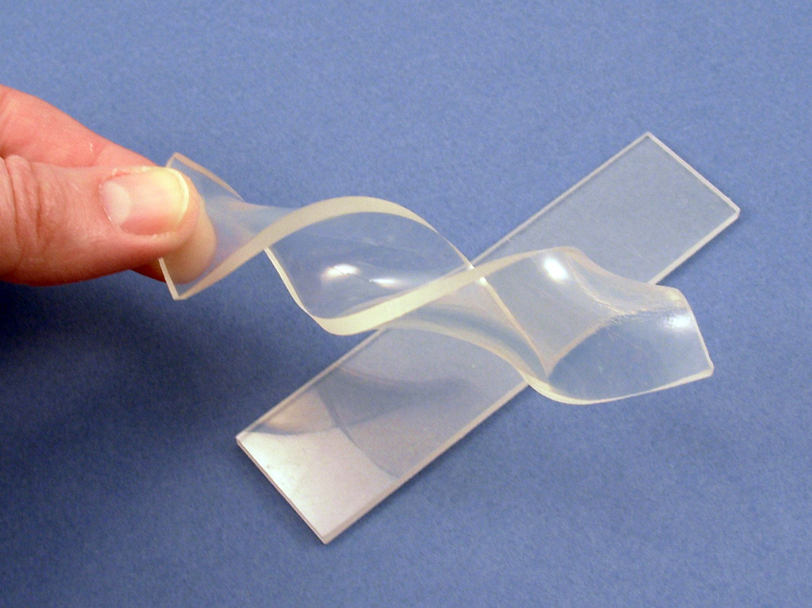
A shape memory polymer can change from a temporary shape that is achieved by deforming it, to a previous shape which is its permanent shape when it is not being deformed.
There are different stimuli that can be used to achieve this, so far this has been achieved using heat, light, irradiation with infrared light, immersion in water, and application of electric or magnetic fields.
There are an almost infinite amount of applications for shape memory polymers, the ability to return to a shape after different stimuli are applied allows a dynamic element to product design that could revolutionise certain product types. There are already a series of applications in use in the real world-settings and it is the likely range of applications will continue to grow.

Because shape memory polymers can respond to temperature, light etc. there are many interesting possibilities for these materials in fabric, these include comfort, aesthetics, wound monitoring, protection against environmental conditions, smart controlled drug release, and more.
What are the different types of shape memory polymers?
There are many different types of shape memory polymer and more are being developed all the time.
Three commonly used engineering polymers that can demonstrate the shape memory effect (SME) include polytetrafluoroethylene (PTFE), polylactide (PLA) and ethylene-vinyl acetate (EVA).
Memory alloys versus memory polymers?
Metal alloys such as nitinol were shape memory alloys studied prior to shape memory polymers, but polymers have several advantages over alloys.
They can increase in sixe a lot more, for example, doubling in size versus around 5% increase for nitinol, such size increase means more complex geometries can be designed for a variety of applications.
The SMPs also have a softer feel, with a rubbery consistency, which could mean they are less likely to damage surrounding tissue when used in biomedical devices, although in such applications it is vital that through tests are carried out regards to safety.
Shape memory polymers also have a much lower cost, a lower density, and are easy to process than Sharpe memory alloys. In addition they can sometimes exhibit superior mechanical properties when compare to shape memory alloys.

Polymers can occur in two states, either a crystalline state where it is organised uniformly and becomes a rigid relatively strong structure, or an amorphous state where the polymer subunits are randomly scattered or relatively soft and flexible, moving around fairly easily. The difference with a shape memory polymer is that it has a semi crystalline structure. This means both states occur at the same time within a specific temperature, sally room temperature.
There are different ways that this effect of having a memory is achieved, which have different names like dual state mechanism, dual component mechanism, or partial transition mechanism.
Many applications ranging from biomedical to aerospace have been proposed for the use of shape memory polymers (SMPs). To optimize SMPs properties for appropriately targeting such wide-spreading application requirements, it’s become necessary to understand the structure/property relationship in SMPs. The literature was reviewed and the recent advances made in development of SMPs were determined to establish guidelines for composition and structure considerations for designing SMPs with targeted chemical, physical and shape memory (SM) properties.it was concluded that covalently cross-linked glassy thermosets appear to better SMP candidates because of their intrinsically higher modulus ,greater thermal and chemical stability, higher shape fixity and recovery, and possibly their longer life cycle, however , material design allows for reaching comparable or biter properties for all classes of SMPs. This emphasizes that optimizations of SMPs requires application specific molecular structural and geometric design. Current techniques for improving stress recovery and cycle time, which compared to shape memory alloys are the two main limitations of SMPs, are extensively discussed. Understanding the relationship between the composition and structure of an SMP and its SIM properties as well as it limitations enable one to better define the development areas for high performance SMPs.

References
barnatt, c. (2013). 3D printing the next industrial revolution. createspace independant publishing platform.
hovarth, j. (2014). matering 3D printing. apress.
jinsong leng, s. d. (2010). shape memory polymers and multifunctional composites. china: taylor and francis.
kalaskar, d. m. (2017). 3D printing in medicine. london: woodhead publishing.
kan, g. k. (2017). cylic plasticity. china: john wiley and sons.
loretto, m. h. (1984). electron beam analysis of materials. amsterdam: springer netherlands.
takeda, q. s. (2017). advances in shape memory polymer. japan: springer.
utke, i. (2012). focused ion and electron beams. oxford: oxford university press.
white, c. w. (2012). laser and electron beam processing of materials. cambridge massachusetts: elsivier science.

