Marketing Management Assessment 1

Student Name: Vladimir Rebrik
Student Number: (1914780)
Assignment Title: Individual Report
Module Code: LCMB7001
Lecturer: Tushara Balendran

Table of Contents

Table of Contents...................................................................................................2
1. Introduction........................................................................................................3
2. Company's background.....................................................................................3
3. Communication. The Shannon and Weaver Model...........................................3
4. Integrated Marketing Communications..............................................................4
5. New Leon Restaurants promotional strategies.................................................5
6. Keller's Brand Equity Model .............................................................................6
7. Customer journey ..........................................................................................14
8. Touchpoints....................................................................................................15
9. Customer Persona..........................................................................................18
10. Leon Restaurant Customer Journey Map......................................................20
11. The total engagement model.........................................................................22
12. Recommendations.........................................................................................23
13. Conclusion......................................................................................................24
14. References.....................................................................................................24

Introduction
In this report, the author will discuss the communication Shannon and Weaver model, IMC (integrated marketing communications); he will share the background of the chosen organisation, Leon Restaurants - a healthy fast food restaurant chain based in the UK. The author will propose new promotion strategies for Leon Restaurants, identify and describe all stages of Keller’s Brand Equity Model, and relate them to the company in the main part of the report. The author will create the Leon Customer Persona, discuss the Customer Journey theory and all its stages, create a Leon Customer Journey Map in the diagram and right after will, discuss its strengths and weaknesses. Also, in the main part, the author will focus on existing Leon's touchpoints and propose new ones in the recommendation section. In the final part, the author will debate the Total Engagement Model and give a Conclusion and References of used materials.
Background information about the chosen company
Leon Restaurants ltd company was founded by John Vincent, Allegra McEvedy, and Henry Dimbleby in 2004. Leon launched and opened their first restaurant on Carnaby Street in London with the vision of offering ‘naturally fast food (Iain, 2015). Since then, the group has grown to more than 80 restaurants and has become one of the fastest-growing brands in the UK food market, taking advantage of vegan and healthy eating lifestyles (Moran, 2023). In 2021 the EG Group (a petrol stations empire spanning the US, UK, EU - countries, and Australia with revenues of $25bn a year), which is also the owner of ASDA, the owner of the largest KFC franchise operator in the UK and Ireland, and which runs Greggs and Subway stores from its petrol station sites, within their strategy to expand into food retailing, acquired the Leon chain for £100m (Abboud et al., 2021).
Communication. The Shannon and Weaver Model
Communication is sending and receiving messages from one person to another and involves interpretation and meaning (Steinberg,2007).

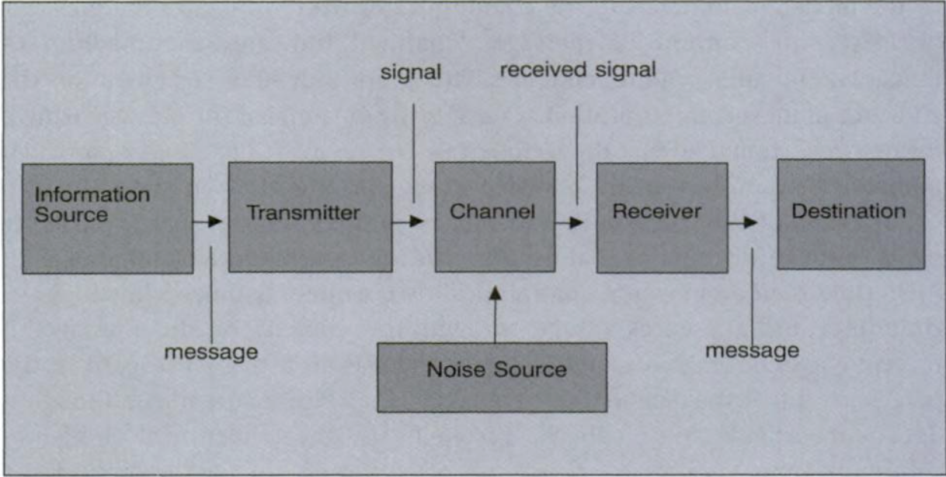
Figure 1. The Shannon and Weaver Model 1949 (Steinberg,2007).

The American scientists Shannon and Weaver worked for the Bell Telephone Laboratory and were mainly interested in finding engineering solutions on how communication channels could be used most efficiently. Shannon and Weaver developed a transmission communication model consisting of the following elements:
• information source (sender) that produces a message
• transmitter, which converts the message into signals
• channel, to which signals are adapted and which is used to send them
• receiver, which decodes (translates) the message from the signal
• destination or place where the message arrives
• noise source - a dysfunctional factor that does not allow the message to reach the receiver entirely without distortion
Shannon and Weaver's model describes communication in its simplest form as a two-way exchange between two stakeholders (Steinberg,2007). The sender might be a company representative and the receiver - their customer or vice versa. The noise might be a missing text in an email message or any distraction the stakeholders might experience during their talk. For their profit, any company must communicate with new and existing customers; marketing communications facilitate this process.

Integrated Marketing Communications
Integrated Marketing Communications (IMC) - is a strategic approach to marketing communication planning that acknowledges the added value and crucial role of a comprehensive plan that usually includes many various communication activities and disciplines and combines them to provide clarity, consistency, efficiency, and maximum communication impact in a particular business. Integrated Marketing Communication Tools include all aspects of marketing, such as advertising, sales promotion, direct marketing, public relations activities, customer service and others. The main goal of integrated marketing communications is to create a consistent contact and brand identity that customers will recognise across a particular industry and rapidly changing marketing communication landscape (Tourky & Kitchen, 2022).

New Leon Restaurant's promotional strategies
(Recommended by the author of the report)
Offline
1. Sponsorship
By sponsoring relevant events, and projects, Leon can create positive associations between the audience and the company business. Customers tend to choose products and services connected with positive emotions they experienced, which increases the likelihood of them choosing Leon's chain over its competitors. For example, the report's author suggests that EG Group, which recently acquired Leon, consider entering into sponsorship agreements with the London Marathon and a Premier League football team. Sponsorship is a marketing strategy which involves both - internal and external stakeholders. In this case, the internal stakeholders are the EG group and external stakeholders - the London Marathon organiser and Premier League representatives.
2. Celebrity Marketing
Establishing brand awareness for a restaurant business can be challenging. The report's author suggests a celebrity strategy for Leons Restaurants' management - to engage a sport or showbusiness celebrity as a spokesperson and role model. Recognisable celebrity faces have a unique ability to catch the attention of potential customers, which can be difficult for lesser-known restaurant names as Leon still is for most of the public. While showcasing the restaurant's offerings is crucial, customers also want a personal connection. By featuring a celebrity's face in advertising or promotional events, diners can feel less isolated when trying out a new restaurant. As a part of the future agreement, the author strongly recommends obligating celebrities to use their social media platforms to mention the Leon Restaurant brand. The author recommends hiring one of the top London marketing agencies to select a suitable star for representing the Leon chain.
Celebrity Marketing strategy involves both - internal and external stakeholders. In this case, the internal stakeholders are the EG group, and external stakeholders could be the marketing agency (for selecting the candidate) and the celebrity agent. Additionally, if successful - the author recommends exploring the possibility of forming a long-term partnership agreement with the chosen celebrity.
3. Setup a Leon's Selfie Station
As social media becomes increasingly popular, customers seek unique, positive experiences and tend to share them with others online and sometimes - immediately. The report's author suggests that Leon's management should consider setting up a Leon Selfie Station at each chain restaurant to capitalise on this trend. This will give customers a charming and visually appealing background to take pictures in front of, encouraging them to record and take photos of their breakfast, lunch or dining experience and share it on their social media. By doing so, Leon's can benefit from free advertising and significantly increase its brand awareness while providing customers with a memorable experience. Selfie Stations strategy mainly involves internal stakeholders. In addition, the company could benefit from inviting external stakeholders - designers, builders, and decorators.
A great example (see Figure 2) is a selfie station from Café La Jefa in Palm Springs, CA (Cafe La Jefa Coffee House - Specialty coffee, tea, and healthy food., 2021). These photos were taken and published by customers on their personal Instagram accounts.
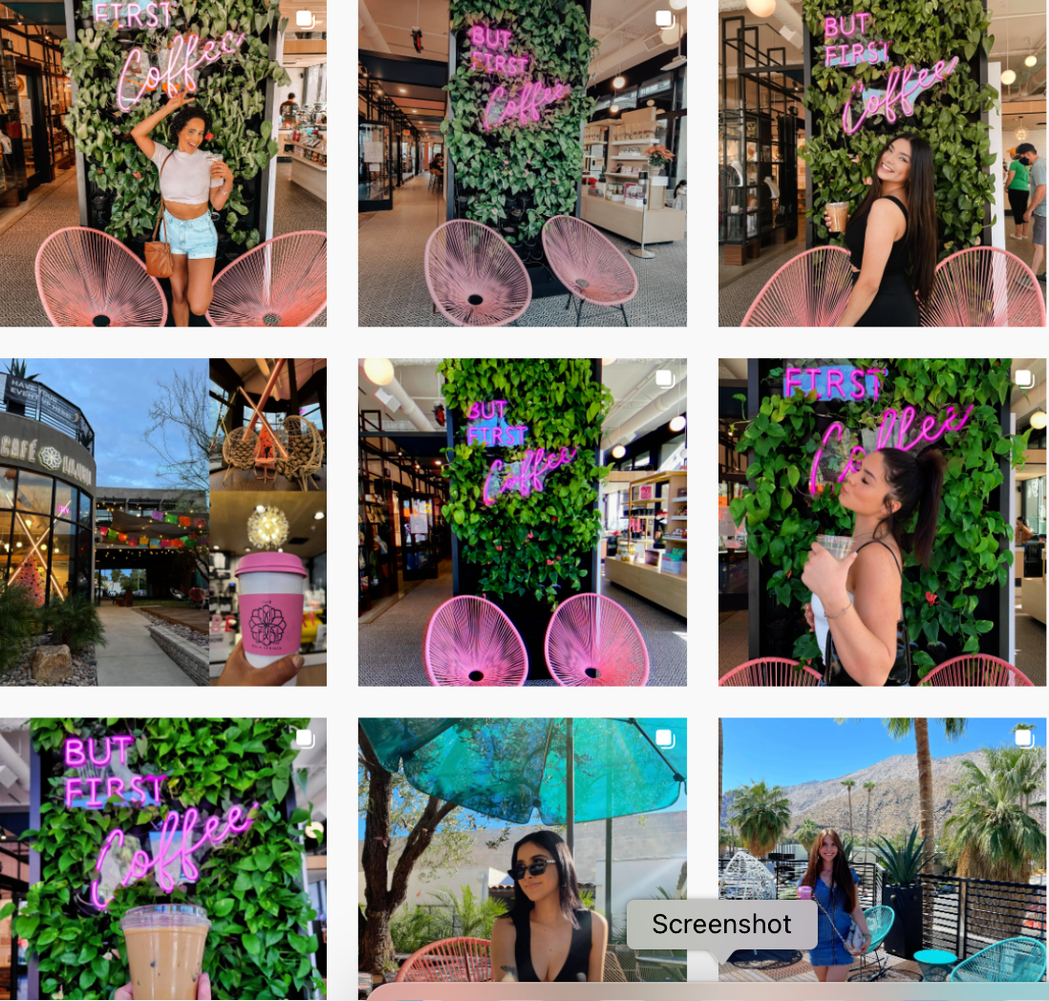
Figure 2. Cafe La Jefa Coffee House - Specialty coffee, tea, and healthy food., 2021).

4. Networking with Other Local Business's strategy
Online - Offline
A great restaurant digital marketing strategy involves collaborating with other small business owners in a particular locality. The report's author recommends that Leon's management establish an affiliate partnership with businesses that will complement Leon's fast-food chain.
For example, Leon can connect with a local, nearby hotel to ask their management to recommend Leon's restaurant to travellers, guests, and their staff. Additionally, they could cooperate, such as contributing to each other's blogs, endorsing their respective businesses, and various other possibilities doing this in person and through their website and their official social media. In the author's opinion, Leon must consider partnering with other small businesses to provide discounts on meals for business-related events, such as sales meetings, team lunches, birthday celebrations and other after-work parties. The main idea is to offer added value to each other businesses and build stronger relationships within Leon's local community, increasing customer traffic and influence and raising brand awareness and recognition.
Keller's Brand Equity Model
A brand is a sum of the following attributes - a name, history, reputation, packaging style, logo, price, the ways of promoting or any other feature of a particular company or its products or services or both. A successful brand is an identified and acknowledged product or service in such a way that the customer recognises the relevant, unique, sustained added value that - completely matches their needs or most closely. Branding means distinguishing the products or services of one company from those of another (Marino, Wallace, and Keller, 2016).

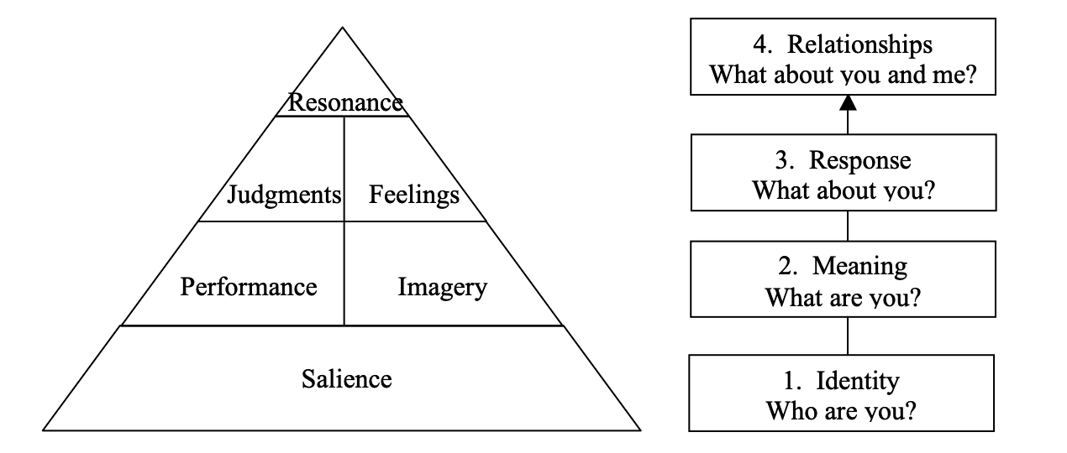

Figure 3. Keller's Customer-Based Brand Equity Pyramid (Kuhn, Alpert, 2004).

Keller's Brand Equity Model, also recognised as the Customer-Based Brand Equity (CBBE) Model, was developed by marketing scientist Kevin Lane Keller with the main idea that the power of a particular brand depends on what customers have learned, felt, seen, and heard about the specific brand over time. That means a company which possesses substantial brand equity, its customers tend to buy more from that company, and they are inclined to recommend that brand to others; they also become more loyal, and it is less likely to lose them to competitors. Accordingly, to Figure 2, Keller's Brand Equity Model includes four following levels focused on achieving an outcome that contributes to brand equity:
Level 1. Brand Identity
In building brand identity, customers must be understood based on the audience segments, their needs and how they interact with the brand, how they distinguish the company's products from competitors when making decisions, and their perception of the brand. Achieving a solid brand identity requires creating brand salience related to consumers' brand awareness. Building brand awareness involves ensuring customers understand the product or service category in which that brand competes. Brand awareness usually links the particular brand with its brand name, logo, symbol, other attributes, and associations in memory - connected with a specific company, its product or service.
Leon Restaurants Brand Identity
A Leon restaurant brand identity combines elements that reflect its mission and atmosphere. For example, every design aspect claims the Leons chain is health-focused, from its chocolate bar wrappers, menu boards, packaging, print, and website to fascia signage. Leons Founders Henry Dimbleby and John Vincent (former management consultants) hit on the idea to change the fast-food model by including tasty, healthy ingredients; served enthusiastically reasoned that healthy stuff could be delicious, quickly prepared and served too. The restaurant received the same name Leon as Vincent's father because it was simple, European-sounding and had no ready-made associations (Staff, 2013).
Salience
Leon restaurant's Vision is - "to make it easy for everyone to eat good food."
The Leon restaurant's Mission is - " Making it easier for everybody to eat well, live well and be kind to the planet".
Distinctive signs:
Logos: "Hand holding the orange" and" "Leon ladies" are used in the majority of signage and product packaging to signify the natural ingredients used in Leon's food on offer (LEON, 2023).


Figure 4, (LEON, 2023).

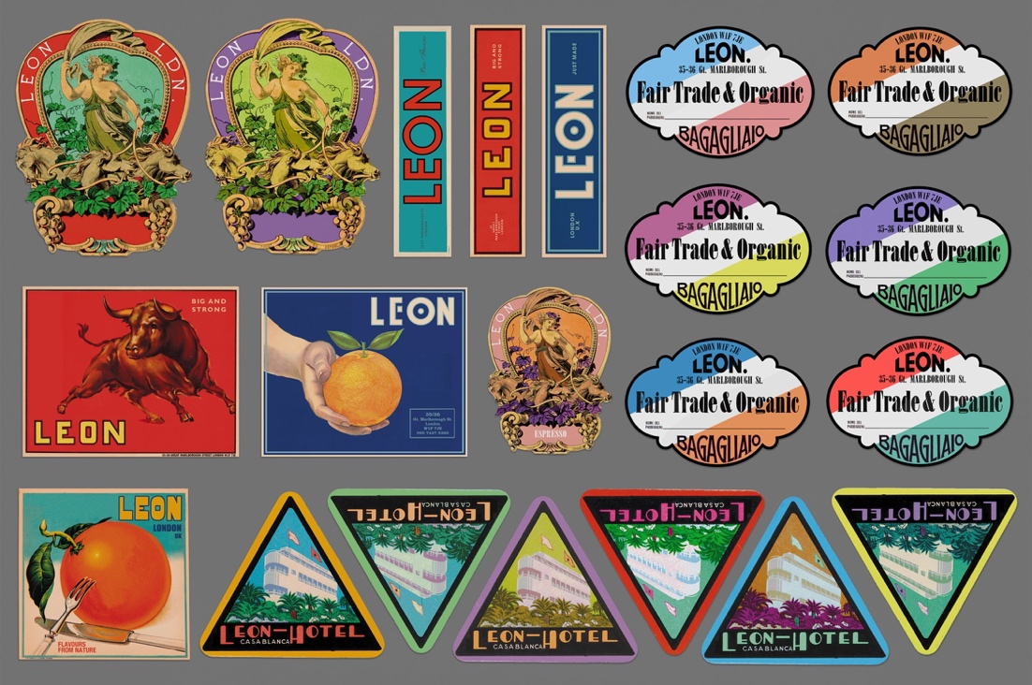
Figure 5, (Behance, 2016).

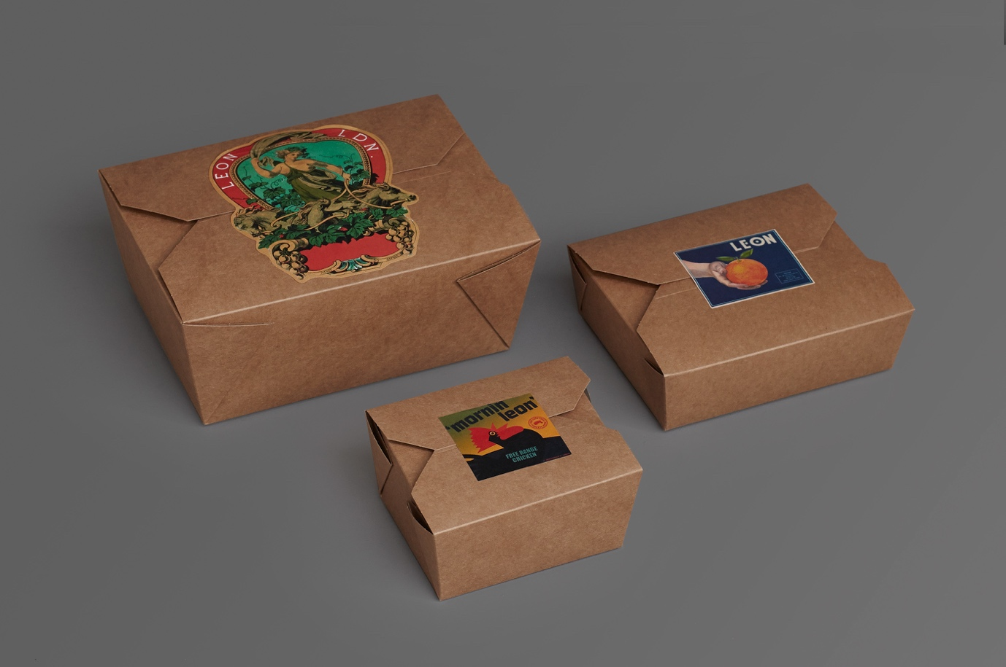 Figure 6, (Behance, 2016)

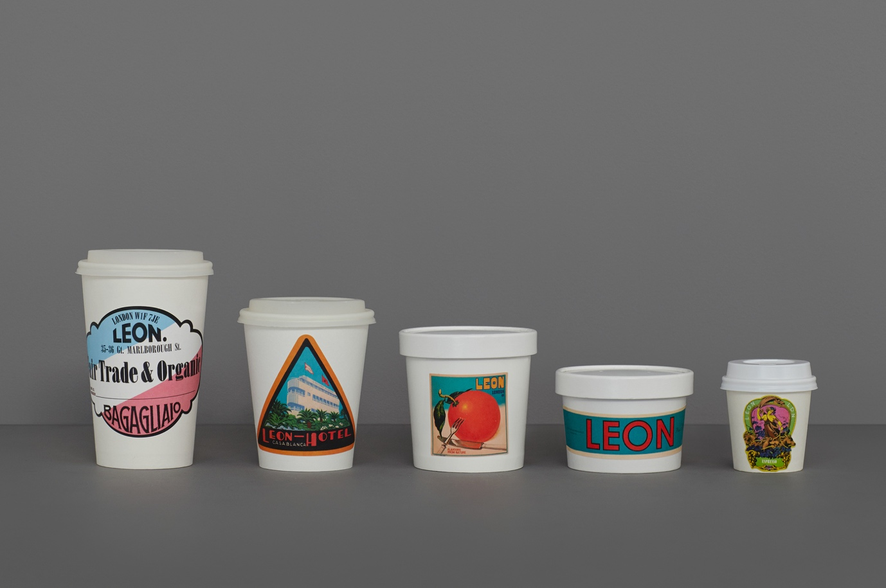
Figure 7, (Behance, 2016).

Level 2. Brand Meaning
Brand salience is essential in developing brand equity, but more is needed. Most customers need other considerations, such as the brand's meaning, divided into performance and imagery.
Brand Performance
Brand performance refers to how the company's product or service will meet customers' functional needs and is the brand's property regarding inherent product or service features and characteristics. The brand performance attributes and benefits that define functionality will vary widely, but five following important types underlie brand performance:
1. Primary characteristics of a product operate (e.g., low, medium, high, or very high) and secondary features (some special, possibly even patented, features) that complement primary characteristics.
2. Product reliability, durability, and product service. It also impacts product performance perceptions, delivery speed and accuracy, and installation options.
The level of customer service and training, the quality of repair service, and the time involved.
3. The effectiveness, efficiency, and empathy of brand services. Service effectiveness means how entirely the brand satisfies customers' service requirements, whereas efficiency refers to how on-time services are delivered. Service empathy refers to the level of service providers being seen as trusting and caring to the customers.
4. Style and design where performance may depend on sensory aspects (product looks, feels, perhaps what it sounds or smells like).
5. Price.
The pricing policy creates associations in customers' minds to the relevant price tier or level for the brand in the category and to its corresponding price volatility or variance, which also means that consumers identify the price of the brand (e.g., low, medium, or high).
Thus, the sum or any of these brand performance dimensions can serve as a means by which customers differentiate the brand.
Performance:
Primary characteristic: There are four criteria any Leon dish needs to tick:
• taste remarkably good.
• consumers need to feel good after they eat it.
• must be affordable
• It has to be as kind as possible to the planet.
Secondary characteristics: quick service, motorway service, mobile delivery, motorway service, Drive Thru, kids’ area, order machine, clean, attractive surroundings (restaurantonline.co.uk, 2015).
Leon Restaurants Brand Performance
Efficiency: Leon always tries to improve efficiency with new technologies, for example, such as using a discreet and highly efficient Daikin air conditioning system to deliver comfort and energy efficiency in a space-saving design (Daikin Internet, 2018).
Price
Leon frequently offers customers special promotions and discounts, including discounts for students and NHS workers (Bistrobe.com, 2023).
Brand Imagery
Brand imagery relates to the extrinsic properties of the product or service in which the brand attempts to satisfy customers’ psychological or social needs. Brand imagery comprises more intangible aspects of the brand, such as the following four categories:
1. User profiles.
The user profile associations involve the type of person or organisation that utilises the brand. It may result in a profile or mental image by customers of actual users or the imagination of more aspirational, idealised users.
Associations of brand users may be based on demographic factors (gender, age, race, income, or marital status) or abstract psychographic factors (attitudes toward life, lifestyles, careers, religion, possessions, social issues, or political institutions) (Keller, 2001).
2. Purchase and usage situations.
Associations of a typical purchase situation may be originated from various considerations, such as types of channels (e.g., department store, unique store, online shops, or some other means); specific stores (e.g., Foot Locker, or Fogdog.com, Macy's,); ease of purchase and rewards options, if any. It may be based on considerations, such as time or season of the day, week, month, or year when the brand is going to be used; a place where the brand is used (e.g., inside or outside the home) or type of activity (e.g., formal, or informal).
3. Personality and values.
Brand personality refers to the more descriptive usage of imagery but involves much richer, contextual information such as sincerity (e.g., down-to-earth, wholesome, honest, and cheerful); excitement (e.g., daring, spirited, imagination); competence (e.g., intelligent, successful, reliable,); sophistication (e.g., upper-class, and charming); ruggedness (e.g., outdoorsy and challenged).
4. History, experiences, and heritage
These associations may involve personal experiences and also related to past behaviours and experiences of friends, family or just some people around so that it may be more public and broad-based and, as a result, will be shared significantly and include more specific, concrete examples.
Leon Restaurants Brand Imaginary
User profile: Leon tries to reach customers in each category with affordable prices and good service. The brand especially tries to engage and satisfy people interested in healthy and unique products (vegans, healthy lifestyle supporters).
Purchases and usage: Leon's strategy is to have restaurants close to travellers (underground, train, bus stations) in airports and at extensive shopping and business locations.
Level 3. Brand Responses
Brand responses relate to customers' thoughts or feelings about the brand, how they respond, and its marketing activity. Brand responses can be distinguished according to brand judgments and feelings.
Brand judgments
Brand judgments focus on personal customer opinions and evaluations and involve putting together all the different performance and imagery associations to form those opinions. In terms of building a solid brand, four types of summary brand judgments are particularly important:
1. Brand quality. Which is a measure of the value and the perceived value that a specific brand offers.
2. Brand credibility. A high level of that means the brand is seen as credible regarding perceived expertise, trustworthiness, and likability.
3. Brand consideration. Brand consideration suggests the likelihood that customers will include the brand in the brand's list they might buy or use. The brand consideration depends on how customers find the brand appropriate and meaningful for themselves after making an overall appraisal.
4. Brand superiority.
Superiority relates to what level customers consider the brand unique and if it offers advantages that other brands do not.
Superiority is critical in creating intense and active customer relationships and depends on the number and nature of unique brand associations that form the brand image.
Brand Feelings
Brand feelings refer to customers' emotional reactions and responses concerning the brand and relate to the social currency evoked by the brand. The brand affects customers' feelings about themselves and their relationships, which can be mild, intense, harmful, or positive. Six types of feelings are essential in brand-building:
1. Warmth. Warmth can make consumers feel a sense of calm or peacefulness, making them think sentimental or affectionate about the brand.
2. Fun. Feelings of fun can make consumers feel amused, light-hearted, playful, cheerful, and so on.
3. Excitement. Brands that evoke feelings of excitement can make consumers feel energised and experience something special.
4. Security. Security feelings appear when the customers associate the brand with eliminating worries they might feel when it produces a sense of safety and comfort.
5. Social approval.
Social approval happens when using the brand results in consumers' feeling positively about the reactions and feedback received from others.
6. Self-respect. Self-respect occurs when the brand makes customers feel better about themselves, and they feel pride, accomplishment, or fulfilment (Keller, 2001).
Leon Restaurants Brand Responses
Leon aims to fit into an affordable luxury spot, delivering maximum value for money through delicious taste, freshness, and quality to attract more customers. However, based on the opinion of 645 people, Leon received 3.8 from 5 stars on their official Facebook account. Leon's customers are primarily satisfied with the menu and the quality of the dishes. Still, they also complain about the long queues, unheated meals, and insufficient quality of customer service (Facebook.com, 2018).

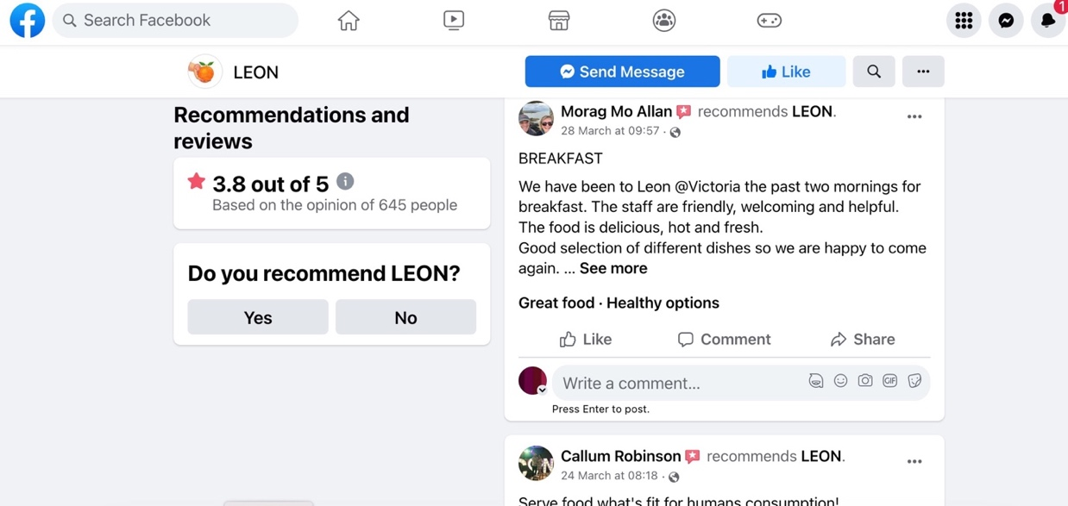
Figure 8, (Facebook.com, 2018)

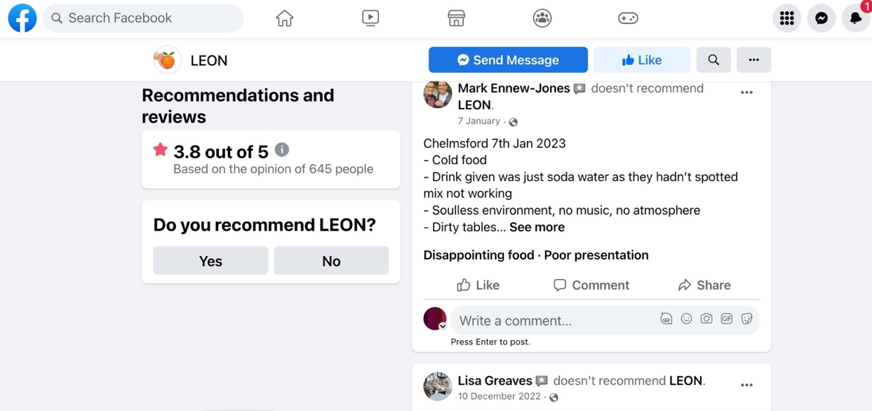
Figure 9, (Facebook.com, 2018)

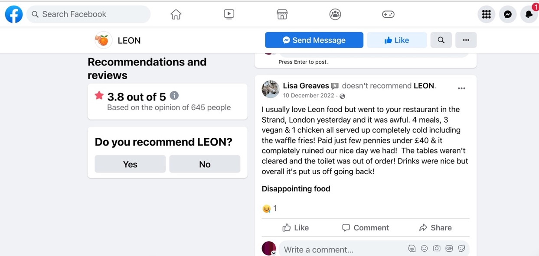
Figure 10, (Facebook.com, 2018).

• Brand Superiority
The Mediterranean healthy diet inspired Leon's restaurant menu, which also became unique for those following alternative, free-from diets such as vegan, paleo, vegetarian, and pescatarian. After finding a suitable concept, it comes to a continuous process of mixing and matching ingredients. Leon's chefs tried to make each meal as nutritionally beneficial and delicious as possible. When customers enter a Leon restaurant, they know that by choosing the convenience of fast food, they are not sacrificing taste or nutritional value. That is proper here, where, and how Leon earns its uniqueness and brand superiority (Nutritics: The world's most trusted source of food data. Nutritics Food Industry Case Study, n.d.).
• Feelings: Warmth, relaxed, fun, colourful, cosy, and playful.
Excitement: People like spending time at Leons restaurants because of their colourful and warm interior design, reminding them also a healthy lifestyle, healthy food menu options,
offering very often new products and many promotions. At the same time, Leon customers, as seen from their reviews (see Figure x), might experience regret and disappointment, which are related emotions from poor customer service, which is very important in the context of customers' decision-making.
Level 4. Brand Relationships
The final level of Keller's Brand Equity Model is brand relationships, which focuses on the ultimate customer relationship with the brand. Brand resonance defines the nature of that relationship, the extent to which they feel "in sync" with the brand, and the intensity or depth of customers' psychological bond with the brand. Brand resonance can be broken down into four following categories:
1. Behavioural loyalty. The first dimension of brand resonance is behavioural loyalty in terms of how often customers purchase a brand and how much they purchase.
2. Attitudinal attachment.
To create brand resonance, a solid personal attachment is also necessary; customers with a great deal of attitudinal passion for a brand may describe it as one of their favourite possessions or a "little pleasure" they look forward to.
3. Sense of community.
Identification with a brand community may make customers feel an affiliation with other people associated with the brand. It also may involve fellow brand users instead of employees or company representatives in the brand awareness process.
4. Active engagement. The most robust affirmation of brand loyalty happens when customers are willing to invest their time, energy and finance, or other resources into the brand beyond those expended during the purchase or consumption.
Resonance
Loyalty

Leon Restaurants Brand Responses
Leon adopts a strategy - "gaining awareness using social media", which helps the company create more awareness for its product and maintain customer relationships. A company uses its official Instagram, Facebook, and Twitter accounts and YouTube channel and keeps them updated (LEON, 2023).
Community: Leon created its LEON Club as an influential community, as it says - "to help us shape the future of fast food", where the "Leons Lovers" present the most loyal its customers (LEON, 2023).
Advantages and Disadvantages of Keller's brand equity model
Advantages:
• model helps companies to find a way to build a solid brand by shaping how their customers think and feel about them.
• model helps to identify the stage the company brand belongs to and what actions need to be taken to move further up.
• it seeks to build strong relationships between the brand and the customer.
• model clarifies that brands with high resonance receive benefits like increased customer loyalty and reduced vulnerability to competitors.
Disadvantages:
The customer-centred brand equity model is preferred by academics and practitioners in marketing research and is ultimately unsuitable to investors, manufacturers, or retailers involved in different processes and using other tools such as Financial Perspective (Financial - Based Brand Equity), Employee Perspective (Employee - Based Brand Equity) Models.
Customer journey
The customer journey records what the company's customer does (or wants to do), thinks and feels before, during and after interacting with company products, staff, or marketing activities. The journey consists of several stages, each of which the customer accomplishes tasks, possesses unanswered questions, and feels different emotions.
(Angrave,2020).
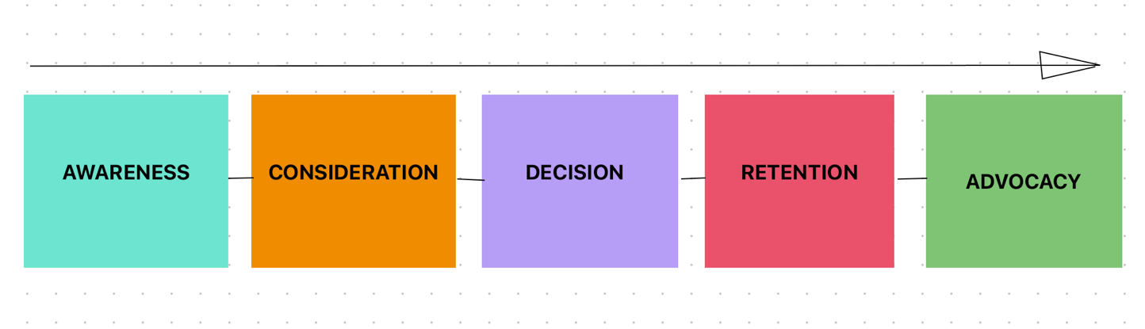

Figure 11, Stages of Customer Journey Figure (2023, by author).

Stages of the customer journey:
1. Awareness
Consumers search for solutions and meet multiple brands and products at this stage. It can involve searching online to find answers to keyword problems, reading reviews, blog posts and news articles, browsing online advertising, and first meeting brands.
2. Consideration
At the consideration stage, prospects weigh company products against competitors. This phase lasts on many different factors, including the cost of a product.
3. Decision-making stage
Once a prospect is satisfied with the results of researching and comparing their options, they may decide. The decision phase is based on product specifications and shopping experience, and also, consumers want to support a brand they trust to provide a quality solution to their problems.
4. Retention
Retention means keeping customers satisfied with a relationship organisation/customer to stop customers from leaving and lead them to the final stage – make them so loyal to the brand that they choose to advocate for the product and service of that brand. A regular, loyal customer transforms an organisation into a consistent business, costing less than the activities to bring one newer customer.
5. Advocacy stage
Advocacy can take various forms, from posting reviews online to recommending a to friends and family in person a particular brand. The company must acknowledge the benefits of word-of-mouth communications and plan for boosting customer advocacy. Keeping customers satisfied and exceeding their expectations with innovation and customer service makes them more likely to recommend that brand and product, for example, to friends and co-workers. Involving social media influencers or guest bloggers can be an effective alternative to traditional word-of-mouth forms of advocacy (Angrave,2020).
Touchpoints
A touchpoint is any physical or virtual facility that enables customers to interact with a brand through different channels before, during, or after they purchase something from that brand. Each touchpoint of those interactions or activities corresponds with one or more of three touchpoint experience stages: pre-purchase, purchase (or usage), and post-purchase (Turnbull, Fill 2019).
Leon Restaurants pre-purchase touchpoints:
• Company website
The Leon Restaurants website is a central online platform of various digital marketing touchpoints such as:
• General information
• Menu
• Click & Collect
• Delivery
• Locations
• Social media links
• Leon Club
Leon's website is its online shop and showcase. The company spends a lot of finance and other resources to keep it informative, helpful, and attractive for loyal customers and impress and engage new people (LEON, 2023).
• Business Profile on Google
Leon utilises its Business Profile on Google, allowing the company to show its restaurants in local searches and on Google Maps. Customers also can find there some basic information such as:
Location/Address, Category, Website, Phone number, Opening hours (Leon, 2023).

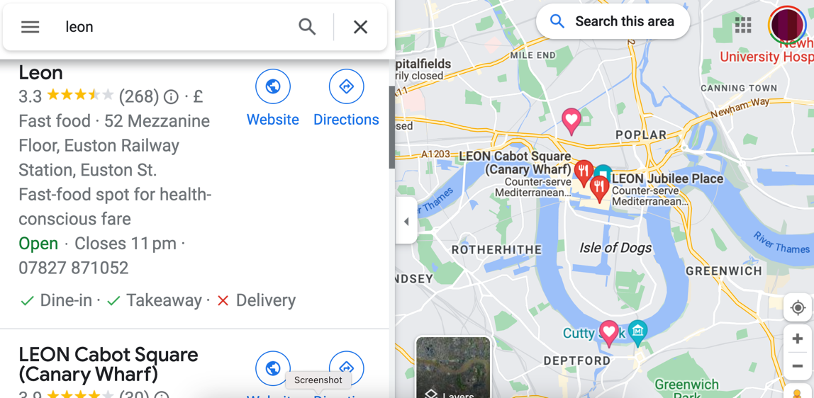
Figure 12, (Google.com, 2019).

• Word-of-mouth. Word-of-mouth is technically the oldest and one of the most effective forms of restaurant marketing phenomenon and the same time, one of the natural touchpoints. According to a report, 92% of customers worldwide trust credible media sources, such as word-of-mouth and recommendations from co-workers, friends, and family. One of the most efficient marketing strategies is to invest in a single customer who can potentially bring in more customers (The Restaurant Times, 2017).
• Mobile App
Leon Restaurants Mobile App (LEON Club app) is widespread; only in Google Market as of 2023 has it been downloaded more than 10K+ times.

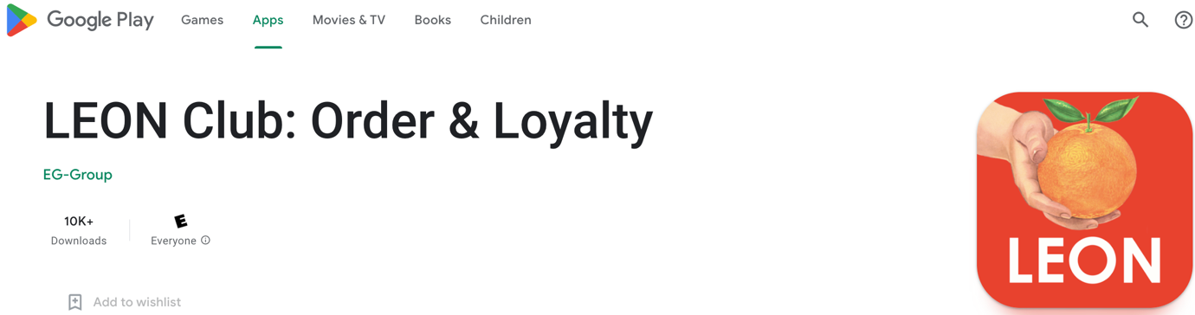

‌ Figure 13, (LEON, 2023).
Users other than regular access to general company information have many options, some of them - SMART ORDER, RE-ORDER, LOYALTY & REWARDS, TREATS, and others.
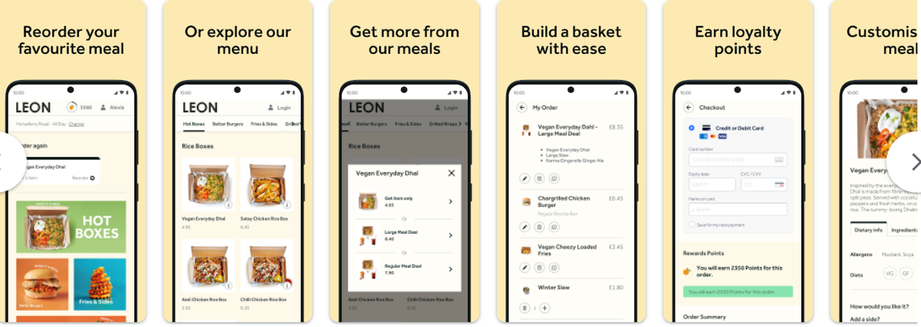
Figure 14, (LEON, 2023).

• Advertising on the London Underground
Leon restaurant strategically advertises on the TFL London Underground inside the stations and carriages, giving the company direct access to an audience (5 million daily journeys) that is outgoing, affluent, and talkative – a valuable target for any fast-food brand (Global, 2022).

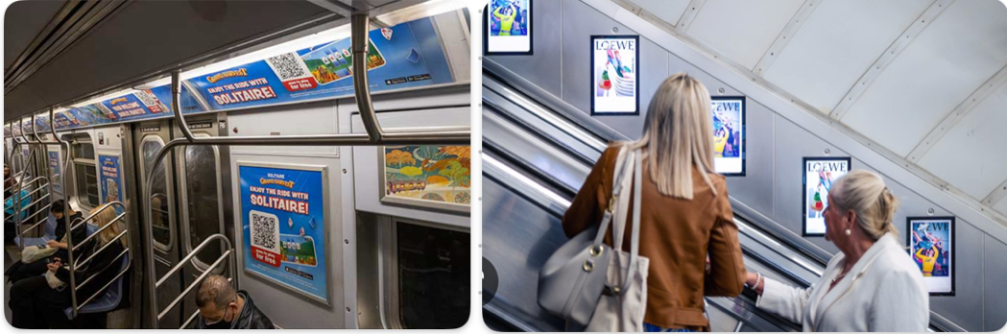
Figure 15, (Global, 2022).

Leon Restaurants purchase touchpoints:
• Leon restaurant chain stores
Leon has 80 stores in London and 5 in the Netherlands. Apart from these locations, the chain operates in other major cities such as Manchester, Oxford, Birmingham, Brighton, and Leeds. Recently, it has opened a new premise in Harrogate (World Coffee Portal, 2022).
• Mobile App - SMART ORDER (Click & Collect)
The LEON Club app user can skip the queue and easily order their favourite dishes for pick-up from Leon's natural fast-food restaurants. The application asks users to select the nearest restaurant, choose dishes, pick-up time (incl. ASAP option), checkout and pay (LEON, 2023).

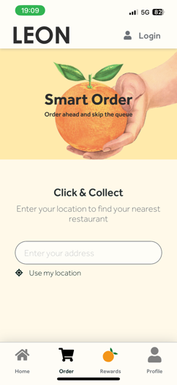
Figure 16, (LEON, 2023).

• Sainsbury online/offline shopping
The restaurant chain, Leon, has partnered with Sainsbury's supermarket to offer LEON Coffee and some other products in their stores.
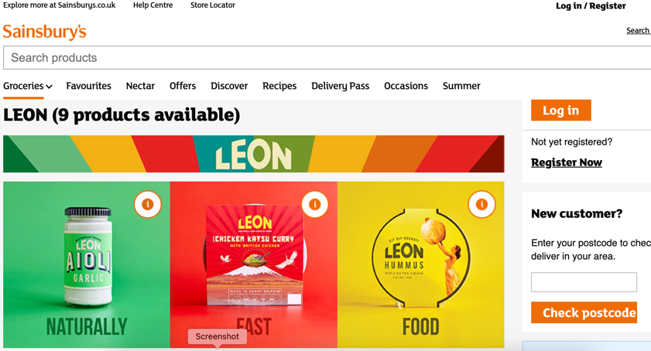
Figure 16, (LEON, 2023).

• Amazon. Leon's restaurant recipe bookselling.
Leon sells its best recipe books online on the Amazon platform. Customers can buy it in hardcover, paperback, and Kindle book formats (Amazon.co.uk, 2023).

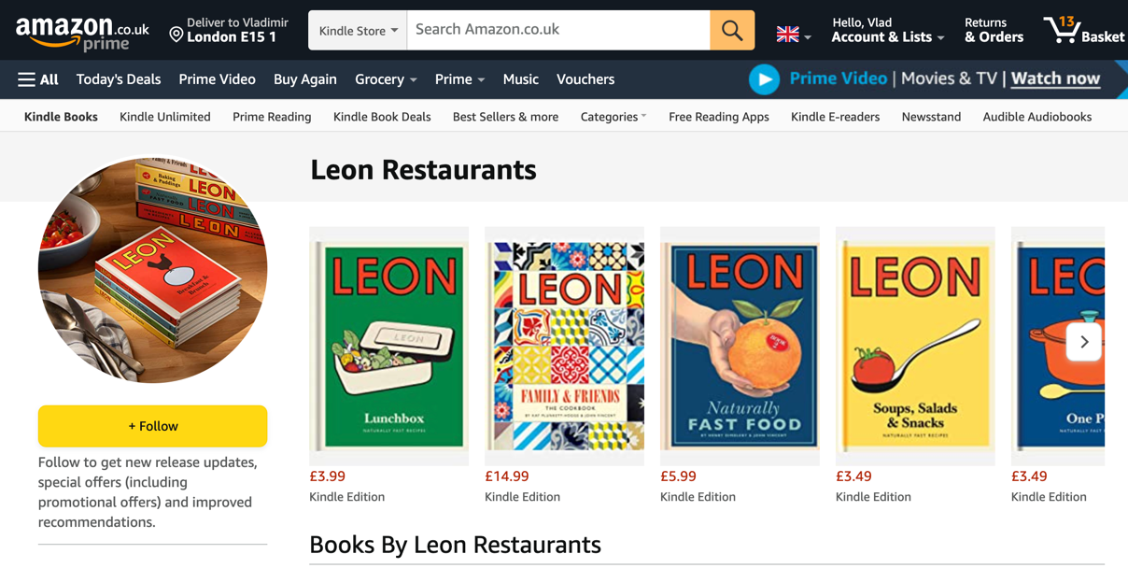
Figure 17, (Amazon.co.uk, 2023).

Leon Restaurants post-purchase touchpoints:

• Social Media Engagement
Leon customers can follow the company on Instagram, Twitter, Facebook, and YouTube. Reengaging with people who talk about the Leon restaurant brand on social media helps the company to expand its online reach and create a feeling of community around the business, resulting in that customer (and some of their friends and relatives) becoming repeat customers (LEON, 2023).
• Follow-up Messaging and emails.
Leon uses practices to reach out to customers and handle follow-up interactions once gathered data. Using these touchpoints, Leon shares valuable information with customers and obtains their personal information and feedback.
• Leon restaurants guest's feedback
One of the most crucial pieces of customer data that Leon gather and utilises is guest feedback. Leon's staff and managers collect and analyse post-dining reviews daily to improve customer service.

Leon Restaurants chain - Customer Persona

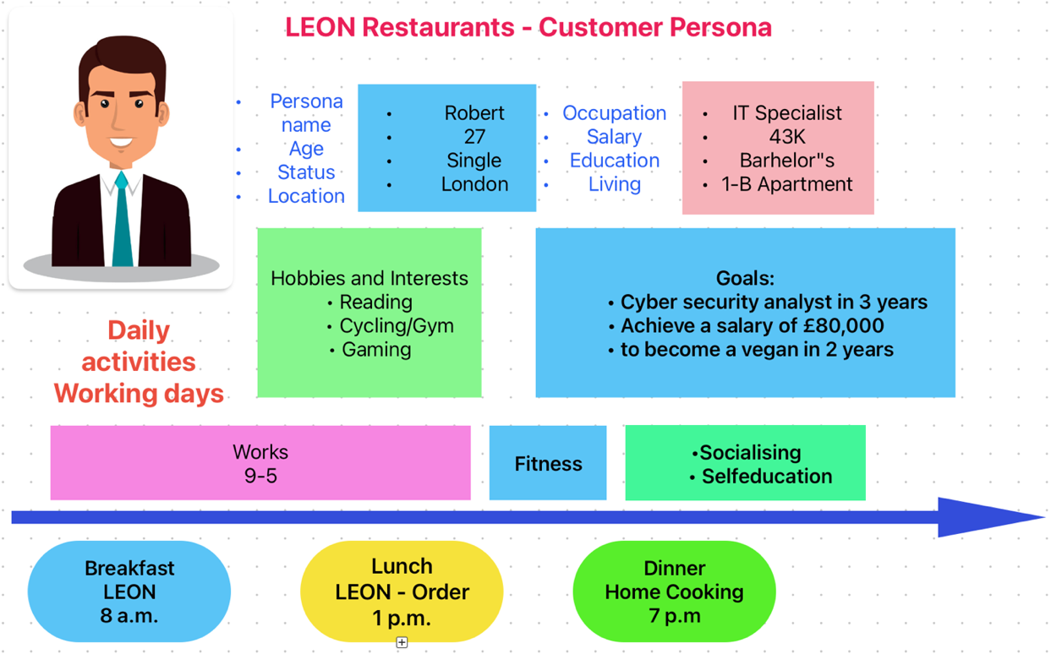
Figure 17. Customer Persona - Robert

Leon Restaurant Customer Journey Map
Robert has lunch in the office at his workplace. See Figure 18,19.

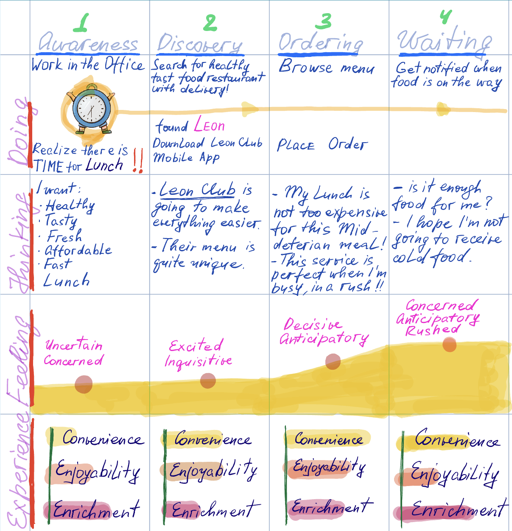

Figure 18

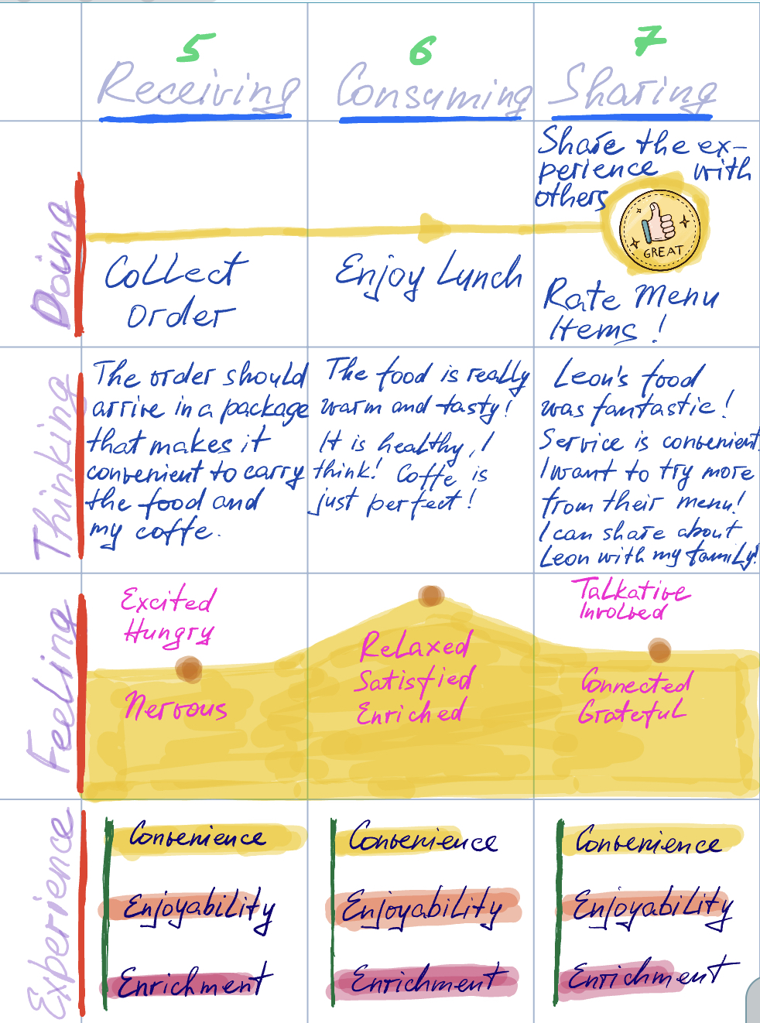

Figure 19

Strengths and weaknesses of Leon Restaurant's customer journey map
Strengths
• Leon's Business Profile on Google helped Robert to find the nearest Leon fast food restaurant. It also gave him the link to the official website. With all features as a touchpoint, Google Business Profile is working perfectly.
• Leon's official website presented Robert with a menu with descriptions, stunning photos, prices, and discounts and gave him a link to download and install the Leon Club mobile app on his mobile Phone. Leon's official website, with all features and options as touchpoints, is working perfectly.
• Leon Club mobile app Allowed Robert to view the menu, choose his lunch, place an order, pay for it and arrange delivery. Leon Club mobile app as touchpoint is working perfectly.
• After lunch, Robert used the Leon Club mobile app to write a positive review about his experience. Leon Club's mobile app helped Robert to express and share his feeling of satisfaction and gratefulness to Leon's staff. In this way, Robert once again experienced the positive emotions of accomplishment of giving feedback and satisfaction with the product. This further strengthened his association with the Leon Restaurants company, increasing his likelihood of repeatedly utilising their services. Resume: Leon Club mobile app as feedback platforms touchpoint is working perfectly.
Weaknesses
• Robert was concerned about his lunch delivery since he had no more option in Leon Club mobile app but to use a lesser-known delivery company. He was unsure and a bit nervous that his food order would arrive in whole and warm condition on time, which could ruin his dining experience. Robert had often experienced issues with similar London delivery companies, which added to his worries. In this aspect, the Leon Club mobile application has a weak point as a touchpoint because it cannot offer various product delivery options or practically guarantee its speed, quality, and accuracy.

The total engagement model

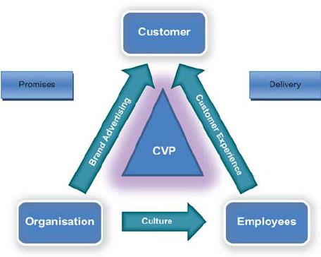

Figure 20,(Roberts and Alpert, 2010).

In achieving stable business growth, it is essential to establish a strategic and collaborative connection between engaged employees and engaged customers. Engaged staff members are committed to the company's success; they become more productive, peaceful, and loyal. To reach better customer engagement results, aligning brand and internal culture with the company's value proposition and planned customer experience is vital.
The Total engagement model combines several linkages to align the four crucial elements of brand advertising, customer experience, culture, and value propositions. These elements are as follows:
1. Company brand is more than just a logo or name. It reflects company identity and values, and the value proposition should lead in shaping the brand.
2. Culture is how businesses do things internally. It includes goals, values, and behaviours, which should create an environment where staff can consistently deliver company value and customer experience.
3. Customers' experience when interacting with the company is a combination of physical and emotional components that the company provide them.
4. The company's value proposition to its customers is the unique benefit it provides that sets it apart from competitors. It is why customers choose to buy from that company instead of someone else.
To create engaged customers, the company must develop a unique value proposition based on customer insights, communicate, and highlight it consistently in advertising, and ensure its staff members understand their delivery functions. This leads to a planned customer experience that fulfils the advertising promise and customer expectations. (Roberts and Alpert, 2010).

Recommendations
New Leon Restaurants Touchpoints (Recommended by the author of the report)
1. Hyper Personalised Marketing 2.0
Personalisation refers to effective communication between company representatives and customers at every touchpoint and interaction! This approach involves forecasting and anticipating customer behaviour to deliver services tailored to their preferences, including what they want, how they want it, and when they want it. By utilising artificial intelligence (AI) and real-time omnichannel data, the hyper-personalisation approach enables the creation of personalised data and customer personas tailored to specific restaurant segments and locations, resulting in more meaningful interactions and communications with customers and practical strategies and campaigns that increase customer loyalty. It also will provide customers with more relevant information.
The author of this report recommends that Leon Restaurants management provide Hyper Personalised Marketing 2.0 in each Leon restaurant using an internal computer network, needed devices and software.
2. Standardised and personalised Delivery Procedure
According to the Leon Restaurant Journey Map (Figure 18,19), one of the company's current weaknesses lies in the low customer satisfaction surrounding external delivery companies, as Leon needs more control.
To maintain service efficiency, the report's author recommends that Leon management assign specific and personal delivery responsibilities to each restaurant kitchen manager and delivery driver. Technically, this can be arranged by using special software and digital devices on each company site with a rating on a five-point scale for each delivery. Outsourced drivers should be 100% prepared to know their coverage areas and communicate well with Leon's staff to prevent mistakes and save time. Both kitchen managers and delivery drivers should receive fair compensation based on their estimated rating. If their scores fall below expectations, immediate action should be taken to replace them.
3. Printed production
Sometimes, customers sitting and waiting for their orders take a break from their devices and step out into the real world, and it is an excellent opportunity to connect with them during these moments. While they may seem outdated, print paper flyers still have a substantial impact and can reach people at various consumer journey stages. The author suggests that the Leon management organise production and constantly have printed brochures, and booklets, with information about healthy food, the history of the menu, stories about the company, new products sold in the restaurant and also some little books for kids and to have this in each restaurant.
4. Using QR Codes
The report's author is convinced that QR codes can be a valuable addition to Leon's restaurant chain, offering several benefits. For one, they provide a fast and easy way for customers to place orders while also allowing the restaurant to save money on printing costs. In the author's opinion, Leon is still a fast-food restaurant, so they do not need the classic massive, printed menu used in traditional restaurants.
Additionally, QR codes will improve hygiene and safety by reducing physical contact between guests and staff when handling menus. Lastly, they can help improve brand visibility and increase brand awareness. By utilising a QR code generator, restaurants also can quickly create a digital menu that their customers can access easily. In addition, using a QR code allows the restaurant to effortlessly collect the customer's contact information when they connect to the ordering and payment platform.
QR codes are becoming increasingly popular, and restaurants need to be on the edge and use this technology to enhance the customer experience. QR code will improve Leon's marketing processes and gives them more control over guest relationships. It also reduces reliance on third-party systems that mainly collect data for their benefit.

Conclusion
With the current uncertainty in global markets, players in the fast-food industry must adapt their marketing strategies to overcome competition. For any business to succeed, it is essential to continually adjust its operation activities and marketing strategies to meet customers' needs and maintain a solid commitment to the company's vision and mission. Otherwise, without a proper marketing strategy, a company may face internal and external organisational pressures that could result in going out of business. In the face of the EG Group, the Leon Restaurant chain in 2020 has found new owners and, at the same time - financially powerful potential investors and in that case according to the author of this report, all that the Leon Restaurant company needs to prosper in the future is to find new marketing strategies and apply them. The author analysed the Leon Restaurants company's marketing strategy using marketing tools, and recommendations were prepared that the company can successfully apply according to his opinion.

References:

• Abboud, L., Wiggins, K., Barker, A. and Massoudi, A. (2021). EG Group buys restaurant chain Leon for £100m. [online] @FinancialTimes. Available at: https://www.ft.com/content/e0fe5403-7121-4751-a6ae-7148dcbab4eb [Accessed 9 Apr. 2023].
• Angrave, J. (2020). The Journey Mapping Playbook: A Practical Guide to Preparing, Facilitating and Unlocking the Value of Customer Journey Mapping. Germany: De Gruyter.
• Amazon.co.uk. (2023). Leon Restaurants. [online] Available at: https://www.amazon.co.uk/kindle-dbs/entity/author/B00AASWM8U?_encoding=UTF8&node=266239&offset=0&pageSize=12&searchAlias=stripbooks&sort=author-sidecar-rank&page=1&langFilter=default#formatSelectorHeader [Accessed 25 Apr. 2023].
‌‌• Behance (2016). Leon Restaurants - Branding and Packaging Design. [online] Behance. Available at: https://www.behance.net/gallery/34930809/Leon-Restaurants-Branding-and-Packaging-Design [Accessed 18 Apr. 2023].
• Bistrobe.com. (2023). Expand. [online] Available at: https://bistrobe.com/leon-menu-prices/?utm_content=cmp-true [Accessed 19 Apr. 2023].
• Cafe La Jefa Coffee House - Specialty coffee, tea and healthy food. (2021). Home - Cafe La Jefa Coffee House. [online] Available at: https://cafelajefa.com/ [Accessed 27 Apr. 2023].
‌•Daikin Internet. (2018). Leon's restaurant. [online] Available at: https://www.daikin.eu/en_us/about/case-studies/leon.html [Accessed 19 Apr. 2023].
• Facebook.com. (2018). LEON. [online] Available at: https://www.facebook.com/LEONrestaurants/reviews/ [Accessed 19 Apr. 2023].
• Global. (2022). London Underground Advertising | Global. [online] Available at: https://global.com/outdoor/rail/tfl-rail-estate-advertising/london-underground-advertising/?network=g&fm_kwd=london%20tube%20advertising&owa_medium=referral&owa_source=google.co.uk&owa_campaign=FM2%20London%20Underground%20Exterion%20Media&owa_ad=FM2%20London%20Underground%20Exterion%20Media&owa_ad_type=search&gclid=CjwKCAjw9J2iBhBPEiwAErwpeXs_8qqdXR5FlPQaTa7oO0hF-n4w3KuIFWJ9kCilwaClEYjml9iw7xoCem8QAvD_BwE [Accessed 25 Apr. 2023].
• Google.com. (2019). leon google maps - Google Search. [online] Available at: https://www.google.com/search?q=leon%20google%20maps&oq=leon+google&aqs=chrome.0.0i512j69i57j46i10i512j0i10i512l7.16416j0j15&sourceid=chrome&ie=UTF-8&tbs=lf:1,lf_ui:4&tbm=lcl&sxsrf=APwXEdf90eFpyBODqxMhXzBTcrgO-sFV_Q:1682627137116&rflfq=1&num=10&rldimm=16301091469774516797&lqi=ChBsZW9uIGdvb2dsZSBtYXBzIgOIAQFIt8L9g9S2gIAIWgoQABgAIgRsZW9ukgEUZmFzdF9mb29kX3Jlc3RhdXJhbnSqATYQASoIIgRsZW9uKAAyHhABIhreQGIUmsEchNZ0U1grHkzQWBPgGOGUNgmT4jIIEAIiBGxlb24&ved=2ahUKEwiZ96_G8sr-AhUoQ0EAHb9gAcAQvS56BAgLEAE&sa=X&rlst=f#rlfi=hd:;si:16301091469774516797,l,ChBsZW9uIGdvb2dsZSBtYXBzIgOIAQFIt8L9g9S2gIAIWgoQABgAIgRsZW9ukgEUZmFzdF9mb29kX3Jlc3RhdXJhbnSqATYQASoIIgRsZW9uKAAyHhABIhreQGIUmsEchNZ0U1grHkzQWBPgGOGUNgmT4jIIEAIiBGxlb24;mv:[[51.534962799999995,-0.0112477],[51.5012104,- ‌0.14007]];tbs:lrf:!1m4!1u3!2m2!3m1!1e1!2m1!1e3!3sIAE,lf:1,lf_ui:4 [Accessed 27 Apr. 2023].
• Iain (2015). Food Chain Magazine. [online] FoodChain Magazine. Available at: https://foodchainmagazine.com/news/leon-restaurants/ [Accessed 9 Apr. 2023].
• Keller, K. (2001). Building Customer-Based Brand Equity: a Blueprint for Creating Strong Brands. [online] Available at: http://thearf-org-unified-admin.s3.amazonaws.com/MSI/2020/06/MSI_Report_01-107.pdf.
• Kuhn, K., & Alpert, F. (2004). Applying Keller's Brand Equity Model in a B2B Context: Limitations and an Empirical Test.
• LEON. (2023). Homepage - LEON. [online] Available at: https://leon.co/ [Accessed 24 Apr. 2023].
• Leon (2023). Leon. [online] Leon. Available at: https://www.google.com/maps/search/leon/@51.5005792,-0.060024,12.64z [Accessed 24 Apr. 2023].
• Marino, R., Wallace, D., & Keller, A. (2016). The Physics of Brand: Understand the Forces Behind Brands That Matter. United States: Adams Media.
• Moran, L.J. (2023). A growing pride: The takeover and expansion of Leon. [online] Catering Today. Available at: https://www.cateringtoday.co.uk/comment/features/a-growing-pride-the-takeover-and-expansion-of-leon/ [Accessed 9 Apr. 2023].
‌• Nutritics: The world's most trusted source of food data. Nutritics Food Industry Case Study. (n.d.). Available at: https://www.nutritics.com/downloads/resources/Nutritics-Case-Study-LEON.pdf.
• restaurantonline.co.uk (2015). Business Profile: Leon. [online] restaurantonline.co.uk. Available at: https://www.restaurantonline.co.uk/Article/2015/06/08/Business-Profile-Leon [Accessed 19 Apr. 2023].
• Roberts, C. and Alpert, F. (2010). Total customer engagement: Designing and aligning vital strategic elements to achieve growth. [online] ResearchGate. Available at: https://www.researchgate.net/publication/49513186_Total_customer_engagement_Designing_and_aligning_key_strategic_elements_to_achieve_growth/link/004635289737039023000000/download [Accessed 27 Apr. 2023].
• Staff (2013). Champions of Design: Leon. [online] Campaignlive.co.uk. Available at: https://www.campaignlive.co.uk/article/champions-design-leon/1173281 [Accessed 18 Apr. 2023].
• Steinberg, S. (2007). An introduction to communication studies. South Africa: Juta.
• Tourky, M. E., Kitchen, P. J. (2022). Integrated Marketing Communications: A Global Brand-Driven Approach. Switzerland: Springer International Publishing.
‌‌• Turnbull, S., Fill, C. (2019). Marketing Communications. United Kingdom: Pearson Education Limited.
• World Coffee Portal (2022). LEON: The fast and the luxurious. [online] World Coffee Portal. Available at: https://www.worldcoffeeportal.com/Latest/InsightAnalysis/2022/November/LEON-The-fast-and-the-luxurious [Accessed 25 Apr. 2023].

‌

‌
‌
‌
‌
‌‌
‌
‌

