University of Wales Trinity Saint David
School of Engineering


Engineering Technical Report
Workshop and Practice (ACHA4011)

Rhys Thomas
(2303931)
20th November 2023

Contents
Introduction 2
Chapter 1 – Health and Safety with risk assessments 2
Chapter 2 – Engineers Role in Society 4
Chapter 3 - Problem Solving 6
Chapter 4- Team Structure 8
Chapter 5 – Personal Development Plan 10
Conclusion 12
References 13
Table of Figures 13

Introduction
In this Technical Report, the researcher will investigate a range of topics including Health and Safety with risk assessments, the Engineer's role in society, Problem-solving, Team structure, and a personal development plan. The section on Health and Safety with risk assessments will feature a risk assessment matrix concerning a task completed within the workshop setting. This section will outline the risks involved in undertaking certain tasks in the workshop setting, particularly in terms of required Personal Protective Equipment (PPE). The Second Section is Discussing the different organisations that provide engineers with chartership. The third Section will show problem solving skills that a team of engineers will need when facing everyday issues. The penultimate section is a personal review of myself when working in a team. The final section will be a personal development plan, that will show how the researcher will develop themselves in both short and long terms.

Chapter 1 – Health and Safety with risk assessments
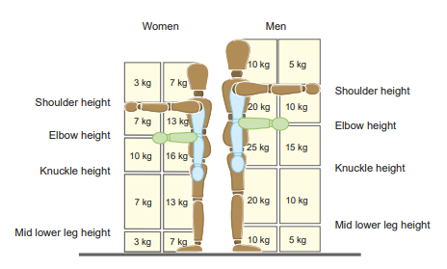
When working in a workshop there are many rules that should be followed to ensure that everyone stays safe during all work activities, these rules are governed by the health and safety executive, they are a public body that are responsible for creating and staying up to date with these regulations. They are constantly updating and informing companies of new regulations. There are so many different industries they create regulations for. In the automotive industry there are so many different tasks that are undertaken which require their own set of guidelines. For example, when moving heavy objects like an engine from and to different heights and places, there is one main regulation that should be followed when carrying out this task this is the “Manual handling - Manual Handling Operations Regulations 1992” (Health and Safety Executive, 2016). These are guidelines that dictate what a worker can and can’t do when moving objects depending on their size and weight. There is a pictorial diagram that shows the maximum weight that a worker is allowed to lift depending on gender, how heavy the object is and where the object is being held.
Figure 1 - Weight lifting limitations

(Health and Safety Executive, 2020)
 |  | Impact
 |  | Minimal | Medium | Severe
Probability | Low | Carrying a small light object. | Carrying a small but medium weight object | Carrying a small but very heavy object
Probability | Medium | Carrying a larger but still lightweight object | Carrying a medium sized object that is medium weighted | Object being Heavy and medium sized
Probability | High | Carrying a very big but light object | Carrying a medium weighted object that is very big. | Object Being too big as well as heavy.
If the object that needs to be moved is heavier than this weight then a more detailed risk assessment should be carried out for that individual object, in this case the engine block being moved is heavier than what can be manually handled, so therefore equipment needs to be used to aid the worker. A lifting and lowering trolly is then used to lift to the height of the engine and slide it onto the platform, this is allowed and does not need to be further investigated to ensure that it is safe to be carried out.
When doing anything in the workshop it is realty important to be wearing to correct PPE (Personal Protective equipment). The health and safety executive have guidelines on what PPE should be worn and when it should be used. When undertaking manual handling you need to ensure that the PPE you are wearing will protect you, this will be hand and foot protection, gloves should be worn to ensure that the object does not cause any harm to your hand if it is sharp or heavy it could cause skin to tear or bruise. Foot protection should be worn to stop your foot being crushed in case anything was to go wrong and the object was dropped this could cause again either tearing of the skin or a badly bruised foot if not wearing the correct PPE.
Figure 2 - Risk Assessment Matrix

Chapter 2 – Engineers Role in Society
Chartered Engineers are expected to follow the code of conduct that their chartership organisation sets depending on the organisation depends on the different conducts to be followed. Their code of conduct shows rules that are to be followed with regards to sustainability and environmental impacts especially with “air pollution on the rising incidence of many respiratory diseases.” (Patella, 2018)
The IMechE, or Institution of Mechanical Engineers,
Mitigation of Environmental Impacts: It is expected of engineers to reduce the environmental impact of mechanical engineering operations. This involves cutting back on waste, increasing energy efficiency, and introducing sustainable methods and technologies.
Sustainable Innovation: Engineers are encouraged to create new approaches that can help develop how we can stay as sustainable as possible, This This involves creating energy-efficient, carbon-minimized, and ecologically mindful systems, products, and procedures. For example, electric vehicles and hydrogen vehicles.
Best Practises and Compliance: Engineers must adhere to environmental laws and regulations, but they should also work to go above and beyond these minimal standards by utilising sustainable and environmentally friendly practises.
The Engineering council,
Sustainable Development: Engineers must emphasise the concepts of sustainable development while considering the economic, social, and environmental effects of their work. Engineers must create, run, and oversee engineering solutions with the least number of detrimental effects.
Ethical Responsibility: It is required of chartered engineers to act ethically by advocating for sustainable practises and making ethical decisions that put sustainability and environmental protection first.
Continuing Professional Development (CPD): Urges engineers to stay current on environmental technology and sustainability techniques to promote continuous learning and progress in sustainable engineering practises.
Section written with aid of ChatGPT (ChatGPT, 2023)
The Engineering Council and IMechE both stress the importance of engineers' contributions to environmental preservation and sustainable development. The Engineering Council emphasises the social implications of engineering solutions, while IMechE concentrates on innovation and operational impact.

Chapter 3 - Problem Solving
In the world of engineering, various challenges arise regularly and demand quick solutions. These issues might involve creating new products, addressing problems with existing ones available in the market, or dealing with issues related to suppliers during the production process. There are many different ways of problem solving, even when there isn’t a big problem for example “the earliest method of making cars involved teams of men moving from one car to another. Henry Ford turned it all upside down. He put the car frames on belts and moved them past the men.” (Adair, 2019) To illustrate the diverse approaches to solving these engineering issues, three flowcharts have been created. These diagrams outline different ways to solve problems.

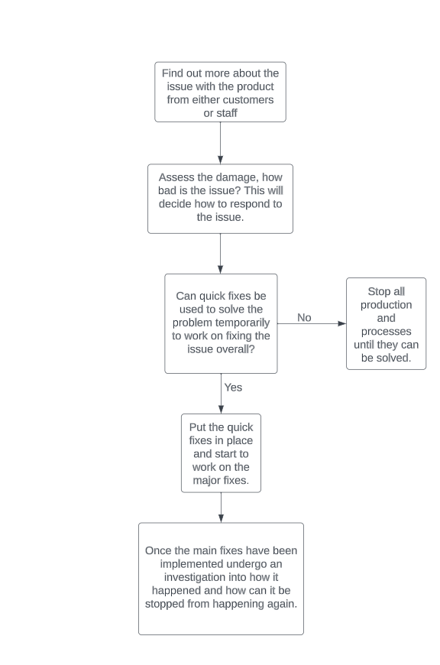
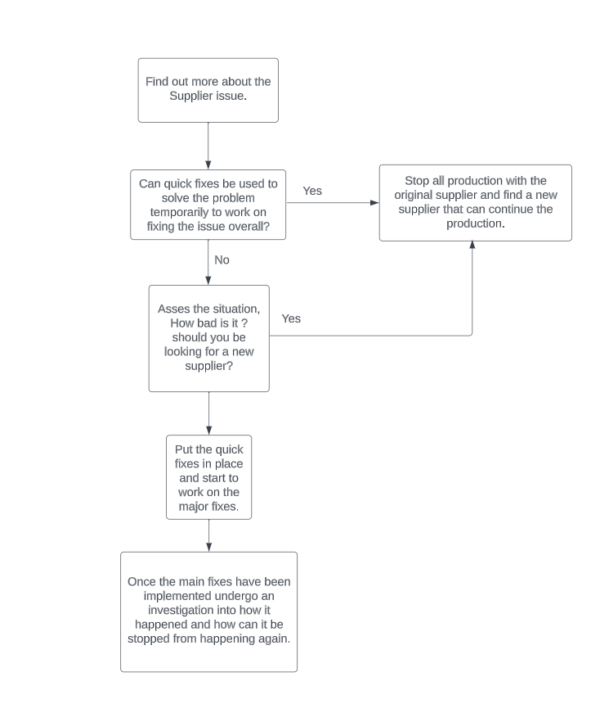
Figure 3 - Product issue flowchart
Figure 4 -Supplier issue flowchart
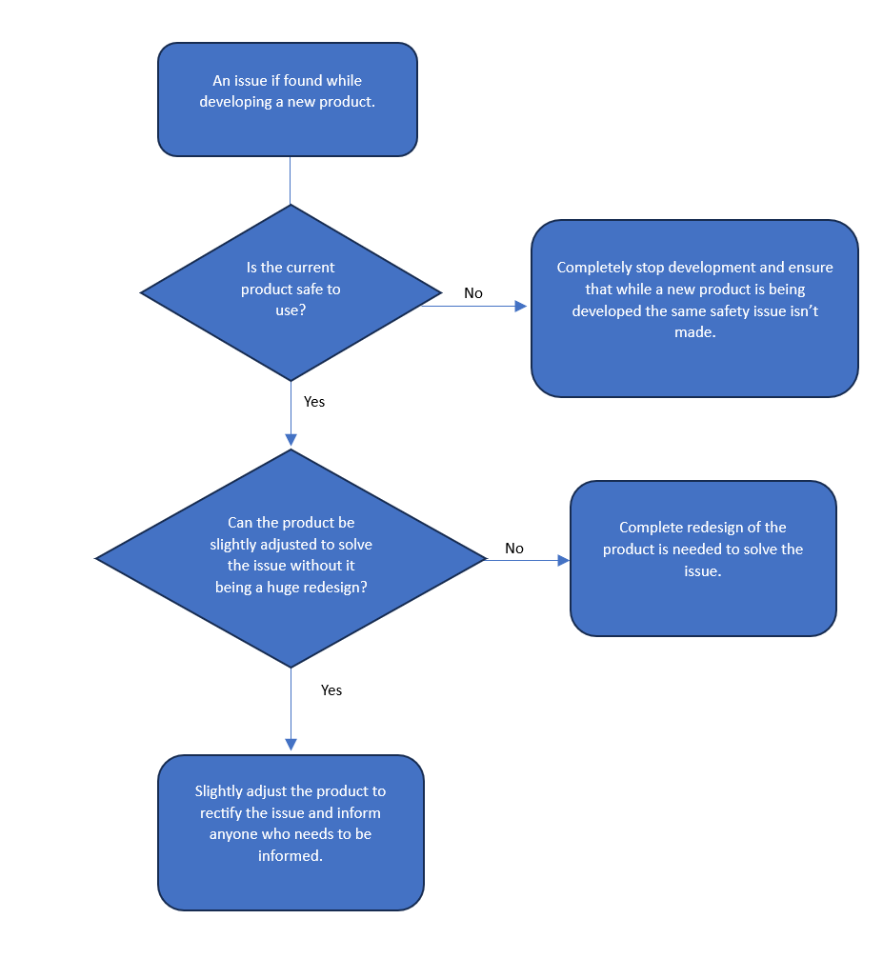
Figure 5 - Product development issue flowchart

Chapter 4- Team Structure
Working together as a team not only increases productivity but also guarantees that everyone on the team has clear responsibilities, which keeps everyone motivated and helps leaders keep an eye on performance and accountability. There is also a major health benefit to this working in a team will keep boost your mental health “About one third of our adulthood is spent at work where social relationships often play an important role” (Bilek, 2023).
Whilst attending my comprehensive school I decided to take part in the Duke of Edinburgh Bronze Award, this required a team of 6 to complete three months’ worth of volunteering, physical activities and skills development whilst also completing a two day and one night expedition. When on the expedition our team needed to cover 10 miles each day. So therefore, there was a few tasks that needed to be handled by each member of the team. Everyone had their own tasks to be doing throughout the two days due to have good team members most of these tasks were completed without any issues. Some of the tasks were forgotten about and then when they needed to be done nobody knew who was supposed to be completing them. This led to the team arguing over whose job it was but overall, the team was very good and between the practice expeditions and the main expedition we were always ahead of schedule and finished before all the other teams.
However, the team lacked in some leadership roles, for example when the tasks were being handed out to each member of the team it would have been great for a leader to write down who was to be completing each task so that it didn’t lead to them being missed out. Also, on one of our practice expeditions we lost 2 of out members at a fork in the path, due to being on an expeditions phones and technology are prohibited but we had a plan for if we lost our team and that was to go back to out last food/drink stop, these happened often enough that it wouldn’t cause us to go too far afield. There should have been a leader constantly keeping track of where people were at all times but because there wasn’t this happened, we should have made this adjustment before completing out final expedition, but we still completed it without any issues.

Overall, our team lacked having a main leader that would take charge over the weekend. We should have used a hierarchical structure that would clearly outline who has what job and their position, however due to being children in comprehensive school this may have been hard to do due to childish behaviours. whereas I’m now part of a race team that has a Product-focused divisional structure that works very well and splits the team to focus on each car/half of the team. This possibly could have worked on my expedition to split the team into different sections to manage responsibility.
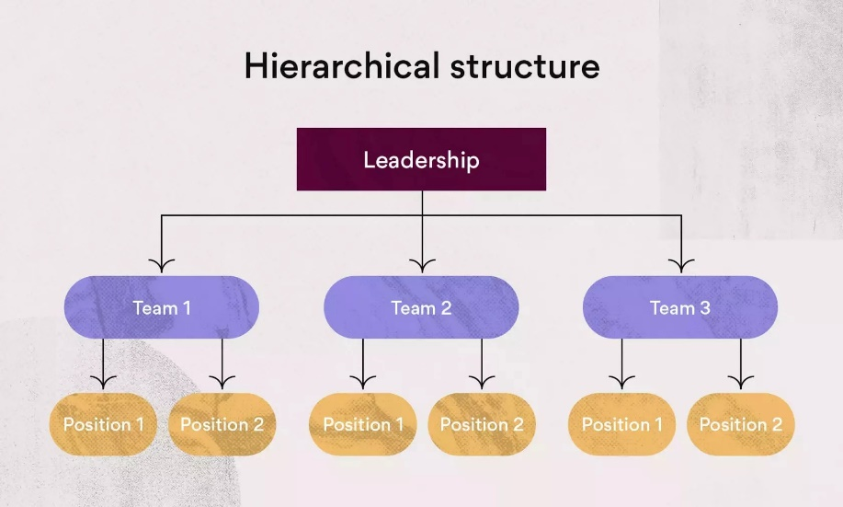
Figure 6 - Hierarchical Structure
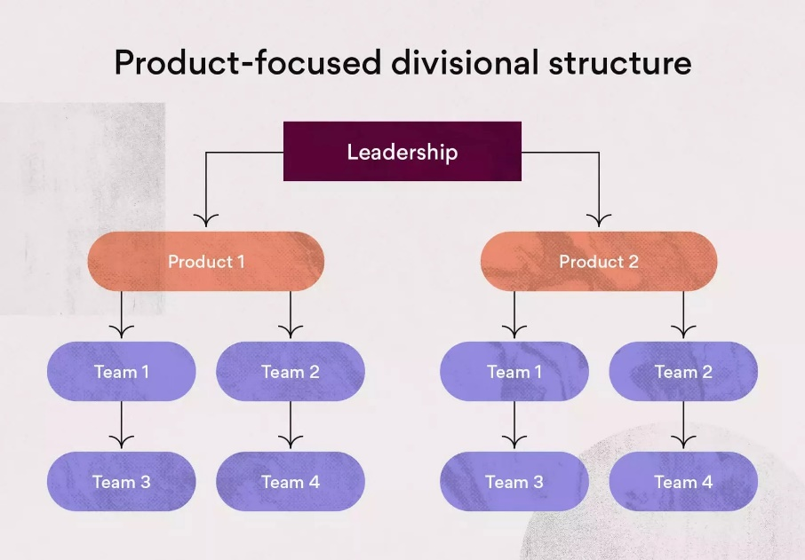
Figure 7 - Product- Focused Divisional Structure

Chapter 5 – Personal Development Plan
Personal Development Plan
Name – Rhys Thomas
Degree – Motor Sport Engineering
Previous Qualifications –
GCSE - Information and communication technology A*
Mathematics B
Home Economics: Food and Nutrition B
Double Award science B
Welsh Second Language B
Design & Technology B
Numeracy C
English Literature C
English Language C
Duke Of Edinburgh - Bronze Pass
College - BTEC Level 3 Diploma in Advanced Distinction
Manufacturing Engineering Motorsport
Previous Experience – Worked in The Range from 2021-2022
Currently employed at B&Q 2022-present
Have got experience working on vehicles through college and during my
own time and thoroughly enjoy it.
I was in the Royal Air Force Air Cadets for 2 years.
Long Term Goals (5 to 10 years)
Work in a motorsport team as a Mechanic or engineer.

Short Term Goals (0 to 5 years)
Complete My Motorsport Engineering degree at UWTSD.
Complete a total rebuild on friends original mini.
Gain a full understanding for how to work on lorries.

Goal | Objective | Resources Required | Measurement | Target Date
Complete a total rebuild on friends original mini. | Continue to work on the car over weekends. | Books and online articles on how to reconstruct some parts of the car. | Take weekly updates to ensure that the build is on target. | May 29th 2024
Gain a full understanding for how to work on lorries. | Continue to help at my friend’s logistics company and learn new skills. | Use any Experience from the main mechanic that he has learnt over years working on heavy goods vehicles | Ensure that I go there often enough to continue to learn and develop. | Within next 3 years.
Complete My Motorsport Engineering degree at UWTSD. | Work through all my assignments and submit them on time as well as revising for exams ready to take them. | Any books from the library and online library, using google and any other resources available. | Ensuring that I am getting | End of university year 2026
Work in a motorsport team as a Mechanic or engineer. | Gain all the skills and knowledge needed to get a job as motorsport mechanic/engineer | Use all resources from the university or online to gain the correct knowledge. | Ensure that I am constantly learning and developing my skills so that I can archive this goal. | 2028 onwards

Conclusion
In summary, this report emphasizes the significance of workplace health and safety, the responsibility of engineers in developing global sustainability, the need for skilful problem-solving across varied situations, and the importance of effective teamwork within a structured team framework, alongside emphasizing the necessity of a personal development strategy.

References
Adair, J., 2019. Decision Making and Problem Solving: Break Through Barriers and Banish Uncertainty at Work. 4 ed. London: Kogan Page, Limited.
Bilek, E., 2023. Working in a tam and mental health. 94 ed. s.l.:Nervenarzt.
ChatGPT, 2023. Chat GPT. [Online]
Available at: https://chat.openai.com/
[Accessed 26 11 2023].
Health and Safety Executive, 2016. Manual handling - Manual Handling Operations Regulations 1992. [Online]
Available at: https://www.hse.gov.uk/pubns/books/l23.htm
[Accessed 23 11 2023].
Health and Safety Executive, 2020. Manual handling - Manual Handling Operations Regulations 1992. [Online]
Available at: https://www.hse.gov.uk/pubns/indg143.pdf
[Accessed 23 11 2023].
Patella, V., 2018. Urban air pollution and climate change. “The Decalogue: Allergy Safe Tree” for allergic and respiratory diseases care, 16(1), p. 12.

Table of Figures
Figure 1 - Weight lifting limitations 2
Figure 2 - Risk Assessment Matrix 3
Figure 3 - Product issue flowchart 6
Figure 4 -Supplier issue flowchart 6
Figure 5 - Product development issue flowchart 7
Figure 6 - Hierarchical Structure 9
Figure 7 - Product- Focused Divisional Structure 9

