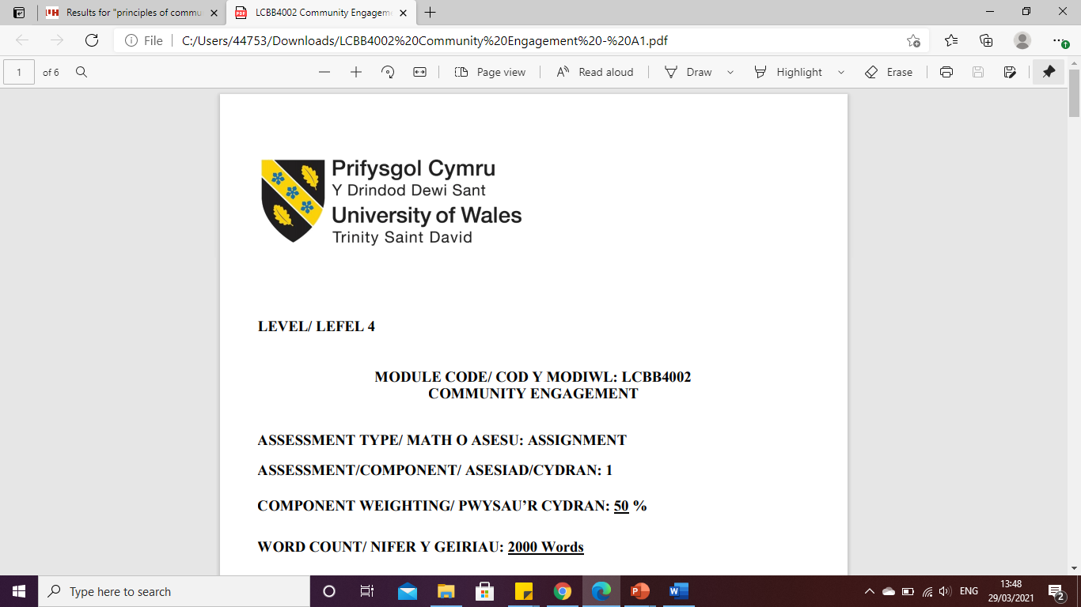

LEVEL 5

Assignment 1 Report
MODULE CODE: LCBB5001
ENTREPRENEURSHIP

ASSESSMENT TYPE: ASSIGNMENT
ASSESSMENT/COMPONENT: 1
COMPONENT WEIGHTING: 50 %
WORD COUNT: 2423 Words
SUBMISSION DETAILS:
Name: Cosmin Adrian Mitu
Student Number: 2021613

Table of Contents

1. Introduction 3
2. QUESTION 1 3
3. QUESTION 2 6
3.1. Description 6
3.2. Feeling 6
3.3. Evaluation 7
3.4. Analysis 7
4. Conclusion 8
5. Action plan 9
References 10

Introduction
This study aims to evaluate entrepreneurship theory and use Gibb's Reflective Cycle to consider one's own personal growth. Entrepreneurs are essential to any economy because they have the knowledge and drive to foresee requirements and sell viable new ideas. An entrepreneur can genuinely pick up a business strategy on the fly by using efficient communication and sales techniques, as well as having a laser-like focus and a high capacity for learning. It also emphasises the significance of new product creation, which is the backbone of businesses and essential to their organic expansion.

QUESTION 1
The nutritional needs of older individuals are always varied from those of younger people, and these differences may increase if they suffer from certain medical conditions. They typically require home-cooked food that is simple to chew and digest. In conclusion, senior adults should eat balanced meals prepared at home. At record-breaking rates, seniors are embracing food delivery. According to a recent study, 1 in 4 seniors bought groceries or food delivery in 2020, a considerable rise from 2019; this suggests that food delivery is becoming more accessible and well-liked among seniors (Seniorliving, 2022). The food delivery app I plan to develop for seniors will be the one that offers non-oily, non-spicy, home-cooked cuisine prepared by reputable home chefs. Seniors now can receive home-delivered meals from home chefs because the food will be freshly prepared in their kitchens using premium ingredients. Elderly couples living alone do not have to worry about their food needs anymore because we will be only a phone call away.
Instead of working with restaurants, this meal delivery service will work with home chefs based in London, Jaywick and Birmingham to give those who want to start a small business but are unable to do so because of financial difficulties possibilities. In this way, consumers will always be able to eat the healthiest meals for far less money than they would with other traditional food delivery applications. Additionally, we intend to hire those people in London, Jaywick and Birmingham living on the poverty line who have lost their jobs or wish to work extra hours for an extra money but lack the resources to do so as delivery agents. This will encourage some employment and help to some extent address the issue of unemployment.
As we primarily serve seniors, users of this software do not even need to be tech-savvy or have a high level of technical understanding. They may easily download the app and start using it, or there will be a 24-hour phone line to take orders and deliver them on schedule. Food would only be prepared once a customer made an order, and they could choose from the broadest variety of food cuisines. Our home chefs will be housewives with a passion for cooking who will be chosen for their outstanding culinary abilities. Because it will give jobless people and stay-at-home moms options to start their jobs, this app will help us handle the main issue of unemployment in the larger community and the world.
Far from us, my grandparents live alone. Their everyday needs are entirely met by their servants. As a result, at this advanced age, they truly struggle to prepare food or eat healthy meals whenever the maids are gone. Their utter helplessness inspired me to consider the creation of a meal delivery app to assist thousands of these older folks in getting what they want to eat at the ideal time without relying on others.
The four primary components of the marketing mix, or the 4ps, are appropriate when evaluating items; however, when evaluating products for the service sector, an expanded marketing mix concept is used, which takes into account people, processes, and physical factors (Niazi et al., 2021). The four Ps are the main factors that must be carefully chosen and put into practice in this situation if I am to advertise my goods and services successfully.
Product—My app for senior citizens that delivers food would give them fresh, handmade meals whenever they desire. They truly do not need to rely on anyone to place their orders because they can phone us at any time. For the growth of our business, I wish to focus in particular on senior persons or older individuals. I am hoping that the popularity of the food delivery service will increase because if we are successful in meeting their needs, word-of-mouth referrals and orders from customers seeking authentic homemade cuisine may result. Pricing: The price range will be extremely limited because we do not initially focus on high sales and financial gains. Instead, we choose to provide high-quality food that will last longer on the market. Additionally, the programme is readily available for free online download. Place: A web version of the food delivery app will be accessible. However, we also accept phone calls, and we would fulfil actual orders placed online. Promotion: With clever taglines and intriguing adverts, we hope to spread the word about our app on numerous social media platforms.
SWOT Analysis is a tried-and-true management framework that will allow our entrepreneurial enterprise to evaluate its operations and performance in relation to its rivals. A project's or commercial venture's strengths, weaknesses/limitations, opportunities, and threats are assessed using the SWOT analysis, a strategic planning technique (Habimana et al., 2018). We believe that our food delivery app's strengths, particularly for older people, would cause potential customers to view it as a speciality product (focused only on home-cooked meals), thanks to its superior technology, high brand awareness, top-of-mind positioning, straightforward user interface, and creative marketing approach. The drawbacks may include restricted expansion due to competition from search engines and other similar apps and vulnerability to poor content due to rapid growth. The opportunities include the potential to expand into new areas, rising internet penetration, an increase in smartphone users, and swift technological advancement. Threats include fierce rivalry, a lack of clear rules and regulations, and changes in government policy that could easily have an impact on our business model or cause it to be duplicated by rivals.
Our strategy-building process begins with Porter's Five Forces analysis. Based on the idea that an organisational strategy should confront the opportunities and threats in the organisation's external environment, Porter's five forces framework (rivalry between existing competitors, the threat of new entrants, power of suppliers and buyers, substitute products and services) is used to analyse competitive environments (Bruijl et al., 2018). The Threat Of New Entrants: Depending on the type of goods, this factor ranges from low to high. Increased infrastructure expenses drop. Where the cost of operating is lower, it rises. The threat of substitution: Because every meal delivery service is offered to users on the same platform, there is a real risk that we could be replaced. The user can effortlessly go from one programme to another because there are numerous options available at the same time. The Bargaining Power Of Customers: The availability of comparable products increases commerce in the internet food industry because of the danger of substitutes. Similar to that, it increases the customer's ability to bargain. The buyer has several possibilities thanks to promotional offers, discounts, and a wide selection of products. The Bargaining Power Of Suppliers: In this online meal delivery industry, suppliers include food establishments like restaurants, cafes, bakeries, and fast food restaurants. Standardisation is the main requirement for adding suppliers. Competitive rivalry: Competitive rivalry is more intense. Each of the food categories is attracting a large number of domestic and foreign firms due to the expanding market potential.
Before putting into action, the concept to establish an online food delivery service for seniors, both primary and secondary market research has been conducted. In addition to conducting brief interviews with a few senior individuals, we have conducted a survey of the current markets. We were better able to comprehend their genuine needs in relation to online meal delivery and what made it most comfortable for them to place an order over the phone or through an app. We have examined the data that has already been made available online based on secondary research. Before diving into the plan, this helped us better understand the company. Additionally, the figures clarified what has to be done to address vulnerabilities and potential risks.

QUESTION 2
  - Description
This business assessment has been done with the perspective to help old people to get nutritional foods. I go to various places, and from various research, I observe that though in the entire United Kingdom there are many restaurants and online food services, they are not always appropriate for everyone. Those foods are not digestible for kids and old people sometimes. Mainly old people and along with this these are not affordable also for them. On the other side, I notice one more issue that is unemployment and insufficient income for poor people. In my opinion, the reason for their unemployment and insufficient income is their lack of qualification or ignorance of large companies. Now keeping these two types of issues and people, I have decided to do something for them that will become part of my business and provide business opportunities for me also. I have planned for an online nutritional food platform which is different from the common restaurant or online platforms as I am going to help poor families to start a business in cooperation with me. They will be asked to make healthy, hygienic and light nutritional food for aged people all over the United Kingdom.
  - Feeling
This business idea is connected with my emotion also, as it really forces me to think of something drastic that will help them to live a comfortable and hopeful life. A basic idea of my plan has already been mentioned, but now I am going to express this plan in detail. My plan is to open an online food platform in some of the cities in the United Kingdom, such as London, Jaywick and Birmingham. The reason for choosing these three cities is that from a report it has been observed that the poverty rate in the United Kingdom is noticed in these cities and London is at the top of this list. In London, almost 28% of people are living in poverty (Trustforlondon, 2022). I have decided that I will make a list of some poverty suffering people and make contact with them. I will offer them a job where they need to start a business with a minimum level of investment which might not create issues in the hope of their own business. In this job responsibility, they need to cook healthy, hygienic and light food for old people. They will be highly suggested to cook foods that can be digestible for old men and women. Along with this, some of them also asked for delivery of the foods. Next, an online platform will be created and introduced to the aged people so they can order food online. The foods will be provided at least price to them so everyone can afford the foods. I am feeling anxious about whether I can successfully implement the idea or not.
  - Evaluation
In the entire planning, there are many things that I know can proceed well, and I am also aware of the fact that I need to work hard and prepare myself with lots of patients because there are some sorts of problems that will for sure create issues in my business plan. Let me divide it into two parts or activities, so I can better explain what is going well and what are things to worry about. The first activity is to talk with poor people about the opportunity. When they are asked about this business, they seem to be convinced with my idea, but there are two problems observed. One is that they are not feeling ok with the invested money that they are asked for, and another is the rate of income that they will get from it. As I have decided to provide foods at a minimum price, there is no huge scope for huge profit, but I do not want to increase the price rate otherwise, there will be no difference between this online food platform and other expensive food platforms. Now considering the second activity, the good thing is that aged people feel happy, satisfied and hopeful with it, but the problem is all of them do not possess enough knowledge to use their mobile devices in order to purchase their foods.
  - Analysis
My strengths are helpful for me to get opportunities and minimise threats that I am facing in implementing this online food platform. Some of the strengths that are helpful to a huge extent are Communication skills which include both verbal and non-verbal, all the 7 C’s (clarity, conciseness, correctness, courtesy, consideration, concreteness, and completeness), SOLER, and Graphical skills (Krishna, 2018). My communication is one of my biggest strengths that enables me to communicate with all the people who are part of this business plan. Effective Communication is necessary to convince a person or express my ideas and thoughts clearly to someone. Leadership skills are another skill that will help in leading a team successfully. In organisational change, it helps in the practice of management (Stouten et al., 2018). My Contingency leadership skills help me to understand when I need to take which sort of decisions and what I need to ignore in order to accomplish my plan. Other strengths are Creativity and innovation skills that will help in making the business operation creative so people can get attracted towards it and Business mind and analytics skills. Along with this, I have some weaknesses also, and these are Problem-solving skills and Time management skills. These weaknesses may create threats, but threats can be minimised with my strengths.

- Conclusion
As I lack the time management and business mind skills, I need to develop these skills so I can face all the problems and solve them. Problem-solving skills will help me to face all the problems boldly and overcome them. Time management skills will help in accomplishing all the tasks quickly. In this service, the time has a significant role. Time management helps in sustainable entrepreneurship (Tubulingane, 2020) As aged people will order their food, they expect that they will get their food as fast as possible and to fulfil their expectations it is necessary that cooks will prepare their food quickly and quick delivery will be done. I am looking to attain to make myself a successful entrepreneur.

- Action plan
Development objectives | Priority | Activities to be taken | Control | Time Bound
Cognitive leadership | Very high | Attend Online courses | Ask for review from others | 6weeks
Time management | High | Online courses will be joined and apply it on daily life and daily task | Review for my successful implementation of time management in my daily task | 6 weeks
Problem solving | Very high | Try to solve the difficult question, and situations | Get feedback from others by solving their problems | 9 weeks
Marketing | Medium | Marketing courses will be done. | Review form others | 7 weeks
IT | High | Take help of IT students | Check the progress of the online platform | 2 weeks
Human Resource | Medium | Gain knowledge from any short courses | Weekly review | 4 weeks
Sales Technique | High | Work in a sales job for a short period of time and gain more knowledge. | Ask for feedback from others | 12 weeks

References
KRISHNA, D.K., 2018. Decoding 7c’s in Effective Communication. INTERNATIONAL JOURNAL OF COMMUNICATION, 28(1-2).
Stouten, J., Rousseau, D.M. and De Cremer, D., 2018. Successful organizational change: Integrating the management practice and scholarly literatures. Academy of Management Annals, 12(2), pp.752-788.
Trustforlondon. (2022). London's Poverty Profile. Available at. https://www.trustforlondon.org.uk/publications/lpp2020/ (Accessed 20 January 2022)
Tubulingane, B.S., 2020. Sustainable Entrepreneurship and Management Skills at a Crossroad in the Circular Economy. In Handbook of Research on Entrepreneurship Development and Opportunities in Circular Economy (pp. 501-519). IGI Global.
Niazi, N., Rashid, M. and Shamugia, Z., (2021). Role of Marketing Mix (4Ps) in Building Brand Equity: Case Study of Shell Petrol, UK. International Journal of Applied Business and Management Studies, 6(1), p.2021.
Habimana, T., Mutambuka, D. and Habinshuti, P., (2018). The contribution of SWOT analysis in the competitiveness of business enterprises in Rwanda. Journal of Economics, Business and Management, 6(2), pp.56-60.
Bruijl, D. and Gerard, H.T., (2018). The relevance of Porter's five forces in today's innovative and changing business environment. Available at SSRN 3192207.
Seniorliving. (2022). Online Food Delivey for Elders. Available at.
https://www.seniorliving.org/internet/food-delivery/ (Assessed on 21 July 2022)

