
Developing Innovation and creativity for business advantage
BA Leadership and Management Skills for the Workplace BMSW6102

July 10, 2023
sABRINa REID - 1920873
Lecturer: Dr Abdullah Ijaz

Table of Contents
Bee Ables Innovative Service Proposition 2
Introduction 2
Innovative Product and services 3
Where/ How Sales of Product and Service 3
Unique Selling Point 4
Emerging Customer Needs and Wants Service Attends to 5
Bee Ables Competitive Advantage 5
Competitors in this field, what are they doing and how they sell their service. 6
How Bee Ables value proposition is providing some value to customers that other competitors are not. 7
E-commerce 9
The Kneel Chair 11
Bee Ables Team of Staff 12
Using Payment Services 13
Marketing 14
Product and services 14
Promotions 20
Conclusion 20
References 21


Image 1, Source: Author

Bee Ables Innovative Service Proposition

Introduction
Studies frequently demonstrate the significant value of organizations innovative strategic concepts. With the aim to identify and meet new consumer requirements, for business innovation and performance, 'Bee Able', a fresh contemporary wheelchair designing company, has developed a commercially viable, contemporary-designed kneel chair that addresses the diverse needs and interests of those who use this product as an innovative service proposition.
Innovation refers to adjustments and enhancements made to technology, goods, operations, and services that are beneficial for customers and other stakeholders in a commercial organisation Rainey, (2005).

Innovative Product and services

The Kneel Chair
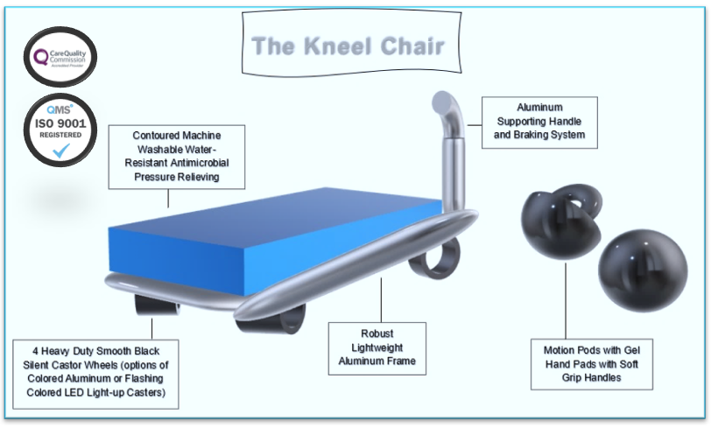
Image 2, Source: Author
The Bee Ables Kneel Chair is a brand-new, state-of-the-art device designed specifically to assist people who have temporary disabilities or limited to moderate mobilities who experience access-related restrictions in areas such as the office, landings, bedrooms, narrow hallways, kitchens, or even bathrooms. By assisting them to live a higher quality of lifestyle within their homes, places of employment, places of learning, and perhaps more importantly when they are visiting relatives and close friends. Through fulfilling the needs recognized by individuals with disabilities while providing more significant mobile accessibility, the Kneel Chair can give individuals an entirely fresh perspective on daily life. The Kneel Chair additionally boosts equality, integration, socialization, independence, dignity, mobility, and a sense of security, with the amenities aimed at improving the overall quality of their daily lives. According to (Haag, 2013), "the aim of the product service & description is of providing a description of the product or service provided. emphasized distinctive features consist of those which stand out and present an advantage over the competition.

Where/ How Sales of Product and Service
Bee Ables products and services are available to purchase through the e-commerce marketplace, utilising stores such as, Bee Ables, Sunrise Medical, Amazon, and eBay where customers can browse through the online catalogue, and select the items they desire, enabling them to use their creativity when designing their Kneel Chairs specifications during their ordering. With a pop-up text support engine to assist the customers, in conjunction with access to online customer services. In addition to in person, using a physical store to cater to clients who require personal appointments regarding weighing, measuring, and testing for tailored specifications. Furthermore, if a customer’s health insurance is unable to pay the cost of the Kneel Chair or if they only need it temporarily, they can elect to rent it instead of purchasing it. The company will put customers first and constantly endeavour to assist them in making decisions that will be in their best interests. Bee Able will provide all customers with great service together premium quality products.
Bee Ables Market Sales Strategies
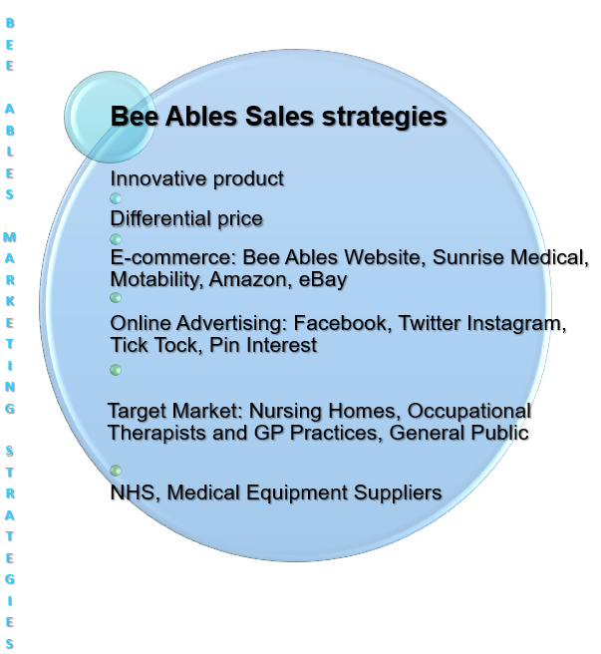
Image 3, Source: Author

Unique Selling Point
For those with low to moderate mobility, there are currently no other competing items on the market that offer this special product or service, instead, my closest competitors include manual wheelchairs, walking sticks, wheeled walking frames, and powered wheelchairs. The Kneel Chair is a brand-new, original, and distinctive product that is a customised wheelchair that is not only light and portable with swivel wheels but also comfy and environmentally friendly, that has yet to become available on the market.
While maintaining a sturdy aluminium frame, it provides those with limited mobility or moderate abilities with increased independence, for instance when they need to use the restroom at a friend's or relative's house. The user slides onto the pressure-relieving cushion that is located on top of the Kneel Chair frame and can access the seating area by using the grabrails on either side of the chair and a sliding board. The Kneel Chair is lightweight and can be easily carried upstairs.
The user may then fold down the grabrails, which also releases the brake mechanism, once they are comfortable sitting with their legs crossed or kneeling down. The user may then put their hands in the motion pods and start to sketch while rolling on any landing or corridor, gaining access as they turn into a small bathroom, where they can replace the brake system to easily use the lavatory. Any other area of the property where a wheelchair would be too big, bulky, or heavy to enter could easily be accessed using the same procedure.

Emerging Customer Needs and Wants Service Attends to
Wheelchair users often find difficulties utilising the bathroom amenities within other people’s homes, whilst visiting, as some houses retain long narrow corridors, small narrow bathrooms, or upstairs lavatories at the end of a long landing. Bee Ables Kneel Chair is a brand-new, innovative device designed specifically to assist people who have temporary disabilities or live with limited to moderate mobilities who experience access-related restrictions within these areas, maybe to gain access from one room to another or within a room in any property that may not be wheelchair accessible or adapted to meet the need of a wheelchair user.

Bee Ables Competitive Advantage
The clear advantage over competitors is the assistance provided to wheelchair users and individuals with limited to moderate abilities to live a higher quality of life inside their homes, the workplace, and schools, and perhaps more importantly, the freedom and peace of mind to visit relatives and friends whose homes are not particularly wheelchair friendly. A few of the leading UK (United Kingdom) e-commerce firms for mobility and handicap aids and equipment. However, none of these devices can provide the user with the additional independence that the Kneel Chair can.
The Kneel Chair has the power to give people a completely new perspective on daily life by enabling and meeting the needs acknowledged by people with disabilities while providing more significant mobile accessibility. This will improve equality, integration, socialisation, independence, dignity, mobility, a sense of security, and a sense of self-confidence with the amenities aimed at improving the overall quality of their everyday experiences. The following conclusions were reached after doing competitive research and gathering information from potential rivals to examine the market:
Bee Ables Market Audit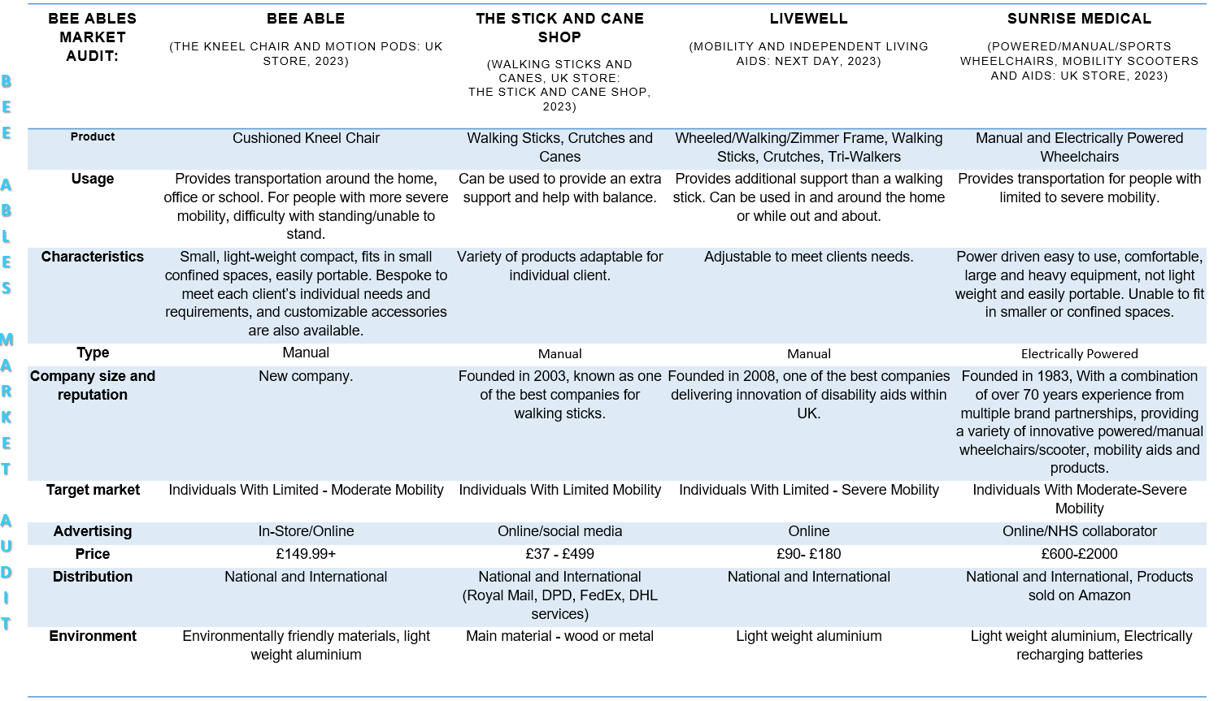
Image 4, Source: Author

Competitors in this field, what are they doing and how they sell their service.
Sunrise Medical, a leading e-commerce company that provides innovative disability aids and equipment in the UK, as well as maintaining distribution and sales offices in 8 countries, 10 countries with manufacturing sites, and distribution across 130 countries, employs over 2000 associates globally and is a significant rival of Bee Able. Sunrise Medical was founded in 1983. For customers with limited to severe mobility, Sunrise Medical offers a wide selection of manual and electrically powered wheelchairs, as well as a variety of mobility aids and accessories.
However, powered wheelchairs are neither lightweight nor compact, and more crucially, they cannot be folded and put in a car's trunk, instead, they must be physically pushed into accessible cars and to accessible locations. The manual and sporting wheelchairs are collapsible, portable, and made of lightweight aluminium. However, neither of these wheelchairs is as portable or adept at navigating confined spaces as the Kneel Chair. Sunrise offers wheelchairs starting at £600 through their web store. Able. For customers with limited to severe mobility, Sunrise Medical offers a wide variety of manual and electrically driven wheelchairs, as well as a variety of mobility aids and accessories.
The Stick and Cane Shop, a fiercely competitive business in the market founded in 2003, offers a wide selection of walking sticks, crutches, and canes that assist those with temporary or limited mobility. Crutches and walking sticks give people the additional support and assistance they need to maintain their balance while walking. Additionally, they provide walking sticks that may be adjusted to the user's height needs. Walking sticks, crutches, and canes may assist a person navigate into tight areas while being lightweight, portable, and simple to store. Nevertheless, in order to use this assistance, the user must be able to bear their own weight and walk to some extent.
Originated in 2008 Livewell one of the top online retailers of devices for independent living and mobility is Livewell in the UK. Livewell evolved from its initial days as an online marketplace to supply used-for-demonstration and reconditioned products to include new completed products across a variety of categories such as wheeled walking frames, and walking sticks. Currently fully established as one of the top e-commerce companies in the UK for disability and mobility aids and devices. However, none of these devices can provide the user with the additional independence that the Kneel Chair can.


How Bee Ables value proposition is providing some value to customers that other competitors are not.
Through carrying out target market research and collected data from potential consumers, to analyse the demographic behaviour of the market demand the findings are as follows:
Target Market Questionnaire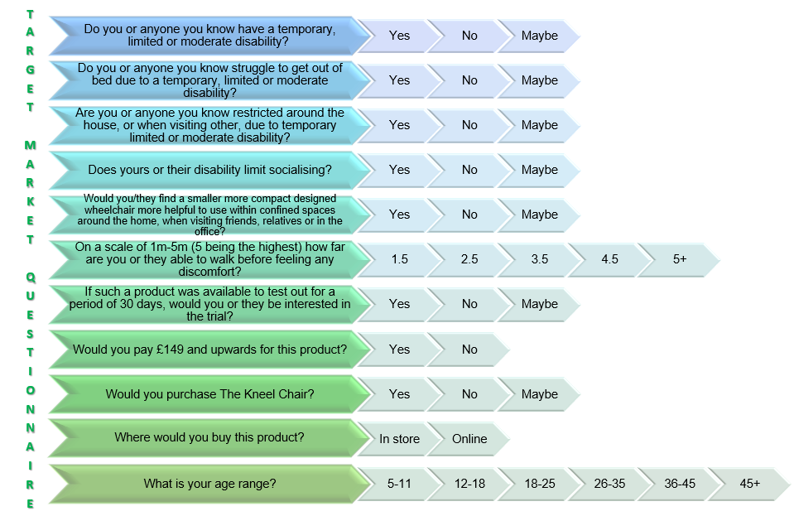
Image 5, Source: Author
Target Market and Demographic Behaviour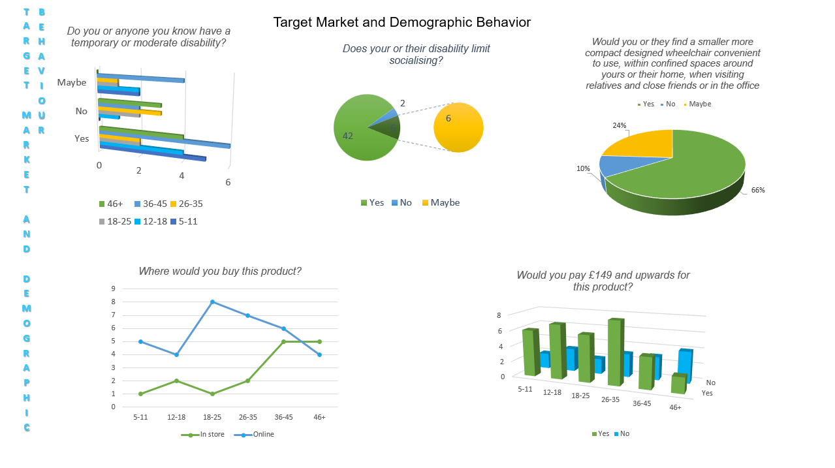
Image 6, Source: Author


Market Analysis
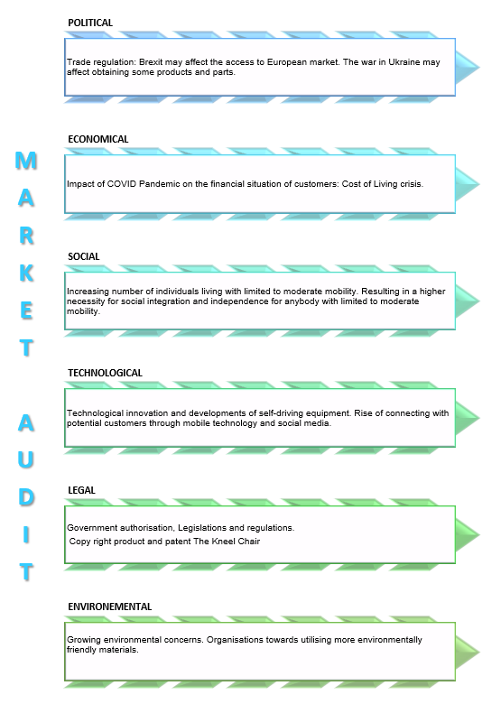
Image 7, Source: Author

E-commerce
The Kneel Chair will be publicly available to purchase through the Bee Able website. Customers can browse the catalogue online and choose the items they are interested in, enabling them to use their creativity when designing their Kneel Chairs specifications during the ordering process. Customers will additionally have access to online customer services as well as an interactive text assistance engine. Using an actual retail space to serve customers that are interested in personal appointments for weighing, measuring, and testing for the purpose of meeting customised requirements in person. In addition to utilising stores such as, Bee Ables, Sunrise Medical, Amazon, and eBay.
Java will be utilized throughout Bee Ables' website for developing and operating all mobile applications, creating, and scaling cloud applications, developing chatbots and other tools for advertising, powering all enterprise-level web-based applications, and aiding with the company's artificial intelligence (AI) and internet of things (IoT) mobile devices. Bee Able will employ Microsoft 365 for complex business applications which include customer relationship management (CRM), and enterprise resource planning (ERP), together with document management, in addition to corporate productivity apps including email, collaboration, and calendaring.
The main benefit of Bee Able selling on Amazon is the breadth of its online presence, which may increase sales from the highly visited marketing channel. With almost 2.4 billion interactions monthly via desktop and mobile devices, Amazon has an extensive customer base that may increase Bee Ables company sales through new customers who prefer to shop online.
Social media platforms particularly Facebook, Instagram, Twitter, and Tik Tok will be utilized to promote merchandise posted by Bee Ables customers as evidence of Bee Ables brand's consistency and to assist in capturing new customers. Additionally, hashtags are utilised to improve company conversions, enhance sales, and drive visitors to the Bee Able brand, making it simpler to purchase company items on Instagram via the brand page along with coming up with deals and discounts that attract new consumers and excite loyal ones. In addition to employing buyable pins, Pinterest attracts high-value clients and increases exposure for websites with high conversion rates.
Making pages may be used to promote the Kneel Chair if Bee Able has amassed a sizable audience. Joining groups can help the company remain current, appealing, relevant, and up to date of present trends within the business world as well as attract prospective clients. In addition to analytics, which is essential, to assist with analysing the effectiveness of Bee Ables' marketing initiatives and subsequently plan for the future of the company along with utilizing social media analytics to determine the effectiveness of business tactics and what further needs to be done to increase the company’s conversion rates.
Bee Able has Trademark patents and copyright protection to safeguard the company's Kneel Chair design and prevent unauthorized copyright infringement of the Kneel Chair design.

The Kneel Chair
Furthermore, a preliminary budget of £21,790 was awarded covering all payments for Bee Ables’ platform, payment gateway, hosting, website maintenance, ISO, SEO (Search Engine Optimization), GDPR (General Data Protection Regulation) in addition to SSL certifications, and marketing. Bee Able has SEO and SSL certification and employs SEO as a marketing strategy to increase visitors to the company website by improving its visibility on search engines' results pages (SERPs). To ensure for certain that the company complies with the new rules and is in good standing with the Information Commissioner's Office (ICO), Bee Able has secured a General Data Protection Regulation (GDPR) compliance certification.
Furthermore, SSL certificates functions as both a passport that confirms the legitimacy of the Bee Able website and a key that enables formidable encryption to protect the data of the companies. The company uses payment gateway software to enable every customer to make transactions with their debit or credit cards. The infrastructure and resources required to run and maintain the company online store are provided and made accessible for Bee Able through the web hosting service, a type of rented space, or digital real estate. In addition, an initial budget of £68,670 was allocated for all equipment and supplies for the company. Expenses shown in figures shown below. 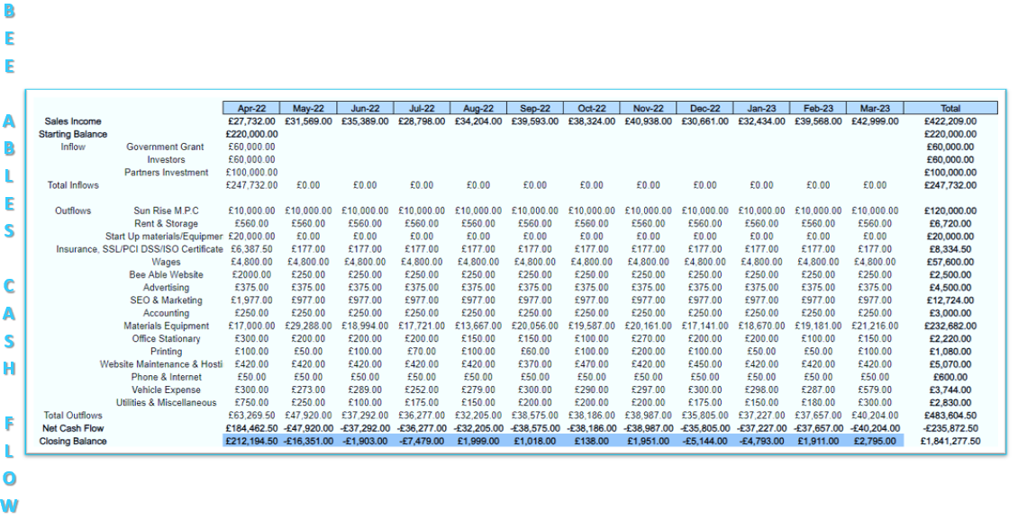

Bee Ables Team of Staff
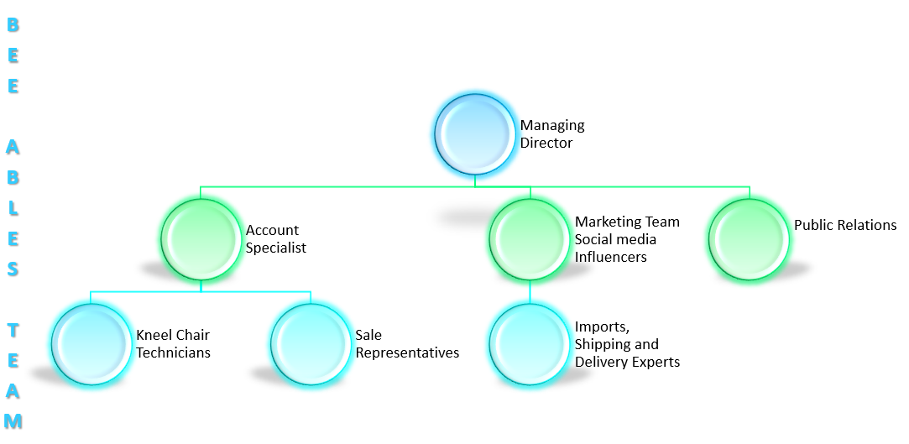
Client Kneel Chair Technician will aid the recipient fit and operating the Kneel chair and motion pods, while company personnel will ensure the recipient is able to follow the instructions. To minimize any possible risks, an easy-to-follow textual and visual instruction guide is being supplied to assist with using the device. Clients will be given instructions on concerns about safety, malfunctioning device indications, and general maintenance at home. Import experts will monitor shipments and collaborate with clients in minimizing their fees due. Bee Ables team members will have the capability to be able to continually maintain meticulous records of the brand and model of each component of products purchased or leased by utilizing barcode scanning, this shall assist the marketing team monitor the flow of supply and products. The scanning and tracking technology will make the re-ordering decisions practical. The frequency of purchased products can potentially be determined and the level of customer demand for the products can be predicted using previous statistics. The Bee Ables marketing team will investigate the demands of the target audience and how they react to advertisements. Make appealing product listings for the public. In addition to coordinating social media campaigns with marketing teams and analysing the traffic to the website to assess the efficacy of promotions alongside identifying and recommending changes and improvements.

Using Payment Services
The account specialist will handle the payments, claims, and getting reimbursement required by all customers, which necessitates the requirement for great ability in the paperwork, invoicing, coding for medical purposes, and finalisation of all Keel Chair packages. During the stage of placing an order on the company's website or in person when customers visit the Bee Able facilities, funds for purchased or hired products will be debited directly out of the customer's bank accounts utilizing a secure online payment with options, such as their debit or credit card, via PayPal or Clear Pay.



Marketing

Product and services

The Kneel Chair
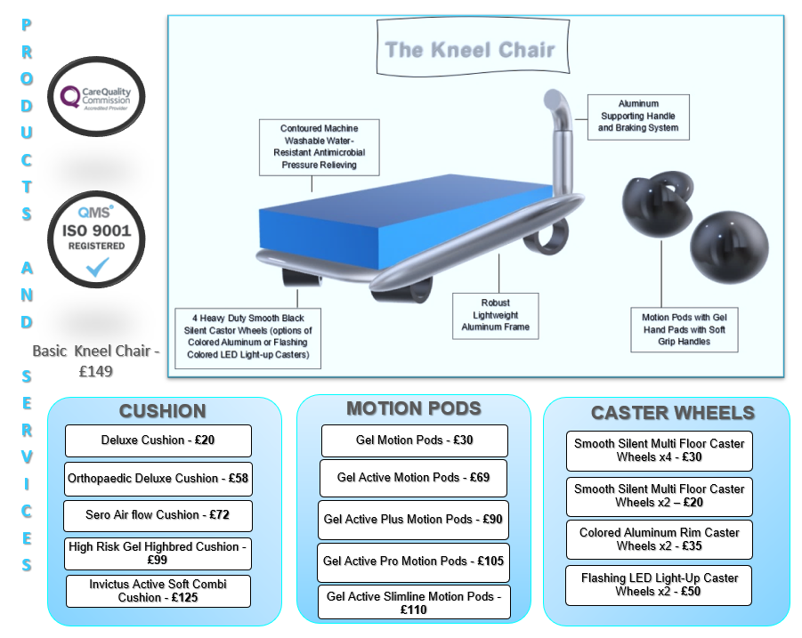
Image 8, Source: Author
The unique design, usability, and primary function of the Kneel Chairs are all that distinguish and set apart this wheelchair from others. It comes with an effective pressure-relieving cushion and quiet, lockable swivel wheels which are offered in a selection of striking colour combinations. Soft gel handle spherical motion pods are also incorporated for the user's hands' comfort and support during movement. These attributes provide the user with padding, comfort, stability, plus the agility to retain movement in confined locations that traditional wheelchairs would typically find challenging to reach, such as upstairs on the landing or even when using a relative's lavatory. The Kneel chair is significantly more economical and cost-effective than its closest rivals, with costs starting at £149.99 as opposed to other wheelchairs, which start at £600.00.
Budgeting is an economic strategy that manages all of a company's resources. distributing all of these resources to an identifiable goal is the purpose of establishing a budget (Martin, 2022).
With prices starting at £149.99 compared to comparable wheelchairs' £600.00 starting price, the Kneel chair is substantially more affordable and cost-effective than its closest competitors. With a variety of options available, The Kneel Chair gives customers the flexibility to custom design their Kneel Chair to meet their exact requirements. A Kneel Chair that is one size fits all is unsuitable since Bee Able recognises that each of our customer's conditions is complex and individual. Customers of Bee Able have the choice to personalise their Kneel Chairs with unique components, which include motion pods and contoured pressure-relieving cushions, in addition to selecting customised caster wheels. Bee Able offers a range of pressure-relieving cushions, including High-Risk Gel Hybrids, Active Soft cushions, and luxury soft gel memory foam cushions.
PRODUCT | PRICE
Deluxe Cushion | £20.00
Orthopaedic Deluxe Cushion | £58.00
Sero Air Flow Cushion | £72.00
High Risk Gel Hybrid Cushion | £99.00
Invictus Active soft Combi Cushion | £125.00

Image 9, Source: Author
In addition, Bee Able provides a variety of custom-crafted, active motion pods, from the conventional design to the active design collection, that not only look great yet additionally provide the user with more comfort and agility.
PRODUCT | PRICE
Gel Motion Pods | £30
Gel Active Plus Motion Pods | £90
Gel Active Pro Motion Pods | £105
Gel Active Slim line | £110
Image 10, Source: Author
Bee Able offers a selection of caster wheels, including colour coated aluminium rim wheels, flashing coloured LED light-up designs, and smooth, silent all-floor caster wheels.
PRODUCT | PRICE
Smooth Silent Multi Floor Caster Wheels x4 | £30
Smooth Silent Multi Floor Caster Wheels x 2 | £20
Coloured Aluminium Rim Caster Wheels x2 | £35
Flashing Coloured LED Light-up Caster Wheels x2 | £50
Image 11, Source: Author
The Kneel Chair & Motion Pods will be manufactured and assembled through Sunrise, an innovative manufacturing designer of medical equipment. A deal has been concluded with Sunrise, Bee Able is paying Sunrise £10,000.00 for every 100 units, where 1 unit is equal to 1 kneel chair and a single pair of motion pods. Sunrise will receive £2,000 from Bee Able for the first 20 devices it produces. In order to guarantee certainty that the Kneel Chair complies with all the European Medical Device Directive 93/42/EEC (MDD) EN 12183 norm testing for manual wheelchairs requirements, and in protecting the health & safety of Bee Ables customers, a prototype will also be created (Iso,2014).
Sunrise will manufacture and provide all the necessary environmentally friendly components, including the silicone exterior shell motion pods with silicone gel padding, along with the aluminium frame and braking systems. The LED castor wheels are available from Wheelchair Parts Dot Net with starting price of £22.00. The coloured aluminium caster wheels are purchased from ECP Wheelchairs for £15.00, and the pressure-relieving cushion is purchased from Medical Care Suppliers for £15.00.
Sunrise has been hired to fully manufacture, assemble, and package each Kneel Chair for £85.00 and each pair of Motion Pods for £15.00, for a total manufacturing cost of £100.00. Be Able will sell the Kneel Chair starting at £149.00, making a profit of £85.00.
The Kneel Chair can be produced custom-made, with the buyer having the option to purchase a conventional all-in-one package for £229.00. The Kneel Chair may be individually customized by customers with their personal preferences for cushions, caster wheels, and motion pods. With the premium customized package, priced at £484.00, Be Able will generate a profit of £359.00. The price of a kneel chair differs depending on the individual specifications required by each customer, however, within the first three years, a profit will be demonstrated.

Bee Ables Sales Forecast 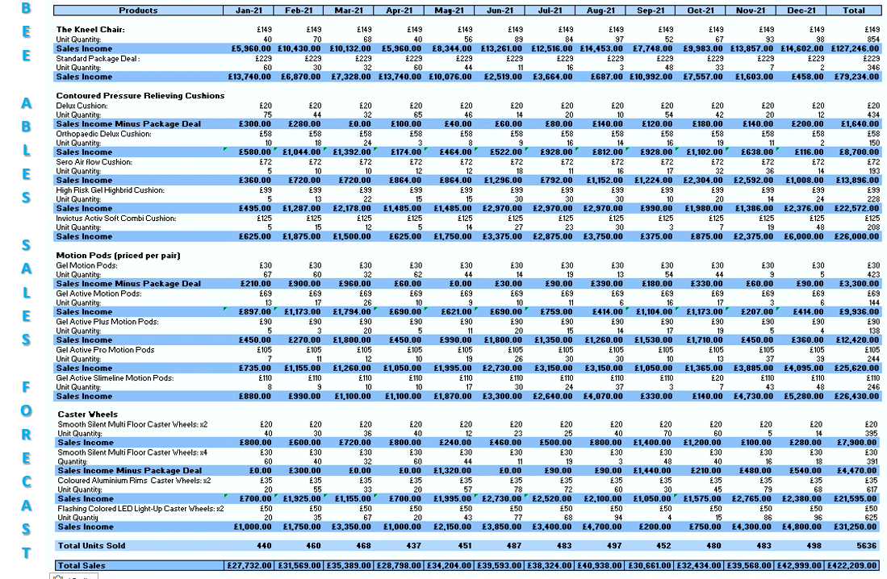
Image 12, Source: Author
Bee Ables Cash Flow
Image 13, Source: Author


Bee Able Budget Forecast
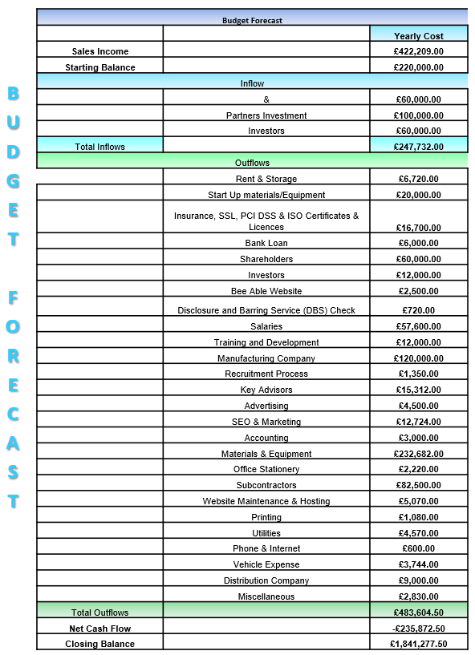
Image 14, Source: Author
Bee Ables products and services are offered remotely through the e-commerce market, utilising stores such as, Bee Ables, Sunrise Medical, Amazon, and eBay where customers can browse through the online catalogue, and select the items they desire, enabling them to use their creativity when designing their Kneel Chairs specifications during their ordering. Resulting in specifically tailored designed Kneel Chairs and accessories, with a pop-up text support engine to assist the customers, in conjunction with access to online customer services.
In addition to in person, using a physical store to cater to clients who require personal appointments regarding weighing, measuring, and testing for tailored specifications. The Kneel chair will be delivered to the customer's residence via Bee Able shipping and delivery specialists, then through the Predict app, the customer will receive an email with a one-hour delivery window.
The customer has the option to change the delivery time using Predict. The following day, the Kneel Chair Technician is scheduled for unpacking, assembling, and handing the assembled Kneel chair to the client for the usage of the device. To reduce liability, the personnel will be engaged on a contract basis. Bee Able will engage trained, skilled wheelchair technicians who provide assistance to Bee Ables customers with product selection, fitting, maintenance, and repairs.
Customers with specific health requirements, will be evaluated for those requirements, and provide a response appropriately while collaborating with the medical professional. A technician will always need to be present on site, while the other will be working with clients that need home delivery out in the community. Customers and close relatives will need to be educated by the mobility device experts on how to operate the devices safely and how to do basic home maintenance on the Kneel Chair.

Image 15, Source: Author

Promotions
The first 100 consumers who visit Bee Ables’ website will receive 25% discounts, in addition, the company will capitalise on platforms that include Facebook, Instagram, Tik Tok, Twitter, and LinkedIn groups to connect with their customer base. Additionally, Bee Able will advertise the Kneel chair in the mobility magazine, on social media, and in online disabilities forums. Prospective customers will have the opportunity to be shown the Kneel Chair prototype while attending demonstrations so they can test it out.
In addition, Bee Able will hold open days, which will be promoted on social media channels as part of their paid advertising that might attract and reach people in their demographic. Newspapers, shopping malls, pop-up stores, and other venues are among the areas where the Kneel Chair is being advertised. Additionally, spam emails are sent to all website visitors and customers of Bee Able, both present and past and prospective.

Conclusion
Within the first three years, a profit will be demonstrated through the kneel chair's pricing. Bee Able remains committed to specializing in its commercial approach with the objective to remain successful in the highly competitive e-commerce marketplace, develop effectively, and accomplish the business's goals and objectives. Bee Able intends to capitalize on every opportunity presenting itself and act swiftly with the aim to establish its position in the e-commerce innovative medical equipment trade.



References
Haag, A. (2013). Writing a Successful Business Plan. Workplace Health and Safety. [Online]. 61(1), 19-29. [11 July 2023]. Available from: https://journals.sagepub.com/doi/pdf/10.1177/216507991306100104
Iso. (2014). ICS: 1118010 Aids and adaptation for moving. ISO 7176-1:2014(en) Wheelchairs — Part 1: Determination of static stability. [Online]. 1(3), 28. [26 November 2022]. Available from: https://www.iso.org/obp/ui/#iso:std:56817:en
Livewell. (2008). Livewell. [Online]. [23 June 2023]. Available from: https://www.livewelltoday.co.uk/
Martin, H. (2022). Viva Financial Tuition. [Online]. [26 November 2022]. Available from: https://www.vivatuition.com/cima-knowledge-centre/why-is-budgeting-important-to-a-business
Quickie. (2023). Sun Rise Medical LTD. [Online]. [23 June 2023]. Available from: https://www.sunrisemedical.co.uk/wheelchairs/quickie/lightweight-wheelchairs
Rainey, D. (2005). Product innovation: Leading Change Through Integrated Product Development. [Online]. New York: Cambridge University Press. [4 July 2023]. Available from: https://www-vlebooks-com.ezproxy.uwtsd.ac.uk/Product/Index/2004001?page=0&startBookmarkId=-1
Silva, A & Simoes, R. (2011). Handbook of Research on Trends in Product Design and Development: Technological and Organizational Perspectives. [Online]. Hershey, Pennsylvania: IGI Global Publisher of Timely Knowledge. [28 June 2023]. Available from: https://www-igi-global-com.ezproxy.uwtsd.ac.uk/gateway/book/41797
Sunrise. (2023). Sun Rise Medical. [Online]. [29 June 2023]. Available from: https://www.sunrisemedical.co.uk/company-information#

