DS 1 Template

My Screenshots/Photos
- Please add 4–6 screenshots or photos of your digital life.
- You can use your phone or laptop.
- For each screenshot, write one or two sentences explaining what it shows.

Screenshot/Photo 1
[Insert Photo/Screenshot below]
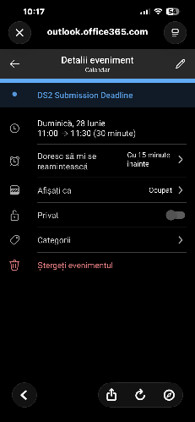
There is an image in my Outlook calendar in class I learned how to add an event on my calendar.

Screenshot/Photo 2
[Insert Photo/Screenshot below]
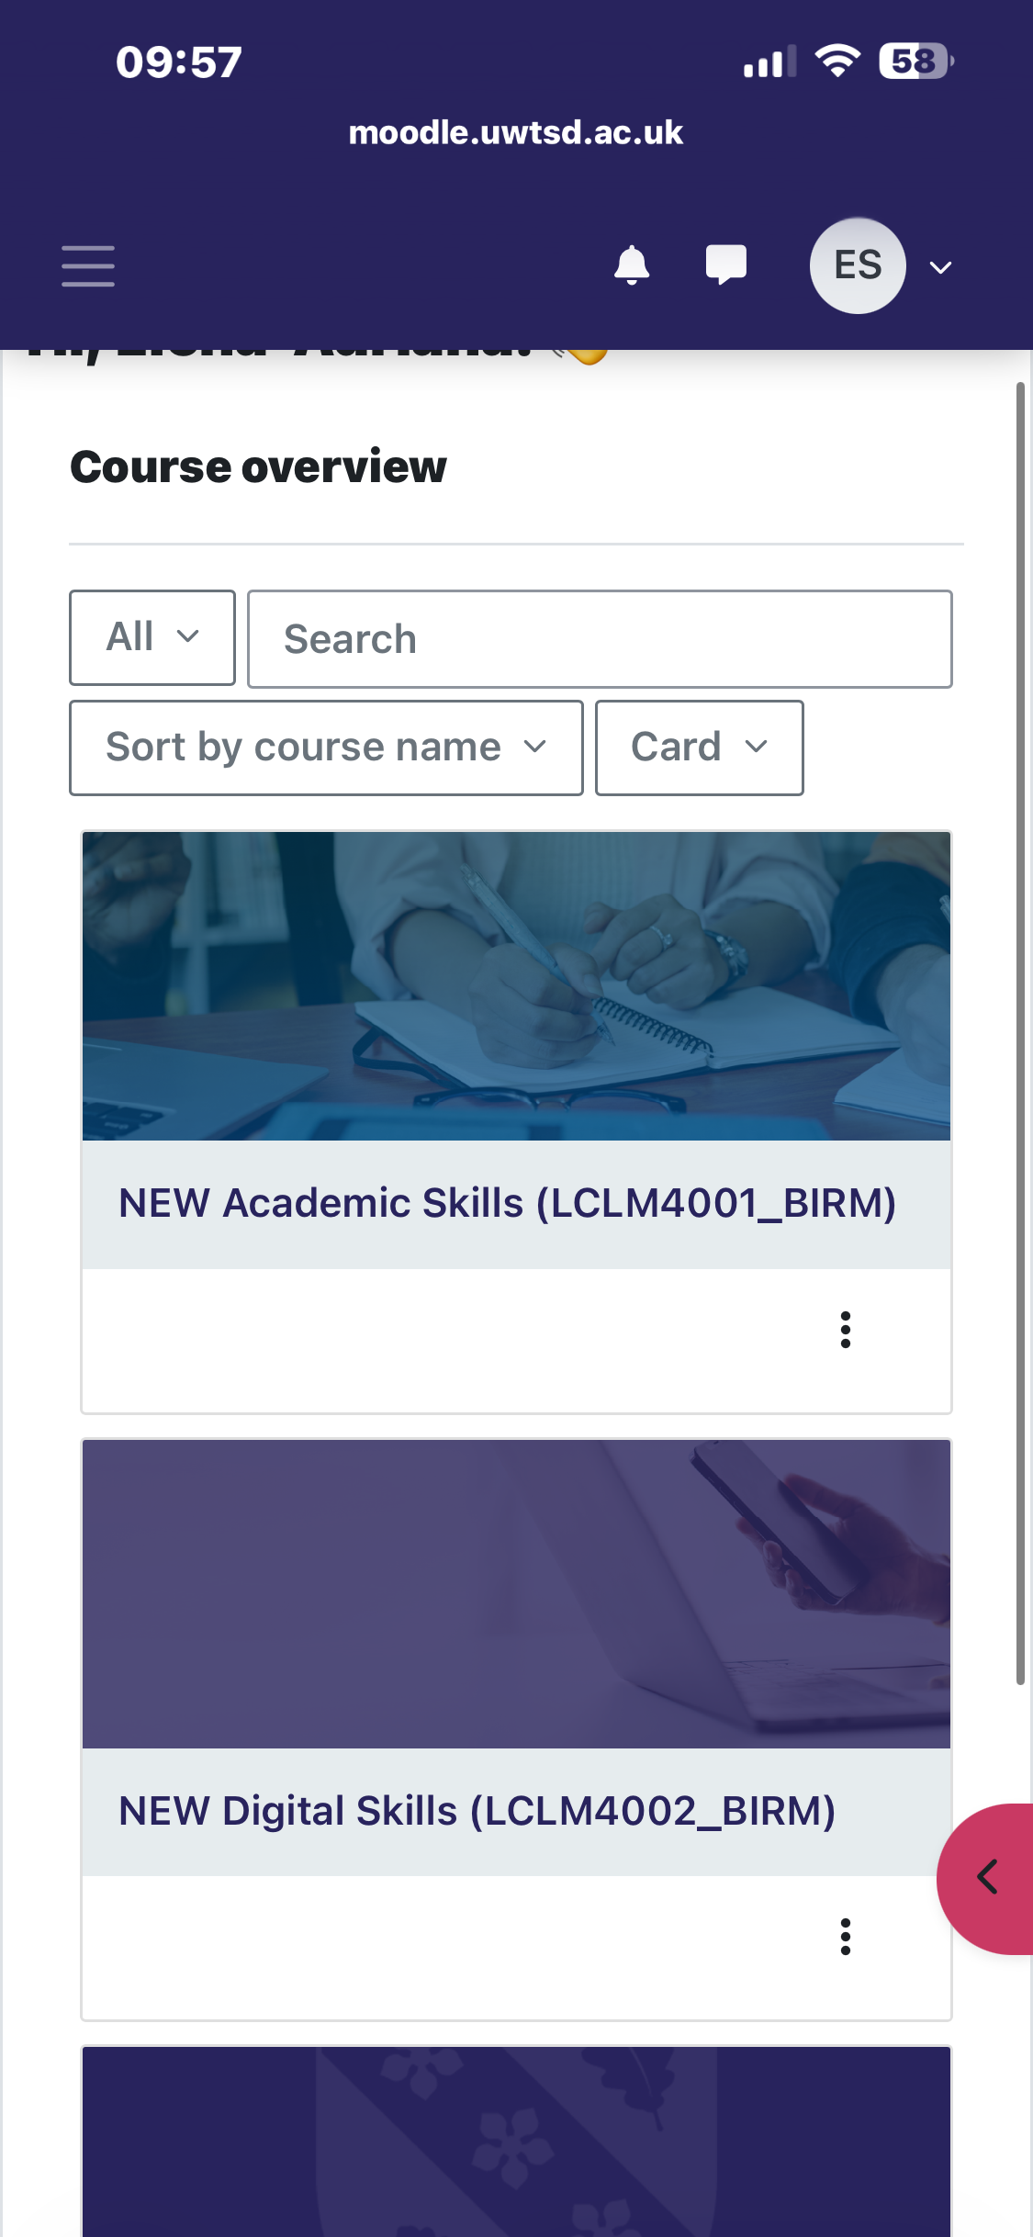
[Write what this shows of your digital life]
These are the modules that I study.

Screenshot/Photo 3
[Insert Photo/Screenshot below]
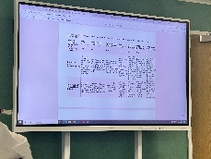
[Write what this shows of your digital life
There is the marking criteria for assessments.

Screenshot/Photo 4
[Insert Photo/Screenshot below]
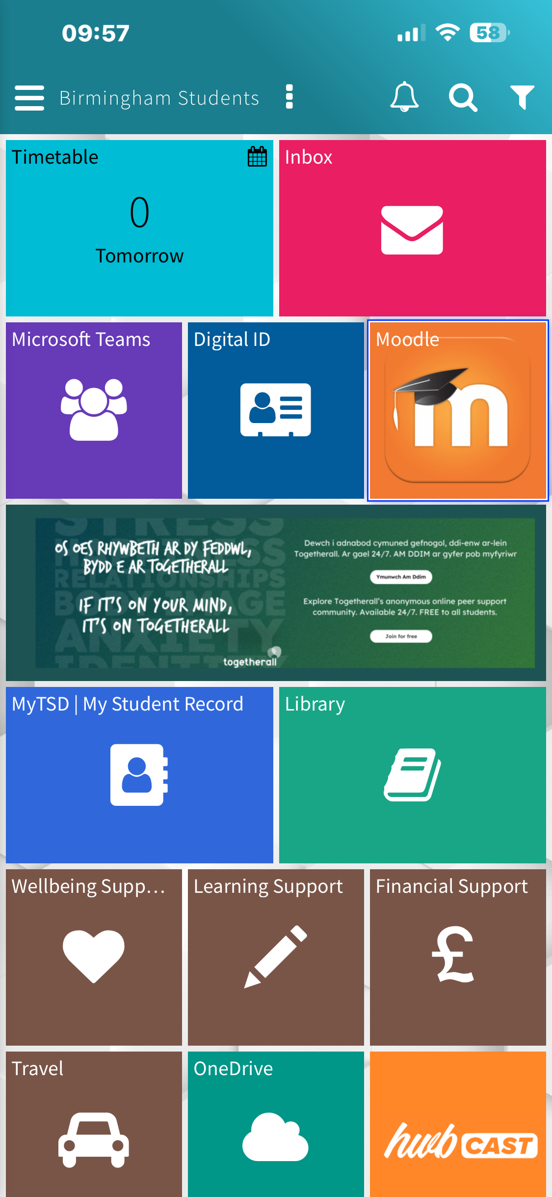
[Write what this shows of your digital life]
There is my platform for learning, UWTSD HWB

Screenshot/Photo 5
[Insert Photo/Screenshot below]
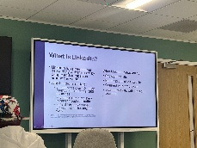
[Write what this shows of your digital life]

Screenshot/Photo 6
[Insert Photo/Screenshot below]

[Write what this shows of your digital life]

My Short Reflection
- Write 5–8 simple sentences about your digital life.
- You can use the sentence starters below if helpful.
Sure! Here are some example answers in English for those sentence starters:

• I use digital tools to stay organized and communicate with others easily.
• I feel confident when I create presentations or edit documents using digital software.
• I want to improve my skills in using social media for professional purposes.
• I often use these tools: email, Google Drive, Microsoft Word, and social media apps.
• I sometimes feel nervous about trying new software or troubleshooting technical problems.
• I hope this module will help me become more comfortable and efficient with various digital tools.
• Digital skills are important for me because they help me work faster and connect with others around the world.

Sentence starters
- I use digital tools to …
- I feel confident when I …
- I want to improve …
- I often use these tools: …
- I sometimes feel nervous about …
- I hope this module will help me …
- Digital skills are important for me because …
You can write more if you want.

Submission Checklist
Before you submit, please check:
​​​ ☐ I added 4–6 screenshots
☐ I wrote short sentences for each screenshot
☐ I wrote my short reflection
☐ My work is my own
☐ My file opens correctly
​​☐ My file opens correctly

