BMSW4004 Problem-Solving and Decision Making
Role Play
Joselyn Castillo Cabral
ID 2121046
Management Consultant: Good morning. We meet after quite some time. I believe you are facing some issues in terms of working with us. Is everything okay with the job?

Unsatisfied Employee: I beg to address that it has not been very good lately. With all the things that are going around, I am starting to feel dissatisfied with my job here. I have no work-life balance and it has created many problems with my personal life where I cannot find the minimum time for myself. It has become a complete issue of work overload, announced overtime. I don't think that company policy is in action here.

Management Consultant: I see. I don't think we have had similar problems before. What do you think is the cause behind it?

Unsatisfied Employee: I simply think the fact that there are no scheduled holidays is being maintained and in most cases, it is very minimal. There is also working hours that are assigned to us which are completely out of bounds and put us in a position where there is no consistency. The Human Resources Department does not have any clear objectives in terms of resolving this problem or implementing a good policy that can help us to work in a good environment where we can have a good work-life balance. The vacation policy is also very hampering because there is none at existence at the moment.

Management Consultant: I get where this is coming from. As you might know currently, the peak season is going on. We have a lot of work that we need to cover as the business is starting to flourish. As a result, we have tried to provide some additional grammar narration to everyone hoping that they would understand that this is nothing personal and only the requirement of the organisation for the current moment.

Unsatisfied Employee: That is understandable but no matter what I do need a work-life balance through which I can complete my personal activities as well. I need to spend time outside of work where I need to achieve a lot of things as well. I have some personal goals and other requirements which I have to put with outside of work. This job cannot be everything but I spend all my time.

Management Consultant: As of the current circumstances, we need people to put in some extra hours. This is something we cannot really curtail at the moment. But do you think there can be anything that can help you bring back your work morale?

Unsatisfied Employee: The only thing that I believe I can be satisfied with in my job here is that a proper policy reformation takes place. You can expect us to work harder or put in more tasks but it has to be within a fixed working hour. Unannounced overtime must be stopped as it has become a trauma for almost every day we step into this office. It has grown like a fear. And moreover, you guys can introduce a different type of benefit like a leave system.

Management Consultant: Even though it is not possible to implement right away, what we can do as of the current circumstances is that we can add additionally provide you guys with a new system like the accumulated leave system. Under the system, you will have a definite number of leaves allocated for your entire year. You can enjoy these leaves on the respective days or you can accumulate them together to enjoy a big vacation at any time of the year you want. This will allow you to have better flexibility and choose your own vacation. So we believe this is something the employees can look forward to. It will work as a driving force to build up satisfaction in work. While we also implement the new policy of fixed working hours and on top of that introduce the accumulated leave system, I believe it will work well with your expectations from the company.

Unsatisfied Employee: Well I believe this is something new and something which interests me. I believe both the policy implementation and the accumulated leave system can be a very good drive for job satisfaction. I am really looking forward to the implementation.

Management Consultant: Hopefully it will be implemented in a very structured way. We can also do a review afterwards about the pros and cons of this implementation and policy formation.

Unsatisfied Employee: Thank you. Let's see how this turns out.

Management Consultant: You are welcome.

Assessment – 2
Individual Report
Table of Contents
Introduction 4
The Complex Problem in Travelodge 4
Analysis of the Information 5
Root Cause Analysis (RCA) 5
Holidays 5
Working Hours 6
Organisation 6
Work-life balance 6
Applying the Situational Analysis Model 6
PESTLE Analysis 6
Political 6
Economic 6
Social 7
Technological 7
Legal 7
Environmental 7
Range of Alternative Solutions 8
Solution - 1 8
Solution – 2 8
Solution - 3 8
Evaluation of Alternative Solutions 9
Implementing the Solution 9
Communication Plan with Shareholders 10
Stakeholders List 10
Influence/Power and Interest Matrix 10
Application of the Matrix to Travelodge 11
Stakeholder Engagement Plan 11
Monitoring and Review Techniques 12
Awareness 12
Desire 12
Knowledge 12
Ability 12
Reinforcement 13
Conclusion 13
References 14
Appendix 16
Role Play 16

Introduction
The phrase "problem-solving" is often used in the business sector to refer to the ability to deal with tough or unexpected events and find solutions to complex business challenges (Millmore and Lewis, 2007). Employees with exceptional problem-solving skills will do a thorough analysis of the situation, generate many options for how to fix the problem, and then make the best possible choice. Employees that do challenging work and are counted on to come up with innovative solutions to crucial business concerns will be better equipped to handle the issues that have arisen in the 21st century (Kusluvan et al., 2010). Travelodge is not immune to these issues in the workplace as well. Travelodge debuted in 1985 as the first low-cost motel in the United Kingdom. The firm has swiftly become the best-performing and also the most imaginative hotel chain in the United Kingdom, Ireland, and Spain, with more than 550 hotels under its umbrella. In terms of the hotel industry, Travelodge is unrivalled in London, Birmingham, and Cambridge. These days, you can usually find a Travelodge right in the middle of a large city or other popular tourist destination (Bloomberg, 2022). Hotels under the Travelodge brand come in a variety of forms, including those that were built specifically for the purpose, those that were renovated from older structures, those that were acquired, and those that were created through joint ventures with major pub chains, supermarkets, and retail chain. An in-depth analysis of the issues plaguing the Travelodge workplace, together with solutions for and updates on implementing those solutions, are presented in this report.

The Complex Problem in Travelodge
Despite the fact that Travelodge is a successful firm, its employees frequently deal with the challenging issue of being overburdened with work. This issue is recognised as a complex issue in the workplace. An instance of work overload can be defined as any circumstance in which the requirements of the job exceed the resources that are currently available (Glassdoor, 2022). The employees of Travelodge are considered to be weighted down by workload in the event that they are unable to cope with the responsibilities at hand, experience frustration, and feel as though they are pressured for time or money (Hospitality Net, 2022). In terms of the quality of the job, the work overload at Travelodge may surpass the capacities, talents, and competencies of an individual or a team to cope with an urgent work situation.
In terms of the number, overload may manifest itself as a shortage of time in the day or an insufficient number of people on the team. The most detrimental effect of having too much work to do is that it has a bad affect on both an individual's mental and physical health. This, in turn, has the effect of simply paralysing an employee's efficiency and preventing them from coming up with innovative solutions to problems (Kusluvan et al., 2010). When employees are overworked and anxious, it not only has a negative impact on their health but also produces a snowball effect. It leads to an overwhelming amount of work for the employer, which keeps the whole staff busy. Therefore, the issues need to be resolved as quickly as possible in order to preserve the prosperity of the organisation.

Analysis of the Information

Root Cause Analysis (RCA)
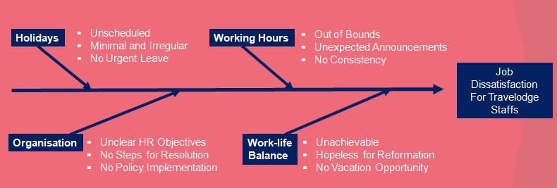
Figure – 1: Fishbone Analysis for Travelodge Staffs

Holidays
Vacation time allows workers to relax and reconnect with their family members outside of the office, a crucial component of achieving work-life harmony. When employees are confused about when they will be off work, they may lose incentive to do their best at the office. Employees may feel suffocated and dissatisfied with their jobs if they are not given enough paid time off or if they are only allowed to take the absolute minimum in the way of sick days and holidays (Caruso, 2004).

Working Hours
It is of critical importance to the contentment of the workers in their jobs that they be able to leave work before the end of the allotted shift time. However, requiring employees to consistently put in extra hours without compensating them in any way for their efforts might have a negative impact on their mental and physical health.

Organisation
An ideal company would communicate its clear mission to its staff members, allowing those workers to better understand the significance of their work and develop a stronger sense of affiliation with the company (Baum, 2016). The employees of Travelodge find it demotivating since the company's objectives are not clear, that the rules have no practical applications, and that there are no upgrades for new resolves.

Work-life balance
The corporate workplaces should make sure its employees have a healthy mix of work and life outside of work. If employees are unable to maintain a healthy balance between their work and personal lives while they are employed by the company, they will become dissatisfied with their employment, which will lead to a decline in the quality of their performance (Caruso, 2004). If there is no chance of reformation in the workplace, it may have a significant impact on the employees.

Applying the Situational Analysis Model

PESTLE Analysis

Political
If Travelodge's employees are happy with their working conditions, the company may be able to reduce costs and increase productivity. Travelodge can pick and select from a huge pool of possible employees and pay them their bare minimum due to the reduction of restrictions for migratory labour around the EU (Prezi, 2022).

Economic
Tourists, who increased by 5 percent, and locals, whose numbers increased by 4 percent, will find a cheap hotel just right in most of Europe and in the United Kingdom. Although the decline in consumers' discretionary income is disappointing news for Travelodge, the relatively elastic demand for hotels means that customers will still choose low prices.

Social
An estimated 10 million Britons are now 65 or older. Consequently, the hotel sector is seeing a new form of demand as a result of the increasing number of elderly guests. Customers of the type Travelodge would serve would be savvier and more adaptable, they might want for and require more individualised care and attention as a result (ToughNickel, 2017). This might lead Travelodge to consider expanding into more remote locations.

Technological
Emailing clients takes just a few seconds and is significantly more cost-effective than writing a letter. Security systems have also benefited from the rise in technological sophistication. This allows for the installation of safety measures like fire and alarm systems, as well as CCTV cameras, for the benefit of both staff and customers (Prezi, 2022). Innkeepers may relax about the security of collecting credit card transactions for rooms and granting lines of credit to suppliers.

Legal
As a matter of law, the amount of money someone is awarded must be considered. The company needs to be able to offer its workers at least the minimum wage if it wants to keep them satisfied and productive. The age limit at which an employee can be employed, as well as the employee's rights to paid time off, sick leave, and retirement benefits, must be upheld.

Environmental
Hotel air conditioning systems are a substantial contributor to localised air pollution and greenhouse gas emissions. The high energy use of hotels' air conditioning systems is cause for concern in light of the grave problem that is global warming in today's society (ToughNickel, 2017). Travelodge needs to portray itself as more environmentally friendly in order to attract consumers who are environmentally aware.

Range of Alternative Solutions
Solution No. | Company Policy Reform | Leave Benefits
Solution - 1 | Fixed Working Hour | Weekly Sports After Work
Solution - 2 | Fixed Weekly Holiday | Employees Food Outing
Solution - 3 | Additional Weekly Holiday | Monthly Case Competition with Prizes

Figure – 2: Alternative Solutions for Travelodge Staffs

Solution - 1
Implementing regular work hours is the first step that might be taken to improve conditions at Travelodge. Management must give at least a week's notice before requiring employees to work overtime without pay (Siebert et al., 2015). It might also assist staff recharge on a weekly basis if activities like sports are organised for them.

Solution – 2
Management should adhere rigorously to the weekly holiday schedule so workers are never caught off guard (Lauer, 2010). Getting out of the office and enjoying a meal with coworkers may be a refreshing change of pace and a great way to foster team spirit.

Solution - 3
The staff at Travelodge could benefit from having the option to take an extra day off every week. It will facilitate a healthier work-life balance for the staff. They will be able to work faster and more efficiently as a result. The company might hold case competitions with valuable prizes to increase performance and motivation.

Evaluation of Alternative Solutions
The weight-decision-making matrix below will be used to determine which option is the most effective.
Solutions | Company Policy Reform (6) | Leave Benefits (4) | Total
Solution – 1 (5) | 5 x 6 = 30 | 5 x 4 = 20 | 50
Solution – 2 (4) | 4 x 6 = 24 | 4 X 4 = 16 | 40
Solution - 3 (3) | 3 x 6 = 18 | 3 x 4 = 12 | 30

Figure – 3: Weight Decision Matrix
Thus, "Solution-1," which involves enforcing normal work hours and promoting rejuvenating activities for Travelodge employees, is the optimal solution.

Implementing the Solution
Gantt chart can help Travelodge to implement the solution for fixing the workplace problems. The chart is provided here.
Tasks | Specific Activity | Week 1 |  |  |  |  | Week 2 |  |  |  |  | Week 3 |  |  |  |  | Week 4
Policy Reformation | Proposal Design
Policy Reformation | Addressing New Fixed Schedule
Policy Implementation | Design Accumulated Leave System
Policy Implementation | Notify and Discuss new Accumulated Leave System
Control and Monitoring | Feedback Session after Barnstorming
Control and Monitoring | Monitoring and Review

Figure – 4: Gantt Chart for Implementation

Communication Plan with Shareholders

Stakeholders List
The stakeholders who will be responsible for the successful adaptation and implementation along with monitoring and review will be
- Senior Manager
- Human Resource Manager
- Chief Operating Officer

Influence/Power and Interest Matrix

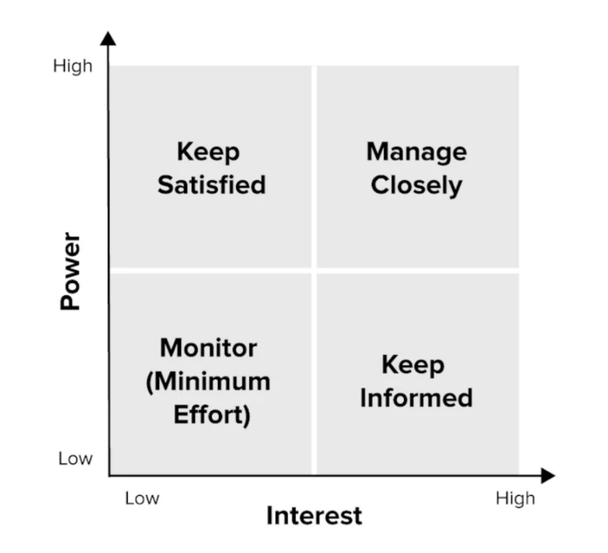
Figure – 5: Influence/Power and Interest Matrix

Application of the Matrix to Travelodge
- Senior Manager – Monitor
- Human Resource Manager – Manage Closely
- Chief Operating Officer – Keep Informed

Stakeholder Engagement Plan
Stakeholder Communication Plan
Stakeholders | Power/Interest | Key Interests and Issues | Communication Vehicles | Frequency | Comments
Senior Manager | Moderate | Task Completion in Time | E-mail and Meeting | Weekly | Priority in Monitoring
Human Resources Manager | High | Leave Policy and Working Hours | Dashboard, E-mail, One-to-one and Meeting. | Daily | Priority in Managing Closely
Chief Operating Officer | Moderate | Satisfaction of the Employees | Reports and Meeting | Monthly | Priority in Keeping Informed
Figure – 6: Stakeholders Communication Plan for Travelodge

Monitoring and Review Techniques
The ADKAR Model is a well-known and widely-used framework for analysing and comprehending change. From a sociological point of view, the five ADKAR aspects constitute the foundation for bringing about transformation (Karambelkar and Bhattacharya, 2017). According to the ADKAR change management model, your goal should be to get from where Travelodge is now, where changes are required but has not yet occurred, to the next stage, where it has begun. Acquiring new skills and knowledge happens throughout the changeover, and long-term reinforcement is emphasised.

Awareness
The Senior manager and Human Resources Manager must make sure very individual is aware of the changes that are being implemented gradually.

Desire
The Senior manager and Human Resources Manager should also have the desire to make sure they can fulfil the desires of the employees which are related ot working hours, holidays, organisation and work-life balance.

Knowledge
The Senior manager and Human resources manager and the Chief operating officer must have the knowledge that needs to be provided regarding each step and their viewpoints along with the goals that they are willing to accomplish.

Ability
The employees must comply with the change and have the ability to take in this change over time and adapt to it appropriately with a collective effort (Karambelkar and Bhattacharya, 2017).

Reinforcement
The changes must be enforced in a systematic and gradual process so that everyone can catchup but no one is left out of the bracket.

Conclusion
Companies like Travelodge have a responsibility to address issues that arise in the workplace so that they can better serve their workforce. This is necessary because the human element is one of the most important factors in determining the success of a company. Employee discontent, low levels of job involvement, and low levels of organisational commitment can have far-reaching consequences. Employees who feel violated may retaliate in other ways when they become dissatisfied with their work environment. Dedicated workers who feel appreciated may go above and beyond in their service to customers, maintain impeccable records at the office, and strive for perfection in every aspect of their profession. So Travelodge should analyse the problems, develop solutions, and implement them promptly.

References
Baum, T., 2016. Human resource issues in international tourism. Elsevier.
Bloomberg, 2022. Travelodge Hotels Ltd - Company profile and news. [online] Bloomberg.com. Available at: https://www.bloomberg.com/profile/company/349265Z:LN&gt; [Accessed 14 Dec. 2022].
Caruso, C.C., 2004. Overtime and extended work shifts; recent findings on illnesses, injuries, and health behaviors.
Glassdoor, 2022. Travelodge Hotels (UK) work life balance - FAQ. [online] Glassdoor. Available at: https://www.glassdoor.co.uk/FAQ/Travelodge-Hotels-UK-Question-FAQ200052-E39978.htm&gt; [Accessed 13 Dec. 2022].
Hospitality Net, 2022. Travelodge (UK) by Travelodge. [online] Hospitality Net. Available at: https://www.hospitalitynet.org/brand/23000189/travelodge-uk.html&gt; [Accessed 14 Dec. 2022].
Karambelkar, M. and Bhattacharya, S., 2017. Onboarding is a change: Applying change management model ADKAR to onboarding. Human resource management international digest.
Kusluvan, S., Kusluvan, Z., Ilhan, I. and Buyruk, L., 2010. The human dimension: A review of human resources management issues in the tourism and hospitality industry. Cornell hospitality quarterly, 51(2), pp.171-214.
Lauer, T., 2010. Change management. Springer Berlin Heidelberg.
Millmore, M. and Lewis, P., 2007. Strategic human resource management: contemporary issues. pearson education.
Prezi, 2022. Competitor analysis on Premier Inn, travelodge &amp; holiday inn. [online] prezi.com. Available at: https://prezi.com/vggv0r6gborj/competitor-analysis-on-premier-inn-travelodge-holiday-inn/&gt; [Accessed 14 Dec. 2022].
Siebert, S., Paton, R.A. and McCalman, J., 2015. Change management: A guide to effective implementation. Change Management, pp.1-336.
ToughNickel, 2017. Travelodge: Comprehensive Business Analysis and international expansion plan. [online] ToughNickel. Available at: https://toughnickel.com/industries/Travelodge-Comprehensive-Business-Analysis-and-International-Expansion-Plan&gt; [Accessed 14 Dec. 2022].

Appendix

Role Play

Management Consultant: Good morning. We meet after quite some time. I believe you are facing some issues in terms of working with us. Is everything okay with the job?

Unsatisfied Employee: I beg to address that it has not been very good lately. With all the things that are going around, I am starting to feel dissatisfied with my job here. I have no work-life balance and it has created many problems with my personal life where I cannot find the minimum time for myself. It has become a complete issue of work overload, announced overtime. I don't think that company policy is in action here.

Management Consultant: I see. I don't think we have had similar problems before. What do you think is the cause behind it?

Unsatisfied Employee: I simply think the fact that there are no scheduled holidays is being maintained and in most cases, it is very minimal. There is also working hours that are assigned to us which are completely out of bounds and put us in a position where there is no consistency. The Human Resources Department does not have any clear objectives in terms of resolving this problem or implementing a good policy that can help us to work in a good environment where we can have a good work-life balance. The vacation policy is also very hampering because there is none at existence at the moment.

Management Consultant: I get where this is coming from. As you might know currently, the peak season is going on. We have a lot of work that we need to cover as the business is starting to flourish. As a result, we have tried to provide some additional grammar narration to everyone hoping that they would understand that this is nothing personal and only the requirement of the organisation for the current moment.

Unsatisfied Employee: That is understandable but no matter what I do need a work-life balance through which I can complete my personal activities as well. I need to spend time outside of work where I need to achieve a lot of things as well. I have some personal goals and other requirements which I have to put with outside of work. This job cannot be everything but I spend all my time.

Management Consultant: As of the current circumstances, we need people to put in some extra hours. This is something we cannot really curtail at the moment. But do you think there can be anything that can help you bring back your work morale?

Unsatisfied Employee: The only thing that I believe I can be satisfied with in my job here is that a proper policy reformation takes place. You can expect us to work harder or put in more tasks but it has to be within a fixed working hour. Unannounced overtime must be stopped as it has become a trauma for almost every day we step into this office. It has grown like a fear. And moreover, you guys can introduce a different type of benefit like a leave system.

Management Consultant: Even though it is not possible to implement right away, what we can do as of the current circumstances is that we can add additionally provide you guys with a new system like the accumulated leave system. Under the system, you will have a definite number of leaves allocated for your entire year. You can enjoy these leaves on the respective days or you can accumulate them together to enjoy a big vacation at any time of the year you want. This will allow you to have better flexibility and choose your own vacation. So we believe this is something the employees can look forward to. It will work as a driving force to build up satisfaction in work. While we also implement the new policy of fixed working hours and on top of that introduce the accumulated leave system, I believe it will work well with your expectations from the company.

Unsatisfied Employee: Well I believe this is something new and something which interests me. I believe both the policy implementation and the accumulated leave system can be a very good drive for job satisfaction. I am really looking forward to the implementation.

Management Consultant: Hopefully it will be implemented in a very structured way. We can also do a review afterwards about the pros and cons of this implementation and policy formation.

Unsatisfied Employee: Thank you. Let's see how this turns out.

Management Consultant: You are welcome.

Slide 2
The nature of the complex problem that has been identified for the company recently has been its work overload, frequent overtime imposed on the employees and forcing the employees to work on holidays. In terms of the impact, it has disrupted the work-life balance of all of the employees who are only staying in the office from the start to the end. It has also taken away with personal time from everyone's life and pushed them towards monotonic and negligence which is very much visible in all the tasks they are completing.

Slide 3
We have implemented a fishbone analysis for the cause and effect of the complex problem. In terms of the holidays it has been maintained very irregularly and no urgent leave is provided in employees. In terms of the working hours, it is completely out of bounds and sometimes there are unexpected announcements to stay in late for work. There is no consistency provided by the human resource department as they do not have any resolution plan or policy implementation. Moreover from the employees and there is no work-life balance. There is barely any hope for the double formation and they are not getting any vacation opportunities to take the monotony of the job away.

Slide 4
The first alternative solution remains imposing fixed working hours with an accumulated leave system. The second option is providing the Employees with fixed weekly holidays and a fixed annual leave at the end of the year. Lastly providing additional weekly holidays so that they have to come in for one day less in the week along with an official tour at any time of the year.

Slide 5
Applying the weighted decision system we find that the first solution is the most effective solution as it will not only provide the Employees with fixed working hours every day which they can look forward to but the accumulate in the system can help them to choose their own vacation time and how they want to spend it.

Slide 6
And lastly, after applying the Gantt chart the implementation plan is outlined with the entire plan for the month and how each activity will be completed.



