STARTERS
£10.95

Squid dipped in salt and lemon aioli
Tasty and peppery squid dipped in salt and pepper, with Dijon mustard and tomato served with lemon aioli.

Meet balls covered in Tuscan seasoning
Tuscan seasoned Meatballs with sun-dried tomatoes cooked in red wine

Meet the cheeses with meats
Soft cheese, Sliced ham, Mortadella, Salami and Chorizo. with mild cheddar cheese.
£7.00

Chorizo salad
With mixed tomato, leaves, onion, olive, feta and exotic Chorizo, cooked and roasted in honey.

Caesar salad
freshly grilled Chicken breast , with poached egg,, baby lettuce, anchovies and croutons served in a Caesar dressing

Main Course
£12.95

Pasta Penne Pesto (V)
pasta cooked in tomato sauce, with crisped vegetables and bread stick on side

Steamed cooked fish with salad
fish cod Filet and mushy peas, with side topping of cheese and fries, complementary choice of beer for one

traditional Roasted meat
any choice of your meat, with roasted nuts and served in the home cooked gravy
Chicken breast baked with bacon and with cheese topping
Vegan dinner
£7.00
Vegetable soup with Mushroom Salad (VE) Fried potato with mayo and Onion Rings (VE)
Mountain Burger with Mushroom toasted bun and salsa sauce (VE)
Veg Burger with Sweet Potato fries (VE)
MEALS WITH WINE
£14.95
Box Beef roasted Dinner
roasted Beef chuck and Mushroom served with a glass of aged classic wandering bear rose

Camembert Fig With Onion Tart
Puffy Pastry cooked in butter with a glass of Maison Belenger Red

Box Rump Steak cooked with mushroom
Rump steak cooked with potatoes and mushroom with a glass of Charles Smith Kung Fu Girl

Cajun and fried salad
with a glass of Zensa Primitivo Italy

Sirloin Steak
with a glass of Tuffolo Gavi Italy

Extravagant Meal With Extra Something

Lets chill with Fruit and Yoghurt (V)
Natural fruit flavor yoghurt with freshly sliced fruits of your choice

Fresh tomato soup with corn bread(V)
Chef recommends

Chefs Chicken curry
Served with rice, chutney, and fries

Creamy Fried Pan Salmon
with vegetables and baked potato
£14.95
£16.00
Chicken Grilled with cheese and chips Boz fried fish with onion rings and BBQ Ribs

Available- 12 pm- 10 pm
Available 12pm-11pm Available 6pm-12am


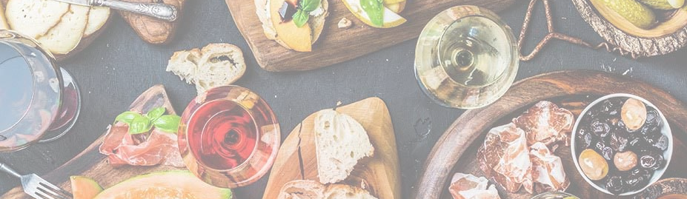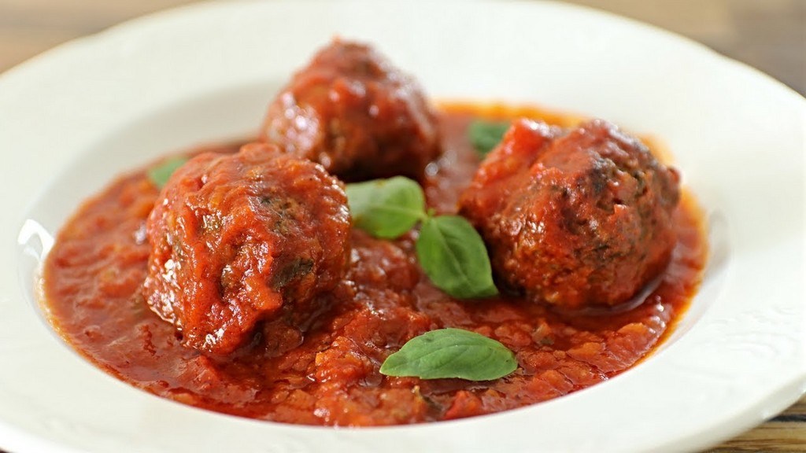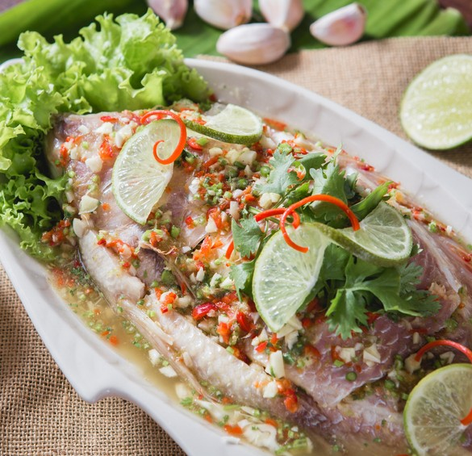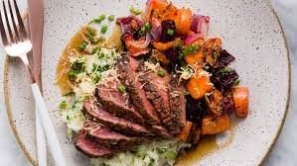
HT
Hotel trinity
Swansea

Contact Us: Tel: 01792####00
Email: HotelTRINITY@Gmail.com
- @HotelTrinity

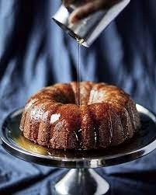

Let's Have Something Sweet
£6.95

Brownie dipped in chocolate sauce and Ice-Cream
Lemon Tart Cheesecake
Rum Cake(Seasonal) Chocolate Truffle Torte
Some Wine
ROSE WINE
£7- 75 ml
£11.00- 250ml
Wandering Bear Rose(South Africa)
Ultimate Provence(France)
RED WINE
Maison Belenger Red France Zensa Primitivo Italy WHITE WINE
Tuffolo Gavi Italy
Charles Smith Kung Fu Girl Riesling USA
Try Some Drinks
Champagne Belstar Prosecco Jeio Roee
Beer Budweiser Corona Stella Cidre Guinness
Bud Light
£7.00- 25ml
As per the label

(V) - Vegetarian (Ve) Vegan

You can pay through Cash Google pay
VISA card facilities are also available here
(GF)- Gluten-Free
Food Allergen Information Contained is accessible by this QR code, kindly ask The team to guide you.

Kindly Speak to the staff Before Ordering about your allergies, to know more about the dish, kindly ask them to answer your query.
WE are Unable to guarantee that food sold here is
free from all the traces of any allergens.

