

Assignment Title :Effective Team Work and Communication
Name : Ramona Dore Lia Stefan
Student ID : 2022359
Lecturer : Dr Nandish V Patel
Module Code : BMSW4002
Module Name : Effective Team Work and Communication
Level 4 : Certificate In Higher Education
Health And Social Care June 2021

Table of Contents
Table of Contents 2
Introduction 3
Communication 3
Different Types of Communication Model 3
Berlo’s SMCR Model of Communication 4
Shannon and Weaver Model of Communication 4
Schramm’s Model of Communication 5
Communication Skills 6
Listening 7
Nonverbal Communication 7
Clarity 8
Concise 8
Confident 8
Friendly 8
Patience 9
Example of Poor Communication at Workplace 9
How to improve the Poor Communication at Workplace 10
Appropriate Training of Communication 10
Leadership 10
Precise and Clear 10
Feedback 10
Dealing with Cultural Diversity 11
Conclusion 11
References 12

Introduction
Success of any organisation in any industry depends significantly on the efficiency of their employees or management to communicate with all its stakeholders because organisation is the result of the togetherness of different kinds of people and their activities. For this reason, in the success of any organisation, communication plays a significant role as it is the primary element of keeping people together towards the accomplishment of their goals and objectives. In this report, different areas related with communication especially the effective communication for the organisations have been discussed with appropriate real life examples in order to make the readers of this report very much aware about the importance of communication and the important areas of communication to emphasize by the people in order to make the communication process successful under any circumstances.

Communication
Communication refers to the exchange or sharing of information by speaking, writing, any other media like online, offline or anything (Morrissy-Swan, 2018). Human being requires effective communication skills in order to express their thoughts and ideas. This particular activity is very much required for business organisations as managing both the employees and the customers depends significantly on efficient and effective communication by the employers for the managers. For this reason, communication plays a very significant role in the name of business communication for the organisations of different types in different industries across the world (Morrissy-Swan, 2018). For this reason, learning about effective communication is very important. In health and social care settings, the effective communication skill is essential because it will help the people in health and social care settings to understand they are patients appropriately and give the necessary treatments according to their mental and physical condition.

Different Types of Communication Model
In order to be successful in effective communication, individuals need to apply different kinds of model in their way of work in both academic and professional sectors. There are different types of models are very much common for the organisations to make the communication process effective. The most common of them are:

Berlo’s SMCR Model of Communication
Communication depends significantly on four basic elements. They are senders, messages, channels, and receivers (Tufte, 2006). The efficiency of communication depends on the skills of the senders to encode the message efficiently in order to make the message understandable or decodable to the receivers (Tufte, 2006). Here, both the senders and receivers must have efficient skills to understand the message properly. One of the major things in this process of communication is the channel through which the message will be transmitted. Selection of efficient and the most effective channel will be the key of success for effective communication by both the parties.

Figure 1: Berlo’s SMCR Model of Communication (Source: Narula, 2006)
Now, Revive Care Service and all its employees are trying to be their efficient in this process of communication because it will definitely increase the efficiency of the senders to send the message to the receivers like patients very efficiently in order to make it easier for them to record the message and communicate efficiently. The entire process will definitely then help the organisation to deal with all the problems of the patients efficiently.

Shannon and Weaver Model of Communication
Just like Berlo’s SMCR Model of Communication, Shannon and Weaver Model Of Communication is another very popular and efficient model of communication for the people who are working in health and social care settings. In this model, everything is pretty much similar with Berlo’s SMCR Model of Communication. But this model emphasizes that much on the noise and the feedback by keeping all other things pretty much similar with Berlo’s SMCR Model of Communication. Noise is one of the major problems that can easily make any kind of communication process fail (Narula, 2006). For this reason, at the time of picking up communication media, it is necessary to find the best possible one without any noise.

Figure 2: Shannon and Weaver Model of Communication (Source: Sergio, 2000)
In social and health care setting, the impact of noise can be very significant it can change the mind of the receivers especially the patients to communicate with the employees which may causes significant delay in the treatment process of the individuals (Hallnagel, & Woods, 2005). For this reason, keeping noise out of the communication media will be the key factor for effective communication in social and health care setting. In addition with this, evaluating the feedback of the patients or the receivers from time to time will be another very important element of establishing effective communication in any health and social care setting. Revive Care Service, in order to make their communication process effective, is also trying to be very efficient in establishing this model in its communication process in order to become more efficient in providing appropriate and effective care service to the patients.

Schramm’s Model of Communication
While establishing both the models above, Revive Care Service always tries to follow the rules of communication developed by Wilber Schramm in 1954. According to Mr. Schramm, information has to be very precise and accurate in order to make it meaningful to the receivers. For this reason, encoding of information plays a very significant role for both the receivers and the senders in order to make the communication process effective (Cooren, 2012).
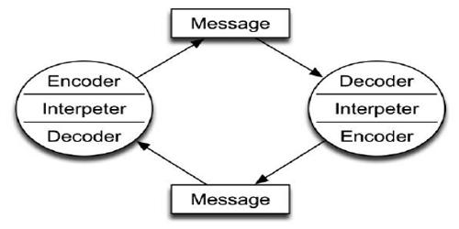
Figure 3: Schramm’s Model of Communication (Source: Carey, 2009)
Therefore, at the time of working with the patients, Revive Care Service wants to make sure that they are using the right words for the communication processes with their patients in order to make the communication process successful. The choice of words in terms of encoding the information along with the decoding of information is very effective in this sort of condition because any kind of miscommunication may take place between the patients and the employees due to inefficient use of words (Cooren, 2012). Therefore, according to the history of the patients, it is the responsibility of the employees to use efficient and appropriate words effectively in order to make the communication process successful to understand the patients and their need properly which is definitely a pure and perfect application of Schramm’s Model of Communication.

Communication Skills
Every individual has different ways of communication to express their thoughts with others. But not all the communication strategies are very much effective in order to make the receivers aware about the information shared or exchanged by the senders (McCoy, 2017). For this reason, there is the difference between communication and effective communication. To make any communication effective, there are some skills that individuals need to insure when they are in professional environment or any other environment via expression of thoughts is very important. In social and health care setting, the following communication skills are very much essential for the employees of the organisations to have.

Listening
Revive Care Service puts significant emphasize over the listening skills of their employees. It will have the employees of the organisation to learn about their patients efficiently (McCoy, 2017). Listening is all about the activities to give importance in the words of expressions of the senders in order to understand them properly. For this reason, Revive Care Service requires this skill in every single employee to understand the patients properly.

Nonverbal Communication
This can also be called as gestures. In any kind of communication, the position and the movement of the body of the senders can create significant impact in the mind of the receivers (Miller, 2005). For this reason, nonverbal communication or uses of gestures at the time of communicating with the patient have been considered as one of the major elements of effective communication in Revive Care Service.
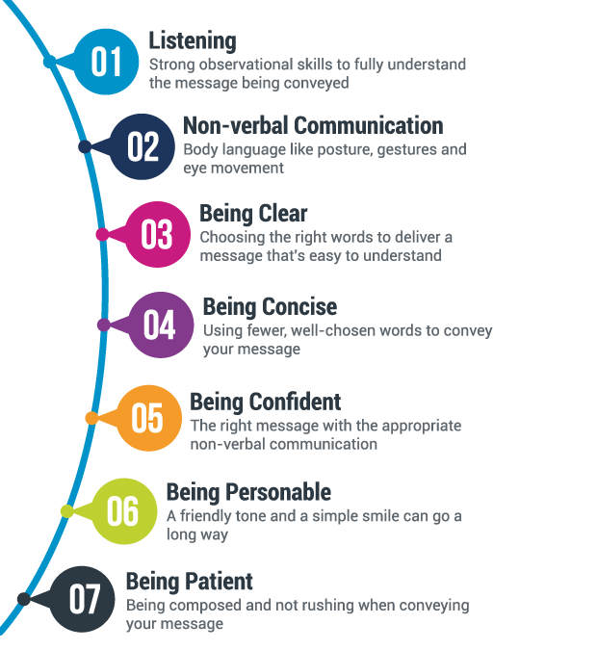
Figure 4: Communication Skills (Source: Pavlik, & McIntosh, 2017)

Clarity
At the time of communicating with others especially with the patients, it is the responsibility of the employees to use the right words that can create impact in the mind of the patients in a positive way which will definitely make the communication process effective (Miller, 2005). Revive Care Service requires clarity for all source of communication of their employees not only with their patients but also with their management in order to share the status of the patients with the stakeholders of the entire healthcare setting with the aim of making the entire activity of the organisation successful.

Concise
In any kind of communication, it is important for the senders of information to find the best precise way communication with others. It will not only make the information short but also helps the receivers to understand the message of the senders quite easily. In this regard, uses of the appropriate words can be the key of success for the senders (Pavlik, & McIntosh, 2017). To keep patience of the patients, it is the responsibility of the stakeholders of Revive Care Service to make the communication process short and concise.

Confident
While communicating with others, confidence of using the right words and confidence of sharing appropriate information and the important information with the receivers will be very much important for making the communication process effective (Pavlik, & McIntosh, 2017). The importance of the receivers towards the messages of the senders depends significantly on the confident of the senders. For instance, at the time of sharing the development process of the patients with the stakeholders such as the doctors, nurses, any other people, Revive Care Service requires confidence among their employees in order to make their words very much important to them for making them interested to take any kind of quick decisions regarding the patients.

Friendly
Creation of friendly atmosphere at the time of communication will not only increase the efficiency of communication but also create long-term relationship between the senders and the receivers of information which definitely increase the efficiency of both the parties to get appropriate information according to the situation (Pavlik, 2017). In health and social care setting, at the time of taking information from the patient, it is the responsibility of the employees, to get friendly with the patients in order to help them feel comfortable while sharing their experiences.

Patience
And finally, in order to make any kind of communication process effective, at the time of sending the message and at the time of receiving the message, individuals need to be very patient in order to get profile idea about the entire message before proceedings towards any kind of response (Pavlik, 2017). It will definitely work for Revive Care Service while taking information about the patients directly from the patients or they are relatives.
So, effective communication is essential for health and social care sitting under any circumstances to make the entire process of treatment for the patients effective and efficient.

Example of Poor Communication at Workplace
There are lots of issues related with the inefficiency of communications in workplace that create mess for the organisation to go ahead efficiently toward their goals. For example, Barry and his restaurant experience significant and dangerous difficulties in work from their employees due to lack of clear communication with them from Barry's view point. Language has become one of the major constraints for the restaurant for this kind of condition. In addition with this, leadership can be another cause for this kind of condition of that particular restaurant with which Barry need to work.
In addition with the restaurant of Barry, Revive Care Service where I am working is also having different kinds of communication problems. For example, sometimes, the stakeholders fails to communicate clearly about their strategy to provide necessary supports to the patients which creates trouble for others to provide their services to the organisation efficiently. Moreover, lack of evolution of the feedback of the patients and their relatives is also creating trouble for the organisations to understand the actual condition of the patients properly results in making the entire process of treatment very much difficult. Furthermore, cultural diversity among the employees of the organisation also creates trouble for the management to control all the employees of the organisation efficiently and according to the plan. Due to lack of efficiency of the management in communication with their employees, they are getting demoralised to work at the level best for the organisation results in making it difficult for the organisation to control efficient treatment environment for their patients.

How to improve the Poor Communication at Workplace
In order to improve the communication skills of both Barry's Restaurants and Revive Care Service there are certain policies that both the organisations need to implement in their premises.

Appropriate Training of Communication
In order to make the communication process efficient and effective, establishment of appropriate training to the trainers for communicating with the employees of all types of language will be the key of success (Myers, 2016). In this regard, ensuring the training of the trainers will be very important.

Leadership
While communicating with the employees, it is the responsibility of the managers to understand the requirements of the employees first along with their capability to learn (McCombs, & Shaw, 2017). After getting enough information about the employees, uses of words of different types to different employees will definitely help the leaders to communicate with their employees efficiently without any miscommunication.

Precise and Clear
The message which the leader of the organisation wants to provide to their employees has to be very clear and precise to the employees and other stakeholders of the organisations as well (McCombs, & Shaw, 2017). It will not only help the organisation to save time while communicating with any stakeholder but also help the receivers to understand the messages of the senders quite easily without spending much time to read the message or listen to the message which can be boring as well.

Feedback
Getting feedback from the receivers or the employees of the organisation or any other party and evaluating those feedback efficiently will definitely help the organisation to find out more efficient and appropriate way of communication with them in future because it will help the senders to understand the loopholes of communication with the other parties along with the capability of the receivers to receive the messages efficiently results in making the senders more precise and accurate in the next time (Robbins, Judge, Millett, & Boyle, 2011).

Dealing with Cultural Diversity
Sometimes, due to the changes in the culture it has become difficult for the senders to communicate with the receivers of different cultures in the same way (Turner, & West, 2013). For this reason, it is necessary for the senders to understand about the culture of the receivers from the very beginning of the communication in order to make the process effective all the time.
After following all these strategies efficiently, organisations will be very much effective and successful in communicating with all their stakeholders efficiently without having any kind of troublesome condition due to the miscommunication or inefficiency of information among them.

Conclusion
In conclusion, it can be easily said that without having efficiency in communication neither human being nor organisation can become successful. Efficiency of the organisations significantly depends on the efficiency of the communication process they are adapting. For this reason, understanding Communications of different types and understanding the loopholes of communication will help any organisation to become successful to accomplish their goals and objectives quite easily. Therefore, organisations and their management should be very much focused on building effective environment of communication for all their stakeholders in order to make the entire business process satisfactory and successful for all the parties of each and every single person of the organisation.

References
Carey, James W. (2009). Communication as culture : essays on media and society (Rev. ed.). New York: Routledge. ISBN 9780415989763.
Cooren, F. (2012). Communication theory at the center: Ventriloquism and the communicative constitution of reality, Journal of Communication.
Hollnagel, Erik and Woods, David D. (2005). Joint Cognitive Systems: Foundations of Cognitive Systems Engineering. Boca Raton, FL: Taylor & Francis. ISBN 978-0-8493-2821-3.
McCombs, Maxwell E.; Shaw, Donald L. (2017). "The agenda-setting function of mass media". The Agenda Setting Journal. Theory, Practice, Critique. 1 (2): 105–116.
McCoy, J. (2017) ‘A handy dandy guide on how to write social media posts: best practices, length and more’
Miller, Katherine (2005). Communication Theories: Perspectives, Processes, and Contexts (2nd ed.). McGraw-Hill Higher Education. ISBN 978-0-07-293794-7.
Morrissy-Swan, T. (2018) ‘What your handshake says about you’, The Telegraph.
Myers, Patrick (2016). "Protecting Personal Information: Achieving a Balance between User Privacy and Behavioral Targeting". University of Michigan Journal of Law Reform. 49 (3): 717–747.
Narula, Uma (2006). Handbook of communication models, perspectives, strategies. Atlantic publishers&distributors.
Pavlik, John (2017). Converging Media; A New Introduction to Mass Communication. New York: Oxford University Press. p. 185.
Pavlik, John; McIntosh, Shawn (2017). Converging Media; A New Introduction to Mass Communication. New York: Oxford University Press. pp. 11, 99, 107, 108, 110, 127, 130, 192, 219, 243–246.
Robbins, S., Judge, T., Millett, B., & Boyle, M. (2011). Organisational Behaviour. 6th ed. Pearson, French's Forest, NSW pp. 315–317.
Sergio Verdü (2000). "Fifty Years of Shannon Theory". In Sergio Verdü and Steven W. McLaughlin (ed.). Information Theory: 50 Years of Discovery. IEEE Press. pp. 13–34. ISBN 978-0-7803-5363-3.
Tufte, Thomas (2006). Communication for social change. Anthology: historical and contemporary readings. Denise Dray-Felder. ISBN 0-9770357-9-4.
Turner, L.H., & West, R.L. (2013). Perspectives on family communication. Boston: McGraw-Hill.

