INTERCULTURAL COMPETENCE REPORT

Student Name: Victoria Prodan
Student ID: 2245322
Module Title: Foreign Languages & Cultural Awareness
Module Code: BMIH5003
Lecturer: Giulia Chifari
Word Count: 1005
Executive Summary
In this study is attempt to identify cultural divergences between England and Germany. It is evaluating its influences on the interpersonal skills of leaders in the hospitality industry. It bases its analysis on the GLOBE study which is made up of cultural and leadership insights applied comparatively. The crucial issues connected to intercultural leadership in the hotel and tourism industry will be presented along with the suggestions on to tackle the intercultural team management in a right way.

Table of Contents
Introduction 4
Main body 4
Key Differences Between England and Germany 4
Analysis of England and Germany Using GLOBE Project's Cultural Dimensions 4
Challenges of Intercultural Leadership in the Hospitality Industry 5
Conclusion 6
Recommendations 6
Reference List 8

Introduction
As the finally selected GM of a Multicultural Hotel & Spa, London, England. In order to being a cosmopolitan city, the employees develop from Germany and it is crucial that cultural diversity issues are handled well for effective leadership. This report focuses on the ethnocultural differentiations between countries England and Germany, presents the GLOBE Project's cultural dimensions to apply to the discussed nations, and converses about the issues related to intercultural management in the hospitality business.

Discussions

Key Differences Between England and Germany
The settings of England and Germany show the specific cultural development that computerize different spheres when it comes to communication style. Germans, more frequently prefer direct and concise language, while the English use generalizing and are more polite (Jaeger et al., 2023). In addition to that, Germans work towards meeting deadlines and executing tasks precisely whereas, the English give most of the value to creative thinking and interaction with humans.
In terms of culture, the Germans are characterized by hierarchical order of things and for their total respect of authority. On the other side, the English have more of an egalitarian level of things (Breaugh et al., 2023). In this regard, the Germans especially like their work life and their private life clearly divided from each other, whereas the English frequently do not distinguish their working life and their normal life that clearly.
In Germany the business processes stand for precision and strict rule following, while for the English the mobility and sensitivity for improvisation matters most (Pickel and Pickel, 2023). Moreover, the level of risk is different stating the Germans as the more risk-averse should the English people.
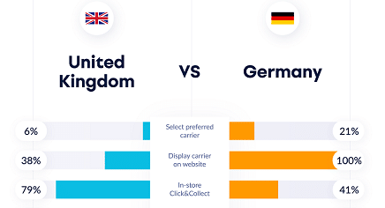
Figure 1: Key differences
(Source: Breaugh et al., 2023)

Analysis of England and Germany Using GLOBE Project's Cultural Dimensions
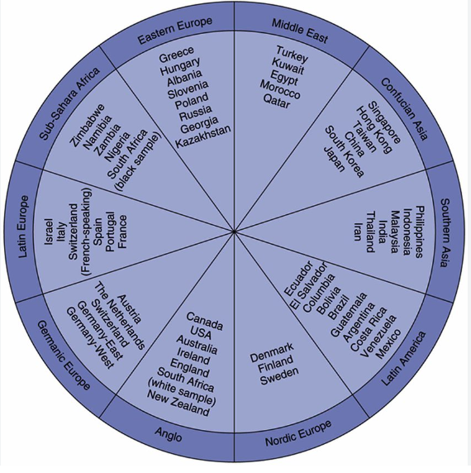
Figure 2: Globe project culture
(Source: Battistella et al., 2024)
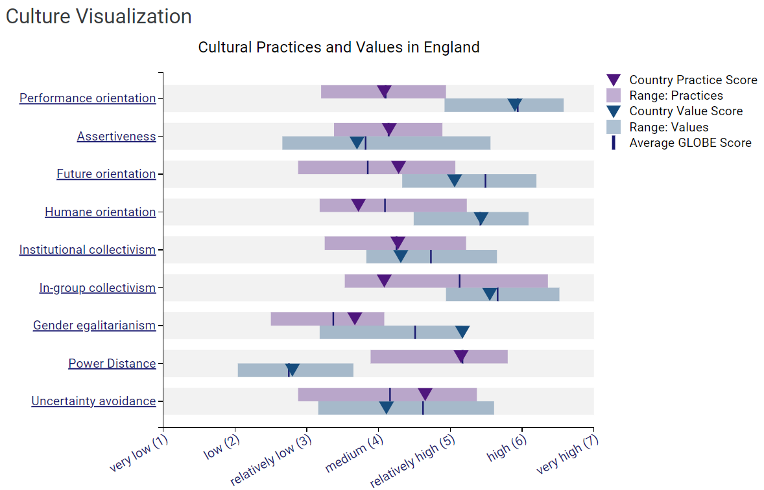
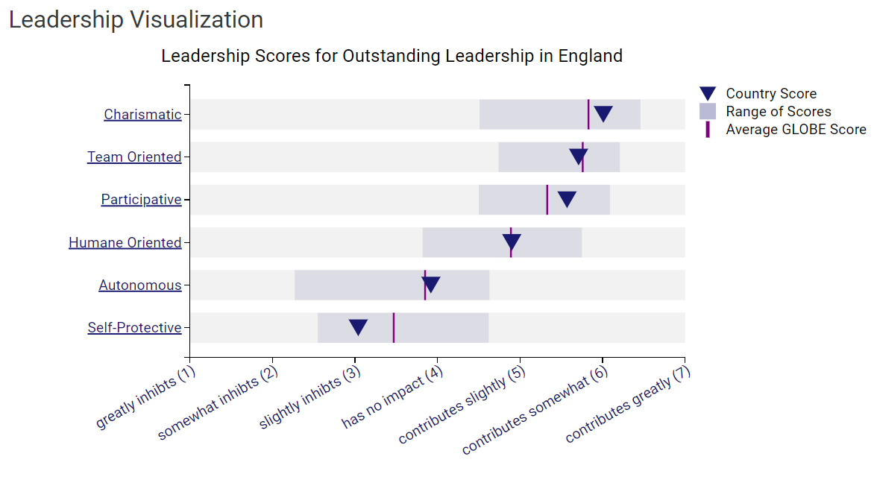
Figure 2: Globe Project analysis for England
(Source: Globeproject.com, 2024)
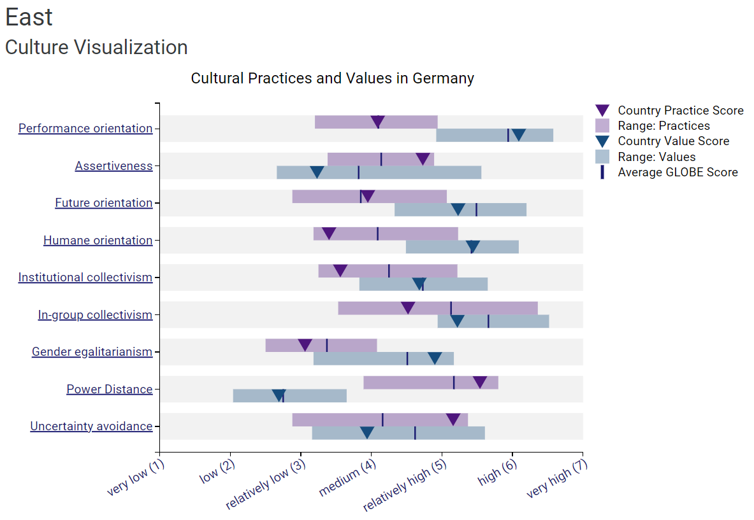
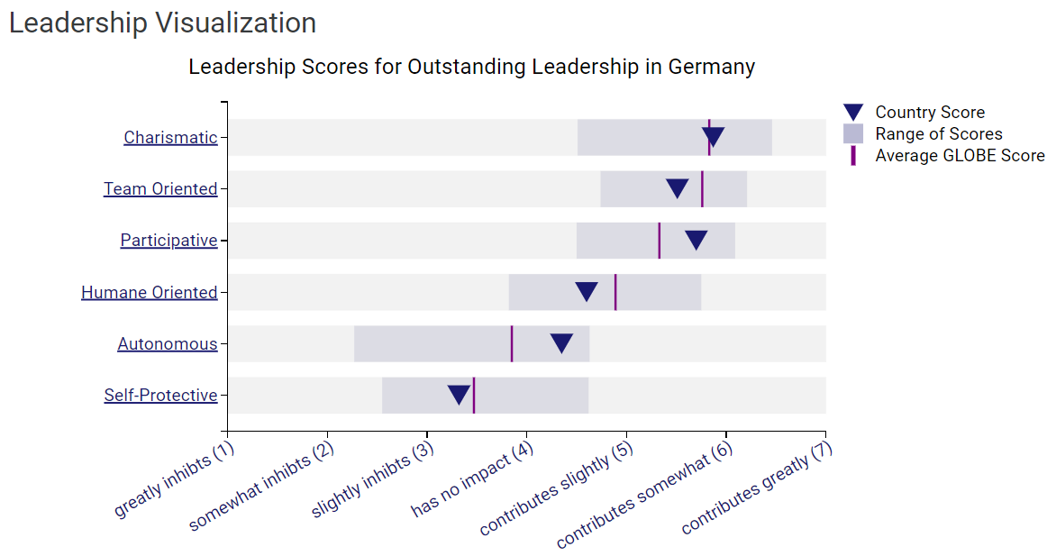

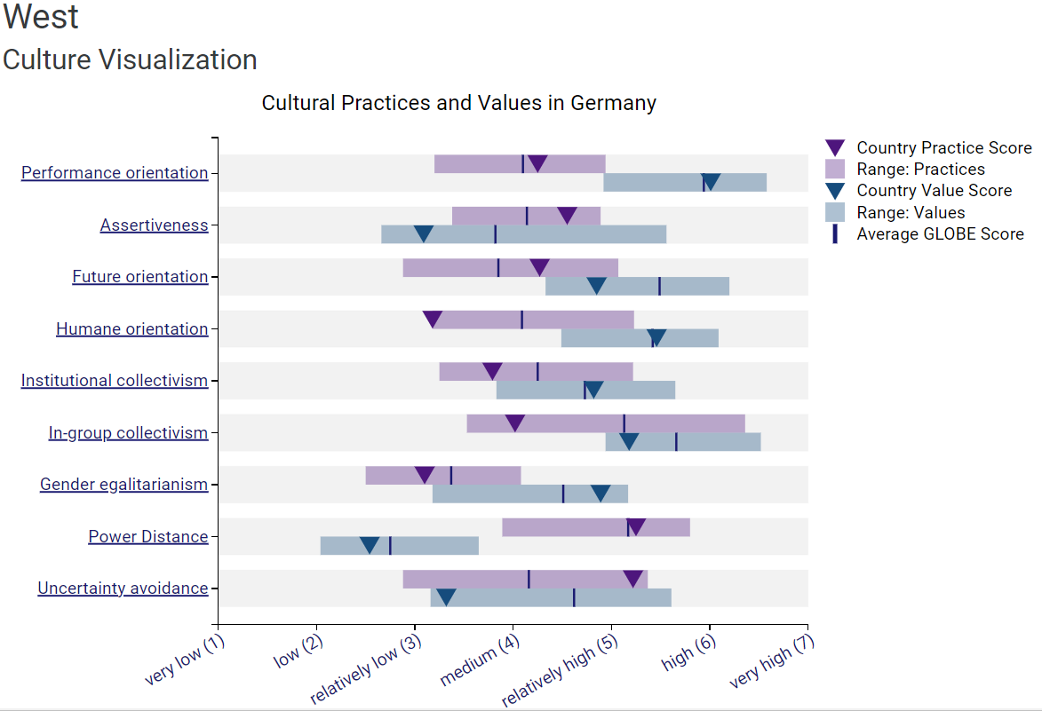
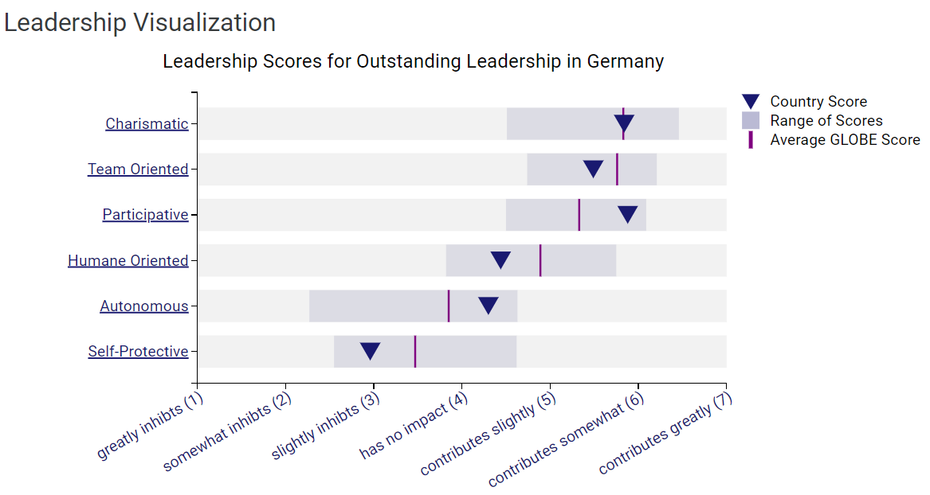
Figure 3: Globe Project analysis for Germany
(Source: Globeproject.com, 2024)
Power Distance: Similarly, the power distance in German is higher as these are ready to accept the authority and superior role while England has a lower power distance which means the value of equality and autonomy is the part of the culture.
Uncertainty Avoidance: Germany usually is more risk averse, so there is a willingness to have clear-cut rules and tight structures in place (Moshona et al., 2023). In contrast, there is lower uncertainty avoidance in England that leads to a tolerance of ambiguity and being flexible in dealing with it.
Collectivism vs. Individualism: Germany, inclines towards collectivistic features where people strive for group unity and harmony, contrast England that followers’ individualistic values by putting achievements in front of relationships.
Assertiveness: Germany usually is a quite aggressive player, who likes competition and ambition, and the English one is more equal, moderating and balancing side, and also plays for cooperation and compromise (Battistella et al., 2024).
Future Orientation: While the development for future orientation exists in both countries, Germany may be very much geared towards the long run (Bylund et al., 2023). It is focusing on major pillars for long term planning and stability, whereas England may be rather flexible.

Challenges of Intercultural Leadership in the Hospitality Industry
Communication: Different modes of interpretation in communication can result in misunderstanding of intents or meanings and conflict. Because of that, Germans may feel that they are being criticized when these are actually just being straightforward like the directness of German communication (Khoa et al., 2023). While English employees may think that the reason, these are not getting the whole picture is that Germans are trying to be too indirect like the indirectness of English communication.
Hierarchy and Authority: Striking a balance between the hierarchical 'German' workplace practices and the more equitable 'English' culture may result in bemusement and upheaval.
Work-Life Balance: German colleagues might anticipate a quite absolute bound between professional and personal spheres, while English employees are more likely to be flexible in combining these two domains (Ratna et al., 2024). Correct expectations management shall be done by careful and proper promotion.
Decision Making: Various factors of the decision making, like the love for consensus in Germany against individualistic approach in England. It can also develop the harmony and thus cause a lower efficiency.
Conflict Resolution: Cultural variance of conflict resolution styles like directly confronting issue in the German whereas rather avoiding this in England (Tanveer et al.,2024). It may also pose with serious problems in coming to an effective resolution in a conflict.

Figure: 3: Challenges of Intercultural Leadership in the Hospitality Industry
(Source: Self-created)

Recommendations
Cross-cultural Training: Educate all the employees thoroughly to do intercultural communication in order to remove the places of ambiguity.
Adapt Leadership Style: A leader must be versatile enough with regard to the leadership style. He or she must also be able to show respect to cultural differences as well as encourage cooperation and inclusiveness.
Encourage Dialogue: Support free speech and let the members of the team talk openly about their views without fear and limitations (Tanveer et al.,2024).
Promote Cultural Awareness: Encourage diversity by means of activities such as events, workshops, or cultural exchange programs (Khoa et al., 2023). It hasaimed at the organization and create awareness of different cultures throughout the organization.
Conflict Resolution Mechanisms: Formulate and put in place fair and equitable procedures to be followed by parties in addressing differences that apply due respect for cultural diversity and encourage all sides to understand one another.

Conclusion
The culture of England and Germany being distinctive, it is of paramount importance to acquaint and adapt for effective leadership role in the hospitality industry. The development from organizational culture dimensions of the GLOBE Project enables managers to foresee turbulences and ensure certainty in a culturally diverse atmosphere. One example of that is paying attention to the great distance between the German top and the bottom, which allows devising strategies that will reconcile hierarchy and the English position of equality. This strategic view provides an opportunity to cultivate a more safeguarded and fruitful workplace, where varied opinions are often considered.

Reference List

Battistella, C., Bortolotti, T., Boscari, S., Nonino, F. and Palombi, G., 2024. The impact of cultural dimensions on project management performance. International Journal of Organizational Analysis, 32(1), pp.108-130.
Breaugh, J., Rackwitz, M. and Hammerschmid, G., 2023. Leadership and institutional design in collaborative government digitalisation: Evidence from Belgium, Denmark, Estonia, Germany, and the UK. Government Information Quarterly, 40(2), p.101788.
Bylund, E., Khafif, Z. and Berghoff, R., 2023. Linguistic and geographic diversity in research on second language acquisition and multilingualism: An analysis of selected journals. Applied Linguistics, p. amad022.
Globeproject.com, 2024. Country Analysis. Available at : https://globeproject.com/results/countries/DEU%3Fmenu=list.html#list [Accessed on 7/5/2024]
Jaeger, S.R., Harker, F.R. and Ares, G., 2023. Consumer insights about sustainable and ‘beyond organic’agriculture: A study of biodynamics in the United Kingdom, Australia, Singapore, and Germany. Journal of Cleaner Production, 401, p.136744.
Khoa, D.T., Gip, H.Q., Guchait, P. and Wang, C.Y., 2023. Competition or collaboration for human–robot relationship: a critical reflection on future cobotics in hospitality. International Journal of Contemporary Hospitality Management, 35(6), pp.2202-2215.
Moshona, C.C., Lepa, S. and Fiebig, A., 2023. Optimization strategies for the German version of the soundscape affective quality instrument. Applied Acoustics, 207, p.109338.
Pickel, S. and Pickel, G., 2023. The wall in the mind–Revisited stable differences in the political cultures of western and eastern Germany. German Politics, 32(1), pp.20-42.
Ratna, S., Saide, S., Putri, A.M., Indrajit, R.E. and Muwardi, D., 2024. Digital transformation in tourism and hospitality industry: a literature review of blockchain, financial technology, and knowledge management. EuroMed Journal of Business, 19(1), pp.84-112.
Tanveer, M.I., Yusliza, M.Y. and Fawehinmi, O., 2024. Green HRM and hospitality industry: challenges and barriers in adopting environmentally friendly practices. Journal of Hospitality and Tourism Insights, 7(1), pp.121-141.

