Powertrain Design and Efficiency - Assignment 2
Richard Lewis
Jack Edwards – P147482
- Abstract
1.1 During this report there will be discussion as to two forced induction options for a given engine, along with the intercooler calculations to support the modifications. There will be research into the uses of turbochargers as well as different designs for different applications including the use of monitoring systems within the turbocharger circuit.

2. Contents
Title | Paragraph number
Abstract | 1
Contents | 2
Figures | 3
Introduction | 4
Literature review/research | 5
Methodology | 6
Results/Analysis | 7
Conclusion | 8
References | 9
3. List of figures

Figure number | Title
1 | Turbo Assembly
2 | Coolant/oil feed and return lines, compressor housing bolts.
3 | Turbine shaft assembly
4 | Bearing cap
5 | Coolant passage
6 | Wastegate arm closed
7 | Wastegate arm open

4. Introduction
4.1 This report has been written to outline the procedure that was adopted in dismantling a turbocharger including the process for re-assembly, during this report there will be calculations and methodology used to find a suitable turbo setup for a given engine, as well as the intercooling system. There will be references to suitable literature in support of the findings disclosed in this report, as well as the evolution of the turbocharger from its introduction to modern applications.

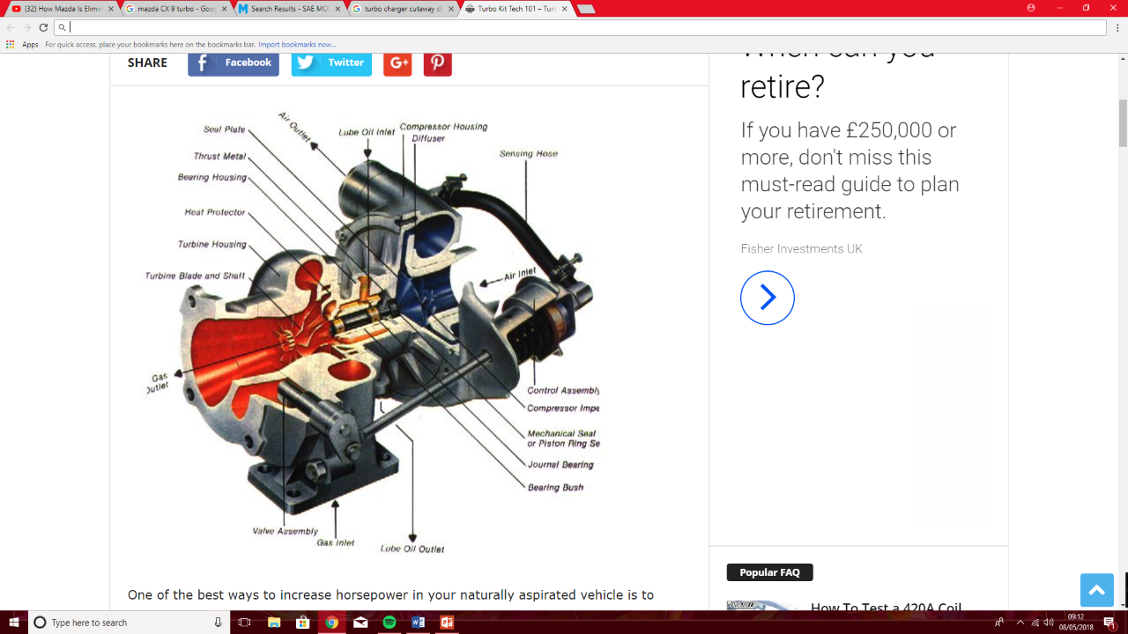
5. Research/literature review
5.1 Before the investigation was undertaken, background research must be completed to gain a better understanding of the turbocharger. Robert Bosch, 2011 describes the turbo charger as an exhaust gas driven turbine system whereby residual exhaust gas energy can be used to carry out useful work. Figure 1 shows the direction of exhaust gas flow, and subsequently air flow into the compressor housing. All turbo chargers have an oil feed and return as shown in figure 1, and later turbos have a coolant feed and return to aid in maintaining turbo charger temperature.
5.2 Early turbo chargers used on performance petrol spark ignition engines were basic to those used in modern cars, they often used vacuum operated boost control valves (wastegates) which could become problematic if there is damage to the vacuum line as without a vacuum the wastegate will fail to open and the turbo charger will provide too much boost. Due to this issue with vacuum operated wastegates and the development of modern management systems, modern turbo chargers use a solenoid operated control valve, which allows the ECU to monitor not only the position of the wastegate relative to the boost pressure, but check for circuit integrity which allows the system to notify the driver of the vehicle that there is an issue with the system and will put the vehicle in “Limp” mode due to the damage that can be caused during over boost conditions.
5.3 The development of the turbo charger since Alfred Buchi, 1905 original concept means smaller engines and smaller turbo chargers can be used as means of increasing thermal efficiency and increasing overall engine power and torque. Due to modern emission legislation many car manufacturers are downsizing engines as means to meet the stringent emission laws, meaning the turbo charger is used more predominantly than ever before.
5.4 The variations of turbochargers have changed due to changing demands and requirements, one of the most beneficial changes to the turbo charger system is the use of VV turbo chargers (Variable vein/variable geometry) turbo charges. Robert Bosch, 2011 describes the Variable geometry turbocharger as a unit whereby the rotation of the veins within the turbo charger allow it to regulate its own boost pressure without the use of a wastegate, in effect the wastegate is integrated into the turbo design. Like a solenoid operated wastegate, the variable geometry turbo uses a solenoid control valve to adjust the position of the turbo veins to regulate boost pressure.
5.5 The modern dynamic pressure turbocharger as used on the Mazda CX9 utilises a solenoid flow control valve to direct exhaust gas down a smaller area during low engine speeds (Below 1620RPM) to increase exhaust gas flow speeds as at low engine speeds here is little exhaust gas flow, then after 1620RPM the solenoid valve opens the flow control valves and allows full flow of the exhaust gas, this method was developed to reduce turbo “lag” during low engine speeds.
5.6 Vehicle manufacturers have also used more lightweight materials on the rotating components of the turbo, as this will reduce inertia and reduce lag by allow the turbo to spool faster as the exhaust gas energy is not being used to overcome the rotational inertia of the turbine assembly. Cantemir, C 2001 describe modern systems being equipped with a secondary blow off valve which allows additional safety within the circuit, for instance in the event of a failed vacuum operated wastegate, or mechanical failure of a modern wastegate system the blow off valve will act as secondary boost control valve.
5.7 The use of intercoolers in forced induction systems has developed since its introduction, the necessity to maintain low charge temperature is due to the heat generated by the turbo charger in providing pressure increase to the ambient air entering the system means as the air is compressed the particles within the gas increase in temperature, and subsequently a loss of oxygen mass occurs. Modern intercoolers often use Air-Air coolers as they are simple and effective at high speeds. Air-Air intercoolers work by cooling charge temperature by having fins within the intercooler to allow maximum surface area available for the ambient air to pass through it during drive cycles, however these intercoolers are most efficient during high speeds as the volume of ambient air cooling the intercooler is greater than at low speeds.
5.8 One method if increasing low speed intercooler efficiency is to use a water-air intercooler, whereby an external motor is used to circulate either refrigerant gas or a coolant around the intercooler to absorb as much heat as possible from the charge air. However, these systems are not as efficient as an air-air intercooler at higher speeds as the flow of refrigerant gas/coolant is limited by the pumps ability to supply adequate flow around the circuit.
Figure 1.

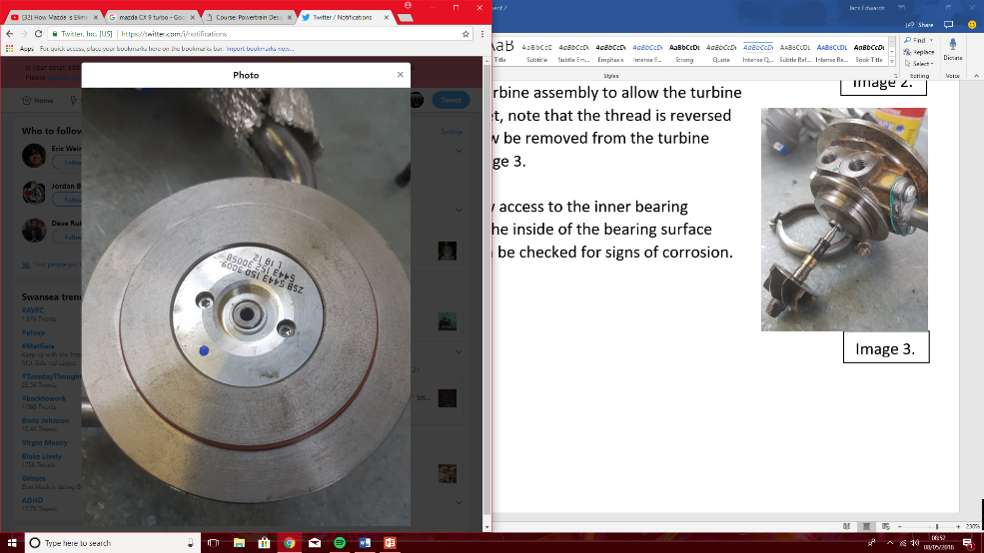
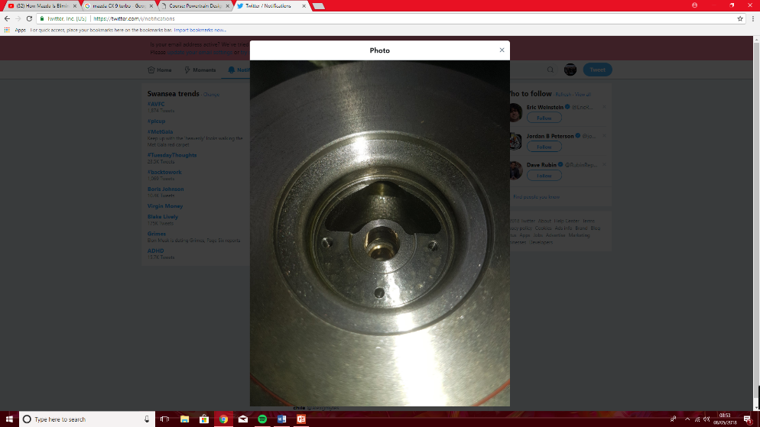
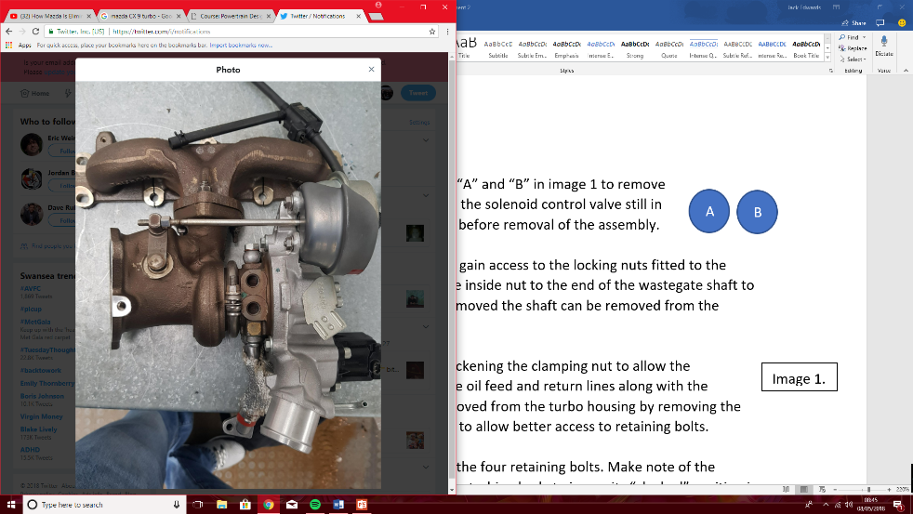
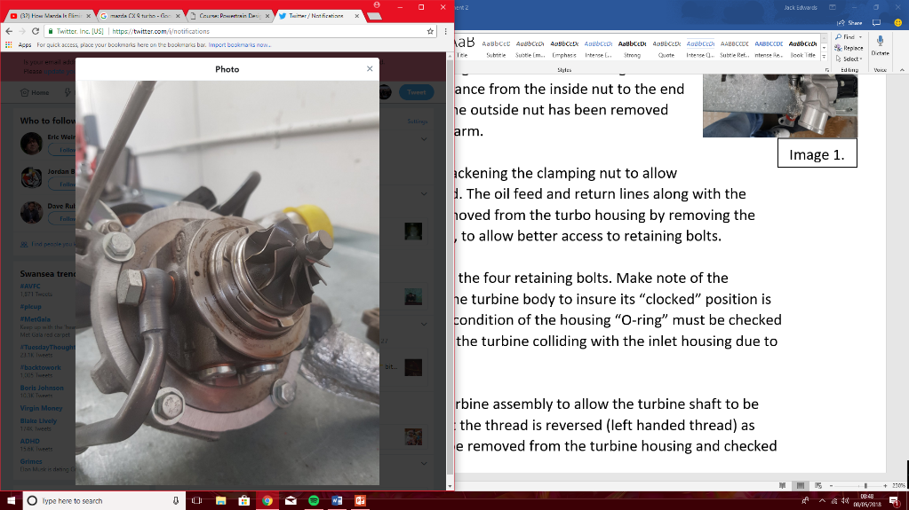
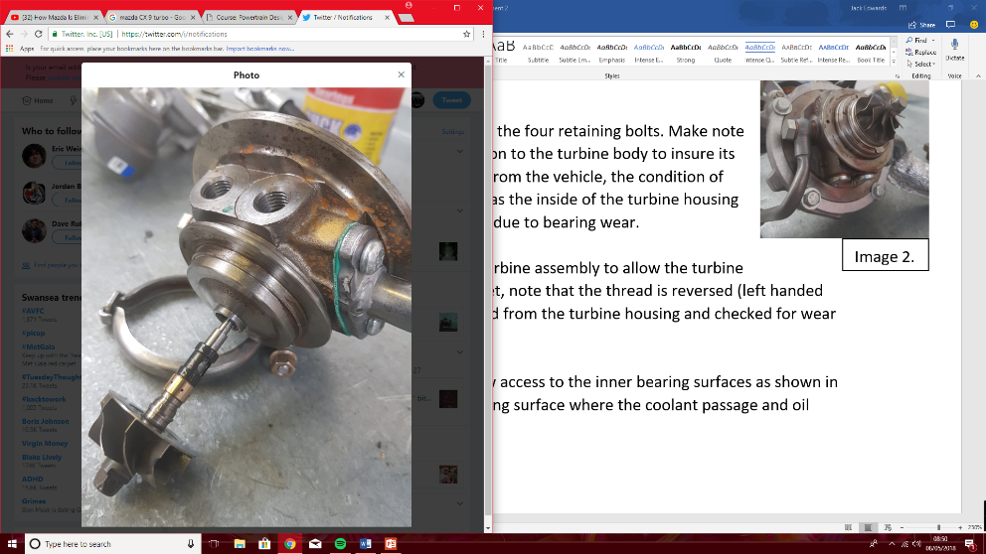
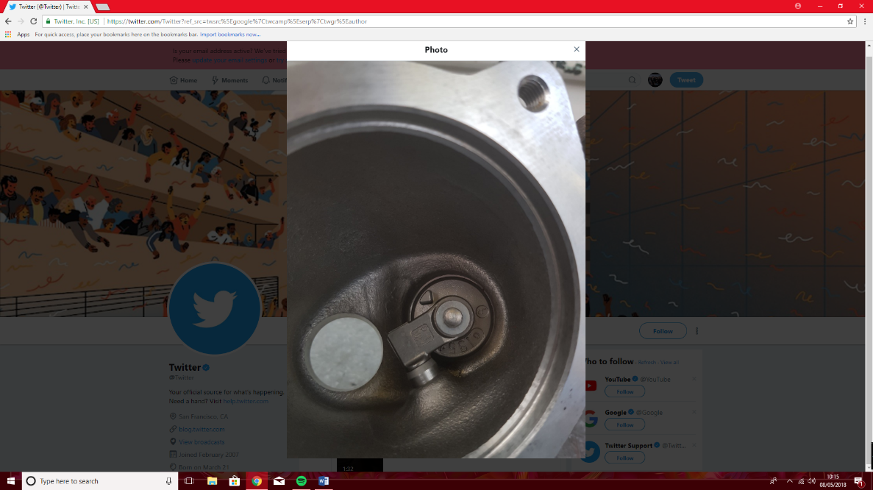
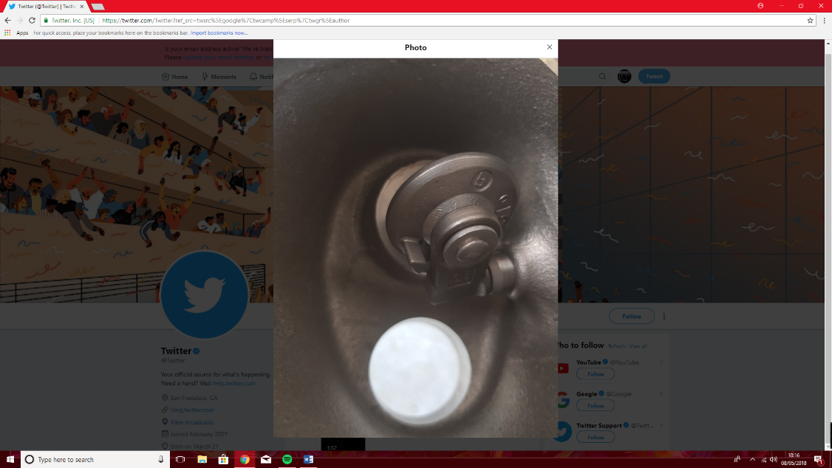
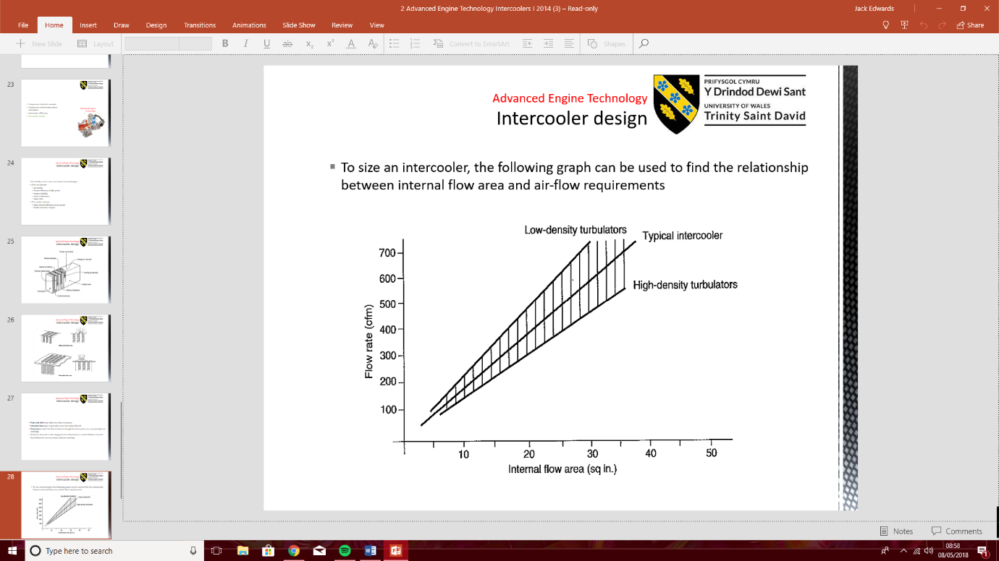
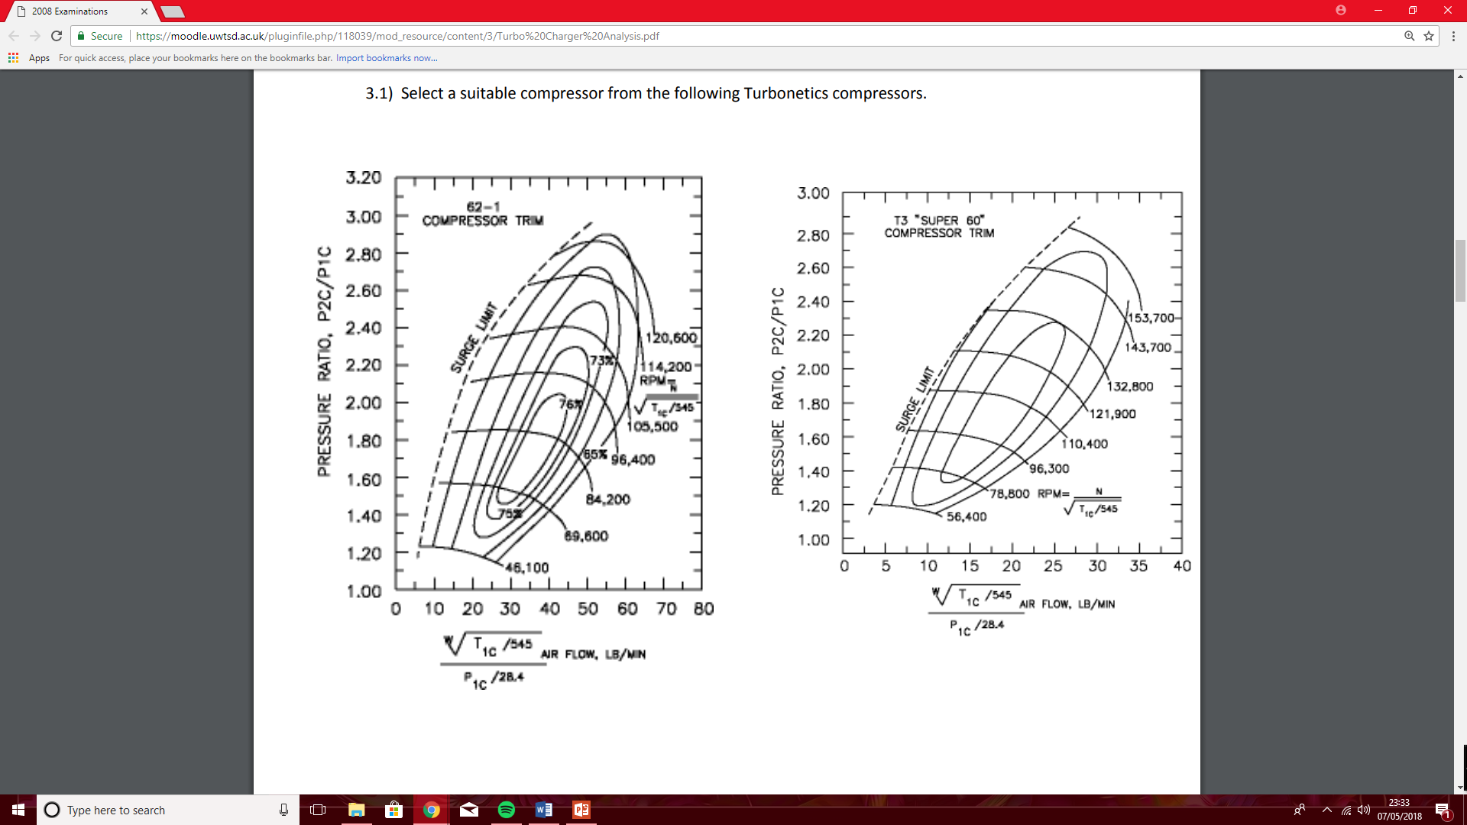
6. Methodology
6.1 Dismantling turbo charger unit.
1. Remove the two nuts and two bolts in image 1 that hold the the vacuum operated wastegate assembly onto the turbo unit, remove with the solenoid control valve still in place, insure all vacuum lines are disconnected before removal of the assembly.
2. The metal locking cover must be removed to gain access to the locking nuts fitted to the wastegate shaft, measure the distance from the inside nut to the end of the wastegate shaft to refer to later, once the outside nut has been removed the shaft can be removed from the wastegate arm.
3. The “V-band” clamp must be removed by slackening the clamping nut to allow the remaining exhaust manifold to be removed. The oil feed and return lines along with the coolant feed and return lines must now be removed from the turbo housing by removing the appropriate “banjo” bolts as shown in image 2, to allow better access to retaining bolts.
4. Remove the inlet housing next, by removing the four retaining bolts. Make note of the orientation of the inlet housing in relation to the turbine body to insure its “clocked” position is as it was when removed from the vehicle, the condition of the housing “O-ring” must be checked as well as the inside of the turbine housing for the turbine colliding with the inlet housing due to bearing wear.
5. Remove the nut from the inlet side of the turbine assembly to allow the turbine shaft to be removed using a punch and a mallet, note that the thread is reversed (left handed thread). The turbine shaft can now be removed from the turbine housing and checked for wear as shown in image 3.
6. The two torx bots must be removed to allow access to the inner bearing surfaces as shown in image 4. Image 5 shows the inside of the bearing surface where the coolant passage and oil passage can be checked for signs of corrosion.
6.2 Re-assembly of the turbo unit.
1. Place the main body of the turbo in a vice, refit the bearing cap with the torx bolts as shown image 5, and torque to specification.
2. Once turbo oil seal and bearing cap has been reinstalled, the heat shield labelled in image 2 must be installed onto the turbine shaft prior to installation. Now the turbine shaft must be lubricated using engine oil or assembly lubricant and reinstalled with the bearings fitted as shown in image 4, making sure the snap ring seats into position when installed and the turbine shaft can rotate freely.
3. Insure the turbine shaft has been inserted through the second oil bearing that is within the bearing cap. Insure the washer shown in image 7 has been reinstated before re-assembly of the turbine shaft can begin.
4. With the turbo body secured in a bench vice, insure the exhaust turbine is facing down and place the inlet turbine onto the turbine shaft, and use a drift/punch to seat the inlet turbine onto the turbine shaft.
5. Install the left-handed turbine nut on the shaft and torque to manufacturers specification. Once the O-ring shown in image 3 has been replaced and lubricated, the Inlet housing can now be re-installed, noting the marked position of the turbine body relative to the turbine inlet housing as described in paragraph 6.1 – 4., this will insure the turbine housing is “clocked” correctly upon re-installation to the vehicle.
6. Re-install the four bolts that secure the inlet housing to the turbine body once the inlet housing has been correctly “clocked”, torque the four retaining bolts to specification. At each stage insure the turbine shaft is free to spin, and all moving parts are adequately lubricated to avoid premature wear.
7. The oil feed and return pipes along with the coolant feed and return pipes must be reinstated, insuring new copper washers are used to maintain adequate seal, the “banjo” bolts must then be torqued to specification.
8. The remaining exhaust manifold section must be installed, making sure the seat for the “V-band” clamp has been cleaned to allow it to provide a sufficient seal. Once the exhaust manifold section has been installed, the vacuum operated wastegate assembly must be re-installed.
9. The bolts that hold the wastegate actuator to the turbo must be torqued to specification. The actuator arm must then be fed into the wastegate arm. The locking nut must then be fitted and the distance from the inside of the nut that was left on the arm as discussed in paragraph 6.1 – 2. to the end of the actuator arm must be checked to insure it is the same as when it was removed.
10. This will mean when the diaphragm moves the arm, the wastegate will open and close as designed. Once this measurement is confirmed the locking metal clip can be fitted to prevent the nuts unwinding and risk the wastegate not opening when required.
11. A handheld vacuum gauge can now be used to check that the wastegate assembly moves freely under an applied vacuum, check manufacturer specification for point at which the wastegate opens under a given vacuum. The wastegate should move as shown in images 6 and 7 and operate smoothly, insuring the wastegate seats correctly when a vacuum is not applied to the actuator. The remaining vacuum lines and solenoid valve can now be re-instated, at this point the turbocharger is ready to be refitted to the vehicle.
7. Results/Analysis
7.1 As part of this report, calculations were made to choose a turbo charger for a given engine. The engine was a V8 with a bore of 95mm and stroke of 80mm, with a max RPM of 9500 RPM. The naturally aspirated engine has a volumetric efficiency of 85% and would be required to run 12PSI of boost, therefore the following calculations were made to find a suitable forced induction system.
7.2 Firstly, the naturally aspirated volumetric flow rate must be calculated, the formula reads: V= v x Nv x N/ 2 x 60, once the engines values are inserted it gives V = 4.54x10^-3 x 0.85 x 9500/2 x 60 = 0.306m^3/s. The flow value must be converted from M^3/s to CFM then to Lb/min, this gives 0.306 x 2119 = 647.36CFM, then 647.36 x 0.07 = 45.32 Lb/min. These values will be used in later calculations.
7.3 Then the pressure ratio must be calculated to be used later to calculated Vt, the pressure ratio formula reads: 14.7+boost/14.7 = PR. Therefore, when the values for the given engine are used, it gives: 14.7+12/14.7 = 1.82. Now the PR is calculated, the Vt can be calculated using the formula: PR x V = Vt, this gives 1.82 x (4.54x10^-3 x 0.85 x 9500/2 x 60) = 0.5556 M^3/s. The turbo charged flow value must now be converted to CFM then to Lb/Min, as described in paragraph 7.2. By multiplying the M^3/s value by 2119 it will have converted to CFM, then that value is multiplied by 0.07 to convert from CFM to LB/min, the final turbo charged flow rate value is 82.47 Lb/min.
7.4 The flow rates must now be calculated for 100% flow at 12psi boost, 50% flow at 12psi boost, and then at 20% flow and 0psi boost pressure. The 100% turbo charged flow value will be used from the original Vt calculation, the 50% flow is the same formula used in the original Vt calculation, only now the N (Engine speed) must be reduced to 4750 rpm to calculate 50% flow. The final calculation will use a PR value of 1.00 to simulate zero boost pressure, and an N (engine speed) of 1900 rpm which simulates 20% flow. The calculated values are as follows: 82.47 lb/min @ PR=1.82 – max flow, 41.24 lb/min @ PR=1.82 – 50% flow, 9.06 lb/min @ PR=1.00 – 20% flow.
7.5 The thermodynamics of the turbo charger system must now be calculated to estimate the internal flow area of an intercooler that is suitable to operate with the chosen turbo. Tco (temperature of compressor outlet) must be calculated first, using the formula: Tco = PR^0.28 x Tin, it gives Tco = 1.82^0.28 x 300K = 354.77K. From here Tio must be calculated next, Tio is the temperature of the air leaving the intercooler. Using the formula: Tio=Tco-(Ni(Tco-Ta)), gives Tio = 354.77- (0.60(354.77-300)) = 321.91K.
7.6 Actual temperature rise is calculated by using the following formula: Actual Temperature Rise = (PR^0.28 x Tin)-Tin/Nc, inserting the values from the compressor map and the previous calculations gives: Actual Temperature Rise = (1.82^0.28 x 300)-300/0.78 = 70.21. Finally, the intercooler’s internal flow area must be calculated, Using Graph 1, it was found that the flow on the graph was not sufficient enough to plot the results. Therefore, from calculating the gradient of the “typical intercooler” curve, it gave: (Y) Gradient = 19.355x, after re-arranging to find X it was calculated as: 1178.2/19.355 = 60.87 SQ/in.
7.7 From the above calculations, the following compressor map graphs can be used, and the calculations plotted on the graphs below to determine which out of the four suggested single compressors would be suitable for the example engine.
Image 4.
Image 5.
Image 1.
Image 2.
Image 3.
Image 6.
Image 7.
Graph 1.
Compressor map graph 1
Compressor map graph 2
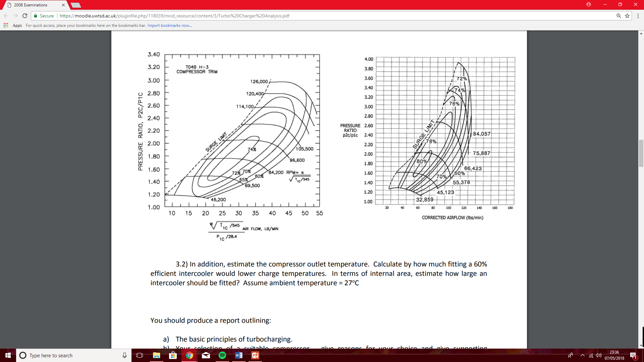
8. Conclusion
8.1 From the compressor map graphs above, it can be concluded that “compressor map 4” is the only suitable single compressor solution. As out of the four suggested compressors “compressor map 4” is the only turbocharger that can supply the flow necessary for the engine. From “compressor graph 4” it can be concluded that the operating parameters are within the surge limit of the turbo, at 50% flow the turbo is rotating at approximately 48,000RPM and is operating at an efficiency of 60%. Then under 100% flow conditions will be spinning at approximately 51,000RPM and operating at an efficiency of 74%.
8.2 However, due to the design of the V8 engine it inherently has two banks of cylinders due to its “V” arrangement. This provides an additional forced induction options such as twin turbochargers. Twin turbo charger systems use separate turbo charger circuits for each bank of the engines cylinders, while being able to use two smaller turbo chargers to reduce turbo lag as supposed to a single larger compressor.
8.3 The calculations completed in paragraph 7.3 – 7.4 must be repeated, only now the flow rates must be halved as we are considering the flow on each side of the engine separately instead of total volumetric flow. This gives Vt/2 = 82.47Lb/min /2 = 41.24Lb/min @ PR = 1.82 – 100% flow, 20.62Lb/min @ PR = 1.82 – 50% flow and 9.06Lb/min @ PR = 1.00 – 20% flow.
8.4 These values can now be used to calculate which pair of turbos from the four compressor map graphs would be suitable. Looking at the dashed lines on the compressor maps, it can be concluded that the ideal turbo chargers to be used in the twin turbocharger setup is “Compressor map graph 1” as it operates under a higher efficiency during its application than in “Compressor graph 3”. During its operating parameters it is always safely within the “surge limit”, at 100% flow and PR of 1.82 the turbo is operating at approximately 84,200RPM and at an efficiency of 76%, at 50% flow and PR of 1.82 the turbo is operating at a speed of approximately 83,000RPM and at an efficiency of 65%. This means a gain of 5% efficiency at 50% flow and a 2% efficiency gain at 100% flow.
8.3 Using the new CFM values calculated for the smaller twin turbo setup, the following calculations can be completed to find the internal flow area of an intercooler required for this setup. Using the gradient of the curve calculated in paragraph 7.6, the following equation is used: 589.1/19.355 = Internal flow area, this gave an internal flow area value of 30.44 SQ/in for each of the two intercoolers.
9. References
9.1 Robert Bosch, 2011 – Bosch automotive handbook 8th edition.
9.2 www.prostreetonline.com, linked - http://my.prostreetonline.com/2016/04/22/turbo-kit-tech-101-turbocharger-basics/ - image of turbo cutaway diagram.
9.3 Cantemir, C., "Twin Turbo Strategy Operation," SAE Technical Paper 2001-01-0666, 2001, https://doi-org.ezproxy.uwtsd.ac.uk/10.4271/2001-01-0666.
Compressor map graph 3
Compressor map graph 4
Compressor map graph 3
Compressor map graph 4

