Conservation management plan
Pavilion on S side of College Playing Field
Ceredigion, Lampeter
Cadw Ref: 21392
OS Grid Reference: SN 57268 48093
Easting: 257268 Northing: 248093

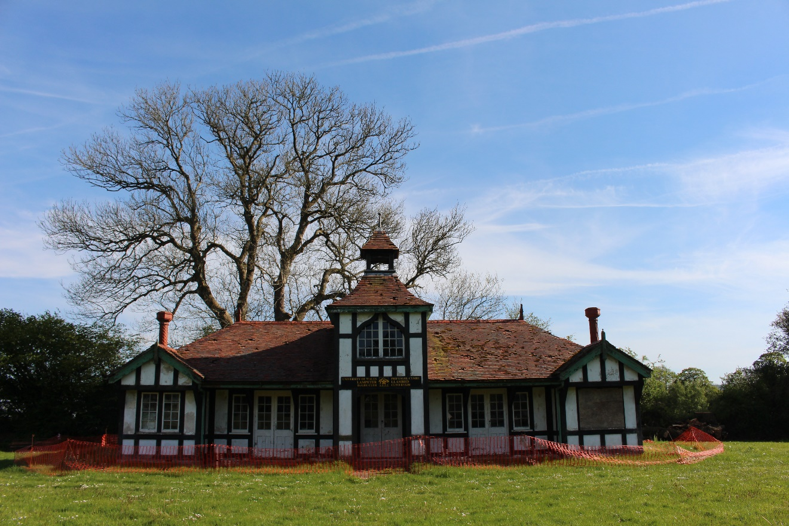

TAble of
Contents
Introduction 1
Understanding the Building & Setting 2
Assessment of Significance 6
Proposals for Re-use 6
Vulnerability & Risks 7
Conservation Policies 8
Bibliography 9
Appendix 2 – Interior Damage Photographs 10
Appendix 2 – Historical Photographs 14

Introduction
This Conservation Management Plan is for Lampeter Pavilion and associated playing pitches. The Pavilion is a Grade II listed building which has been deemed of special architectural interest. The property was first designated on 23/02/1999 and subsequently amended on 10/02/2012. The property is owned by the University of Wales Trinity Saint David who are also responsible for its upkeep. Currently the condition of the building puts it at risk and it is unsafe to use as are the pitches. Proposed uses for the building are that it be restored for use as a sports pavilion and the pitches repaired and maintained for university and town sports teams. Additionally, a picnic and park area to be created with barbeque facilities which will act as an outdoor area for social gatherings for the whole community. A “Town & Gown” collaboration.
Unfortunately, the building and the pitches have been allowed to fall in to a dangerous state of disrepair and the university teams have not been able to train on the pitches since last year due to frequent injuries when they did.
Many members of the sports teams were saddened by the current state of affairs. A committee has been set up including members from the university students, alumni, town council, local MP and community with the aim to encourage the university with the aid of the committee to undertake the necessary urgent works required followed by a restoration works.
The following plan is a working document and shall be updated on a quarterly basis.

Understanding the Building & Setting
Location, Layout, Site & Ownership
Exterior
The sports pavilion consists of a double story building with imitation Tudor-style half timbering to the front and sides and stone and brickwork to the back. The roof is tiled and there are two molded terracotta chimneys of different designs and wooden and terracotta finials. The chimney at the back of the building is constructed of red brick. There is a central bell tower below which there is room that has an ogee Gothic window. At each end of the building at the front there is a gable with windows below. Between the gables are recessed sections. There are three sets of double leaf doors consisting of glass windows on the upper sections. The doors directly next to the gabled sections are flanked by windows which match the glass windows of the doors. Centrally there is another double leaf door that is also recessed and directly below the bellcote and ogee window.
Interior
There are two large rooms on the ground level to the front of the building. Facing the front of the building, the room to the right has a small area to the back where there is a pantry and a toilet. The room to the left has a staircase which leads to the upper floor. The upper floor consists of only one small room which contains the ogee window. On either side of this room there are doors that open onto attic areas.
The Pavilion and the grounds that make up the playing pitches are owned by the University of Wales Trinity Saint David and the university is responsible for the upkeep of the buildings and grounds.
On paper the key stakeholder in the building’s future is the university, however, it is the local population of Lampeter and the students that will have the most to gain from the conservation and reuse of the Pavilion.
The field where the pavilion and playing pitches are was purchased by the university (which was then a college) in 1904. One assumes that the reason that the pavilion was commissioned was so that a place for the teams to change, use facilities and somewhere for the preparation of refreshments was available closer to the place of play, however, this is not explicitly mentioned.
Historical Context
The building was designed by local businessman, Llewellyn Bankes-Price in partnership with one of the Colleges’ professors, Revd. Edmund Tyrrell Green.
The purchase of the grounds was thanks Mr Harford who was Lampeter’s Lord of the Manor. The Harford family had been generous benefactors to the College since its foundation. The pavilion was made possible from surplus subscriptions that had accumulated over the years from the various sports teams.
In 1939 baths had been installed in the pavilion. During WWII pupils of Wycliffe College in Gloucestershire were evacuated to the College in Lampeter. The remaining pupils from the Saint David’s University (SDU) were forced to vacate their lodgings on campus in favour of the English students and take up residence in the town of Lampeter. Unfortunately, many of the SDU students found themselves living in lodgings that did not have bathing facilities and they were allowed to use the pavilion baths once a week. This is the only time that the pavilion has been used as anything more than a sporting respite venue. The building is not currently in use but in the past, it has always been used as a sports pavilion. While a newer changing block was constructed to the rear in 1966, the pavilion was still utilised as somewhere to shelter, prepare and consume refreshments and the upper room was used as a vantage point to observe and report on whatever sports were being played on the field.
There have been no significant changes in the fabric, contents or ownership since the building was erected. There have been some glass windows that have been replaced by Perspex sheeting. The use of the building has not changed either, however, it has been allowed to fall into such a state of disrepair by the university that it is now considered dangerous. There are multiple electrical outlets that have been taped over with warning tape not to be used. There is a damp problem to the back of the building. There are roof tiles missing leading to holes in the roof and the weakening of the upper floor. These and other repairs that are required have made the building impossible to use in its current state.
The Building Elements
The building has not developed significantly since it was built. However, behind the listed Pavilion is a new modern changing block equipped with male and female changing rooms, showers and toilet facilities.
No recent work has been carried out and the building consists of only one phase of construction.
There have been no significant alterations that have been identified. However, documentation in the form of the school magazine indicates that in 1939 a bath was installed in the Pavilion which is now no longer there. It is unclear where the bath was or when it was removed. Additionally, the kitchen cupboards are not original.
Significant architectural details externally include the terracotta chimneys, finials, half-timbering and bellcote. Significant fixtures internally include the air vent covers and the unfinished wood panelling.
Condition
The following assessment of condition has not been prepared by a surveyor.
The condition of the building at present is mixed. Structurally it seems sound although a full survey will need to be carried out. However, there are elements both externally and internally that have been neglected resulting in some urgent and non-urgent repairs being required.
Urgent Repairs & Works
Missing tiles from the roof need to be replaced.
The guttering to the building has not been maintained and much of it is now missing and needs to be replaced.
Some damp has invaded the back of the building, this should be treated before it spreads.
The upper floor and staircase have become weakened and remedial works should be carried out to make these safe.
Broken windows need re-glazing to stop any further damage from weather.
It is unclear if there is an electrical supply to the building at present. Given the state of the electrical wiring and the warning tape on many of the electrical outlets the supply should be cut until such time as a full rewire can take place.
The Pavilion currently contains assorted sports equipment, catering equipment, old sports programs etc. These have not been stored neatly and the building should be cleared of all debris and equipment that is to be retained should be stored neatly preferably elsewhere.
Setting
The Pavilion and associated playing grounds are located very near to the centre of the historic market town of Lampeter. The Pavilion is set back from the road at the farthest point allowing for a panoramic view of the playing field. Although the building is close to the centre of the town and faces the main road, it is very peaceful when sitting outside. Additionally, to the west of the structure and running parallel to the boundary is the Nant Creuddyn. The sounds of the stream can be heard from the area in front and to the side of the Pavilion adding to the peaceful nature of the site. To the east of the Pavilion is an assisted living facility, Lampeter Tennis Club and Lampeter Bowling Green.

Assessment of Significance
In terms of architecture the Pavilion has been deemed important as it was an unusual example of a sports pavilion. The architect, Llewellyn Bankes-Price was a local businessman who also designed the school in Bryn Road that has recently been demolished, The Victoria Hall and the War Memorial in Lampeter.
But, for many of those interested in the Pavilion it is the place in history and memory where the most significance is held. Lampeter and more specifically the university is considered to be the birthplace of rugby in Wales. The game was introduced to students by Rev. Professor Rowland Williams who used to play as a student at Kings College, Cambridge in the 1850s with the first competitive match in 1866. The game went on to what could be argued is the Welsh national sport.
Sport played an integral part in the university’s curriculum. To this end it was the surplus subscription money from the sports societies that paid for the pavilion and the playing fields were purchased due to the generosity of Mr Harford who was one of the university’s benefactors. Such was the celebration that the Welsh International Rugby Union XV played the opening game in 1910 against the St. David’s XV. Given Lampeter’s connection to rugby there have been some high-profile matches played on the pitches with the Pavilion being used as a vantage point for commentary. The Pavilion and associated pitches are held in warm regard with alumni of the university and the local community.

Proposals for Re-use
The use of the Pavilion and Playing Grounds has not changed since their inception and there is no desire from the interested parties to overly change the function of Pavilion and adjoining pitches. They have always been used as a place to play sport and the Pavilion has always been used as a clubhouse. Only during WWII, did the Pavilion function alter so that the university students that had been forced to relocate into the main town were allowed to use the Pavilion as a place to take a bath once a week.
Only in the last year have the sports societies ceased using the playing pitches due to their condition. The Pavilion has been deemed dangerous by the university and is also no longer in use. The university students have set up a committee with representatives from the university sports teams, societies, alumni, local historians, local council members and county council representation. There is a vested interest that the playing pitches and the Pavilion are restored so that both the university and the local community can make use of this valuable commodity.
There have also been suggestions that the use of the space is widened and that a small picnic area outside with a possibility of some built in barbeque facilities be constructed. Additionally, there is enough space that a landscaped area could be constructed in such a way that it can be used as a park or a playing area for ball games, frisbee or relaxing. Lampeter, has a high population of young people in addition to the university students. The last census indicates that Lampeter has a population of nearly 3000 and approximately another 1000 is added to that figure when you take into account the university. Yet there are very few outside spaces for people to visit or congregate. It is hoped that if this can be a more inviting area for the local community then it can be used to inspire both students and townspeople of all ages to become more involved in sports. Additionally, the picnic area will serve as a place that people can come together socially. In the true spirt of the origins of the Pavilion, this project is an example to Town and Gown collaboration.

Vulnerability & Risks
The building is currently and has always been owned by the University of Wales Trinity Saint David. Under their ownership in the past, the Pavilion was a source of pride and was well looked after. However, since its listing in February 1999 the building has suffered from neglect. On the official listing, one of the reasons for the designation was that it was “especially well preserved”. The building is currently disused due to its state as some parts of the building are now deemed to be dangerous. There are electrical issues and warning tape has been placed over the sockets. This neglect and disuse have also led to some vandalism. It could be argued that the university have no interest in maintaining the building and are completely unsympathetic to its condition. The university has previously tried to sell the Pavilion and the land in 2011.

Conservation Policies
Policy 1: Given the interest that has been expressed by so many parties throughout Lampeter, the current students and alumni of the university to conserve and restore the Pavilion and associated playing fields it is necessary to encourage the university to take an active role to ensure that this goal can be achieved.
Policy 2: To reassure university that the newly formed committee will aid with fundraising so that the cost of works will not be prohibitive.
Policy 3: To ensure that this effort to conserve and restore the Pavilion and playing pitches to a suitable standard remains a combined effort between “Town & Gown” for the good of the whole community.
Policy 4: To ensure that all urgent works are undertaken as soon as possible and that once these have been completed to ensure that regular maintenance is carried out so that the site never falls into such disrepair again.
Policy 5: To ensure that initial fundraising is for remedial works but that further fundraising will actively be sought for restoration works.

Bibliography
Anon (2016). St David's College Cricket Pavilion, May 1914. [image] Available at: https://www.facebook.com/photo.php?fbid=10157148402445271&set=g.2404221966&type=1&theater&ifg=1 [Accessed 14 May 2019].
Anon, (1908). Saint David College Magazine, (X), p.68.
Anon, (1910). Saint David College Magazine, (X).
Barkley, A. (2006). College VS Old Boys '05. [image] Available at: https://www.facebook.com/alex.barkley.7/photos [Accessed 14 May 2019].
Cadw. (2019). Listed Buildings - Full Report - HeritageBill Cadw Assets - Reports. [online] Available at: http://cadwpublic-api.azurewebsites.net/reports/listedbuilding/FullReport?lang=en&id=21392 [Accessed 24 Apr. 2019].
Davies, D. (2016). Welsh Union and SDC Rugby Football Teams 1968. [image] Available at: https://www.facebook.com/photo.php?fbid=10157152551065271&set=g.2404221966&type=1&theater&ifg=1 [Accessed 14 May 2019].
Davis, D. (n.d.). Lampeter Pavilion 1909. [image].
Historic Wales. (2019). Historic Wales. [online] Available at: https://historicwales.gov.uk/#zoom=7&lat=248098.49988&lon=257415.32512&layers=BFFTFFTFFTTT [Accessed 23 Apr. 2019].
Misstear, R. (2016). Birthplace of Welsh rugby celebrated 150 years on. [online] walesonline. Available at: https://www.walesonline.co.uk/news/wales-news/little-town-birthplace-welsh-rugby-11042012 [Accessed 10 May 2019].
New Pavilion for St. David's College Lampeter. (1909). The Architect and Contract Reporter, p.280.
Principal's Report. (1910). Saint David’s College Magazine, (Vol. X, no. 3,), p.139.
Roberts, S. (n.d.). Pavilion.
Welsh Rugby Union. (2019). History. [online] Available at: https://community.wru.wales/the-wru/about-the-wru/history/ [Accessed 21 May 2019].

Appendix 1 – Interior Damage Photographs
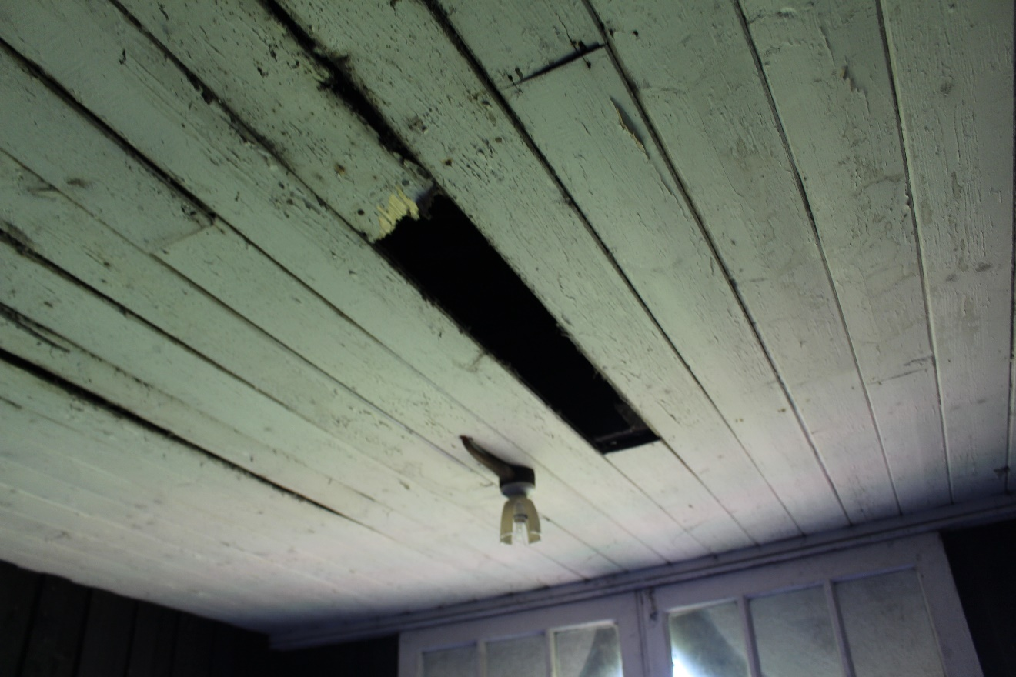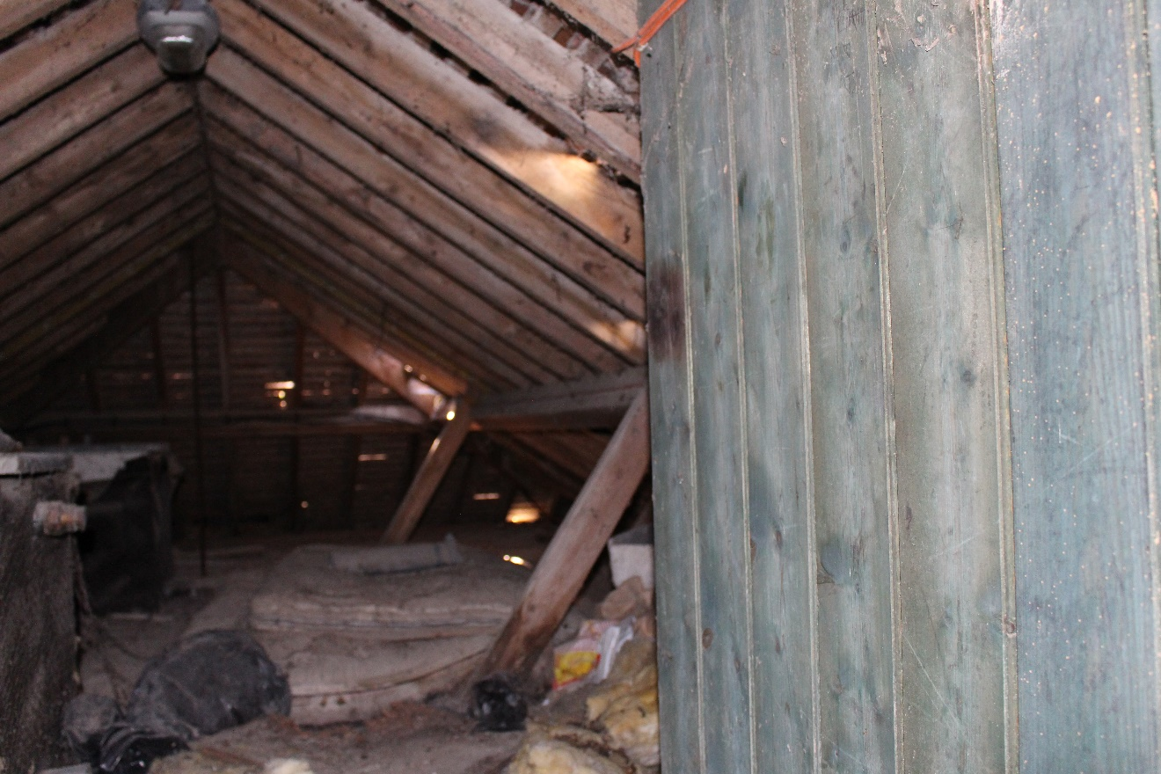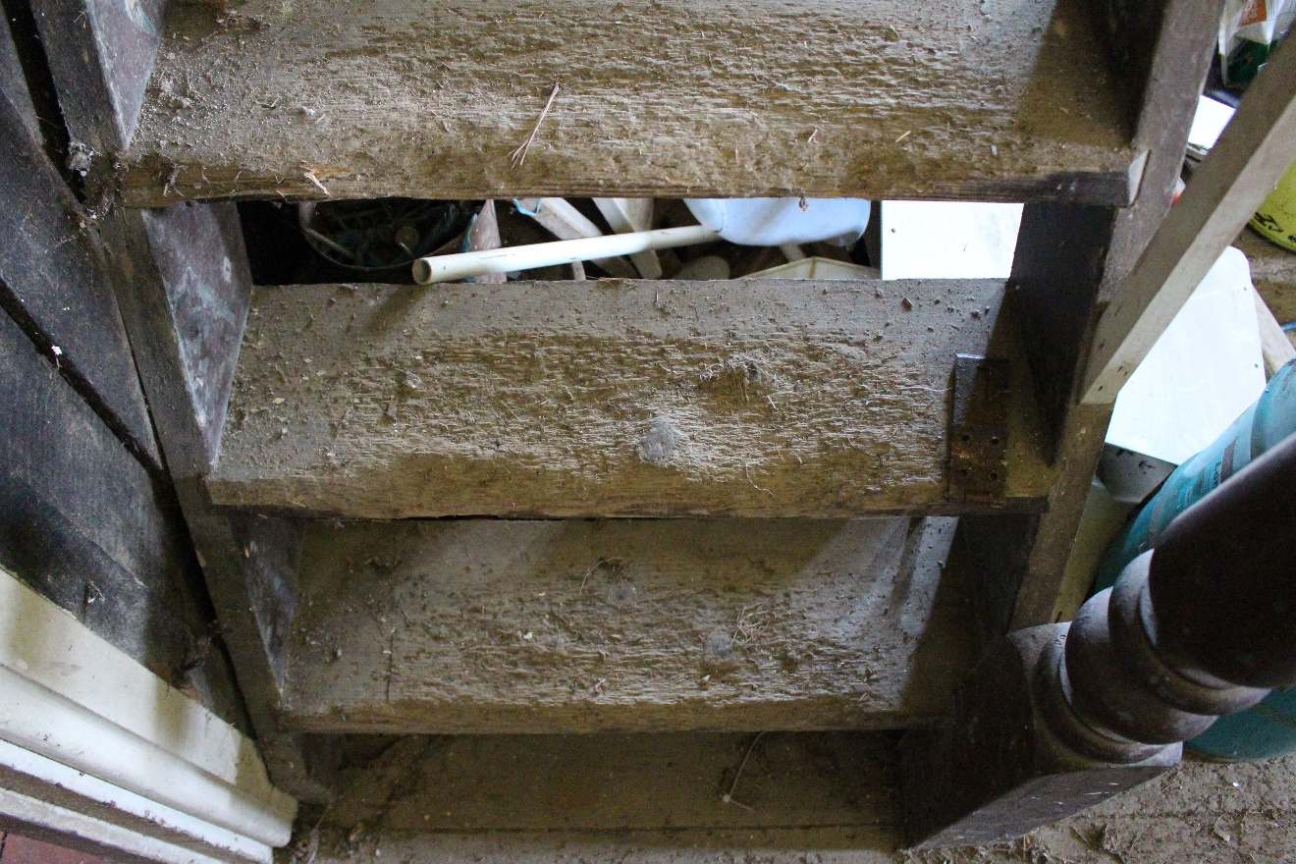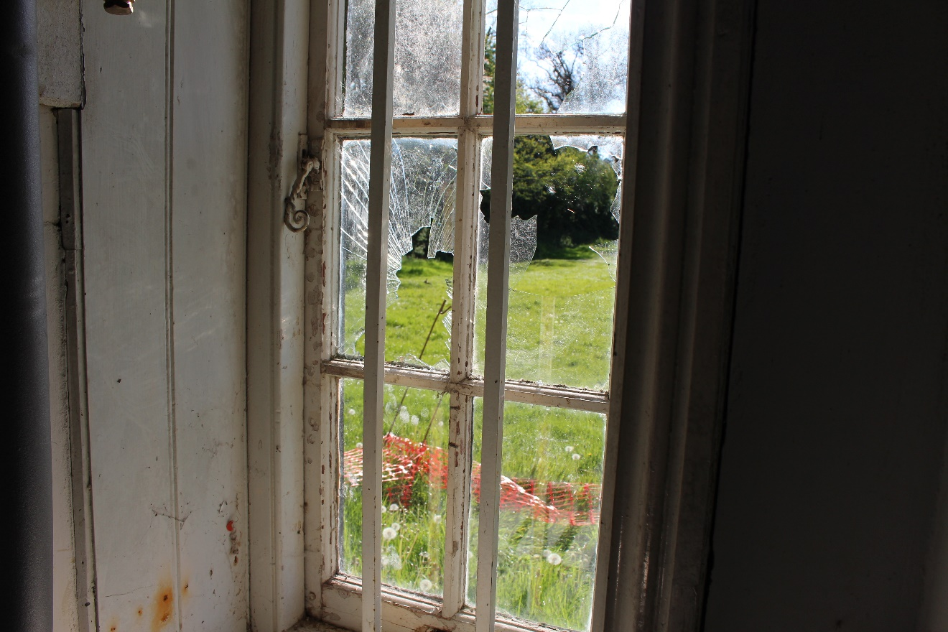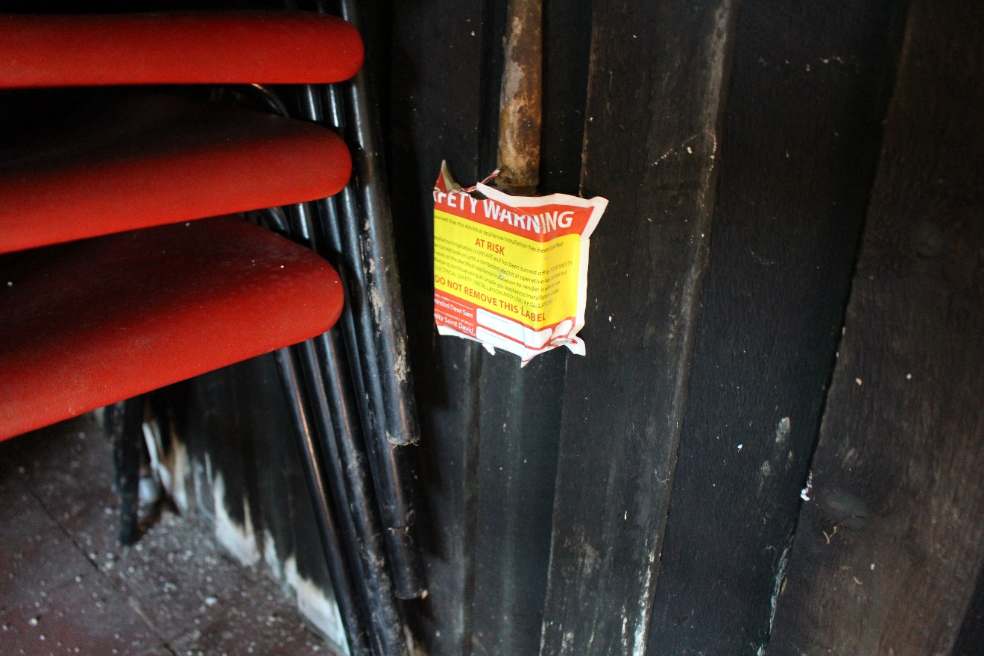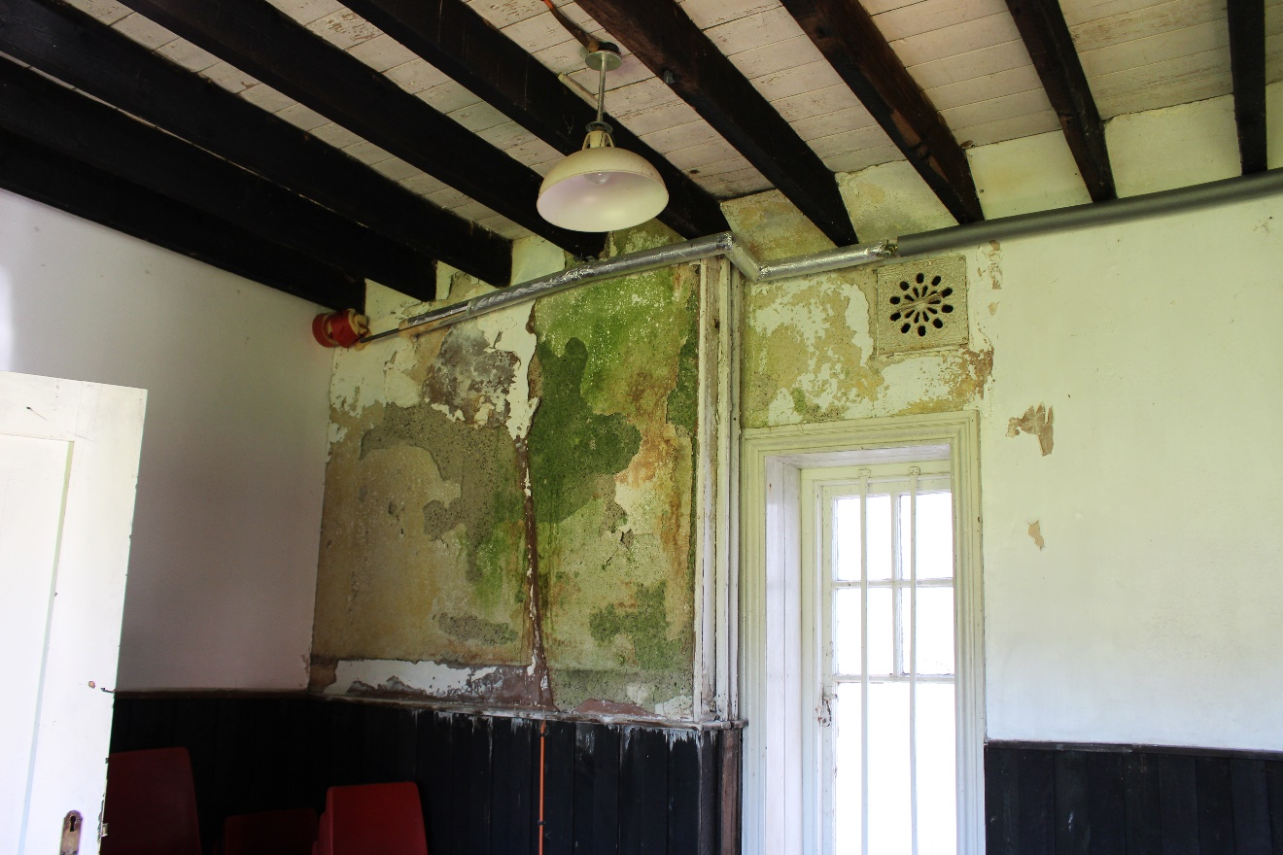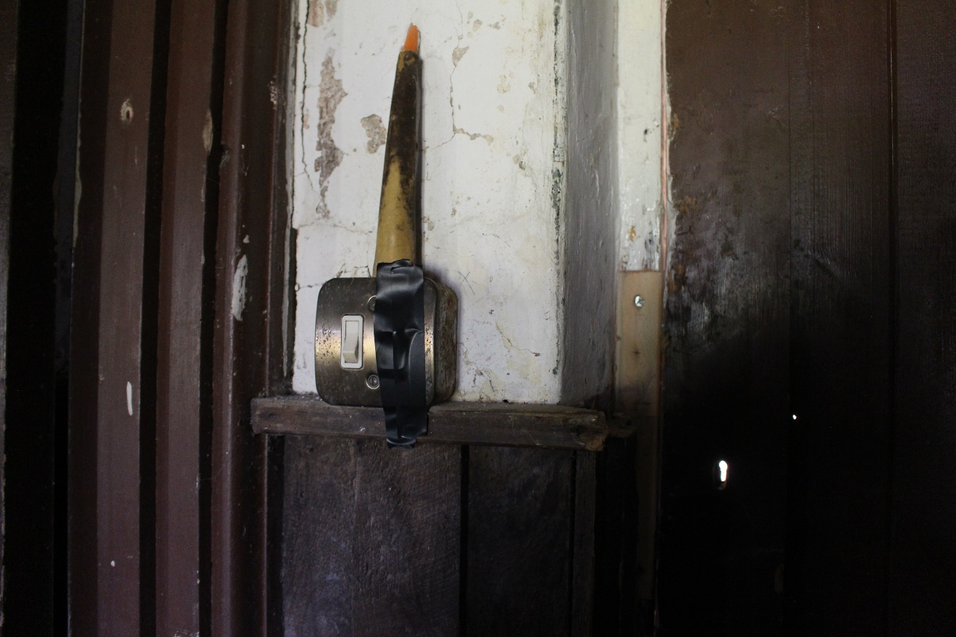
A collection of photographs depicting ceiling and roof damage, broken windows, badly worn stairs, damp and electrical issues – (V. Genn, 2019)

Appendix 2 – Historical Photographs
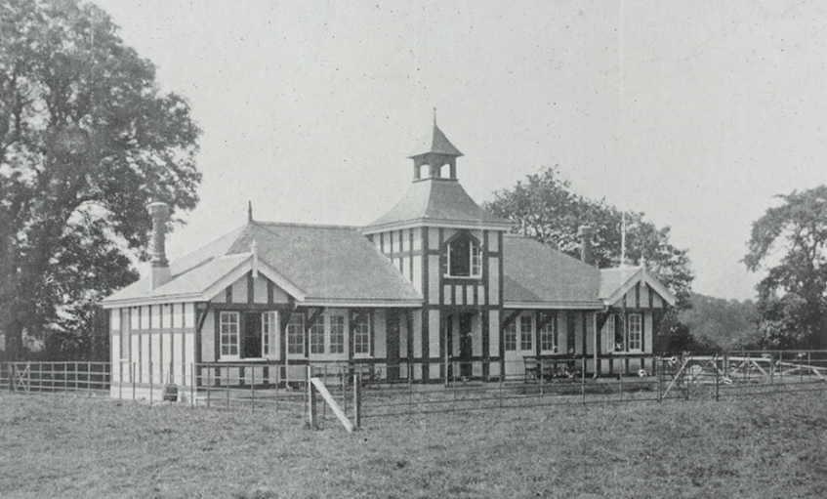
Lampeter Pavilion 1909, (D. J. Davies, 1909) – (Saint David College Magazine Vol. X, 1910)
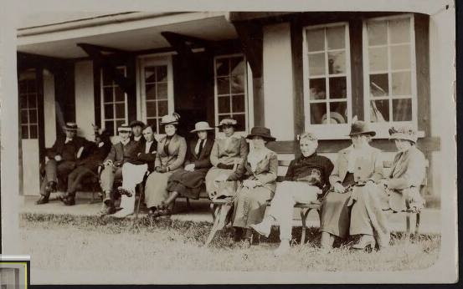
St David’s College Cricket Pavilion (Anon, May 1914) – (Tim Griffiths post on The Lampeter Society Facebook Page, 2016)

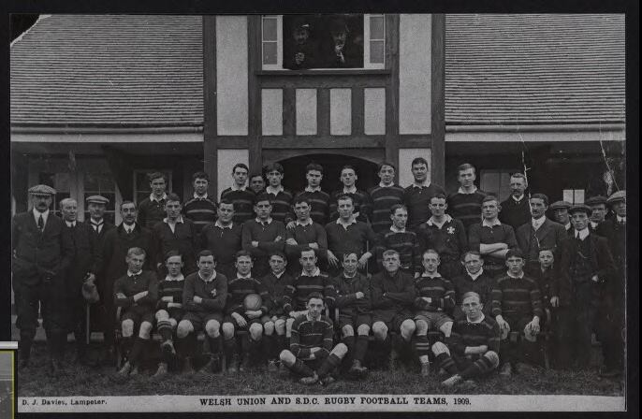
Welsh Union and SDC Rugby Football Teams 1909, (Davies, 1909) - (Tim Griffiths post on The Lampeter Society Facebook Page, 2016)
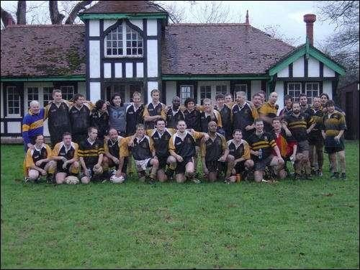
College VS Old Boys 2005 – (Barkley, 2006)
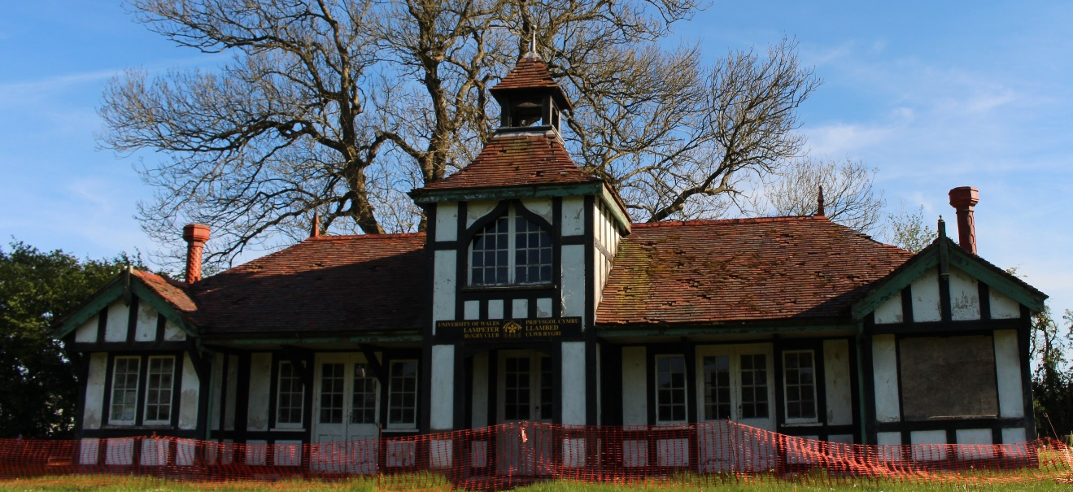
Lampeter Pavilion May 2019 – (V. Genn, 2019)

