Ramona Iulia Ungureanu

2028821

BMSW4002 - Effective Team Work and Communication

Lloyd Beharry

- Introduction
‘Communication’ is the act or process of using words, sounds, signs, or behaviours to express or exchange information such as your ideas, thoughts, feelings, etc., to someone else (Britannica, 2022). It is vital in the work place to have a clear communication since it is essential to express a concept in a clear way in order that everybody understand it. If this will not happen, the poor communication often creates a tense environment where people are not motivated to be productive and not inspired to collaborate. The consequence of this lack of motivation then affects how employees relate to clients and potential customers, negatively affecting the bottom line (Khan, 2021). However, the poor communication could lead to a lack of predictability and stability within the workplace, consequently, an uneasy environment for employees to work in. Employees might not clearly understand their objectives for the week or might misunderstand the process for a project, leading to unproductivity and ineffectiveness at their job (Khan, 2021).
2. Models of communication
2.1 Shannon and Weaver (1948/49)
Shannon and Weaver Model is designed to develop a good communication between sender and receiver in which they find some factors which influences the communication process called “noise”. The model is formed by Information source, transmitter, Noise, channel, message, receiver, channel, information destination, encode and decode (Shannon and Weaver Model of Communication, 2022). The below is the explanation in details of Figure 1:
- Sender: the author of the message selects message
- Encoder: the transmitter which converts the message into signals
- Note: the messages are the sender are converted into signals such as waves
- Decoder: the opposite process of encode
- Note: the receiver converts those waves into message which is understandable for receiver. If this will not happen the receiver is not able to receive the exact message and it will affect the communication between sender and receiver
- Receiver: the destination of the message from sender
- Note: based on the decoded message, the receiver gives their feedback to sender
- Noise: messages are transferred from encoder to decoder through channel. However, in the meantime those messages could be affected by a noise which might distract in the channel during the transmission process which will have an impact on the communication flow or the receiver may not receive the correct message
- Note: the model deals with external noises which affects the messages or signals from external sources (Shannon and Weaver Model of Communication, 2022).
According to case study of “Maria and Pedro”, Pedro misunderstood Maria due the noise of his workplace which is the building site and instead understanding “chicken” he heard “kitchen”. The model of Shannon and Weaver is the model which best describes the scenario since it is based on Sender-Noise-Receiver where in the scenario above the sender is Maria, Noise is the building site and Receiver is Pedro. However, the misunderstanding could be avoided if Pedro could have repeated the word that he understood consequently, Maria could help him to understand the right word even though the background was noisy.
An example of a similar scenario of the case study of “Maria and Pedro” happened recently to me in my workplace. I work in a university in the reception and one of my usual duties is answering calls. Most of the time when students call their background is noisy (such as underground, supermarket) and at the time that I ask them their student ID number always through the phone the number eight gets confused with zero. To avoid misunderstanding I usual repeat the numbers once they finish talking. To get mistakes from a noise is very easy on the other hand there are a lot of ways to avoid it such us repeating the word after hearing that.

2.2 Schramm (1954)

According to Figure 2, Schramm’s Model is different from the one of Shannon and Weaver. Schramm’s Model is not a traditional model rather then a practical one in which it breaks the model between sender and receiver. As soon as the information reaches the recipient its responsibility is understand what the speaker intends communicate. As Figure 2 demonstrates the Schramm’ model is circular, from the sender to receiver and back to sender. The model is a dynamic model which shows how a situation could change, why redundancy is an essential part and feedback which is the central feature (Schramm’s Model of communication, 2022). “In this model interference could be voided through feedback which is a way to measure how the audience has received the message. This enables the sender to improve the effectiveness of the way messages are composed and sent. It is essential for effective communication in an open communication environment to offer the opportunity to provide feedback” (Janse, 2022).
In the case study of “Maria and Pedro”, Pedro could have phoned Maria to ask if she did mean “kitchen”. In Schramm model this is called feedback, which is helpful since it helps the audience to receive a clear and effective message and do not create or have confusion between the sender and the receiver.

2.3 Berlo (1964)

Figure 3 represents the “Berlo’s SMCR” which is similar to the others. He described the factors which affects the individuals in the communication and it makes the communication more efficient. The model is based on encoding and decoding in other words it happens before sender sends the message and before receiver receives the message. The model of Berlo has four components in order to describe the communication process. They are sender, message, channel and receiver. Each of the component is affected by many factors (Janse, 2022).
- Sender: The Sender is the source of the message or the person who originates it. The below are the factors related to sender and is also the same in the case of receiver.
Communication Skills
Attitude
Knowledge
Social Systems
Culture
- Message: The Message is what is being sent to the receiver by the sender. It could be in the form of voice, audio, text, video or other media. The key factors affecting the message are:
Content
Elements
Treatment
Structure
Code
- Channel: The Channel is the medium used to send the message and the fives sense of a human being has been used, which are:
Hearing
Seeing
Touching
Smelling
Tasting
- Receiver: The Receiver is the person who gets the message sent in the process. This model is sticked with the thinking pattern and all other factors mentioned above must be in sync to that of the sender for the communication to be effective. The receiver must also have a very good listening skill. Other factors are similar to that of the sender.
Communication skills
Attitudes
Knowledge
Social Systems
Culture (Janse, 2022).
In the case study of “The Professor and the Village People”, The professor was living in a house nearby the village. One night, he felt asleep while smoking his pipe and the pipe felt onto the carpet and started a fire, consequently he went out screaming a couple of times ‘The edifice is being consumed by a great conflagration!’ but nobody helped him. The day after, he went to the village crying asking to people why they did not help him and they answered him why he did not say that the edifice which was burning was his house. Subsequently, the village people did not help the professor since he was not been clear expressing the message: he mentioned the edifice and not his house. To received help from the village people he should have said “My house is being consumed by a great conflagration”
In my workplace happens a similar situation, in regards of the student ID cards. A student was asking me his student ID card, which already got, instead of a student discount card.

3.0 COMMUNICATION SKILLS

Robinson and Robinson (1982) noticed that many factors may edge to a inability of listener to caught what a speaker means. At my workplace, for instance, the manager calls a meeting of all member of staff in the morning and tells them what they have to do for the day. He is Irish consequently speaks quickly to us, which English is not first language and do not understand him. When he finished to speak, he leaves the room and a lot of confused staff. We do not get to ask for clarification, which could be dangerous because one of our duties is to give students the right information about heir exam and we need clear instructions. In the case of Maria and Pedro, the confusion could have been avoided if there was feedback. Similarly, our manager should ask us if we understand what he had said. This will avoid confusion and accidents.

4. THE ADVANTAGES and DISADVANTAGES of Communication TECHNOLOGY

The communication technology is based on electronic system used for communication between individuals or groups. It makes easy the communication between individuals or groups who are not physically present at the same location. Systems such as telephones, telex, fax, radio, television, and video are included, as well as more recent computer-based technologies, including electronic data interchange and e-mail (Communication of Technology: Advantages and Disadvantages, 2012). The next few lines present advantages and disadvantages of the communication technology. The advantages of the communication technology are that it is a more efficient way and faster method of communication during emergencies, individuals are able to communicate from anywhere in the world and communicate with long distance is easier. On the other hand, the disadvantages of the communication technology are that it is hard to use for individuals of older generations, the cyber-bullying and cyber-skyping made possible, it is not always reliable, it makes communication less personal and you not always sure who you are communicating with (Communication of Technology: Advantages and Disadvantages, 2012).

CONCLUSION

Concluding, at the begging of the above assessment, it gives the definition of communication. Once understood the meaning, the paper demonstrated the strategies for an effective team working and explained a range of communication skills to be successful in the workplace. The previous lines are been demonstrated in the assessment through three models of communication which are Shannon and Weaver (1948/49), Berlo (1964) and Schramm (1954) and the communication skills and the advantages and disadvantages of technology in communication. For every of each theories a case study has been applied with examples of poor communication in the workplace and suggestions how it could be improved.

REFERENCES

- Britannica, E., 2022. Communication Definition & Meaning | Britannica Dictionary. [online] Britannica.com. Available at: <https://www.britannica.com/dictionary/communication> [Accessed 15 August 2022].
- Communication Theory. 2022. Shannon and Weaver Model of Communication. [online] Available at: <https://www.communicationtheory.org/shannon-and-weaver-model-of-communication/> [Accessed 17 August 2022].
- Janse, B., 2022. Berlo's SMCR Model of Communication. [online] toolshero. Available at: <https://www.toolshero.com/communication-methods/berlos-smcr-model-of-communication/> [Accessed 18 August 2022].
- Janse, B., 2022. Schramm Communication Model. [online] toolshero. Available at: <https://www.toolshero.com/communication-methods/schramm-communication-model/> [Accessed 18 August 2022].
- Khan, H., 2021. The Causes & Effects of Poor Communication in the Workplace | Simpplr. [online] Simpplr. Available at: <https://www.simpplr.com/blog/2021/causes-effects-poor-communication-workplace/#:~:text=Poor%20communication%20often%20creates%20a,negatively%20affecting%20the%20bottom%20line.https://www.simpplr.com/blog/2021/causes-effects-poor-communication-workplace/#:~:text=Poor%20communication%20often%20creates%20a,negatively%20affecting%20the%20bottom%20line.> [Accessed 15 August 2022].
- Mackenziejones212.blogspot.com. 2012. Communication of Technology: Advantages and Disadvantages. [online] Available at: <http://mackenziejones212.blogspot.com/2012/02/google-chrome-advantages-and.html> [Accessed 21 August 2022].
- QS Study. 2022. Schramm’s Model of communication. [online] Available at: <https://qsstudy.com/schramms-model-communication/#:~:text=Schramm's%20Model%20of%20Communication%20was,words%20and%20conveyed%20to%20others.> [Accessed 18 August 2022].

APPENDIX

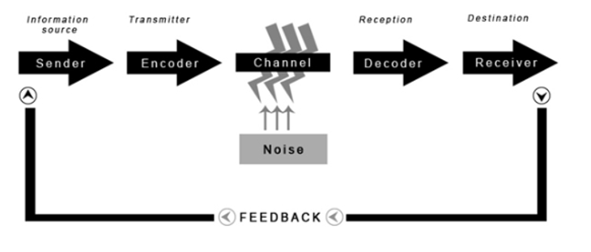
Shannon-Weaver Model of Communication – Figure 1 (Shannon and Weaver Model of Communication, 2022)

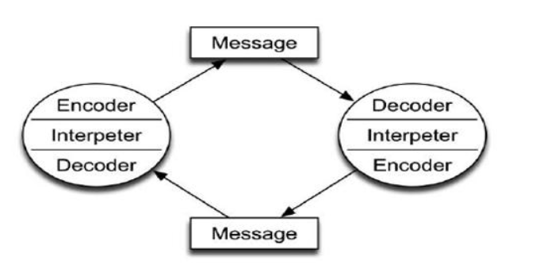
Schramm (1954) – Figure 2 (Schramm’s Model of communication, 2022)

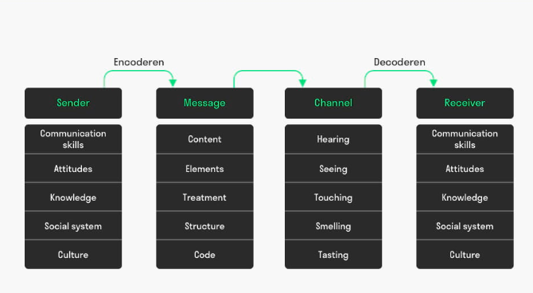
Berlo (1964) – Figure 3 (Janse, 2022)

