Student: 1705196 Michele Russell
BA Course: Architectural Glass

Task: Independent Inquiry (ADAD6001)
Tutor name: Julia Lockheart

Title of Independent Inquiry
An investigation into art and the emotions and how they relate to the use of stained-glass, specifically in churches in post-war Germany.

Submitted in partial fulfilment of the requirements for the degree of BA (Hons) University of Wales Trinity Saint David, Swansea College of Art.

Word count: 6,591
(Excludes Summary, References / Bibliography and Appendices)

10th October 2019

TABLE OF CONTENTS |  |  | PAGE
1.0 | Summary |  | 3
2.0 | Introduction |  | 4
3.0 | Chapter One | An Exploration of Art and its Link to the Emotions | 7
4.0 | Chapter Two | Understanding Emotions and Their Link to Art | 13
5.0 | Chapter Three | The Use of Stained-Glass as an Emotional Medium | 19
6.0 | Chapter Four | The Role of Emotion in the Re-creation of Glass in German Churches Post-war | 26
7.0 | Conclusion |  | 34
8.0 | References/ Bibliography |  | 36
9.0 | Appendix 1 | List of illustrations | 42
10.0 | Appendix 11 | Interviews | 47

1.0 Summary

The topic of this independent inquiry is the emotional value of art. The aims are to consider the potential for art to release emotions in both artists and viewers. The objectives are: to research the emotional experiences of artists and whether it affects their art; to explore how viewers connect with art and whether the emotions created for both groups are the same; to learn about emotions; and to consider the use of stained-glass as an emotional medium in churches generally and specifically in post-war Germany.

2.0 Introduction

This independent inquiry attempts to address the issue of the emotional value of art. It will explore whether artists use creativity as an emotional release, if viewers use art to satisfy emotions and whether these two groups are connected. It will research how emotions are created and how the emotional lives of artists affect their work. It will consider to what extent stained-glass has been used as an emotional medium and if historically, it has contributed to the emotional welfare of communities.

My interest in this subject began as I needed to draw for my stained-glass practice. I was not always able to draw; I feared drawing. One day, whilst sitting in a hospital corridor, awaiting my husband’s cancer diagnosis and under enormous stress, I instinctively started to draw. I couldn't stop, I felt my tension ease. I wanted to understand why drawing was helping me and was I alone in the use of such therapy. The artists I researched have been important in my own emotional development.

The issues and focus of my research explored the connection between an artist’s life and their creative output, the effect of art on the viewer and their combined emotions. Further issues involved understanding emotions, the history of stained-glass and its emotional power and the creativity of Johannes Schreiter as a major contributor in pushing boundaries in glass. This led to a personal and emotional investigation into the role of the Church in Nazi Germany.
My sources for artistic research concentrated on the UWTSD library facilities. The library catalogue also proved invaluable for research into non-artistic subjects. I used the internet for directional leads. Interviews in the UK and a trip to Germany, exploring the life and career of Johannes Schreiter, were valuable as a primary research tool.

This investigation is important because we are seeing increasing amounts of mental illness in school-age children as well as in the wider community. In seeking to understand if art can help to combat this social condition, it has prompted me to further study the use of art in youth clubs where I volunteer.

This inquiry is structured into four chapters. Chapter one considers what is art, how it is used by artists and viewers, the mutual understanding between them and the possible links with emotion.

Chapter two examines emotions from an etymological, scientific and philosophical perspective. It discusses the emotional lives and work of three artists.

Chapter three investigates the history of stained-glass through to the present day, its use to emotionally instruct and enlighten congregations and its attempts to be accepted into mainstream art.

Chapter four explores the role of the Church in Nazi Germany and how this facilitated the career of glass designer Johannes Schreiter as he contributed to the design of a new visual language for the German people, helping them post-war to create a new emotional beginning.

3.0 Chapter One – An Exploration of Art and its Link to the Emotions

An exploration of the word art, shows that it is ambiguous. Raymond Williams says that it was known originally as “any kind of skill” and first used in the 19th century (1976, p.40). In this inquiry, art refers to any tangible object, created by a person for themselves or a wider public; to use, to enjoy or simply an expression. We do not know the origins of art but Ernst Gombrich reminds us that stone age man used coloured earth to create bison on walls of their caves (1995, p.15) and that all peoples, throughout the world, create (1995, p.39). We can assume there is a need and an emotional comfort in using art as a common language.
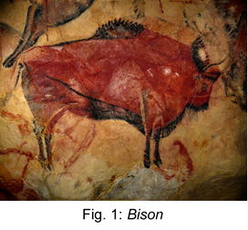
Whatever the objectives in creating a work of art, as viewers we usually have a view about its artistic value and believe we comment knowledgeably. Whether our homes are simplistic or overly decorated, we find space for art. Alain De Botton says that hanging a piece of art in our homes, acts as an emotional “guardian of a mood” (2006, p.121) and reminds us to remain true to our “authentic self” (2006, p.119). He suggests that we use our “surroundings” and therefore art, to remind us of who we really are and to effectively ground ourselves; we call these places “home” (De Botton 2006, p.106). De Botton believes that when we feel sad, out of control and at odds with the world, yet see a work of beauty and order, we weep not for the beauty itself, but for that which we yearn within ourselves (2006, p.150). Therefore, art it seems gives us an emotional connection to ourselves and the external world. It connects us to our inner, real self and beautiful art causes us to strive for beauty within ourselves. We use art to make ourselves feel safe and at home, whether that is the place in which we live or places like Churches that make us feel at home.

Our view of a work of art can change depending on our own emotional feelings. Wilhelm Worringer’s essay Abstraction and Empathy (1907) gives two examples (De Botton, 2006, p.154). Abstract art seeks “symmetry” and “order” and attracts people in times when they need “tranquillity”, whereas “realistic art” evokes “vibrancy” and appeals to people when they feel secure and need to find “intensity of feeling” (De Botton 2006, p.156-157). Our view of art possibly changes as we change, thus our connection with last year’s picture hanging changes too, alongside our emotions that it once invoked.

Our understanding of the viewer’s emotional connection with a work of art is just one side of this story, an investigation is required into the link between an artist’s state of mind and the creation of their art. Artists are often unsure of what they will produce until they begin to create, Jenefer Robinson says “all he is conscious of is a perturbation or excitement” (2005, p.235). Quoting Robin Collingwood, Robinson goes on to say “art is an expression of the artist’s emotions” (2005, p.239). Marcel Duchamps agrees that we all “struggle toward the realisation...a series of efforts, pains, satisfaction, refusals, and decisions” (1957). It would reasonable to assume that artists draw what their eyes see and how their mind interprets the scene. Juhani Pallasmaa describes this as “the seamless and unconscious collaboration” (2009, p.82). He says that when working in harmony, the artist feels a voyeur as the work “seems to be producing itself” (Pallasmaa 2009, p.82). Pallasmaa quotes Cezanne “The landscape thinks itself in me, and I am its consciousness” (2009, p.82). Robinson adds when the creation is completed, they feel free “in a way from which this sense of oppression has vanished” and “mind is somewhat lightened and eased” (2005, p.235). Being an artist is always a struggle, what you want to create and what you achieve never seems good enough, but it is this struggle that keeps an artist feeling alive.

If we accept that both artists and viewers feel emotions about a work of art, it raises the question as to whether we are experiencing the same emotions. John Berger says, “When we see, we are not just looking - we are reading the language of images” (1972, back). Using the example of Van Gogh's “Wheatfield with Crows” (1890), Berger suggests that we first see it, we look at it for what it is; crows in a field of wheat, an ordinary image (1972, p.27-28). However, when Berger confirms that it was the last picture Van Gogh painted before committing suicide, he suggests that emotionally, we view it differently – the image now foreshadows the action that followed (1972, p.27-28). Our emotion – memories of the tragedy of the artist, has not changed the image but has altered how we, the viewer, respond. Van Gogh’s darkness has been well documented and he commentated on this picture himself “returning there, I set to work. The brush almost fell from my hands...I had no difficulty in expressing sadness and extreme solitude” (1890). This example suggests that there is a connection between our emotions and art for both artists and viewers, but that they are not necessarily the same.
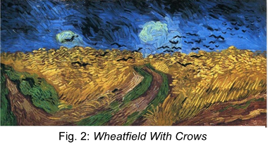
It seems that sometimes, viewers use art to display their inner dreams, artists create to express life experiences; together they are linked by their emotions. Both satisfies the others need to talk or to listen. We could express this as completion, or what Marcel Duchamps called the “co-efficient” as being “the gap between an artist’s intention and the artworks realisation – where viewers actively engage with and interpret the art” (1957). He said that an artist cannot fully express his own intent so the viewer must complete the creative act” (Duchamps, 1957). The Romantic Movement (1800-1850) would have agreed; they believed that to “understand an artwork” the viewer must be able to feel what the artist felt” (Robinson 2005, p.237). Conversely, Ursula Rothfuss gave an example of Johannes Schreiter, saying he “has no need for you to like his work, but it should make you feel differently”, she added “he does not care what you think of it and he sees no need to explain it to you, he knows that you do not need to know” (20:08:19). The viewer clearly has a role to play in the completion of works of art, they act as an important collaborator and interestingly, sometimes an interpreter.

We cannot presume that all artworks offer an emotional insight into the artist's mind. Robinson quotes Robin Collingwood as he argues that some artists create an emotion in audience that they do not feel such as those Romantic artists who were often commissioned to create emotional art (2005, p.237).
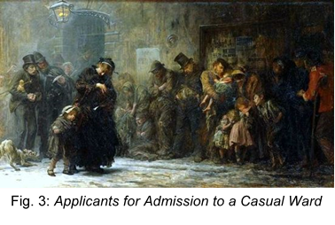
Most artists use signifiers to create emotions within us; the colour red being a signifier of danger but some are subtler, Derek Matravers suggests we look at Rothko’s “planes of colour” against Chagall’s “wistful imaginative scenes” he suggests that they both represent sadness yet their styles could not be more different (1998, p.207).
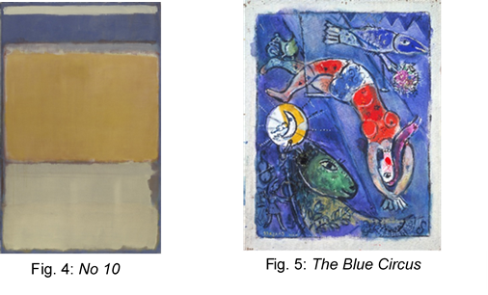
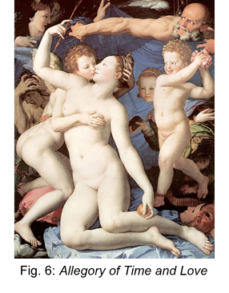
Berger offers Bronzino’s Allegory of Time and Love (1545) as a painting that contains “complicated symbolism” (1972, p.54-55). If we consider the way in which her body is arranged as “nothing to do with their kissing” but “to display her nakedness to the man looking at the picture” thus inciting an emotion of lust rather than love (Berger 1972, p.54-55). The emotional value in art still exists and can reflect the mind of the artist but it’s not prescriptive; viewers see and feel their own emotions which sometimes the artist has purposefully stimulated.
Fig. 6: Allegory Venus, Cupid, Folly and Time

In summary, art is normally any tangible object created for expression, it is a common language that connects people. Viewers use art to connect with their inner being and make themselves feel at home. It can be affected by our emotions that may change over time. Artists often struggle to create and feel there is a higher power guiding them. Together, we complete a work of art but as artists or as viewers, our emotions are not always the same. Art has some emotional value but sometimes it is formulated to invoke emotion in the viewer.

4.0 Chapter Two – Understanding Emotions and Their Link to Art

Collins Dictionary notes that the origin of the word: emotion, can be traced to 16th century France and the old French word esmovoir, to excite; from the Latin ēmovēre, to disturb and from movēre, to move (2019). It says that as a noun, it means “any strong feeling such as joy, sorrow or fear”, and includes feelings “such as happiness, love, fear, anger or hatred” (Collins Dictionary, 2019). It can also be used to describe “the part of a person's character that consists of their feelings, as opposed to their thoughts” (Collins Dictionary, 2019). This would suggest that emotions are unscientific, uncontrollable reactions to events.

There is no conclusion by scientists, philosophers, psychiatrists or theorists as to how emotions are made. Scientifically, Frank Anderson tells us that the “human brain has 85 billion neurons, 100 trillion synapses and 100 chemical neurotransmitters”, the neurons talk to each other via the neurotransmitters, across gaps between themselves, they converge at synapses; these networks activate “thoughts, emotions and actions” (Anderson 2015, p.25). Amelie Oksenberg Rorty concurs, quoting Paul MacLean who says emotions come from “three layers of the brain” (1980, p.5). Thus, emotions are perhaps the brain talking to itself.

Philosophically, Robert Solomon questions whether “a person’s choice of his emotions constitutes a choice of self-identification” (Rorty 1980, p.6). Jenefer Robinson differs describing emotion as a “process” in three stages (2005, p.59). Firstly, an “affective appraisal of the situation”, which “causes physiological responses” leading to a “discriminating cognitive appraisal” (Robinson 2005, p.59). Thus, emotions are perhaps reactions to external stimuli, a set of reactionary triggers; shock, stomach churn and finally laughter as you jump at a slamming door.

Psychologically, James Averill considers “early Darwin theory” of “biological determinants” (Rorty 1980, p.5) whilst Paul Ekman “maps” and uses “facial configurations in the context” of “cultural and conventional variations” (Rorty 1980, p.5). Lisa Feldman-Barrett looks at emotions differently, “you might think that in everyday life, the things you see and hear influence what you feel, but it’s mostly the other way around: that what you feel alters your sight and hearing” (2018, p.79). She talks of emotions being linked to memories indicating that instead of being in our DNA - we are certainly not born with pre-wired emotions – our personal history dictates our emotional responses (Feldman-Barrett 2018, p.157). Thus, emotions are perhaps merely triggered memories and as such might be controllable.

Theoretically, Jon Elster, says there are “important conceptual implications” in art affecting us emotionally, he believes emotions are “triggered by a prior cognitive assessment”, such as memories (1999, p.405). Richard Wollheim agrees that emotions are linked to memories, he explains “once a memory has become the carrier of the undue influence of the past, then on each occasion of its revival this effect is likely to be reinforced” (Rorty 1980, p.315). Fortunately, today, it is possible to rewire the brain; to desensitise memories and thus emotions, known as EMDR (eye movement desensitisation and reprocessing) therapy (EMDR, 2019). All these differing views show that our understanding of emotions is still in its infancy. It would seem that when we create or look at art, our emotional response may be recreating or re-experiencing an unconscious memory that may be subject to change.

If artists express emotions in their art, and emotions are memories, then it follows that early lives affect output. Three artists are explored as evidence that memories influence works of art. Edvard Munch’s life was indeed expressed in his art; Josef Paul Hodin says that “Munch was the initiator of the movement known as Expressionism”, explaining that this was meant as a way in which “humanist concepts and attitudes could find their realisation in man’s creative work” (1972, cover).

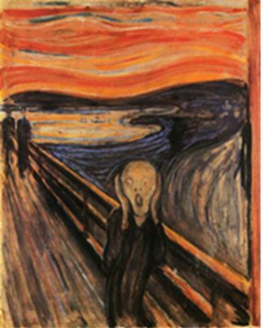
Born in Norway in 1863, Munch’s mother died when he was five and his father became “melancholy”, living “a life of seclusion”, his belief in religion “grew out of all proportion” and he had “a difficult temper, with nervousness and periods of religious anxiety which bordered sometimes on insanity” (Hodin 1972, p.11). He said of his childhood: “I always felt that I was treated unjustly, without a mother, sick and with the threat of punishment in hell hanging over my head” (Hodin 1972, p.12). Indeed, elements of this background can be seen in his most famous work, The Scream (1893), it shows raw emotion, the face contorted in panic, the background is fearful of the figures leaving him. Jenefer Robinson says the painting “articulates so powerfully a particular state of mind” (2005, p.283). Hodin concludes that Munch’s art had an “autobiographical element, the themes based on personal emotional experiences, which guaranteed the uniqueness of his art” (1972, p.203). In his life Munch feeling abandoned by both his parents, would have experienced emotions such as severe anxiety and a sense of being out of control. These themes are evident in his work and he is certainly not unique amongst artists.
Fig. 7: The Scream

Piet Mondrian’s (1872-1944) work of few lines and fewer colours appears at first, simplistic. John Milner, suggests that Piet Mondrian was “a fastidious individual”, living in “an apartment of cell-like severity”, his studio was “stark” and his pictures hung, in order, on the walls (2002, p.7). He lived a simple life with little money, food or possessions, the latter being limited to a gramophone, however he was always dressed with a “neatness approaching elegance” (Milner 2002, p.7). Born in 1872 in the Netherlands, Susanne Deicher says that Mondrian’s father was an impoverished “religious zealot” with an invalid wife, resulting in Mondrian being raised by his 8-year-old sister; “Piet must have lost his trust in the world and humanity at an early age” (2096, p.7). Throughout his life, he was unable to enjoy “lasting relationships” (Deicher 2096, p.7) and he worried about his state of mind in coming to terms with the “emotional distance from his father” (Deicher 2096, p.7-8). He found solace in the “imaginary worlds of art” (Deicher 2096, p.8). Deicher describes Mondrian’s “love of tango” and how he talked of “the rhythm of his paintings” (2096, p.7). Mondrian felt they were “moving” and that “this rhythm of the forms arouses different moods” (Deicher 2096, p.7). This is evident in a work such as the Broadway Boogie-Woogie (1943). It is possible that the emotional distance from his parents was reflected in the increasing control, lack of form and limitation of palette in his painting; eventually resulting in the abandonment of the line itself. It would be reasonable to conclude that the simplicity, precision and rhythm of his art reflected the man and his emotional life experiences.
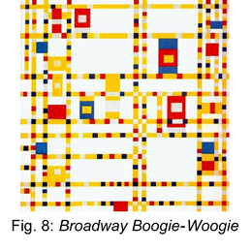
Mark Rothko’s (1893-1970) childhood was also plagued by poverty and fear that he never had the emotional resilience to overcome. Born in 1893 in the poor Jewish city of Dvinsk, Russia, the family suffered from Jewish persecution as the period 1906-1911 was the worst in the history of Russian Jewry. It was a time of fear. James Breslin contends that he was “a high-strung, noticeably sensitive child”, bullied, he witnessed the digging of mass graves and massacre; he was “profound” and “locked into his painting” (1993, p.17). As an immigrant child in the USA, he suffered feeling a loss of his previous life and felt like an “exile” (Breslin 1993, p.25). He was affected by his father’s death and declared his art as “a clear preoccupation with death” (Breslin 1993, p.27). In works such as Red on Maroon (1959), we see his solitude, emptiness and loss (Breslin 1993, p.28). Despite being the first living member of his generation to have a one man show at Museum of Modern Art, New York, the exhibition stressed him. Breslin records that on opening night, he visited a friend saying “I am in despair”, “everyone will see what a fraud I am” (1993, p.7). It is remarkable that an artist who would later achieve such public acclaim could have such emotional self-doubt, but his life story explains so much about his mental state and an analysis of his childhood. His work may be a predictor that eventually he would take his own life.
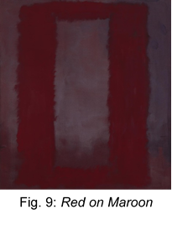
In summary, the dictionary definition of emotions is about feelings rather than thoughts but there is no agreed conclusion; scientifically emotions are neurons talking to each other, philosophically they are a process of thoughts, psychologically and the view of theorists, are that emotions are memories. It seems that the emotional lives of artists affect their art and our own emotional stories reflect what we see when we view. Munch might serve to help anxious people feel not alone, Mondrian might make compulsive behaviour more acceptable and Rothko might make some people feel safe. The emotional value in art is the release of these emotions for both artists and the audience.

5.0 Chapter Three – The Use of Stained-Glass as an Emotional Medium

We have noted the emotional value in art, recognising that artists sometimes create artworks to stimulate emotions in viewers. An example of this creation is to be found in stained-glass in churches. Early Christians had believed the more beautiful the environment, the more faithful the congregation. Alain De Botton explains their thought process: “a beautiful building could reinforce our resolve to be good” and so “the delicate setting of a pane of glass” might enhance the delivery of “a sermon on the theme of gentleness” (2006, p.117). Catherine Brisac says that painted glass was used to tell “of the exemplary lives of Christ, his Mother, and the saints or illustrated passages from the scriptures” (1986, p.7). She quotes Bishop Durand de Mende, in the thirteenth century, “Stained-glass windows are divine writings that spread the clarity of the true sun, who is God, through the church, that is to say, through the heart of the faithful, bringing them to enlightenment” (Brisac 1986, p.7). De Botton agrees that these “early theologians” thought that the congregation would learn more by “looking” than by” reading” and thus learn “more about the nature of kindness in a stained-glass window than in a holy book” (2006, p.117). Therefore, until the Reformation and indeed beyond, congregations not able to read the bible, relied instead on their church and its verbal and picturesque teaching for their spiritual and emotional well-being. Generations of churchgoers were entranced by stained-glass telling them of bible stories throughout various art movements and their belief in the Church became unshakeable. Thus, stained-glass had found its way into the hearts and minds of communities.

Glass always had magical and emotional properties from its initial discovery and throughout history. Andrew Moor talks romantically of grinding rocks, heated to pouring consistency and cooled on a flat surface until hard and allowing light to reflect through it and onto surfaces beyond (1997, p.13). He describes it as “hard and heavy, yet also very brittle and fragile” (Moor 1997, p.13). Historically we know from Paul San Casciani that it was used in buildings as far back as Roman times when “translucent alabaster” was used to fill the gaps in buildings created for light but “by the eighth century”, “coloured glass” was being used in “ecclesiastical buildings” (1996, p.104-105). Casciani continues, that the creation of stained-glass might have come from the connection between enamellers, who used pieces of metal to hold enamels together and glaziers who created glass and subsequently held it together with leads in the tenth century; there are records of stained-glass in the twelfth century (Casciani 1996, p.104-105). At such a time, stained-glass would have been seen as remarkable and emotionally awe inspiring but it would take a statesman like Abbot Suger (1081-1151) to understand the contribution that glass could make for congregations.

Chartres Cathedral in France was the turning point for stained-glass as an emotional medium. Gombrich points to The Annunciation, in Chartres dating it to mid-12th century, he says about this time there was a new “freedom from the need to imitate the natural world that was to enable” artists “to convey the idea of the supernatural (1995, p.183).
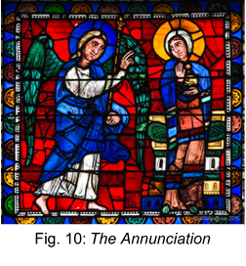
Charles Connick records that Abbot Suger was the key instigator to the new way of magical way of thinking in the creation of Chartres, he understood people; and as such knew “the spiritual values that workmen gain through work of their hands” (1937, p.6). Casciani supports this; Suger “believed that beautiful objects in churches were a tribute to the glory of God” and “the Church taught that light was the symbol of the Divine Spirit: thus, transmitted through coloured images on the screen of the windows, it brought message from heaven” (1996, p.105). De Botton agrees; it was believed “a ray of afternoon sun shining” and its reflection, was created by God (2006, p.117). People felt “a cathedral was God’s house” where the “Garden of Eden had been resurrected” and the stained-glass, casting its reflection “prefiguring that which would radiate in the next life” (De Botton 2006, p.112). Gombrich quotes from Revelations about congregations hearing “sermons and hymns of the heavenly Jerusalem with its gates of pearl, its priceless jewels, its streets of pure gold and transparent glass” (1995, p.188-189). He comments “this vision had descended from heaven to earth” (Gombrich 1995, p.189). Suger knew, as Casciani records, that people living in dark squalid conditions would have been over-awed by the colour, the painted imagery and the force of light as they entered a Church (1996, p.105). Churches were no longer “cold and forbidding” (Gombrich 1995, p.189) they were full of beautiful jewel-like stained-glass so those who entered would see the vision for themselves. This belief in beautiful surroundings continued throughout the Middle Ages and beyond, congregations continued to be “entranced” as they saw their church turn into “a heavenly Jerusalem” (Brisac 1986, p.7). Connick quotes the architect, Viollet-le-Duc who wrote that stained-glass artists “played with light and colour as musicians play with sound” (1973, p.7). God was thought to be light, and glass being a conductor of light, they became synonymous.

The problem for glass was not whether it was emotional but whether it could be accepted as art. In his thesis glass designer, Rodney Bender records that the “artist” became respected during the Renaissance and the “glazier” was expected to merely technically craft “the artist’s cartoons into stained-glass” (1986, p.6). Thus, stained-glass was not accepted as a comparable medium to sculpture and painting in terms of artistic merit. Glass designer, Andrew Moor writes how Charles Rennie Mackintosh and Louis Comfort Tiffany tried, albeit in an ornamental form, to bring stained-glass out of churches and into mainstream art (1989, p.14).
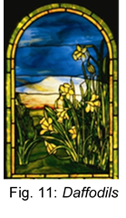

He believes Frank Lloyd Wright was its greatest visionary (Moor 1989, p.14). Yet, cheap reproductions denigrated the medium, by taking away the emotion, losing the “aura” of the original as explained by Walter Benjamin (2008, p.7). He believed that we need works to have “the here and now of the work of art – its unique existence in the place where it is at this moment”, Benjamin continued “the here and now of the original constitute the abstract idea of its genuineness” (2008, p.5); the historical changes linked with the work of art, creating wear and tear need to be present. It is this emotional aura that touches our soul in a way in which producers of reproductions, can only dream.

Patrick Reyntiens asserts that the Germans were responsible for “the greatest of the twentieth century's achievements in the medium of leaded glass” (1977, p.13). Indeed, a new art movement in 1920s Germany, the Bauhaus School - created by architect Walter Gropius and Artists Theo van Doesburg and Josef Albers, included stained-glass in the curriculum. Doesburg was influenced by the De Stijl movement in Netherlands.
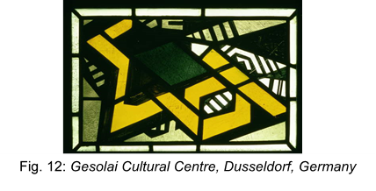
Josef Albers, Paul Klee and Johann Thorn Prikker all produced glass work of note, although less emotional in style.
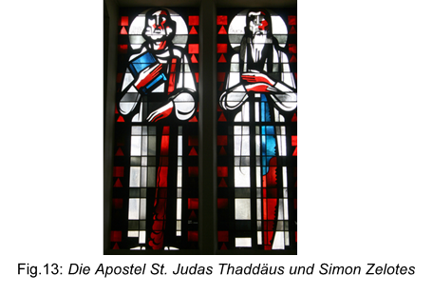
Moor tells us that students of Prikker, Heinrich Campendonck and Anton Wendling attempted to build on the Bauhaus movement with some success (1989, p.17).
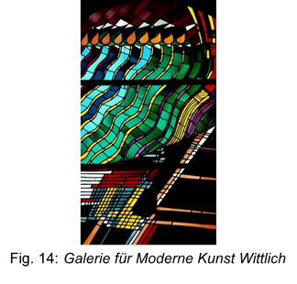
He continues that the problem with the emergence of modern stained-glass artists (such as Georg Meistermann, Johannes Schreiter and John Piper) was that they were predominantly found in churches rather than mainstream art galleries, thus continuing the emotional connection with congregations but limiting their exposure as art (Moor 1989, p.15). Since 1945, the UK has commissioned very little stained-glass in comparison to the huge volumes in Germany (Moor 1989, p.16-17). However, the opportunities for emotional innovation in Germany were far greater post 1945 and in the 21st century new British artists such as Martin Donlin and Brian Clarke have made the leap of faith from Church into mainstream art with success although it could be argued that the emotional merit of their work is now in the eye of the viewer rather acceptance by congregations.
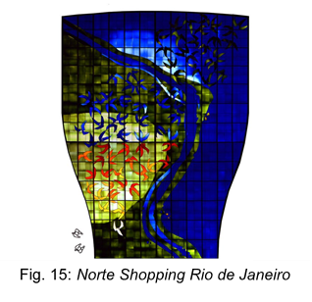
In summary, stained-glass in churches is a good example of art created to stimulate emotions. It has been used ecclesiastically to teach and to inspire communities. Stained-glass has historically been considered a design and craft occupation rather than art. In recent times, in broadening its subject matter from the retelling of bible stories it has been accepted in its own right and therefore now competes on its emotional appeal in the world of mainstream art.

6.0 Chapter Four – The Role of Emotion in Post-war Re-creation of Stained-glass in German Churches

We have discussed the importance of the church in the emotional well-being of their congregations and communities and the role that stained-glass has historically played in creating these emotions. Sadly, in 1930s Germany this unshakeable belief in the Church as an emotional, spiritual leader was tested. It had failed speak out against Nazism during the Holocaust as Robert Drinan states, quoting from Encyclopaedia Judaica (1971) “the Christian response” was “mild, vague and belated” (1980, p.180), it showed “ineffectiveness” and “failed in any significant way to provide political or moral leadership” (1980, p.179). It is important to understand the depth of the abandonment of the Germany people by the Church because it explains the vast volumes of money that was spent post-war, not on conservation or restoration but on new modern buildings and the creation of a new glass movement.

The Church was the historical home of everything that was good, whose stained-glass windows reflected Christ's teachings yet as Robert Ericksen reveals in his 1985 monograph Theologians Under Hitler “the extent to which leading Protestant theologians embraced the racial ideology of National Socialism” (2012, p.22-23) is a terrifying proposition. He asks, “Is it possible...that ordinary Germans who became killers for the Nazi state felt they had received permission from their churches?” (Ericksen 2012, p.22-23). Phayer summarises “this discussion is not about the degree of resistance to Nazism but the degree of compliance” (2001, p.330). He quotes Christel Beilmann in saying “the message of the Church at the time was unequivocal – obey the state” (Phayer 2001, p.333). Churchgoers were therefore left to be “indoctrinated into the explicit Nazi justification for war, the fight for Lebensraum” (Phayer 2001, p.329). The German people were essentially emotionally forsaken by their religious leaders and as if by divine retribution, 700-800 churches were damaged in the Second World War (Lighting The Way, 2017).

It is understandable that in 1945, the German people would have wanted to re-engage with their religious belief. Like neglected children, post-war, they returned to the “homes” (De Botton 2006, p.106) within their church and longed for a fresh start and forgiveness. Ursula Rothfuss, confirmed this when interviewed; post-war, German people were “emotional”, they sought not so much healing but forgiveness from God (20:08:19). They looked for “a new way”, “new beginnings” and “new security” and despite letting them down during the war, the people considered the Church as “a home” as it gave them “a sense of purpose”; emotional security (Rothfuss 20:08:19). Talking to ordinary Germans; that need for forgiveness, remains today.

Thus “so many churches” were needed to be re-built after the war “to help people recover” (Rothfuss 20:08:19); in fact, more Churches were built in 40 years than the previous 400 (Halstead, 2017). The people’s need for a fresh approach was delivered by architects such as Hans Schadel and stained-glass artists like Johannes Schreiter. The re-building of their churches and replacement of the stained-glass was an opportunity they grasped. Rothfuss concluded “post-war stained-glass artists would have to commit suicide not to get commissions, such was the demand for their designs” (20:08:19). Bender agrees with Rothfuss; in response to my enquiry as to why these architects and designers had the freedom to progress new ideas:
There was a desire to make a clean break from the past and embrace the future. The Church was tainted from the Nazi era. The Church also had a lot of money, as state taxes could be allocated to specific denominations. The narrative goes that in the UK, the State nor the Church were tainted, cultural traditions were reinforced. The past provided reassurance in the post-war uncertainty (23:07:19).

This was a huge opportunity and it is not surprising that against the emotional history, designers were determined to find “a new visual language, divorced from the taint of the country’s recent past” (Moor 1987, p.98). They took the opportunity to “re-invent a thousand-year-old art form” (Halstead, 2017). This new movement is referred to by Moor as “eccentric graphics” (1997, p.97). It followed the view expressed by Bender who quotes the historian Charles Winston that stained-glass should be made of “its own time rather than an imitation of the past” (1986, p.6). The emerging glass designers were about to turn glass into a modern medium.
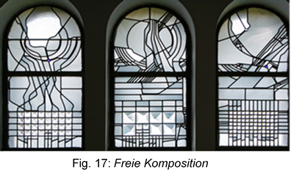
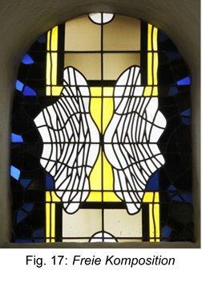
One of the greatest artists of this movement was Johannes Schreiter, born in 1930 in East Germany, Schreiter had his own emotional journey as he slipped under the barbed wire into West Germany in 1948. At art school, Schreiter was under the tutelage of Vincenz Pieper who practised stained-glass.
Fig. 17: Freie Komposition

Schadel commissioned Schreiter to produce his first work in stained-glass at Saint Margareta Church, Burgstadt on Main (Bender 1986, p.28). At this time, “Architects such as Schadel, Dominikus Bohm and Rudolf Schwarz were designing new ideas for the re-building of Churches. They “included stained-glass as an integral part of the building” (Bender 1986, p.29). Bender says that Schreiter was given “no specific brief” and that Schadel “freed him of his own fears of failure” (1986, p.29). Thus, Schreiter made “no attempt” to create Christian themes at Burgstadt (Bender 1986, p.30) instead he concentrated in his interest in light rather than glass itself, he built on the architect’s design at Burgstadt where Schadel had left the East wall empty so the focus was on the altar, Schreiter therefore planned that the “communicant returning to the congregation would be confronted by a massive wall of light” on the opposing West wall, “a visual explosion” (Bender 1986, p.36). Congregations could not help but be moved by the experience of turning from darkness to face the light of God.
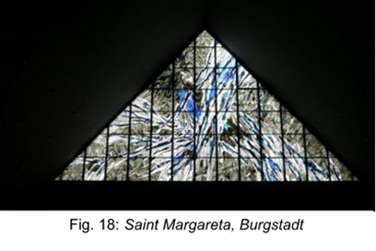
Fig. 18: St Maragaretha, Burgstadt

It must not be assumed that Schreiter was without religious belief, quite the contrary, Rothfuss recalls Schreiter saying “belief and art, for me belong together symbiotically” (20:08:19). She said Schreiter is a “free Protestant” and “the most Christian artist for me is Schreiter” and continued “he considers himself a missionary”, having “a connection to God” and “dedicating his work to God”, using the acronym “SDG meaning Soli Deo Gloria, to God alone be glory” (Rothfuss 20:08:19). Hans Gercke and Rainer Volp agree with Rothfuss confirming Schreiter viewed his modern designs as emotional and spiritual; the windows at Exerzituenhaus in Leutesdorf/Rhein “proved to be a breakthrough in Schreiter’s stained-glass work” (1988, p.31). Here, he dispensed with colour in order that “man will keep open free spaces in which to unfold his own emotional powers” (Gercke and Volp 1988, p.32). Thus, Schreiter gave his viewers permission to feel.

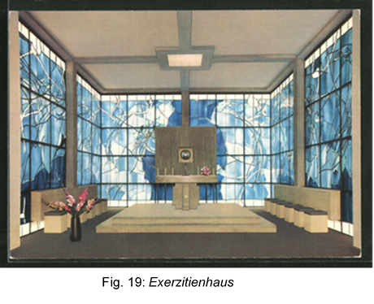
The window in the airport chapel at Frankfurt Main has a theme of “Parousia, the second coming of Christ”, it invites “contemplation” (Gercke and Volp 1988, p.34). Schreiter was expressing his personal religion. His reputation grew as this first window “contains many of the basic themes which were to be developed in subsequent windows” (Bender 1986, p.23). Rothfuss recalls how Schreiter “enters a space and rather than design the windows, he designs the whole space in order to change the atmosphere of the room” (20:08:19). “He considers the artistic problem of the room, it tells him something and he answers to the room” (Rothfuss 20:08:19). Schreiter “always designs in full scale, working on tracing paper showing the colour of the room underneath”, “he draws in the extensions of the leaded line” and lists the precise “lead widths” required (Rothfuss 20:08:19). He spoke a new language in glass, “a dialogue about the tensions and harmony of contiguous space” (Moor 1989, p.21). Schreiter freed the lead line from being a mechanism holding the glass in place, to using it to wander, seemingly aimlessly, across the panel tapering to “restful pregnant endings, creating an interplay of enigmatic spaces” (Moor 1989, p.21). The line is in fact not aimless. Just as the recurring theme of the peg symbolises an open hand wanting to be touched, the lines are signifiers; angry lines, searching lines, determined lines, moody lines and flattering lines (Schreiter, 2015). Schreiter’s lines are in fact, emotional expressions.
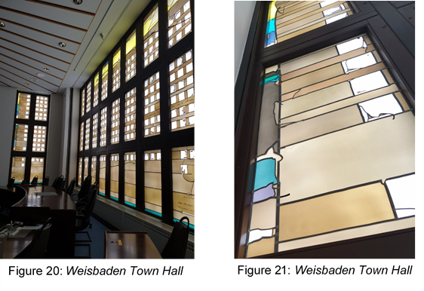
Fig. 20: Weisbaden Town Hall
Fig. 21: Weisbaden Town Hall

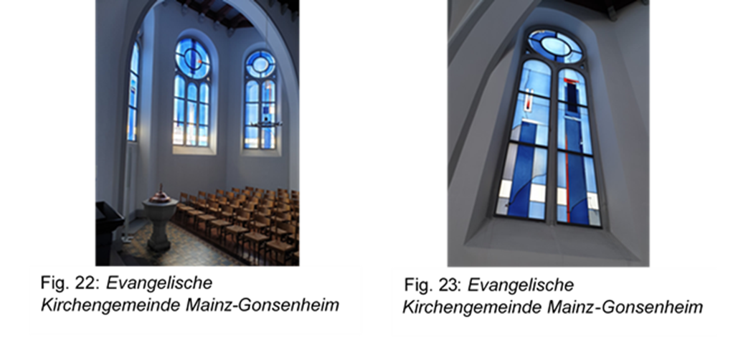
Fig. 22: Evangelische Kirchengemeinde Mainz-Gonsenheim
Fig. 23: Evangelische Kirchengemeinde Mainz-Gonsenheim

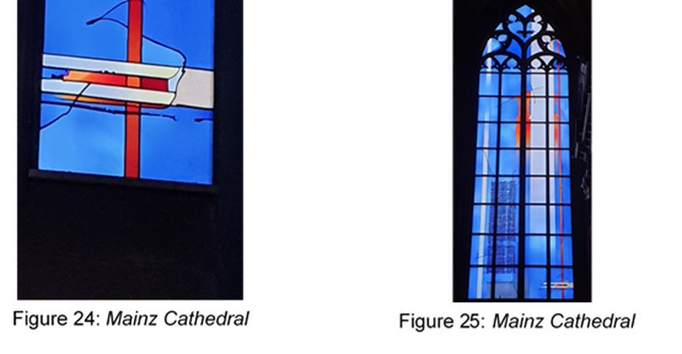
Fig. 24: Mainz Cathedral
Fig. 25: Mainz Cathedral

In summary, in the rise of Nazism, German congregations were abandoned by their pastoral leaders. Post-war, the people needed to return to the Church for emotional support and forgiveness. As so many churches had been destroyed, architects and glass designers used this as an opportunity to create in a modern style. Johannes Schreiter was a lead designer in this new movement, known as Eccentric Graphics. The glass in German Churches today can be seen in their full emotional glory, once more connecting communities to God.
7.0 Conclusion
This independent inquiry has concluded that whilst art is a tangible, common language, emotions are not simple to understand. They may be feelings sent by neurotransmitters in the brain, prompted by our memories.

It concluded that artists, while often struggling to create, often do so using emotional memories. Viewers use art to connect with themselves and are probably rekindling memories of their own. Neither artists nor viewers share the same memories, therefore do not experience the same emotions and do not even always see the same picture. All these emotions are subject to change.

This inquiry has concluded that stained-glass has historically been used as a design craft to invite emotion. It was created to tell the story of Christianity, for communities to see God’s light shining on them and understand that sermons could make them better people. More recently stained-glass has been seen as an art form in its own right.

It concluded that whilst the creation of a modern glass movement contributed to the feeling of home and new beginnings, so needed by the people of Germany to rebuild their faith post-war, Johannes Schreiter designed only for God and not for communities. He did however design from his own emotional connection with light and religion, congregations were therefore free to interpret their own emotions from his work.
In arriving at these conclusions, I considered art and its effects on viewers and how artists create. I investigated the link between them. I researched alternative views of emotions, from etymological, scientific, philosophical, psychological and theoretical perspectives; I sided with Feldman-Barrett that emotions are not part of our DNA but memories invoked by external stimuli. I assessed whether artists deliberately create emotion in their work and concluded that some artists draw what they feel, sometimes unconsciously, and some create emotions that they do not feel at all. I analysed the lives of three artists and the possible effects on their work. I explored the historical use of stained-glass in churches and reviewed the growth of new glass movements. As I learned about Johannes Schreiter, I unexpectedly needed to inquire into the role of the church in Germany in emotionally supporting their communities during the rise of Nazism.

I conclude in the words of the singer/songwriter Don McLean, “Now I understand, what you tried to say to me and how you suffered for your sanity and how you tried to set them free. They would not listen, they did not know how, perhaps they'll listen now” (McLean, 1970). Artists should perhaps be asked to talk about their work, it may help them to talk about their emotions in a safe environment. Viewers may also find it helpful to talk about their opinions of art. All people should be encouraged to re-create their emotional experiences in art; it has an emotional value.

8.0 References used in text / * Bibliography read but not used in text

Anderson, F. G. (2015), Internal Family Systems Therapy (IFS), A Revolutionary and Transformative Treatment for Permanent Healing of PTSD, Anxiety, Depression, Substance Abuse and More, Wisconsin: PESI

Bayles, D. and Orland, T. (2001), Art and Fear: Observations on the Perils (and rewards) of Artmaking, Santa Cruz, CA: Image Continuum Press

Bender, R. (1986), Two Approaches to Stained Glass John Piper - P Reyntiens and Johannes Schrieter – W. Derix, Swansea: Self published

Bender, R. (2019), Interview (23 July 2019)

Benjamin, W (2008), The Work of Art in the Age Mechanical Reproduction, London: Penguin Books Ltd

Berger, J. (1972), Ways of Seeing, London: Penguin Books Ltd

Botton, De A. (2006), The Architecture of Happiness, The Secret Art of Furnishing Your Life, London: Penguin Books Ltd
Breslin, J. E. B. (1993), Mark Rothko, A Biography, London: The University of Chicago Press

Brisac, C. (1986), A Thousand Years of Stained Glass, New York: Doubleday and Company Inc

Casciani, P. S. (1996), The Technique of Decorative Stained Glass, London: B. T. Batsford Ltd

Connick, C. J. (1973), Adventures in Light and Colour, An Introduction to the Stained Glass Craft, London: George G. Harrap and Co Ltd.

Deicher, S. (2006), Mondrian 1872-1944 Structures in Space, Köln: Taschen GmbH

Duchamps, M. (1957), The Creative Act, Lecture at the Museum of Modern Art, https://www.fiammascura.com (Accessed 30 June 2019)

Drinan, R. F. (1980), The Christian Response to the Holocaust, The Annals of the American Academy of Political and Social Science, Vol. 450. Reflections on the Holocaust: Historical, Philosophical and Educational Dimensions (Jul 1980), pp. 179-189, USA: Sage Publications https://www.jstor.org/stable/1042567 (Accessed 14 August 2019)
Elster, J. (1999), Alchemies of the Mind, Rationality and the Emotions, Cambridge: Cambridge University Press

EMDR Institute. Inc https://www.emdr.com/what-is-emdr/ (Accessed 6 September 2019)

Ericksen, R. P. (2012), Complicity in the Holocaust: Churches and Universities in Nazi Germany, New York: Cambridge University Press

Feldman Barrett, L. (2018), How Emotions Are Made, The Secret Life of the Brain, London: Pan Books

Gercke, H. and Volp, R. (1988), The Stained Glass Art of Johannes Schreiter, Darmstadt: Verlag Das Beispuel GmbH

Gombrich, E. H. (1995), The Story of Art, London: Phaidon Press

*Gregory, D. (2003), Everyday Matters, New York: Hachette Books

Halstead, S. (2017), Lighting the Way: The German Pioneers of Contemporary Stained Glass https://youtu.be/E0A1NWEpIbg (Accessed 16 July 2019)
Hodin, J. P. (1972), Edvard Munch, London: Thames and Hudson Ltd

*Jung, C. G. (1990), Man and his Symbols, London: Arkana, Penguin Group

*Kolk, van der B. (2015), The Body Keeps the Score, Mind, Brain and Body in the Transformation of Trauma, UK: Penguin Books

Matravers, D. (1998), Art and Emotion, Oxford: Oxford University Press

McLean, D. (1970), American Pie, Vincent, Universal Music Publishing Group www.songfacts.com/facts/don-mclean/vincent (Accessed 27 July 2019)

Milner, J. (2002), Mondrian, New York: Phaidon Press Inc.

Moor, A. (1997), Architectural Glass Art, London: Reed International Books

Moor, A (1989), Contemporary Stained Glass, London: Mitchell Beazley Publishers

Pallasmaa, J. (2009), The Thinking Hand, Existential and Embodied Wisdom in Architecture, West Sussex: John Wiley and Sons Ltd

Phayer, M. (2001), Questions about Catholic Resistance, The American Society of Church History 70 no. 2 Jun 2001 pp. 328-344 https://journals.cambridge.org.e2proxy.uwtsd.ac.uk (Accessed 14 August 2019)

Reyntiens, P. (1977), The Technique of Stained Glass, London: B. T. Batsford Ltd

Robinson, J. (2005), Deeper Than Reason, Emotion and its Role in Literature, Music and Art, Oxford: Oxford University Press

Rorty, A. O. (1980), Explaining Emotions, California: University of California Press

Rothfuss, U. (2019), Interview (20 August 2019)

Schreiter, J. (2015) https://multimedia.evangelisch.de/johannes-schreiter#216 (Accessed 21 August 2019)

Van Gogh, V. (1890) https://www.vincentvangogh.org/wheat-field-with-crows.jsp (Accessed 7 September 2019)

Williams, R. (1976), Keywords, A Vocabulary of Culture and Society, London: Fontana Press https://www.collinsdictionary.com/dictionary/english/emotion (Accessed 22 June 2019)


9.0 Appendix 1 – List of Illustrations

Figure 1: Artist Unknown (Palaeolithic) Bison (Pigment on stone). Available at: https://www.ancient.eu/image/3537/cave-painting-in-the-altamira-cave/ Accessed: 10 September 2019.

Figure 2: Van Gogh, V. (1890) Wheatfield With Crows (Oil in canvas). Available at: https://www.vincentvangogh.org/images/paintings/wheat-field-with-crows.jpg Accessed: 10 September 2019.

Figure 3: Fildes, L. (1874) Applicants for Admission to a Casual Ward (Oil on canvas). Available at: https://www.carolynemerick.com/uploads/2/1/6/9/21694870/luke-fildes-applicants-for-admission-to-a-casual-ward-1874_orig.jpg Accessed: 10 September 2019.

Figure 4: Rothko, M. (1950) No 10 (Oil on canvas). Available at: https://www.moma.org/collection/works/78594 Accessed: 10 September 2019.

Figure 5: Chagall, M. (1950) The Blue Circus (Oil on canvas). Available at: https://www.tate.org.uk/art/images/work/N/N06/N06136_10.jpg Accessed 10 September 2019.

Figure 6: Bronzino, A. (1545) Allegory Venus, Cupid, Folly and Time (Oil on canvas). Available at: http://witcombe.sbc.edu/davincicode/images/bronzino-allegory.jpg Accessed: 10 September 2019.

Figure 7: Munch, E. (1893) The Scream (Oil on canvas). Available at: https://www.edvardmunch.org/images/paintings/the-scream.jpg Accessed: 10 September 2019.

Figure 8: Mondrian, P. (1943) Broadway Boogie-Woogie (Oil on canvas). Available at: https://www.piet-mondrian.org/images/paintings/broadway-boogie-woogie.jpg Accessed: 10 September 2019.

Figure 9: Rothko, M. (1959) Red on Maroon (Oil on canvas). Available at: https://www.tate.org.uk/art/images/work/T/T01/T01165_10.jpg Accessed: 10 September 2019.

Figure 10: Artist Unknown, (mid12th Century) The Annunciation (Glass), Available at: https://holycrossrumson.typepad.com/.a/6a0120a4f88a1c970b01b8d24073d2970c-500wi Accessed: 10 September 2019.

Figure 11: Tiffany, L. C. (1916) Daffodils (Glass), Available at: http://www.morsemuseum.org/assets/uploads/made/assets/uploads/art/Daffodils_window_web_152_243.jpg Accessed: 10 September 2019.

Figure 12: Prikker, J. T. (1926) Gesolai Cultural Centre, Dusseldorf, Germany (Glass), Available at: https://www-bridgemaneducation-com.ezproxy.uwtsd.ac.uk/en/search?filter_text=johann+thorn+prikker Accessed: 10 September 2019.

Figure 13: Wendling, A. (1957) Die Apostel St. Judas Thaddäus und Simon Zelotes (Glass), Available at: http://www.glasmalerei-ev.net/pages/b2874/b2874_1_0.jpg Accessed: 10 September 2019.

Figure 14: Meistermann, G. (1960) Städt. Galerie für Moderne Kunst Wittlich (Glass), Available at: http://www.meistermann-gesellschaft.de/assets/images/Gnadenstromfenster__verkl._.JPG Accessed: 10 September 2019.

Figure 15: Clarke, B. (1996) Norte Shopping, Rio de Janeiro (Glass), Available at: http://www.brianclarke.co.uk/sites/default/files/styles/full-page-width/public/work-main-image/Canopy%20web.jpg?itok=rA7lsiiA Accessed: 10 September 2019.

Figure 16: Schaffrath, L. (1969) Freie Komposition (Glass), Available at: http://www.glasmalerei-ev.net/pages/b2758/b2758_2_1.jpg Accessed: 10 September 2019.

Figure 17: Pieper, V. (1961 Freie Komposition (Glass) Available at: http://www.glasmalerei-ev.net/pages/b4514/b4514_1_0.jpg Accessed: 10 September 2019.

Figure 18: Schreiter, J. (1960) St Maragaretha, Burgstadt (Glass), Available at: https://www.derix.com/wp-content/uploads/johannes-schreiter-B%C3%BCrgstadt-st-maragaretha-1-1-400x225.jpg Accessed: 10 September 2019.

Figure 19: Schreiter, J. (1960) Exerzitienhaus (Glass), Available at: https://i.ebayimg.com/images/i/362681768742-0-1/s-l600.jpg Accessed: 10 September 2019.

Figure 20: Schreiter, J. Weisbaden Town Hall, Photographed by author on research trip: 20 August 2019.

Figure 21: Schreiter, J. Weisbaden Town Hall, Photographed by author on research trip: 20 August 2019.

Figure 22: Schreiter, J. Evangelische Kirchengemeinde Mainz-Gonsenheim, Photographed by author on research trip: 22 August 2019.

Figure 23: Schreiter, J. Evangelische Kirchengemeinde Mainz-Gonsenheim, Photographed by author on research trip: 22 August 2019.

Figure 24: Schreiter, J. Mainz Cathedral, Photographed by author on research trip: 22 August 2019.

Figure 25: Schreiter, J. Mainz Cathedral, Photographed by author on research trip: 22 August 2019.

10.0 Appendix 11 – Interviews

Ursula Rothfuss, Glass Maker, Director of Derix Studios, Germany, contemporary of Johannes Schreiter. Interview held in Germany on 20 August 2019.

Question 1
MR: Did the new glass in the new churches bring spiritual healing to the people of Germany post-war?
AR: Post-war, German people were emotional, they sought not so much healing but forgiveness from God. They looked for a new way, new beginnings and new security.

Question 2
MR: Why were so many churches built after the war?
AR: The people considered the Church as a home as it gave them a sense of purpose; emotional security. Thus, so many churches were built at this time to accommodate the need to help people recover.

Question 3
MR: Was it easy for stained-glass artists to find work in this new environment?
AR: Post-war stained-glass artists would have to commit suicide not to get commissions, such was the demand for their designs.

Question 4
MR: Was Schreiter always a religious man?
AR: I remember Schreiter saying “belief and art, for me belong together symbiotically”. He is a free Protestant and the most Christian artist for me is Schreiter. He considers himself a missionary with a connection to God and he always is dedicating his work to God, using the acronym on all his works; SDG meaning Soli Deo Gloria, to God alone be glory.

Question 5
MR: What method does Schreiter adopt when designing?
AR: Johannes enters a space and rather than design the windows, he designs the whole space in order to change the atmosphere of the room. He considers the artistic problem of the room, it tells him something and he answers to the room. He always designs in full scale, working on tracing paper showing the colour of the room underneath and he draws in the extensions of the leaded line and lists the precise “lead widths” required.

Question 6
MR: Why are there no descriptions or background story of the Schreiter windows?
AR: Johannes has no need for you to like his work, but it should make you feel differently, basically he does not care what you think of it and he sees no need to explain it to you, he knows that you do not need to know. His audience is God.

Rodney Bender, Glass Designer / Maker, contemporary of Johannes Schreiter. Interview held in UK by email 23 July 2019.

Question 1
MR: Why were architects allowed such a free rein post-war Germany?
AR: There was a desire to make a clean break from the past and embrace the future. The Church was tainted from the Nazi era. The Church also had a lot of money, as state taxes could be allocated to specific denominations. The narrative goes that in the UK, the State nor the Church were tainted, cultural traditions were reinforced. The past provided reassurance in the post-war uncertainty.

