
Foreign Languages and Cultural Awarness
Module code: BMIH5003

Lecturer Name:Antoinette Milne

Georgiana Camelia Otesanu

Student Id:2239363

Table of Contents
INTRODUCTION: 1
Scenario Description 1
Analysis of the Misunderstanding 2
Personal Reflection and Learning 3
Component 2 - Training Plan Title: Enhancing Cultural Competence at Ashford International Hotel & Spa Objective 4
Component 3 - Student Self-Reflection Title: 7
Component 4 – Training Presentation Title: 9
REFERENCES: 14

INTRODUCTION:

Understanding cultural and linguistic variations is essential for running a successful business and satisfying consumers in the fast-paced world of overseas hospitality. Interactions between personnel and guests from different origins are a major issue in this business. Even minor misunderstandings can upset guests. Language problems caused me to make a mistake at Ashford International Hotel & Spa. It examines a hotel bar incident during a full dinner service. A linguistic barrier made it impossible to understand who ordered a drink. This research will examine how linguistic misunderstandings affect people and demonstrate how crucial language skills and cultural awareness are for hospitality workers. This idea seeks to explain these misunderstandings and provide strategies for people to grow and change to prevent them.

Describe the scenario

A crowded dinner service at the Ashford International Hotel & Spa's exquisite bar involved a major F&B error by a staff member and a foreign guest. The bar has a sophisticated atmosphere and many customers. That night was especially busy, making cross-cultural communication easier. A French-born guest who didn't know English tried to order a "pain," which means bread. The barman mistook it for "Pimm's," a popular British drink. This mistake occurred because the two terms sound similar with a thick French accent.

Since the guest didn't know French, the staff didn't understand his requests, making the relationship harder. The guest's anger and the employee's confusion made the issue worse. This demonstrated that the service provider's language and cultural abilities were lacking. To avoid these misunderstandings, hospitality workers must comprehend linguistic and cultural clues.

Look at the Misunderstanding

The Ashford International Hotel & Spa's bar blunder was primarily caused by the F&B employee's language and cultural ignorance. French bread, "pain," sounds like "Pimm's," which puzzled the worker, who mistook the guest's order. Many hotels have this issue: people think things that sound alike in different languages mean the same thing.

Since French restaurants and pubs give bread with their meals, the customer thought the worker would understand his request. His patience quickly turned to fury as he tried to make the same request multiple times without success. The staff initially offered to help, but as the communication gap widened, they became more confused and frightened. Hospitality workers must know fundamental terms in multiple languages and understand how different cultures eat, as these practices might vary greatly.

Self-reflection and learning

This incident demonstrated the need of linguistic and cultural awareness for hospitality workers. To avoid these misconceptions, strengthen your language abilities by learning key words in our guests' most common languages. Teaching personnel about cultural awareness will help them accept varied eating and communication styles (Personnel Today).

Because many of our guests speak French and Spanish, I'll take language classes in those languages. I also want to attend cultural competence classes to learn how to handle international guests. The hotel will improve service and I will improve my skills with this proactive approach.

Gibbs' Reflective Cycle can arrange your Ashford International Hotel & Spa thoughts. You could investigate Part 1's mistake using each model part:
(Friedman, A., 2012).

1. Describe

French guests requested for 'pain', which means bread, but F&B staff thought it meant 'Pimm's', a drink. This happened during hotel bar dinner service. The language barrier and bustling environment made it even more perplexing (Journal of Human Resources).

2. How you feel

I was furious and bewildered since I didn't understand why the guest didn't like the drink. The guest seemed more agitated, which stressed me out and made me want to address the matter quickly (Marchington, M., & Wilkinson, A., 2016).

3. Checking Out

The guest was dissatisfied that his simple request wasn't met, and I felt awful for not serving him better. This case highlighted the need for assistance providers to improve their language and cultural skills (Friedman, A., 2012).

4. Analysis

To make matters worse, "pain" and "Pimm's" sound alike, and I didn't speak French. This shows how easily language barriers can disrupt service. I didn't consider our guests' diversity because I assumed all conversation would be in English (Horn, R., 2009).

5. In conclusion

This encounter showed me where to enhance my language and cultural knowledge. Realising these flaws will help me handle similar situations in the future (Human Resource Management Journal).

6. Action Plan

To avoid this confusion, I'll:

• Learn basic Spanish and French in language classes.

• Receive cultural awareness training for our guests' home countries.

• Test your new abilities with coworkers to gain confidence.

• Create a quick reference guide for myself and coworkers with common non-English demands and words (Marchington, M., & Wilkinson, A., 2016).

Target: Improving Cultural Competence at Ashford International Hotel & Spa

The aim

"Enhancing Cultural Competence at Ashford International Hotel & Spa," the suggested training programme, aims to equip our team to handle linguistic and cultural differences. This training helps our team understand and talk to clients from diverse backgrounds to give them a more tailored and pleasant experience. We expect service misconceptions to decrease and visitor satisfaction to grow as people master crucial languages and cultural differences. Our personnel will learn how to meet and exceed foreign clients' expectations through this training. This will enhance our reputation as a culturally sensitive and welcoming company (Department for Energy Security and Net Zero - GOV.UK).

Training Content

To teach all skills, the training plan will focus on three areas:

Language Skills Improvement: We'll work to improve your French, Spanish, and other guest languages. Simple conversational words, hospitality concepts, and language nuances will be covered throughout the course to avoid confusion (Gallagher, K., 2016).

Cultural Sensitivity Training: Our personnel will learn about our clients' cultures and how to respect varied communication styles, dining habits, and customs. We'll discuss cultural norms, greeting guests, and body language in different countries.

Practical Communication Strategies: Workshops will teach how to clarify and speak properly.

The training will emphasise role-playing to help people recall these abilities. The scenarios will be realistic so workers may practise their new abilities safely. This will boost their confidence and prepare them for genuine guests. This hands-on strategy will help you remember and respond faster under pressure (Journal of Human Resources in Hospitality and Tourism).

Strategy for Implementation

The "Enhancing Cultural Competence" training will be released over three months. This will minimise disruptions to Ashford International Hotel & Spa operations (Chartered Institute of Personnel and Development (CIPD), Performance Reviews | Factsheets).

Online Lessons (Month 1)

• Workable online lessons will teach fundamental language and cultural understanding. These will be available on several devices so employees can do them when they want (Journal of Human Resources in Hospitality and Tourism).

Phase 2 includes in-person workshops (Month 2).

• After completing online modules, workers will attend intensive workshops to strengthen their language abilities and practise using cross-cultural knowledge in realistic contexts. Workshops will include role-playing and group discussions (Horn, R., 2009).

Things We Need:

Educational Materials: Language-learning software and cultural guides.

Hire experienced language and culture trainers.

Workshops take place in hotel meeting rooms.

Timetable:

• Staff must finish online lessons in the first month.

• Four weeks of in-person seminars in the second month, with follow-up sessions in the third month to assist people recall.

Verifying and Giving Feedback

To evaluate the "Enhancing Cultural Competence" training, feedback tools and direct observation will be employed. Following the course, participants will complete extensive feedback forms to score their satisfaction with the material, its usefulness, and their skill improvement. Managers will also observe staff' guest service to evaluate the training.

This feedback and observation will be used to regularly review and change the training plan. This continuing evaluation will ensure that the training is current, covers all relevant issues, and meets our staff and guests' evolving needs (Chartered Institute of Personnel and Development (CIPD), Performance Reviews | Factsheets).

Student Self-Reflection Part 3:

Start and Choose a Model

I'll use Gibbs' Reflective Cycle to discuss hospitality's cultural sensitivity. This model's description, feelings, evaluation, analysis, conclusion, and action plan facilitate deep reflection. This makes it ideal for this examination. Gibbs' model explains how personal experiences effect careers. It's ideal for deciphering culturally complex conversations. This systematic process will let me reflect on how culture impacts hospitality, see how my ideas have changed, and improve personally and professionally (Customer 1st International).

Notes on My Learning

School and hospitality jobs have taught me a lot about cultural understanding. At initially, my cultural knowledge was limited to avoiding mistakes. At Ashford International Hotel & Spa, I learned that cultural awareness goes beyond preventing blunders as I came to know people from diverse cultures. This includes actively appreciating and adjusting to varied cultural norms and standards (Horn, R., 2009).

A conversation with Japanese guests changed my perspective. I guided a guest to the eating area by lightly touching his shoulder. My culture considers this nice, while Japanese society considers it disrespectful. The guest was clearly uneasy, and this event showed how sensitive cross-cultural encounters can be. I learned that knowing both the big picture of cultural customs and the minor things that might make guests happy and comfortable is crucial.

I learned more about global cultures and communication from this encounter. I became accessible and respectful instead of avoiding people. This perspective shift has improved my professional interactions and generated a lifetime interest in various cultures (Institute of Customer Service).

How Crucial the Experience

In hospitality, misunderstandings about other cultures, like the Japanese visitor, are crucial for personal and professional growth. They demonstrate how complex human connections can be, transcending language borders and into cultural customs and beliefs. To make customers feel comfortable, you must understand and follow these guidelines and provide thoughtful, customised, and pleasant service. This awareness distinguishes excellent service from good service in a connected world (Horn, R., 2009).

Hospitality workers can boost or hurt the brand's reputation with every guest interaction. Knowing how to handle ethnic diversity is crucial for a professional. These experiences have taught me the value of cultural awareness, which helps me work with diverse clients.

From now on, this understanding will greatly impact my business interactions. As I study, I want to understand more about cultural customs and communication skills so I may be respectful, educated, and culturally aware in my job contacts. I will share these thoughts with coworkers and integrate them in training. This will foster an inclusive workplace. This drive to knowing other cultures will help me develop in my job and make the workplace more friendly and flexible for guests (Marchington, M., & Wilkinson, A., 2016).

Part 4: Training presentation title:

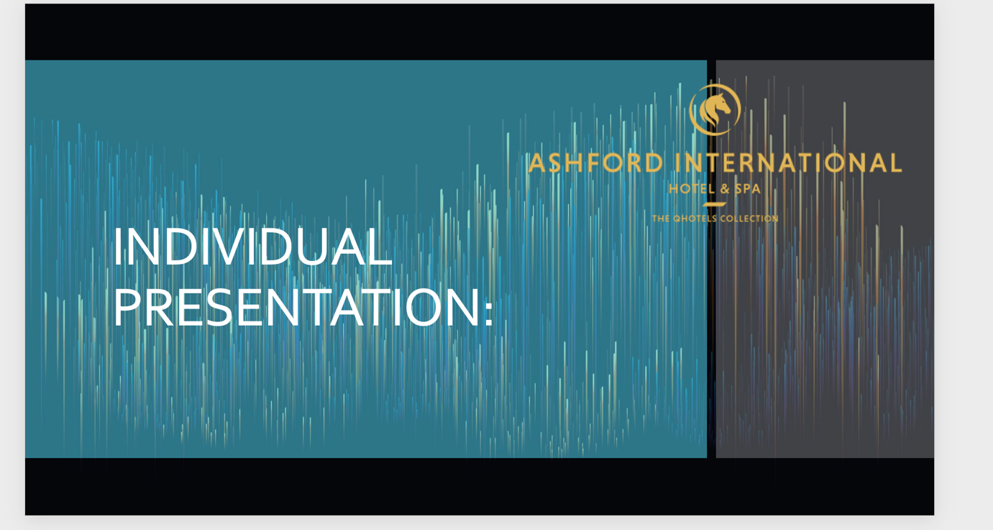
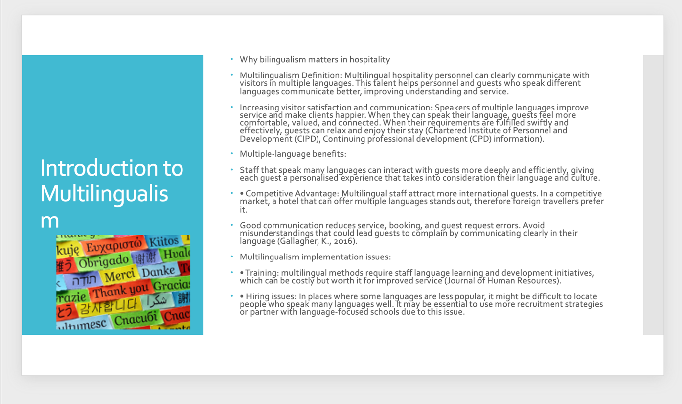

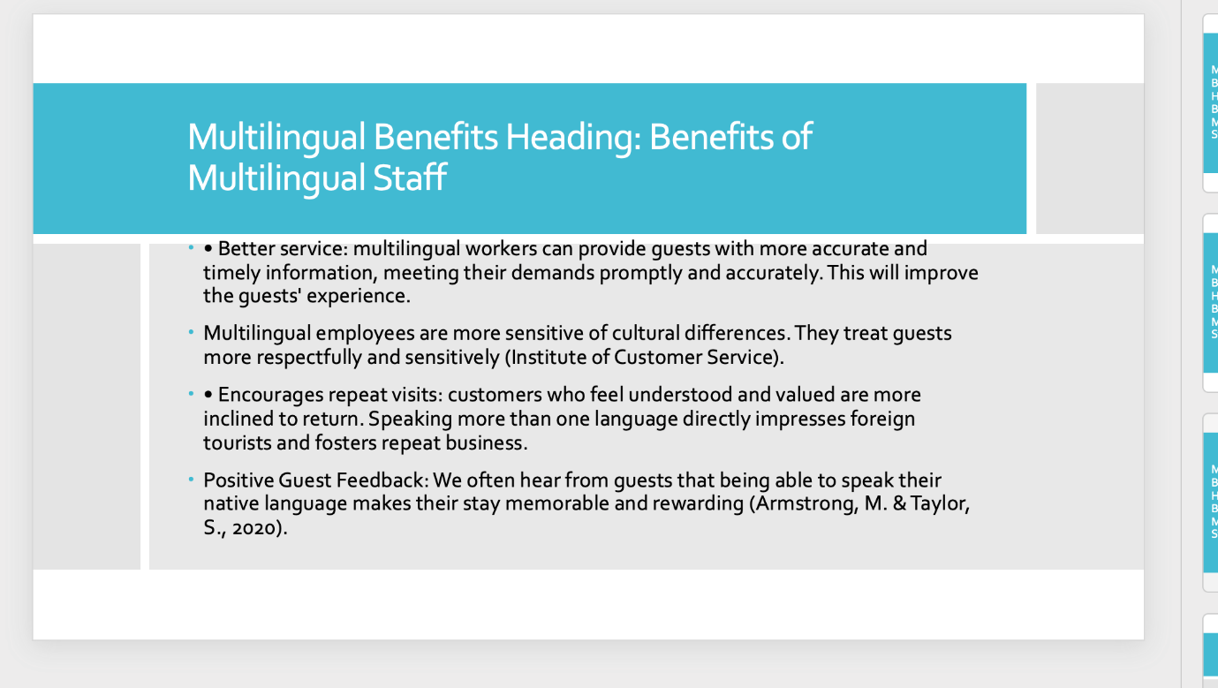

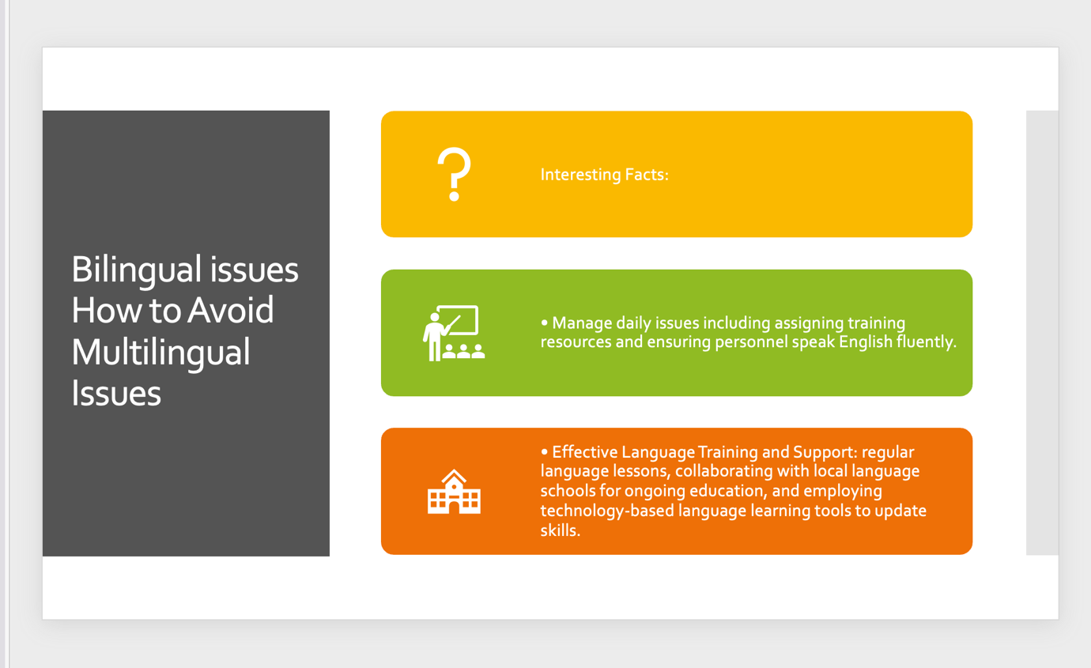

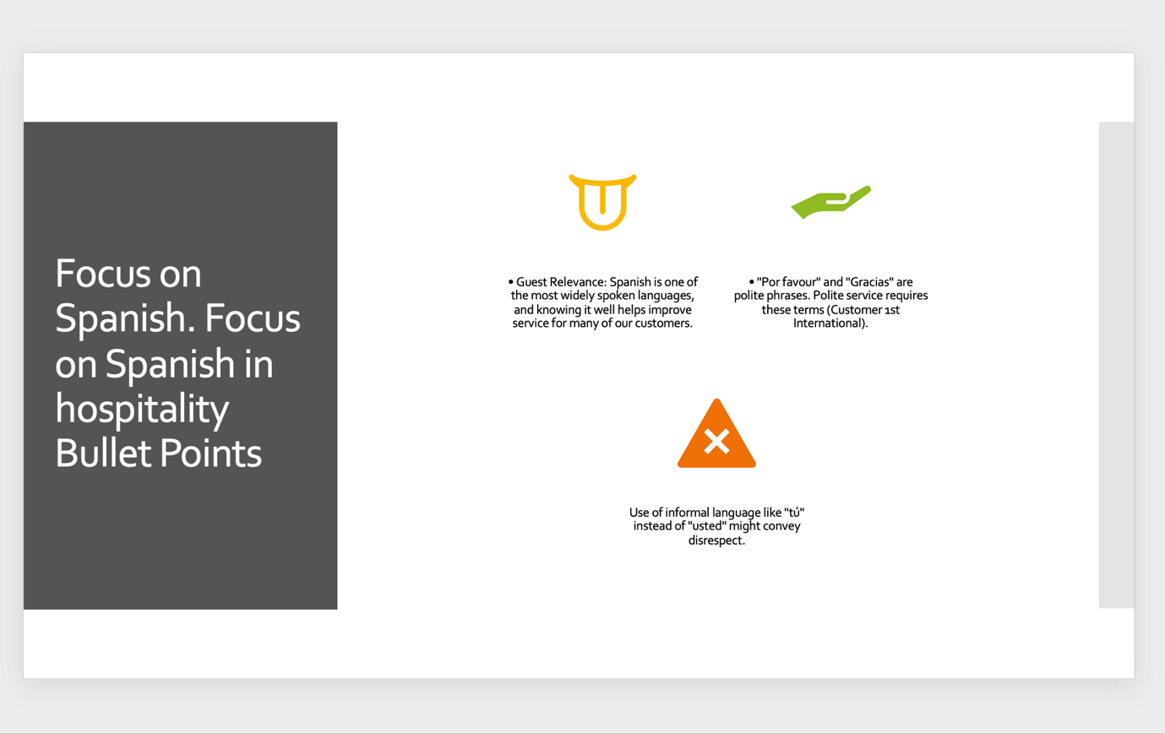

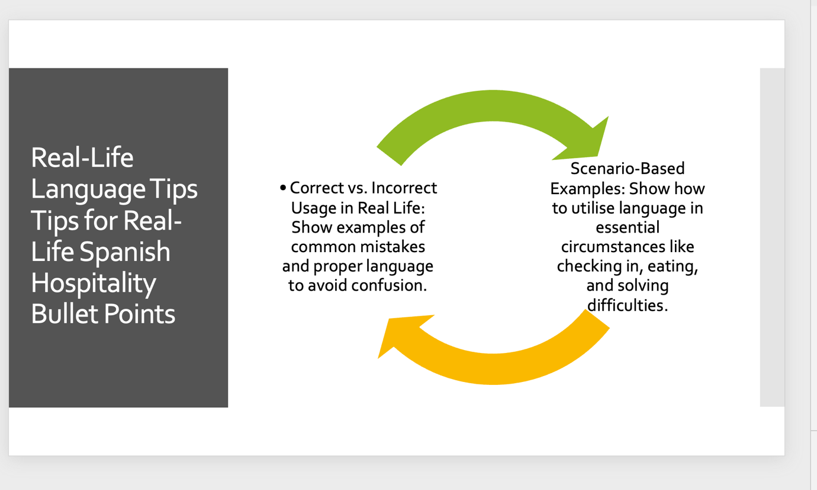
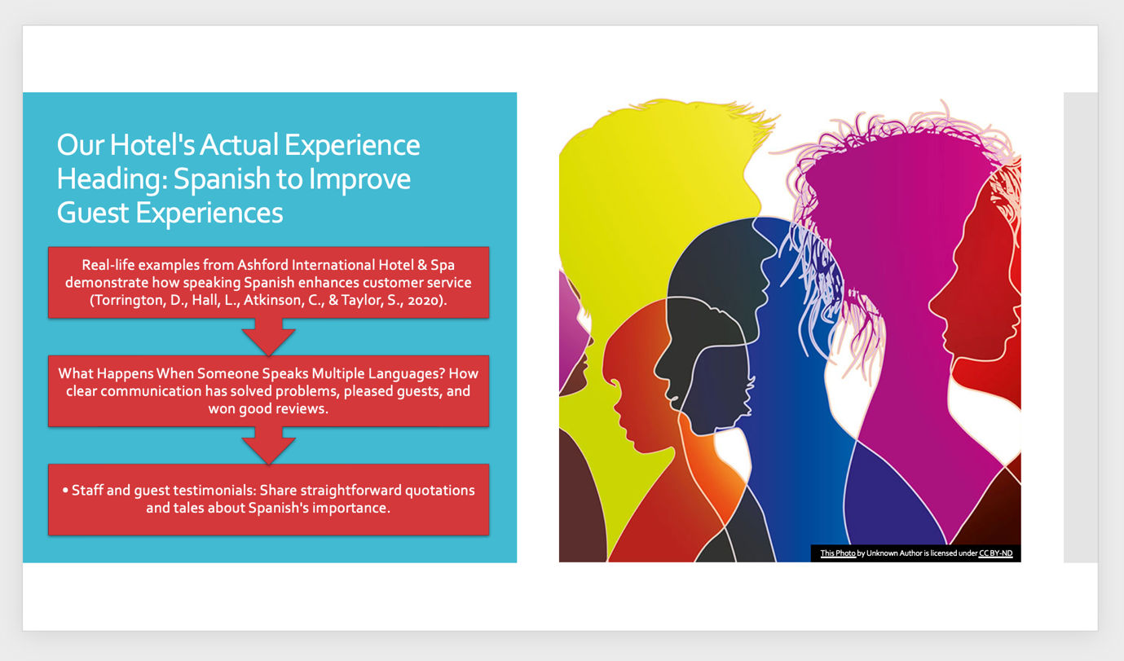

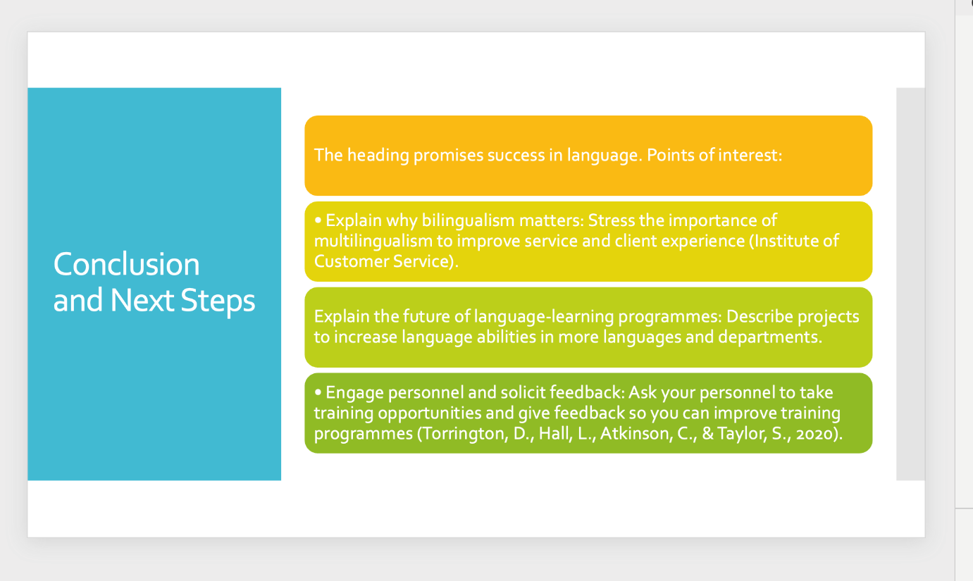

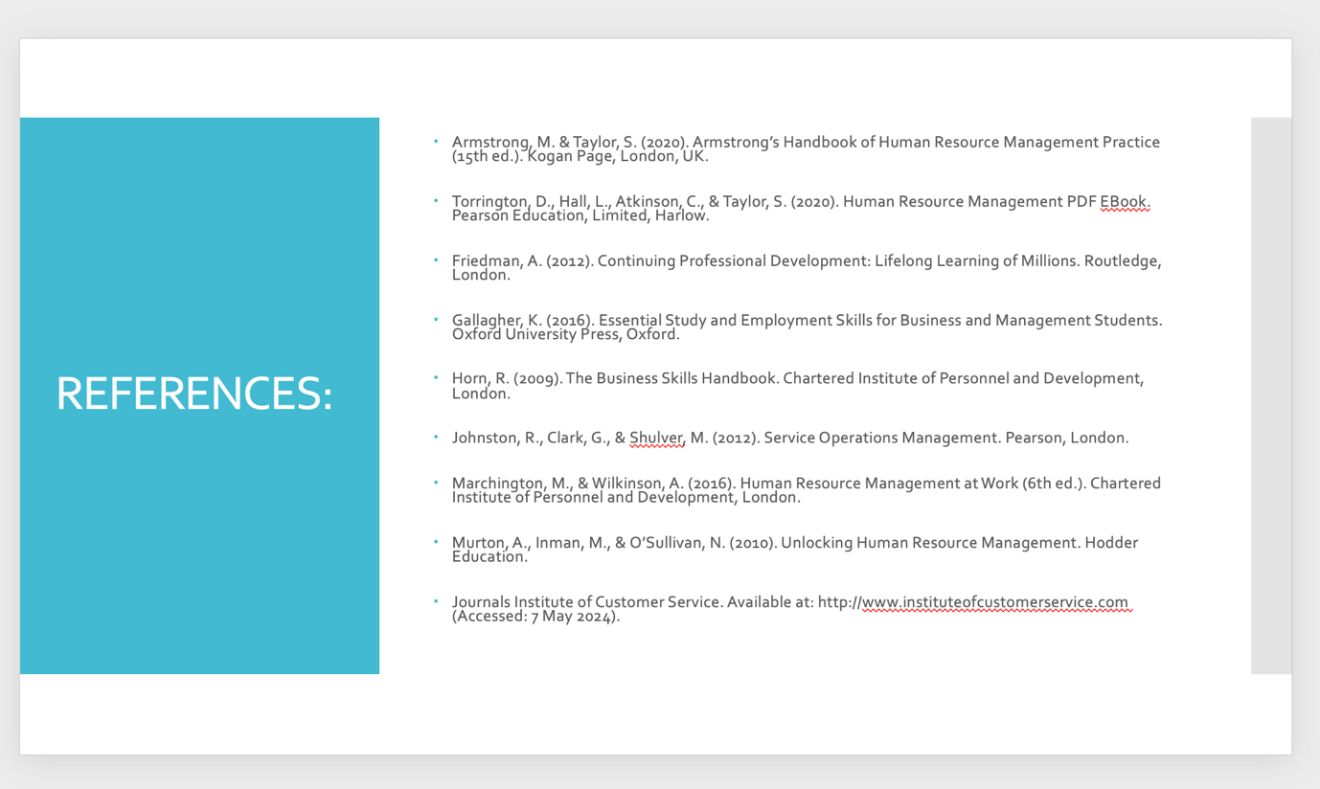

Slide 2: Multilingualism Overview

Why bilingualism matters in hospitality

Definition of Multilingualism Multilingual hospitality professionals can communicate successfully in multiple languages. This talent helps personnel and guests who speak different languages communicate better, improving understanding and service (Johnston, R., Clark, G., & Shulver, M., 2012).

Speaking multiple languages improves communication and guest satisfaction. When they can speak their language, guests feel more comfortable, valued, and connected. When their requirements are fulfilled swiftly and effectively, guests can relax and enjoy their stay.

Multiple-language benefits:

Staff that speak many languages can interact with guests more deeply and efficiently, giving each guest a personalised experience that takes into consideration their language and culture (Customer 1st International).

• Competitive Advantage: Multilingual staff attract more international guests. In a competitive market, a hotel that can offer multiple languages stands out, therefore foreign travellers prefer it.

Good communication reduces service, booking, and guest request errors. Avoid misunderstandings that could lead guests to complain by communicating clearly in their language (Chartered Institute of Personnel and Development (CIPD), Performance Reviews | Factsheets).

Multilingualism implementation issues:

• Training: multilingual methods require staff language learning and development initiatives, which can be costly but worth it for improved service.

• Hiring problems: In places where particular languages are less popular, it can be hard to locate multilingual personnel. It may be essential to use more recruitment strategies or partner with language-focused schools due to this issue.

To conclude, being multilingual in hospitality requires more than just language skills. It also means establishing a setting where people can freely communicate, cultural differences are acknowledged, and guests have better experiences. Although difficult, integrating multilingual talents strategically is a crucial investment for any hotel that does business with foreigners.

Slide 3: Multilingual Benefits

What makes multilingual staff useful

Interesting Facts:

• Better service: multilingual workers can provide guests with more accurate and timely information, meeting their demands promptly and accurately. This will improve the guests' experience.

Multilingual employees are more sensitive of cultural differences. They treat guests more respectfully and sensitively.

• Encourages repeat visits: customers who feel understood and valued are more inclined to return. Speaking more than one language directly impresses foreign tourists and fosters repeat business (Personnel Today).

Positive Guest Feedback: We often hear from guests that being able to speak their native language makes their stay memorable and rewarding.

Bilingual challenges (Slide 4).

Addressing Multilingual Issues

Interesting Facts:

• Handle everyday issues like providing training funds and ensuring personnel speak English properly.

• Effective Language Training and Support: regular language lessons, collaborating with local language schools for ongoing education, and employing technology-based language learning tools to update skills (Johnston, R., Clark, G., & Shulver, M., 2012).

Slide 5: Focus on Spanish.

A Look into Spanish Hospitality

Interesting Facts:

• Guest Relevance: Spanish is one of the most widely spoken languages, therefore knowing it effectively helps improve service for many of our clients.

• "Por favour" and "Gracias" are polite phrases. Polite service requires these terms.

Use of informal language like "tú" instead of "usted" might convey disrespect (Torrington, D., Hall, L., Atkinson, C., & Taylor, S., 2020).

Slide 6: Language Tips

Helpful Spanish for Hospitality

Interesting Facts:

Scenario-Based Examples: Show how to utilise language in essential circumstances like checking in, eating, and solving difficulties (Johnston, R., Clark, G., & Shulver, M., 2012).

• Correct vs. Incorrect Usage in Real Life: Show examples of common mistakes and proper language to avoid confusion.

Slide 7: Our Hotel's Actual Experience

Heading: Spanish to improve guest experience

Interesting Facts:

Actual examples from the Ashford International Hotel & Spa show how knowing Spanish enhances customer service.

• How speaking many languages has improved guest service by solving difficulties, making guests happier, and getting good evaluations (Human Resource Management Journal).

Staff and guest testimonials: Share honest quotations and tales about how vital Spanish is.

Slide 8: Conclusion and Next Steps

The title is "Dedication to Language Excellence."

Interesting Facts:

Repeat why multilingualism matters. Highlight the importance of service quality and guest experience (Horn, R., 2009).

• Discuss future language training projects to increase language abilities in more languages and places.

• Encourage Staff Participation and Feedback: Ask staff to participate in training opportunities and provide feedback to improve training courses (Department for Energy Security and Net Zero - GOV.UK).

REFERENCES:

Books
- Armstrong, M. & Taylor, S. (2020). Armstrong’s Handbook of Human Resource Management Practice (15th ed.). Kogan Page, London, UK.
- Torrington, D., Hall, L., Atkinson, C., & Taylor, S. (2020). Human Resource Management PDF EBook. Pearson Education, Limited, Harlow.
- Friedman, A. (2012). Continuing Professional Development: Lifelong Learning of Millions. Routledge, London.
- Gallagher, K. (2016). Essential Study and Employment Skills for Business and Management Students. Oxford University Press, Oxford.
- Horn, R. (2009). The Business Skills Handbook. Chartered Institute of Personnel and Development, London.
- Johnston, R., Clark, G., & Shulver, M. (2012). Service Operations Management. Pearson, London.
- Marchington, M., & Wilkinson, A. (2016). Human Resource Management at Work (6th ed.). Chartered Institute of Personnel and Development, London.
- Murton, A., Inman, M., & O’Sullivan, N. (2010). Unlocking Human Resource Management. Hodder Education.

Journals
- Human Resource Management Journal. (Accessed: 7 May 2024).
- International Journal of Human Resource Management. Available at: https://www.tandfonline.com/loi/rijh20 (Accessed: 7 May 2024).
- Journal of Human Resources. Available at: https://www.jhr.uwpress.org (Accessed: 7 May 2024).
- Journal of Human Resources in Hospitality and Tourism. Available at: https://www.tandfonline.com/journals/whrh20 (Accessed: 7 May 2024).
- People Management. Available at: https://www.peoplemanagement.co.uk/ (Accessed: 7 May 2024).
- Personnel Today. Available at: [link] (Accessed: 7 May 2024).
Websites
- Chartered Institute of Personnel and Development (CIPD). Performance Reviews | Factsheets. Available at: https://www.cipd.org/uk/knowledge/factsheets/appraisals-factsheet (Accessed: 7 May 2024).
- Chartered Institute of Personnel and Development (CIPD). Continuing professional development (CPD) information. Available at: https://www.cipd.co.uk/cpd (Accessed: 7 May 2024).
- Customer 1st International. Available at: https://www.customer1st.co.uk (Accessed: 7 May 2024).
- Department for Energy Security and Net Zero - GOV.UK. Available at: https://www.gov.uk (Accessed: 7 May 2024).
- Institute of Customer Service. Available at: http://www.instituteofcustomerservice.com (Accessed: 7 May 2024).

