YouTube: Business Strategies, Challenges and Revenue Mechanisms. How to use YouTube as a tool for Commercialisation of Music.

Adrienne Angelescu

Short history and current scale

Founded in 2005 by 3 former PayPal employees, YouTube is a video-sharing platform that was bought by Google in 2006. It allows users to view, upload, rate, comment, share, playlist videos, and to subscribe to users whose content they want to see more of. The content on it varies wildly, from music and entertainment to lifestyle, travel, DIY tutorials, product and service reviews, and also an immense collection of funny animal videos, to mention a few. A 2017 report states that at that moment, 400 hours of content were uploaded every minute and that one billion hours of content are watched each day. In 2019, it was revealed that the uploaded content per minute increased to 500 hours (Hale, 2019).

As far as music and entertainment content are concerned, YouTube reigns supreme. In a 2018 article, Music Business Worldwide declared that “More music is played on YouTube than on Spotify, Apple Music and every other audio streaming platform combined”. (Music Business Worldwide, 2018) MBW also state that the 2017 research conducted by Ipsos reveals that out of the 55% on-demand streaming represented by video streaming, 46% was on YouTube. This makes YouTube extremely important for the music industry.

How to get noticed. A case study on Psy’s success with Gangnam Style
In a guide on promoting one’s Youtube channel, Brent Barnhart claims YouTube is the second largest search engine, and that optimising one’s content so that it shows first is of paramount importance (Barnhart, 2019).
It is thus also very important that artists ensure their content is not only present on YouTube, but that much consideration is given to ensuring as many people watch it as possible. The strategy employed will be a big factor in whether a video gains traction or, even better, if it goes viral. But how does one go around getting noticed on YouTube? The answer seems to lie in the business and marketing strategies employed, and in this matter, the case study on Korean pop artist Psy’s success is very relevant (The Drum, 2012). In that case, it was record label YG Entertaiment’s astute campaign that led to the worldwide success that not only made PSY famous abroad, but also shone a light on Korean pop music in general. The first step that YG made was to ensure it had a presence in the US and UK industry by creating partnerships within the US and UK, long before the single was released. This ensured that when they decided to push a song abroad, they would already have a platform on which millions of possible fans of the song would already be gathered. The Drum says the next important step was to ensure that the music video would be attractive for a vast number of people of all ages, and that both song and lyrics would be catchy and memorable to people of all ages. Last but not least, The Drum highlights that media outside of Korea was slow to pick up the video. Launched on July 15th 2012 and preceded by Twitter promotion by an American based celebrity and music gossip site which focuses on Korean music, the single initially received relatively little attention in Western media despite debiting as number 1 on Korean music charts. The Drum mentions two articles on 26th and 27th of July only caused a slight boost in attention, and that the story in The Gawker on July 30th and subsequent coverage by Billboard, Huffington Post, CNN and Sky News were what actually got the ball rolling. YouTube trends highlighted the video as Video of the Month on August 7th. A further push came later on, from celebrities mentioning the song on social media, with the final nudge coming from Guinness World Record in the form of a press release where they declared that Psy broke all records for the number of views. In the same case study, researcher Andy Barr admits that the campaign “very well thought out, well executed” and that “many online marketing analysts cited celebrity tweets as the reason behind the Gangnam Style success, but this was clearly wrong: celebrity tweets did not happen until after the initial spikes in traffic.”
The fact that Psy’s video was uncontroversial and family friendly was also another benefit. Eminem’s newest single Darkness, released on 17/10/20 has over 13 million views at the time of writing this paper (Eminem, 2020). However, it does not show on Youtube’s list of Music section of Trending, where some of the videos featured have fewer views than Eminem’s single has likes. It is, however, possible, that the trending list does not update daily, though that would be doubtful. This however seems to still work in Eminem’s favour, as it is causing more fan engagement with the video, with many believing that Youtube manually removed the video from the Trending list due to its political, anti-gun underlying message.(screenshots of the above information are available in the appendix section of this paper).

Marketing Strategies for Artists

As for artists that do not have massive teams supporting their releases, there are many sources online that offer guidance on how to build and maintain a following on YouTube. Many center around ideas such as researching and knowing one’s audience and being consistent (which can translate as adding teasing videos or muted short clips to garner interest and generate hype for the release of a single/EP/album).
Another suggestion that seems to be very important deals with maximising the chances of the video being found by people searching for specific words. The guides however warn than too many hastags are detrimental, and advise users to use under 15, but to also include artist handles and other such information in the generous description section (Hootsuite, 2019).
Other ways in which fans could find an artist on YouTube could be via recommendations (in which case an interesting thumbnail may be what makes somebody interested), but also via YouTube ads. Should ads be considered, it is important to ensure they are interesting. In a guide on promoting content on YouTube, Hootsuite advises: “With YouTube advertising, the key is to produce relevant, engaging content that makes viewers forget they’re watching an ad. Generally, that means keeping things short, entertaining, and hyper-targeted” (Hootsuite, 2019) A way to assist artists in their targeting for ads is to analyse information they have on their content already. Looking at the data on YouTube analytics but also the comments viewers left and how fans engage with the content can be a good way to determine who the targets for the next advertising campaign should be.
Live streaming is quickly becoming another popular way to gain attention on YouTube. Whether it is a show, an interview, a live studio session or simply an interaction with an influencer, going live attracts attention to the brand and allows fans to have direct interaction with the artist.
All of these factors will help create a social presence, which can be quite important for reasons outside of YouTube. Brent Barnhart states that “an optimised social presence can signal your status as a professional. In an industry where competition is so cutthroat, having pristine profiles out there lets people know that you’re anything but an amateur. (Barnhart, 2018)

Revenue mechanisms. How do artists make money from YouTube?

In basic terms, artists get paid for more or less hosting ads on their channel along with their content. YouTube itself gets its money from advertisements it plays before allowing users to watch the content, and from its premium subscription service.
In addition to income from views on the content they upload themselves, artists make money from the content their fans upload, via YouTube’s Content ID application. The application helps identify content that was uploaded for example by a fan and links it to the artist that created the song. The artist then has the option to either block the video from being viewed, monetise the video with ads and get 55% of the income from those ads (Salomone 2017), and track the video’s viewership statistics (Google, n.d.). The artist that owns the content would also receive a different pay rate for videos monetised via Content ID, which explains why some artists choose to have uploads containing their worked blocked. (Soundcharts, 2019).

It is worth noting that artists get paid 3 different rates, depending on how their content was played. If the views are coming from users which are subscribed to YouTube’s premium service, the artist gets paid a little bit more than if the viewer is using YouTube free of charge. The rate artists receive for Content ID views is the lowest of the 3. Additionally, another avenue for artists is to also sell merch and provide information on tours and ticketing via their description, or to sell merch via YouTube’s Merch Shelf feature.

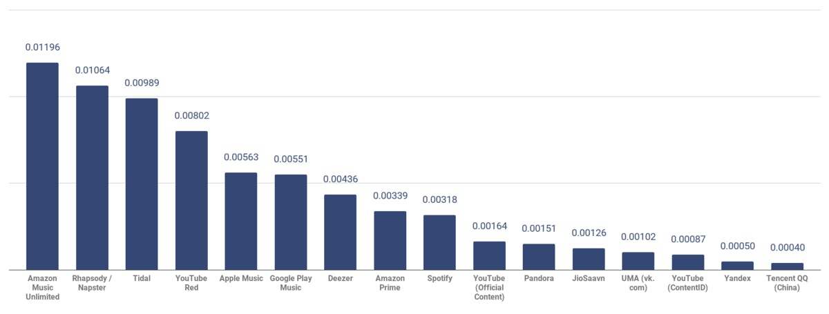
Weighted Average Per-Stream Payout Rate, by Platform, USD
Source: Soundcharts

Youtube and Intellectual Property
Considering that each minute, 500 more hours of content are added to YouTube, a system had to be implemented to ensure that original works receive their due, and that artists are able to manage their rights as they see fit. YouTube’s main way of ensuring this happens is by implementing Content ID.
Content ID is software developed by Google to identify and manage copyrighted content. The way it works is that it creates an ID File for copyrighted audio and video material, and a database in which to store this information. Each new piece of content being uploaded gets checked against the database, a process that can take up to 2 weeks. Any match leads to the copyright owner policies being checked to see if that is something they would allow, if the piece in question to be blocked, if they want information on its viewings, or if they want to add advertising to that content with proceeds going to them. It is important to mention that the entity uploading the new content does not have a say in this and that should the policy of the copyright owner be to place ads and monetise the video, the uploading entity not only cannot oppose it , but they would only receive 45% of the ad income. The Content ID algorithm is considered to be very accurate, about 99.7%, which is to be expected as YouTube reportedly invested USD 60 million in this system, and according to YouTube, it is responsible for about half of the USD 3 billion paid out to the music industry as early as 2016 (Dredge, 2016).
It is noteworthy that YouTube and the artists who received income from the Content ID application might soon deal with a rather unfriendly climate within the EU, as the EU has voted to adopt Art 13, which would mean that every video that has been or will be uploaded to platforms such as YouTube would have to be filtered and blocked if it breaks any copyright rules. (Reynolds, 2019). However, given how the article is worded, content such as covers, mash-ups, and parodies would also be liable to being deleted (if uploaded from the EU) or hidden from EU users if uploaded elsewhere (YouTube, 2018). Even though the UK is scheduled to leave the EU, it is thought that the UK will adopt its own version of Art 13, given that it was one of the 19 countries that supported it being adopted in the EU (BBC, 2019).

Challenges in monetising content on Youtube

One of the main gripes against YouTube seems to be the idea of Value Gap. A 2018 IFPI article then explains a concept called Value Gap, where even though audio streaming has fewer users (272 million), it generated 5.57 bn in revenue for artists, whereas the 1.3 bn users of video streams only generated USD 856 million (IFPI, 2018). The term ‘Value Gap’ comes from the notion that fewer users generate a much larger income for the industry. However, the Chief Business Officer of YouTube Robert Kyncl claims that YouTube paid over $1bn to the music industry just from ads (Kyncl, 2016). Moreover, Christophe Muller, the Head of Youtube International Music Partnerships claims and that the number is growing each year (Muller, 2016). The numbers, are, therefore, contradictory and the issue persists.

Moreover, a case study from RBB Economics looked into the concept of cannibalisation by YouTube of other music services. The study analysed a survey done on 1500 people, which were asked what would they do if music videos were no longer shown on YouTube (RBB Economics, 2017). The results indicated that around 85% of the time they currently spend on music on Youtube would be shifted to what the paper considers lower value channels (TV. Radio, Internet radio, personal music collections, filesharing or piracy). This acts as proof that even though Youtube does not pay the artists much per play, it is still preferable to artists removing their content from YouTube entirely and hoping their fans would choose one of the higher value channels (streaming subscriptions, physical media, digital downloads).

Conclusion

The fact is, whether or not it generates much income for the artists, YouTube is a great platform on which to get noticed. Artists such as Justin Bieber and Macklemore owe their ascent from anonymity to the community of fans they developed on YouTube. Many other artists rose to fame through covers of already well-known songs. A good such example is Bad Wolves covering The Cranberries’ Zombie, which according to Brent Barnhart accumulated over 130 million views in a 6-month span of time (Barnhart, 2018).

Appendix
Appendix 1: Screenshot of stats for Eminem’s new single “Darkness”, as of 19/01/20
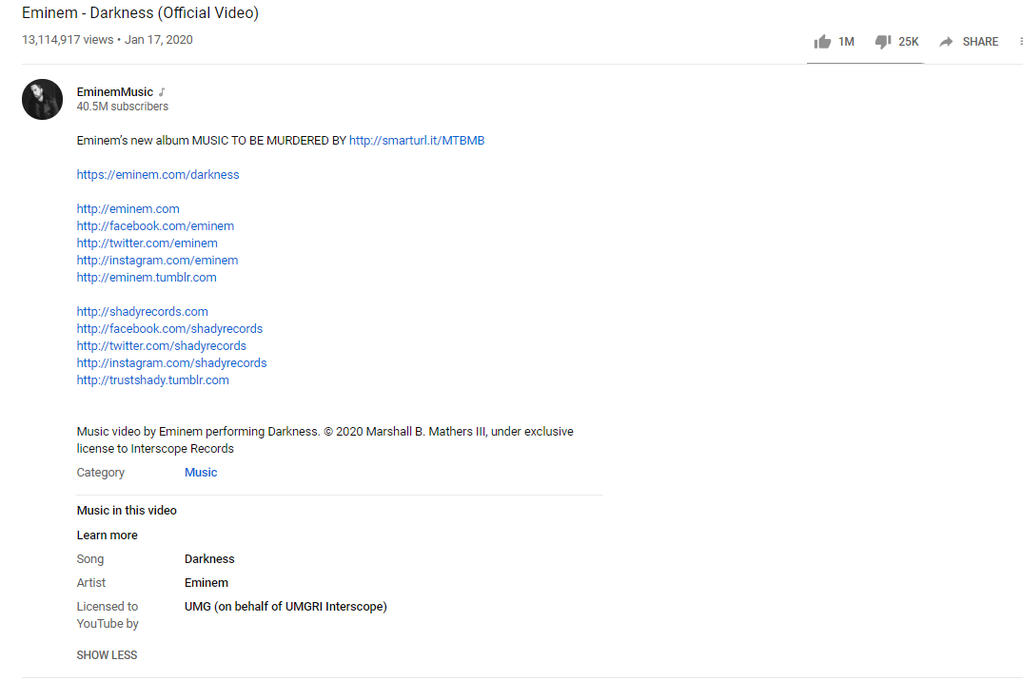

Appendix 2: Screenshot of the first few videos on YouTube’s Music section of their Trending videos as of 19/01/20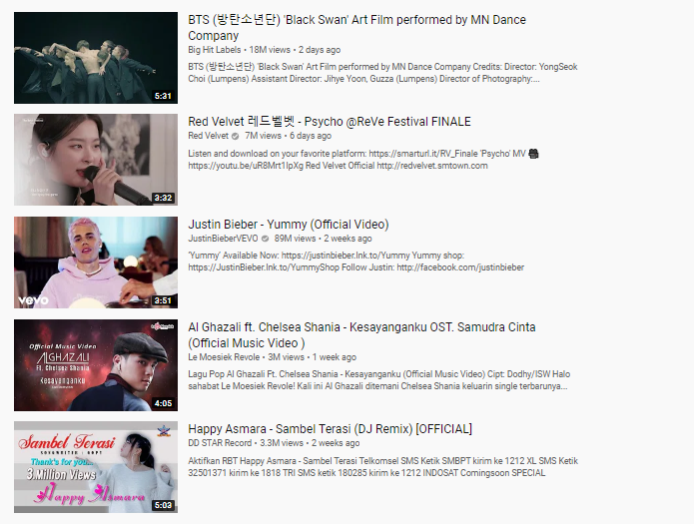

Appendix 3: Screenshot of the next few videos on YouTube’s Music section of their Trending videos as of 19/01/20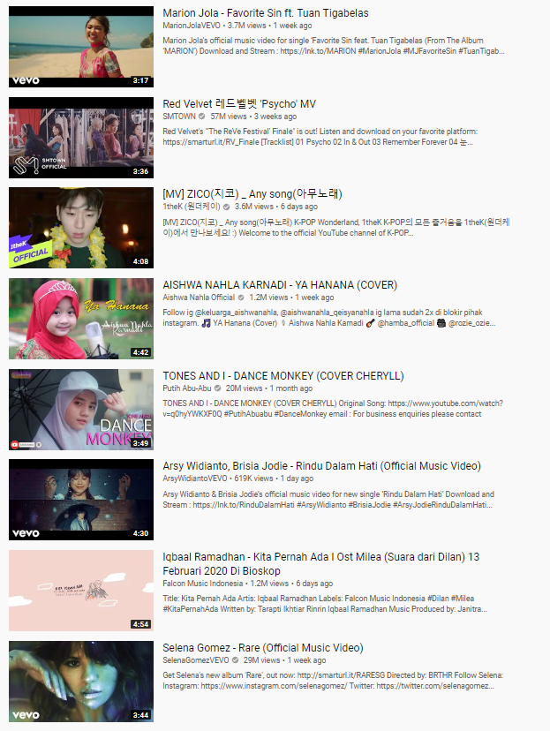
Appendix 4: Screenshot of the next few videos on YouTube’s Music section of their Trending videos as of 19/01/20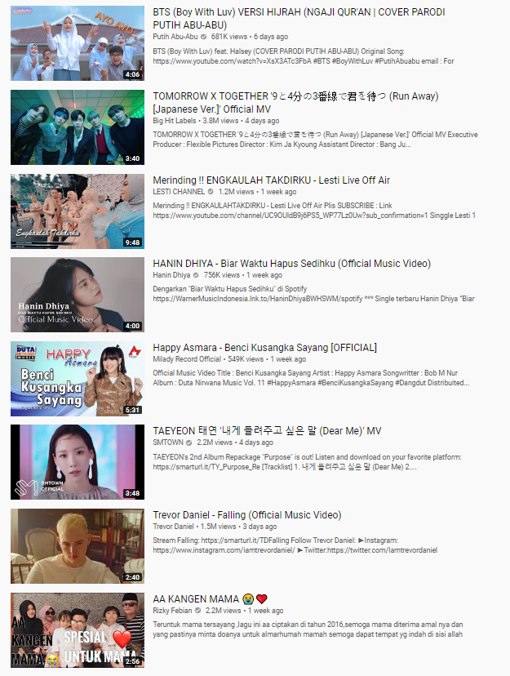

Appendix 5: Screenshot of the last few videos on YouTube’s Music section of their Trending videos as of 19/01/20
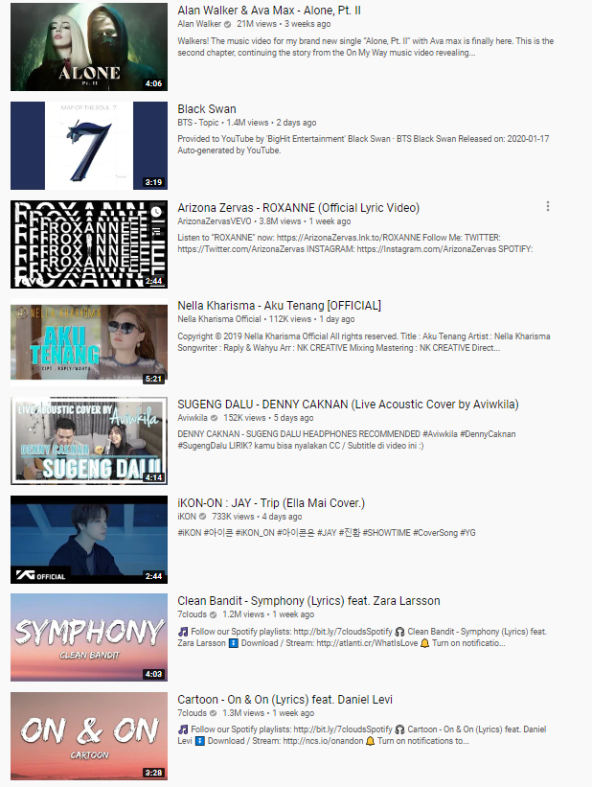

References
Barnhart, B. (2018). The complete guide to social media for musicians. [online] Sprout Social. Available at: https://sproutsocial.com/insights/social-media-for-musicians/ [Accessed 19 Jan. 2020].
Barnhart, B. (2019). How to promote your YouTube channel to maximize views. [online] Sprout Social. Available at: https://sproutsocial.com/insights/how-to-promote-your-youtube-channel/ [Accessed 19 Jan. 2020].
BBC (2019). UK helps push through EU copyright revamp. [online] BBC News. Available at: https://www.bbc.co.uk/news/technology-47933530 [Accessed 19 Jan. 2020].
Dredge, S. (2016). Why is the music industry battling YouTube and what happens next?. [online] The Guardian. Available at: https://www.theguardian.com/technology/2016/may/20/music-industry-battling-google-youtube-what-happens-next [Accessed 19 Jan. 2020].
Eminem (2020). Eminem - Darkness (Official Video). [online] Youtube.com. Available at: https://www.youtube.com/watch?v=RHQC4fAhcbU [Accessed 19 Jan. 2020].
Google (n.d.). How Content ID works - YouTube Help. [online] Support.google.com. Available at: https://support.google.com/youtube/answer/2797370?hl=en-GB&ref_topic=4515467 [Accessed 19 Jan. 2020].
Hale, J. (2019). More Than 500 Hours Of Content Are Now Being Uploaded To YouTube Every Minute. [online] Tubefilter.com. Available at: https://www.tubefilter.com/2019/05/07/number-hours-video-uploaded-to-youtube-per-minute/ [Accessed 19 Jan. 2020].
IFPI (2018). Fixing The Value Gap. Breaking Down The Value Gap. [online] Ifpi.org. Available at: https://www.ifpi.org/downloads/GMR2018_ValueGap.pdf [Accessed 19 Jan. 2020].
Kyncl, R. (2016). A billion reasons to celebrate music on YouTube. [online] Official YouTube Blog. Available at: https://youtube.googleblog.com/2016/12/a-billion-reasons-to-celebrate-music-on.html [Accessed 18 Jan. 2020].
Muller, C. (2016). YouTube: 'No other platform gives as much money back to creators'. [online] the Guardian. Available at: https://www.theguardian.com/music/musicblog/2016/apr/28/youtube-no-other-platform-gives-as-much-money-back-to-creators?CMP=twt_a-music_b-gdnmusic [Accessed 18 Jan. 2020].
Music Business Worldwide (2018). More music is played on YouTube than on Spotify, Apple Music and every other audio streaming platform combined - Music Business Worldwide. [online] Music Business Worldwide. Available at: https://www.musicbusinessworldwide.com/more-music-is-played-on-youtube-than-on-spotify-apple-music-and-every-audio-streaming-platform-combined/ [Accessed 18 Jan. 2020].
RBB Economics (2017). Value of YouTube to the music industry - Paper I - Cannibalisation. [online] Rbbecon.com. Available at: http://www.rbbecon.com/downloads/2017/05/Value-of-YouTube-to-the-music-industry-Paper-I-Cannibalization.pdf [Accessed 19 Jan. 2020].
Reynolds, M. (2018). What is Article 13? The EU's divisive new copyright plan explained. [online] Wired.co.uk. Available at: https://www.wired.co.uk/article/what-is-article-13-article-11-european-directive-on-copyright-explained-meme-ban [Accessed 19 Jan. 2020].
Salomone, N. (2017). YouTube for Musicians: "How is all the $$ made?" | DIY Musician Blog. [online] DIY Musician Blog. Available at: https://diymusician.cdbaby.com/youtube/youtube-musicians-made/ [Accessed 19 Jan. 2020].
Soundcharts (2019). What Music Streaming Services Pay Per Stream (And Why It Actually Doesn’t Matter). [online] Soundcharts.com. Available at: https://soundcharts.com/blog/music-streaming-rates-payouts [Accessed 19 Jan. 2020].
The Drum (2012). Case Study: How Gangnam Style went viral with a strategic marketing campaign from YG Entertainment. [online] The Drum. Available at: https://www.thedrum.com/news/2012/10/30/case-study-how-gangnam-style-went-viral-campaign-yg-entertainment [Accessed 18 Jan. 2020].
Youtube (2018). Article 13 - Burning Questions #SaveYourInternet. [online] Youtube.com. Available at: https://www.youtube.com/watch?v=TRYSxIYHS0w [Accessed 19 Jan. 2020].

