Game Design and Critical Analysis - M6X02045

Jordan Lee – P1702727
Creative Computer Games Design
5466 words

Richard Morgan
Julian Hainsworth
Jessica LaCombe

Table of Contents
Table of Contents 2
Table of Figures 3
Introduction 5
Research 6
Methodology – Questionnaire 1 11
Methodology – Verbal Feedback 18
Methodology – Questionnaire 2 19
Results and Analysis 20
Conclusion 34
References 35
Appendix 37
Bibliography 43

Table of Figures
Figure 1. 1 - Table displaying the most time people are willing to spend carrying out surveys 6

Figure 2. 1 - Introduction for questionnaire 12
Figure 2. 2 - Learning about the respondent 12
Figure 2. 3 - Respondent experience and interest in animation 13
Figure 2. 4 - Questions for emotional protrayal of each animation 14
Figure 2. 5 - The window with animation videos labelled 15
Figure 2. 6 - General feedback and interest in attending future sessions 15

Figure 4. 1 - Second questionnaire new questions for animation feedback 18

Figure 5. 1 - Question 1 results 20
Figure 5. 2 - Question 2 Results 21
Figure 5. 3 - Question 3 Results 21
Figure 5. 4 - Question 4 Results 22
Figure 5. 5 - Question 5 Results 22
Figure 5. 6 - Question 6 Results 23
Figure 5. 7 - Question 7 Results 24
Figure 5. 8 - Question 8 Results 25
Figure 5. 9 - Question 9 Results 26
Figure 5. 10 - Question 10 Results 27
Figure 5. 11 - Question 11 Results 27
Figure 5. 12 - Question 12 Results 28
Figure 5. 13 - Question 13 Results 28
Figure 5. 14 - Question 14 Results 29
Figure 5. 15 - Question 15 Results 30
Figure 5. 16 - Question 16 Results 30
Figure 5. 17 - Question 17 Results 31

Introduction
This document will be discussing the process in which we will be carrying out various questionnaires and aim to receive feedback that can help increase the quality of our animations for the main companion character – HAL, it is important to note that all animations spoken about in this document has been applied to HAL as he was made and rigged for the HumanIK rig. With the focus primarily being on receiving feedback on body language we will be creating various questionnaires. The choice to use questionnaires as our primary and formal method of feedback was decided within the team, as well as allowing verbal feedback to be a form of informal feedback which will also be recorded. However, the survey will be formed with questions as well as producing visual aids that will be used as reference imagery for people that have both experienced the game in Virtual Reality (VR) in addition to the stand-alone animations themselves. We project to make different iterations of the questionnaire to try both increase the quality and efficiency of the survey itself, as well as obtaining data that can allow development on the emotion the body language is portraying without the use of context. The animations will be isolated, and the participant will be asked to give their entries honestly with the security of all submissions being anonymous. We will be using questionnaires to obtain feedback to gain data to help improve the quality of the character animations, and then analyse the data we gather and develop on the current version or allocate time to make alterations next semester. These playtesting sessions will primarily be conducted on university grounds, and will have allocated times where other student and friends can try the game.

Research
In relation to carrying out of playtesting sessions and acquiring feedback through various forms, one of these being that of a questionnaire. However, we must first consider what comprises that of an efficient questionnaire. One of the aspects we will be considering is that of “Survey fatigue” (Porter, 2004). This being “it’s a problem that occurs when survey respondents become bored, tired or uninterested in the survey and begin to perform at a substandard level.” (Stiles, 2016). We want to ensure that this is avoided at all costs, as we will be primarily be asking peers and friends to carry out the survey numerous times as we develop the game. So, it is imperative that the questions we ask are concise and informative so we can take it, discuss it and potentially apply it to our current ideas to improve the quality of the game. To combat this, we will aim to have the questionnaire duration to be between 5-15 questions long with around 5-15-minute completion time and have peers test the questionnaire to see what average time is scored when casually carrying out the test. Once we have an initial draft of the questionnaire established, we will measure the length of our survey by carrying out a few tests of different people completing the questionnaire. We can then use this information to then adjust questions, so we do not exceed the recommended time for an average person being able to willingly carry out the survey. As it can be seen from Figure 1, ideally people who carry out surveys will only be willing to spend 5-15 minutes to complete a survey and be willing to carry it out again in the future. (Sorman, n.d.)
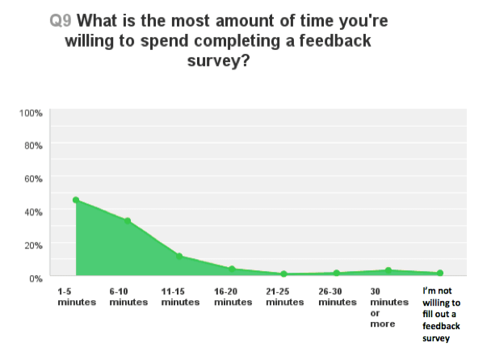
Figure 1. 1 - Table displaying the most time people are willing to spend carrying out surveys
Ideally, the less time it takes the better as it indicates that the survey is efficient, and the participant may also be willing to carry out other surveys during the same session. As there will be various surveys available with different focuses, having a single participant being willing to carry out more than one survey will significantly increase the quantity of entries and therefore, the amount of feedback we can extract from this process. In addition, Sorman then goes onto discuss the importance of providing “incentives to motivate respondents to take your survey”. This is an aspect we will ensure we encourage as we are aware that most of the people that will be carrying out our questionnaires will be primarily students which have their own work to do, so providing compensation for their time we will be offering a form of food or drink as a reward for their cooperation. This will also possibly encourage the participant to return and carry out our survey again in the future with the promise of a reward.
In terms of what kind of questions our survey will be comprised of, we will first declare that all entries will be submitted anonymously. We will be using Microsoft Forms through the Microsoft Teams software as the platform to create our questionnaires, and the participants will carry out the survey within the playtesting space on one of the development team’s accounts. The computer in which the participant will be using to complete the survey will also be away from the development team, as we do not want our presence to influence feedback and allow the participant to be completely honest and give us direct and critical criticism that can potentially improve the current stage of the game. (Elizabeth, 2016) However, Elizabeth then goes on to discuss that there is a downside to using this method, as it does not allow us to bring up potential concerns within the feedback if it was to occur. When considering each side, we think the anonymous aspect provides a significant improvement in the quality and honesty of the feedback that we will more than likely use this method for the base format for our questionnaire.
The type of questions that are found within questionnaires are one of two types, “open ended questions” and “close ended questions”. The difference between the two formats of questions comes from the contrast in length of answers expected to fill in the question.
For example, close ended questions are defined by giving the participant a set of “pre-defined responses” (Questionpro.com, n.d.). These can range from simple yes/no answers, multiple choice questions or scale/rating questions. Despite close ended questions providing a more efficient questionnaire due to their quick completion speed from the choices already being presented, it makes the feedback easier to understand when reviewing however will lack detail and the response could be broad (Mcleod, 2018). The participant will naturally go through the questions quickly when compared to that of open-ended questions as close ended questions also restrict the person carrying out the survey to select only set answers which could influence and lead the answers to a more suited answer, and therefore making the feedback biased and less reliable (Jackson, 1979). When using closed ended questions, we must ensure that we do not lead the participant with the wording or choices of the question as the feedback quality will not give us the information we need when aiming to develop our project.
On the other hand, we have open ended questions. These are the questions that allow the participant to “express what they think in their own words” (Mcleod, 2018). This format provides more of an in-depth scope of feedback, allowing the participant to express their opinion over something in their own way (Geer, 1988). This produces a more detailed and unrestrained entries but at the expense of time to answer (Mcleod, 2018). However, one of the negatives of asking the respondent to take their time and formulate an answer (Mcleod, 2018), this process could take anywhere between 1-3 minutes to complete, which significantly reduces the potential to add multiple questions like this in one questionnaire as it can easily turn the task into a chore for the participant, and therefore playing into survey fatigue as discussed above. In addition, when reviewing the feedback, the time taken to analyse the data will be directly relative to the time taken to carry out the answer, even when providing detailed information, we must consider the broadness of the question we are asking an answer for, we aim to maintain the 5-10-minute completion time throughout iterations of the questionnaire.
Another means of acquiring feedback is through a verbal questionnaire. This is an informal method of acquiring our data in a more organic and relaxed environment. Despite losing the anonymity and potentially putting the participant on the spot we can learn first thoughts when they are exposed to an element of the game. The questions asked in this form will not be changed from that of the written form of feedback, but instead of the respondent writing down the answers we will be writing it down, thus saving them from having to fill out the paperwork, and also in the situation where the participant is not so comfortable with their ability to write, we can take that element away.
When we begin the stage where we will start to form questions, we must be aware of the importance of avoiding biased and leading questions, as these questions can lead to unreliable results and could corrupt the data we gather. (Hawksworth, 2017)
“Leading questions” are written in a way that influences the respondent to answer in a way that is in the “right direction” (Hawksworth, 2017). When formulating the question, the use of giving examples of possible answers could come across as “ideal answers” and therefore again, corrupting the answers, if in the scenario the question is difficult to word and the use of possible answers is needed, we must request that the participant provides a few answers or “choose their top 1 or 3” (Hawksworth, 2017), doing this will ensure that we have a few more answers that are not just from the possible listed answers we have given as examples. When failing to ask for multiple answers we will usually find more positive entries, however while playtesting and gathering data from the questionnaires we want the respondent to give us negative feedback as it is usually a way of them having an input of what needs to change to make them happy within the current state of the game. If we then take that information and apply it, it will encourage further involvement in these questionnaires as they know we are listening to the feedback given. (Hawksworth, 2017)
“Bias questions” can be avoided by the help of the questionnaire being anonymously answered, as there will be no hard feelings between possible friends, family or random entries. It will only show the raw and reliable data. (Hawksworth, 2017) Another method to avoid bias answers is also to ask someone distant from the topic, such as friends of friends or peers from other courses that have no affiliation with the subject. (Hawksworth, 2017)

Methodology – Questionnaire 1
As lead animator within the team, the questionnaires that we will be producing will be targeted towards the body language and emotional portrayal of the characters’ movements. This will allow us to gather information in both quantitative and qualitative feedback. This meaning we will be gathering information that is gathered from a number of people as well as asking them for their opinion to increase the quality of the animations. Due to the research gathered from our dissertation we found that a significant amount of communication can be derived from “body language”, papers vary from percentages but body language may account for between 60-65 percent of all communication” as suggested by (Foley, 2010), as well as other documents that share the message that body language holds most of the information when regarding communication (some of these papers can be found in the bibliography). Therefore, encouraging us to ensure that the HAL animations we produce are conveying the correct emotion as spoken words of the character only holds a small amount of communication. These will be the topic of most of our questions in our questionnaire.
In terms of location, we intend to use the university facilities and equipment to carry out our playtesting sessions. We will alert the participants in advance to ask if they will be willing and available to assist us in these sessions. The benefits of using this as the location to conduct our testing are things such as, equipment (vast numbers of computers with multiple monitors to use as questionnaire submission stations with references being accessible on the other screen), variety of peers from different courses (this also benefits the different perspectives of which the animations will be assessed by), open space of the classroom and most importantly its free.
We will also be providing a form of time compensation at each playtesting session in form of doughnuts and soft drinks. We wanted to give incentive for the participants to come and help us as well as provide them with suitable compensation for their time.
The choice of VR we will be primarily testing on is the Oculus Rift and later in the process, PlayStation VR. However, it is important to note that we only have access to a single Oculus Rift (provided by the university) to carry out our playtesting, so it is imperative that if there are multiple people wanting to attend our sessions that we ensure all get a chance to experience the game as well as participate in feedback surveys efficiently.
Using the software Microsoft Teams as a platform for our team’s, we will be using the extension called Microsoft Forms. The choice to use these was decided amongst our team as it provides an organised place to keep all our member’s questionnaires in the scenario one of our team will not be able to attend the session, data can still be gathered. An additional feature to this platform is the function to automatically create various charts from the data gathered, also providing a clear way to show the results and the option to expand one entry to see duration of completion and answers. On top of that we also have the option to imbed images and videos to offer a visual aid to help support the question.
The use of the “PlayBlast” feature found in the Maya2018 software allows us to give a video of our animation and allow the respondent something to refer to if they have forgotten what animation we are referring to in the question. However, the effect of how the animation is portrayed will be different from a simple Gif compared to being able to see it in the VR experience. It would be ideal for the respondent to play the game before carrying out our questionnaire but the Playblasts allow the option to without the game.
As discussed above, we will ensure the respondent knows they are remaining anonymous this will hopefully increase the validity and reliability of our data when we reach the analysis phase. We will declare it in the title description. The introduction will read:
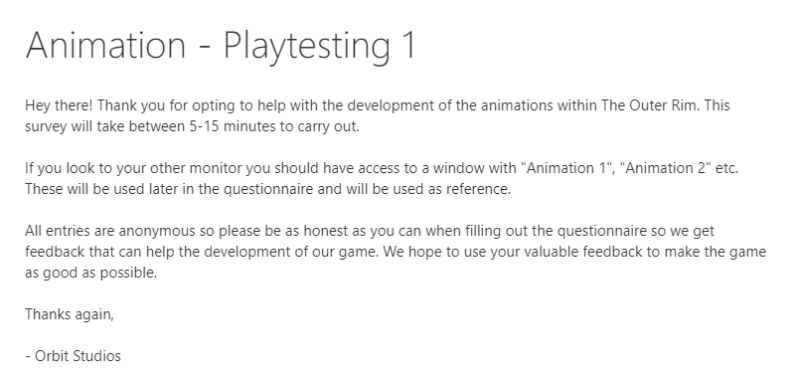
Figure 2. 1 - Introduction for questionnaire
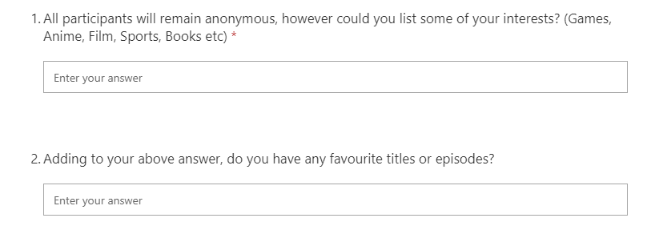
In terms of questions, we will first request to find out more about the respondent. The purpose of these questions is to attempt to find out what kind of feedback we will receive, someone who from an animation course for example with interests in anime could be analysing different aspects of the animation to that of someone who only plays hyperrealism games.
Figure 2. 2 - Learning about the respondent
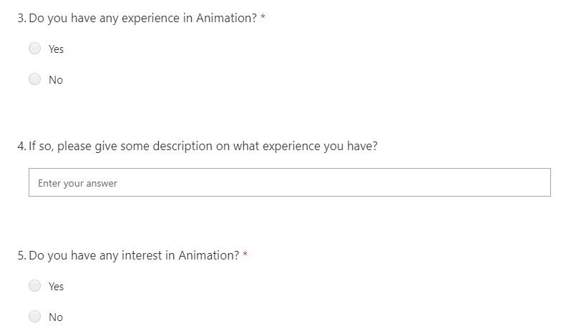
I then follow these questions with animation related questions and if the participant has had any prior experience with animation within games or 3D software (this will be a closed yes/no question), as well as giving them an optional question to elaborate on their experience if they have answered yes. From this we intend to gather information if the respondent is invested into the animation subject and thus may have prior knowledge on the mechanics behind animating (such as principles of animation). Ending the group of questions with asking if the participant has interests in animation. This will be a closed yes/no question but will also show us if they will be invested in spending time analysing the animation for emotion. If answered “No”, then we could find a quicker time of completion and less detailed entries and could be a simple attempt to get through the questionnaire as soon as possible. This could potentially make some data unreliable so we must remain vigilant.
Figure 2. 3 - Respondent experience and interest in animation
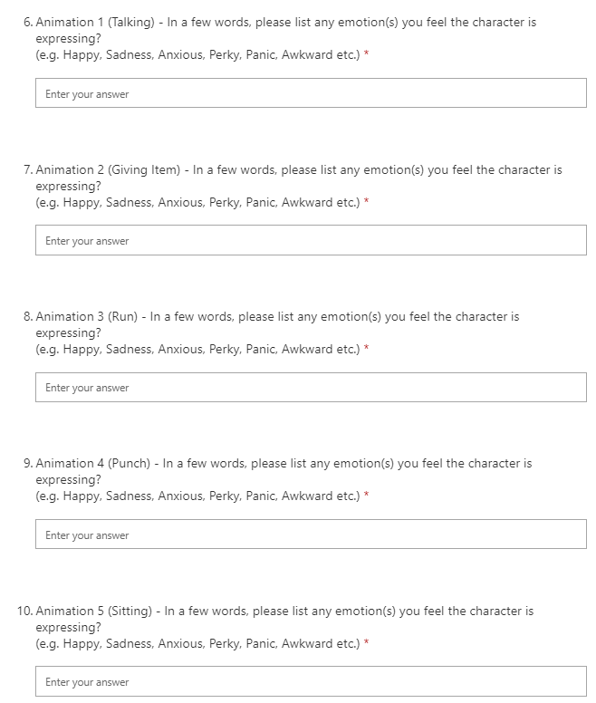
The participant will then be asked to refer to the animation reference tab on the other screen. The following questions will be the animation-oriented that will be asking to describe what kind of emotion the animation is displaying. There will be five different animation clips that will be displayed and provided with limited context associated with them, they are labelled “Animation 1”, “Animation 2” etc. These questions are made so the respondent analyses the animation in isolation. Despite this possibly “leading” the answer as discussed above, we use a uniform list of emotions throughout all questions which are both positive and negative emotions. This is just used as an example and not be interpreted as leading. Below you will find the questions with some context to the label of each animation. All of which are open-ended questions that require entries, and have the “Long answer” feature enabled if the respondent wishes to expand on their answer:
Figure 2. 4 - Questions for emotional protrayal of each animation
Due to the first questionnaire asking for feedback on five separate animations, these open-ended questions significantly will increase the completion time. Ideally, we would like to isolate and receive small and more direct feedback on one animation individually, however due to time constraints the format in which we test numerous animations at once is needed to make sure we gain feedback on all accessible. Adding onto this, we also included optional questions under each animation allowing the participant to suggest possible actions that could help support the emotion we are trying capture.
To complete these questions the participant will need to refer video reference of the animations which will be open in a window on the second monitor of the feedback station.
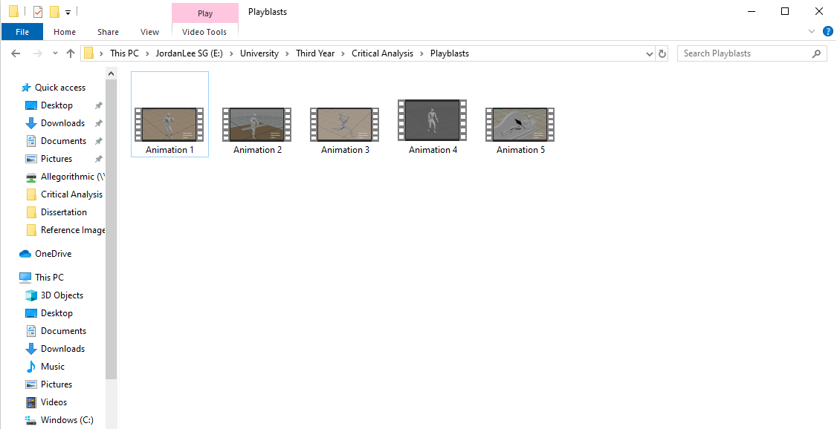
Figure 2. 5 - The window with animation videos labelled
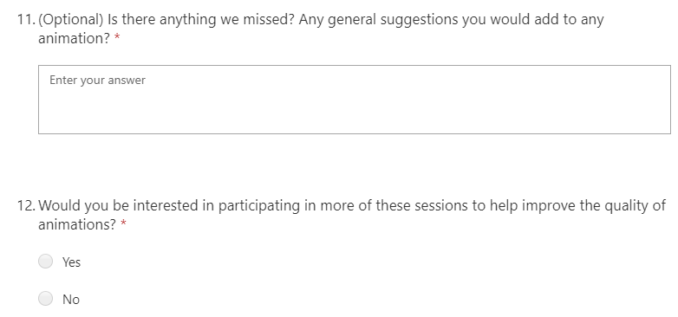
Concluding this iteration of the survey we give the participant a chance to mention anything we potentially forgot to ask, as well as any general feedback they have regarding animation that they want to speak about. There is no obligation for this answer to be completed as it is optional question with long answer feature enabled to give the opportunity to expand on their feedback. This will be followed by the final question of the survey, simply requesting if the play tester would be interested
in participating in more sessions like this.
Figure 2. 6 - General feedback and interest in attending future sessions
Due to this questionnaire hosting several animations we must stress that the next iteration, will not have the introduction questions as well as not have as many animations. As answering questions, you already have in previous version simply wastes time. In addition, the importance of finding if each participant is willing to carry out playtesting is important for us, as it means the sessions are enjoyable for them and we can continue to carry them out in the format we are. If someone replies “No” for the final question, we will have to analyse their entry to try discover the issue. This could be a variety of things such as the questionnaire taking too long or not being able to experience the game themselves despite waiting. This is a limitation we face while we only have access to one Oculus currently.
A full version of the questionnaire can be found in the appendix A.

Methodology – Verbal Feedback
As discussed above, the ability to ask questions and receive verbal feedback while the participant is looking at the animations and being inside VR will hold potentially more accurate results as the same animation can have a different impact when exposed to it in VR when compared to first person on a screen, it allows the player to personally explore around the animation as they wish. This will be a form of qualitive research as we will be engaging them in conversation asking them for their opinion on how they see the animation and then collecting the data. In addition to this, it allows the player to stay immersed inside the world and saves the respondent from having to repeatedly taking the headset on and off again to fill in our questionnaires, thus increasing questionnaire efficiency.

Methodology – Questionnaire 2
Built based off the first iteration, we noticed a trend that the initial test in which we attempted to gain an average completion speed around 10-15 minutes. Ideally, we want to aim between the range of 5-10 minutes to complete the questionnaire. To address this issue, we began to alter the questionnaire and introduce a close ended question that was rating based out of 5.
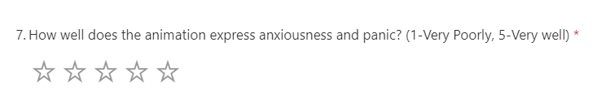
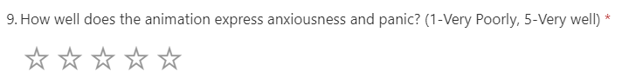
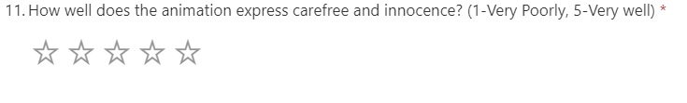
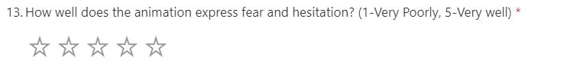
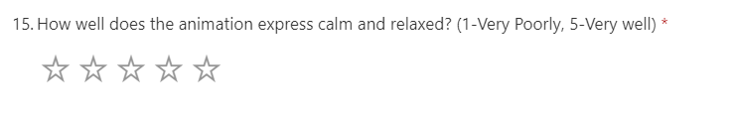
The choice to implement more close-ended questions to increase speed of completion times was to substitute sections where the player suggests additional actions for HAL to carry out (in an open-ended format) to assist in the portrayal of a specific emotion. Once we begin to narrow down on what animations that are being executed well, we will be able to move on and reduce the amount of questions within a single questionnaire and simultaneously reduce the overall time for completion.
Figure 4. 1 - Second questionnaire new questions for animation feedback
A full version of the questionnaire can be found in the Appendix B.

Results and Analysis
Through various playtesting sessions that we conductions with the first and second year of game designers, as well as a few different open days and taster days hosted by the university we found ourselves with the opportunity to gather a lot of invaluable data to improve our game and new audiences each time to carry out our survey.
From the ten entries we had across the various iterations of the questionnaire we found the average time of completion to be 11 minutes and 20 seconds. This is slightly higher than the recommended time of 10 minutes to carry out questionnaire, despite it not being a terrible time, we did have the longest entry taking 20 minutes and 10 seconds to complete which is unacceptable. We must take into consideration this was the day we received over 30 people offering to playtest, the busy room might have been distracting to complete the questionnaire efficiently. However, the aim is to get the duration of completion to below 10 minutes. To do this we believe we need to trim down the amount of animations within each survey. As discussed above, due to the bottleneck in animations we began playtesting with 5 animations which significantly increased completion time. As we begin to check off animations as complete and ready for the game, we can begin to reduce the size of the questionnaire questions. The adjustments and completion of the animations will be projected to be done at the start of next semester, as well as introducing new characters and animations for them. Managing time will be imperative next semester’s success.
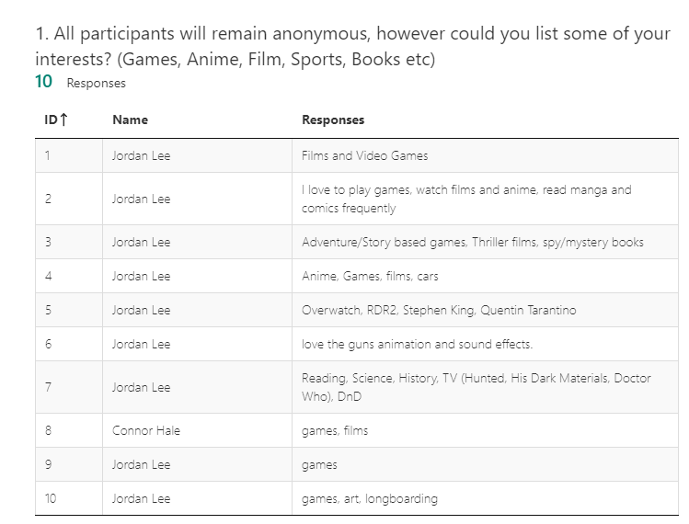
In terms of the questions we will be breaking down each question and what the predictions of a model answer would be and then analysing the feedback gathered.
Figure 5. 1 - Question 1 results
There is no particular prediction to what answer we want during these first few questions but it was to obtain an idea of the respondent.
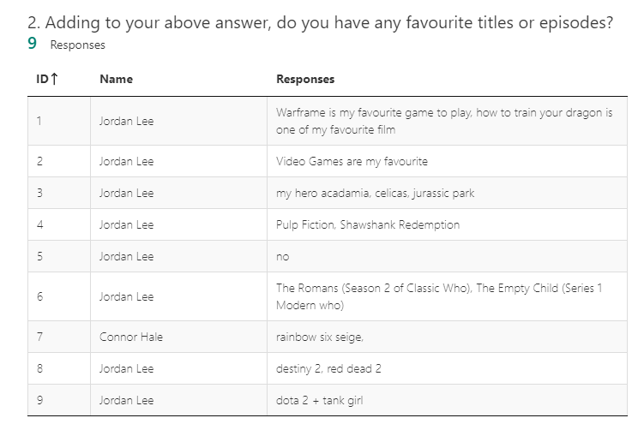
Figure 5. 2 - Question 2 Results
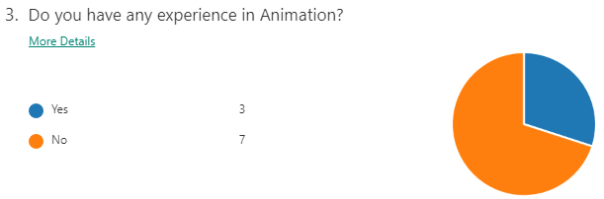
This is allowing a development on the previous question to learn what particular games if they play, the contrast of hyperrealism and cartoon style could be interesting if a trend occurs in the results later on in the questionnaire.
Figure 5. 3 - Question 3 Results
This was useful to know as most of the people taking the questionnaire was focused on the animation visual itself and a small amount looking at the mechanics of animation. Giving me variation in the results.
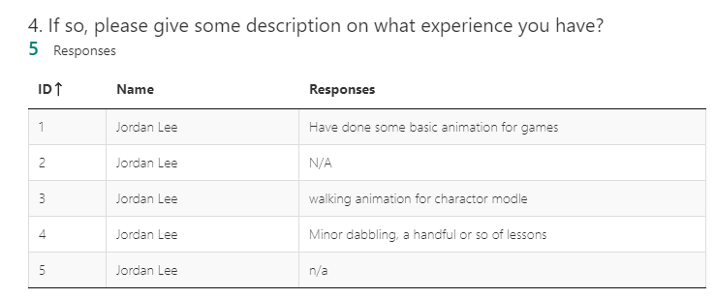
Figure 5. 4 - Question 4 Results
Useful data that assists in knowing the participant. If the result here shows “industrial level animator” for example, that entry should host invaluable and detailed data that could significantly increase the quality of the animation. However, the entries we find are students.
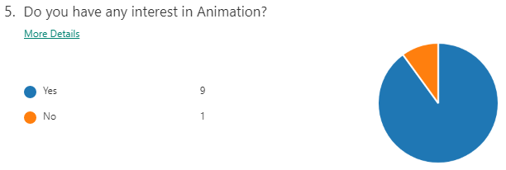
Figure 5. 5 - Question 5 Results
We find that the majority of people participating in the survey have some interest in animation so expectation of engaged entries could be expected.

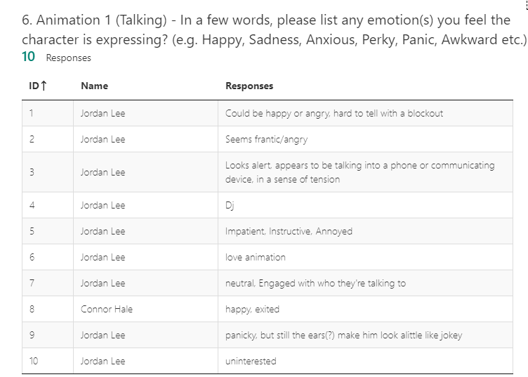
Figure 5. 6 - Question 6 Results
This was the first of the animation body language analysis questions. The aim of the animation is conveying a sense of anxiousness and pressed for time. From the feedback we an see there is no unanimous emotion, some bring up technical issues that will be resolved by the implementation of the high poly model next semester. However, we want the animation to look energetic and frantic which some entries say which is good, but this will require development next semester to hone on the desired emotion.

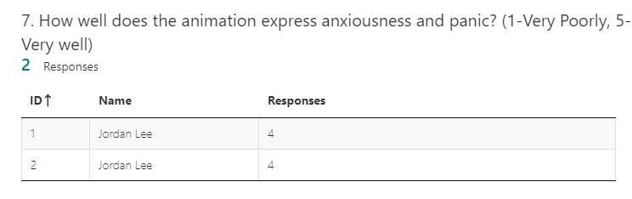
Figure 5. 7 - Question 7 Results
A later iteration led to a low amount of data gathered but it does show with context that the animation does display the emotion to a reasonable level.

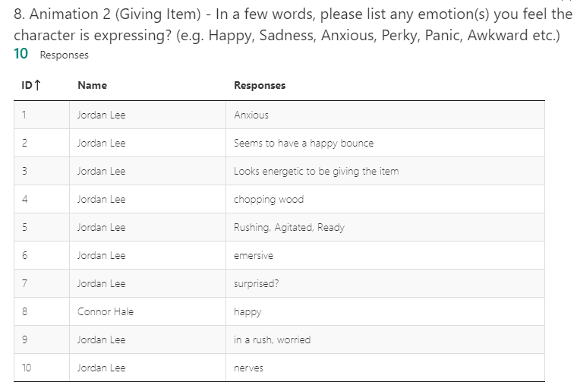
Figure 5. 8 - Question 8 Results
The desired emotion we wish to capture from this animation is the same as question 6, as HAL will transition to this animation following the one from question 6. The feedback on this animation however was more towards the projected emotions, which allows us to simply polish the animation slightly so it is not so rigid, but we will not require to spend significant time to alter this.

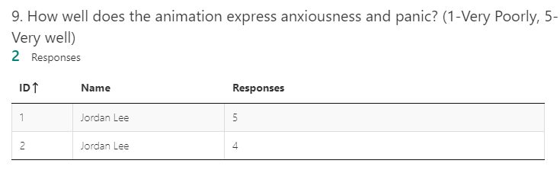
Figure 5. 9 - Question 9 Results
We gather that the entries are satisfied with the portrayal of the emotion we are aiming to convey. Ideally more data will be needed to validate and make the entries more reliable, but this is something that will need to be addressed next semester.

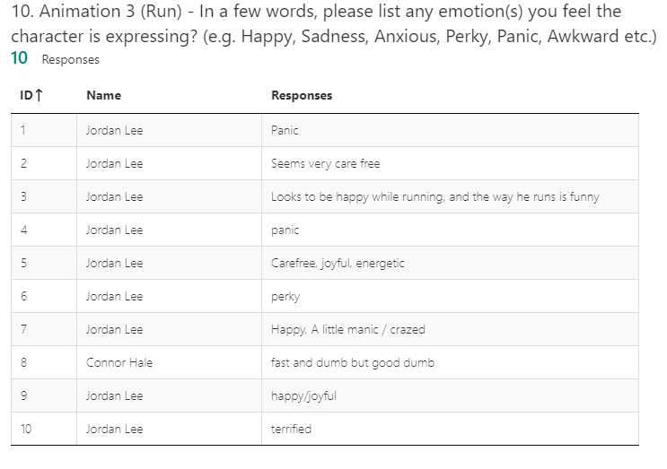
Figure 5. 10 - Question 10 Results
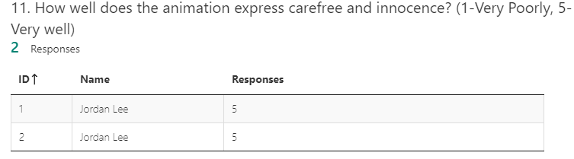
This animation is intended to show the personality of HAL. The aim was to show his carefree, childish and happy nature but also give the sense that he is being chased. The results hold data that we can relate to characteristics that a child has; therefore, we will take the feedback as a success and briefly revisits the animation next semester to polish in the graph editor in Maya2018.
Figure 5. 11 - Question 11 Results
This feedback shows the animation portrays the emotion we aim to convey well.

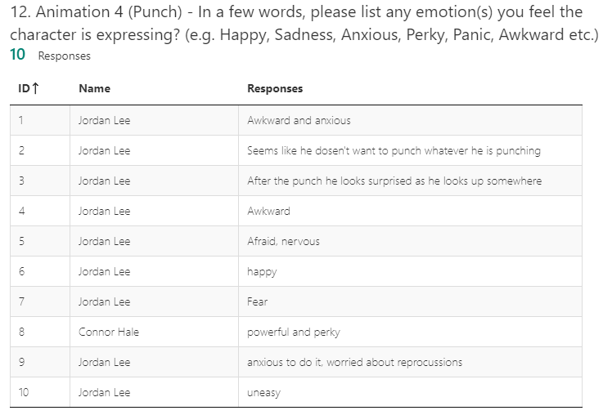
Figure 5. 12 - Question 12 Results
The emotion we aimed to show is fear and afraid of his own strength. This is a characteristic of HAL that we decided as a team, and this was a good time to show a flaw in the character. As we can see from the results, that around half enter the sense of awkwardness and nervousness which is what we wanted to achieve.
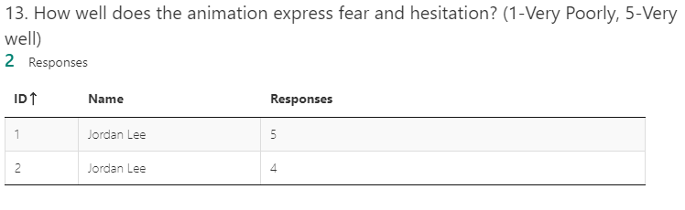
Figure 5. 13 - Question 13 Results
We can see that the limited data we have show that the emotion we aimed to translate is well shown in the animation.
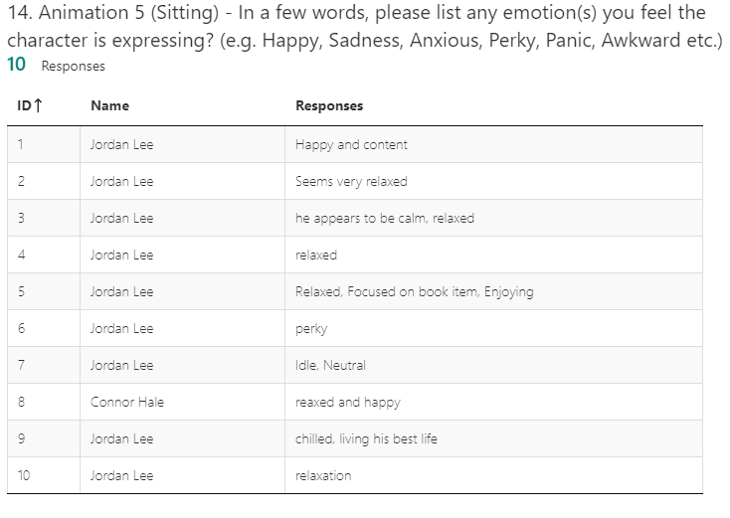
Figure 5. 14 - Question 14 Results
The animation is aimed to show a relaxed and calm emotion from HAL. As we can see from the data we collected, due to the slow movements of the animation in comparison to others it successfully gives off the emotion we wanted.

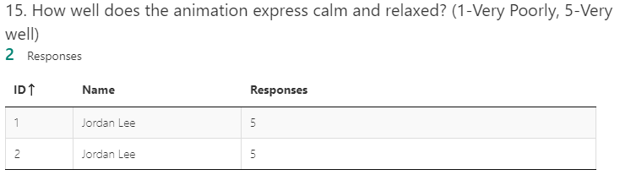
Figure 5. 15 - Question 15 Results
The limited amount of data we gathered shows that the animation conveys the relaxed emotion perfect. This will most likely require the least amount of polishing next semester.
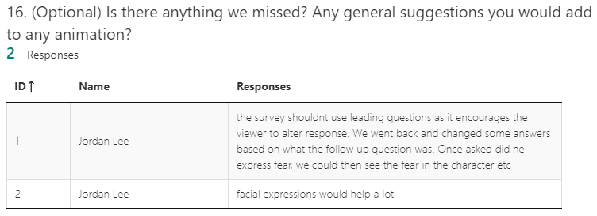
Figure 5. 16 - Question 16 Results
The limited responses for the second iteration of the questionnaire holds significant feedback as in the attempt to reduce the completion time I now noticed that I was indirectly leading the question to my emotion, which we can see from the feedback led the participant to go back and alter their previous entries. This also significantly increased their competition time, so moving forward we will remove these questions and possibly introduce the suggestion questions found in the first iteration of the questionnaire. Now that we have determined the animation that are portraying the correct emotion, we can remove them from the questionnaire moving forward and therefore reducing the completion time.
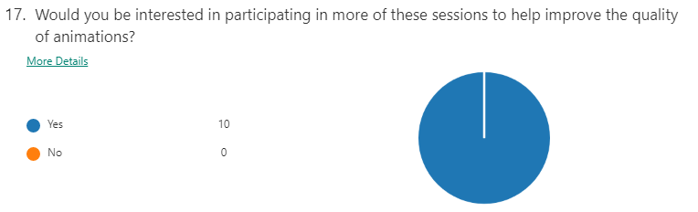
Figure 5. 17 - Question 17 Results
Finally, the last question shows that all participants would enjoy coming back to help with the development of the game. This was assisted by the incentives we provided to them as compensation of their time. This also ensures that even though the duration was long for some entries, they would not mind attending future sessions which is good to hear as a development team.
As seen above, one of the respondents speak about the formatting of the second iteration of the questionnaires. Describing the supporting question as “leading” the following question. This is something that is important to address immediately as it can cause our data to become biased and unreliable. The changes were only made in attempt to reduce completion time, however from the feedback we find that despite it helping the question count, it causes the participants to retrace their steps when being told an emotion should be seen. We made the mistake of having this question in our questionnaire, but we will reword/remove these questions to make sure the feedback is valid in the third iteration of the survey next semester.
In addition to the question, our unfamiliarity with the Microsoft Forms software, we wished to make a copy of our current questionnaire to alter a few questions to address some of the known issues when people were carrying them out. It was important to adjust questions to attempt to keep the duration of the test as low as possible to avoid server fatigue. However, due to our inexperience with the Forms software we accidentally deleted a question that was holding data from previous playtesting sessions. These were sadly lost, and we lost useful information on how to improve the animation. However, we will more than likely use similar questions from the questionnaire we lost to attempt to gain the feedback restored. However, we are now aware of the issue and will avoid it and make a separate questionnaire if we have new/old play testers.

Conclusion
Overall, we feel the process in which we carried out playtesting has gone smoothly each time we host a session. We engage with the participants and try to encourage more people to try our game. Each time we conduct a playtesting session people always enjoy the option of a food or drink for their cooperation and assistance with the development of the game. We think the promise of compensation for their time is something that our play testers are willing to trade.
In terms of the questionnaires, we believe we will be reverting to a format of the first questionnaire we formed, without the star rating questions. This is due to the ability for participants to offer their own ideas of some possible interesting ideas for the character to do is better and encourages involvement with us. The later iteration of the questionnaire was given feedback that it has leading questions that had the opposite to the desired effect of reducing completion time.
In addition to this we plan to create a version of the questionnaire that doesn’t have the introduction questions. This will primarily be for the people who have already attended and participated in previous playtesting sessions. We want to ensure that we are not wasting our respondents’’ time as well as our own with asking them repetitive questions.
Moving onto next semester we intend to adjust current animations with the support of the feedback data we have accessible to us from the playtesting already this year. Until we as a team, are satisfied that the correct emotion is being portrayed we will allocate time to work on each animation, but ensuring that we do not tunnel vision on one animation to get it perfect, as we need to develop animations as well as new character rigs and animations. All these will need to be discussed within the team and allocate time and set a priority list moving on for next semester to avoid we are becoming a bottleneck and not putting excessive pressure on ourselves to complete a task in unrealistic time frame. The new animations we know about next semester are emotionally engaging so we need to ensure that the body language communicates and works with the dialogue and tone to create the correct emotion.

References
Elizabeth (2016). the invaluable benefits of conducting an anonymous survey. [online] Novisurvey.net. Available at: https://novisurvey.net/blog/the-invaluable-benefits-of-conducting-an-anonymous-survey.aspx [Accessed 27 Dec. 2019].
Foley, G. (2010). Nonverbal Communication in Psychotherapy. [online] PubMed Central (PMC). Available at: https://www.ncbi.nlm.nih.gov/pmc/articles/PMC2898840/ [Accessed 8 Dec. 2019].
Geer, J.G., 1988. What do open-ended questions measure?. Public Opinion Quarterly, 52(3), pp.365-367.
Hawksworth, C. (2017). How To Avoid Leading Questions | Avius. [online] Avius. Available at: https://avius.com/2017/01/31/how-to-avoid-leading-questions/ [Accessed 28 Dec. 2019].
Jackson, J.E., 1979. Statistical estimation of possible response bias in close-ended issue questions. Political Methodology, pp.393-423.
Mcleod, S. (2018). Questionnaire | Simply Psychology. [online] Simplypsychology.org. Available at: https://www.simplypsychology.org/questionnaires.html [Accessed 28 Dec. 2019].
Porter, S.R., Whitcomb, M.E. and Weitzer, W.H., 2004. Multiple surveys of students and survey fatigue. New Directions for Institutional Research, 2004(121), pp.63-73.
Questionpro.com. (n.d.). Close Ended Questions: Definition, Types with Examples | QuestionPro. [online] Available at: https://www.questionpro.com/close-ended-questions.html [Accessed 27 Dec. 2019].
Sorman, A. (n.d.). 5 ways how to get people to take a survey | SurveyMonkey. [online] SurveyMonkey. Available at: https://www.surveymonkey.com/curiosity/5-best-ways-to-get-survey-data/ [Accessed 27 Dec. 2019].
Stiles, K. (2016). Survey Fatigue 101: Everything You Should Know Before Creating Your Next Online Survey. [online] Surveycrest.com. Available at: https://www.surveycrest.com/blog/survey-fatigue-101/ [Accessed 20 Dec. 2019].

Appendix
- First Iteration of questionnaire
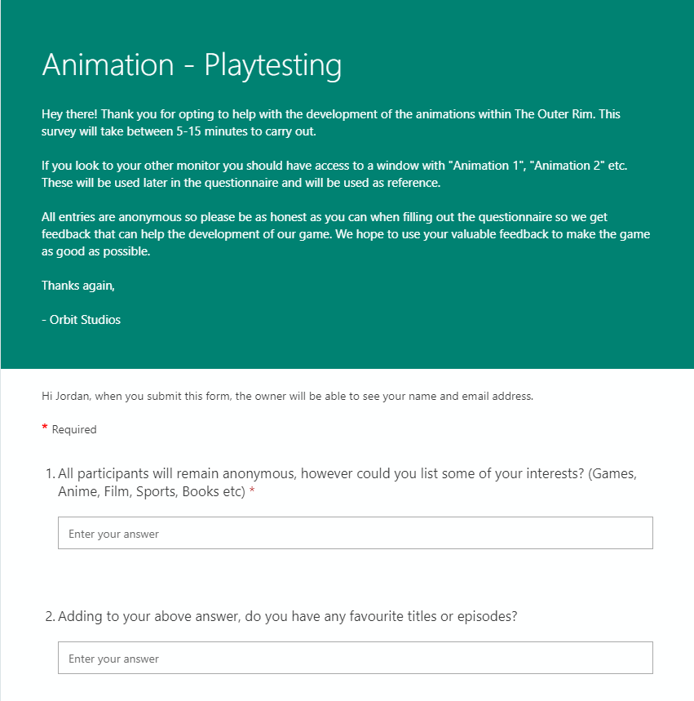
https://forms.office.com/Pages/ResponsePage.aspx?id=-REPTm4EBUWcuNshUjEeIXBq1vH4_TJAhw7UYpa5ACxUQUZaTEtXR1hGSjZRTEpUV1VMVzRYMDJJNiQlQCN0PWcu

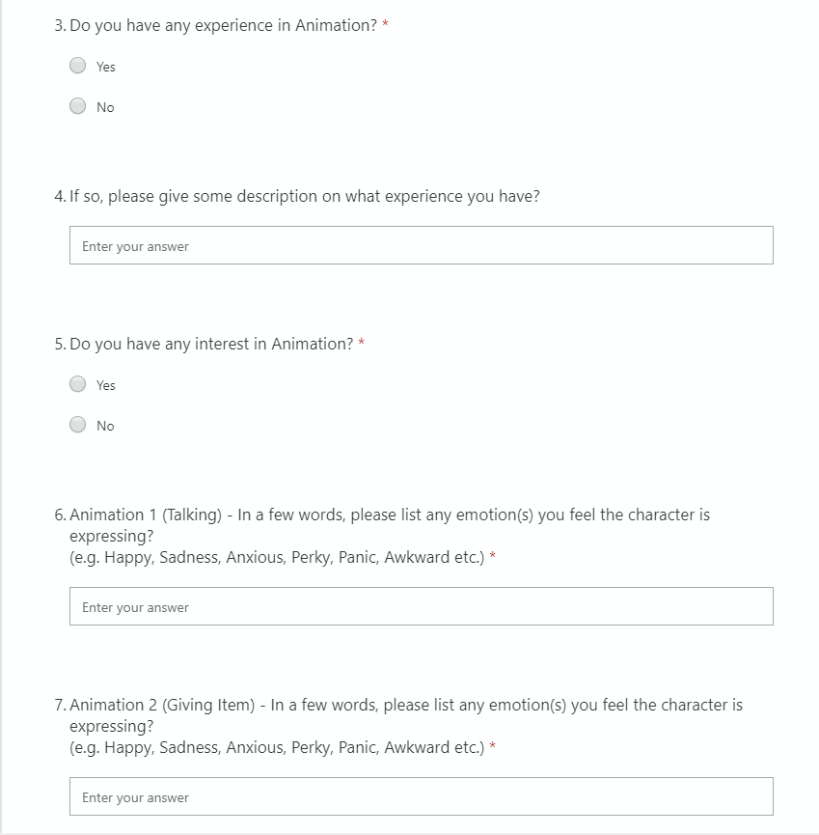

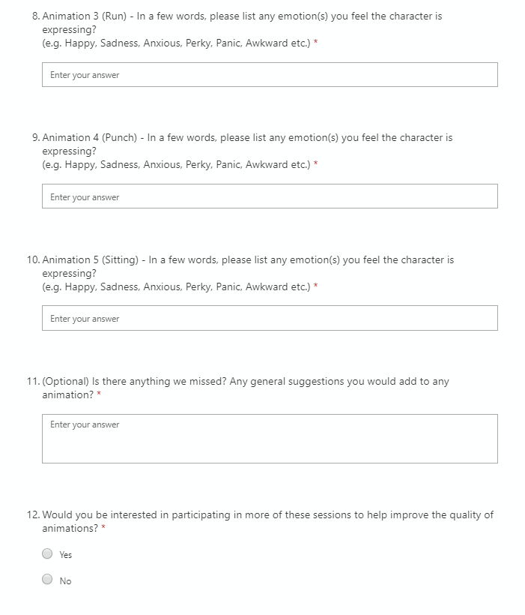

- Second iteration of questionnaire
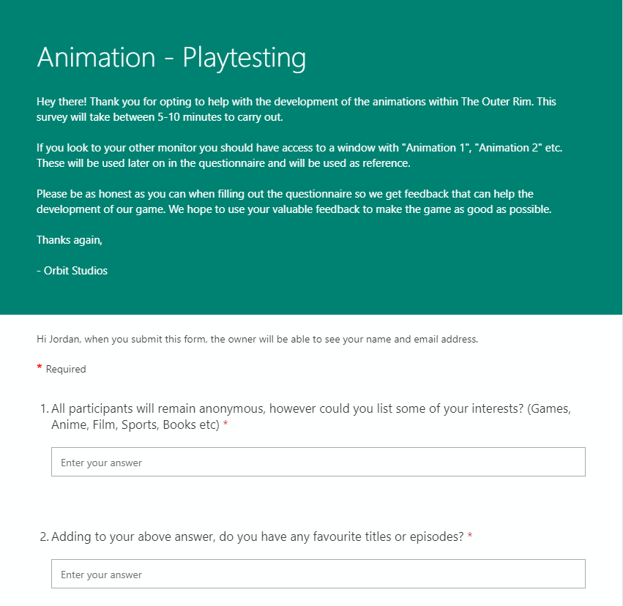
https://forms.office.com/Pages/ResponsePage.aspx?id=-REPTm4EBUWcuNshUjEeIXBq1vH4_TJAhw7UYpa5ACxUNkM4QUxGUlZHRkwyRDRDU0FNN1hCNFVBNyQlQCN0PWcu

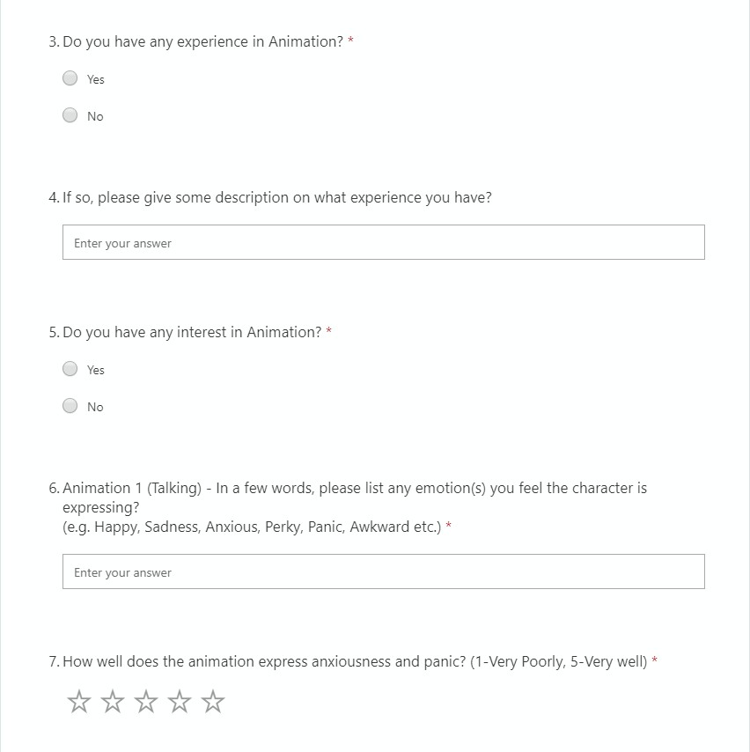
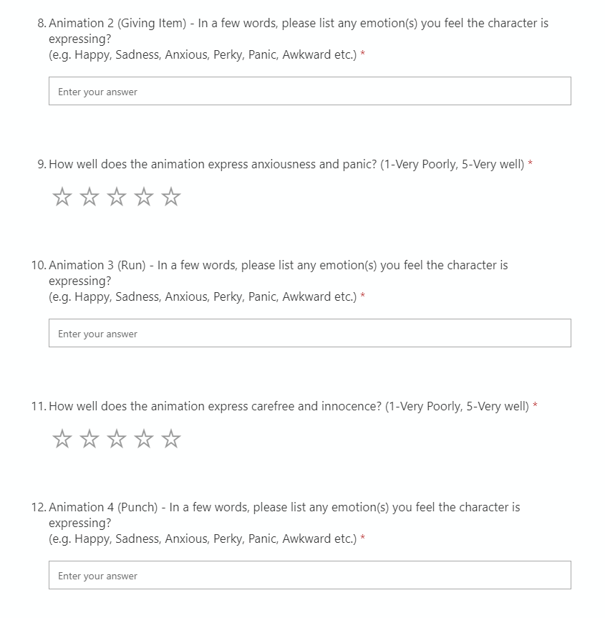

Bibliography
Cherry, K. (2019). How to Read Body Language and Facial Expressions. [online] Verywell Mind. Available at: https://www.verywellmind.com/understand-body-language-and-facial-expressions-4147228 [Accessed 7 Dec. 2019].
Debois, S. (2019). 10 Advantages and Disadvantages of Questionnaires - Survey Anyplace. [online] Survey Anyplace. Available at: https://surveyanyplace.com/questionnaire-pros-and-cons/ [Accessed 28 Dec. 2019].
Elnicki, D.M., Layne, R.D., Ogden, P.E. and Morris, D.K., 1998. Oral versus written feedback in medical clinic. Journal of general internal medicine, 13(3), pp.155-158.
Krosnick, J.A., 2018. Questionnaire design. In The Palgrave handbook of survey research (pp. 439-455). Palgrave Macmillan, Cham.
Oppenheim, A. (1966). Questionnaire Design, Interviewing and Attitude Measurement. New York: Basic Books, Inc.
Price, M. (2013). Nonverbal: Body Language & Touch. [online] Twelve Lessons from Disney. Available at: https://twelvedisneylessons.wordpress.com/2013/03/27/nonverbal-body-language-touch/ [Accessed 4 Dec. 2019].
Reja, U., Manfreda, K.L., Hlebec, V. and Vehovar, V., 2003. Open-ended vs. close-ended questions in web questionnaires. Developments in applied statistics, 19(1), pp.159-177.

