
Bethan Francis – 1802113
2021
BSc Policing and Criminology
Cyberbullying: A study into student support mechanisms available within the University of Wales Trinity Saint David (UWTSD)

Impact of COVID-19
Considering the continuing impact of the global pandemic, it is important to include a statement at the start of my dissertation which outlines the effects that COVID-19 has had on the research that I have undertaken that goes towards my undergraduate degree.
The University of Wales Trinity Saint David recognises that the COVID-19 pandemic, and consequent closures of our campus (18th March 2020) and national and international lockdowns, has directly or indirectly impacted the work of many of our undergraduate researchers. Although the campus had periods of re-opening in 2020 and 2021, some research will have been disrupted and some personal circumstances difficult to manage. Teaching was arranged via suitable meeting software and documents shared electronically. All research data collection was designed to utilise digital data collection.
The inclusion of this statement is to facilitate the reader’s awareness, both now and in the future, that the pandemic may have influenced the scope, direction, and presentation of the research.
The academic standards and quality threshold for the award remains unchanged. I wish to reassure the readers that this statement is not evidencing a lack of original research or quality. The research has had to change and adapt in order to adhere to both the UWTDS guidelines and the government guidelines.

Acknowledgements
I dedicate this dissertation to my Farther, Stephen Eynon Francis. Who has been my biggest supporter through my entire academic career, and continues to push me to achieve my best and continues to inspire me to work hard.
Furthermore, I would like to thank my family and partner for their continuous unwavering support and believing in me when I did not believe in myself.
In addition, I would like to express my thanks and gratitude to all the teaching staff at UWTSD for providing me will all the support and help that I have needed. Specifically, the help of my supervisor Wynne Jones, for his support and guidance. As well as for pushing me to constantly improve and better myself and my work.

Declaration
This work has not previously been accepted in substance for any degree and is not being concurrently submitted in candidature for any degree.
Signed: B.Francis
Date: 04/05/2021

STATEMENT 1
This dissertation is being submitted in partial fulfilment of the requirements for the degree of BA.
Signed: B.Francis
Date: 04/05/2021

STATEMENT 2
This dissertation is the result of my own independent work/investigation, except where otherwise stated.
Other sources are acknowledged by footnotes giving explicit references. A bibliography is appended.
Signed: B.Francis
Date: 04/05/2021

STATEMENT 3
I hereby give consent for my dissertation, if accepted, to be available for photocopying and for interlibrary loan, and for the title and summary to be made available to outside organisations.
Signed: B.Francis
Date: 04/05/2021

STATEMENT 4
I hereby give consent for my dissertation, if accepted, to be available on the university’s IT system to those who have consent to use the system.
Signed: B.Francis
Date: 04/05/2021

Abstract
The aim of this dissertation was to critically evaluate the support mechanisms that are available to students within the University of Wales Trinity Saint David (UWTSD) regarding cyberbullying. This included policies that UWTSD has in place such as the safeguarding policy and the anti-bullying policy, these support mechanisms are vital to students and the appropriate support should be provided to safeguard students. It was unclear what support was available and how to access the support, which is a problem when it should be easily assessable.
An online questionnaire was then created and distributed online; this was done through Facebook and Twitter as it was intended for university students, the online survey was the main form of data collection. There was a total of seventy-nine responses. The findings identified that students feel that cyberbullying is an issue within Universities and that more appropriate support is needed. Secondly, students feel that the appropriate support is not being made available to them through the University, and that the support being provided is hard to access and confusing for students. Finally, the findings support the idea that stronger polices are needed from the University, and more needs to be done to make these policies effective for students to access help. In response to this the University needs to improve on the available support for students making it assessable and appropriate for Higher Education students.

Table of Contents
Abstract 0
Chapter One Introduction 3
1.1 Introduction 3
1.2 Background 3
1.3 Rationale 4
1.4 Aims and Objectives 5
1.5 Structure 6
1.6 Conclusion 6
Chapter Two literature review 7
2.1 Introduction 7
2.2 The Internet and Cybercrime 8
2.3 Online Harassment 9
2.4 Cyberbullying 10
2.5 Support for Students 13
2.6 Conclusion 14
Chapter Three methodology 15
3.1 Introduction 15
3.2 The Research Onion 16
3.3 Paradigm 16
3.4 Choice 17
3.5 Approach and Strategy 17
3.6 Time Horizon 18
3.7 Sample 18
3.8 Survey Design 18
3.9 Pilot Study 19
3.10 Online Survey Design 19
3.11 Ethical Considerations 23
3.12 Conclusion 23
Chapter Four Data Analysis 24
4.1 Introduction 24
4.2 Data Analysis Purpose 24
4.3 Students in the Swansea Area? 25
4.4 What is Cyberbullying? 25
4.5 Cyberbullying is it a Threat to University Students? 26
4.6 What Would You Do About Cyberbullying or Online Harassment? 27
4.7 How Can the University Better Support Students? 28
4.8 Conclusion 30
Chapter Five Conclusions and Recommendations 30
5.1 Introduction 30
5.2 Conclusions 31
5.3 Limitations 32
5.4 Recommendations 32
Bibliography 34
Appendix 37

Figure 1: Saunders Research Onion (SAUNDERS, ET AL.,2019) 16

Chapter One Introduction

1.1 Introduction
The purpose of this dissertation is to evaluate if the appropriate support is provided by the University of Wales Trinity Saint David (UWTSD) for students if they have become a victim of cyberbullying. This subject area has a paucity of academic research, with regards to if university students receive appropriate support for online issues. This chapter will provide the rationale and background for the study and will highlight real life issues which support the study. The study is necessary for the future well-being of students at UWTSD.

1.2 Background
Cyberbullying is a relatively new phenomena which in recent years it has become a recognised form of bullying considered by some to be more damaging than other forms intimidation. Cyberbullying is an aggressive, intentional act that is carried out by an individual or as a group. It takes place on social media using electronic forms of contact and takes place over a long period of time (Smith & Steffgen, 2013). What makes cyberbullying particularly worrying is that in the 21st century most if not all individuals are online, and as a result cannot escape cyberbullying like they can traditional bullying. The internet is also a fast-changing landscape meaning that cyberbullying can change and adapt to become worse or even become online harassment overtime (Smith, et al., 2008). Traditional forms of bullying are well established in society, they are particularly prevalent amongst school children. Bullying creates power imbalances and causes harm to individuals. The key difference between traditional bullying and cyberbullying is that cyberbullying happens online over social media or text and can include messaging individuals and or posting harmful comments (Thomas , et al., 2015).
There are many misconceptions about cyberbullying and this dissertation will aim to find some clarity on these matters. One common misconception is that cyberbullying, or any form of bullying can only happen to school children, however evidence suggests that this is incorrect, this study will aim to look at how university students perceive cyberbullying and if the appropriate support is being made available to them (Sabella, et al., 2013). Many people simplistically consider that in order to prevent cyberbullying from taking place one can simply turn off a mobile telephone or social media device, however the reality is that the issue of cyberbullying is far more complex to stop and prevent. This dissertation will look at what students have done to prevent cyberbullying and or what action they have taken as victims or witnesses to cyberbullying, to provide a solid base of research within this area. Bullying has always been a main concern for educators’, councillors and policy makers and often is made out to be the one big problem that the youth of today face. However little research has been done to see if this is the case within higher education students (Olweus, 2012).
At present there is no criminal law against cyberbullying and Universities have little or no policies in place to protect students. Currently there are two relevant policies within UWTSD, these being the safeguarding policy and the policy on bullying and harassment. Currently there is no focused policy on cyberbullying suggesting that there is a lack of understanding, clarity, and guidance for students on this matter (University of Wales Trinity Saint David, 2019). Being a current student at the University has allowed the researcher to focus the study directly on university students making it an interesting and new area of research.

1.3 Rationale
The research into cyberbullying is still ongoing and is fast moving with the internet and social media constantly changing and evolving. However, there is a paucity of academic research when it comes to university students, and if the services and help available to them is of appropriate quality (Minor, et al., 2013). Consequently, it might be argued that more research needs to be caried out within this specific area, which will allow Higher Education in general and UWTSD specifically to investigate whether the appropriate levels and quality of support for students is available (Watts, et al., 2017).
The rational for this proposed research is to collate the data that is currently available, the theories, data and research into university students and cyberbullying by the way of original research. There is a lack of academic literature and research within this specific area making it the researchers focus area.

1.4 Aims and Objectives
The aim of this dissertation is to critically analyse and evaluate if the appropriate support is available to university students if they fall victim to cyberbullying. To help aid this aim there are three objectives:
- To critically analyse existing credible literature, this includes data collected by professional bodies to understand the impact of cyberbullying.
- To conduct primary research using online surveys to explore the impact of cyberbullying and to also explore if the University is providing the appropriate services for cyberbullying.
- To synthesise literature that is already existing and to use the primary research to make recommendations on existing and potential new policies the University could adopt to cyberbullying.

1.5 Structure
To successfully achieve these objectives a structure will be needed; chapter two will look to analyse the available academic literature. This will be focused on students within higher education, cyberbullying and cybercrime, as well as what support the University currently offers for victims of cyberbullying. This will identify if there are any gaps in the current literature that will then allow the researcher to explore these gaps in more detail when conducting the primary research.
Chapter three will aim to identify the most suitable method as well as methodology, that will then be used by the researcher to conduct the primary research. This will be aimed at the gaps in academic research that was identified in chapter two.
Chapter four will then be used to analyse the data that was collected through a mono method approach. The data will be analysed in hopes to clearly present the findings of the primary research and then show what this research has concluded.
Chapter five will be the concluding chapter and aim to discuss the findings and the implications. From these findings’ changes could be made to the support that university students are able to access. By this point all objectives should be achieved. Recommendations and limitations will also be included within this chapter, this will then bring a conclusion to the research that has been conducted.

1.6 Conclusion
This chapter has successfully outlined the aims and objectives of this dissertation, this has been done by considering the background and the rational of the study. This study will look into gaining an understanding of if the support the University is offering to victims of cyberbullying is appropriate.
Chapter two as already mentioned will aim to critically analyse current and previous academic literature, on cyberbullying and if the appropriate support is being provided for university students. This as a result will identify key and relevant issues which will then allow the researcher to explore these issues further and then be able to conduct primary research within this area.

Chapter Two literature review

2.1 Introduction
The purpose of this chapter is to review the relevant literature concerning university students views on cyberbullying, as well as the relevant literature that looks at what the University is doing to support the victims of cyberbullying. It will also be used to critically analyse previous academic literature in this area, and to look at if the appropriate support is available from the University and if this support is easily available to students.
In order to critically analyse previous literature in this area a range of sources will be used these will be reliable sources. This will include government publications, academic journals, relevant textbooks and publications from The University of Wales Trinity Saint David (UWTSD). The purpose of the literature review is to evaluate the limitations of the current research in this area and identify where the gaps in research are. In order for the aims of the research to be achieved.

2.2 The Internet and Cybercrime
In 2020 it was found that 96% of households in Great Britain had internet access, showing that the majority of households have internet access available to them (Office for National Statistics, 2020). The Oxford internet study is carried out every two years and was carried out most recently in 2019, this study looks at how many users the internet has, what people use the internet for and if the users feel safe online. It concluded that in 2019 eighteen- to twenty-four-year-olds made up for 98% of the people on the internet, and students think that they have the best ability to use the internet rating themselves as 95% on the fact that they have the excellent computer skills (Blank, et al., 2019). These figures demonstrate that the majority of people that use the internet are in fact young adults and students, it could be argued that these are the individuals who have grown up in the online age. As many have had internet access from a young age, and this begs the question of if they are aware of their safety.
The Crown Prosecution Service (CPS) outline that cybercrime can be committed in one of two ways the first being cyber-dependent crimes this is where the crime can only be committed by the use of Information Communications Technology (ICT) devices and the device has to be used as the tool for both committing the crime and the target of the crime. The second way of committing a cybercrime is called cyber-enabled crime and this is where the traditional crimes are increased in scale or their reach by the use of computers, computer networks or other forms of ICT this is where the online harassment is included (CPS, 2019).
Saunders (2017) states that cybercrime is growing at a rapid pace and as a result is evolving, this means it is becoming more aggressive and is costing the economy billions of pounds each year. City of London police record statistics for all cybercrime that has happened in the past thirteen months, this includes all forms of cybercrime from fraud to computer misuse and these are updated every minute. In the past thirteen months there has been 471,138 reports of cybercrime and the amount of money lost is £2.5 billion (City of London Police, 2021). This shows that cybercrime is a growing problem within today’s society, and as more people are going online due to the COVID-19 pandemic many people may not know the dangers to themselves if they are unprotected online.

2.3 Online Harassment
Cyber aggression is the blanket term used for aggressive behaviour online, such as cyber-harassment or cyberbullying. Cyber-harassment is where the use of digital platforms is used to harass, threaten or unreasonably embarrass an individual (Bryant & Bryant, 2018). In the year ending December 2018 there were 59,999 offences of online harassment and stalking, these are the most up to date statistics and show that a high number of online offences were recorded by the police (Elkin, 2019). Another study found that in the year 2018, 47% of adult internet users had seen hateful content online showing that online harassment is a prevalent in the online world (Davidson, et al., 2019). This is the most up to date data on these crimes as there is little statistical data in these areas.
Lindsay, et al (2016) conducted a study to find out emerging adults experiences with online harassment, concluded that online harassment is a growing problem (Lindsay, et al., 2016). This study also concluded that the majority of online harassment within university students was due to romantic relationships, as more often than not university students are in on and off relationships. It also concluded that dating relationships in University are often of the biggest form as conflict as many students are still trying to find out who they are and what they like in a person, and the online world plays a big part in the conflict. Social media also makes students more vulnerable as most young people allow open access to Twitter and Instagram this means that anyone can gain their personal information, and as a result open them up to online harassment (Lindsay, et al., 2016).
Wolak, Mitchell and Finkelhor (2007) asked the question of if cyberbullying and online harassment could potentially be the same thing, this is due to the fact that the two are very closely linked together. They found that online harassment is typically someone unknown to the victim, and that cyberbullying should not be the same as online harassment due to the fact that under current UK law cyberbullying is not a criminal offence whereas online harassment is. It does however pose an interesting question as to if individuals in higher education are facing online harassment rather than cyberbullying as when does bullying turn into harassment.

2.4 Cyberbullying
There are many different forms of bullying that can take place and most do not realise that it is something that does not happen to just school children, different forms of bullying are evolving and changing and how cyberbullying has changed to effect students in University. Students at University especially first years are vulnerable due to the fact that it is often their first time away from home and living independently, making them targets as vulnerable people ( Martínez-Monteagudo, et al., 2020). Cyberbullying happens when bullying enters the online world and can be defined as the transmission of any electronic, visual, oral communication, textual or written communication that has to be with the intent to abuse, torment, or intimidate an individual (Hinduja & Patchin, 2014). Cyberbullying can happen to anyone at any time due to the fact that it takes place in the online world. Currently there is no legislation in Great Brittan against cyberbullying unless it counts as online harassment.
Safety Net in collaboration with The Children’s Society and Young Minds got together to look at cyberbullying and young people. This study concluded that 39% of young people have experienced some form of online bullying. In young people aged between eighteen and twenty, only 12% thought that they had faced some form of online bullying (Chalk, et al., 2017). Luker and Curchack (2017) also focused on the perception of cyberbullying in higher education, they found out that social media is the main way people experience cyberbullying. The study found that 49.3% of participants had either experienced cyberbullying or had witnessed it online. Both of these studies show that cyberbullying does exist within Universities and just because students are more grown up than the usual school children who experience bullying, it does not mean that they don’t experience cyberbullying just the same.
There can also be an overlap between traditional bullying and cyberbullying, Waasdorp and Bradshaw (2015) indicated that most victims of cyberbullying had experienced at least some form of traditional bullying showing a link between traditional bullying and cyberbullying. However, the same study also concluded that the majority of cyberbullying victims did not know the bully online. Concluding that there may not be a link between taking bullying directly online and that victims are often unaware of the perpetrator or that the victim considered that individual to be a friend was also a common theme that friends often were the main form of bully online (Waasdorp & Bradshaw, 2015). Mishna, Saini and Solomon (2009) identified from their study that students may not feel comfortable going to parents or teachers about issues regarding cyberbullying and often did not tell an adult about issues online. This is down to the fact young people have lived most of their lives online and reporting this type of crime to an adult could mean that their privacy is lost. Often young people do not want their parents to know what they do online as they feel they will be judged and even punished for the things that they have done or posted. This linked into the fact that young people do not feel that adults have the correct knowledge of what is taking place online and may not know how to help so the appropriate support should be provided by schools, colleges and Universities to support students and help them feel less judged.
Slonje, Smith and Frisen (2013) identified that cyberbullying could cause more harm to the victim due to four key factors, the first point is that cyberbullying is different from normal bullying. This is due to the fact that cyberbullying can reach a large audience of people in a short amount of time making it more accessible for the perpetrators to target individuals. It is also hard for the victim to escape from cyberbullying because it happens in the online world which in 2021 is huge as people have access to the internet everywhere they go, making cyberbullying a constant bother in the victim’s life. They also argue that people are more likely to commit bullying online due to the fact that the perpetrator does not have to witness the harm they are causing, it is easier to make fun of someone when your hidden behind a computer screen or an anonymous online account (Slonje, et al., 2013).
Whitaker and Kowalski (2015) carried out a study that looked directly at college aged students in America which identified key themes that students identified when asked about cyberbullying. This study showed that cyber aggressive comments towards a known peer where perceived as the most negative by students and if the comments were targeted towards an unknown individual then this was less negative. They also found that 55% of students had witnessed cyberbullying online, and that most individuals (34.1%) just reported and blocked the individual who was the cyberbully rather than taking other action or getting support from their college.
Kota, et al (2014) identified that most students have experienced some form of cyberbullying whilst at university agreeing with previously mentioned research. They go on to say that cyberbullying is linked to student’s sexuality, political views and social views as well as the romantic relationships which also links to previously mentioned studies rather than social hierarchy like it is in primary school (Kota, et al., 2014).

2.5 Support for Students
University students in today’s, day and age are used to using online resources and digital technology as the norm due to the fact that the internet is integrated in their everyday life. Students are commonly thought to know what they are doing online, however this should not be assumed and just because students have grown up with the internet does not mean that they know how to keep themselves safe online. Many may not understand the risks or recognise cyberbullying as it has become the normal. In the United Kingdom schools are required by law to have in place anti-bullying policies for all forms of bullying including cyberbullying and in Wales a new curriculum is being worked on by both the schools and the Welsh Government for better ICT education (Universities UK, 2019). This begs the question of why University’s do not have the same policies on campus and allowing students to know where they can get the help and support that they may need.
Myers and Cowie (2017) looked at cyberbullying and the perception that university students have of cyberbullying, this study was conducted due to the fact that students have access to a range of online social media platforms as well as multiple ways in which they can access the internet from computers to smartphones. This study indicated that students felt that Universities in the United Kingdom have a lack of specific policies that link to cyberbullying, and due to the fact that there is no legal legislation in place for cyberbullying, students felt that the lack of support that they were given by University’s was inadequate.
The University of Wales Trinity Saint David currently has two policies in place to protect and help students, the safeguarding policy and a policy on bullying and harassment. The safeguarding policy is mainly aimed at staff rather than students and outlines that the University is committed to providing a safe environment and that they have a duty of care to safeguard vulnerable individuals. There should be a safeguarding officer that is available to speak to these people and should be made easily assessable if they need help (University of Wales Trinity Saint David, 2019). The second policy is The Student and Harassment and Bullying policy, this covers the University itself, and states the University does not tolerate any form of harassment or bullying regardless of if its online or in person and it covers any bullying that may happen off the University campus as in on social media (University of Wales Trinity Saint David, 2019). However, the policies do exist to protect students but what is not made clear is where the support is available and how to access the support, this is what the main focus of research will be on, and to made sure students are unaware that there is support for them and if they know where to look for and access it.

2.6 Conclusion

This chapter has achieved aim one:
To critically analyse existing credible literature, this includes data collected by professional bodies to understand the impact of cyberbullying.
In conclusion there is plenty of existing literature on cyberbullying within school children, however there is a lack of research that looks at cyberbullying within higher education and university students. There is also a lack of understanding as to how university students are supposed to gain the support needed as again there is not enough academic research into that specific area. The next chapter looks into the best methodology to use to conduct primary research and will hope to look into the gaps that have been identified in the literature review.

Chapter Three methodology

3.1 Introduction
The previous chapter achieved the first objective and demonstrated that there is a need for more research regarding what support the University offers for students if they face issues online. This means that a highlighted area for research has been identified within this area. This chapter attempts to provide the methodology to the research that is being carried out, to achieve the second objective:
To conduct primary research using online surveys, to explore the impact of cyberbullying and to also explore if the University is providing the appropriate services for cyberbullying.
In order to complete this objective, the researcher will identify the most suitable method for the data collection. The researcher will also identify the best methodology, for the research and how this will be used to conduct the primary research. The method of primary research will be analysed using Saunders et al (2016) ‘Research Onion’ to identify the best approach. It will also be used to justify the method of research that the researcher uses for the study.


3.2 The Research Onion
Figure 1: Saunders Research Onion (SAUNDERS, ET AL.,2019)
The research must have a robust research strategy, this is an important aspect of the research being successful. Therefore, the research strategy used will be that of ‘The Research Onion’, this was developed by Saunders et al in 2007 (Saunders, et al., 2019). By following the layers of ‘The Research Onion’ a robust research strategy can be formed, each layer of the onion relates to a stage of the research. The research being carried out will be cross-sectional and mono-method in approach and will be quantitative in nature as a survey or questionnaire will be conducted. For this reason, it will also be deductive and have a positivist philosophy (Saunders, et al., 2009). The reason for choosing these aspects of the research will be further explained throughout the methodology.

3.3 Paradigm
It is important that the right philosophy is chosen for this research, as the correct beliefs need to be chosen for the research to be the reliable and have the correct justification. Epistemology is often stated to be the branch of philosophy that is linked to the study of the nature of knowledge, as well as the process in which this knowledge is gained by and validated by (Devi, 2017). It is important to understand the application of this philosophy in order to understand the application of epistemology to the research being carried out. Therefore, a large number of questionnaires will be used to generate quantitative data, and these will be distributed online (Wilson, 2014). This will be done to evaluate the overall satisfaction of the services provided by the University, as well as the understanding that university students have of cyberbullying. Therefore, a positivist approach to the research will be the most appropriate, as it will allow the researcher to have a minimal role in the research and there will be no impact on the findings (Saunders, et al., 2019).

3.4 Choice
The researcher has decided to take a mono method approach to the research, and this means that only a single research strategy will be used to collect the quantitative data. The research strategy chosen is that of surveys and therefore a mono method approach will be used, as it will be the only method of data collection. (Saunders, et al., 2019).

3.5 Approach and Strategy
The research strategy that has been chosen by the researcher is that of online surveys, this is because the researcher is able to gather a large amount of data from online surveys in a short period of time (Adams, et al., 2013). This data will be quantitative. This is coupled with the fact that the researcher can ask specific questions about what the research is about, making it focused on the main aims and objectives of the research. This is the reason that the research will be positivist in nature, as the data being collected will be primarily quantitative. As well as the fact that the data needs to give a definitive answer as to if the appropriate support is given to students who have faced cyberbullying (Salkind, 2010). This means that and appropriate data collection method will be used, and as a result allows the researcher to build on previous research in that area.

3.6 Time Horizon
Time horizon is a layer in the ‘research onion’ that indicates the time in which the research takes place. The time horizon that the researcher has chosen is that of cross sectional. A cross sectional time horizon is appropriate for this research since the data collected will represent one moment in time. It will also only be across a sample of the population making it cross sectional (Dawson, 2019).

3.7 Sample
The method of sampling that will be used in this research will be non-probability sampling, this will be done as it will collect data from the correct homogenous group. The researcher will decide what participants are needed to fit the demographic of the study, in this case University students. The rest of the population will be excluded from this research (Denscombe, 2017). Cameron & Price (2009) outline that exclusion criteria is vital to support the aims of the study, as it is specifically focused on University students and will exclude anyone who does not fit the criteria. The sample size of this research will be 100 participants, and this is sent in response to the positivist approach to research as it is more likely to provide the researcher with more statistically significant data (Cameron & Price, 2009).

3.8 Survey Design
Sue and Ritter (2012) oultine that a survey is a system for collecting information, and to make sure that the survey is being designed in the correct way for the correct information to be collected. It is important that the researcher takes into consideration the objectives of the research. The researcher will take the aims and objectives into consideration when designing the survey, as the aims and objectives are what the researcher is hoping to achieve (Sue & Ritter, 2012). If the aims and objectives are instigated into the online survey, then the correct data analysis and conclusions can be drawn from the research. This is why there will be a mix of both open and closed questions used by the researcher to ensure that there is a depth to the data that is collected. The researcher will use open ended questions to help gain a further understanding of the response from the participants. This will also allow for the identification of key themes that will help in the data analysis (Collins & Hussey , 2014). The researcher has decided to use an online survey, as it will be the most efficient and effective way of gaining a lot of data in a short amount of time. It is also the most valuable way of collecting sensitive data (Reynolds, et al., 2007).

3.9 Pilot Study
A pilot study was conducted in order to ensure that the online survey and the research had the correct values of being reliable as well as valid. This was also done to ensure that the research was ethical and the instructions on the online survey were clear to the participants. This would allow the researcher to adapt any questions or instructions, if they were unclear to the user (Practor, 2005). The pilot study used a continent sample to make sure that the questions were appropriate for the demographic that the study is aimed at.

3.10 Online Survey Design
Questions | Questions drawn from previous chapters
Q1) The data collected from this survey will be confidential and anonymous, please state if you give your consent for your results to be used as part of my research project.  - Yes  - No  Q2) What is your age range?  - 18-20  - 20-30  - 30-40  - 40+  Q3) What gender do you identify as?  - Female  - Male  - Non-Binary  Q4) Are you a University student within the Swansea area?  - Yes  - No  - Other  Q5) What Swansea University are you from if yes to previous question?  - University of Wales Trinity Saint David  - Swansea University  - Other  Q6) What year of your study are you in?  - 1  - 2  - 3  - 4  - Other | Questions 1-6 are demographic questions that will provide the necessary background information for analysis.
Q7) What social media platforms do you currently use? Please select all that apply:  - Snapchat  - Instagram  - Facebook  - Twitter  - Tumblr  - Other | This question is included to gain an insight into what social media platforms are preferred by students, as well as to gain an understanding of how many people used social media.
Q8) What do you classify as cyberbullying?  - Open ended question to gain students perspective of cyberbullying and online harassment. | This question is to gain an understanding of if students understand what cyberbullying is, as this is the main focus of the research.
Q9) Have you ever been a victim of cyberbullying?  - Yes  - No  - Maybe | (Blank, et al., 2019) (Office for National Statistics, 2020) used to gain an understanding of if students have faced online harassment or cyberbullying.
Q10) If yes to previous question what measures did you take online to stop or report the harassment or cyberbullying?  - Open ended questions so students can provide an answer as there are multiple ways of dealing with online harassment and cyberbullying. | Used to gain an understanding of what measures students are aware of and what measures they would use so the researcher can gain an understanding of what universities could do to better support students.
Q11) Are your social media accounts set to private?  - Yes  - No  - Yes, but not all accounts | Looks at if students are being safe online or if people, they may not know have access to their accounts
Q12) Have you ever witnessed online harassment or cyberbullying on social media?  - Yes  - No  - Maybe | To see if cyberbullying and harassment is a prevalent issue within university students.
Q13) What would you do if you witnessed someone facing online harassment or cyberbullying?  - Do Nothing  - Discuss the harassment or bullying with the bully but not the victim  - Discuss the situation with the victim but not the bully  - Discuss the situation with both the bully and the victim  - Look at the social media platforms rules for online harassment and follow the correct steps  - Report the incident to the University  - Other | (Luker & Curchack, 2017) Gain information on what students would do, and how university’s deal with this or what should they do to make it easier to report harassment or bullying online.
Q14) Have you been made aware of how to report incidents of cyberbullying and online harassment to your university?  - Yes  - No  - Maybe | (Luker & Curchack, 2017) To see if students are aware of policies within university that could help them or if the policies are not known of.
Q15) Do you feel like online harassment and cyberbullying is a problem for students in higher education?  - Open ended question to gather a better understanding of how students feel about cyberbullying. | Gain an understanding as to if students think that cyberbullying is an issue the universities should address.
Q16) Are you aware of any policies that your university has to protect and help those who have faced cyberbullying and online harassment?  - Yes  - No  - Maybe | Used to see how students feel about the university providing more help to them if cyberbullying has been an issue and if the appropriate support is being provided.
Q17) Would you know who to get help from within your University if you faced online harassment or cyberbullying and who would you go to?  - Open ended question to know if students know who to get help from within the university  - As well as if this help can be easily accessed | Used to know if students would feel confident in going to their university if there was an issue online.
Q18) Would you feel safe going to ask your University for help if you were facing these issues online?  - Yes  - No  - Maybe | Seeing if students have confidence that someone would help them and if they are willing to get help from someone within the university.
Q19) Do you think Universities should be doing more to educate students on the risks of online harassment and cyberbullying?  - Yes  - No  - Other | Asking if students fell that universities should be doing more to educate students whilst at university and gain an understanding of if the universities should be doing more.
Q20) What support do you think Universities could provide or implement for students who face this type of problem online?  - Open ended question allows students to answer and then later identify key themes. | Used to ask students of their opinion and input as to what universities could be doing. Students also have an understanding of these issues and suggestions made could be implemented by the university, based on what students want the help and support to look like.

3.11 Ethical Considerations
Sunders et al (2019) states that research should not cause harm or risks to the participants, and the correct measures should be taken by the researcher to ensure the participants safety. The researcher has ensured that the participants will be safe during the study as the UWTSD ethics form requires approval by both the supervisor and the researcher’s co-ordinator and was approved. Participants have the right to withdraw from the study at any time. Also, due to the demographic that the research is aimed at, the participants will have to be over the age of eighteen. The survey is online allowing the participants to be anonymous, the data collected will also be stored on a password protected device (Farrimond , 2013).

3.12 Conclusion
This chapter has successfully identified and explained the research methodology and as a result has completed the second objective. The justification for a mono method approach and online surveys have been explained. Chapter four will collect, analyse, and present the findings from the data collection that was gathered by the method explained in chapter three.

Chapter Four Data Analysis

4.1 Introduction
Chapter three consisted of the methodology for the primary research, chapter four aims to look at analysing the data that was collected from the primary research. It looks to aid in the overall aim of the research into if university students feel that the University is doing enough to support students if they are facing cyberbullying online. The focus was to look at if the appropriate support is provided by the University.
The purpose of the chapter is to analyse the data that has been collected through a mono-method approach and to present the findings to achieve objective two:
To conduct primary research using online surveys, to explore the impact of cyberbullying and to also explore if the University is providing the appropriate services for cyberbullying.
The online survey took place over a month, between the 23rd February 2021 and 26th March 2021. This then allowed for the researcher to gain the most responses, the total response was seventy-nine. The researcher has decided to use excel as a statistical tool to analyse the data to compare to previous research identified in chapter two. This will allow the researcher to identify if there is a significant application for their research, and if this should have an impact as a result. Excel will be used as the main form of data analysis, but for the open-ended questions the researcher will use key themes to analyse the most popular response and then to draw an accurate conclusion.

4.2 Data Analysis Purpose
Data analysis refers to bringing organisation, structure and meaning to the data that has been collected through the primary research. In hopes to bring meaning to the data that has been collected so that the key themes will naturally arise (Bloomberg & Volpe, 2008). This is why data analysis is important to the research as it will allow the researcher to draw conclusions and analyse the results. Then the correct recommendations can be made which is the main aim of the chapter.

4.3 Students in the Swansea Area?
The researcher felt that it was important to identify the area in which the students were studying, the main objective of the research is focused on students within the Swansea area and specifically within UWTSD. A total of 67% of respondents were students based within the Swansea area, and furthermore 43% of these students’ study at UWTSD. This is the focus group for the researcher’s study. Indicating that over half of the responses directly relate to students studying within the University and their experience with cyberbullying, making their viewpoint important to the research.

4.4 What is Cyberbullying?
It is important to understand what student’s perception of cyberbullying is, as there is often a lot of confusion around this area. Cyberbullying happens when bullying enters the online world and the messages sent have the intent to hurt, abuse or intimidate an individual (Hinduja & Patchin, 2014). When asked about this, 31% of students replied with the key theme that cyberbullying was bullying online, and furthermore 17% indicated that it had to be targeted towards an individual. This indicates that students are aware of what cyberbullying is and have a prior knowledge of the definition of cyberbullying.
Cyberbullying and online harassment are often confused for the same thing and can be closely linked together, therefore unsurprisingly 12% of students indicated that cyberbullying was someone being harassed online. This indicated that there is a lack of understanding between the two definitions, which could be cause for concern when students come across this type of behaviour online. This is reenforced by Wolak, Mitchell and Finkelhor (2007) who found that online harassment is covered under UK law and cyberbullying is not, the two offences should be kept separate. As a result, this indicates that more education is needed surrounding the difference between online harassment and cyberbullying within Universities.

4.5 Cyberbullying is it a Threat to University Students?
When the participants were asked directly if they had been victims of cyberbullying, 43% of participants indicated that they had not themselves been a victim. This is supported with previous research in this area as Chalk, et al. (2017) indicated that only 12% of young people felt that they had been bullied online. This links to the fact that students do not feel like they are being directly targeted and cyberbullied online. This also suggests that students are taking the correct measures to protect themselves online, this can be seen through the 68% of students who responded to having their social media accounts set to private, potentially meaning that they are aware of the risks they may face to online harassment or cyberbullying.
The students were also asked if they felt that online harassment and cyberbullying was a problem for students within higher education. Of those who responded to the question, 46% indicated that yes, they felt that it was a problem. This illustrates that students feel that cyberbullying is a problem for them at a higher education level. Supporting the idea that the appropriate support is needed, and that there is still room for improvement to services providing support to cyberbullying within Universities.
When students were asked if they had witnessed cyberbullying or harassment online 73% of participants indicated that they had. This may show that even though it might not directly affect the students who were asked, it clearly is an issue on social media for students who are witness to this type of behaviour. This is further supported by Luker and Curchack (2017) who also found that during their study a high percentage of participants had witnessed cyberbullying online, indicating that cyberbullying is a problem within Universities. This supports the idea that more needs to be done to support students as this is an underestimated problem.
Within the survey a multiple-choice question was asked to the participants about how many of their social media accounts were set to private. 29% of those who answered, answered with the option that not all accounts were set to private. This makes students open to the threat of some form of cyberbullying or online harassment, since one or more of their social media accounts were not set to private and open to public viewing and potential harm. This suggests that universities need to be doing more to educate students on making sure that their accounts are all private, therefore reducing the chance of being targeted or witness to cyberbullying.

4.6 What Would You Do About Cyberbullying or Online Harassment?
Upon analysing the seventy-nine survey responses, question thirteen asked what students would do if they noticed cyberbullying or online harassment. Perhaps surprisingly 32% of participants indicated that they would go to the University for help. This directly suggests that students feel safe within the University environment and going to a lecturer for help, which is a positive thing for the University. The survey also found that 53% of students would feel safe going to the University for help even though they may not know directly where to get the help from.
The flipside to this however is in the follow up questions, 63% of students indicated that they did not know how to report incidents of cyberbullying to the University. Furthermore, when asked if they were aware of any policies the University’s had directly against cyberbullying or online harassment a further 69% indicated that they were unaware that the University had policies in place. When in fact there are two policies that the University has in place to safeguard students and a policy on bullying and harassment students are unaware that this could help them (University of Wales Trinity Saint David, 2019).
This is supported by Myers and Cowie (2017) who also found that although students felt supported, they also felt that there was a lack of guidance and academic legislation within the Universities. This suggest a need to be improve and better protect students, through supporting them when they are in a vulnerable position. It is rather the lack of policies that lets the students down. So, even though students would feel safe going to the University for help they may not know directly where to get the help from and may need guidance in that area and this clearly needs to be improved upon.

4.7 How Can the University Better Support Students?
Clearly students feel safe going to ask their Universities for help and additionally feel that the University is the place they should look to get the help and support they need. Students stated that if they were facing cyberbullying and did go to their University then 36% would go to some form of lecturer for help, as this is where students feel safe.
However, when asked to further express what the participants meant when answering yes to the question of had they been a victim of cyberbullying, an opened ended question was asked as to what measures did, they take to stop the harassment or cyberbullying. Only 3% of students responded saying that they would go to the University for help and 6% said they would go to a lecturer. This result contradicts the 36% of student that said they would go to some form of lecturer for help, suggesting that students who had been a victim of cyberbullying had not actually gone to their University, asking the question of do they actually feel safe to do so. Furthermore 22% of students indicated that they would just block and report the individuals to the social media platforms rather than going to the Universities. Favouring other alternatives being the most popular choice, this might suggest that there is no need for direct support from university as they are able to handle the situation themselves.
Due to students being able to supposedly handle situations of cyberbullying themselves. This suggests that participants may have already had some form of education prior to degree level education. Taking that into account 68% of student still say that more should be done to educate students at a higher level of education on the risks of cyberbullying. It is also increasingly obvious that even if students are not themselves directly targeted. 73% say they have been witness, to cyberbullying and would like to be made aware of services and support, so that they can direct the victims to the right support if there was any available.
Students should shape the support that is available to them which is why the researcher felt that it was important to ask directly what support students would want for cyberbullying within the university. More promotion and more education were two common themes as 13% of students mentioned that more visual representation was needed around campus. This links into the point that many students do not know what support and policies are available to them so making this clear as to where and how students can receive that support would be beneficial. The most popular theme that immerged was that students wanted some kind of easy online reporting system within the University. This would make support accessible and would link back into the fact that students need to be made aware that this is an option. Also, as students do not know the policies that UWTSD currently has it would be of no use to update these support measures without changing the policies to support and link in with the new more appropriate support being put in place.
University is a safe place for students, the University has a duty of care to their students under the safeguarding policy. Therefore, it makes sense that the majority of students feel safe going to a lecturer and why 14% of students feel that there should be a designated lecturer or member of staff to deal with these issues. Students feel like cyberbullying is an issue and that more should be done to support the students who are most affected.

4.8 Conclusion
The objective for this chapter has been achieved as the researcher has analysed the data that was collected from the online surveys and presented the findings in a clear and understandable way. There are key findings that have been identified as a result of this data analysis, that cyberbullying is a problem for students within higher education, students do not know the policies that the University have in place to safeguard students and that more education, support and awareness is needed of online issues such as cyberbullying within the University. The next chapter is the final chapter which will look at the final objective to make recommendations based on the data analysis and discuss new polices that the University could adopt with regard to cyberbullying.

Chapter Five Conclusions and Recommendations

5.1 Introduction
The data that was collected through primary research was analysed in chapter four which resulted in the completion of part of objective three. To complete the rest of objective three, the concluding chapter sets out recommendations on potential new support systems the university could offer meaning that the last of the dissertation will be achieved:
To synthesise literature that is already existing and to use the primary research to make recommendations on existing and potential new policies the University could adopt to cyberbullying.
This chapter will offer recommendations but also conclude the dissertation and think about the limitations of this research study. The recommendations will be based on the research that was conducted during the course of this study and the findings from the data that was collected.

5.2 Conclusions
This study has achieved both the aims and objectives and has also provided the researcher with a better understanding and knowledge of cyberbullying and online harassment with regards to university students.
This dissertation has identified the key issues within cyberbullying and the support that the University offers, also indicating that the appropriate support for students is not being provided. The study has also suggested that the two policies that UWTSD has in place for cyberbullying are inadequate and hard for students to find and do not point them in the direction of appropriate support within the University and this needs to change.
Overall, this study has shown that students want the University to change how they respond to cyberbullying and online harassment and that the appropriate support is needed for students. There is a need for change and reform to help the University better support students.

5.3 Limitations
This dissertation was intended for current university students, however some of the participants were either past students or people who did not indicate that they were students meaning that they did not fit the demographic of the study. At the top of the survey the researcher did indicate that participants should be University students, however there was no way to verify if individuals were in fact students making some participant answers irrelevant as they did not fit the correct homogenous group.
Another limitation of this study is the number of participants as there was only a total of seventy-six, when the researcher wanted a total of one hundred participants. This shows that the sample size was relatively small and more research would be needed within this area to draw more accurate conclusions as it only samples a small part of the student population.

5.4 Recommendations
- A clear distinction needs to be made between the difference of online harassment and cyberbullying, clear indication is needed from the Government and law makers on the fact that online harassment is a criminal offence and as to when cyberbullying changes to online harassment.
- More research needs to be carried out into the characteristics of both cyberbullies and the victims of cyberbullying as common themes such as age, gender and sexuality could all help identify those at risk of becoming victims as well as who may become a bully.
- Social media companies should improve detection of cyberbullying and online harassment, such as improving blacklists to detect abusive words, inappropriate images and anything that could be considered as harmful and make active changes to remove this hate from the platforms.
- Making sure that the appropriate support is provided for all university students with regards to online harassment and cyberbullying.
- Changing the safeguarding and Anti-bullying policy at UWTSD to directly include cyberbullying and online harassment and them making these policies easy for students to access.
- Making cybercrime such as cyberbullying and online harassment part of the course modules, where appropriate this can already be seen on master’s courses such as Criminal Justice and Policing but educating students on these issues makes it easy to identify when these issues do happen.
- Training lecturers in issues such as cyberbullying and online harassment so that students know that the lecturers will understand the issues they may be facing and also will be taken seriously.
- More promotion is needed around the University such as posters and helpline numbers available to students as well as potentially taking part in Anti-bullying week to raise awareness that university students face these issues as well as taking a zero-tolerance stance to any form of bullying.
- There should be some form of online reporting available to UWTSD students this should be for students to anonymously report issues of cyberbullying and online harassment and then get the appropriate support.

Bibliography
Martínez-Monteagudo, M. C., Delgado, B., García-Fernández, J. M. & Ruíz-Esteban, C., (2020). 'Cyberbullying in the University Setting. Relationship With Emotional Problems and Adaptation to the University'. Frontiers in Psychology, 10, pp. 1-9.
Adams, J., Khan, H. & Raeside , R., (2013). Research Methods for Business and Social Science Students. 2nd ed. London: SAGE.
Blank, G., Dutton, W. & Lefkowitz, J., (2019). Perceived Threats to Privacy Online: The Internet in Britain.
Available at:https://papers.ssrn.com/sol3/papers.cfm?abstract_id=3522106 (Accessed: 18th January 2021)
Bloomberg, L. D. & Volpe, M., (2008). Completing Your Qualitative Dissertation: A Roadmap from Beginning to End. London: SAGE Publications.
Bryant, R. & Bryant, S., (2018). Blackstone's Handbok for Policing Students 2019. 13 ed. Oxford: Oxford University Press .
Cameron, S. & Price, D., (2009). Business Research Methods: A Practical Approach. London: Charterd Institute of Personnel and Development .
Chalk, A., Brennan, S. & Reed, M., (2017). Safety Net: Cyberbullying's Impact and Young Peoples Mental Heath.
Available at:https://youngminds.org.uk/media/2189/pcr144b_social_media_cyberbullying_inquiry_full_report.pdf
(Accessed: 19th January 2021)
City of London Police, (2021). NFIB Fraud and Cyber Crime Dashboard - 13 months of data.
Available at:https://colpolice.maps.arcgis.com/apps/opsdashboard/index.html#/60499304565045b0bce05d2ca7e1e56c
(Accessed: 4th May 2021)
Collins, J. & Hussey , R., (2014). Business Research A Practical Guide for Undergraduate and Postgraduate Students. 4th ed. London: Palgrave Macmillan .
CPS,2019. Cybercrime-Prosecution Guidance. Available at: https://www.cps.gov.uk/legal-guidance/cybercrime-prosecution-guidance (Accessed: 18th January 2021)
Davidson, J. et al., (2019). Adult Online, Hate, Harassment and Abuse: A Rapid Evidence Assessment. Available at:https://assets.publishing.service.gov.uk/government/uploads/system/uploads/attachment_data/file/811450/Adult_Online_Harms_Report_2019.pdf (Accessed : 22th January 2021)
Dawson, C., (2019). Introduction to Research Methods 5th Edition: A Practical Guide for Anyone Undertaking a Research Project. 5th ed. London: Robinson.
Denscombe, M., (2017). The Good Research Guide: For Small-Scale Social Research Projects. 6 ed. Berkshire: Open University Press.
Devi, S. P., (2017). Research Methodology : A Handbook for Beginners. Chennai: Notion Press.
Elkin, M., (2019). Crime in England and Wales: Additional tables on fraud and cybercrime. Available at: https://www.ons.gov.uk/peoplepopulationandcommunity/crimeandjustice/datasets/crimeinenglandandwalesexperimentaltables (Accessed: 22nd January 2021)
Farrimond , H., (2013). Doing Ethical Research. London: Palgrave Macmillan.
Hinduja, S. & Patchin, J., (2014). Bullying Beyond the Schoolyard Preventing and Responding to Cyberbullying. 2 ed. London: Corwin.
Kota, R., Schoohs, S., Benson, M. & Moreno, M., (2014). 'Characterizing Cyberbullying among College Students: Hacking, Dirty Laundry, and Mocking'. Societies, 4(4), pp. 549-560.
Lindsay, M., Booth, J., Messing, J. & Thaller, J., (2016). 'Experiences of Online Harassment Among Emerging Adults: Emotional Reactions and the Mediating Role of Fear'. Journal of Interpersonal Violence, 31(19), pp. 3174-3195.
Luker, J. & Curchack, B., (2017). 'International Perceptions of Cyberbullying Within Higher Education'. Adult Learning, 28(4), pp. 144-156.
Minor, M., Smith, G. & Brashen, H., (2013). 'Cyberbullying in Higher Education'. Journal of Educational Research and Practice, 3(1), pp. 15-29.
Mishna , F., Saini, M. & Solomon, S., (2009). 'Ongoing and online: Children and youth's perceptions of cyber bullying'. Children and Youth Services Review, 31, pp. 1222-1228.
Myers, C.-A. & Cowie, H., (2017). 'Bullying at University: The Social and Legal Contexts of Cyberbullying'. Journal of Cross-Cultural Psychology , 48(8), pp. 1172-1182.
Office for National Statistics, (2020). Internet Access - Housholds and Individuals, Great Britain: 2020.
Available at: https://www.ons.gov.uk/peoplepopulationandcommunity/householdcharacteristics/homeinternetandsocialmediausage/bulletins/internetaccesshouseholdsandindividuals/2020/pdf (Accessed: 18th January 2021)
Olweus, D., (2012). 'Invited Expert Discussion Paper Cyberbullying: An overrated phenomenon?'. European Journal of Developmental Psychology , 9(5), pp. 520-538.
Practor, T., (2005). Essentials of Marketing Research. 4th ed. Harlow: Pearson.
Reynolds, R., Woods, R. & Baker, J., (2007). Handbook of Research on Electronic Surveys and Measurements. London: IGI Global.
Sabella, R., Patchin, J. & Hinduja, S., (2013). 'Cyberbullying myths and realities'. Computers in Human Behavior, Volume 29, pp. 2703-2711.
Salkind, N., (2010). SAGE Research Methods Positivism. Available at: https://methods.sagepub.com/reference/encyc-of-research-design/n321.xml (Accessed: 6th February 2021)
Saunders , J., (2017). 'Tackling cybercrime - the UK response'. Journal of Cyber Policy, 2(1), pp. 4-15.
Saunders, M., Lewis, P. & Thornhill, A., (2009). Research Methods for Buisness Students. 5th ed. Harlow: Pearson.
Saunders, M., Lewis, P. & Thornhill, A., (2019). Research Methods for Business Students. 8 ed. Harlow: Pearson.
Slonje, R., Smith, P. & Frisen, A., (2013). 'The nature of cyberbullying, and strategies for prevention'. Computers in Human Behavior, 29, pp. 26-32.
Smith , P. & Steffgen, G., (2013). Cyberbullying Through the New Media : Findings From an International Network. London: Psychology Press.
Smith, P. et al., (2008). 'Cyberbullying: its nature and impact in secondary school pupils'. The journal of Child Psychology and Psychiatry, 49(4), pp. 376-385.
Sue, V. & Ritter, L., (2012). Conducting Online Surveys. 2nd ed. London: SAGE.
Thomas , H., Connor, J. & Scott, J., (2015). 'Integrating Traditional Bullying and Cyberbullying: Challenges of Definition and Measurement in Adolescents – a Review'. Educ Psychol Rev , 27, pp. 135-152.
Universities UK, (2019). Tackling Online Harassment and Promoting Online Welfare Litrature Review.
Available at: https://www.universitiesuk.ac.uk/policy-and-analysis/reports/Documents/2019/tackling-online-harassment-literature-review.pdf (Accessed: 21st January 2021).
University of Wales Trinity Saint David, (2019). Safeguarding Policy. Available at: https://www.uwtsd.ac.uk/media/uwtsd-website/content-assets/documents/accommodation/Safeguarding-Policy.pdf (Accessed: 22nd January 2021).
University of Wales Trinity Saint David, (2019). Student Harassment and Bullying Policy. Available at: https://www.uwtsd.ac.uk/media/uwtsd-website/content-assets/documents/strategies-policies/2.0-Student-Harassment-and-Bullying-Policy-FINAL---7.11.2016.pdf (Accessed: 22nd January 2021).
Waasdorp, T. & Bradshaw, C., (2015). 'The Overlap Between Cyberbullying and Traditional Bullying'. Journal of Adolescent Health, 56, pp. 483-488.
Watts, L., Wagner, J., Velasques, B. & Behrens, P., (2017). 'Cyberbullying in higher education: A literature review'. Computers in Human Behavior, 69, pp. 268-274.
Whitaker , E. & Kowalski , R., (2015). 'Cyberbullying Via Social Media'. Journal of School Violence , 14, pp. 11-29.
Wilson, J., (2014). Essentials of Business Research: A Guide to doing your Research Project. 2 ed. London: SAGE.
Wolak, J., Mitchell, K. & Finkelhor, D., (2007). 'Does Online Harassment Constitute Bullying? An Exploration of Online Harassment by Known Peers and Online-Only Contacts'. Journal of Adolescent Health, 47, pp. s52-s58.

Appendix
Appendix 1: Copy of questionnaire
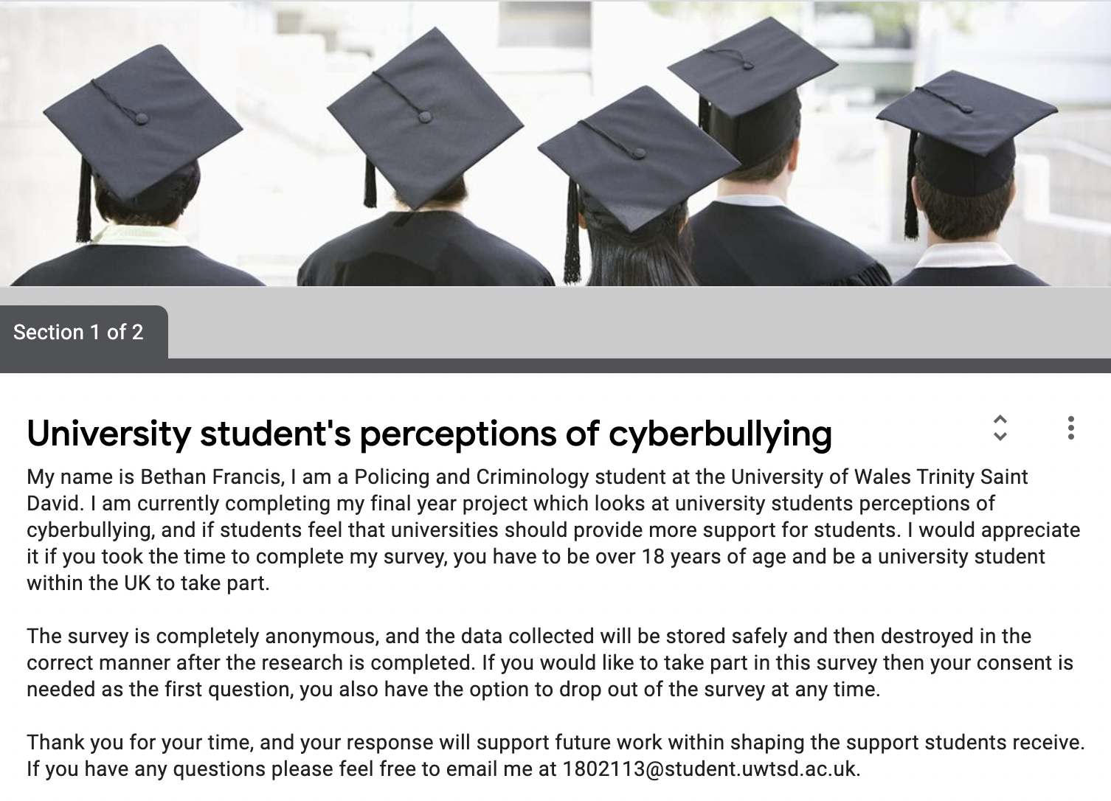

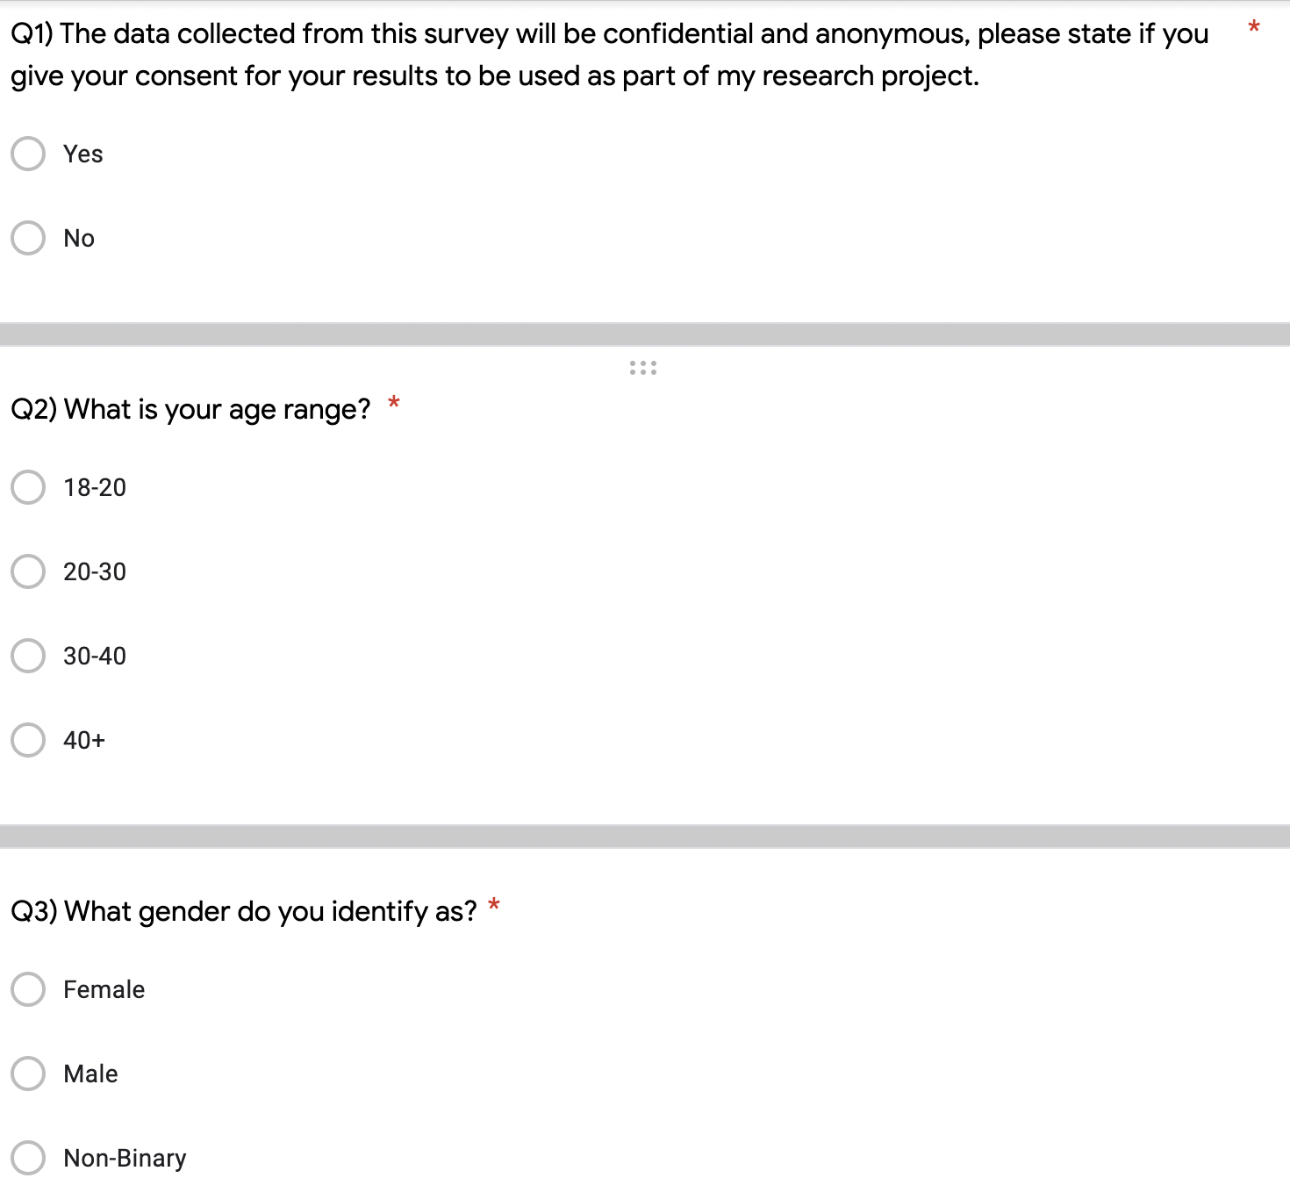
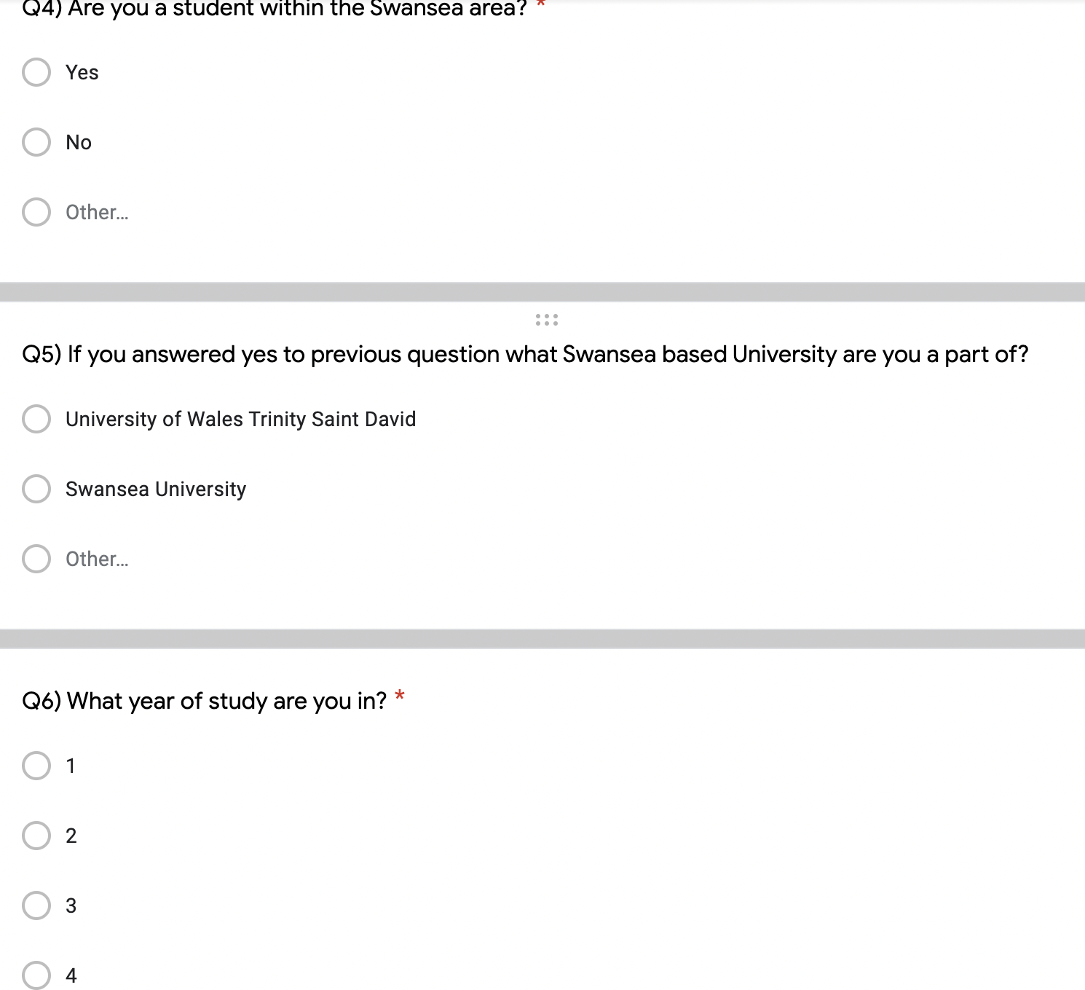
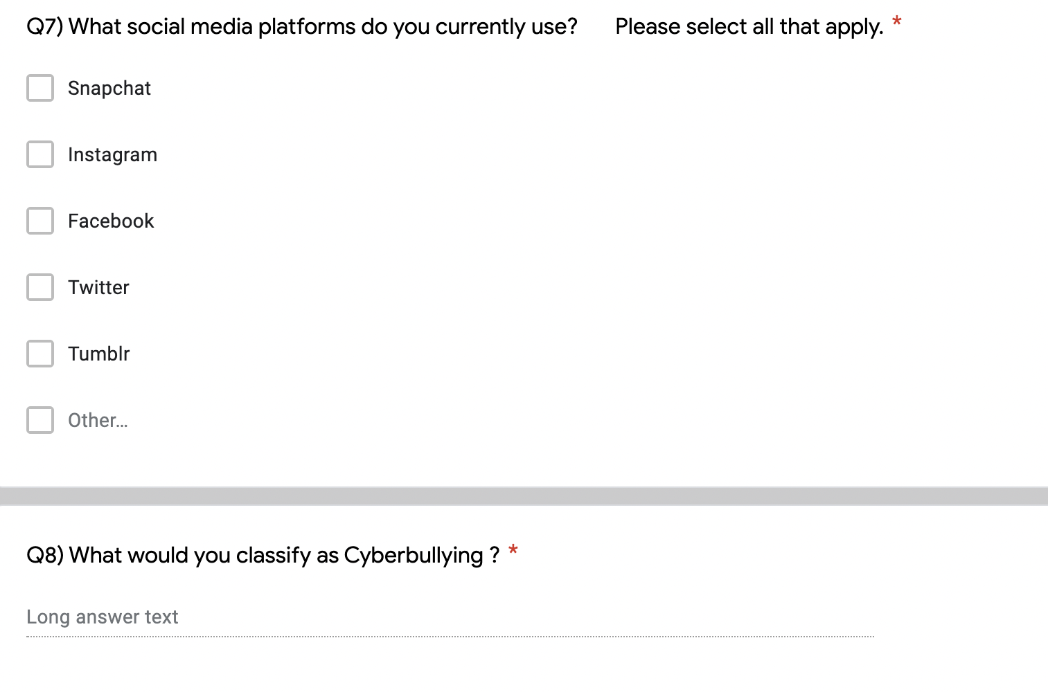

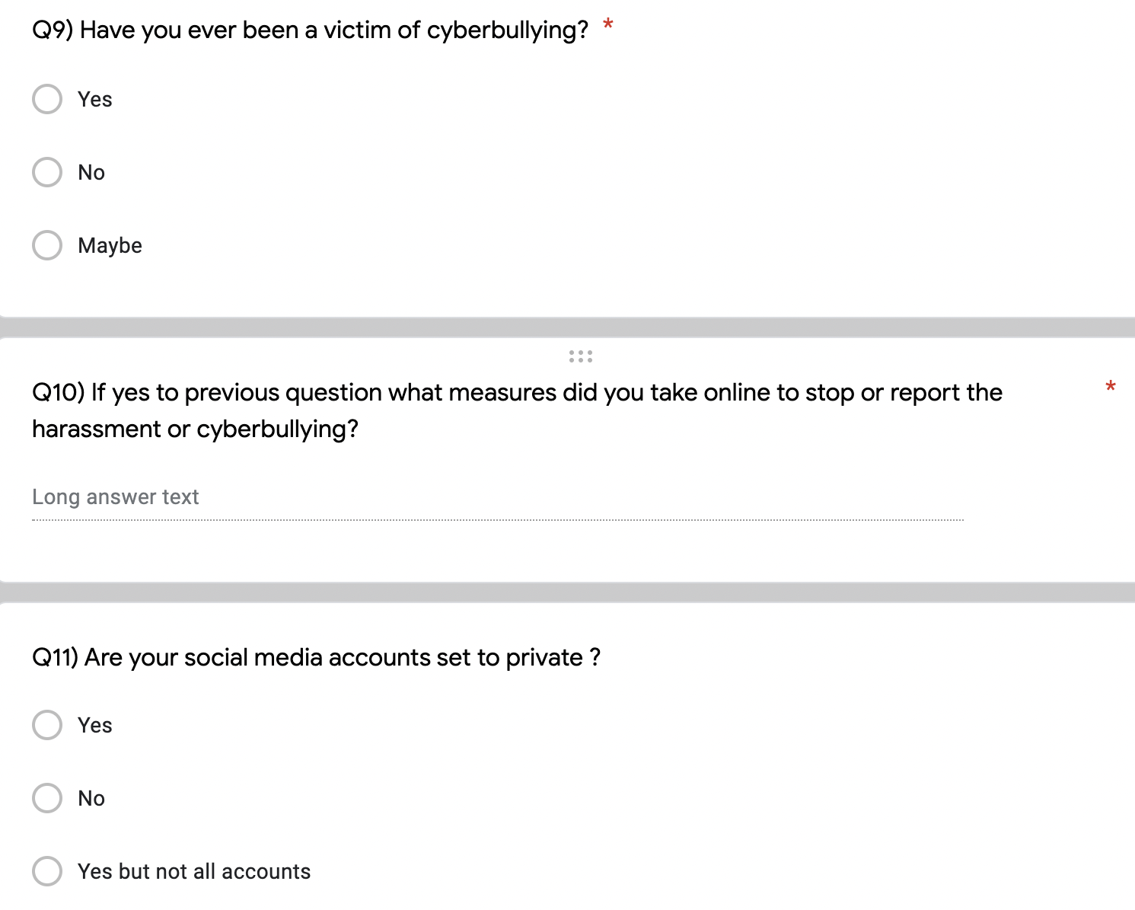

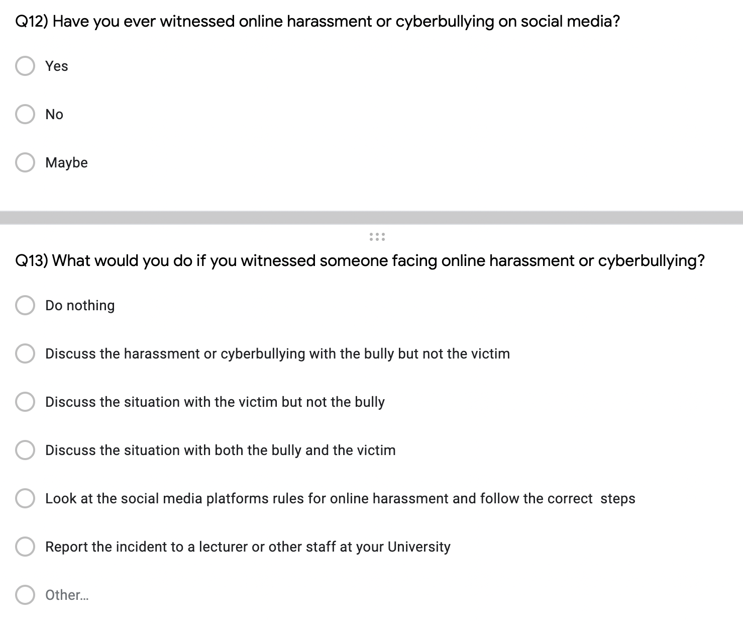

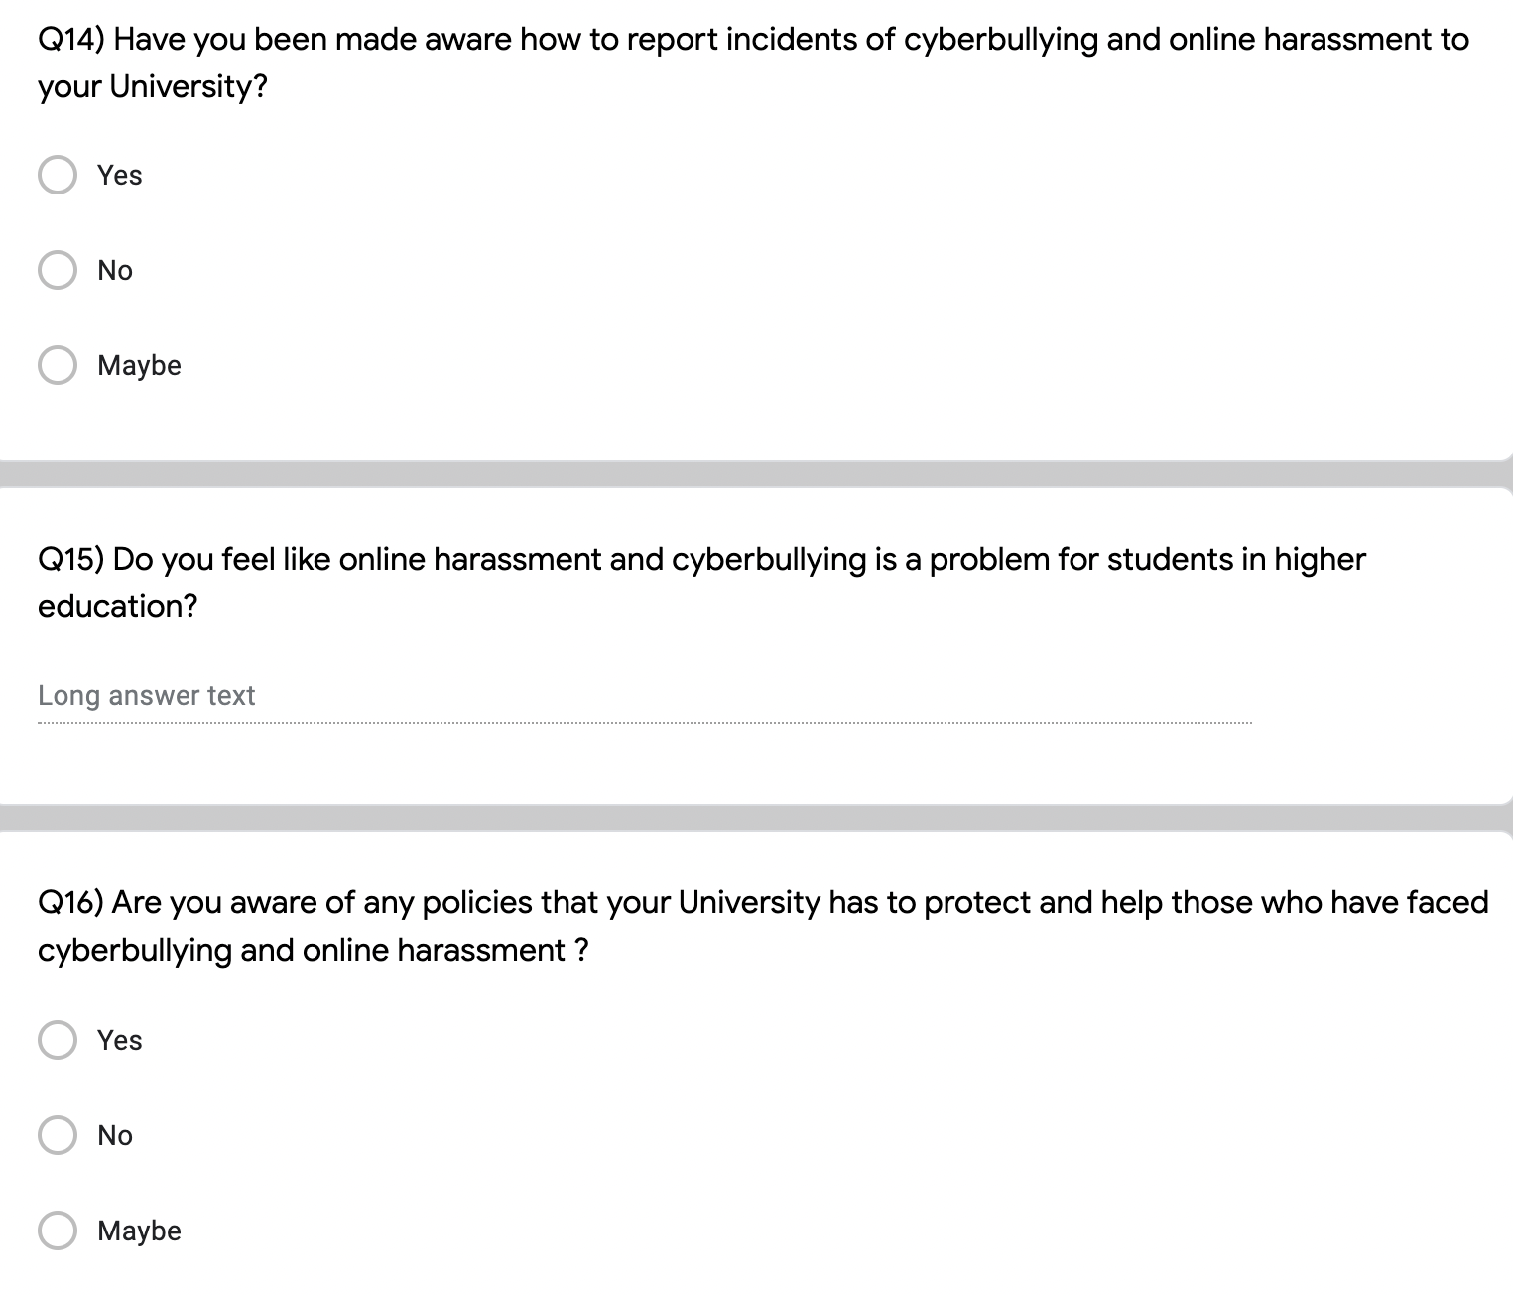
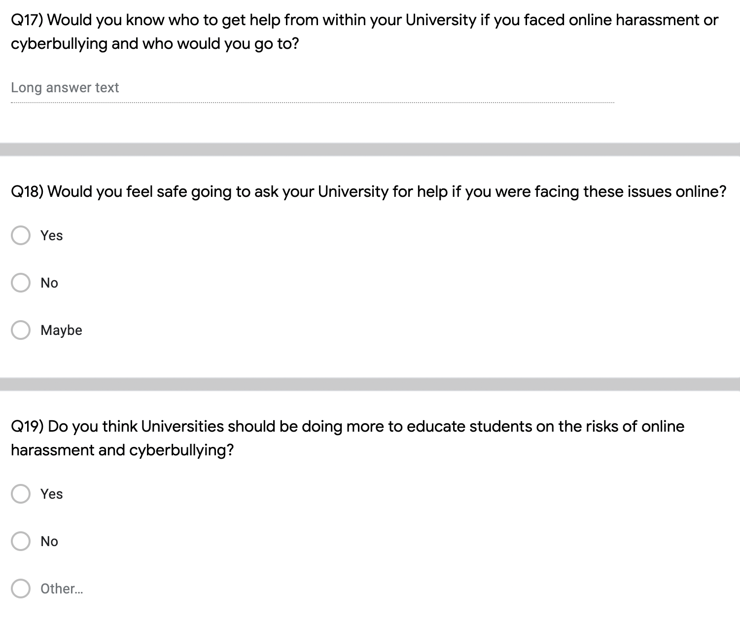

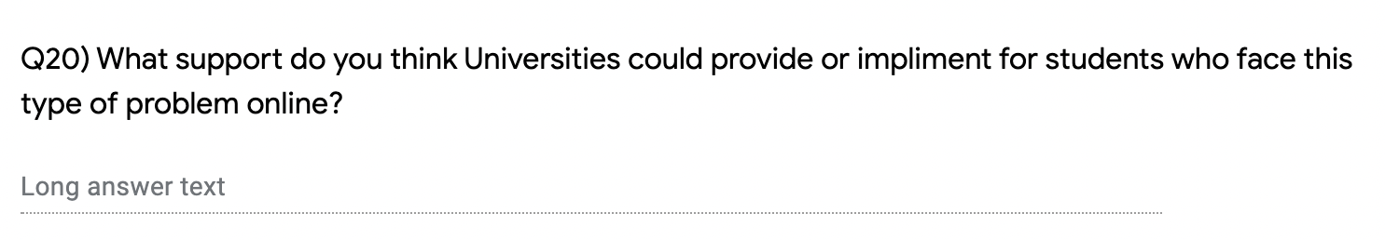
Appendix 2: Raw data results

APPLICATION FOR ETHICAL APPROVAL

In order for research to result in benefit and minimise risk of harm, it must be conducted ethically. A researcher may not be covered by the University’s insurance if ethical approval has not been obtained prior to commencement.

The University follows the OECD Frascati manual definition of research activity: “creative work undertaken on a systematic basis in order to increase the stock of knowledge, including knowledge of man, culture and society, and the use of this stock of knowledge to devise new applications”. As such this covers activities undertaken by members of staff, postgraduate research students, and both taught postgraduate and undergraduate students working on dissertations/projects.

The individual undertaking the research activity is known as the “principal researcher”.

Ethical approval is not required for routine audits, performance reviews, quality assurance studies, testing within normal educational requirements, and literary or artistic criticism.

Please read the notes for guidance before completing ALL sections of the form.

This form must be completed and approved prior to undertaking any research activity. Please see Checklist for details of process for different categories of application.

Delete the Guidance Notes at the end of the form BEFORE submitting your application

SECTION A: About You (Principal Researcher)
1 | Full Name: |  | Bethan Francis
2 | Tick all boxes which apply: |  | Member of staff: | ☐ | Honorary research fellow: | ☐
3 | Undergraduate Student | ☒ | Taught Postgraduate Student | ☐ | Postgraduate Research Student | ☐

4 | Institute/Academic Discipline/Centre: | Business Campus
5 | Campus: | Swansea
6 | E-mail address: | 1802113@student.uwtsd.ac.uk
7 | Contact Telephone Number: | 07423555201
 | For students:
8 | Student Number: | 1802113
9 | Programme of Study: | BSc Policing and Criminology
10 | Director of Studies/Supervisor: | Caroline Jawad  Bronwen Williams

SECTION B: Approval for Research Activity
1 | Has the research activity received approval in principle?  (please check the Guidance Notes as to the appropriate approval process for different levels of research by different categories of individual) |  | YES | ☒ | NO | ☒
 |  |  |  |  | Date
2 | If Yes, please indicate source of approval (and date where known): Approval in principle must be obtained from the relevant source prior to seeking ethical approval | Research Degrees Committee |  | ☐
3 |  | Institute Research Committee |  | ☐
4 |  | Other (write in)  : Lecturer |  | ☒

SECTION C: Internal and External Ethical Guidance Materials
 | Please list the core ethical guidance documents that have been referred to during the completion of this form (including any discipline-specific codes of research ethics, and also any specific ethical guidance relating to the proposed methodology). Please tick to confirm that your research proposal adheres to these codes and guidelines.
1 | UWTSD Research Ethics & Integrity Code of Practice | ☒
2 | UWTSD Research Data Management Policy | ☒
3 |  | ☐

SECTION D: External Collaborative Research Activity
1 | Does the research activity involve collaborators outside of the University? |  | YES | ☐ | NO | ☒
2 | If Yes, please provide the name of the external organisation and name and contact details for the main contact person and confirmation this person has consented to their personal data being shared.as part of this collaboration.
3 | Institution
4 | Contact person name
5 | Contact person e-mail address
6 | Has this individual consented to sharing their details on this form? |  | YES | ☐ | NO |  |  | ☒
7 | Are you in receipt of a KESS scholarship? |  | YES | ☐ | NO |  |  | ☒
8 | Is your research externally funded |  | YES | ☐ | NO |  |  | ☒
9 | Are you specifically employed to undertake this research in either a paid or voluntary capacity? | Voluntary | YES | ☐ | NO |  | ☒
10 |  | Employed | YES | ☐ | NO |  | ☒
11 | Is the research being undertaken within an existing UWTSD Athrofa Professional Learning Partnership (APLP) | If YES then the permission question below does not need to be answered. | YES | ☐ | NO |  |  | ☒
12 | Permission to undertake the research has been provided by the partner organisation | (If YES attach copy)  If NO the application cannot continue | YES | ☐ | NO |  |  | ☒

Where research activity is carried out in collaboration with an external organisation
13 | Does this organisation have its own ethics approval system? | YES | ☐ | NO | ☒
14 | If Yes, please attach a copy of any final approval (or interim approval) from the organisation

SECTION E: Details of Research Activity
1 | Indicative title: | Cyberbullying: An Investigation into the Online World and the Dangers that it Presents to University Students.
2 | Proposed start date: | November 2020 | Proposed end date: | May 2021
3 | Introduction to the Research (maximum 300 words)  Ensure that you write for a Non-Specialist Audience when outlining your response to the three points below:  - Purpose of Research Activity  - Proposed Research Question  - Aims of Research Activity  - Objectives of Research Activity  Demonstrate, briefly, how Existing Research has informed the proposed activity and explain  - What the research activity will add to the body of knowledge  - How it addresses an area of importance.
4 | Purpose of Research Activity  The purpose of this research activity is to analyse the role of cyberbullying. The impact that it has on University students, also if University students are correctly educated on cyberbullying. It will consider if social media plays a role in effecting the mental health of young people and if the correct education and support is being given  . Then it will aim to look at the education offered by the University and the impact this has on University students.
5 | Research Question  Q1. What are the key determinants to cyberbullying?  Q2. To what extent are University students affected by cyberbullying?  Q3. What role does the University play in protecting students from cyberbullying?
6 | Aims of Research Activity  The study aims to analyse the effect that cyberbullying has on University students as well as if the education provided by the University is credible and easily accessed, this is done in order to gain an insight of the effects that cyberbullying and social media has on University students.
7 | Objectives of Research Activity  - To critically analyse existing credible literature, this includes data collected by professional bodies to understand the impact of cyberbullying.  - To conduct primary research using online surveys to explore the impact of cyberbullying and to also explore if the University is providing the correct services for cyberbullying.  - To synthesise literature that is already existing and to use the primary research to make recommendations on existing and potential new policies the University could adopt to cyberbullying.
8 | Proposed methods (maximum 600 words)  Provide a brief summary of all the methods that may be used in the research activity, making it clear what specific techniques may be used. If methods other than those listed in this section are deemed appropriate later, additional ethical approval for those methods will be needed.
9 | The research will be focused in the form of an online survey, this will be delivered to social media. This is due to the fact that it will be distributed to the target demographic through means of student focused University Facebook pages. This means that it will focus on students in the Swansea area first before potentially being distributed to wider ranges of students.  (this box should expand as you type)

10 | Location of research activity  Identify all locations where research activity will take place.
11 | Swansea  (this box should expand as you type)
12 | Research activity outside of the UK  If research activity will take place overseas, you are responsible for ensuring that local ethical considerations are complied with and that the relevant permissions are sought. Specify any local guidelines (e.g. from local professional associations/learned societies/universities) that exist and whether these involve any ethical stipulations beyond those usual in the UK (provide details of any licenses or permissions required). Also specify whether there are any specific ethical issues raised by the local context in which the research activity is taking place, for example, particular cultural and/or legal sensitivities or vulnerabilities of participants.
13 | (this box should expand as you type)

14 | Use of documentation not in the public domain: Are any documents NOT publicly available? | NO | ☒
14 |  | YES | ☐
15 | If Yes, please provide details here of how you will gain access to specific documentation that is not in the public domain and that this is in accordance with prevailing data protection law of the country in question and England and Wales.  (this box should expand as you type)

SECTION F: Scope of Research Activity
1 | Will the research activity include: | YES | NO
2 | Use of a questionnaire or similar research instrument? | ☒ | ☐
3 | Use of interviews? | ☐ | ☒
4 | Use of diaries? | ☐ | ☒
5 | Participant observation with their knowledge? | ☐ | ☒
6 | Participant observation without their knowledge? | ☐ | ☒
7 | Use of video or audio recording? | ☐ | ☒
8 | Access to personal or confidential information without the participants’ specific consent? | ☐ | ☒
9 | Administration of any questions, test stimuli, presentation that may be experienced as physically, mentally or emotionally harmful / offensive? | ☐ | ☒
10 | Performance of any acts which may cause embarrassment or affect self-esteem? | ☐ | ☒
11 | Investigation of participants involved in illegal activities? | ☐ | ☒
12 | Use of procedures that involve deception? | ☐ | ☒
13 | Administration of any substance, agent or placebo? | ☐ | ☒
14 | Working with live vertebrate animals? | ☐ | ☒
15 | Other primary data collection methods, please explain in this box  For example, ‘focus groups’. Please indicate the type of data collection method(s) in this box and tick the accompany box. | ☐ | ☒
16 | Details of any other primary data collection method:  (this box should expand as you type) | ☐ | ☒
If NO to every question, then the research activity is (ethically) low risk and may be exempt from some of the following sections (please refer to Guidance Notes).

If YES to any question, then no research activity should be undertaken until full ethical approval has been obtained.

SECTION G: Intended Participants
1 | Who are the intended participants: | YES | NO
2 | Students or staff at the University? | ☒ | ☐
3 | Adults (over the age of 18 and competent to give consent)? | ☒ | ☐
4 | Vulnerable adults? | ☐ | ☒
5 | Children and Young People under the age of 18? (Consent from Parent, Carer or Guardian will be required) | ☐ | ☒
6 | Prisoners? | ☐ | ☒
7 | Young offenders? | ☐ | ☒
8 | Those who could be considered to have a particularly dependent relationship with the investigator or a gatekeeper? | ☐ | ☒
9 | People engaged in illegal activities? | ☐ | ☒
10 | Others (please identify specifically any group who may be unable to give consent) please indicate here and tick the appropriate box. | ☐ | ☒
11 | Other – please indicate here: | ☐ | ☒

12 | Participant numbers and source  Provide an estimate of the expected number of participants. How will you identify participants and how will they be recruited?
13 | How many participants are expected? | 200
14 | Who will the participants be? | Questionaries will be answered by University students in order to collect quantitative data. These questionaries will be self-administered.
15 | How will you identify the participants? | The interviewees will be selected with a purpose sampling technique: this means that a large sample of the survey participants will be University students in the Swansea area.

16 | Information for participants: | YES | NO | N/A
17 | Will you describe the main research procedures to participants in advance, so that they are informed about what to expect? | ☒ | ☐ | ☐
18 | Will you tell participants that their participation is voluntary? | ☒ | ☐ | ☐
19 | Will you obtain written consent for participation? | ☒ | ☐ | ☐
20 | Will you explain to participants that refusal to participate in the research will not affect their treatment or education (if relevant)? | ☒ | ☐ | ☐
21 | If the research is observational, will you ask participants for their consent to being observed? | ☐ | ☐ | ☒
22 | Will you tell participants that they may withdraw from the research at any time and for any reason? | ☒ | ☐ | ☐
23 | With questionnaires, will you give participants the option of omitting questions they do not want to answer? | ☒ | ☐ | ☐
24 | Will you tell participants that their data will be treated with full confidentiality and that, if published, it will not be identifiable as theirs? | ☒ | ☐ | ☐
25 | Will you debrief participants at the end of their participation, in a way appropriate to the type of research undertaken? | ☒ | ☐ | ☐
26 | If NO to any of above questions, please give an explanation
27 | (this box should expand as you type)

28 | Information for participants: | YES | NO | N/A
29 | Will participants be paid? | ☐ | ☒ | ☐
30 | Is specialist electrical or other equipment to be used with participants? | ☐ | ☒ | ☐
31 | Are there any financial or other interests to the investigator or University arising from this study? | ☐ | ☒ | ☐
32 | Will the research activity involve deliberately misleading participants in any way, or the partial or full concealment of the specific study aims? | ☐ | ☒ | ☐
33 | If YES to any question, please provide full details
34 | (this box should expand as you type)

SECTION H: Anticipated Risks
1 | Outline any anticipated risks that may adversely affect any of the participants, the researchers and/or the University, and the steps that will be taken to address them.  If you have completed a full risk assessment (for example as required by a laboratory, or external research collaborator) you may append that to this form.
2 | Full risk assessment completed and appended? |  | Yes | ☐
2 |  |  | No | ☒
3 | Risks to participants  For example: emotional distress, financial disclosure, physical harm, transfer of personal data, sensitive organisational information
4 | Risk to Participant:  Flinders Ethical framework (1992) outlines that there are three types of risks that can occur regarding the participants.  - Recruitment stage. The participants could face emotional distress when they answer questions on a time that could have been particularly hard for them.  - Field work stage. There could be concern about the questions being asked to the participants as it could be sensitive information.  - Reporting stage. There are and can be concerns about the confidentiality as well as the anonymity of personal data. | How will you mitigate the Risk to Participant  - Emotional distance needs to be considered as the participant may have emotional challenges. Participants will be reminded that they can withdraw participation at any time. There will be support for those who experience this distress through referral to the correct support. Participants will also be debriefed at the end of the survey.  - All data collected will be confidential and protected in the correct way.  - There will be confidentiality of all data collected, that falls in line with the correct laws and legislation. This data will be destroyed when the research project is completed.
5 | If research activity may include sensitive, embarrassing or upsetting topics (e.g. sexual activity, drug use) or issues likely to disclose information requiring further action (e.g. criminal activity), give details of the procedures to deal with these issues, including any support/advice (e.g. helpline numbers) to be offered to participants. Note that where applicable, consent procedures should make it clear that if something potentially or actually illegal is discovered in the course of a project, it may need to be disclosed to the proper authorities
 | (this box should expand as you type)
6 | Risks to investigator  For example: personal safety, physical harm, emotional distress, risk of accusation of harm/impropriety, conflict of interest
 | Risk to Investigator:  1.Self-disclosure and objective sampling of who the survey is put out to.  2. The potential of contingencies not related to the investigator. This could be participants dropping out, or being unable to find the correct number of participants in the time given. | How will you mitigate the Risk  - Emotional distance needs to be put in place, and anonymity of the participants will be put in place as interviews will be conducted online.  - The investigator will have to be fully prepared to deal with these potential difficulties when or if they occur.
7 | University/institutional risks  For example: adverse publicity, financial loss, data protection
 | Risk to University:  The risk to the University is that the investigation could have a negative impact on the University. | How will you mitigate the Risk to University:  The good reputation of the University will be kept in mind at all times during the investigation.

8 | Disclosure and Barring Service
9 | If the research activity involves children or vulnerable adults, a Disclosure and Barring Service (DBS) certificate must be obtained before any contact with such participants. | YES | NO | N/A
10 | Does your research require you to hold a current DBS Certificate? | ☐ | ☒ | ☐

SECTION I: Feedback, Consent and Confidentiality
1 | Feedback  What de-briefing and feedback will be provided to participants, how will this be done and when?
 | Feedback will be provided on a shared free wordpress.com site after the research has been completed.
2 | Informed consent  Describe the arrangements to inform potential participants, before providing consent, of what is involved in participating. Describe the arrangements for participants to provide full consent before data collection begins. If gaining consent in this way is inappropriate, explain how consent will be obtained and recorded in accordance with prevailing data protection legislation.
 | I will ensure that the consent and consent form will be approved by the ethics committee. The participants who are volunteers in the research will be given sufficient information on the research to allow them to make an informed decision on if they would like to participate or not. I will also make sure that they understand the importance of the consent form as at the time consent is given before the survey starts. The online questionaries will be presented with the same information in written form and written consent may be obtained.
3 | Confidentiality / Anonymity  Set out how anonymity of participants and confidentiality will be ensured in any outputs. If anonymity is not being offered, explain why this is the case.
The participants anonymity as well as confidentiality will be guaranteed by the researcher.
There are multiple ways I will ensure this, to keep the subject’s identity both confidential as well as anonymous. The records will be kept in password protected files, as well as they will be encrypted when information is shared over the internet. The information given by the participants will not be recorded in a way that links them to the information such as any identifying information. No participants names will be taken. I will only report aggregate information to the public and not individual-level data.

SECTION J: Data Protection and Storage
In completing this section refer to the University’s Research Data Management Policy and the extensive resources on the University’s Research Data Management web pages (http://uwtsd.ac.uk/library/research-data-management/).
1 | Does the research activity involve personal data (as defined by the General Data Protection Regulation 2016 “GDPR” and the Data Protection Act 2018 “DPA”)? | YES | NO
 | “Personal data” means any information relating to an identified or identifiable natural person (‘data subject’). An identifiable natural person is one who can be identified, directly or indirectly, in particular by reference to an identifier such as a name, an identification number, location data, an online identifier or to one or more factors specific to the physical, physiological, genetic, mental, economic, cultural or social identity of that natural person. | x | ☐
2 | If YES, provide a description of the data and explain why this data needs to be collected:
 | This will be done in order to provide and evaluation are perceived by a defined sample of University students, age, gender, location and experience will be a part of the research.
3 | Does it involve special category data (as defined by the GDPR)? | YES | NO
 | “Special category data” means sensitive personal data consisting of information as to the data subjects’ –  (a) racial or ethnic origin,  (b) political opinions,  (c ) religious beliefs or other beliefs of a similar nature,  (d) membership of a trade union (within the meaning of the Trade Union and Labour Relations (Consolidation) Act 1992),  (e) physical or mental health or condition,  (f) sexual life,  (g) genetics,  (h) biometric data (as used for ID purposes), | ☐ | x
4 | If YES, provide a description of the special category data and explain why this data needs to be collected:
 | (this box should expand as you type)

5 | Will the research activity involve storing personal data and/or special category data on one of the following: | YES | NO
6 | Manual files (i.e. in paper form)? | ☐ | ☒
7 | University computers? | ☐ | ☒
8 | Private company computers? | ☐ | ☒
9 | Home or other personal computers? | ☒ | ☐
10 | Laptop computers/ CDs/ Portable disk-drives/ memory sticks? | ☒ | ☐
11 | “Cloud” storage or websites? | ☐ | ☒
12 | Other – specify: | ☐ | ☒
13 | For all stored data, explain the measures in place to ensure the security of the data collected, data confidentiality, including details of password protection, encryption, anonymisation and pseudonymisation:
- Technical and organisational measures will be taken to prevent unauthorised access. The way to identify the user will be through using a strong password, that will contain a mix of letters both upper and lower case, numbers and symbols that has no personal ties to personal information as well as no dictionary words.
- There will be clear access rules, such as denying or allowing access to specific data. This will be based on the function of each user within the project such as granting access to my supervisor.
- A logbook may be used for organisational purposes this will allow the best possible control to track who has accessed the information and when.
- The participants information will be recorded in a way that links them to the responses in regard to identifying information this will be done with codes only known to them.

14 | All Data Storage
15 | Will the research activity involve any of the following activities: | YES | NO
16 | Electronic transfer of data in any form? | ☒ | ☐
17 | Sharing of data with others at the University? | ☐ | ☒
18 | Sharing of data with other organisations? | ☐ | ☒
19 | Export of data outside the European Union or importing of data from outside the UK? | ☒ | ☐
20 | Use of personal addresses, postcodes, faxes, emails or telephone numbers? | ☐ | ☒
21 | Publication of data that might allow identification of individuals? | ☐ | ☒
22 | Use of data management system? | ☒ | ☐
23 | Data archiving? | ☒ | ☐
24 | If YES to any question, please provide full details, explaining how this will be conducted in accordance with the GDPR and DPA (and/or any international equivalent):
- To ensure storage security, there are concerns are important even if data is stored on my local PC, storage device or in the cloud. There will be passwords to protect files and in order to gain access then the password will be needed.
- To endure that there is safe electronic communication when transferring data. There will be encrypted communication. There will also be firewalls put in place, anti-virus as well as anti-malware protection on the system to protect data.
- There will also be other IT controls put in place, so security on computer that is up to date, backup of files as well as blocking specific software installation.

25 | List all who will have access to the data generated by the research activity:
 | Myself
26 | List who will have control of, and act as custodian(s) for, data generated by the research activity:
 | Myself
27 | Give details of data storage arrangements, including security measures in place to protect the data, where data will be stored, how long for, and in what form. Will data be archived – if so how and if not why not.
 | The research data must and will be stored in a managed environment that will protect it against data loss as well as corruption, unauthorised access and modification from outside users. This will also comply with the relevant legal and contractual for the time that it needs to be kept. The correct steps will be taken to maintain the integrity of the data and that the appropriate security measures are put in place to prevent any unauthorised access. The data will be transferred to a managed storage environment as soon as possible. The data collected will be stored on my local PC, and cloud storage that is on the University’s office 360 system that has a strong password to verify the user. The unauthorised access will be prevented through the operating system controls, local as well as database encryption, as well as turning the data into a form that makes them unintelligible. This data as a result will be stored until the research and project and will then be deleted.
28 | Please indicate if your data will be stored in the UWTSD Research Data Repository (see https://researchdata.uwtsd.ac.uk/ ). If so please explain. (Most relevant to academic staff)
29 | Confirm that you have read the UWTSD guidance on data management (see https://www.uwtsd.ac.uk/library/research-data-management/) | YES | ☒
29 |  | NO | ☐
30 | Confirm that you are aware that you need to keep all data until after your research has completed or the end of your funding | YES | ☒
30 |  | NO | ☐

SECTION K: Declaration
31 | The information which I have provided is correct and complete to the best of my knowledge. I have attempted to identify any risks and issues related to the research activity and acknowledge my obligations and the rights of the participants.  In submitting this application I hereby confirm that I undertake to ensure that the above named research activity will meet the University’s Research Ethics and Integrity Code of Practice which is published on the website: https://www.uwtsd.ac.uk/research/research-ethics/
 | Signature of applicant: | B.Francis | Date: 26/11/2020

For STUDENT Submissions:
32 | Director of Studies/Supervisor: |  | Date:
33 | Signature: |  | Date:

For STAFF Submissions:
34 | Academic Director/ Assistant Dean: |  | Date:
35 | Signature: |  | Date:

Checklist: Please complete the checklist below to ensure that you have completed the form according to the guidelines and attached any required documentation:
☒ | I have read the guidance notes supplied before completing the form.
☒ | I have completed ALL RELEVANT sections of the form in full.
☒ | I confirm that the research activity has received approval in principle
☒ | I have attached a copy of final/interim approval from external organisation (where appropriate)
☒ | I have attached a full risk assessment (and have NOT completed Section H of this form) (where appropriate) ONLY TICK IF YOU HAVE ATTACHED A FULL RISK ASSESSMENT
☒ | I understand that it is my responsibility to ensure that the above named research activity will meet the University’s Research Ethics and Integrity Code of Practice.
☒ | I understand that before commencing data collection all documents aimed at respondents (including information sheets, consent forms, questionnaires, interview schedules etc.) must be confirmed by the DoS/Supervisor, module tutor or Academic Director.
☒ | I have deleted the guidance notes before submitting the PG2 for consideration

RESEARCH STUDENTS AND STAFF ONLY
All communications relating to this application during its processing must be in writing and emailed to pgresearch@uwtsd.ac.uk , with the title ‘Ethical Approval’ followed by your name.
You will be informed of the outcome of your claim by email; therefore it is important that you check your University and personal email accounts regularly.
STUDENTS ON UNDERGRADUATE OR TAUGHT MASTERS PROGRAMMES should submit this form (and receive the outcome) via systems explained to you by the supervisor/module leader.

