

Postgraduate/Distance Learning
Assignment coversheet & feedback form

THIS SHEET MUST BE THE FIRST PAGE OF THE ASSIGNMENT YOU ARE SUBMITTING (DO NOT SEND AS A SEPARATE FILE)

For completion by the student:
Student Name: Tedi Teabout

Student University Email: 2316800@student.uwtsd.ac.uk
Module code:HPCA7015  Module title:  Foundations Cultural Astronomy Astrology | Student ID number:2316800 |  |  | Educational support needs:  Yes/No
Assignment title: Sky Journal Assignment

Assignment due date: 11/30/2023
This assignment is for the 1st X 2nd 3rd 4th 5th 6th module of the degree
I confirm that this is my original work and that I have adhered to the University policy on plagiarism.
Signed ……………………………………………………………
Email submission:if you are submitting this form via email, please tick this box □X
(as a substitute for your signature) to confirm that you agree to the above declaration.
Assignment Mark
1st Marker’s Provisional mark
2nd Marker’s/Moderator’s provisional mark
External Examiner’s mark (if relevant)
Final Mark

NB. All marks are provisional until confirmed by the Final Examination Board.

For completion by Marker 1 :
Comments:

Marker’s signature: |  |  | Date:
For completion by Marker 2/Moderator:

Comments:

Marker’s Signature: |  | Date:
External Examiner’s comments (if relevant)

External Examiner’s Signature: |  | Date:

Sky Journal

Introduction

Van Gogh writes, ‘Be clearly aware of the stars and infinity on high. Then life seems almost enchanted after all. Stars, the sky, enchantment, this may seem like talks of fairytale and yet those who have given themselves not only intellectually but emotionally to the profundity of life can understand the depth and reality of these words. To truly explore the world around us we need to be available to moments of wonder and even enchantment if the occasion arises. To restrict our own senses and wonder is to sever some of our very own intellectual tools, as all great discoveries begin with a sense of wonder, a sense of wanting to know more, and a sense of longing for resolution, even if that longing is subconscious. Van Gogh explores first with his senses and allows the senses to organize into a structure (paintings). In this way I hope to explore this essay in a similar fashion. While logic and framework is critical to organizing information, we will navigate this sky journal project through the senses, not the typical five senses, but through the intuitive senses, through the intuitive provocation of the sky. In this way, we experience first and intellectualize secondly.

This essay discusses the experience of keeping a sky journal in San Diego, California for one month from October 20th through November 20th, 2023. The aim of the observation was to consider my personal spiritual experience as it relates to the demonstration of sky phenomena. The rationale for this observation period is to relate a conscious internal experience to an observable external sky photograph. I was curious to consider how my spiritual and emotional experience shifts with various skyscapes. Initially, I took photos from my yard for consistency, however, as I continued the project, I found myself expanding my awareness and taking photos away from the boundary of my yard. My methodology was reflective. I chose a reflexive methodology in order to capture the depth of this experience, with Aristotelian themes being considered, in this project, secondary. All photos were captured via iPhone.

When I think of the sky and its relation to life in a metaphysical and literal sense, I am left with more questions than answers. Whether I examine the sky with a naked eye or an intuitive inclination, no conclusive answer emerges. Of course, this is to be expected, however, as someone who has never given a serious thought to this matter it is an astounding revelation to reflect on. As a human race we know so much. We more or less know where every other species in our ecosystem originates from, accept man. In the sections below we will travel through individual occasions, in which the sky served as a provocation for my rumination of the origin of life.

Observation 1

The sun rises and sets every single day, however, most days I am too preoccupied with other things to stop and take notice. On this day, October 24th, 2023, enchanted by the beauty of the sun arising over the hills outside of my home in San Diego, California, the sun introduced itself to me, more formally than ever before. This, you could say is documentation of our new beginning. At around 7:30am, I wrote in my sky journal:

“The sun centers inside of its own golden glow, its rays disseminate over mountains, valleys, curves and lines, feeding the atmosphere with colors of yellow and orange. Everything the sun’s rays touch are absorbed in a soothing yet energizing light. The sun rises to feed my body and soul. It blesses my day”.

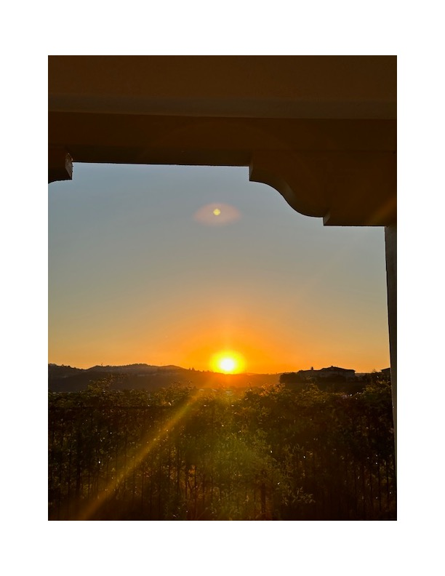

Figure 1. Reflections. Tuesday 24 October, 7:30am. Photo: Tedi Teabout.

Here, in figure 1, I am left unsure. I can recall Plato’s wisdom, ‘Everything that becomes or is created must of necessity be created by some cause, for without a cause nothing can be created’. In this infinite wisdom the question remains, what or whom is the cause? We witness the effect. Even the source of science as a cause only verifies the culmination of several effects. There is beauty and longing in partial truths. On this day, I am left with a feeling of connection, but to whom and what, eludes me. I feel so many questions bubbling beneath the surface, yet unready to reveal itself. It is as if my mind has not passed the initiation to consider such topics. I feel that one day, I will be allowed entry into the mysteries the “Greats” have liaised. I suspend inquiry and accept the feeling of peace as truth, for now.

Observation 2

Wednesday, November 1st, 2023, the sun creeps over the mountain, again layered and wrapped in hues of yellow and orange. Funnily, my instinct reminds me this is picturesque. And then I remember, there is no need for a picture because I am staring at the original inspiration for the paintings and photoshopped photos. I am happy to capture this moment, feeling ungrateful for the times I have taken such beauty for granted.
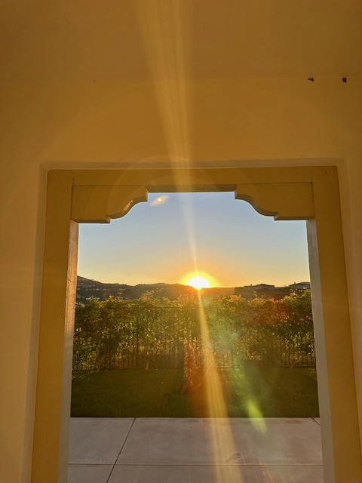

Figure 2. Reflections. Wednesday 01 November, 7:30am. Photo: Tedi Teabout.

I am no closer to an explanation of the origin of creation. Will I adhere to Aristotle and his explanation of matter being the primary creative substance of life? It would be “easy” to believe my eyes and give in to the science of material cause and effect. We see clearly, rationally, the ecosystem at work, not only verifying the explanations of the material world but doing its job in spectacular fashion. Yet, I am unsatisfied with this as an entire explanation. Surely, there is something, behind all of this! Surely, there is more than atoms and molecules. There is a soul, right? I restrain my mind from frustration, I interject with reason when the emotional charge becomes nearly infuriating. Reason is easier than accepting that there are things I may never wholly know. On this day, I will leave my contemplation open for further influence.

Observation 3

My left and right brain reconcile only in observing and emotionally processing the beauty of this moment. How could this not be the work of God? Or, is this simply the elements colliding? An intuitive exchange is where the sky and I converge. No words, no symbols, no gestures, a simple perceiving. Knowing that something is there, watching, welcoming, protecting. And with all this, the who and how, a torturous game for the mortals. Of course, there is beauty in this game, meaning in this game, ascending in this game, but is that enough? It has to be.

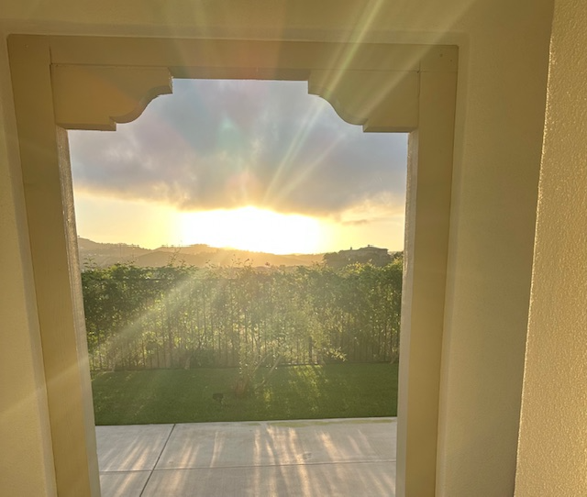

Figure 3. Reflections. Tuesday 14 November, 7:42am. Photo: Tedi Teabout.

Observation 4

On this day, November 19, 2023, I drive into a blanket of clouds and suddenly, the world feels small. It is as if I am in a fishbowl. The analogy of restriction counterintuitively offers a feeling of freedom. If the limitation is artificial, capacity becomes limitless. As a tinge of fear starts to creep in, I quickly dismiss it. Curiosity and beauty remain. Surrender to the unknown becomes my new default and I understand the sky to be a portal, but to what?
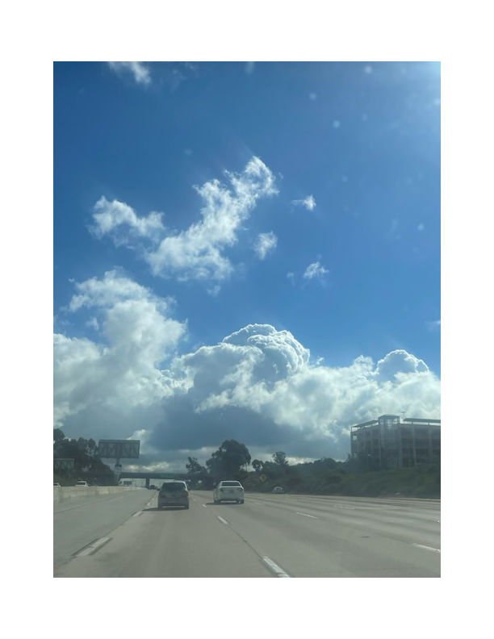
Figure 4. Reflections. Sunday 19 November, 11:02am. Photo: Tedi Teabout.

Reflections

Having taken some time observing the sky in various settings over the course of a few weeks, it is likely no surprise to the reader of this text that questions began to arise. The questions arise less from an intellectual pondering but from an intuitive longing. To attempt to reconcile the concept of the creator and created at this at this early a stage in my academic quest would be futile, and so, instead, allowing my mind to generate more questions, even if it causes me to go round in circles, is more beneficial than reaching a conclusion. I find myself left with more, curiosities than conclusions. Does something so perfect as a sunrise come from a perfect place, a perfect system, a perfect being? Or, is the perfection of the sun rising simply a result of many imperfections being made into something perfect?

Reflecting on these days in a more mundane sense, I recall the impact the sky has on my behavior. On days such as this, with the sun shining brightly, its rays receiving a thankful and loving reception, it influences my thoughts, feelings and actions in a positive way. This leaves me to realize how impactful the sky is in not only my life, but in the lives of all creation on earth. The sky dictates when we plant crops, what clothes we wear, how we travel through the environment, what elements can and cannot grow etc. We check the forecast days in advance to dictate our responses. The sky is powerful and yet passive. The sky will lie dormant, always there, communicating in its own language and yet not speaking at all, easily overlooked and taken for granted until it chooses to make a grander statement.

The sky speaks to those who choose to interpret its language. Reading the stars, reading the seasons, reading the weather, reading the sunrise and sunsets is an absolute vernacular. There is sky, there is water and there is land. Things we, as humanity have chosen to construct in those spaces are additional. This is progressive and to a large extent necessary, yet, lest we not forget we have overlay and interpreted our own system over the natural systems. As I reflect on the sky and my reaction to it, the only true conclusion I come to is that I have been neglecting a conscious awareness of the sky and its impact on my life.

Conclusion

Unsure of what would come of this project, I expected to look here and there and be satisfied with my observations. Instead, the density of my curiosity began to unpack itself. On the more contemplative days I can empathize with those who dedicate their lives to mysteries such as these. I can also understand how some would go mad searching, longing, trying, and failing. As I watch, and listen, and learn, I cannot hinder myself from the query, is the natural world is simply a distraction? Is the truth simply too emotionally charged for humankind to digest? Is it easier to acknowledge facts and figures, substance and angles? No one can deny the material world has its laws and truths and yet, anyone who has not succumb to the restriction of reason can confess to something beyond simple matter.

Before this project the sky was simply a backdrop in my life. I am left with an enhanced curiosity. Anyone on a serious quest for a version of truth can attest that his curious road will be a long one. My starting point is the connection between spirit and nature, not an either or, at least in that way I have a solid starting point for further interrogation of life. The sky in all its complexity, from location to weather systems, to unmatched beauty only reinforce, for me, a knowing that to exclude any reason, even if that reason is only a conclusion that all angles need to be considered before being excluded, would be to preclude parts of the whole and leave me no closer to a true resolve. Leaving this project being no closer to a conclusion then when I started imparts an open curiosity that I seek to maintain throughout my studies. I understand reason and theory to be a human explanation of the omnipotent. In this way I understand reason to be of extreme use to humankind, however, it is only an interpretation of the whole. For this reason, I venture to keep my mind and spirit open to the improbable, in hopes that one day my reason will be an appropriate container for the fantastical.

Bibliography

Gogh, Vincent van, and Ronald de Leeuw. The Letters of Vincent Van Gogh. London: Penguin Books, 1997, p.392.

Plato, Timaeus, 1892, trans by. Benjamin Jowett. (Las Vegas, NV 2023).

Gogh, Vincent van, and Ronald de Leeuw. The Letters of Vincent Van Gogh. London: Penguin Books, 1997, p.392.

