Scrabble Algorithm

Analysing and Solving Problems

Iestyn evans
Student ID:
Date:
2305862
30/11/2023



Contents
Iestyn evans 1
Scrabble Rules 2
Scrabble Tiles 3
Tile Values 3
Starting the Game 3
Placing Tiles 4
Exchanging tiles 4
Ending your turn 4
The First Word Score 4
Replacing Scrabble Tiles 5
The End of a Scrabble Game 5
Tallying Scrabble Scores 5
Implementation of scrabble in a programmatic setting 7

Scrabble Rules - Scrabble Official Rules
scrabble is a game designed for 2-4 players meaning that you will need to store values for each player’s name score, tiles on the board,
tiles currently in the player’s hand, and the current players turn,

The Scrabble Board
A scrabble board is 15 squares high by 15 squares long resulting in a total of 225 the board also contains tiles which can increase the players score these will need to be checked each time a player places a letter on the board so that the players score will be updated correctly these valuable score increasing tiles consist of
- Double letter Scores
- Triple letter score
- Double word score
- Triple word score
When the board is initially rendered the program will need to assign these tiles to the board accordingly and store the tiles to there corresponding values.

Scrabble Tiles
A scrabble game has a total of 100 tiles for the 2-4 players to use 2 of these are blank tiles the game will need to have a variable to track the number of tiles remaining in the bag throughout the game, the game will also need a dictionary so that you can check the varying points obtained via the letters played.

Tile Values
Below are the point values for each letter that is used in a Scrabble game.
0 Points - Blank tile.
1 Point - A, E, I, L, N, O, R, S, T and U.
2 Points - D and G.
3 Points - B, C, M and P.
4 Points - F, H, V, W and Y.
5 Points - K.
8 Points - J and X.
10 Points - Q and Z. [1]

Starting the Game
A player will be chosen at random at the beginning of the game this will require a function to choose a random player the below screenshot illustrates a way of doing this in python .
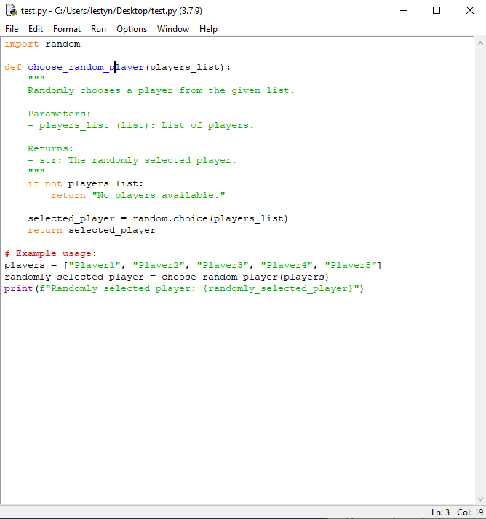
Upon choosing a random player the game should assign each player 7 random tiles from the bag of letters in the game upon doing this it should deduct the tiles drawn from the total number of tiles in the bag.

The players have the choice of three options each turn each of which will require a function to be made for them.

Placing Tiles
The game will require a place words function which will need to check if the players has the required letters in there hand, if the word is within the scrabble dictionary, check if there are any tiles already in the position the player wants to go , check if there are any multipliers in the tiles the player wishes to use, and then it will need to tally the total number of points to add to the players score.
The game will also need to check if players have played all 7 of there tiles as if all 7 are played the player receives a 50 point bonus on top of the word score for what is played.

Exchanging tiles

For the exchanging tiles function the game will require an input to check which tiles the player would like to exchange it will then need to tally the total number of tiles check if there is enough tiles still left in the bag and then randomly the correct amount of tiles from the bag.

Ending your turn
The end turn function will need to check which player is next within the rotation and then allow them to have control of the game it will also need to check if the player passed the previous turn as if you pass for two turns in a row you are automatically forfeited from the game.

The First Word Score
When the game begins, the first player will place their word on the star spin in the centre of the board. The star is a double square and will offer a double word score. All players following will build their words off of this word, extending the game to other squares on the board.
Play continues in a clockwise direction around the Scrabble board.

Replacing Scrabble Tiles
Once tiles are played on the board, players will draw new tiles to replace those. Players will always have seven tiles during the game. Drawing tiles is always done without looking into the bag so that the letters are always unknown.

The End of a Scrabble Game
Once all tiles are gone from the bag and a single player has placed all their tiles, the game will end and the player with the highest score wins.

Tallying Scrabble Scores
When the game ends, each player will count all points that are remaining on their tiles that have not been played. This amount will be deducted from the final score.
A bonus is awarded to the player that ended the game and has no remaining tiles. The tile values of all remaining players will be added to the score of the player who is out of tiles to produce the final score for the game.
The Scrabble player with the highest score after all final scores is tallied wins.

When the game ends there will need to be a function to wrap up the game the function will require the below components.
- Tally all the remaining tiles in the players hands.
- The player who first runs out of cards will get a bonus.
- Wrap up the game and return to the main menu and offer the option to start a new game!

[1] | https://www.scrabblepages.com/scrabble/rules/, “scrabble pages,” scrabble, [Online]. Available: https://www.scrabblepages.com/scrabble/rules/. [Accessed 30 november 2023].

Implementation of scrabble in a programmatic setting
Variable | Variable or constant use
Board size | Board size  the game will require a constant for the size of the board.
Bonus squares | the game will need a list of all the squares which increase the players score when used.
Tile Bag | The game will require an array containing all the letters and their respective scores
Player hand | The game will need an array for each players current tiles in their hand and the corresponding points
Player | The game will require an array to keep track of each players score and name
Current player | The game will need a variable which will update each turn to keep track of the relevant players turn

Pseudo code for sub processes in scrabble

Below is code for distributing the tiles to each player coded in python.

import random

letter_distribution = {
'A': 9, 'B': 2, 'C': 2, 'D': 4, 'E': 12, 'F': 2, 'G': 3, 'H': 2, 'I': 9,
'J': 1, 'K': 1, 'L': 4, 'M': 2, 'N': 6, 'O': 8, 'P': 2, 'Q': 1, 'R': 6,
'S': 4, 'T': 6, 'U': 4, 'V': 2, 'W': 2, 'X': 1, 'Y': 2, 'Z': 1,
}

letter_points = {
'A': 1, 'B': 3, 'C': 3, 'D': 2, 'E': 1, 'F': 4, 'G': 2, 'H': 4, 'I': 1,
'J': 8, 'K': 5, 'L': 1, 'M': 3, 'N': 1, 'O': 1, 'P': 3, 'Q': 10, 'R': 1,
'S': 1, 'T': 1, 'U': 1, 'V': 4, 'W': 4, 'X': 8, 'Y': 4, 'Z': 10,
}

def initializeTiles():
tiles = []
for letter, count in letter_distribution.items():
tiles.extend([letter] * count)
return tiles

def drawTiles(tiles, num_tiles):
# Shuffle the tiles
random.shuffle(tiles)

# Draw the specified number of tiles
drawn_tiles = tiles[:num_tiles]

# Remove the drawn tiles from the available tiles
tiles = tiles[num_tiles:]

return drawn_tiles, tiles

# Example Usage:
allTiles = initializeTiles()
playerRack, remainingTiles = drawTiles(allTiles, 7)

print("Player Rack:", playerRack)
print("Remaining Tiles:", remainingTiles)

The below pseudo code is to check if a move is valid.

If direction == horizontal and tiles already in play horizontally
Return false

Else if direction == vertical tiles already in play vertically
Return false

Check if the word played is in the dictionary if not Return false

Check if it is the current players turn if not

Return false

For each letter in word
Check if it is in the players hand if any of the letters are not in the players hand
Return false

##if none of the above return false the program will continue to the last line and return true

Return true

