BA BUSINESS MANAGEMENT
ASSIGNMENT 1
ESSAY

MODULE: Management Economics
CODE: LCBB5008
LECTURER NAME: Winifred Soribe
STUDENT NAME: Evelina Koleva
STUDENT ID: 2131127

SUBMITTED ON 18TH DECEMBER 2023

Contents
Question 1 3
a. Fundamental Economics Problems 3
b. Various ways of solving the economic challenges: 4
Question 2 5
a. The relevance of demand and supply 5
b. Difference between elasticity and inelasticity of demand 6
c. The Laws of Supply and Demand 7
References 10

Question 1

Fundamental Economics Problems
The global economic landscape is concerned with the production, distribution, and consumption of products for a certain period. The global economy can be affected by various factors such as government rules and regulations, consumer tests and preferences, demand and supply ratio, cultural factors, or social factors(Nguyen, 2023). Additionally, the COVID-19 pandemic has vastly impacted the global economy and hamper the economic growth in every country all over the world. This pandemic directly affects all the economic activities of a country and slowsits growth, especially in the United Kingdom'saftermath of Brexit (Harvard Business Review, 2023). The situations also serve various problems or issues that affect the overall economic conditions. These economic challenges create various problems for businesses, consumers, and the government as well.
The COVID-19 pandemic has directly affected the global business aspects to operate business operations. In the pandemic situations, there are some emergency rules and relations imposed by the government for the country. These COVID-19 rules hamper normal business operations as well as organisational growth and sustainability (OECD, 2021). Moreover, the situations people have to maintain social distancing, hygiene protocols, and lockdowns may lead to reduced consumer engagement with the organisation. These uncertainty challenges may create barriers for businesses to expand their business operations and smoothly run business activities. Therefore, in the pandemic situation, the demand for specific products and services has increased dramatically. Moreover, Brexit also affects product demand and supply chain issues that affect economic growth and sustainability (Thissen et al., 2020). After Brexit, there were a lot of changes in trade policies, customs rate regulations, and other rules that created various complexities in supply chain management. This will also create barriers to the transfer of products or goods across borders and fulfil the market demand. Additionally, these complexities of operating a business may increase the costs and the price of the product will also increase as well which directly affects the economic stability. However, the COVID-19 pandemic changed the consumer perception to make purchasing decisions. People may face uncertainty and fear in purchasing products or services during the pandemic situations, this will directly affect product sales rate and lead to the economic situation (Valaskova et al., 2021). This will also hamper the supply change management issues and make so difficult situations for the businessman to set their product price and meet the market demand as well.
Therefore, the shortage of fuel supply also affects the overall organisational management to maintain the proper supply chain management. This may also create the product distribution to the consumers and affect various economic sectors. The industries are facing excessive costs for transferring goods and products to the consumers which will increase product costs and higher price levels. The shortage of fuel supply also creates a product shortage in the market that can face various challenges for the economic landscape(Foehn et al., 2017). Moreover, if the fuel price increases, the costs of transportation will increase as well. As a result, the rocket price also changes based on the fuel prices and the transportation costs of the products will also increase. Increasing the pricing level of the products and services may create barriers to supply chain management and create various challenges for the economy. This will also affect the consumer budget for the products and affect the stable economic situation.
Enhancing the pricing level of products and services may lead to enhancing the living costs of people. High living costs for people affect their daily life activities. For instance, with rising essential product pricing, the consumer has to pay more money to purchase their necessary products and services. Consumers always trying to avoid luxurious products for comfort. This will create an improper balance between economic growth and sustainability. Sometimes, people are not able to meet the essential costs they need loans and collect funds to meet their needs and wants. High levels of loans and borrowings may affect the potential economic growth and sustainability(Valaskova et al., 2021). However, in the pandemic situation, there are a huge number of employees are losing their jobs and enhanced employment rates. This will affect consumer spending to meet their needs and wants. Decreasing the demands and spending ability may affect the overall economic activity. High borrowing costs for fulfilling consumer demands and wants with high costs of living create economic uncertainties. Losing the income source and increasing the loan or borrowing may lead to bankruptcy which affects the broader economic aspect.

b.Various ways of solving the economic challenges:

To solve the economic problems of the COVID-19 pandemic, Brexit, and other factors that directly affect the economic situation. Comprehensive planning is needed to resolve these issues. Creating flexible business models and applying strategic rules for the organisation that may be aligned with the COVID-19 rules and regulations(Paul et al., 2021). This is most important to adapt to the uncertainty or changing business market landscape. The strategic planning for the organisation could be diversifying products or service offerings to the consumer, ensuring the digital transformation of the business transactions, as well as implementing new technologies in the organisation to enhance productivity and overall business performance. Additionally, in the supply chain management sector, implementing automation systems can help the organisation to reduce the shortage of production (Thissen et al., 2023). Creating a shortage management team for the organisation who are always monitoring the supply chain and finding out the limitations or gaps that can affect the organisational production capacity. The team can provide information about the supply chain management's current situations and the organisation takes the necessary steps instantly to mitigate the shortages or disruptions.
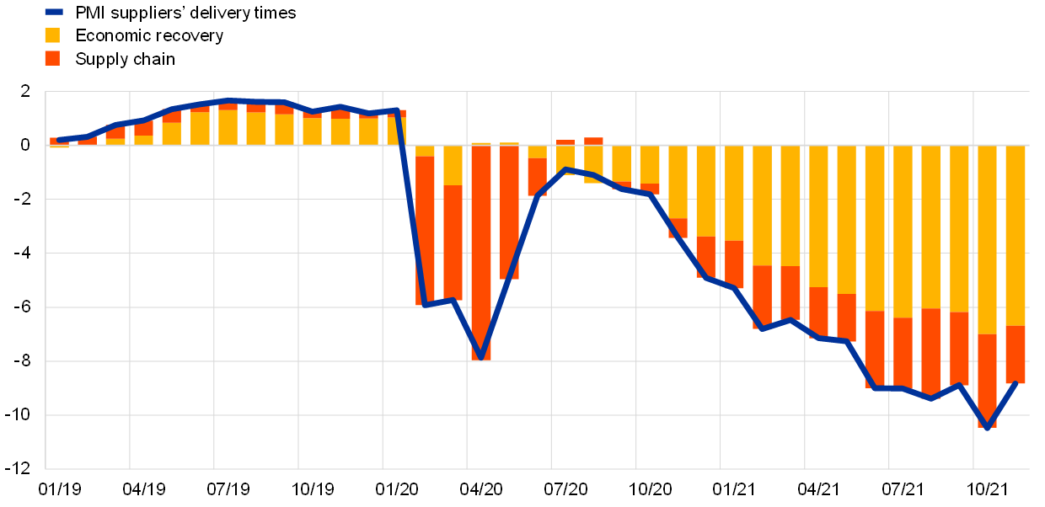

Figure 1Supply chain disruptions and the effects on the global economy
Source: (Attinasi et al., 2022)

Furthermore, the government plays a significant role in enhancing economic growth and sustainability. The government may provide subsidies or support programs for businesses that can help the organisation enhance its activities and survive in these uncertain circumstances. Additionally, the government can implement various rules and regulations that focus on organisational investment, trading regulations, hiring processes, and research and development can foster organisational activities that will ensure stable economic growth (Nguyen, 2023). Moreover, creating an improved supplier corroboration network can mitigate the industry's product shortages. An organisation must focus on the employee who is engaged in the industry's supply chain network and find out the skill gap that hampered the production capacity. Taking proper steps for the employees such as workshops, seminars, or training programs can enhance the knowledge of work among the employees as well as employees feel more comfortable and do the job with more confidence. This will enhance organisational productivity and maintain a strong supply chain management to ensure a proper supply of raw materials for the organisation (Attinasi et al., 2022).
For producing a product or goods, there is a waste for the production. Organisations should take proper action to reduce the waste of goods and services. Reducing waste may also ensure sustainable practices for production. Additionally, organisations may adopt new technologies and machines for producing products that can minimize the waste rate as well as ensure the maximum utilization of resources (Bag and Pretorius, 2022). Moreover, industries may adopt unique or creative solutions to reduce waste and recycle the waste materials for production. This will also help to reduce the environmental impact in the society. Therefore, improves the supply chain management for the organisation and ensures the effective supply of the resources and quality. To reduce production shortages and disruptions, organisations must improve their supply chain management. Additionally, improving the collections with suppliers can create the utmost trust and loyalty. Building a strong relationship with suppliers can reduce the overall costs of production (Attinasi et al., 2022). Industries must ensure always open communication channels and mutually beneficial agreements that can minimize organisational costs. As a result, the organisation can offer the products or services at a minimum price level. Finally, to improve the organisational structure and overall business performance, transparent communication is crucial. Providing up-to-date business information to the stakeholders can increase overall organisational production and reduce shortages or disruptions. Effectively managing these aspects may also enhance sustainable economic growth.

Question 2

The relevance of demand and supply
The case study demonstrates that the impact of COVID-19 all over the world influences the demand and supply. It will also impact the global economy, especially in the United Kingdom in various aspects such as Brexit and other issues. Understanding the demand and supply is paramount for effectively addressing the various challenges and changes that may be faced the businesses in the COVID-19 pandemic situations. Therefore, the demand and supply are relevant in the case study due to the shortage in demand as well as supply as well. One of the most significant aspects highlighted in the case study is that the demand and supply both are decreasing in the COVID-19 pandemic situation. Decreasing the demand and supply would make the relevance of the supply chains (Harvard Business Review, 2023). Generally, in the pandemic situations the supply is not able to meet the consumer's demand due to various reasons such as lack of proper resources and labour shortages especially in the United Kingdom. However, a strategic pricing aspect can effectively manage the demand-supply fluctuations in the market. In the pandemic situation, the supply of the products may hamper or create product shortages due to various reasons. Organisations should set the product price based on the market demand and consumer high demand(Paul et al., 2021). This will help the organisation to earn optimum revenues and make relevant the demand and supply.
Furthermore, the organisation may also consider its competition and set the product price by considering competitor’s prices for the market offerings. Understanding the market demand for the products and supply dynamics helps the organisation to attract the most potential consumers for the organisation and set the relevant price comparatively lower price from the competitors. Additionally, one of the most significant aspects of effectively managing the demand and supply dynamic is gathering comprehensive information about market demand or consumer preferences (Rafieisakhaei et al., 2016). Understanding consumer preferences can help the organisation to take strategic planning for the organisation that can enhance productivity and expansion strategies. For example: Amazon is one of the most successful organisations that operates its business activities online. They have a comprehensive understanding of consumer demands and effectively manage their inventory with the most popular products and goods. This may help to enhance consumer engagement with the organisation and also ensure consumer satisfaction.
A marketing strategy for effective promotion can also help the organisation enrich consumer engagement. Effective marketing strategy can also ensure consumers the availability of specific products during the high demand situations. This may also include effectively managing the inventory that will help the organisation balance between demand and supply(Samuelson et al., 2021).Organisations should implement just-in-time inventory systems. This approach demonstrates that the industry must forecast the future demand for the product in the market. Then measure the current amount of stock as well as ensure the availability of the product while minimizing the caring costs. Therefore, understanding a comprehensive idea of the demand and supply is also a significant aspect of investment. This will also help for initial public offering (IPO) for the private company which can collect money from the public. As a result, the organisation can foster its business activities and enhance organisational growth and sustainability.

Difference between elasticity and inelasticity of demand
Elasticity of Demand
Elasticity of demand refers to the process or methods by which it can be measured the changing the quantity demanded of a particular product, goods, or services and changing an individual’s income, product prices, or other market variables(Mankiw, 2020). It is measured by the change in the percentage of product demands divided by the change in the percentage of the various market factors. For example: if the product price is increased by 15% and the quantity demand of the particular product is decreased by 25%, then the price elasticity of the particular product demand is -1.67.
Inelasticity of Demand:
Inelasticity of the demand refers to the economic terms that describe that the quantity demanded of a particular product remains the same despite the price, income, or other market factors of the particular product being relatively changed. In other words, inelasticity describes that when the price of the product is increased, the quantity demand of the product is still the same and when the price of the product is decreased, the quantity demand of the product also remains the same (Lipsey and Chrystal, 2011). These are the essential products or services for the consumers. For instance: prescription drugs and utilities have an inelastic demand. If the price of the essential drug decreases the demand for the product is still the same as well if the price of the essential drug goes down, the quantity demand for the product also remains the same.
Distinguished between elasticity and inelasticity of demand
- Price Flexibility: Elastic products can affect the market demand based on price, income, and other factors. On the other hand, inelastic products have little effect on changes in the price or other market variables (Samuelson et al., 2021).
- Market Fluctuations: Elastic products can influence market fluctuations. Consumer’s response to changing the price of the product can affect the overall market demand. The inelastic product barely fluctuates in the market. The consumer demand remains the same despite the changes in the product price(Mankiw, 2020).
- Entry Barriers: A new organisation may face various challenges to operate its business with elastic products. The market is very competitive a little price change can affect the overall market demand scenario. In the case of inelastic products, there is an opportunity for new competitors to set high prices for the product though the demand for the products remains the same (Lipsey and Chrystal, 2011).

The Laws of Supply and Demand
Understanding the demand and supply laws is one of the important aspects of effectively operating a business organisation. A comprehensive knowledge of demand and supply can help the organisation to effectively manage the production of goods and services according to the market demand(Boyes and Melvin, 2013). Moreover, the four basic rules for demand and supply should focus on the organisation for producing goods and services.
- When demand is increased for a particular product on the other hand the supply of the product remains constant which means the consumers are more interested in the product. High demand for the product with constant supply describes that consumers are ready to pay more for the products or services(Mankiw, 2020).In this situation, the organisation has the opportunity to enhance the supply of the product with price adjustments and earn more profits from the market.
- The decreased demand for a particular product with the constant supply demonstrates that consumers are losing their interest in purchasing the particular products, goods, or services. This may lead to a lower price of the product and lower product quantity demanded in the market (Samuelson et al., 2021). In that situation, the organisation should reduce the production of the products and face potential reduced profits from the products.
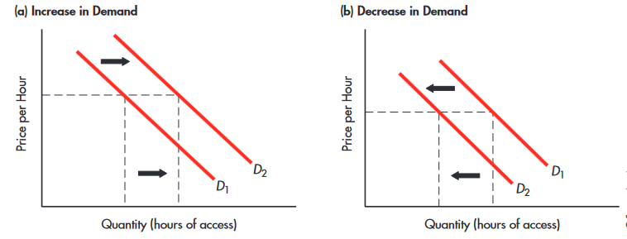
Figure 2 Change in Demand and a Change in Quantity Demanded
Source: (Boyes and Melvin, 2013)
- Increased supply of a particular product in the market while the quantity demanded of the products remains the same. This scenario demonstrates the lower price of the product and higher quantities of the product (Lipsey and Chrystal, 2011). In this situation, the availability of the products is huge, and as a result, the price of the product falls and attracts the most potential consumers from the competitors.
- A decreased supply of a particular product, goods, or services while the demand for the products remains constant may lead to higher prices of the products (Boyes and Melvin, 2013). Consumers are willing to pay more for purchasing the products and goods. In those situations, organisations may enhance the price of the products and earn more profits by delivering scarce goods and services (Valaskova et al., 2021).

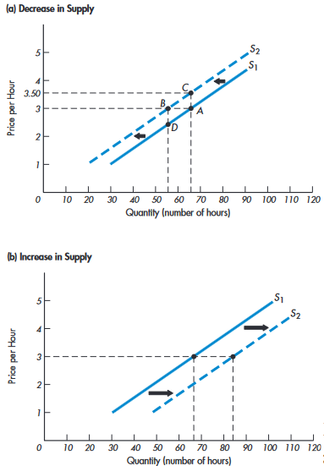
Figure 3 Shift of the Supply Curve
Source: (Boyes and Melvin, 2013)

References
Attinasi, M. G., Balatti, M., Mancini, M. and Metelli, L. (2022) Supply chain disruptions and the effects on the global economy, European Central Bank, [online] Available at: https://www.ecb.europa.eu/pub/economic-bulletin/focus/2022/html/ecb.ebbox202108_01~e8ceebe51f.en.html (Accessed 12 November 2023).
Bag, S. and Pretorius, J.H.C. (2022) Relationships between industry 4.0, sustainable manufacturing and circular economy: proposal of a research framework. International Journal of Organisational Analysis, 30(4), pp.864-898.
Boyes, W. and Melvin, M. (2013) Fundamentals of Economics. Cengage Learning.
Foehn, T., Hagem, C., Lindholt, L., Mœland, S. and Rosendahl, K.E. (2017) Climate policies in a fossil fuel producing country: Demand versus supply side policies. The Energy Journal, pp.77-102.
Harvard Business Review (2023) Global supply chains in a post-pandemic world, Harvard Business Review, [online] Available at: https://hbr.org/2020/09/global-supply-chains-in-a-post-pandemic-world (Accessed 12 November 2023).
Lipsey, R. and Chrystal, A. (2011) Economics. Oxford University Press, USA.
Mankiw, N. G. (2020) Principles of economics. Cengage Learning.
Nguyen, T. L. (2023) The role of government in promoting economic growth and development, Business and Economics Journal, Hilaris SRL, [online] Available at: https://www.hilarispublisher.com/open-access/the-role-of-government-in-promoting-economic-growth-and-development-98025.html (Accessed 12 November 2023).
OECD (2021) The territorial impact of covid-19: Managing the crisis across levels ..., [online] Available at: https://www.oecd.org/coronavirus/policy-responses/the-territorial-impact-of-covid-19-managing-the-crisis-across-levels-of-government-d3e314e1/ (Accessed 12 November 2023).
Paul, S.K., Chowdhury, P., Moktadir, M.A. and Lau, K.H. (2021) Supply chain recovery challenges in the wake of COVID-19 pandemic. Journal of Business Research, 136, pp.316-329.
Rafieisakhaei, M., Barazandeh, B., Moosavi, A., Fekri, M. and Bastani, K. (2016) Supply and demand dynamics of the oil market: A system dynamics approach. In The 34rd International Conference of the System Dynamics Society (Vol. 1).
Samuelson, W.F., Marks, S.G. and Zagorsky, J.L. (2021) Managerial economics. John Wiley and Sons.
Thissen, M., van Oort, F., McCann, P., Ortega-Argilés, R. and Husby, T. (2020) The implications of Brexit for UK and EU regional competitiveness. Economic Geography, 96(5), pp.397-421.
Valaskova, K., Durana, P. and Adamko, P. (2021) Changes in consumers’ purchase patterns as a consequence of the COVID-19 pandemic. Mathematics, 9(15), p.1788.

