

Name
Armands Putersevics

Student ID
2242532

Lecturer
Haoran Liu

Marketing Management (LCMB7024_LON)

Introduction 3
Element 1: Poster 3
Element 2: Segmentation, Targeting, Differentiation and Positioning (STDP) 4
2.1 Introduction 4
2.2 Market Segmentation 5
Geographic Segmentation 5
Demographic Segmentation 5
Psychographic Segmentation 5
Behavioural Segmentation 5
2.3 Targeting 5
2.4 Differentiation 5
2.5 Positioning 6
Table 1: STDP Summary – Rolex Perpetual Smart Bracelet 6
Element 3: Marketing Mix (4Ps) 6
3.1 Introduction 6
3.2 Product 7
3.3 Price 7
3.4 Place (Distribution) 8
3.5 Promotion 9
Table 2: Marketing Mix (4Ps) – Rolex Perpetual Smart Bracelet 10
Element 4: Reflection 11
References 12

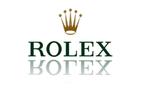

Introduction
Brand development is an important growth strategy that enables organisations to expand their product portfolio, strengthen customer loyalty and respond to changing market needs. As consumers increasingly demand innovative and environmentally responsible products, businesses must develop brand extensions that enhance competitive advantage while supporting long-term sustainability. This portfolio explores the development of a sustainable brand extension for Rolex through the Rolex Perpetual Smart Bracelet. The proposed product combines Rolex's heritage of luxury, precision and craftsmanship with modern wearable technology and sustainable design.
The portfolio consists of four elements. Element 1 presents the sustainable brand extension through a poster, introducing the product concept and its alignment with current sustainability trends. Element 2 applies the Segmentation, Targeting, Differentiation and Positioning (STDP) framework to identify the target market and establish a competitive position. Element 3 evaluates the marketing strategy using the 4Ps—Product, Price, Place and Promotion—to demonstrate how the brand extension can be successfully introduced into the luxury market. Element 4 provides a reflection on the experience of developing the marketing strategy and preparing the poster presentation.
Overall, this portfolio demonstrates how marketing principles can be applied to create an innovative and sustainable brand extension that supports Rolex's long-term growth while meeting evolving consumer expectations.

Element 1: Poster
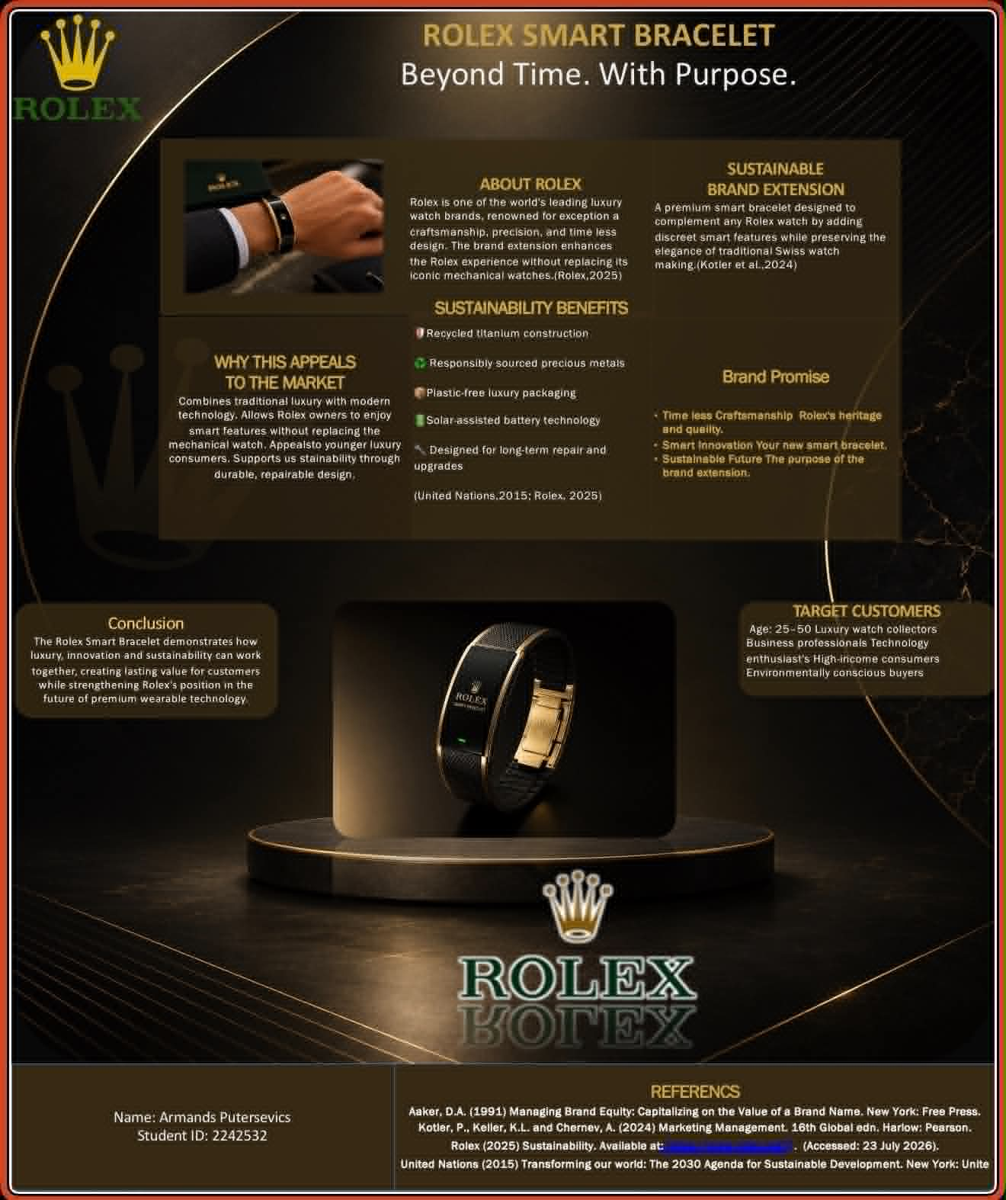

Element 2: Segmentation, Targeting, Differentiation and Positioning (STDP)

2.1 Introduction
The proposed brand extension is the Rolex Perpetual Smart Bracelet, a sustainable luxury wearable that combines Rolex's craftsmanship with modern health and connectivity features. The STDP framework helps identify the most suitable customers, create a competitive advantage and position the product successfully within the luxury wearable market (Kotler et al., 2024).

2.2 Market Segmentation

Geographic Segmentation
The bracelet would initially target developed luxury markets, including the UK, Switzerland, the USA, the UAE, Singapore, Japan and China. Rolex would focus on major cities where demand for luxury products and wearable technology is strongest.

Demographic Segmentation
The primary customers are affluent men and women aged 28–55 with high disposable incomes. This includes business professionals, entrepreneurs, executives and existing Rolex owners who value luxury, innovation and quality.

Psychographic Segmentation
The bracelet is aimed at consumers with premium lifestyles who appreciate exclusivity, craftsmanship and sustainability. They value products that reflect success while supporting responsible consumption and environmental awareness.

Behavioural Segmentation
The extension targets loyal Rolex customers, luxury buyers and consumers interested in wearable technology. They are willing to pay premium prices for high quality, excellent after-sales service and innovative products from trusted brands.

2.3 Targeting
Rolex would use a concentrated targeting strategy, focusing on affluent professionals and existing Rolex customers rather than the mass wearable technology market. This allows the company to maintain its premium image while attracting consumers seeking luxury, advanced technology and sustainable products. Existing Rolex customers are also more likely to purchase the bracelet because of their trust in the brand and appreciation of its heritage.

2.4 Differentiation
The Rolex Perpetual Smart Bracelet differentiates itself by combining luxury craftsmanship with discreet smart technology and sustainable design. Unlike mainstream smartwatches, it uses recycled titanium, responsibly sourced materials and a modular design that allows components to be replaced instead of replacing the entire product. Customers also benefit from Rolex's reputation for quality, exclusivity and long-term servicing.

2.5 Positioning
The bracelet would be positioned as a premium sustainable luxury wearable for successful individuals who value elegance, wellbeing and innovation. It complements traditional Rolex watches rather than replacing them, allowing customers to enjoy smart technology while preserving the timeless style associated with the brand.
Overall, the STDP strategy enables Rolex to target a clearly defined luxury market while strengthening its competitive position through sustainability, innovation and exceptional craftsmanship.

Table 1: STDP Summary – Rolex Perpetual Smart Bracelet
The table below summaries the Segmentation, Targeting, Differentiation and Positioning (STDP) strategy for the proposed sustainable brand extension.
STDP Element | Application to Rolex Perpetual Smart Bracelet
Segmentation | Affluent consumers aged 28–55 in developed luxury markets who value innovation, sustainability, premium quality and exclusive products.
Targeting | Concentrated targeting strategy focusing on professionals, entrepreneurs, executives and existing Rolex customers with high disposable incomes.
Differentiation | Luxury craftsmanship, recycled titanium, modular design, advanced health features, premium after-sales service and Rolex brand heritage.
Positioning | A sustainable luxury wearable that combines timeless elegance, smart technology and environmental responsibility for discerning customers.
Source: Developed by the author based on Kotler et al. (2024).

Element 3: Marketing Mix (4Ps)

3.1 Introduction
The marketing mix provides a framework for developing a successful marketing strategy by ensuring that products meet customer needs while supporting business objectives (Kotler et al., 2024). For the Rolex Perpetual Smart Bracelet, the 4Ps—Product, Price, Place and Promotion—are used to create a sustainable luxury offering that reflects Rolex's heritage of quality and exclusivity while meeting the growing demand for innovative and environmentally responsible products.

3.2 Product
The Rolex Perpetual Smart Bracelet is designed as a luxury wearable that combines advanced technology with the timeless craftsmanship for which Rolex is recognised. Rather than replacing a traditional Rolex watch, the bracelet complements it by providing modern smart functions while maintaining the elegance and prestige expected from the brand.
The bracelet would include premium health and lifestyle features such as heart-rate monitoring, sleep tracking, activity monitoring, stress analysis and smartphone notifications. Unlike conventional smartwatches, the product would have a minimalist appearance without a large digital display, allowing customers to enjoy smart technology without compromising the classic luxury aesthetic associated with Rolex.
Sustainability is a key feature of the product. The bracelet would be manufactured using recycled titanium, responsibly sourced precious metals and environmentally friendly packaging. Rolex would also introduce a modular design that allows batteries and electronic components to be replaced or upgraded instead of replacing the entire product. This approach extends the product's lifespan, reduces electronic waste and supports the principles of the circular economy.
To reinforce exclusivity, the bracelet would be available in limited editions with optional personalised engraving and bespoke finishes. Customers would also benefit from Rolex's global servicing network, ensuring long-term maintenance and product support. These services strengthen customer relationships while reinforcing the brand's reputation for exceptional quality and durability.
By combining luxury craftsmanship, sustainable materials and discreet wearable technology, the Rolex Perpetual Smart Bracelet offers a unique value proposition that differentiates it from both traditional luxury jewellery and mainstream smart wearable devices.

3.3 Price
The Rolex Perpetual Smart Bracelet would adopt a premium pricing strategy, reflecting the brand's prestigious image, superior craftsmanship and exclusive market positioning (Kotler et al., 2024). Rather than competing on price with mass-market wearable technology brands such as Apple, Samsung or Garmin, Rolex would position the bracelet as a luxury investment designed for affluent consumers who value quality, exclusivity and long-term ownership.
The bracelet would be priced between approximately £8,000 and £15,000, depending on the materials, finishes and level of personalisation. Limited edition models featuring precious metals or bespoke engravings could command even higher prices. This pricing strategy reinforces the perception of scarcity and exclusivity, which are key drivers of demand in the luxury market.
From a sustainability perspective, the premium price is also justified by the use of recycled titanium, responsibly sourced precious metals, environmentally friendly packaging and a modular design that allows components such as the battery to be replaced rather than requiring customers to purchase an entirely new product. Although these features increase production costs, they provide greater long-term value by extending the product's lifespan and reducing electronic waste.
Rolex would avoid frequent discounts or promotional pricing, as discounting could weaken the brand's prestige and perceived value. Instead, the company would maintain stable global pricing while offering exclusive services such as extended warranties, lifetime servicing support and personalised consultations through authorised Rolex boutiques. These additional benefits increase perceived customer value without reducing the product's premium positioning.
Overall, the pricing strategy supports Rolex's brand identity by emphasising quality, craftsmanship, exclusivity and sustainability. Customers purchasing the Perpetual Smart Bracelet are investing not only in advanced wearable technology but also in a prestigious luxury product designed to last for many years.

3.4 Place (Distribution)
The distribution strategy for the Rolex Perpetual Smart Bracelet should reflect the brand's exclusive image while ensuring customers receive a premium purchasing experience. Rolex has built its reputation on selling products through carefully selected authorised retailers and official boutiques rather than mass-market channels. Therefore, the smart bracelet would only be available through Rolex boutiques, authorised dealers and the official Rolex website, maintaining strict control over product availability and customer service (Kotler et al., 2024).
Initially, the bracelet would be launched in key luxury markets such as the United Kingdom, Switzerland, the United States, the United Arab Emirates, Japan, Singapore and China. These countries have strong demand for luxury goods and established Rolex retail networks. Launching the product in selected flagship stores would create excitement and reinforce its exclusivity before expanding availability to additional international markets.
The in-store experience would play an important role in the marketing strategy. Customers would be able to experience the bracelet through personalised demonstrations provided by trained Rolex specialists. These consultations would explain the product's technology, sustainability features and craftsmanship while helping customers select materials, finishes and personalisation options. This premium service strengthens customer relationships and enhances the overall luxury buying experience.
Rolex would also integrate digital channels into its distribution strategy. Customers could explore the bracelet online, customise their preferred model and book appointments at authorised boutiques. This omnichannel approach combines the convenience of digital technology with the personalised service expected from a luxury brand.
To support its sustainability objectives, Rolex would optimise its supply chain by using responsibly sourced materials, recyclable packaging and efficient logistics to reduce carbon emissions. Packaging would be designed using sustainable materials while maintaining the premium appearance expected by Rolex customers. In addition, the company would introduce a global servicing and refurbishment programme, allowing customers to replace electronic components and extend the product's lifespan rather than replacing the entire bracelet.
By combining selective distribution, exceptional customer service and sustainable supply chain practices, Rolex can maintain its luxury positioning while supporting the long-term success of the Perpetual Smart Bracelet.

3.5 Promotion
The promotional strategy for the Rolex Perpetual Smart Bracelet should reinforce the brand's image of luxury, innovation and sustainability while creating awareness among its target audience. Rather than relying on mass advertising, Rolex would use an integrated marketing communications (IMC) approach that combines traditional and digital promotional activities to maintain its premium positioning (Kotler et al., 2024).
Digital marketing would play an important role in reaching affluent consumers. Rolex would promote the bracelet through its official website, social media platforms and carefully produced video campaigns that highlight the product's craftsmanship, advanced technology and environmental benefits. High-quality visual content would demonstrate how the bracelet supports an active lifestyle while maintaining the elegance associated with the Rolex brand.
Influencer marketing would focus on partnerships with respected athletes, entrepreneurs, business leaders and environmental ambassadors whose values align with Rolex's image. Unlike many consumer brands, Rolex would avoid excessive influencer promotion and instead collaborate with individuals recognised for excellence, achievement and sustainability. These partnerships would increase credibility while reinforcing the bracelet's premium positioning.
Public relations activities would include exclusive launch events held in flagship Rolex boutiques and luxury venues in cities such as London, Geneva, Dubai and New York. Invitations would be extended to journalists, existing Rolex clients, investors and selected media representatives. These events would provide live demonstrations of the bracelet's features while showcasing Rolex's commitment to innovation and responsible luxury.
Sustainability would remain a central theme throughout all promotional activities. Marketing communications would emphasise the use of recycled titanium, responsibly sourced precious metals, modular product design and recyclable packaging. Rolex could also highlight its long-standing environmental initiatives, demonstrating that the Perpetual Smart Bracelet supports the company's broader commitment to protecting the planet while delivering exceptional quality.
Customer relationship management (CRM) would further strengthen long-term loyalty. Existing Rolex customers would receive exclusive invitations to private product launches, early access to limited-edition models and personalised after-sales services. These initiatives create a sense of exclusivity while encouraging repeat purchases and reinforcing strong relationships with loyal customers.
Overall, the promotional strategy supports the successful introduction of the Rolex Perpetual Smart Bracelet by communicating its unique combination of luxury craftsmanship, advanced technology and sustainability. By maintaining consistent premium branding across every communication channel, Rolex can attract both existing customers and new luxury consumers while protecting its prestigious global reputation.

Table 2: Marketing Mix (4Ps) – Rolex Perpetual Smart Bracelet
The table below summaries how the 4Ps marketing mix supports the launch of the Rolex Perpetual Smart Bracelet.
Marketing Mix Element | Application to Rolex Perpetual Smart Bracelet
Product | Luxury smart bracelet featuring health monitoring, discreet connectivity, recycled titanium, premium craftsmanship and a modular, repairable design.
Price | Premium pricing strategy (£8,000–£15,000) reflecting exclusivity, quality, sustainability and the prestige of the Rolex brand.
Place | Sold through authorised Rolex boutiques, selected retailers and the official Rolex website using a selective distribution strategy.
Promotion | Promoted through luxury launch events, digital marketing, public relations, brand ambassadors, sustainability messaging and personalised customer experiences.
Source: Developed by the author based on Kotler et al. (2024).

Element 4: Reflection
Developing the sustainable brand extension marketing strategy for the Rolex Perpetual Smart Bracelet has enhanced my understanding of how marketing theory can be applied to a real business scenario. Throughout this project, I recognised that successful brand development requires much more than creating a new product. It involves understanding customer needs, analysing market trends, considering sustainability and ensuring that every marketing decision aligns with the organisation's brand identity. This project enabled me to combine theoretical knowledge with practical decision-making, which has strengthened my confidence in applying marketing concepts in a professional context.
One of the most valuable aspects of this assignment was learning how sustainability can become a source of competitive advantage rather than simply a business obligation. While developing the bracelet, I considered how environmentally responsible materials, recyclable packaging and modular product design could support Rolex's long-term business strategy while also meeting changing consumer expectations. This helped me understand that sustainability is becoming an important factor influencing purchasing decisions, particularly within the luxury market. As a result, I developed a greater appreciation of the relationship between corporate responsibility, innovation and long-term brand value.
Completing the STDP analysis improved my ability to identify and evaluate different customer segments using geographic, demographic, psychographic and behavioural characteristics. I learned that selecting the right target audience is essential because even a high-quality product may fail if it is marketed to the wrong consumers. Developing the positioning strategy also showed me how important it is for a brand extension to complement the existing brand image rather than weaken it. In the case of Rolex, it was necessary to ensure that the smart bracelet enhanced the company's reputation for luxury and craftsmanship while introducing modern technology in a way that remained consistent with its heritage.
The marketing mix section further strengthened my strategic thinking. I realised that the Product, Price, Place and Promotion decisions are closely connected and must work together to support the overall marketing strategy. For example, the premium pricing strategy would not be effective without selective distribution and high-quality promotional activities that reinforce Rolex's exclusive image. This exercise demonstrated the importance of creating a consistent customer experience across every stage of the buying journey.
Preparing the poster presentation also improved my communication and presentation skills. Designing a professional poster required me to summarise complex marketing concepts into clear and visually engaging information. Presenting the poster in class helped me develop greater confidence in public speaking while improving my ability to explain marketing ideas within a limited time. I also recognised the importance of using visuals effectively to communicate information to both customers and potential investors.
Overall, this project has contributed significantly to my personal and professional development. I have strengthened my research, analytical, problem-solving and strategic planning skills while gaining a deeper understanding of sustainable brand development. In future projects, I would like to improve my use of market research data and consumer insights to support strategic recommendations with even stronger evidence. I would also continue developing my presentation skills by practising more regularly and using audience feedback to improve my delivery. These improvements will help me become a more effective marketing professional capable of developing innovative and sustainable marketing strategies for global organisations.

References
Aaker, D.A. (1996) Building Strong Brands. New York: Free Press.
Armstrong, G. and Kotler, P. (2021) Marketing: An Introduction. 14th edn. Harlow: Pearson.
Deloitte (2024) 2024 Gen Z and Millennial Survey. Available at: https://www.deloitte.com (Accessed: 5 August 2026).
Jobber, D. and Ellis-Chadwick, F. (2020) Principles and Practice of Marketing. 9th edn. London: McGraw-Hill Education.
Kapferer, J.-N. (2015) Kapferer on Luxury: How Luxury Brands Can Grow Yet Remain Rare. London: Kogan Page.
Kotler, P., Keller, K.L. and Chernev, A. (2024) Marketing Management. 16th Global edn. Harlow: Pearson.
Porter, M.E. (1985) Competitive Advantage: Creating and Sustaining Superior Performance. New York: Free Press.
Ries, A. and Trout, J. (2001) Positioning: The Battle for Your Mind. 20th Anniversary edn. New York: McGraw-Hill.
Rolex (2026a) About Rolex. Available at: https://www.rolex.com (Accessed: 4 August 2026).
Rolex (2026b) Perpetual Planet Initiative. Available at: https://www.rolex.com/perpetual-initiatives/perpetual-planet (Accessed: 8 August 2026).
Solomon, M.R., Marshall, G.W. and Stuart, E.W. (2019) Marketing: Real People, Real Choices. 10th edn. Harlow: Pearson.
Statista (2025) Luxury Goods Market Worldwide. Available at: https://www.statista.com (Accessed: 10 August 2026).
United Nations (2015) Transforming Our World: The 2030 Agenda for Sustainable Development. New York: United Nations. Available at: https://sdgs.un.org/2030agenda (Accessed: 3 August 2026).
World Economic Forum (2024) The Future of Consumer Behaviour. Available at: https://www.weforum.org (Accessed: 5 August 2026).
World Wide Fund for Nature (WWF) (2024) Sustainable Consumption. Available at: https://www.wwf.org.uk (Accessed: 1 August 2026).

