DS 1 Assignment

My Screenshots/Photos
- Please add 4–6 screenshots or photos of your digital life.
- You can use your phone or laptop.
- For each screenshot, write one or two sentences explaining what it shows.

Screenshot/Photo 1
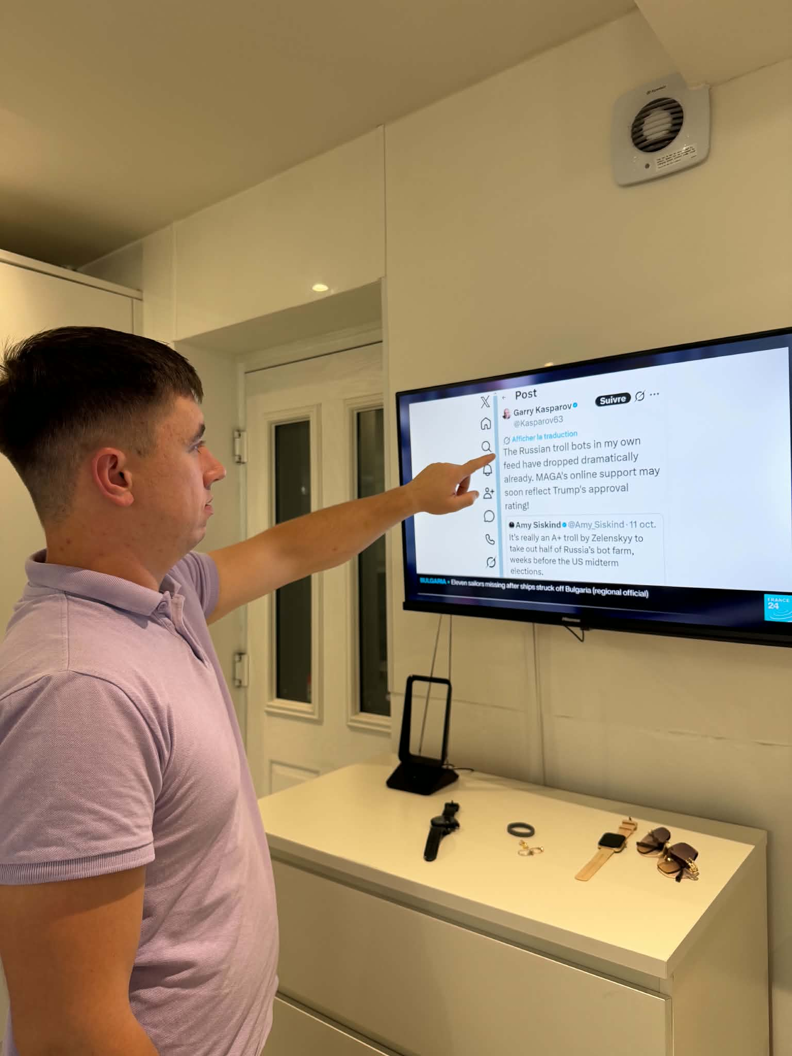
In this photo, l am using a TV to read news on the internet. I use digital technology to find information and learn new things. Digital tools are important in my daily life.

Screenshot/Photo 2
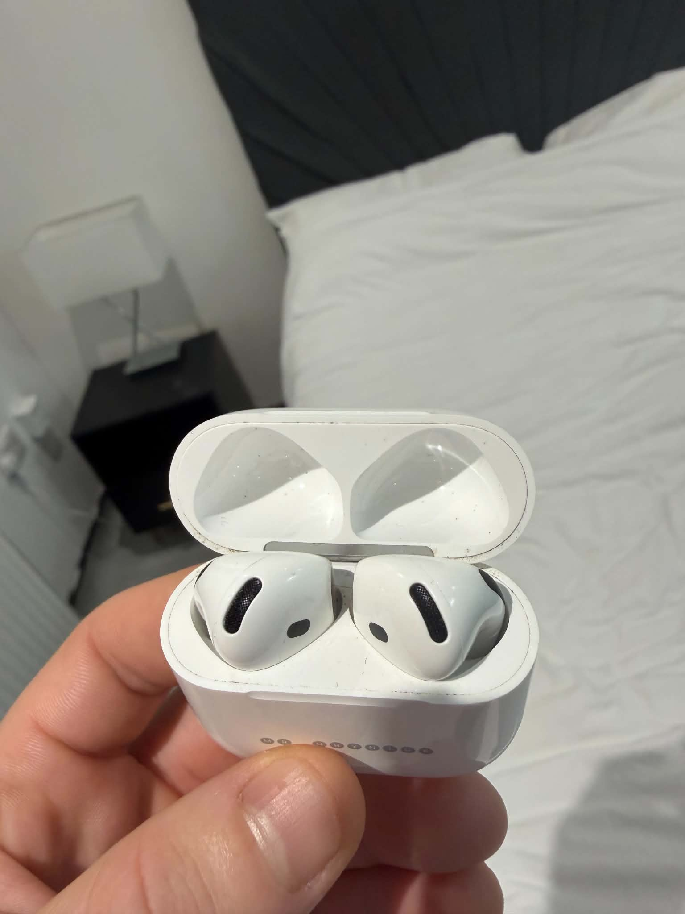
I use my AirPods to listen to music and watch videos. I feel confident using them because they make my life easier.

Screenshot/Photo 3
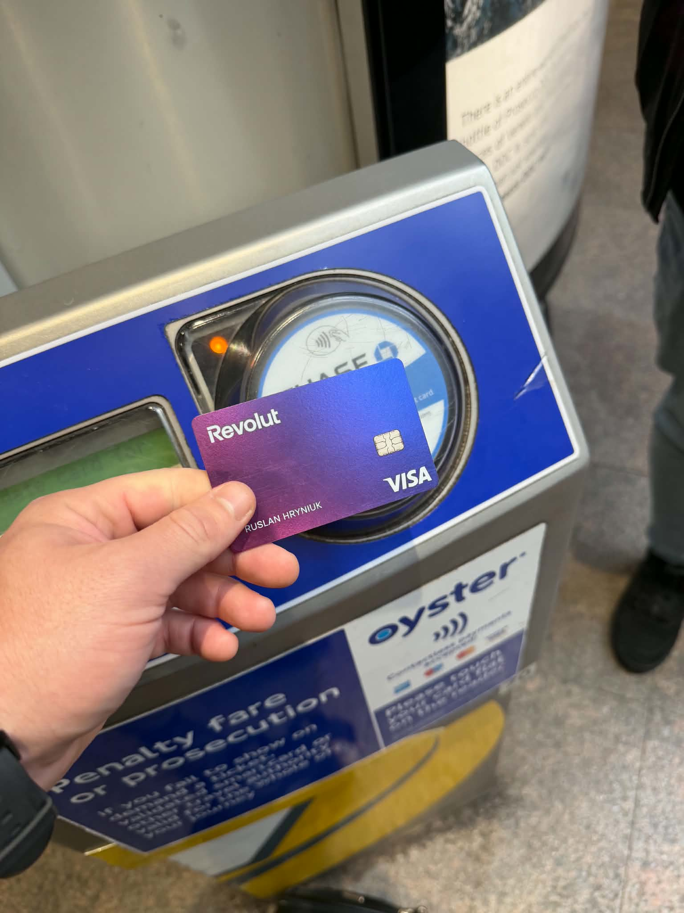
I often use my card to pay for transport and shopping. Digital payments are important for me because they are easy and fast.

Screenshot/Photo 4
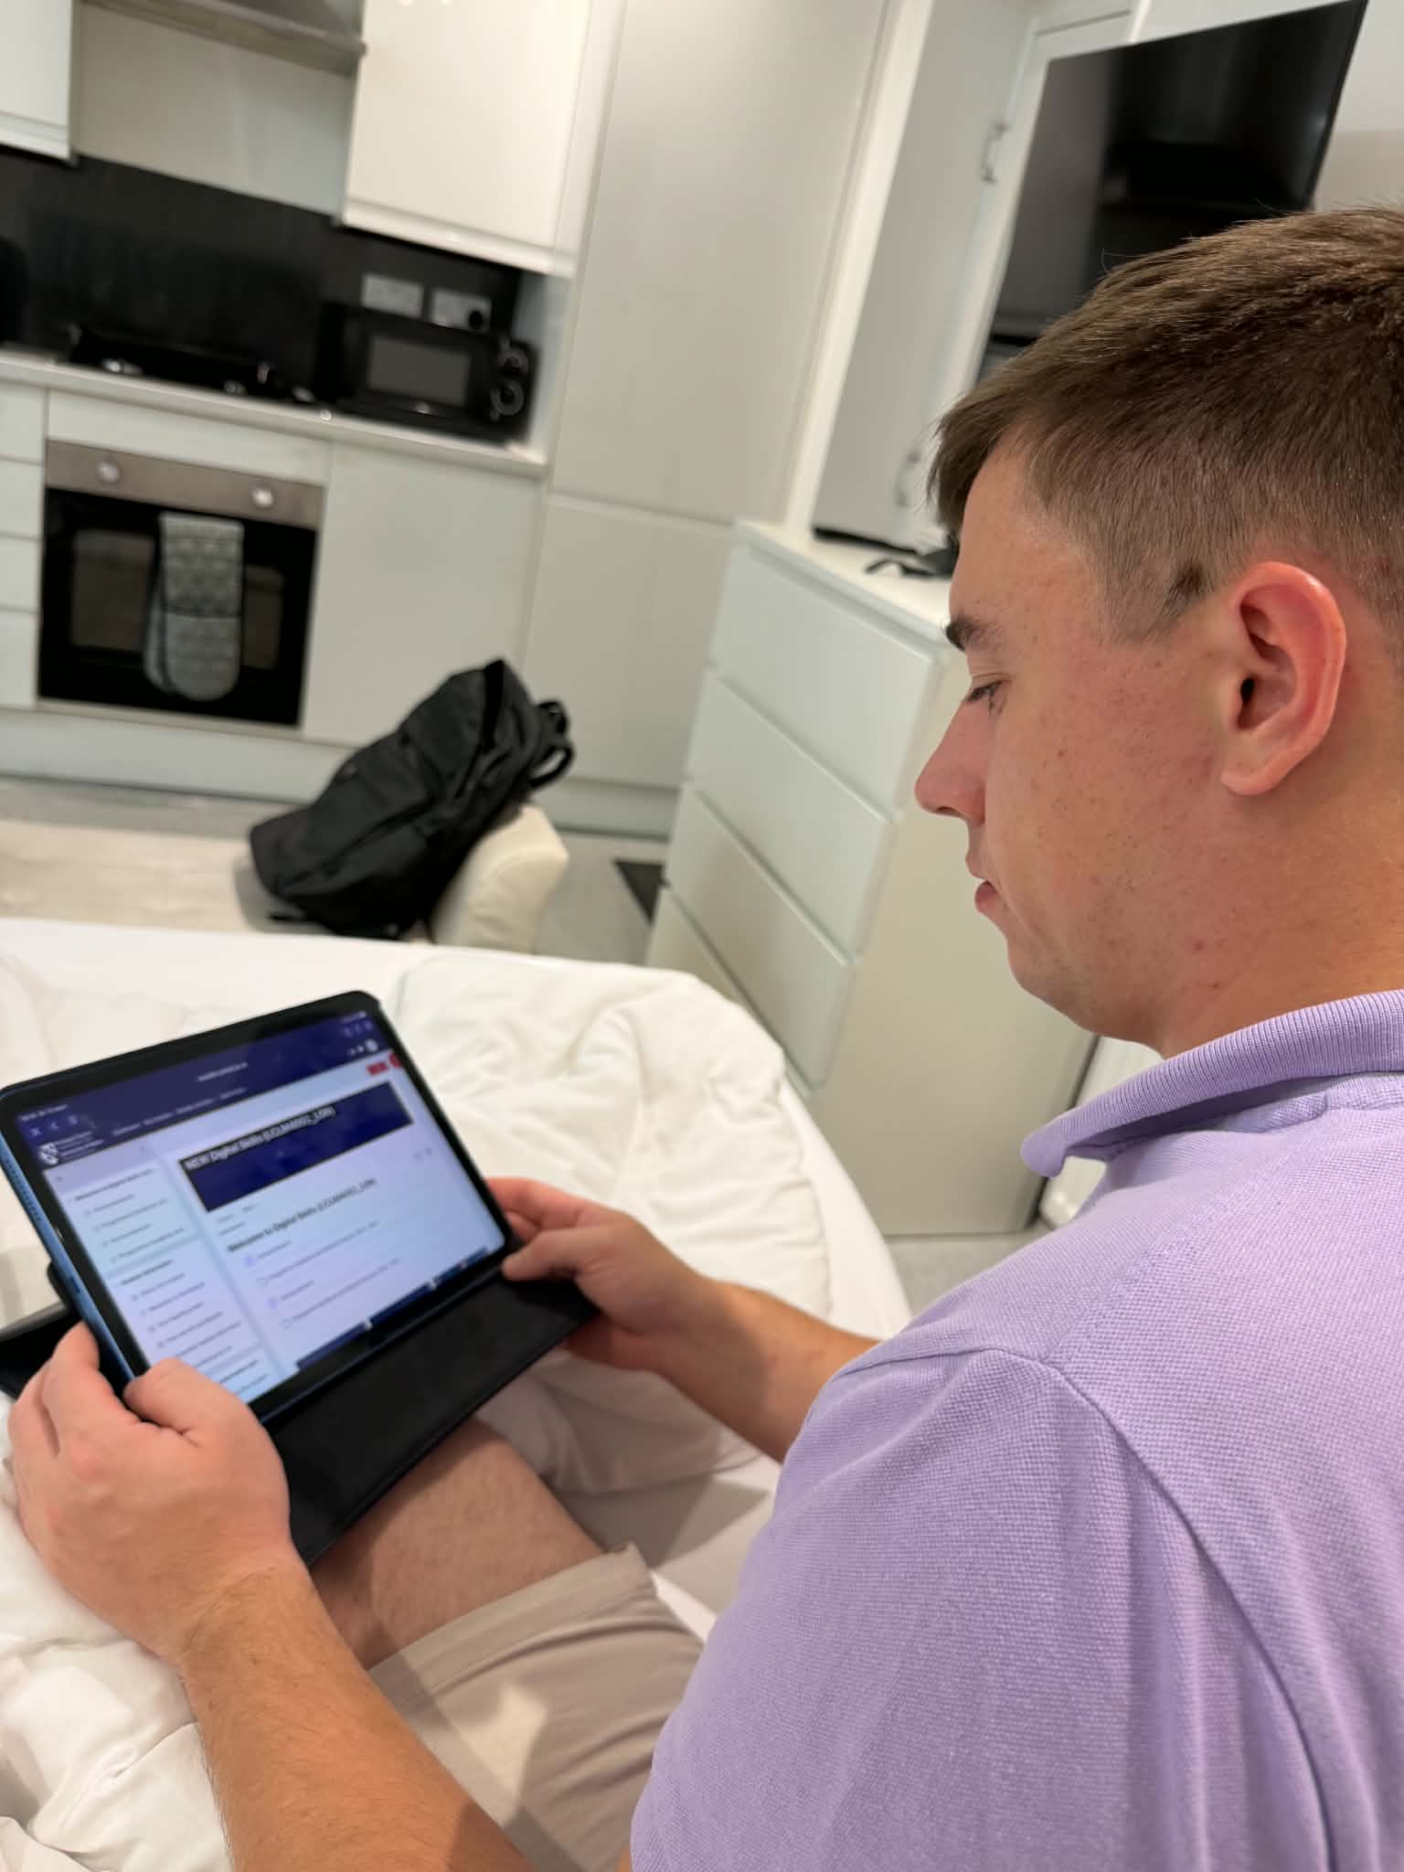
I often use my iPad, to read information and complete university tasks. I feel confident when l use my iPad because it is easy and convenient.

Screenshot/Photo 5
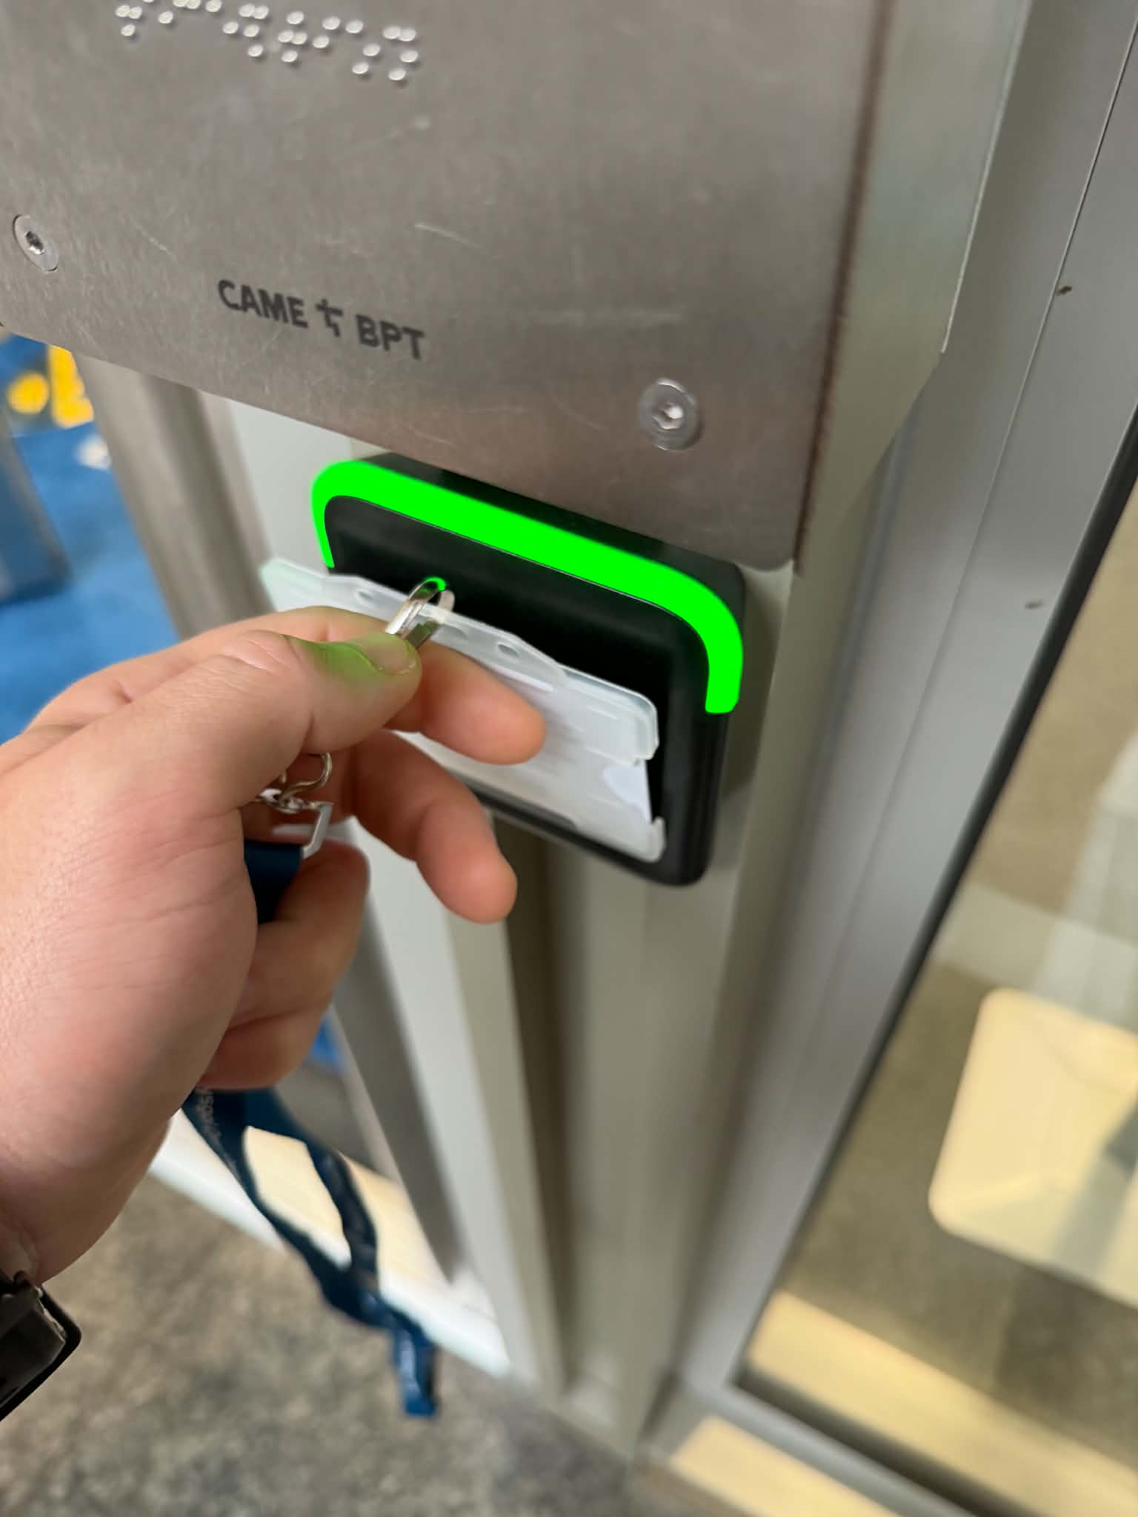
I use my student card to enter the university. It is easy and fast.

Screenshot/Photo 6

I often use my phone to pay in shops. I like digital payments because they are quick and simple.

My Short Reflection
- Write 5–8 simple sentences about your digital life.
- You can use the sentence starters below if helpful.
I use digital tools every day. I often use my phone and iPad to study and find information. I use my AirPods to listen to music. I use my bank card to pay for shopping and transport. I feel confident when I use digital technology. I want to improve my computer skills. Digital skills are important for my university and future work.

Sentence starters
- I use digital tools to …
- I feel confident when I …
- I want to improve …
- I often use these tools: …
- I sometimes feel nervous about …
- I hope this module will help me …
- Digital skills are important for me because …
You can write more if you want.

Submission Checklist
Before you submit, please check:
​​​ ☐ I added 4–6 screenshots
☐ I wrote short sentences for each screenshot
☐ I wrote my short reflection
☐ My work is my own
☐ My file opens correctly
​​☐ My file opens correctly

