Module Title: Foreign Languages & Cultural Awareness
Module Code: BMIH5003
Assignment Type: Report
Teachers Name: Heidi Prosser
Student Name: Marcin Segrecki
Student Id: 2219780
Word Count: 1092

Executive Summary
This particular report has depicted the importance of understanding the culture of a place to run a business. The Anglo Cluster Hotel is a France chain hotel that has an exclusive spa and other services. This is also located in 61 other countries as well as in the UK focusing on this report provides two important factors which are social and cultural aspects to identifying the cultural difference between the two countries. The cultural differences have been understood with the help of global project theory. Thus, in this report, some challenges have been described as intellectual challenges and some solutions have been provided to solve these issues.

Table of Contents
Introduction 4
Key differences between England and France 5
Language 5
Difference in communication style 5
Analyse and compare France and England using the GLOBE Project Culture and Leadership study 6
Performance orientation 7
Future orientation 7
Human orientation 8
Assertiveness 8
Institutional collectivism 8
In- Group collectivism 8
Leadership visualisation 9
Charismatic 10
Team oriented 10
Participative 10
Humane Oriented 10
Autonomous 10
Challenges of intercultural leadership in the hospitality industry 11
Communication barriers 11
Overcoming the stereotype bias 11
Maintaining the conflict 11
Conclusion 12
Recommendations 13
References 14

Introduction
Learning new cultures and languages is important for the Hospitality sector companies' business to expand. Every country has its own unique culture likewise, like England and France. The following report will highlight the cultural differences faced by the Anglo Cluster Hotel in England. Alongside this, some key differences among both countries will be demonstrated in the report. Moreover, the report will give a proper overview of the Global projects and the study of the leadership and its challenges with proper recommendations.

Key differences between England and France

Language
Before the start of the Modern Era countries in Europe had many similarities although after the Wars and shift in the dynamics of the society was the main reason for the current changes. Thus, both countries France and England have different cultures as well as languages. The French people speak in French and another country speaks in English. Through the difference in the language, the Anglo Cluster Hotel will face cultural barriers in England (The Gurdian , 2023).

Difference in communication style
Another cultural barrier for the Anglo Cluster Hotel will be the communication style of the people. For example, the people of France greet each other by giving hugs or kisses whereas the English people shake hands. The people of the French are very proud of their language trend to use fewer English words. Henceforth, the communication style and the accent will be a barrier for the Anglo Cluster Hotel.

Analyse and compare France and England using the GLOBE Project Culture and Leadership study
The GLOBE Project culture and leadership study has 9 factors that help in determining the key differences among various cultures.
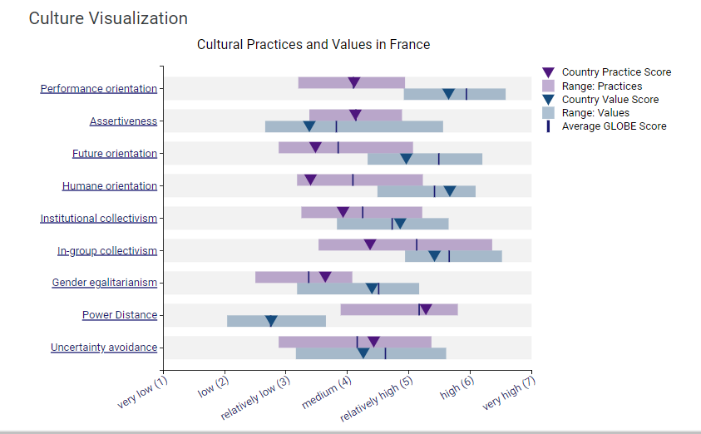
Figure: Cultural Visualisation of France
Source: (Globe, 2020)
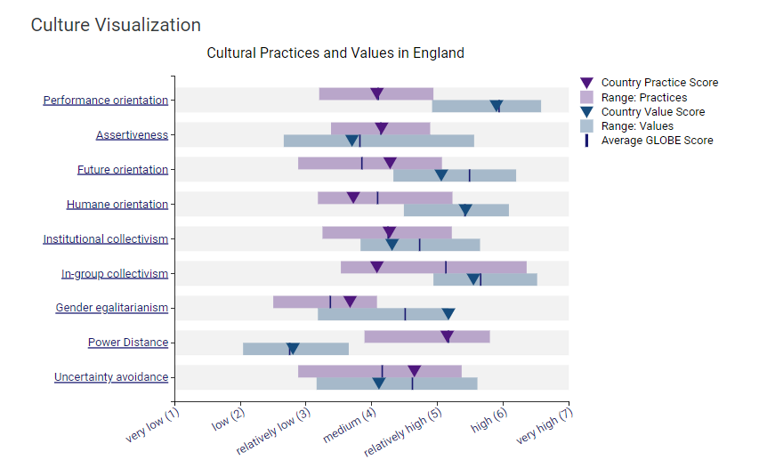
Figure: Cultural Visualisation of England
Source: (Globe, 2023)

Performance orientation
Performance orientation denotes when a community encourages and believes in innovation, high standards, Excellence along performance improvement. A society that has a high-performance orientation values training and development (Abramson and Moran, 2018). The above chart shows the France and UK performance orientation rate shows that France has a higher performance rate.

Future orientation
Future orientation is a process that relates the future behaviour that is influenced by both cognitive and motivational factors. A greater future orientation helps to clear the goals, and a better planning ability to overcome future obstacles (Thompson, 2021). Similarly, the help of positive development and transition into adulthood. According to the above chart, the rate of future orientation is higher in England and lower in France.

Human orientation
Human orientation defines the measure of the kindness, generosity, and altruism that are valued
by others. Human orientation defines the measure of the kindness, generosity, and altruism that are valued by others. Through the help of human orientation, an employee will easily be able to socialise with others effectively. The Chart of the represents that the human orientation rate is higher in England than in France.

Assertiveness
Assertiveness denotes when an individual stands for their rights. Particularly both countries have the same attitude towards assertiveness. The rate of assertiveness in the chart demonstrates that France has slightly higher assertiveness than England.

Institutional collectivism
This is a degree when the organisation provides rewards and encouragement for the distribution of resources. The above-mentioned chart represents the institutional collectivism rate of France and England where the rate is higher in England.

In- Group collectivism
In-group collectivism denotes the degree to which a person expresses their emotion, pride, and loyalty. The rate of in-group collectivism in France is higher than the England.
Gender egalitarianism
Gender egalitarianism is defined as a degree to which it collectively minimises the degree of inequality. The above chart showcases the rates of England and France where it is shown that both have moderated rates.

Leadership visualisation
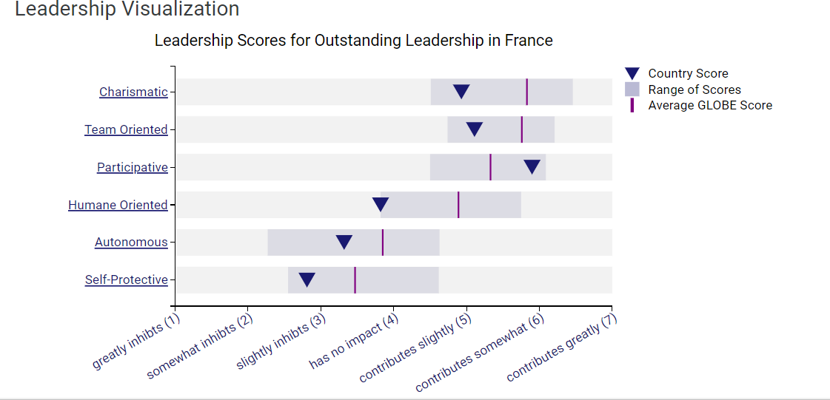
Figure: Leadership Visualisation in France
Source: (Globe, 2020)

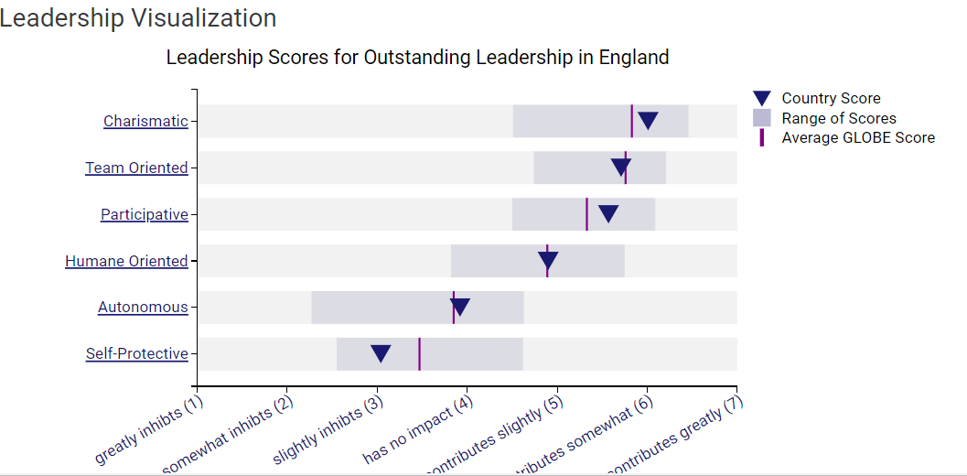
Figure: Leadership Visualisation in France
Source: (Globe , 2020)

Charismatic
The rate of charisma in the countries such as France and England are represented in the above chart which shows that England has a higher rate than France.

Team oriented
Team orientation denotes that the organisation encourages their employees to work productively which will help in the completion of the task. The team orientation was higher in England than in France.

Participative
The rates of the of both taken countries England and France are present in the chart that demonstrates that the rate was moderate in both countries.

Humane Oriented
Human-oriented rates in both countries were demonstrated in the chart that concluded England has the higher rate compared to France.

Autonomous
The Autonomous rate in the above chart stated that the rate of this was low in France in the year 2020 compared to England.

Challenges of intercultural leadership in the hospitality industry

Communication barriers
Cultural barriers are the main reasons for the parties which is the main reason for the misinterpretation and miscommunication in the diversified team. This makes the employee feel less confident less motivated and feel unwelcome in most of the scenarios. Thus, the team leader should be a good expert on cultural norms and must convey the messages thoroughly to prevent future misunderstanding (Maheshkar and Sharma, 2018).

Overcoming the stereotype bias
The cultural barrier among the employees must create misunderstanding and mislead many more. Thus, all the team leaders must treat all the employees with respect and maintain equality. This will end the stereotypes and thoughts about culture and disclose biases among the employees. After overcoming all this a company will be safe and better for the workplace. The reduction in biases will eventually increase the social discrimination rate (Wales, 2021).

Maintaining the conflict
Navigating and understanding other opinions is one of the biggest tasks of the team leaders. The leaders are expected to manage the team better however this becomes difficult if the employees are from different cultures. Moreover, any type of conflict should be resolved by the team leaders for future assurance. In managing a conflict, a leader must not rely on emotional intelligence and negotiation techniques (Deresky, 2017).

Conclusion
The creation of this report is based upon the cultures and socio-cultural aspects of a firm that can change its development. The Anglo Cluster Hotel is a France-based hotel chain that has a branch in the United Kingdom as well. Both countries are different from each other and have their own unique culture. Though the two countries are located in Europe, both countries have some dissimilarities. Moreover, the help analysis with the help of the Global project to compare both cultures is showcased in the report. Some recommendations are also provided in the report to reduce the discrimination rate.

Recommendations
1. Learning a new language is essential as the diversified team should obtain knowledge about the different cultures as well as learning them. Thus, the Anglo Cluster Hotel staff should have a good communicator who can speak English fluently which will prevent future misunderstandings. The development in language ability will help the staff to communicate freely and prevent future conflicts.
2. The diversity in the culture and the possibility of not maintaining the teams effectively leads to the rise of conflicts between the parties. Providing a session that can resolve the problem in a better way is the main way to prevent conflict.
3. A better leader is important for the ethics team to develop their team management. This will guide the team into the right path and in the right direction the team will be back on the right path.

References
Abramson, N.R. and Moran, R. (2018) Managing Cultural Differences: Global Leadership for the 21st Century. 10th Ed. Abingdon: Routledge.
Deresky, H. (2017) International Management: Managing Across Borders and Cultures: Text and Cases. 9th Ed. Harlow: Pearson Education Ltd.
Globe , (2020). England. [Online]
Available at: https://globeproject.com/results/countries/GBR%3Fmenu=list.html#list[Accessed 15 Feburary 2024].
Globe, (2020). Culture Visualization England. [Online]
Available at: https://globeproject.com/results/countries/GBR%3Fmenu=list.html#list[Accessed 15 Feburary 2024].
Globe, (2020). Culture Visualization France. [Online]
Available at: https://globeproject.com/results/countries/FRA%3Fmenu=list.html#list[Accessed 15 feburary 2024].
Globe, (2020). France. [Online]
Available at: https://globeproject.com/results/countries/FRA%3Fmenu=list.html#list[Accessed 15 Feburary 2024].
Maheshkar, C. and Sharma, V. (2018) Handbook of Research on Cross-Cultural Business Education. Hershey: IGI Global.
The Gurdian , (2023). Readers reply: why are the French so much more militant than the British?. [Online] Available at: https://www.theguardian.com/lifeandstyle/2023/apr/02/readers-reply-why-are-the-french-so-much-more-militant-than-the-british[Accessed 15 Feburary 2024].
Thompson, S., (2021). Future Orientation Culture. [Online] Available at: https://bizfluent.com/future-orientation-culture.html[Accessed 15 feburary 2024].
Wales, S., (2021). How to avoid unconscious bias in hospitality. [Online] Available at: https://employers.hosco.com/blog/how-to-avoid-unconscious-bias-in-hospitality[Accessed 15 Feburary 2024].

