Rebecca Davis 2028835
BMPF7010
Total word count: 13,133

What is the impact of voice change on the female adolescent singer? An evaluation of pedological approaches to improve vocal development and singer confidence; a scoping review.

Table of Contents
Project Proposal 3
Context 3
Justification 3
Intended Impact 4
Research Methodology 4
Ethical Implications 6
Insider Research 6
Personal Learning Outcomes 6
Timeline 7
The Project Report 8
Introduction 8
Context 8
Justification 9
The Intended Impact 10
The Expected Learning Outcomes 10
Methodology 11
Physiology 19
Impact on Phonation 21
Emotional Impact 31
Education and Improvement 32
Conclusion 38
Bibliography 40
Appendix 46

Project Proposal

Context
I am a voice teacher specialising in contemporary commercial music (CCM) and musical theatre, primarily working with young female voices. I am keen to explore how puberty impacts the voices of young females, as I have observed that female adolescents often exhibit a breathy voice that can lack stamina and have found improving the tone quality of these voices challenging. I have been investigating ways to assist this group of students in furthering their singing technique during this transitional period.
Both male and female voices change throughout their lifespan (Howard et al., 2019), and there are significant variations that exist between female and male voices; these are due to physical changes that occur within the larynx and affect both speech and singing from before to during puberty (Howard et al., 2019). Pre-puberty, the female and male larynx are roughly the same size (Kahane, 1978); however, pubertal changes increase the length of the vocal folds of boys by more than double that of girls (Kahane, 1978). This growth results in a much lower pitch for boys and a change in voice quality for girls (Fitch and Giedd, 1999). Whilst the male voice becomes deeper and lower in pitch, the female voice may become breathy and rough sounding, attributable to the instability of existing vocal fold vibration due to the growth of the larynx (Williams, 2019). I have witnessed these issues in my voice studio and have observed the frustration experienced by singers when their voice no longer responds as they wish.

Justification

Preliminary searches uncover a wealth of literature regarding male voice changes during puberty compared to those of females. Consequently, adolescent girls often navigate the challenges of voice change without support (Sweet, 2015). One possible reason is that the changing process is not nearly as noticeable or dramatic as it is for males (Gackle, 1991). This assignment investigates the extent of the literature available on female voice change. I shall compile and summarise the information discovered to better inform myself and other voice professionals about addressing the changes in young female voices. This will facilitate the development of appropriate and valuable approaches, ensuring that the student feels understood and supported. I aim to fill gaps in my knowledge regarding the physiological changes affecting the female adolescent voice, how these changes influence the tone and characteristics we can hear, and the singer's mental health. The results of my scoping review will identify any gaps in the literature and what these are. This is particularly important as singing styles are ever-changing, and much of the available literature may need updating to remain relevant to current trends. Many new and emerging singing styles may appeal to female pubertal singers; therefore, I must prioritise the most recent research on my topic, highlighting further areas for subsequent research in the future.

Intended Impact

Through this research, I aim to deepen my understanding of the physiology involved in voice changes among female adolescents. I seek to highlight the issues surrounding these voice changes to assist voice professionals in guiding young singers, which is crucial for their development. I will also consider how these changes may impact the mental health of young singers and the psychological effects of voice change on female adolescents. Additionally, I will explore methods to encourage and reassure these singers, helping them feel confident during these challenging stages and continue singing through puberty.
This project aims not only to enhance my understanding of female adolescent voice change (FAVC) but also to engage the wider community of voice users, choir directors, voice teachers, and voice professionals, highlighting the challenges these individuals face and fostering positive change in this field. This group of students must recognise that they are understood and supported by their voice professionals during this stage of development (Kennedy, 2022).

Research Methodology

A scoping review is a common approach to inform research based on identifying and examining literature (Peters et al., 2020). Exploratory and descriptive scoping reviews are a knowledge synthesis method that identifies trends and gaps within an existing knowledge base or scope of knowledge (Westphaln et al., 2021). They draw evidence, providing a comprehensive overview to address broader review questions than traditionally more systematic reviews of effectiveness or qualitative evidence (Peters et al., 2020). By conducting a scoping review, I can map the literature on my chosen subject and identify gaps in the research. This process benefits my learning style, which aligns with Gregorc’s ‘concrete sequential’ mind style (Gregory, 2023), as I prefer adhering to structured, step-by-step processes and guidelines. My selection of literature will focus on peer-reviewed, voice-specific articles, reports, journals, websites, and books to address my research question. While I will concentrate on peer-reviewed literature, a significant advantage of a scoping review is that it is not limited to peer-reviewed works and can include non-research sources, offering a wider overview to tackle broader review questions (Peters et al., 2020). I will search for literature through The Voice Study Centre’s online student MA system, the university library, my collection of voice books, and online resources. The keywords and phrases I will use in my search are as follows:
- Physiological changes adolescent female voice
- Adolescent voice change females
- Stages voice change female adolescents
- How puberty affects female voice
- Mental health female adolescent voice change
- Teaching girls sing adolescence
- Singing through puberty female voice

My literature search will concentrate on the effects of puberty on the female voice and the best approaches for working with this group of students. I will explore the extent of the available literature to identify any gaps that could be addressed in future research. I shall employ the Arksey and O’Malley (2005) framework to structure my scoping review. They were the first to elucidate the rationale and offer a methodological framework for constructing scoping reviews, which I find particularly intuitive for my learning style.
The stages of the Arksey and O’Malley framework are listed in Figure 1 below.

Figure 1. The Five Key Stages of Arksey and O'Malley's Methodological Framework
Stage 1 | Identifying the research question
Stage 2 | Identifying relevant studies
Stage 3 | Study selection
Stage 4 | Charting the data
Stage 5 | Collating, summarising and reporting the results
(Arksey and O’Malley, 2005, p.22-23)

After reviewing the scope of the available literature, I will define the inclusion and exclusion criteria. I will then summarise and analyse the results and present my data descriptively in a qualitative format; for ease of presentation, this may also be mapped in table or graph form.

Ethical Implications

Since my scoping review will not involve any participants and will focus on reviewing the literature available in the public domain, it is unlikely that I will need to consider any negative impacts my research could have on individuals. However, when working with adolescent female singers in the studio, I must consider any adverse effects they may experience due to changes in the tone and range of their voices. Therefore, as part of my scoping review, I will examine any available literature on the mental health of female adolescent singers to understand how changes in their voices can affect them and how best to support them through this transition. I must remain objective when analysing the literature; I will adhere to my scoping review criteria and avoid potential research bias.

Insider Research

Researchers must clarify their role, especially those using qualitative methodology, to make their research credible (Boote and Beile, 2005). As a voice teacher researching the female adolescent voice, I am an insider researcher and, therefore, have the advantage of some understanding of the female adolescent voice (Unluer, 2012). Nevertheless, despite this advantage, I must remain objective and minimise any biases that may emerge while conducting my research (Costley, 2006). Furthermore, familiarity with a subject can jeopardise objectivity, especially when inadvertently making erroneous assumptions based on prior knowledge (Breen, 2007). Nonetheless, the risk of losing objectivity and introducing bias into the review may be mitigated by strictly adhering to the established framework and identifying precise keywords and string sentences.

Personal Learning Outcomes
- To enhance my understanding of FAVC and how to better support this group of students in my voice practice.
- To enhance my research skills and adopt a more systematic approach when selecting and reviewing literature.
- To assess the scope of the literature available on my subject and highlight any gaps that could facilitate further research.
- To gain insight into scoping reviews and carry out my own based on my research.
- To understand how to become more analytical in assessing my research
- To enhance my writing and presentation skills
- To enhance my reflectiveness throughout the assignment, I will consistently consider what I can do better and how I might develop my research and writing skills.

Timeline

The Gantt chart in Figure 2 below displays a projected timeline for the project.

Figure 2: Project timeline
Task W/C | 28 Oct | 4 Nov | 11 Nov | 18 Nov | 25 Nov | 2 Dec | 9 Dec | 16 Dec | 6 Jan | 13 Jan | 20 Jan | 27 Jan | 3 Feb | 10 Feb | 17 Feb | 24 Feb | 3 Mar | 10 Mar
Agree research with tutor
Context

Justification

Intended impact
Research methodology
Ethics and insider research
Project report: Introduction
Inclusion/exclusion criteria
Search for evidence
Select evidence
Extract evidence
Chart evidence
Write report

Submit report

Prepare presentation slides
Present results

The Project Report

Introduction

Context

The researcher is a voice teacher specialising in contemporary commercial music (CCM) and musical theatre styles; the primary student profile for this study consists of females aged 9 to 16. The female adolescent voice change (FAVC) was examined for the researcher's formative MA assignment in 2021. This focus arose from the observation that as young female students entered puberty, they began to exhibit vocal symptoms such as breathiness and a husky tone, cracks and breaks, instability of pitch, frequent throat clearing, and poor breath control; this group of students were no longer able to project their voices as they had previously. This observation aligns with Gackle (1991), who identifies the following symptoms of female adolescent voice change:

- insecurity of pitch;
- development of noticeable register breaks;
- increased huskiness in the voice;
- decreased and inconsistent range capabilities;
- voice cracking;
- hoarseness;
- generally uncomfortable singing or difficulty in phonation
(Gackle, 1991)

This experience also aligns with Sweet (2015), who conducted a phenomenological study exploring the experiences of female voice change during adolescence in a choral setting. Sweet concluded that the fourteen singers in this study all experienced a complete lack of phonation in certain areas of their vocal range, excessive breathiness in their tone, vocal unpredictability, and a deficiency in strength or endurance while singing (Sweet, 2015). The researcher aims to understand why these changes occur and, more importantly, how the girls can be supported.
Through an initial review of the literature, the researcher discovered that these symptoms were due to the rapid growth of the girls’ vocal folds, which destabilised the existing pattern of vibration and led to a posterior glottal chink caused by weaker adductor muscles (Davis, 2022; Williams, 2019). It was discovered that these students could be assisted by improving breath management skills and aligning the vocal folds with semi-occluded vocal tract (SOVT) exercises (Davis, 2022). In the research, a small selection of voice exercises was selected, which resulted in some improvement in intonation and vocal stamina of the young female adolescent singers (Davis, 2022). Through this scoping review, the researcher aims to build on the initial research and gain a deeper understanding of the physiology and psychology involved in FAVC.

Mak and Thomas (2022) define a scoping review as a knowledge synthesis that systematically identifies and synthesises an existing or emerging body of literature. Munn et al. (2018) add that scoping reviews illustrate the volume of available literature and provide an overview of its focus. Peters et al. (2020) state that the primary reasons for conducting a scoping review are to map the literature's extent, range, and nature and identify any potential gaps within the topic.

The researcher aims to identify the extent of existing literature and provide an overview of current knowledge. Therefore, a scoping review would be an appropriate methodology for this project. A scoping review will enable the identification of the most relevant literature, present an overview of findings to the broader community of voice users and voice professionals, and highlight the challenges faced by female adolescent singers in instigating positive change in this area.

The researcher will compile and summarise the information gathered to better inform themselves and other voice professionals about addressing changes in young female voices. This will facilitate the development of appropriate and valuable approaches, ensuring that students feel more understood and supported. The aim is to fill knowledge gaps regarding the physiological changes affecting the female adolescent voice, how these changes influence the perceived tone and characteristics, and the sensations experienced by females during phonation.

Justification

An initial search for literature on FAVC suggests that research in this area is limited compared to studies on male adolescent voice change. Cooksey (1999) concurs, noting that voice transformation in female adolescents has not received significant attention from researchers over the years; however, he adds that there has been a relatively significant and increasing interest in the 1980s and 1990s as researchers became more aware of the physiological and psychological aspects of FAVC. Decoster et al. (2008) propose that the lack of scientific data may be attributed to the fact that audible vocal changes are less pronounced in girls than in boys and that girls tend to manage vocal growth quite effectively. Sweet disagrees, reporting that adolescent female singers often struggle with emotions such as fear, humiliation, frustration, and embarrassment. Poole and Macdonald (2022) add that the changing and unpredictable nature of the body and voice can present barriers to performance, and females may be hesitant to use the full extent of their singing voice for fear of embarrassment.

When I explain to female students in my voice practice why they suddenly struggle with phonation, they seem surprised. “Why hasn’t anyone explained this to me before?” one student asked. Luchsinger and Arnold (1965) state that it is much less widely known that “girls also undergo vocal mutation” (p.134). Luchsinger and Arnold (1965) believe that informative and accessible education provided at the optimum point of vocal change is essential to help inform young female singers about what is happening with their voices.

The Intended Impact

The impact of this study will be to enhance understanding of the female adolescent voice for both the researcher and their students, enabling them to guide, support, and encourage these young singers throughout their development. The study aims to engage the broader community of voice users, choir directors, voice professionals, and voice teachers by highlighting the challenges these individuals face and effecting positive change within FAVC.

The Expected Learning Outcomes

This study aims to enhance my understanding of how the vocal apparatus of females develops during puberty, the symptoms it presents, and its effects on young female singers. With this knowledge, I can comprehend how, as a voice professional, I can assist singers in improving their vocal quality and self-esteem. My research also seeks to reach the broader voice community to impart knowledge and skills to other voice professionals, students, and parents. I will examine what the literature reveals about the importance of voice professionals being well-informed so they can guide, reassure, and encourage young singers to feel more supported throughout their vocal development (Sweet 2019; Mercado and Drought 2024).

Methodology

The methodology for this scoping review is based on the framework of Arksey and O’Malley (2005), as displayed in Figure 1 below.

Figure 3: The Five Key Stages of Arksey and O'Malley's Methodological Framework
Stage 1 | Identifying the research question
Stage 2 | Identifying relevant studies
Stage 3 | Study selection
Stage 4 | Charting the data
Stage 5 | Collating, summarising and reporting the results
(Arksey and O’Malley, 2005, p.22-23)

The following section uses this framework to construct the study design.

Identify a team: Before step one, Arksey and O’Malley (2005) recommend assembling a team to conduct the research. Given the limitations of this project, identifying additional team members is not feasible. However, the researcher has a personal tutor for consultation, who will not assist with data collection or analysis. Therefore, it is crucial to ensure that the research for this project is as comprehensive as possible.

Step 1: Identify the research question: Creating the research question is a vital first step, and it is essential not to be too broad or too narrow to avoid affecting the feasibility of the review (Levac, et al., 2010). A preliminary literature search can assist in determining the scope of the question, identifying whether a scoping review has already been undertaken and if sufficient literature is available on the topic (Mak and Thomas, 2022). After conducting an initial search and considering all of these factors, it is concluded that the following question will guide the scoping review.
What is the impact of voice change on the female adolescent singer? An evaluation of pedological approaches to improve vocal development and singer confidence; a scoping review.
This question aims to identify the available literature on the subject and prompts reflection on how that literature can best assist voice professionals in supporting female adolescent singers.

Step 2: Identifying relevant studies: Mak and Thomas (2022) suggest that it is essential to devise a search strategy that comprehensively identifies primary studies suitable for addressing the central research question before identifying relevant literature. The search strategy was developed based on the research question, and a search string was designed to source literature on the topic. The search string included terms deemed crucial in answering the research question and was applied across each database. The search string used was ‘Adolescent female voice AND change AND singing AND puberty’. This string was crafted by experimenting with various words and combinations, yielding the most manageable number of applicable studies while incorporating terms considered essential for producing relevant literature. Arksey and O’Malley (2005) state that breadth and comprehensiveness in the literature search are vital; however, the practicalities of the search are equally important. Therefore, it was necessary to narrow down the results to the most relevant articles to ensure the research could be conducted within the given timeframe.
The University of Wales Trinity Saint David’s online library, The Journal of Voice online database, Google Scholar, and The Voice Study Centre’s student MA resources were searched. These resources were selected because they appeared to contain the most relevant data for the project. Since the MA system does not have a search function, relevant studies were hand-retrieved based on their titles and abstracts.
When the terms ‘mental health’ or ‘psychology’ were added to the search string in various combinations, the number of studies generated was zero. However, it was later discovered that the subject was discussed in several articles within the screened studies. Consequently, articles that passed through the initial screening were hand-searched for information on the emotional impact of female adolescent voice change and included in the final selection of literature if suitable. The drawback of this method is that information outside of the selected studies may be available; however, due to time and resource constraints, conducting a hand search beyond the screened studies was deemed impractical.

The time frame of 1991-2025 was selected because it was found that many pioneers in the field of FAVC, such as Bridget Sweet and Lynne Gackle, first published their work during the 1990s, with very little information available before that period. Although Gackle published an initial paper in 1985, it was noted that most of her work was written later. As the project required only the most recent studies for accuracy and time efficiency, it was determined to exclude this specific paper and only source reports from as far back as 1991.

Given that the body of literature on FAVC was relatively limited, it was necessary to consider works from 1991 to provide sufficient studies for analysis. Consequently, it was decided to include literature translated from other languages into English; however, none were considered relevant enough for the final selection. While non-peer-reviewed literature can be appropriate for scoping reviews, it was determined to utilise only peer-reviewed literature to ensure accuracy. Additionally, non-subject-specific literature was excluded from the study to maintain focus on FAVC. The search string uncovered numerous studies that were not primarily centred on FAVC but rather on topics such as the male adolescent voice, anorexia, posture, or those related to speech rather than singing, leading to the exclusion of these in favour of more subject-specific literature.

It was considered valuable to check the bibliographies of screened studies for further literature as important information can be missed due to databases being incomplete, not up to date or because abstracting services can vary in coverage and depth of information (Arksey and O’Malley, 2005). This was completed by identifying key documents to ensure the selection was from the most relevant material. Unfortunately, many of the citations sourced this way were not retrievable due to unavailability of access. If time restraints did not exist, a hand search of key publications might have been beneficial to investigate if any important articles had been missed in the database search.

Step 3: Study selection: After the scope of the available literature had been understood, studies were selected for inclusion in the scoping review. The selection of studies included in the final review was based on the specifics of the research question. The initial perusal of studies using the databases indicated that the search strategy had selected a large number of irrelevant studies. Therefore, many of these needed to be eliminated based on their relevance to the research question. Levac et al. (2010) suggest that inclusion and exclusion criteria are an efficient mechanism to assist in eliminating irrelevant studies for review during the screening process. Mak and Thomas (2022) suggest that to complete the initial screening of papers, the researcher should read the paper's title and the abstract. If the abstract is unavailable, the full text should be read to discover if the report meets the inclusion and exclusion criteria. The criteria were considered once the scope of the literature had been revealed, which was guided by the research question and purpose (Westphaln et al., 2021). The inclusion and exclusion criteria utilised for this review can be found Figure 4 below.

Figure 4: Inclusion and exclusion criteria
Study Inclusion Criteria | Study Exclusion Criteria
Studies or texts with the primary focus on adolescent female voice change | Studies which mentioned the female adolescent voice however the primary focus of the paper was on another area
All primary languages | Studies or texts written before 1991
Studies that were peer-reviewed | Non peer-revied literature

The initial database search yielded 160 articles. Nine duplicates were removed, and the remaining 151 articles were screened by applying their titles and abstracts to the inclusion and exclusion criteria; this process excluded 112 articles. The remaining 39 articles were imported to Mendeley for further, more detailed screening. The PRISMA 2020 flow diagram, shown in Figure 5 below, was used to organise records.

The next stage was to review the full articles to decide whether they should be included in the review. Badger et al. (2000) suggest that reading the full article is essential, as abstracts cannot be assumed to represent the following article or capture the full scope of the literature. Of the 39 articles imported for further screening, 6 could not be accessed, leaving 32 to undergo full-text review. Of these, 20 were considered non-subject-specific. The process resulted in 12 documents to use for the scoping review.

Figure 5: PRISMA ScR 2020 flow diagram
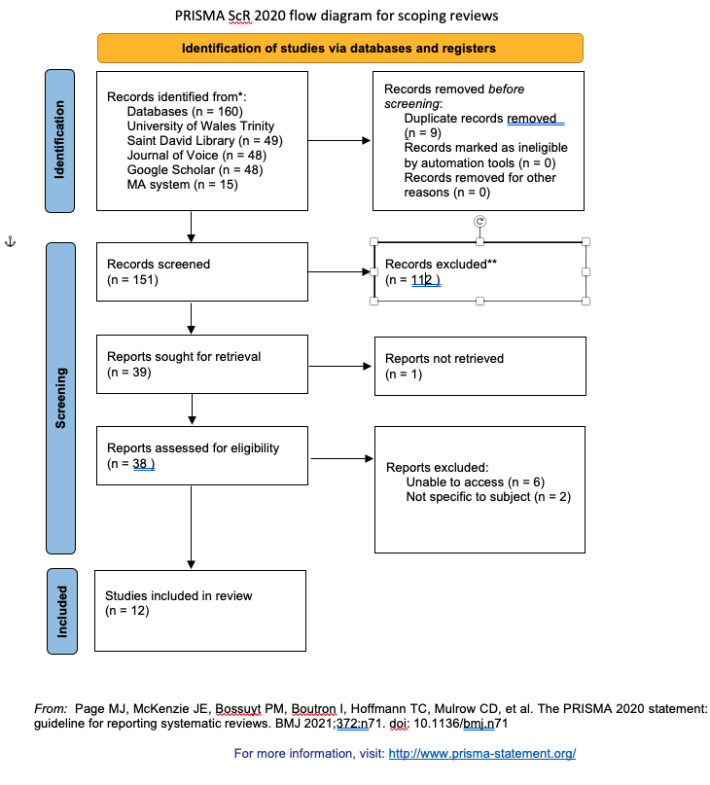
Step 4: Charting the data: Arksey and O’Malley (2005) describe the next stage of the framework as ‘charting’, which means extracting key items of information obtained from the primary reports being reviewed. Richie and Spencer (1994) describe ‘charting’ as a technique for synthesising and interpreting qualitative data by sifting and ordering studies according to key themes which emerge throughout the literature. The charted data was entered onto a ‘data charting form’ (Arksey and O’Malley, 2005), which was created using Microsoft Excel and can be viewed in Table 1 below.

Table 1: Data charting form
Title of study | Author(s)/year/location | Type of study | Main theme(s) | Study population | Intervention/approach | Findings | Does literature align to project themes/ which ones? | Study limitations | Future Recommendations
The Adolescent Female Changing Voice: A Phenomenological Investigation | Sweet (2015), USA | Phenomenological | Phonation and emotional experiences of FAVC. | 14 adolescent female choir members (Two students from each grade (6-12) | Students with a variety of degrees of voice change characteristics were asked to complete a questionnaire and interview about their voices. 3 interviews were made per student for the period of 1 year. | Students experienced passaggio difficulty, breathiness, lack of phonation in areas of their range, lack of strength and limited vocal range. Experience was vulnerability and embarrassment. | Physiology, Impact on phonation,  Emotional impact,  Education and improvement | Not generalised to the broader population | Further and broader research is recommended to better understand singing experiences for FAVC.
Voice Change and Singing Experiences of Adolescent Females | Sweet (2018) USA | Qualitative | Participants' perceptions of singing experiences since age 11. Key themes: perceptions of vocal development, teacher influence and emotion | 17 female undergraduate/graduate choral singers. | Individual and focus group interviews | Vocal experiences were negative after the passing of time. Participants considered their vocal needs not as important as the needs of the choir. They struggled with self-confidence and identity. | Physiology,  Impact on phonation,  Emotional impact,  Education and improvement | Not generalized to the broader population | Further research on FAVC experiences in multiple methodologies.
The developing female chorister voice: case-study of musical development | Howard, Welch, Himonides, Owens (2019) UK | Case-study | An observation of pitch control of the developing female chorister over a period of five years. | Three professional adolescent female choristers | Observation | Abilities in pitch control was changeable over the 5- year period. Improvements were showed in tuning, control of note onsets, pitch control and vibrato. | Physiology,  Impact on phonation,  Education and improvement | Study was for only 3 girls in a professional choral setting | n/a
"Is something Wrong with My Daughter's Voice?" Parental Perceptions of the Female Adolescent Voice Change | Sale (2022) USA | Mixed-method | An investigation of parental perceptions of their adolescent daughter's singing voice and to understand their knowledge of voice change. | 250 parents of female singers aged between 12 and 19. | Questionnaire before and after educational video on FAVC. | Findings suggest that parents notice FAVC even when they do not understand that they are part of vocal development. Education provided an explanation into FAVC, providing empathy and an understanding of the difficulties of FAVC. | Physiology, Impact on phonation,  Emotional impact, Education and improvement | Female participants outnumbered males and all singers were part of a choir. | Recommendations include proactive FAVC education for parents and future investigations.
Female Chorister Voice Development: A Longitudinal Study at Wells UK | Howard and Welch (2002) UK | Longitudinal study | An investigation into the nature of the cathedral chorister's singing experiences and development |  | A recording and comparison of individual and groups of adolescent girls’ voices at ages 12, 13 and 14. | Findings suggest that the dynamic range of the female singers increased over time. | Physiology,  Impact on phonation,  Education and improvement | Study was based on only 3 trained choristers. | Singers are exhibiting the development of higher formants in a frequency region (8012kHz), this requires further investigation.
Voice Change and the Professional Girl Chorister | Poole, L and MacDonald, S (2022) | Longitudinal study interview, questionnaire and case study. | A comparison of lived experiences of adult participants and the voice science of adolescent females. | Interview, questionnaire and case study |  | Findings suggest that elite female choristers can overcome the adverse effects of FAVC. | Physiology,  Impact on phonation,  Emotional impact,  Education and improvement | Limited to choristers aged 11-15. | A longitudinal study to discover the effects of voice change on female choristers across the age spectrum of 7-18.

The Effects of Vocal Exercises and Information About the Voice on the Tone Quality and Vocal self-image of Adolescent Female Singers | Sipley, K.L (1993) USA | Survey and vocal test. | To determine if vocal exercises and knowledge about vocal change processes could make a difference in the tone quality of adolescent females and in their vocal self-image. | 38 eighth grade adolescent female choristers | Students were divided into four groups for 11 weeks, group 1 received no training, group 2 received 21 sessions of vocal exercises, group 3 received 21 information sessions about vocal development and group 4 received both sessions. | Findings suggest that the combination of education and voice exercises is the most effective treatment for adolescent female voice problems. | Physiology,  Impact on phonation,  Education and improvement | Study was limited to eighth-grade choristers and was only an 11-week study. | Exercises and knowledge presented once or twice per week over a semester or year to provide a more comprehensive study.
Eighth and ninth-grade students' perceptions of a curriculum designed to support adolescent female vocal development: An action research study | Mercado, E and Draut, D USA | Action research | Examines eighth- and ninth-grade female students' perspectives of their singing voice when implementing a practitioner/ researcher designed curriculum. | 14 eighth- and ninth-grade students who were part of an advanced treble choir | A curriculum was taught on the respiratory, digestive, skeletal systems and the larynx, with vocal exercises for 11 weeks. Weekly vocal experience worksheets were collected, focus groups were conducted, and observation notes were taken during and after each class. | Overall, participants reported positive feedback on the combination of curriculum and vocal development exercises. | Physiology,  Impact on phonation,  Emotional impact,  Education and improvement |  | Implications for practice include prioritizing a process-oriented curriculum theoretically grounded in the anatomy and physiology of the voice.
Great talent, excellent voices- no problem for pubertal girls? | Decoster, W; Ghesquiere, S and Van Steenberge, S |  | Research investigates if the developmental model of Gackle is helpful in describing the vocal abilities of participants in terms of age and singing range, and if vocal abilities matched the demands of the repertoire. | 17 girl choristers (aged 9;9 y - 16;11 y) |  | The model was greatly applicable. However, all girls had a greater total singing range, (mainly lower tones), and 11 girls used a lower speaking fundamental frequency. A third of the girls met the developmental features of their stage at a younger age. The lower limit of the frequency range of all girls was several semitones below the lowest notes of the pieces being worked on. However, the upper limit of the pieces coincided with or exceeded their upper frequency limit. | Physiology,  Impact on phonation,  Emotional impact,  Education and improvement |  | Gackle's model could be compared to other models and the set of variables under consideration could be extended. Spectral analysis could be informative to assess timbre, and a variety of choir levels and sizes could be studied for extended research. A longitudinal design would be useful to discover evolutions and trends.
The Adolescent Female Voice: Characteristics of Change and Stages of Development | Gackle, L (1991) | Article | A discussion and review of research regarding FAVC. |  | A comparison of the male and female adolescent voice and a categorisation of the stages of development of the female changing voice. | Gackle listed 8 symptoms of FAVC, concluding that the development of sequenced pedagogical techniques applied through the choral experience can provide opportunities for the development of improved vocal efficiency, breath management techniques, and voice building. | Physiology,  Impact on phonation,  Education and improvement
Finding Ophelia's Voice, The Female Voice During Adolescence | Gackle, L (2006) | Article | A discussion and summary of current knowledge regarding FAVC and a criterion for classification. |  | Literature review | Gackle discusses current research and exhibited voice symptoms of voice change and offers a criterion for classification within a choral setting. | Physiology,  Impact on phonation,  Emotional impact,  Education and improvement |  | A requirement for greater knowledge and understanding of FAVC amongst voice professionals and students.
Adolescent Girls' Singing Development | Gackle, L (2019) | Literature review | A comparison between male and female voice change and a review of the physiological symptoms associated with FAVC. |  | Literature review | A discussion of the differences of female and male voice change and phases of female vocal development. A review of current research on FAVC and self-identity. | Physiology,  Impact on phonation,  Emotional impact, Education and Improvement

Several subject themes emerged through most of the final studies selected for review. Therefore, the researcher decided that building the scoping review around these themes would be a practical way to organise the information. The main themes that were identified throughout the studies were:
- Physiology - What changes occur in the larynx as the female starts puberty?
- Impact on phonation – What are these changes' impacts on the FAVC voice?
- Emotional impact – How do these voice changes affect the singer's mental health?
- Education and Improvement - How can the voice professional help educate the singer about the FAVC, and can voice exercises help minimise the effects?

The following findings section will use these four themes as section headings. Each theme will be studied using the selected literature. The authors' opinions will be gathered, and the results of their studies will be analysed and compared.

  - Findings

The findings of this scoping review are discussed to address the question of
‘What is the impact of voice change on female adolescent singers?’ The following paragraphs discuss this question based on the selected authors’ studies.

Physiology

First, an overview of the laryngeal structure will be provided, focusing on the larynx, vocal folds, and vocal tract as many of the papers selected for this scoping review begin with a similar overview; the findings from the literature will be summarised below. This section will examine the development of the vocal apparatus during adolescence in young female singers. This scoping review has chosen to study the larynx and vocal tract, as it is essential to understand the structure in order to grasp the voice change symptoms that adolescent females experience during voice development. According to Sipley (2022), voice educators must be knowledgeable about the physiology of the voice to assist and inform female singers about the voice change process. This education, added Mercado and Draut (2024), can empower and support singers in understanding what is occurring in their voices during puberty, which can be reassuring.

The Larynx

The anatomical changes during adolescence, particularly in the size and shape of the larynx and the consequent impact on the singing voice, are typically very different between males and females (Cooksey and Welch, 1998, cited in Howard and Welch, 2002). According to Weiss (cited in Sweet, 1950), while the male larynx grows in an anterior-posterior direction during puberty, the female larynx increases in both height and width, resulting in a slightly rounded shape. However, the most significant change to the female larynx is the enlargement of the thyroid cartilage (Howard, 2012; Kahane, 1982; Sataloff and Spiegal, 1989, cited in Sale, 2022). The laryngeal cartilage becomes substantially larger and heavier during this initial growth spurt, which occurs at approximately age 11 (Thurman and Klitze, 2000, cited in Macdonald and Poole, 2022). Barlow (2002, cited in Sweet, 2015) adds that, as the larynx serves as the sound source in singing and speech, this growth leads to significant alterations in the voice, necessitating a continuous reassertion of the muscle control skills required for speech and singing.

The Vocal Folds

Boseley and Hartnick (2006, cited in Sale, 2022) describe the gradual descent of the larynx during adolescence and state that the area between the epithelium and vocalis muscles of the vocal folds called the ‘lamina propria’ develop from a monolayer of cells at birth to having signs of three layers by age seven. Vennard (1967, cited in Gackle, 1991) adds that the lamina propria reaches adultlike thickness by age ten, and by age thirteen, the formation of the vocal ligament begins to develop. Vennard (1967, cited in Gackle, 1991) explains that the vocal folds continue to adduct normally; however, the interarytenoid muscles responsible for operating the vocal folds are weakened due to sudden laryngeal growth. Vennard (1967, cited in Gackle, 1991) describes this weakness as a “mutational chink”. This is an “incomplete closure of the vocal folds caused when the membranous portion (front) of the vocal folds are adducted (closed) and vibrate normally, while the cartilaginous portion (back) remains abducted (open) due to insufficient contraction of the interaryteniod muscles, thus creating a gap or triangle at the rear of the vocal folds” (1967, cited in Gackle, 1991. p18). Gackle (2014) says that the mutational chink produces an air leakage between the vocal folds, which results in a breathy quality in the tone of the female voice. According to Luchsinger and Arnold (1965, cited in Gackle, 1991), throughout puberty, the female vocal folds increase in size by 3-4mm, which is small compared to the male growth of 1cm. This growth results in a downward range extension of approximately one-third of an octave and an upward extension of approximately three or four pitches in the female singer (Luchsinger and Arnold, G.E., 1965, cited in Sweet, 2015).

The Vocal Tract

According to Gackle (2014), the size and available space within the vocal tract also increases in height during adolescence. This occurs because the vocal tract is prompted to lengthen as the larynx descends during adolescence. This affects vocal production, leading to a lower fundamental frequency (Fitch and Giedd, 1999). Figure 7 demonstrates the differences between the child and adult larynx.

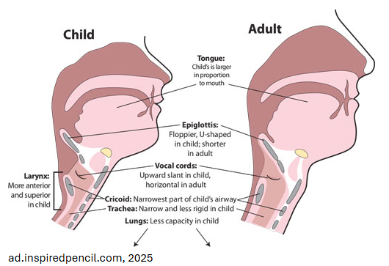
Figure 7: The child and adult larynx

Hormones

Puberty represents a “hormonal earthquake” for females as oestrogen and progesterone levels begin to rise. Secondary sex characteristics such as breast development, body hair, and the onset of menarche appear, with these changes occurring between the ages of 8 and 14 (Schiff, 1999, cited in Gackle, 2019, p. 2). Poole and Macdonald (2022) explain that oestrogen and progesterone affect vocal tissue, influencing vocal production. The vocal folds slightly increase in mass and lengthen, resulting in a voice pitch lowering of up to a third and changes in the tone of the female voice (Abitol and Abitol, 2014, cited in Poole and Macdonald, 2022). According to Sweet (2020), hormones initiate the voice change process and directly impact the voice’s pitch, quality, and harmonics. The symptoms of voice change will be discussed in more detail in the following section titled ‘Impact on Phonation’.

Menarche

Brodnitz (1971, cited in Gackle, 1991) explains that although no conclusive research exists linking changes in the female voice to menarche, the onset of menstruation and the lowering of pitch in the female voice coincide. According to Arbitol (2019, cited in Mercado and Draut, 2024), female singers may experience premenstrual vocal syndrome (PMVS) from four to six days before menstruation and last until three days after its onset, characterised by voice fatigue, a decreased and narrowed range, a loss of power in the singing voice, and a reduction in harmonics. Duffy (1970, cited by Decoster et al. 2008) agrees that the onset of female voice change coincides with menarche. Still, the transition from a girl’s voice to that of a woman’s progresses gradually over a more extended period than male counterparts. As there is no current conclusive research to confirm if voice change symptoms occur alongside the commencement of menarche, this could be a recommendation for future research.

Impact on Phonation

Symptoms

Sale (2002) describes FAVC as a developmentally uncertain time for singers when the vocal anatomy undergoes significant growth and singers experience distinctive symptoms. As the hormones oestrogen and progesterone start to secrete in the female body, a variation of voice tonal quality issues occurs (Sweet, 2015).

Gackle (1991) lists the following seven symptoms of FAVC:
1) insecurity of pitch
2) development of noticeable register breaks
3) increased huskiness in the voice
4) decreased and inconsistent range capabilities
5) voice cracking
6) hoarseness
7) uncomfortable singing or difficulty in phonation

Sweet’s phenomenological investigation into the female changing voice (2015) agrees with Gackle in many of these symptoms (1991). Sweet (2015) found that even though the 14 participants of the study varied in age, they shared similar vocal experiences: “a complete lack of phonation in certain areas of vocal range, excessive breathiness in tone, cracks, vocal unpredictability, a lack of strength or endurance when singing, limited vocal range, and difficulties transitioning across registers” (p78-79). Alderson (cited in Sweet, 2015) adds that adolescent female singers frequently experience excessive breathiness in tone, vocal unpredictability, and transition difficulties between registers. The lack of closure of the posterior portion of cartilage leads to passaggio difficulty, resulting in a husky or breathy quality in the voice.

Howard et al. (2019) examined the developing choral singing voices of three female choristers in a professional English cathedral choir over several years. The research aimed to observe and explore both the continuities and changes in pitch control of the adolescent female voice. The study analysed four recordings for each chorister over four to five years. These recordings included a spoken passage, a sung passage, a two-octave G major scale, and a sung verse from a carol. The participants’ ages at the beginning of the study ranged from 10 to 13 years. The data revealed changing abilities in pitch control, illustrated by fundamental frequency plots over time. These plots, which can be viewed in Appendix 1, indicated improvements in tuning, control of note onsets, and the development of vibrato. Specifically, for these females, the results suggest that the stimulating musical environment fosters a high degree of versatility in pitch and timbre control of their voices—both vital aspects underlying many of the key differences between the voices of professional and amateur choirs. Overall, the differences in spectral slope across the four recordings for each chorister suggest that the experiences gained from singing regularly and professionally within a close-knit choral context enabled a significant level of vocal control and enhanced the overall timbral quality of their voices (Howard et al., 2019). The following sections will discuss the symptoms of FAVC in more detail.

Range

Poole and Macdonald (2022) say that due to the growth of the female vocal apparatus during puberty, the speaking voice lowers, and the singing range and register transitions will fluctuate. Seth and Guthrie (1935, cited in Gackle, 1991) agree, stating that growth of the vocal organs causes a general lowering of range; whilst the lower limit of the girls’ range falls by a third, the upper limit raises slightly. Figure 8 demonstrates Gackle’s model (1991) on the range and tessitura of girls before, during, and after adolescence.

Figure 8: The range and tessitura of girls before, during, and after adolescence (Gackle, 1991)
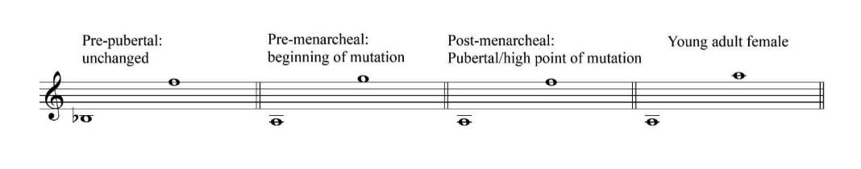

Voice Quality

According to Huff-Gackle (1985), after age ten, there is a marked contrast in quality and colour between female and male voices due to hormonal changes and physical growth in the vocal anatomy. While tonal quality in specific ranges seems effortless in young boys’ voices, the young female voice tends to lack this brilliance and instead possesses a warm resonance (Huff-Gackle 1985). Pubertal adolescents report experiencing vocal fatigue, breathiness, and dryness despite taking measures to care for their voices (Bowers and Daugherty, 2008, cited in Sale, 2022). Gackle (1991) notes that breathiness is evident in the tone, which is airy and unfocused, diminishing girls’ overall vocal performance and producing a husky or breathy quality in their voices. Sale (2022) concurs, stating that with inadequate closure of the vocal folds, singers may feel increased dryness or huskiness as if they lack sufficient air for sustained singing; a previously clear and pure vocal tone can become breathy and, at times, thick and husky. The need for recoordination of the developing laryngeal process can result in voice cracking and intonation issues, while newly accessible singing ranges may temporarily narrow at the peak of voice change (Huff-Gackle, 1985; Ingram and Rice, 1962; Welch, 2001, cited in Sale, 2022). Titze (1994) clarifies that as the overall length of the vocal tract increases, it also affects the tone of the voice since the size of the resonator produces differences in the overall colour of the timbre, resulting in a deepening of the richness of the voice. Gackle (2014) applied a visual analogy to the aural tonal changes that occur during FAVC. At ages 6-8, the girl’s voice is clear and unchanged, which Gackle describes as azure (light blue). As the female undergoes mutational change, this blue colour also transitions to a deeper blue, then royal blue, and finally, navy blue, representing a warm resonance unlike that of the male counterpart.

Howard and Welch (2002) conducted a longitudinal study to gain insight into measurable variations in voice quality among individual female singers aged 12-14. They discovered developmental variations in the larynx closed quotient (CQ), acoustic spectrum (LTAS), and overall amplitude (dB) in these singers. In particular, it was found that individual singers are developing higher formants in the frequency region of 8-12kHz, which is assumed to contribute little to voice quality. Howard and Welch (2002) state that these individual differences are often overlooked in a choral setting; however, it is evident that developmental variations exist between individuals. CQ levels tended to decline over time, likely due to increasing breathiness in vocal production. One chorister, who initially demonstrated the most pronounced falling CQ trend, showed spectral variations and higher frequencies towards the end of the trial, particularly around 12kHz. Howard and Welch (2002) explain that this energy contributes to perceived vocal timbre and quality. This specific chorister also exhibited spectral changes indicative of a developing peak in the singers’ formant region around 4kHz, most notably at the end of the trial. Howard and Welch’s (2002) study further suggested that any breathiness in vocal quality is modified by the vocal task, indicating that results demonstrate lower notes produce an increase in breathy phonation and that musical genre affects outcomes. When performing a carol in three different keys, plots showed some similarity in overall spectral slope, which exhibits a more significant roll-off as the pitch is raised. In all cases, evidence of a peak in the singers’ formant region was found. There is energy around the singers' formant region when performing pop and musical theatre, although it is not well-defined. Its low-frequency boundary, compared with the carol, shows remarkably similar LTAS shapes across two different genres of music.
Furthermore, a broad peak centred around 12kHz was evident, which is absent in the LTAS of the carol. The dynamic range of the carol recordings was measured to determine whether the range had increased or decreased. In all instances, the range did increase slightly for two out of three choristers, suggesting that a greater overall dynamic range is being employed (Howard and Welch, 2002).

Returning to menarche, Amir and Biron-Shental (2004), Klatt and Klatt (1990), and Sataloff and Spiegal (1989, cited in Sale 2022) discuss when this commences, pubertal adolescent females may experience cyclical voice quality variations like dry, pressed creaky phonation and vocal discomfort as lowered oestrogen negatively affects vocal fold tissue and laryngeal function, making the FAVC singing experience unpredictable from day to day (Sweet, 2018).

Registration

Another key feature of FAVC highlighted in the selected literature is the development and alteration of vocal registers. Cyrier (2006, cited by MacDonald and Poole, 2022) explains that the upper transition into head voice typically occurs at a higher pitch in 14-15-year-olds than in 10-11-year-olds due to the progression of FAVC. Gackle (2014) observed that in early mutation, a lower transition area is often first noted at D5-F#5, along with a trend for the upper register transition area to ascend in pitch with age. Alderson (1979, cited in Sweet, 2015) explains that observable passaggio difficulty in FAVC is evident due to sudden laryngeal growth and the incomplete closure of the posterior portion of cartilage in the larynx. Additionally, Willis and Kenny (2011, cited in MacDonald and Poole, 2022) explain that studies have suggested body weight may impact pitch breaks in 13-year-old girls, with breaks occurring most noticeably among those weighing 56-62 kg.

Gackle’s Stages of Development Framework

Gackle first published a framework for female vocal development in 1991, based on a decade of observation of female adolescent voices. The initial version of this framework outlined the various stages of development for female adolescent singers. Subsequently, in 2019, the framework was updated to reflect the gradual nature of the evolving process over time, redefined as ‘phases of development’, as illustrated in Figure 9. Gackle (2014) presents the criteria shown in Table 1 for classifying female changing voices according to vocal development.

Figure 9: Phases of female vocal development (Gackle 2019)
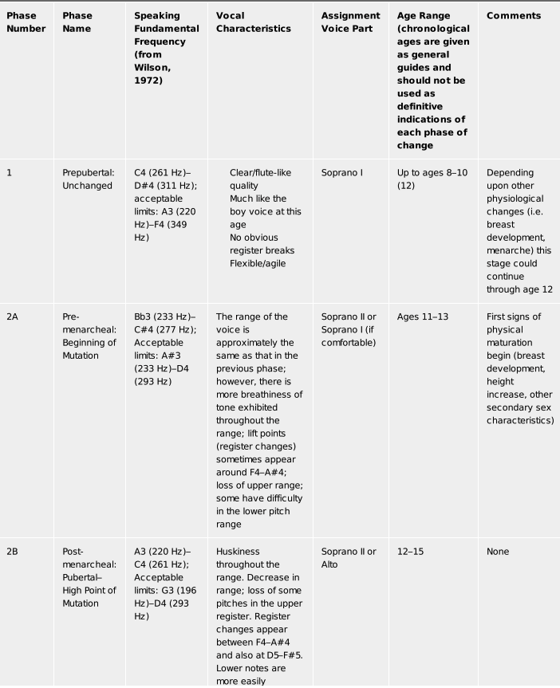
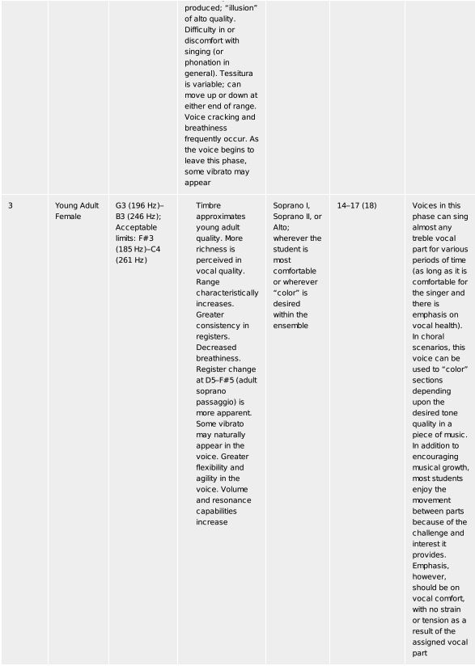

Table 2: Criteria for classifying female changing voices (Gackle 2019)
Average speaking pitch | Determine by asking students to count backwards from 10, pausing on 2-3)
Vocal range/ tessitura | Request students to sing throughout the range on an open vowel such as /a/ to determine lowest and highest singing pitch; note where greatest comfort is in the range
Register development | Appearance of transition notes or passaggi; ask students to sing an ascending diatonic scale or use an ascending vocal glide on open vowel such as /a/, noting where transition notes are audible
Overall voice quality (timbre) | Pure versus breathy tone

Research by Decoster et al. (2008) aimed to investigate whether Gackle’s model (2019) effectively described the vocal abilities and singing ranges of 17 female choristers and whether their vocal abilities aligned with the vocal demands of the actual repertoire. The study analysed phonetograms derived from voice recordings of the girls to measure their total singing range. Participants completed a written questionnaire providing information on their age, singing education, family singing history, vocal speaking behaviour, issues related to singing, and details on secondary sex characteristics and menstruation. The girls were assigned a number based on age, with 1 representing the youngest and 17 the oldest. Each girl was categorised into one of Gackle’s developmental stages by matching the collected data to the criteria outlined in Figure 9. The results of this study are presented in Figure 10 below.

Figure 10: singing and speaking range values for Gackle's developmental model (between brackets, girls are numbered by ascending age). The numbers around the staves indicate the number of girls per category; encircled notes mean the values were exceeded in the research of Decoster et al. (2008)
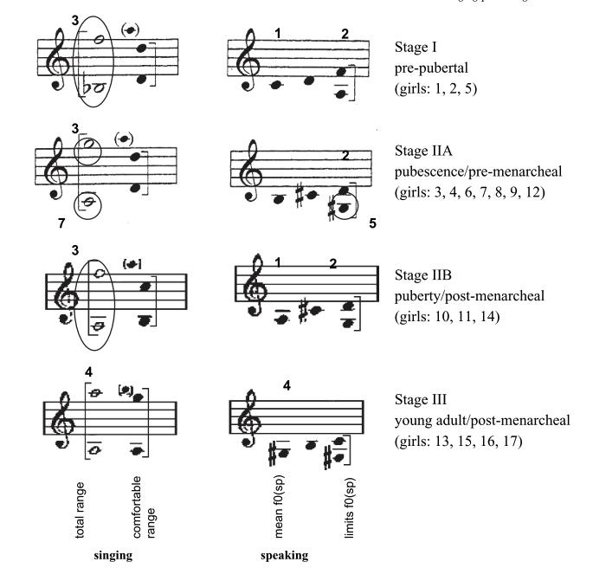

The study by Decoster et al. (2008) found that all participants had a greater singing range than suggested by Gackle and that 5 of the 17 girls met the requirements for their stage at a younger age than suggested. All girls had a greater total singing range, mainly in favour of the lower tones, and 11 girls used a lower speaking fundamental frequency. A third of the girls met their stage's vocal and developmental features at a younger age. The lower limit of the frequency range of all girls was several semitones below the lowest notes of the pieces being worked on at the time of the experiment. However, the upper limit of the pieces coincided with or exceeded their frequency limit. The authors concluded that whilst the physical and vocal features proposed by Gackle (1991) helped assign developmental stages to girls, further long-term research is needed to confirm or adjust the model.

Further Studies into the Impact of FAVC

Sweet (2015) undertook a phenomenological study to investigate the experience of FAVC from the perspective of female middle and high school choral students at the Durham School of the Arts (DSA) in North Carolina. The study occurred over three separate visits to the school’s choral program over six months. Two questions guided the study: How do adolescent female choir students experience voice change? And what the essence of the experience of voice change is for middle school and high school females in choir. Two students in each grade demonstrating various voice change characteristics were selected, providing 14 participants in total. The participants responded in writing to three open-ended questions before the interview: (a) Think of a time when you experienced changes in your singing voice; I would like you to tell me about that in as much detail as possible; (b) Please tell me about your daily singing experiences with your voice; and (c) How do these experiences make you feel? Additional questions for the second and third interviews included (d) Think about times that you experienced changes in your singing voice, either before or since you and I met; I would like you to tell me about these times in as much detail as possible; and (e) How do you feel, or have felt, about your singing voice over the past school year? Prior to an unstructured and open-ended interview regarding the participant’s voice experience, a voice check was given using Gackle’s (1991) female vocal ranges and characteristics to monitor vocal function across the school year.

The experiences of phonation among the singers in Sweet’s study (2015) were similar. 13 experienced challenges throughout the school year; occasionally, their voices returned to full strength, while at other times, they did not return at all or only in a limited capacity. Participants noticed changes in their vocal ranges and found they could no longer sing notes they had previously mastered. They reported a lack of support, cracking, and difficulty transitioning between registers. Throughout the study, several students noted increased strength and control, improved tone, a broadened vocal range, and better breath control. Some participants observed the emergence of vibrato; however, no issues were completely resolved. The emotional experiences recorded in Sweet’s study (2015) will be discussed in the following section titled Emotional Impact.

Sweet’s later investigation into the voice experiences of adolescent females (2018) interviewed adult female choristers on their perceptions of vocal development since age 11. These participants described the resulting adult voice as more open and powerful, with increased coordination throughout the vocal mechanism. Sweet notes that participants may have experienced laryngeal cartilage growth into adulthood, as described by Kahane (1982). Kahane (1982) indicated that “continued cartilage development ultimately makes the vocal mechanism more efficient” (p. 452).

Table 2 compares the voice symptoms reported by the authors in this review to identify the most frequently mentioned symptoms among researchers. It is important to note that the symptoms presented are those cited in the selected papers for this project and do not represent a definitive view of the authors in question. Decoster et al. (2008) primarily focused on the tonal range of adolescent singers; consequently, this paper did not include other symptoms of FAVC. The subsequent findings indicate that the most commonly reported symptoms of FAVC, according to this research, are breathiness, fluctuating range, and changes in timbre. In contrast, the least reported symptoms include hoarseness, discomfort, lack of strength/endurance, and difficulty with volume. The following section will discuss the emotional impact that these voice symptoms have on the young female singer.

Table 3: A comparison of reported voice symptoms of FAVC
 | Sweet | Howard et. al | Gackle | Sale | Poole and Macdonald | Sipley | Mercado and Draut | Decoster et al. (2008) | Total
breathiness in tone | x | x | x | x | x | x | x | x | 8
insecurity of pitch |  |  | x | x | x | x | x | x | 6
breaks and/ or cracks | x | x | x | x | x |  | x |  | 6
huskiness of tone |  |  | x | x | x | x | x |  | 5
hoarseness |  |  | x | x |  | x |  |  | 3
discomfort when singing |  |  | x | x |  | x |  |  | 3
lack of strength/ endurance | x | x |  | x |  |  |  |  | 3
fluctuating range | x | x | x | x | x | x | x | x | 8
appearance of register changes | x | x | x |  | x | x | x | x | 7
difficulty with volume control | x | x |  |  |  |  |  | x | 3
Changes in timbre | x | x | x | x | x | x | x | x | 8

Emotional Impact

Gackle (2014) proposes that there has recently been an acknowledgement of the psychological effects of voice change in adolescent females, which may accompany the onset of puberty and other aspects of female adolescence. Gackle (2014) explains that young female singers often experience a loss of confidence regarding their voices and other areas of an adolescent girl’s life during this mutation. The connection between voice change and self-identity is, according to Gackle (2014), undeniable, as adolescence is frequently filled with feelings of inadequacy, insecurity, and an overwhelming need for peer acceptance. Wright (2005, cited in Gackle, 2014) reports an increased incidence of negative self-image and low self-esteem, which can, at times, place adolescents at risk for depression. These experiences align with Sweet’s phenomenological study (2015), which revealed that many participants felt isolated during vocal challenges, even when singing alongside others. The fear of embarrassment and the unpredictability of their voices impacted their singing, particularly in front of others, resulting in timid voice use in the choir to avoid feelings of inadequacy. Rather than feeling encouraged and supported within the choir, students often held back their voices to avoid standing out, driven by self-consciousness and believing they were the only females facing such challenges. Participants were uncertain about what was amiss with their voices, which further exacerbated their feelings of isolation and loneliness. However, Sweet (2015) asserts that during times of vocal consistency, in the study, women reported feelings of empowerment and heightened confidence, which led to a renewed enjoyment of singing. As the year-long trial progressed, participants began to recognise that other women faced similar voice issues, and feelings of humiliation gradually shifted to a sense of relief in knowing they were not alone. Sweet (2015) explains that, outside school, six participants worked with voice teachers, who provided a more positive experience than they experienced during choir. Overall, in voice lessons, students felt comfortable developing their solo voice. The girls felt a sense of freedom in more relaxed settings such as home. They enjoyed singing whatever and whenever they wanted; they reported singing more confidently and soulfully and experimented with different genres and styles, such as belting, to push their voices into other resisters and ranges. Students admitted to singing in potentially unhealthy ways at home to achieve their desired sounds. The essence of the experience of female voice change for this study in the choral setting was that feelings of vulnerability and fear of embarrassment determined all use of the singing voice, resulting in risk assessment for each singing situation and setting whilst out of the choir, participants enjoyed singing reporting a sense of freedom. The investigation suggested that participants found the choir experience not necessarily positive and described their own needs secondary to that of the choral ensemble. Participants remained passive and did not seek help, resulting in challenges with self-confidence (Sweet, 2018).

Sale (2022) conducted a study examining parental perceptions of the FAVC. In this study, 54 parents of female adolescent community choristers viewed a three-minute educational video on the topic and completed an online questionnaire before and after watching it. The questions explored parental perceptions of the female adolescent voice and their understanding of voice change. The findings indicated that parents lacked knowledge of FAVC characteristics and challenges before viewing the video. However, after watching the video, participants reported gaining insights into their daughters’ singing difficulties. Parents felt better prepared and more empathetic towards their daughters’ experiences with voice change. Arbitol (2019, cited by Mercado and Draut, 2024) suggests that “voice and physical appearance are among puberty’s most delicate challenges because the voice is perceived to reflect its owner’s personality! Therefore, it is essential to support adolescents positively in navigating this metamorphosis successfully, should it be necessary” (p.90). It is clear from the literature that the experience of voice change for the female adolescent singer can be fairly negative and sometimes traumatic, the following section will investigate what can be done to alleviate some of the negative aspects and emotions of voice development.

Education and Improvement

Education on the FAVC for Voice Professionals

Gackle (1991) asserts that when working with female adolescent voices, voice professionals must understand how the female voice matures to effectively guide the development of vocal skills and select appropriate music. Gackle (1991) further explains that professionals must recognise the limitations and characteristics present in adolescent voices, as well as identify when these individuals are speaking and singing within their developmental capabilities or engaging in inefficient and unhealthy vocal practices. Gackle (1991) emphasises that voice professionals must educate themselves to assist young voices in reaching their fullest potential for personal self-expression. With a solid understanding of the sequence of adolescent development, we can more accurately anticipate vocal growth in our students (Gackle, 1991). MacDonald and Poole (2022) agree, reporting that all children progressing through puberty must be informed about their changing voices to continue participating in singing while using their voices safely, ensuring that they sing successfully into adulthood.
Sipley (1993) concurs, adding that voice professionals must educate young singers about the physical development of the larynx, the lengthening of the vocal folds, and how these and other changes can affect singing and speaking. Henry (1992, cited by Sipley, 1993) states that this knowledge will enable adolescent females to apply concepts more effectively to enhance their performance. Sipley (1993) advises that female voice students should be encouraged to utilise their entire range for vocal flexibility and, in the choir, to sing a part that sits within a comfortable tessitura.

MacDonald and Poole (2022) assert that choosing suitable exercises and repertoire is vital and explain that by rehearsing daily and collaborating weekly with expert teachers in individual lessons to develop a solid technique, girls can overcome – or at least work around – the challenges associated with voice change. Furthermore, they maintain that conditioning and toning the vocal apparatus leads to less disruptive changes. ‘Stop when you need to’ should be a common mantra when instructing young females. Girls must understand that changes in their voices, monthly hormonal fluctuations, mood, weather conditions, and even their breakfast choices may affect their vocal range and production on any given day. They should learn to accept that some vocal inconsistency is unavoidable (MacDonald and Poole, 2022).

In the study by Howard et al. (2019), participants indicated that, as adolescents, they trusted their choral teachers and believed their teachers had good intentions. However, according to the participants, their choral teachers primarily adhered to using changing-voice female singers to prioritise the choir's overall well-being, placing the choir's needs above those of individual developing female singers. Nevertheless, as Howard et al. (2019) noted, perceptions regarding choral teachers' decisions—particularly concerning the assignment of female singers to specific voice classifications—now seem misguided to many voice professionals. Sweet’s study (2015) reported that students admitted to singing in potentially unhealthy ways at home to achieve the desired sounds and attempted to counteract voice problems by straining their voices or neglecting their fatigued vocal folds. Sweet’s findings (2015) aim to encourage greater education on healthy vocalisation, which is essential for maintaining vocal longevity. Gackle (2006) asserts that those who teach singing to adolescent females have a duty to help the girls navigate the voice change and its emotional impact, always encouraging healthy singing. Gackle (2006) emphasises the importance of fostering positive self-esteem and assisting girls to view themselves as talented, worthy, and special individuals.

Parental Education and Support

Sale (2022) explains that advising parents about FAVC symptoms and challenges can positively influence their perceptions of their daughters' developing voices. With this information, Sale (2022) continues, parents can educate, reassure, and encourage their daughters to identify as high-achieving musicians. Through musical activities, developing singers can express themselves and cultivate their identity, which, in turn, fosters confidence and self-worth. Barnett (2008, cited in Sale, 2022) reports that with FAVC education, parents may be more inclined to actively promote and engage with singers regarding the FAVC process while advocating for healthy voice use. Sale (2022) agrees, stating that parents can significantly influence their daughters' motivation to sing, and parental involvement can predict participation in the performing arts. Sipley (1993, cited in Sale, 2022) states that female adolescent singers benefit from understanding their physiological development, and their singing experience improves if they can engage with their parents about their development and feelings. Welch (2006, cited in Sale, 2022) notes that parents should be aware that adolescents can often misinterpret their FAVC symptoms as signs of poor singing, and an ill-timed remark by a parent or valued advisor could have a lifelong detrimental effect on singing behaviours and the realisation of musical potential (Gackle, 2014). The literature suggests that parents play a vital role in educating, supporting, and encouraging their daughters in their musical and developmental journeys, and this must be regarded as part of the solution to helping young adolescent singers.

Sale (2022) conducted a study to explore parental awareness and perceptions of the FAVC. Findings suggested that parents notice the changes in their daughters even if they do not understand them. After a brief educational experience, participants described gaining an explanation of their daughter’s current voice concerns and an understanding of FAVC singing skills. Participants expressed empathy for the singing difficulties of FAVC and described being more prepared for the challenges. Sale (2022) concluded that proactive FAVC education is recommended for parents to engage with their daughters about the voice.

The evidence collected thus far indicates that FAVC can profoundly influence a singer’s confidence and that voice professionals and parents can significantly impact how these students perceive themselves and their voices. If voice professionals and parents can explain why the young female is experiencing voice symptoms, this can encourage and support the children to continue singing healthily and avoid negative feelings about themselves or their voices. The following section will explore whether voice training can positively affect the quality of the female adolescent voice.

Voice Training

A review of the selected literature suggests that regular voice training may help alleviate the symptoms of FAVC. Sipley (1993) states that choral directors who dedicate time during rehearsals to teaching students the proper use of their voices can enhance the singers' vocal tone. This is crucial, continues Sipley (1993), as it may be the only vocal instruction the student receives; thus, group voice classes and choral rehearsals must serve as vocal training sessions for adolescents. Ingram and Rice (1962, cited in Sipley, 1993) concur, suggesting that maintaining good posture, proper breath support, developing tone, and refraining from forcing the voice to sing loudly could improve the symptoms of FAVC.

Research conducted by Macdonald and Poole (2022) suggests that regular and efficient vocal exercises could increase the total range of adolescent female singers. Their study utilised Gackle’s (2014) model of suggested vocal ranges before, during, and after FAVC, as illustrated in Figure 11. They compared these ranges to those of professional female adolescent choristers. Based on their experience working with professional female adolescent choristers who train daily and receive focused encouragement and efforts to expand their range in both directions daily, the ranges depicted in Figure 12 below can be achieved.

Figure 11 The range of girls before, during, and after adolescence (Gackle 1991)

Figure 12 Ranges of adolescent females of Antwerp Cathedral Choir (Macdonald and Poole 2002)
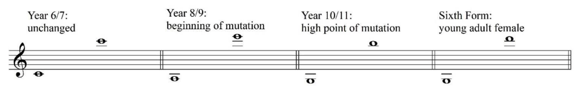

Poole and Macdonald (2022) emphasise the importance of maintaining healthy vocal production for individual choristers and the choir's future. The goal should be to achieve consistently relaxed, healthy, and free legato singing that is always well supported, with a released jaw. The girls in their study are encouraged to openly discuss the effects of growth, hormones, and adolescence with their voice teachers. “It is important for the girls to understand that their voices will be unpredictable, not only on a monthly basis but also throughout their teenage years; this awareness helps them avoid concerns about the changes” (Poole and Macdonald, 2022, pp. 32-33). Establishing a solid vocal technique as early as possible is essential, as it will assist the girls in navigating shifts during transitional phases, fluctuations in range, and changes in phonation fluency. This is a fundamental focus of their weekly voice lessons and is paramount. Poole and Macdonald (2022) assert that their work with professional female choristers demonstrates that, for children in elite choristerships - as is the case for those in elite sports professional, targeted and ambitious training regimes can mitigate the adverse effects of adolescence, puberty, and specifically, voice change. Furthermore, the girls must be prepared to anticipate changes in their voices during their teenage years to sing through these transitions (Poole and Macdonald, 2022).

Poole and Macdonald’s (2022) study is encouraging, and offers hope that some symptoms and negative emotions associated with FAVC can be alleviated through education and voice training. However, Sipley (1993) conducted an 11-week study to investigate the effects of vocal exercises, an understanding of the vocal mechanism, and the vocal development process with a group of 38 adolescent female singers aged 13 and 14, all of whom were members of their school choir programme and were randomly assigned to four groups. The study aimed to determine whether these interventions could enhance vocal self-image and tone quality. Participants completed a student survey before and after the intervention to assess their self-image. They were also given an ascending and descending scale and a short piece to sing before and after the intervention. Vocal samples were recorded and presented to a panel of choir directors with considerable expertise in the adolescent voice for comparison. Subgroup 1 received no intervention, subgroup 2 underwent 21 vocal exercise sessions, subgroup 3 participated in 21 knowledge sessions, and subgroup 4 engaged in both 21 vocal exercise sessions and 21 knowledge sessions. Sipley (1993) concluded that for the participants in this trial, a programme of vocal exercises, combined with knowledge about the vocal mechanism and development process, significantly improved the attitudes of young adolescent female singers towards their singing voices. This time, results indicated that none of the treatments was superior to any other in improving tone quality, as there was no statistically significant difference among the subgroups, and the interventions were no more effective than merely singing in a choir (group 1) (Sipley, 1993). Although the selected literature suggests that good technique can be beneficial in maintaining healthy singing (Ingram and Rice 1962, cited in Sipley, 1993; Poole and Macdonald, 2022), it does not conclude that targeted vocal exercise offers any more benefit than simply engaging in singing activities concerning alleviating the adverse effects of FAVC

To enhance vocal health and support adolescent singers, Mercado and Draut (2024) recommend that teachers select simple songs, avoid voice classifications, and refrain from asking adolescents to sing too loudly or too softly at the extremes of their range (Sweet and Parker, 2019, cited in Mercado and Draut, 2024). Furthermore, Mercado and Draut (2024) suggest that teachers explain to students why certain pitches become inaccessible during the voice change and clarify through appropriate training that those pitches will eventually return. They advocate for all singers to receive education about the anatomy and physiology of their singing voice.

Sweet (2018) suggests that female adolescent singers require individualised vocal assistance, an understanding of the voice change process, and support from their music teachers when necessary. Sweet (2018) further posits that with such efforts, females will cultivate positive perceptions of their voices and singing experiences. Sweet (2018) also asserts that choral teachers must design activities that enable females to comprehend their voices and create an environment where they feel encouraged to discuss and advocate for their vocal development. These initiatives foster positive emotions and enhance singing experiences throughout childhood and into adulthood. However, Gackle (2006) points out that vocal instruction is not accessible to all students, and choral music educators often lack a background in child and adolescent vocal pedagogy. A choral programme incorporating voice-building exercises and enhancing breath control and tone production in adolescent females would be advantageous (Ingram and Rice,1962). Although rigorous voice exercise does not appear to be of much benefit to improving the symptoms associated with FAVC, the research does suggest that good vocal technique in the form of appropriate posture, correct breath control, and tone development could be of benefit and is encouraged (Ingram and Rice,1962). Although individual voice lessons are helpful, these may be inaccessible to many; therefore, voice educators and choir directors must be educated in FAVC and be able to offer singers correct voice technique and advice (Sipley, 1993). The research suggests that this vocal support works well alongside voice professionals' and parents' educational and emotional support.

Several limitations were encountered during this scoping review. Firstly, there was a time constraint. Although this was generous, the project could have been more extensive if additional time had been available, allowing for further research to be included. For instance, research could have investigated whether menarche and voice change symptoms are linked or explored how transgender voices experience voice change. Additionally, Arksey and O’Malley recommend that a research team be appointed to conduct activities; due to the project's limitations, only one researcher could complete the work. While the researcher had access to a personal tutor, this was solely for consultation, and they did not actively contribute to the project. Cost constituted another limitation; several texts that appeared to be relevant emerged during the bibliography search; however, these books were expensive and, consequently, inaccessible to the researcher. Other papers identified during the database search were also not accessible to the researcher or their institution, and these studies could have contained relevant information that might have aided the scoping review. It must also be considered that, as the researcher was an insider, they possessed some prior knowledge of the topics of this project. Although they endeavoured to avoid steering the project in specific directions based on their beliefs, it is challenging to eliminate all bias and remain completely objective.

The study's main strength lies in its thorough methodology; a strong methodology is essential as the researcher prefers to adhere to structured, step-by-step processes and guidelines. Secondly, as the author is an insider researcher, they possess prior knowledge of working with adolescent females, providing an advantage in guiding the study. However, this could also be a limitation if the researcher does not remain objective and open-minded throughout the project.

Conclusion
This scoping review aimed to enhance the researcher’s understanding of the physiology involved in voice change among female adolescents and its impact on young singers and the symptoms they experience. Additionally, the author sought to investigate the psychological effects of voice change on female adolescents and ways to encourage and reassure them, thereby boosting their confidence during the challenging stages of puberty to support their continued singing. The research intended to highlight issues surrounding FAVC to assist both the researcher and the broader voice community in informing and guiding young singers. This project was presented under specific themes that emerged during the review: physiology, impact on phonation, emotional impact, and education and improvement. The reviewer concentrated on these topics, providing information about each in line with the available literature. Each subject was thoroughly explored and presented, supplying evidence from peer-reviewed literature and trials.
Over the past thirty years, an increasing amount of information has emerged regarding the female adolescent voice (Gackle 2014), much of which has been addressed in this project. Authors have shown a growing interest in the physiological and psychological changes associated with female vocal development during adolescence. Although the researcher aimed to discover ways to enhance the tone of the female adolescent voice, findings indicate that voice exercises may not be the solution. This scoping review concluded that while some literature suggests voice exercises may be beneficial in addressing certain effects of FAVC (Poole and Macdonald, 2022), the findings remain inconclusive. In this regard, it is crucial to emphasise that patience is essential when discussing female voice change (Kahane, 1982). Singers should recognise that their vocal mechanism and the resulting voice will continue to develop throughout puberty, and symptoms are likely to resolve over time (Kahane, 1982). This is evident in Gackle’s model (2019), which illustrates the young adult voice as possessing greater richness in vocal quality, an expanded range, reduced breathiness, potential natural vibrato, enhanced flexibility and agility, alongside improved volume and resonance capabilities. Kahane (1982) noted that ongoing cartilage development ultimately renders the vocal mechanism “more efficient” (p. 452).

The findings of this scoping review concluded that the most successful interventions related to the psychology of singers identified in this study are education and support (Sale, 2022). If parents and music educators can inform and reassure young female singers about the effects of FAVC symptoms, these singers can recognise that this is a normal stage of development and understand that they are not alone (Sweet 2015; Wright 2005, cited in Gackle, 2019; Sale 2022). This may help to prevent feelings of inadequacy, insecurity, negative self-image, and low self-esteem, which could place the adolescent at risk of developing depression (Wright 2005, cited in Gackle, 2014). This scoping review provides a comprehensive examination of the existing literature on the female adolescent voice, which has proven to be beneficial to the researcher and may be valuable for other voice teachers, choir directors, and parents. It also establishes a foundation for future research into whether voice exercises could assist this demographic in alleviating the symptoms of FAVC, considering that the findings were inconclusive in this specific review.

By conducting this project, the researcher has gained deeper insights into performing thorough research, writing a scoping review, and engaging in academic planning and writing. Initially, she believed that voice exercises were the solution to the challenges faced by female adolescent singers; however, the results of studies based on this premise are inconclusive. Therefore, the author recommends further investigation into the education of female adolescent singers, alongside that of their parents and the vocal professionals who support them. It is suggested that parents of female adolescents be educated about FAVC and that a short course be developed for parents of young female singers. When parents are informed about the process of voice development, they can educate, reassure, and encourage their daughters, making it more likely for them to engage actively with singers regarding the FAVC process while advocating for healthy voice use (Sale, 2022). The author also advocates for further investigation into educating choir directors about the developmental process of the female voice and for providing educational resources that vocal professionals can deliver to choirs and other singing groups. The next steps for this area of research could involve designing a presentation or video for parents, music educators, and choir directors, or considering visits to these groups to deliver short courses that would benefit the mental health of young female adolescent singers and the future of choirs and singing groups. Another recommendation arising from this scoping review is for studies to confirm or deny whether the onset of menarche coincides with voice change in females, as suggested by Brodnitz (1971, cited in Gackle, 1991) and Duffy (1970, cited by Decoster et al. 2008), but not evidenced by any research.

Teachers could benefit from instructional material that enables them to facilitate FAVC learning for singers and parents. Ultimately, teaching students about the anatomy and physiology of their voice may empower them through the variety of changes they can experience during adolescence (Mercado and Draut, 2024).

Bibliography

Abitol, J. and Abitol, P. (2014). The larynx: a hormonal target. In: J. Rubin, R. Sataloff and G. Korovin, (eds). Diagnoise and treatment of voice disorders. San Diego: Plural Publishing.

Alderson, R. (1979). Complete handbook of voice training. New York: Parker Publishing.

Aliki, T. Lubarsky, S. M., Durning, S. J. and Young, M. E. (2016). Knowledge Syntheses in Medical Education: Demystifying Scoping Reviews. Academic Medicene, 92(2), pp. 161-166.

Amir, O. and Biron-Shental, T (2004). The impact of hormaonal fluctuations on female vocal folds. Current Opinion in Otolaryngology and Head and Neck Surgery, 12(3), pp. 180-184.
Arksey, H. and O’Malley, L. (2005). Scoping studies: Towards a Methodological Framework. International Journal of Social Research Methodology, 8(1), pp.19–32.
Ashley, M. (2015). Singing in the lower secondary school. Oxford: Oxford University Press.
Badger, D., Nursten, J., Williams, P. and Woodward, M., 2000. Should all literature reviews be systematic?. Evaluation and research in Education, Volume 14, pp. 220-230.

Barlow, C. (2002). 'Voice source changes of child and adolescent subjects undergoing singing training - a priliminary study'. Logopedics Phoniatrics Vocology, Volume 27, pp. 66-73.

Barnett, L. (2008). 'Predicting Youth Participation in Extracurricular Recreational Activities: Relationships with Individual, Parent, and Family Characteristics'. Journal of Park and Recreation Administration, 26(2), pp. 28-60.

Boardman, S. and Alt, D. (1992). 'Solos and adolescent singers'. Music Educators Journal, 78(8), pp. 44-49.

Boote, D.N. and Beile, P. (2005). Scholars Before Researchers: On the Centrality of the Dissertation Literature Review in Research Preparation. Educational Researcher, 34(6), pp.3–15.
‌Boseley, M. E. and Hartnick, C. J. (2006). 'Development of the human true vocal folds: Depth of cell layers and quantifying cell types within the lamina propria'. Annals of Otology, Rhinology and Laryngology, 115(10), pp. 784-788.

Bowers, J. and Daugherty, J. F. (2008). 'Self-reported student vocal use at high school summer choral camp'. International Journal of Research in Choral Singing, 3(1), pp. 25-37.

Brodnitz, F. (1971). 'Hormones and the human voice'. National Association of Teachers of Singing, 28(2), pp. 16-18.

Costley, C. (2006). Practitioner-led enquiry as development of professional practice. Middlesex.

Cooksey, J. (1999). Working with Adolescent Voices. St. Louis: Concordia Publishing.

Cooksey, J. M. and Welch, G. F. (1998). 'Adolescent singing development and National
Curricula design'. British Journal of Music Education, 15(1), pp. 99-119.

Cooper, I. and Kuersteiner, K. (1965). Teaching junior high school music. Boston: Allyn and Bacon.

Cyrier, A. (1981). "A study of the vocal registers and transitional pitches of the adolescent female". Missouri Journal in Music Education, 4(5), pp. 84-86.

Davis, R. (2022). Formative assignment: Unpublished.

Decoster, W., Ghesquiere, S. and Van Steenberge, S. (2008). Great talent, excellent voices - No problem for pubertal girls? Logopedics Phoniatrics Vocology, 33(2), pp.104–112.

Duffy, R. (1970). 'Fundimental frequency characteristics of adolescent females'. Lang Speech, Volume 13, pp. 14-24.

Fitch, W. T. and Giedd, J. (1999). 'Morhology and development of the hunan vocal tract using magnetic resonance imaging'. Journal of the Acoustical Society of America, pp. 1511-1522.

Fitch, W. T. and Giedd, J. (1999). 'Morphology and Development of the Human Vocal Tract: A Study Using Magnetic Resonance Imaging. The Journal of the Acoustical Society of America, 106(3), pp. 1511-1522.

Gackle, L. (1991). The Adolescent Female Voice: Characteristics of Change and Stages of Development, The Choral Journal, 31(8), pp.17–25.

Gackle, L. (2014). Adolescent Girls’ Singing Development. In: G. Welch, D.M. Howard and J. Nix, eds. The Oxford Handbook of Singing. Oxford University Press. pp.550–570.

Gray, S. D., Titze, I. R. and Hammond, T. H. (2000). 'Biomechanical and histologic observations of vocal fold fibrous proteins'. Annals of Otology, Rhinology and Laryngology, 109(1), pp. 77-85.

Gregory, O. (2023). www.mededmentor.org. [Online]
Available at: https://mededmentor.org/pages/theory-database/theory-index/mind-styles/

Hardnick, C. J., Rehbar, R. and Prasad, V. (2005). 'Development and maturation of the pediatric human vocal fold lamina propria'. The Laryngoscope, 115(1), pp. 4-15.

Henry, J. (1992). 'The effect of a systematic choral warm-up stratergy on student pitch-matching skills, knowledge of intonation concepts, and self-reported attitudes toward singing'. New Orleans: s.n.

Hirano, M. (1981). 'Psycho-acoustic evaluation of voice'. Clinical examination of voice, pp. 81-84.

Howard, F. (2010). The child-voice in singing: treated from a physiological and a practical standpoint, and especially adapted to schools and boy choirs. Fili-Quarian Classics

Howard, D.M., Welch, G.F., Himonides, E. and Owens, M. (2019). The Developing Female Chorister Voice: Case-Study Evidence of Musical Development. Journal of Voice, 33(4)

Huff-Gackle, (1985). 'The adolescent female voice (ages 11-15): Classification, placement, and development of tone'. Choral Journal, 15(8), pp. 15-18.

Ingram, M. D. and Rice, W. C. (1962). Vocal technique for children and youth. New York: Abingdon Press.

Kahane, J. (1978). 'A morphological study of the human prepubertal and pubertal larynx'. American journal of Anatomy, pp. 11-19.

Kahane, J. (1982). 'Growth of the human prepubertal and pubertal larynx'. Journal of Speech, Language, and Hearine Research, Volume 25, pp. 446-455.

Klatt, D. H. and Klatt, L. C. (1990). Adolescent development and the biology of puberty: Summery of a workshop on new research. s.l.:National Academy Press.

Knight, S. (2013). 'Exploring a cultural myth: What adult non-singers may reveal about the nature of singing'. The phenomenon of singing, Volume 2, pp. 144-154.

Levac, D., Colquhoun, H. and O'Brian, K. K. (2010). 'Scoping studies: advancing the methodology'. Implement Science, 5(69).

Luchsinger, R. and Arnold, G. E. (1965). Voice-speech-language: Clinical communicology; Its physiology and pathology. Belmont: Wadsworth Publishing Co.

Munn, Z. et al. (2018). 'Systematic review or scoping review? Guidence for authors when choosing between a systematic or scoping review approach'. BMC Medical Research Methodology, Volume 18, p. 143.

Poole, L. and Macdonald, S. (2022). Voice Change and the Professional Girl Chorister. Choral Research Journal, pp.23–39.

Richie, J. and Spencer, L. (1994). Qualitative data analysis for applied policy research. In: A. Bryman and R. G. Burgess, (eds). Analysisng data analysis for applied qualitative data. London: Routedge, pp. 157-181.

Sale, J.J. (2022). “Is Something Wrong with My Daughter’s Voice?” Parental Perceptions of the Female Adolescent Voice Change. International Journal of Research in Choral Singing, 10, pp. 197-219.

Sataloff, R. T. and Spiegal, J. R., 1989. 'The young voice'. NATS journal, 45(3), pp. 35-37.

Schiff, M. (1999). 'Sex hormones and the female voice'. Journal of Voice, 13(3), pp. 424-43.

Seth, G. and Guthrie, D. (1935). Speech in childhood: its development and disorders. London: Oxford University Press.

Sipley, K.L. (1993). The Effects of Vocal Exercises and Information about the Voice on the Tone Quality and Vocal Self-Image of Adolescent Female Singers. ProQuest Dissertations and Thesis Global

Stathopoulos, E. T., Huber, J. E. and Sussman, J. E., 2011. 'Changes in acoustic Characteristics of the Voice Across the Life Span: Measures from Individuals 4-93 Years of Age'. Journal of Speech, Language and Hearing Research, Volume 54, pp. 1011-1021.

Sweet, B. (2018). 'Voice change and Singing Experiences of Adolescent Females'. Journal of Research in Music Education, 66(2), pp. 133-149.

Sweet, B. (2015). The adolescent female changing voice: A phenomenological investigation. Journal of Research in Music Education, 63(1), pp.70–88.

Sweet, B. and Parker, E. C. (2019). 'Female vocal identity development: A phenomenology'. Journal of Research in Music Education, 67(1), pp. 62-82.

Tanner, J. 1971. 'Sequencing, tempo and individual variation in growth and development of boys and girls aged twelve to sixteen'. The MIT Press, 100(4), pp. 907-930.

Thurman, L. and Klitze, C. (2000). 'Highlights of physical growth and function of voices from prebirth to age 21'. Bodymind and voice: foundations of voice education , pp. 6906-703.

Titze, I. (1994). Principles of Voice Production. Englewood Cliffs: Prentice-Hall.

Titze, I. (1996). 'Why do we have a vocal ligament'. Journal of Singing, 53(1), pp. 32-32.

Trollinger, V. (2007). 'Relationships between pitch-matching accuracy, speech fundamental frequency, speech range, age, and gender in American English-speaking preschool children'. Journal of Research in Music Education, 5(1), pp. 78-94.

Unluer, S. (2012). 'Being an Insider Researcher Whilse Conducting Case Study Research'. The Qualitative Report, pp. 1-14.

Weiss, D. (1950). 'The pubertal change of the human voice'. Folia Phoniatrica, Volume 2, pp. 126-159.

Welch, G. (2001). The misunderstanding of music, Oxford: Instutute of eEucation.

Welch, G. F. (2006). Singing and vocal development. In: The child as a musician. Oxford: Oxford University Press.

Westphaln, K.K., Regoeczi, W., Masotya, M., Vazquez-Westphaln, B., Lounsbury, K., McDavid, L., Lee, H., Johnson, J. and Ronis, S.D. (2021). From Arksey and O’Malley and Beyond: Customizations to enhance a team-based, mixed approach to scoping review methodology. MethodsX, 8(101375), p.101375.

Williams, B. (1990). An investigation of selected female singing-and speaking-voice charactoristics through a group of pre-menarcheal girls to a group of post-menarcheal girls, s.l.: University of North Texas.

Williams, J. (2019). Teaching Singing to Children. Oxford: Compton Publishing.

Willis, E.C and Kenny, D.T. (2011). 'Voice Training and Changing Weight - Are They Reflected in Speaking Fundimental Frequency, Voice Range, and Pitch Breaks of 13-year-Old Girls? A Longitudinal Study'. Journal of Voice, 25(5), pp. 233-43.

Appendix

Appendix 1: Results of a 5-year study into pitch variation in female adolescent voices over time (Howard, D. et al. 2019)
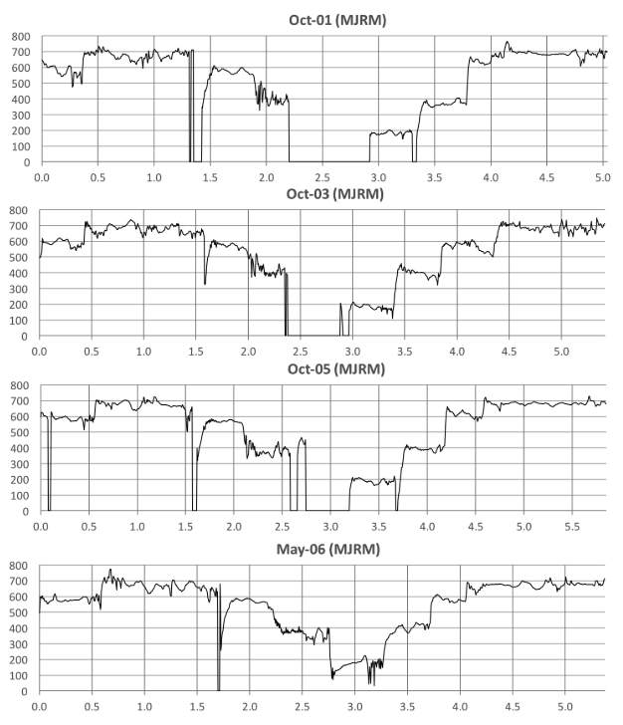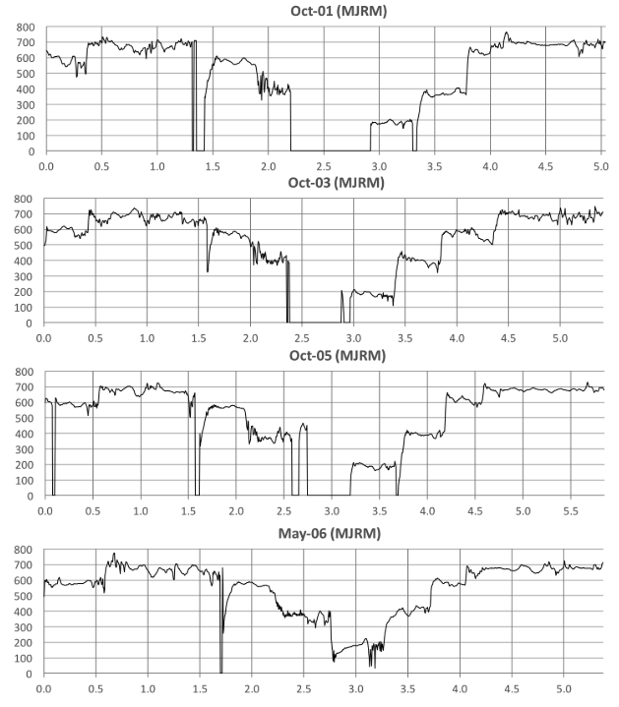

Fundamental frequency (f0) contours for four sung renderings by three individual female cathedral choristers. Note that (a) the X-axis (the time in seconds) varies for each plot since the tempo of their performance was left to the singer's discretion, and (b) the Y-axis is in cents (100 cents is one semitone) above F4, so the starting note of this the second line (B4) is plotted at 600 cents since B4 is 6 semitones above F4 (Howard, D. et al. 2019).

Appendix 2: Ethical Approval



