

LOCATION: Swansea | LLEOLIAD: abertawe
LEVEL 6 | LEFEL 6
EXAMINATION PERIOD | CYFNOD ARHOLIADAU
May 2020 | mai 2020

MODULE CODE:
M6X01201: MATERIALS & MANUFACTURING FOR NICHE MARKETS
TIME: 2 HOURS

answer 3 FROM 4 QUESTIONS

Equipment or materials required – None
Adnoddau neu ddefnyddiau sydd eu hangen – Dim

A formula sheet is provided for reference.

Calculators are permitted.

Assume ‘g’ = 9.81 m/s².

ONE

- Composite materials are composed of two phases. Identify these, and discuss how the primary phase can be used to classify composites. Discuss the different physical forms that the secondary phase can take.
[11 Marks]

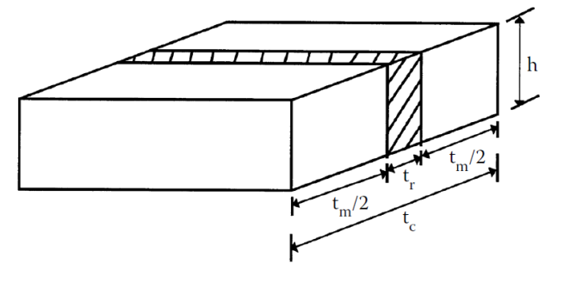

The above Representative Volume Element represents a unidirectional composite.

- Given that ∆_{C} = ∆_{f} + ∆_{m}, where ∆ is the transverse extension of the structure when subjected to a transverse load, and the subscripts c, f and m represent the composite, the fibre and the matrix respectively, prove from first principles. E represents the Young’s Modulus, V is the volume fraction and the subscript 2 represents the transverse (or across fibre) direction.

[7 Marks]

- Hence find the transverse Young’s Modulus of a Glass/Epoxy lamina with a fibre volume fraction of 75% given that E_{f} = 90GPa and E_{m}=3GPa

[2 Marks]

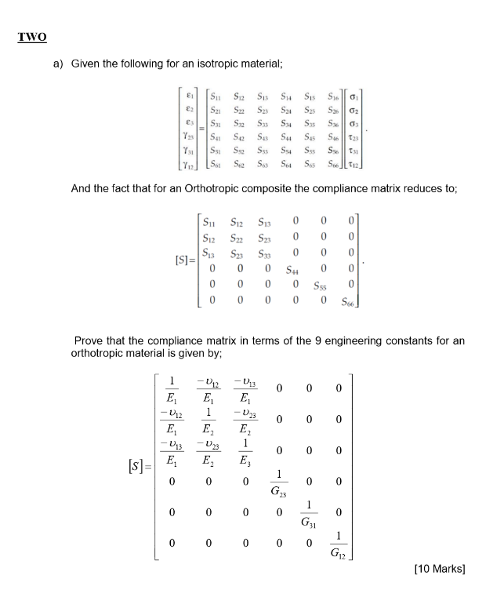
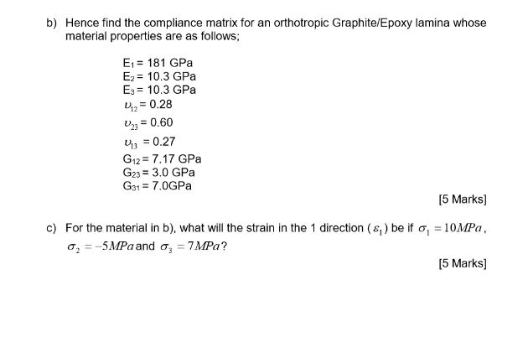
THREE
- When considering the failure of a composite, explain with the help of a diagram, what a failure envelope is.
[8 marks]
- Name 4 failure theories that may be used to identify failure in a single lamina.
[4 marks]
- Explain what is meant by first ply failure and last ply failure and explain with the aid of a diagram, why the stiffness of a laminate is non-linear during failure.
[8 marks]

FOUR

- Discuss why a typical composite structure manufactured from a FRP would have several lamina stacked on top of each other in order to form a laminate.

[4 marks]

- Explain why Hygrothermal stresses and strains may be seen in a laminate and the consequences of these on the design of laminates.

[8 marks]

- Using a diagram, explain how the stress may differ through the thickness of a Laminate, the causes of this, and discuss how this is different to that seen through the thickness of a structure formed from an isotropic material.

[8 marks]

Diwedd/End

