
Electronics II ACDA6001

8x8 Brauns Multiplier & 8x8 Wallace tree Multiplier

By

Robbie Herbert

2405914

Submission Date: 17th April 2025

Lecturer: Jenifer Prince Devaraj

Word Count: 2473

Contents
1. Contents 2
2. List of Figures 3
2.1. List of Tables 5
3. Acronyms, Abbreviations and Units 6
4. Abstract 7
5. Introduction 7
5.1. Background research 7
5.2. Applications and Advantages 8
5.2.1. Brauns Multiplier 8
5.2.2. Wallace Multiplier 9
5.3. Flow Charts/Algorithms 10
5.4. Methodologies 12
6. Main Body 13
6.1. Multiplier block diagram and Algorithms 13
6.1.1. Brauns 13
6.1.2. Wallace Tree 15
6.2. VHDL Codes 17
6.2.1. Full Adder 17
6.2.2. Half Adder 17
6.2.3. Brauns Multiplier code 18
6.2.4. Wallace Multiplier code 22
6.3. Brauns Multiplier Device 25
6.4. Wallace Multiplier Device 26
6.5. Timing Diagrams and Schematics 27
6.5.1. Brauns Multiplier Timing, Longest and Shortest Delay Diagrams & Combinational Delays 28
6.5.2. Wallace Multiplier Timing Summary, Longest and Shortest delays & Combinational Delays 33
6.6. Design Screenshots and Pin Allocation 37
6.6.1. Brauns Multiplier Designs & Pin allocation 37
6.6.2. Wallace Multiplier Designs & Pin Allocation 41
7. Conclusion 45
7.1. Simulation Results 45
7.2. Comparison, Analysis/testing details, and interpretation 58
7.2.1. Interpretation of Power utilisation and LUTs 59
7.2.2. Details of testing 62
7.3. Recommendations 68
8. References 69
9. Appendix 71

List of Figures
Figure 1 flow chart of Brauns multiplier/Algorithm. 10
Figure 2 Wallace Tree Flowchart/Algorithm 11
Figure 3 Brauns multiplier block diagram. 13
Figure 4 Brauns Multiplier Architecture. 14
Figure 5 Wallace Tree Multiplier Diagram 15
Figure 6 Wallace Tree Architecture. 16
Figure 7 Full Adder Code 17
Figure 8 Half Adder Code 17
Figure 9 Brauns Multiplier Start 18
Figure 10 Signal Generation 1 18
Figure 11 Signal Generation 4 & sum & carry signals p1-p4. 19
Figure 12 Sum & Carry signals P12, P13 & P14 20
Figure 13 Full & Half adder components. 20
Figure 14 Brauns Multiplier Partial Products 1 20
Figure 15 Brauns Multiplier Port Maps 1 21
Figure 16 Wallace Multiplier Code start. 22
Figure 17 Wallace Multiplier Code 2 22
Figure 18 Wallace Multiplier Code 3 & Sum & Carry Signals 22
Figure 19 Wallace Multiplier Signal Generation 1 23
Figure 20 Wallace Multiplier Partial Products 1 23
Figure 21 Wallace Multiplier Stage 1 & 2 Reduction 24
Figure 22 Wallace Multiplier Final Stage Reduction 24
Figure 23 Brauns Multiplier Device 25
Figure 24 Wallace Multiplier Device 26
Figure 25 Brauns Multiplier Timing Constraint 28
Figure 26 Brauns Multiplier Shortest Delay Diagram 29
Figure 27 Brauns Multiplier Longest Delay Diagram 30
Figure 28 Brauns Multiplier Synthesis Timing Summary 31
Figure 29 Brauns Multiplier Implementation Timing Summary 31
Figure 30 Brauns Multiplier Combinational Delay 1 32
Figure 31 Wallace Multiplier Timing Constraint 33
Figure 32 Wallace Multiplier Shortest Delay Diagram 33
Figure 33 Wallace Multiplier Longest Delay Diagram 34
Figure 34 Wallace Multiplier Synthesis Timing Summary 34
Figure 35 Wallace Multiplier Implementation Timing Summary 35
Figure 36 Wallace Multiplier Combinational Delays 1 35
Figure 37 RTL Design Brauns 37
Figure 38 Implementation Design Brauns 38
Figure 39 Pin Allocation Brauns 39
Figure 40 Pin Allocation Brauns 2 39
Figure 41 Brauns Multiplier I/O Planning 40
Figure 42 Wallace Multiplier RTL Design 41
Figure 43 Wallace Multiplier Implemented Design 42
Figure 44 Wallace Multiplier Pin Allocation 43
Figure 45 Wallace Multiplier Pin Allocation 2 43
Figure 46 Wallace Multiplier I/O Planning 44
Figure 47 Hex value 1. 46
Figure 48 Brauns Simulation of Hex Value 1 47
Figure 49 Wallace Simulation of Hex Value 1 48
Figure 50 Hex value 2. 49
Figure 51 Brauns Multiplier Hex Value 2 50
Figure 52 Wallace Simulation of Hex Value 2 51
Figure 53 Hex value 3. 52
Figure 54 Brauns Simulation of Hex Value 3 53
Figure 55 Wallace Simulation of Hex Value 3 54
Figure 56 Hex value 4. 55
Figure 57 Brauns Simulation of Hex Value 4 56
Figure 58 Wallace Simulation of Hex Value 4 57
Figure 59 Brauns Multiplier Power Summary 59
Figure 60 Wallace Multiplier Power Report 59
Figure 61 Brauns Multiplier Utilization Hierarchy 60
Figure 62 Wallace Multiplier Utilization Hierarchy 60
Figure 63 Brauns Multiplier Utilization Summary 60
Figure 64 Wallace Multiplier Utilization Summary 61
Figure 65 Brauns Multiplier Project Summary 61
Figure 66 Wallace Multiplier Project Summary 62
Figure 67 Basys 3 FF x FF. 64
Figure 68 Basys 3 13 x 34. 65
Figure 69 Basys 3 EF x EA. 66
Figure 70 Basys 3 AA x AB 67
Figure 71 Signal Generation 2 71
Figure 72 Signal Generation 3 71
Figure 73 Sum & Carry signals P5 & P6 72
Figure 74 Sum & Carry signals P7. 72
Figure 75 Sum & Carry signals P8. 73
Figure 76 Sum & Carry signals P9. 73
Figure 77 Sum & Carry Signals P10 & P11 74
Figure 78 Brauns Multiplier Partial Products 2 75
Figure 79 Brauns Multiplier Partial Products 3 75
Figure 80 Brauns Multiplier Partial Products 4 75
Figure 81 Brauns Multiplier Port Maps 2 76
Figure 82 Brauns Multiplier Port Maps 3 76
Figure 83 Wallace Multiplier Signal Generation 2 77
Figure 84 Wallace Multiplier Signal Generation 4 77
Figure 85 Wallace Multiplier Signal Generation 5 78
Figure 86 Wallace Multiplier Partial Products 2 78
Figure 87 Wallace Multiplier Partial Products 3 79
Figure 88 Wallace Multiplier Partial Products 4 79
Figure 89 Wallace Multiplier Stage 3 & 4 Reduction 80
Figure 90 Wallace Multiplier Stage 5 & 6 Reduction 80
Figure 91 Brauns Multiplier Combinational Delay 2 81
Figure 92 Brauns Multiplier Combinational Delay 3 82
Figure 93 Brauns Multiplier Combinational Delay 4 83
Figure 94 Brauns Multiplier Combinational Delay 5 84
Figure 95 Brauns Multiplier Combinational Delay 6 85
Figure 96 Brauns Multiplier Combinational Delay 7 86
Figure 97 Brauns Multiplier Combinational Delay 8 87
Figure 98 Brauns Multiplier Combinational Delay 9 88
Figure 99 Brauns Multiplier Combinational Delay 10 89
Figure 100 Brauns Multiplier Combinational Max Delay 11 90
Figure 101 Wallace Multiplier Combinational Delays 2 91
Figure 102 Wallace Multiplier Combinational Delays 3 92
Figure 103 Wallace Multiplier Combinational Delays 4 93
Figure 104 Wallace Multiplier Combinational Delays 5 94
Figure 105 Wallace Multiplier Combinational Delays 6 95
Figure 106 Wallace Multiplier Combinational Delays 7 96
Figure 107 Wallace Multiplier Combinational Delays 8 97
Figure 108 Wallace Multiplier Combinational Delays 9 98
Figure 109 Wallace Multiplier Combinational Delays 10 99
Figure 110 Wallace Multiplier Combinational Delays 11 100
Figure 111 Basys 3 Diagram [14] 101

List of Tables
Table 1 Abbreviations, Acronyms and Units table 6

Acronyms, Abbreviations and Units
Ω | Ohms
% | Percent
TC | Time Constant
AC | Alternating Current
DC | Direct Current
ms | Milli-seconds
Hz | Hertz
I/O | Input/Output
DSP | Digital Signal Processing
ALU | Arithmetic Logic Unit
WNS | Worst Negative Slack
LUT | Lookup Table
IOB | Input/Output Buffer

Table 1 Abbreviations, Acronyms and Units table

Abstract

This Paper shows an analysis of the Brauns and Wallace Multipliers used for eight-by-eight hexadecimal multiplication. Shown within the paper are algorithms, architecture, and comparisons between the two multipliers regarding areas of efficiency and speed. Using VHDL and Vivado software, tests were conducted to also see accuracy and power consumption, hardware tests were also performed. The Paper shows within its findings that the Wallace multiplier has advantages with speed, whereas the Brauns multiplier will allow for lower power applications. Simulation results showed that the accuracy of both multipliers is high, the power consumption of the Brauns multiplier is 33.33% less than the power consumption of the Wallace multiplier. The simulations also show that the Wallace multiplier is ≈ 8ns quicker than the Brauns multiplier.

Introduction
Multiplication is found in all areas of life. Multiplication is fundamental within modern systems; the core operation is used within applications such as image processing and machine learning for example[1]. As a result of multiplication being crucial within digital systems, efficient ways to multiply are crucial for optimisation of applications [1]. With use of efficient multipliers consumption of power and speed of multiplication becomes quicker [1]. Two ways of completing fast multiplication are a Brauns multiplier and a Wallace multiplier [1]. This paper aims to compare the two multipliers together and find performance differences, whilst also providing improvements for the multipliers to increase the potential. The results which have been found will help designers in their fields make a choice suitable for their applications for which multiplier to choose between.

Background research
Brauns and Wallace multipliers are both unique in their own ways. They also both have varied advantages and disadvantages with them [1]. The Brauns and Wallace multipliers are used within applications and the applications/systems that they are within will vary in complexity. Current developments within multiplier techniques can be seen as follows [1]:
Multipliers, over many years have become more complex and quicker [1]. The most essential element of a multiplier is to be accurate and now, they have become faster, lower powered, and the accuracy is exceedingly high [1]. Within a practical application of a multiplier, hardware has improved making the multipliers faster [1].
Within the development of the VHDL code the Brauns and Wallace multipliers will use the product family Artix-7 which is an FPGA. The two multipliers will use the same project parts, the name of this project part is xc7a35tcg236-1. This will be used to be able to generate bitstream and apply the software to the Basys 3 hardware this will also be used to allocate pins so that the multipliers will work.
Both the Brauns multiplier and Wallace multiplier can achieve the same thing. However, the speed, power consumption and components used vary quite a large amount. The codes which will be compiled will also vary, especially when the code comes to the port mapping and structure. The code will be created from the diagrams which have been created using Microsoft Visio. The Brauns and the Wallace multipliers are both different and are used within different applications. This is due to the fact of speed of multiplication of the two multipliers.

Applications and Advantages

Brauns Multiplier

The Brauns multiplier is in many applications within daily life and can also be found in many niche applications for the workplace. The Brauns multiplier can be found in image processing [2]. The way that a multiplier works within image processing is that the multiplier will be used to multiply the pixels within the image to make the image much clearer [2]. Depending on the pixel value the image will be clear, within two scenarios the multiplier may create a much clearer image if the correct factor of multiplication has taken place [2]. However, if the factor of multiplication is high and exceeds maximum values then the image will become distorted [2].
The Brauns multiplier can also be found in multimedia technology, as multimedia is graphics, sound, text, video and animation, the multiplier is used to multiply bits within these areas to make the sound clearer for example [2]. As stated previously with image processing, video and animation will be similar as multiplication of pixels will be used to make the quality of the image clearer on the screen. [2]
The Brauns multiplier can also be found in digital signal processing [3]. By using a Brauns multiplier a signal is boosted as its efficiency will be increased [3]. The effect of using a multiplier will also help with the power consumption of the component that is completing the task. [3]
Two of the most critical advantages of the Brauns multiplier are as follows:
Linear multiplication, the Brauns multiplier uses a linear multiplication structure to be able to complete its multiplication tasks [4]. This is named “carry-save.” This improves the accuracy of the multiplier [4]. Critical path, the critical path of the Brauns adder is stated to be its main advantaged for the multiplication task [4]. As a result of the single critical path that the Brauns multiplier has the multiplier can be found in digital signal processing because of the low power consumption [4].

Wallace Multiplier

The Wallace multiplier is used in many applications. This multiplier is an efficient way of multiplying two integers [7]. The Wallace tree multiplier is what is called a parallel multiplier [7]. This means that the multiplier will not contain any method or structure of feedback. Within the Wallace multiplier, the first step is to is to use an AND gate to multiply each bit to another bit [7]. The products of these AND gates are called partial products [7]. Each of these products will go through an array of half adders and full adders to be able to multiply the A and B values to get the full product, or in the case of this multiplier the Hexadecimal value [7]. The Wallace multiplier uses a specific multiplication method, this is because the logic of the multiplication will help power consumption improving the Wallace multiplier and having greater use than other multipliers which do the same thing [7].
There are many applications of the Wallace multiplier. These applications are used in everyday life and within very niche markets [8]. This is because of the multiplier adaptability. The multiplier can be used in digital signal processing (DSP), the multiplier is used because of its fast multiplication [8]. Another application for the Wallace multiplier is ALU’s, the ALU is found in Microprocessors, due to consisting of logic gates. The Wallace multiplier by this logic is found in most electronics [8]. Due to the method of adder logic that the Wallace multiplier uses the Wallace multiplier is much faster than other multipliers [9]. In comparison to other multipliers the Wallace multiplier is much less Complex as it has less Half Adders [9]. Another advantage is the Latency and the power consumption which is less than other multipliers [9].

Flow Charts/Algorithms
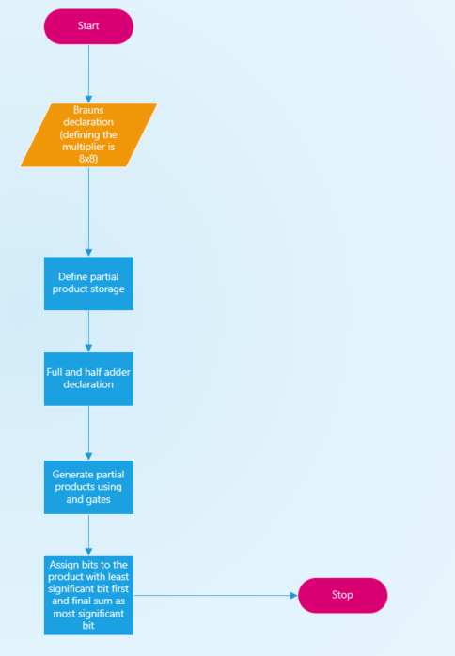
Figure 1 flow chart of Brauns Multiplier/Algorithm.

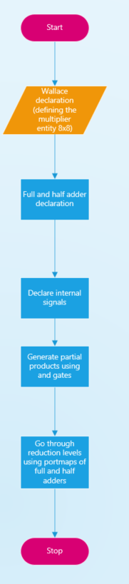
Figure 2 Wallace Tree Flowchart/Algorithm

Methodologies

The methodologies used to create both the Brauns multiplier, and the Wallace Tree multiplier are remarkably similar [6]. Throughout the research carried out many journals have been used and read thoroughly to ensure that they are dependable, and they are relating to the task [6]. CRAAP testing has been conducted on all the sources that are within this paper to create security and reliability of what is being stated within this task [6].
Similarly, within the code methodologies have been used to make sure the code works correctly and is accurate and dependable [6]. The agile methodology has been used to develop both codes. First, within this methodology is planning [6]. The plan is crucial within the rest of the code development as it will help keep the development on track. The plan helps with designing and developing the flowcharts within this paper [6].
The design would come next. The design of the codes helps to visualise what the code will look like [6]. The designs of both the Brauns and Wallace multipliers can be seen below with their respective algorithms [6].
After the design, the development of the code will come next. With use of the designs created the development of the code is much simpler than doing it blind [6]. As the help of the design will drive decisions for the portmaps created for the code [6].
Finally, the testing will come last as deployment of this product created will not occur. Within the test four sets of hexadecimal numbers were chosen [6]. These numbers were used to simulate the multipliers to guarantee the accuracy of the VHDL codes [6]. The hexadecimal values will be compared to the values found on an online calculator. Within the testing there will also be synthesis and then timing reports within the synthesis [6]. The RTL design will also be made with the implementation schematic to show how the code will look using logic. The device and I/O planning will also be completed and shown [6].

Main Body

Multiplier block diagram and Algorithms

Brauns

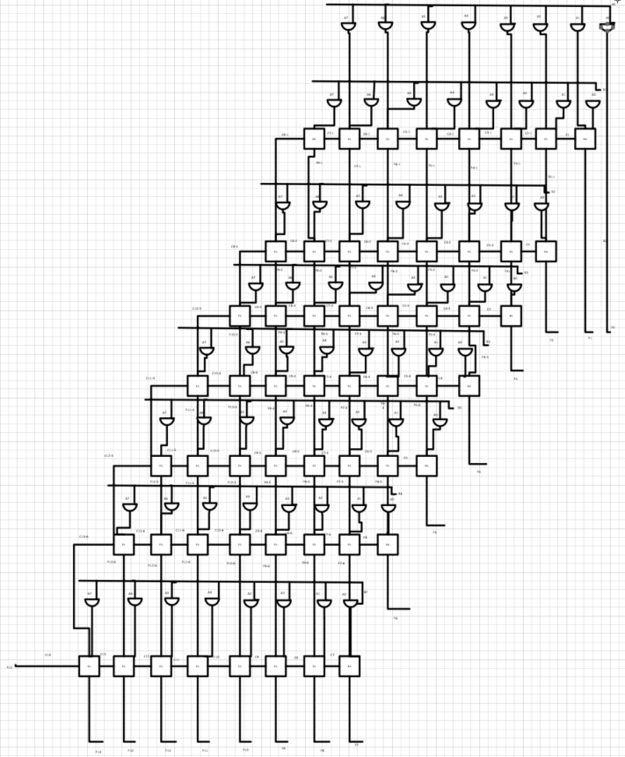
Figure 3 Brauns Multiplier block diagram.

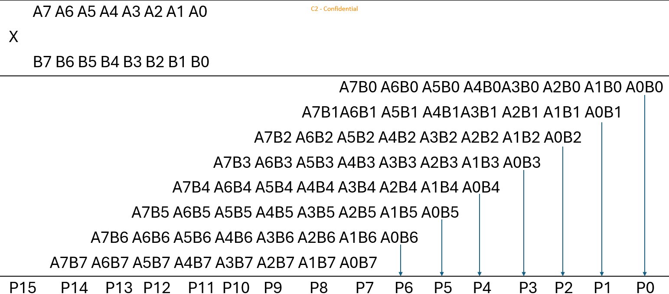
Figure 4 Brauns Multiplier Architecture.

Wallace Tree
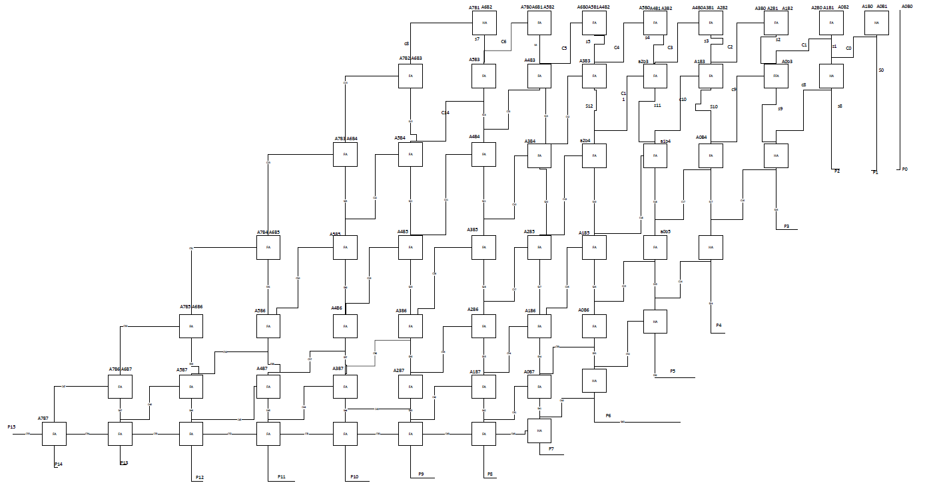
Figure 5 Wallace Tree Multiplier Diagram

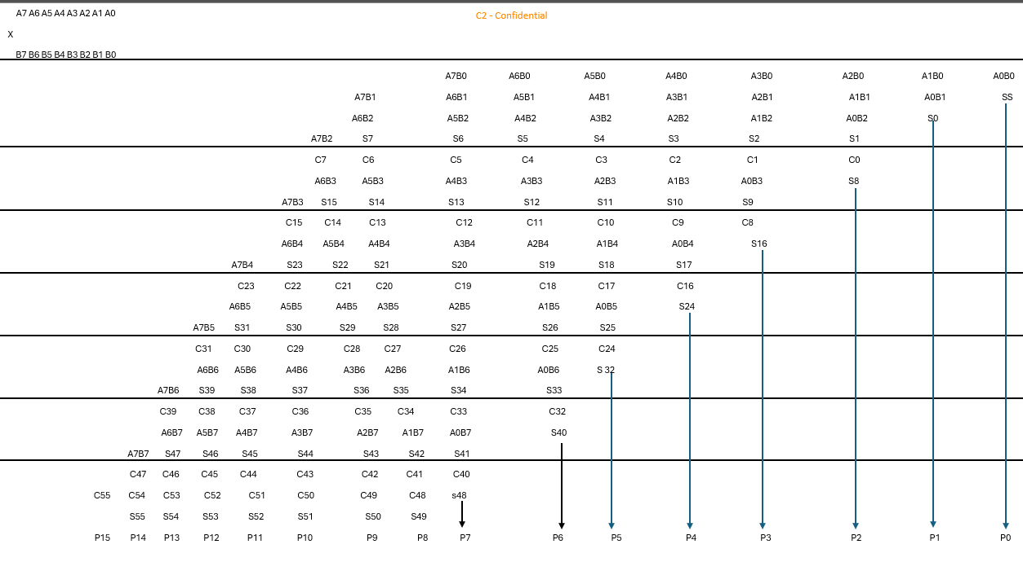
Figure 6 Wallace Tree Architecture.

VHDL Codes

Full Adder
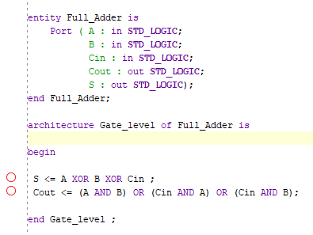
Figure 7 Full Adder Code

Half Adder
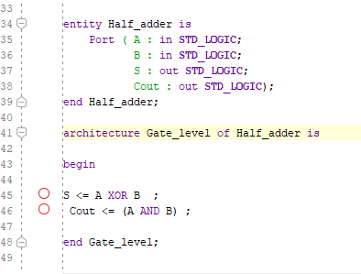
Figure 8 Half Adder Code

Brauns Multiplier code
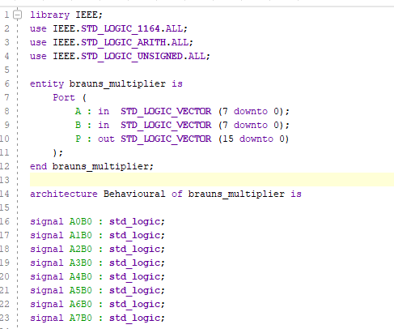
Figure 9 Brauns Multiplier Start
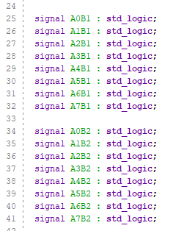
Figure 10 Signal Generation 1
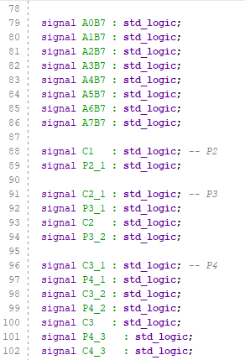
Figure 11 Signal Generation 4 & sum & carry signals p1-p4.
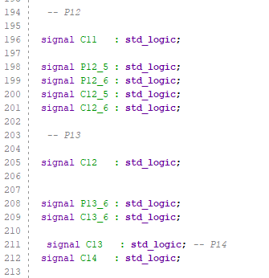
Figure 12 Sum & Carry signals P12, P13 & P14
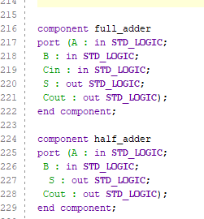
Figure 13 Full & Half adder components.
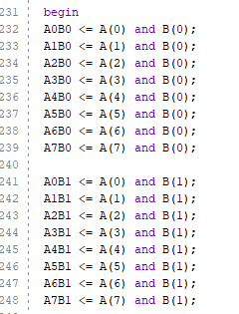
Figure 14 Brauns Multiplier Partial Products 1
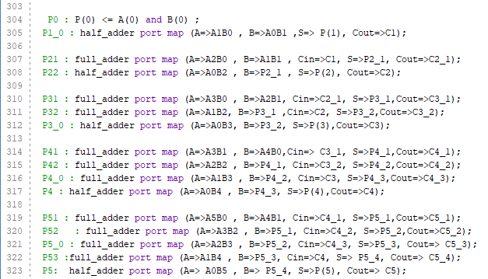
Figure 15 Brauns Multiplier Port Maps 1

Wallace Multiplier code
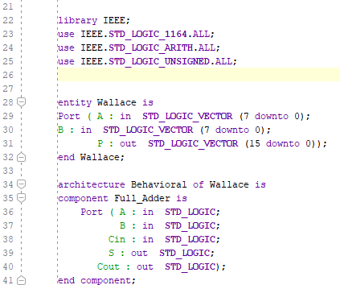
Figure 16 Wallace Multiplier Code start.
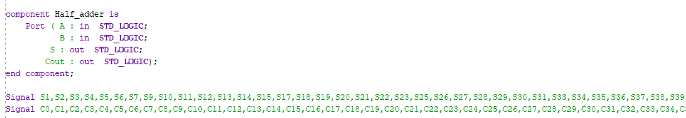
Figure 17 Wallace Multiplier Code 2
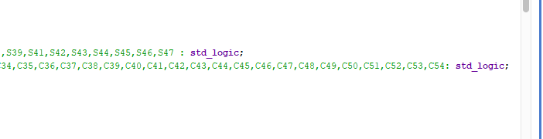
Figure 18 Wallace Multiplier Code 3 & Sum & Carry Signals

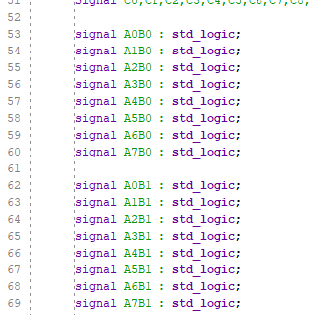
Figure 19 Wallace Multiplier Signal Generation 1
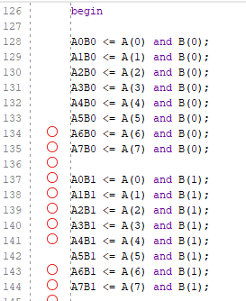
Figure 20 Wallace Multiplier Partial Products 1
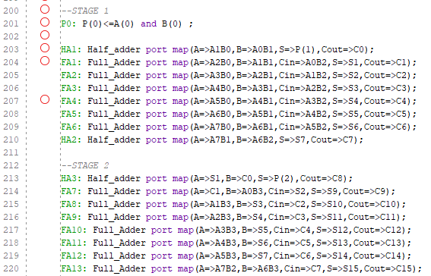
Figure 21 Wallace Multiplier Stage 1 & 2 Reduction
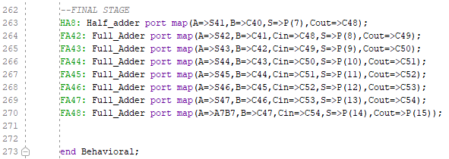
Figure 22 Wallace Multiplier Final Stage Reduction
Shown in the pictures above is the code for both the Brauns and Wallace multiplier, the figures show the declaration of the multiplier, the full and half adder declaration, partial product storage/internal signals, partial products using AND gates, and finally the Port Maps. Additional figures seen in Appendix. Brauns figures 71-82. Wallace figures 83- 90.

Brauns Multiplier Device
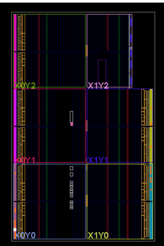
Figure 23 Brauns Multiplier Device
This Figure is to show the Brauns multiplier Device from the Vivado software.

Wallace Multiplier Device
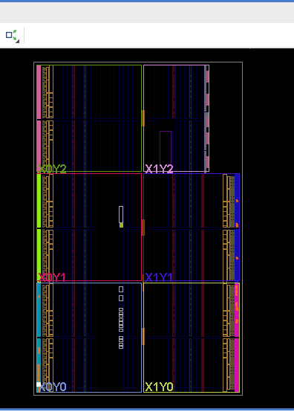
Figure 24 Wallace Multiplier Device
This Figure is to show the Wallace multiplier Device from Vivado Software.

Timing Diagrams and Schematics

The Brauns and Wallace multipliers both have the shortest delay to P0, P15 and the longest delay to P15. This is measured by adding up the delays possible. The delay will amount to the number of full and half adders within the two multipliers. The delays will only account for the very first AND gate that is used to gain the P value, all adders will then be accounted for regardless of being full or half adders. The shortest delay for P0 within both multipliers is 1ns.
Shortest Brauns multiplier delay for P15.
$$1ns+7×\left(2ns\right)=15ns$$
Longest Brauns multiplier delay for P15.
$$1ns+20 ×\left(2ns\right)=41ns$$
Shortest Wallace multiplier delay for P15.
$$1ns+7 ×\left(2ns\right)=15ns$$
Longest Wallace multiplier delay for P15
$$1ns+14 ×\left(2ns\right)=29ns$$

Brauns Multiplier Timing, Longest and Shortest Delay Diagrams & Combinational Delays

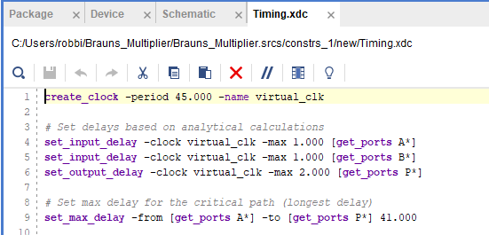

Figure 25 Brauns Multiplier Timing Constraint
Figure to show code used for Brauns multiplier Timing constraint.

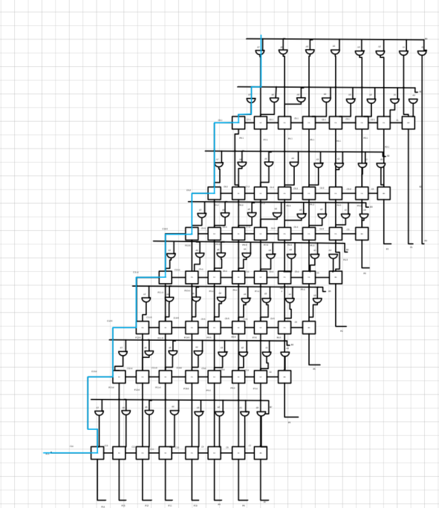
Figure 26 Brauns Multiplier Shortest Delay Diagram
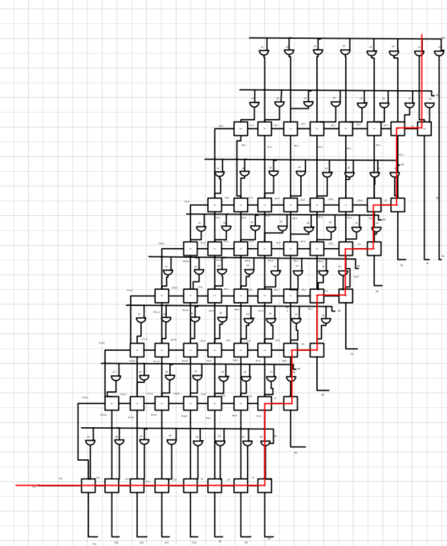
Figure 27 Brauns Multiplier Longest Delay Diagram
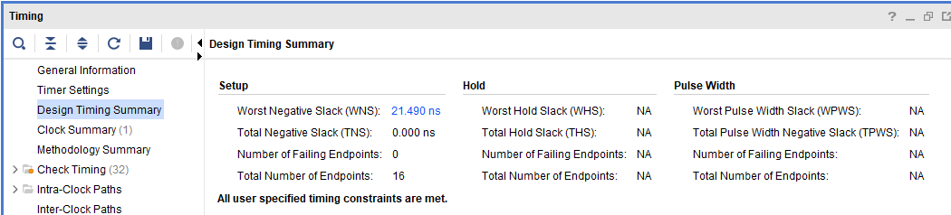
Figure 28 Brauns Multiplier Synthesis Timing Summary

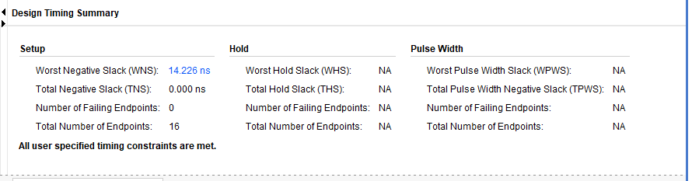
Figure 29 Brauns Multiplier Implementation Timing Summary
Figures showing the Timing summary of the Synthesis and implementation of the Brauns multiplier.

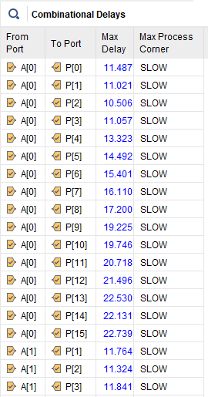
Figure 30 Brauns Multiplier Combinational Delay 1

Figures to show combinational delays of the Brauns multiplier. Additional combinational delays within appendix figures 91-100.

Wallace Multiplier Timing Summary, Longest and Shortest delays & Combinational Delays
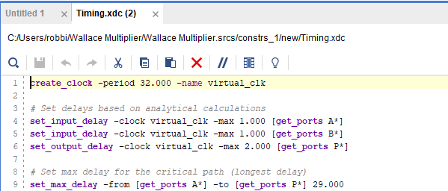
Figure 31 Wallace Multiplier Timing Constraint
Figure to show constraint code for Wallace multiplier.
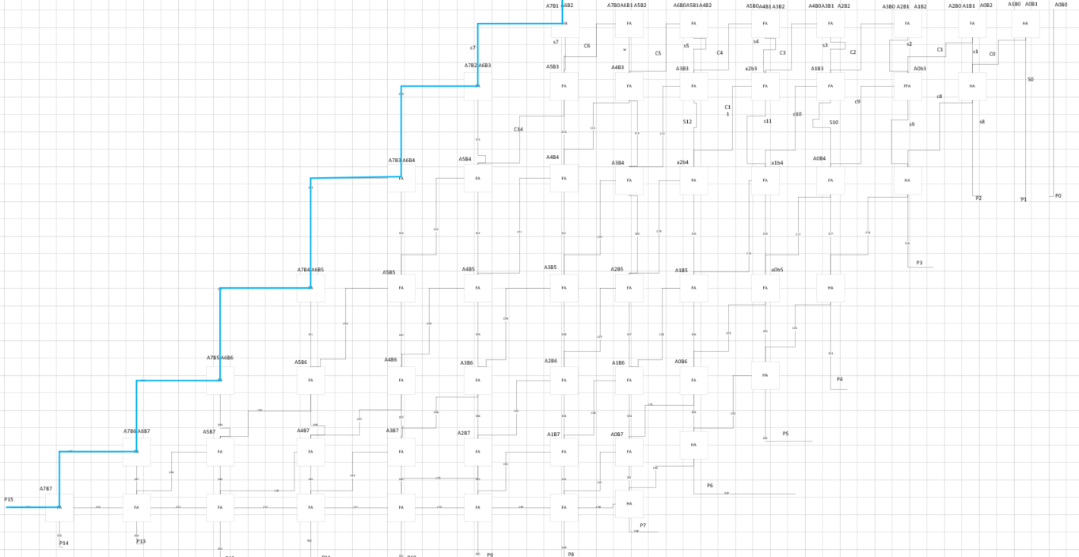
Figure 32 Wallace Multiplier Shortest Delay Diagram
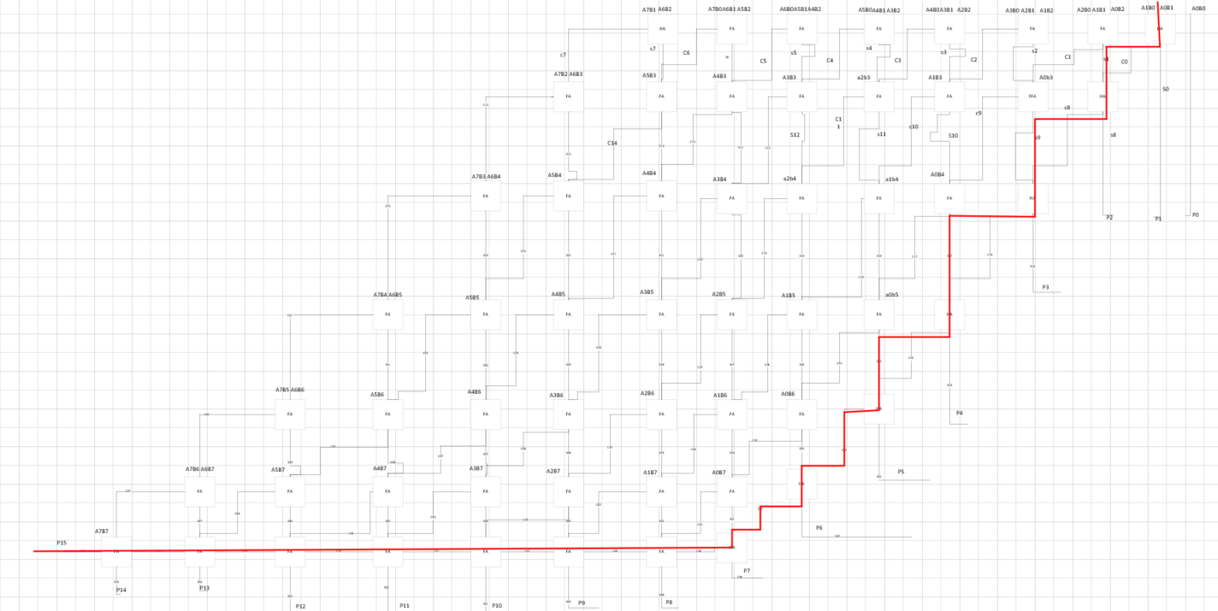
Figure 33 Wallace Multiplier Longest Delay Diagram

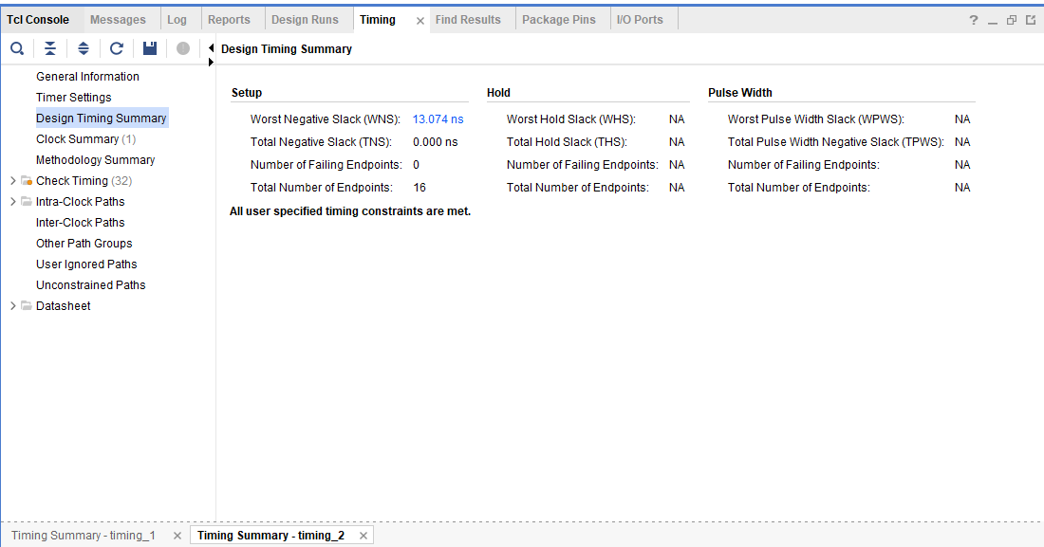
Figure 34 Wallace Multiplier Synthesis Timing Summary

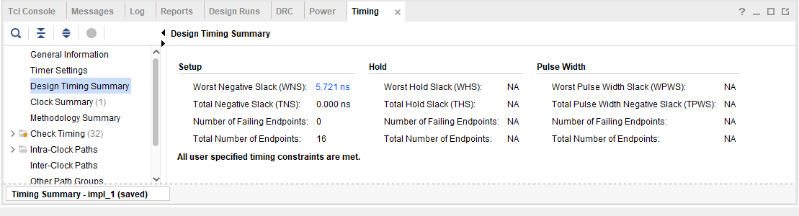
Figure 35 Wallace Multiplier Implementation Timing Summary

Figures show Wallace multiplier synthesis and implementation timing summary.

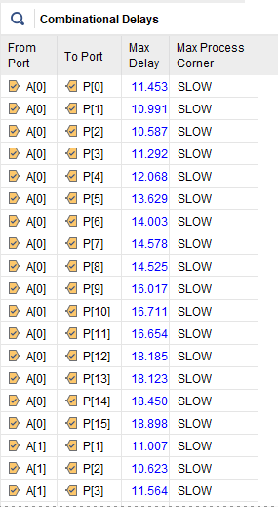
Figure 36 Wallace Multiplier Combinational Delays 1
Figures showing additional combinational delays in Appendix Figures 101-110.

Design Screenshots and Pin Allocation

Brauns Multiplier Designs & Pin allocation
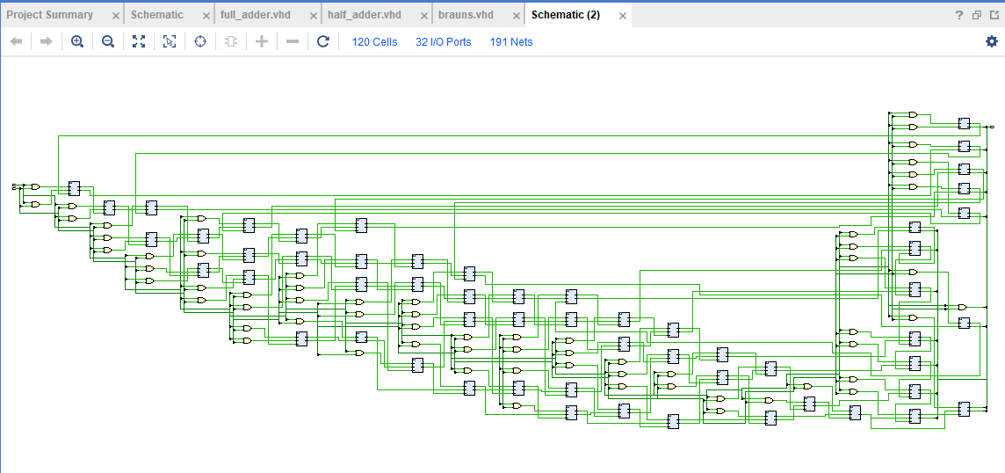
Figure 37 RTL Design Brauns
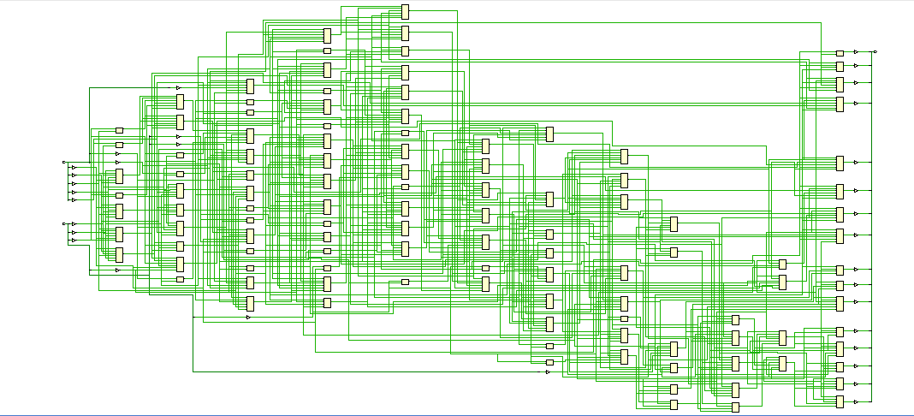
Figure 38 Implementation Design Brauns

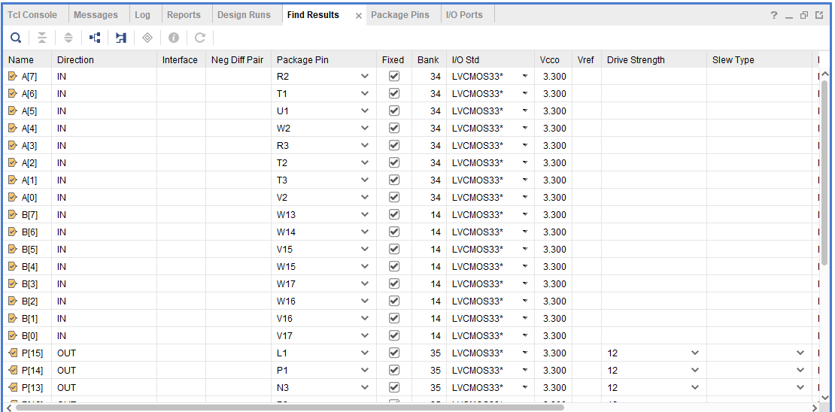
Figure 39 Pin Allocation Brauns

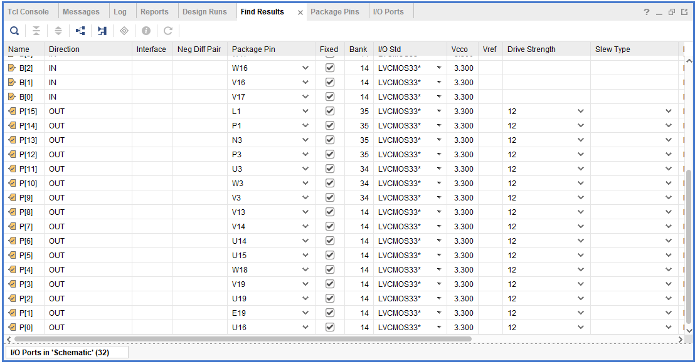
Figure 40 Pin Allocation Brauns 2

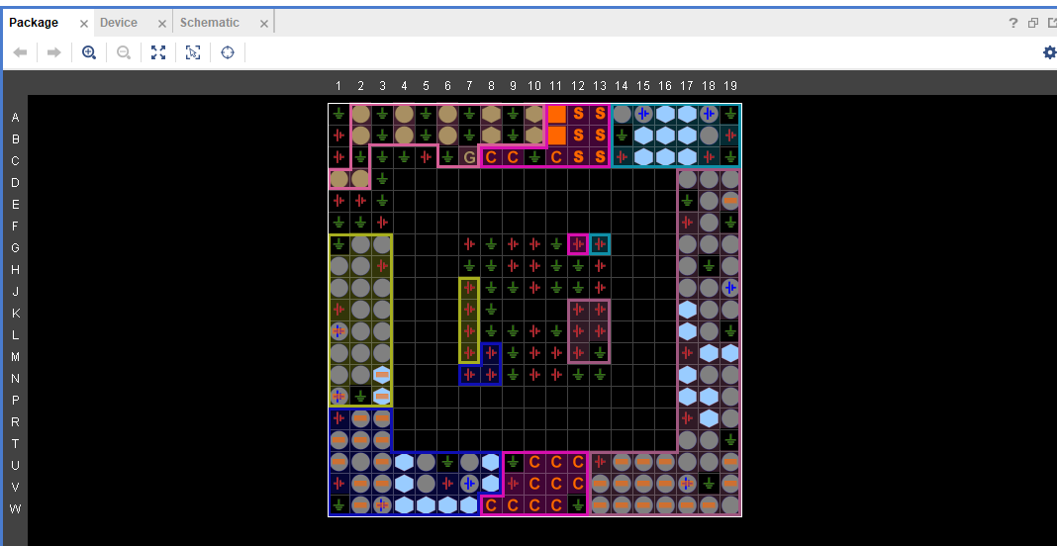
Figure 41 Brauns Multiplier I/O Planning
Figures show the Brauns multiplier designs and Pin Allocation with the I/O planning.

Wallace Multiplier Designs & Pin Allocation
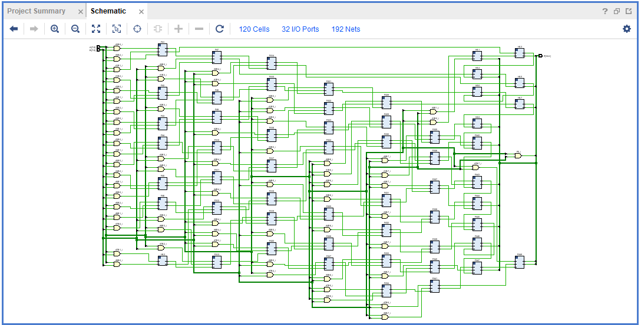
Figure 42 Wallace Multiplier RTL Design

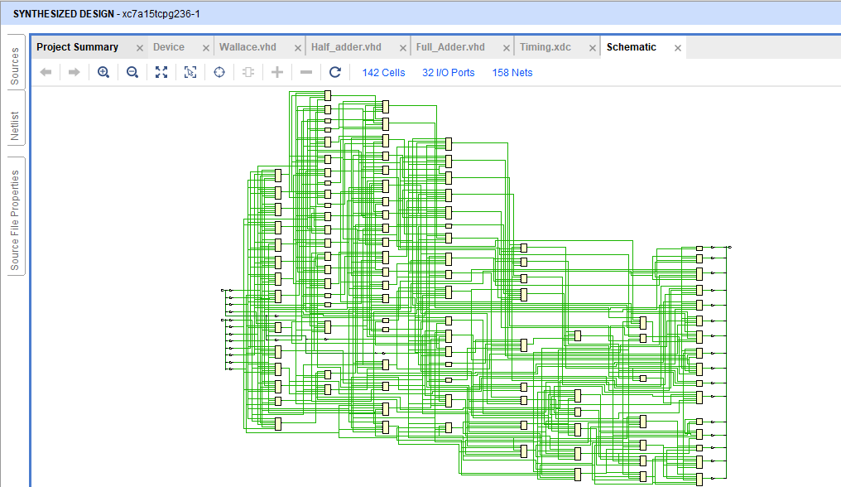
Figure 43 Wallace Multiplier Implemented Design

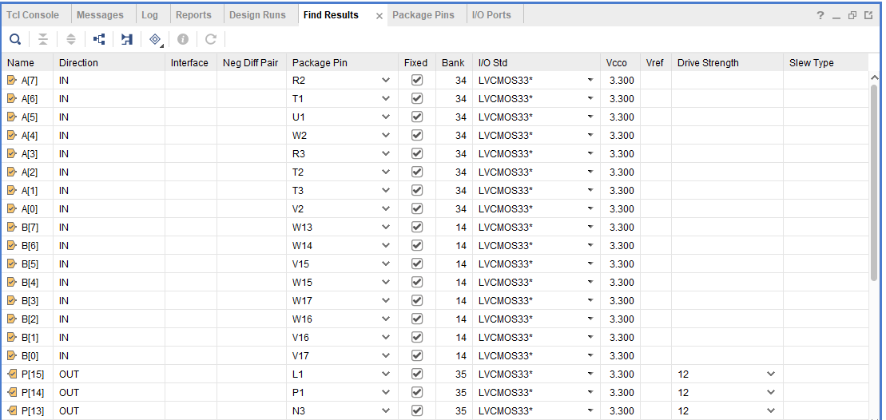
Figure 44 Wallace Multiplier Pin Allocation

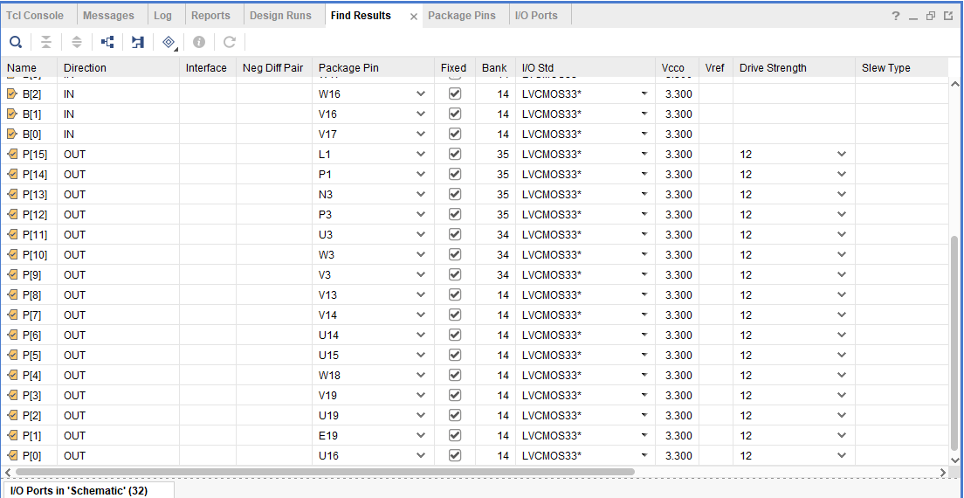

Figure 45 Wallace Multiplier Pin Allocation 2
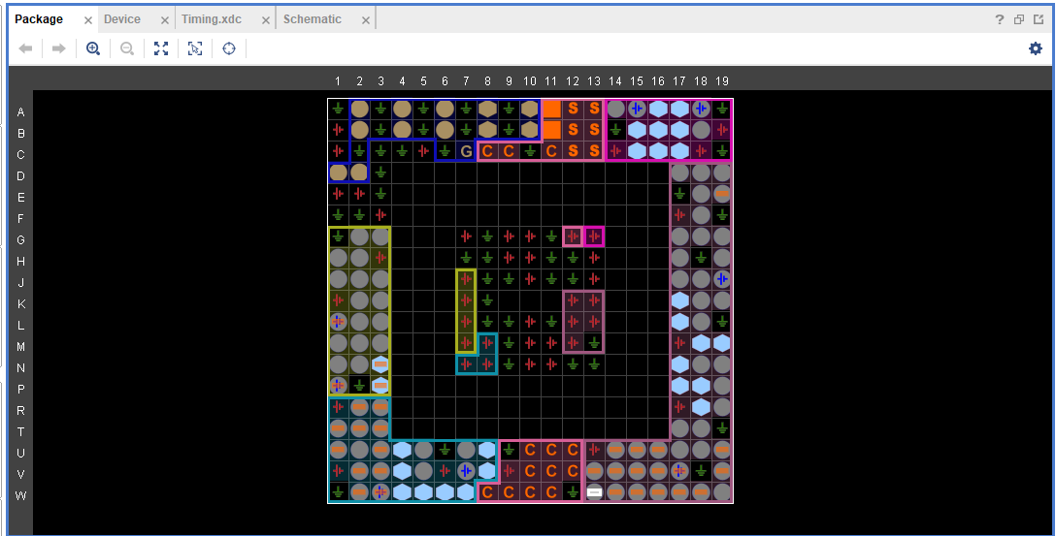
Figure 46 Wallace Multiplier I/O Planning

Figures to show the Wallace multiplier Designs with Pin Allocation and I/O planning.

Conclusion

Simulation Results
Within the Brauns and Wallace multiplier, both were used with the same hexadecimal values to multiply. These values were AA x AB, FF x FF, EF x EA and finally 18 x 34.
The results were all the same with 100% accuracy with the results chosen, comparing the values of the multiplication to an online hexadecimal calculator, As seen in the figures below.

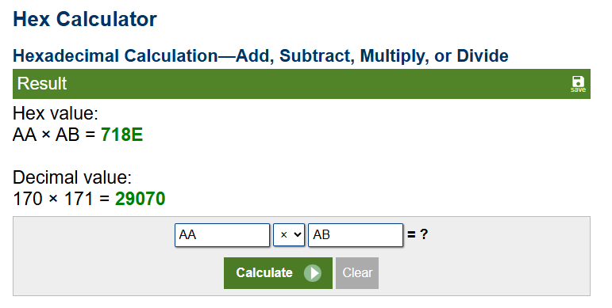
Figure 47 Hex value 1.
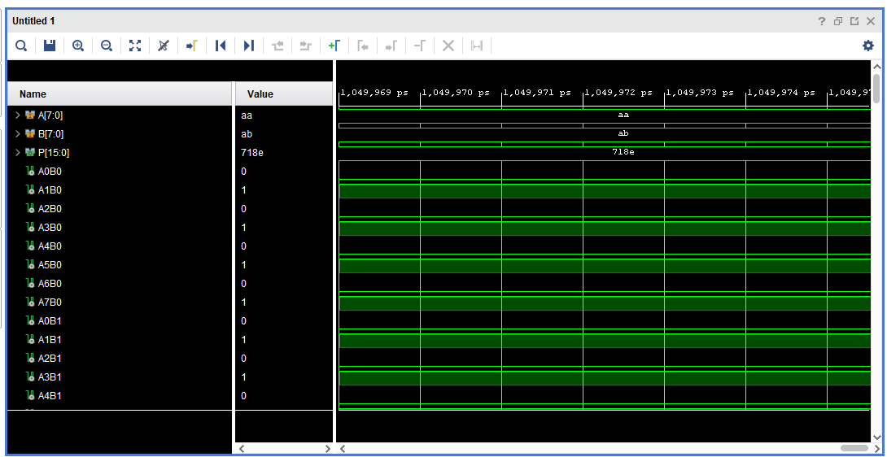
Figure 48 Brauns Simulation of Hex Value 1
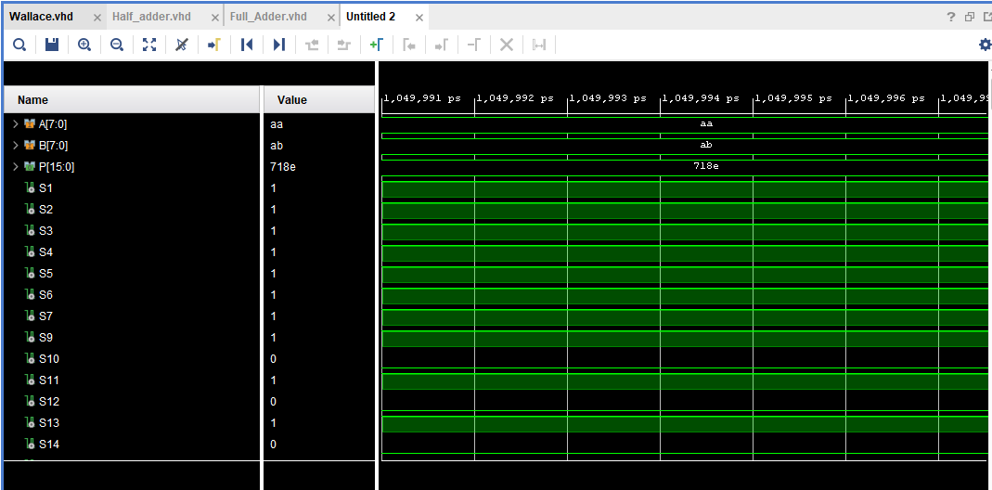
Figure 49 Wallace Simulation of Hex Value 1
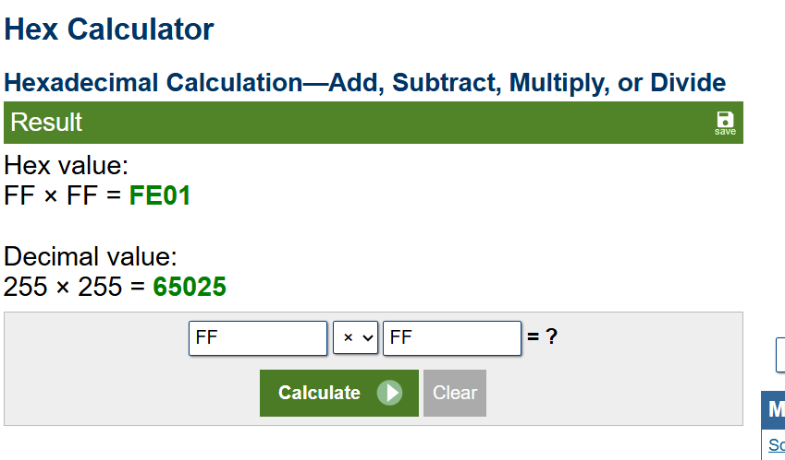
Figure 50 Hex value 2.
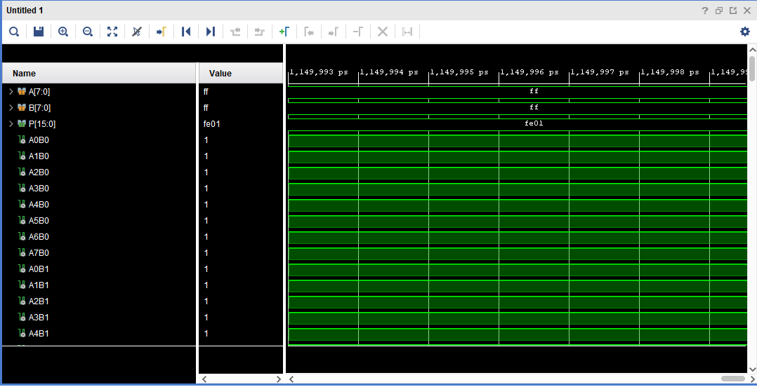
Figure 51 Brauns Multiplier Hex Value 2
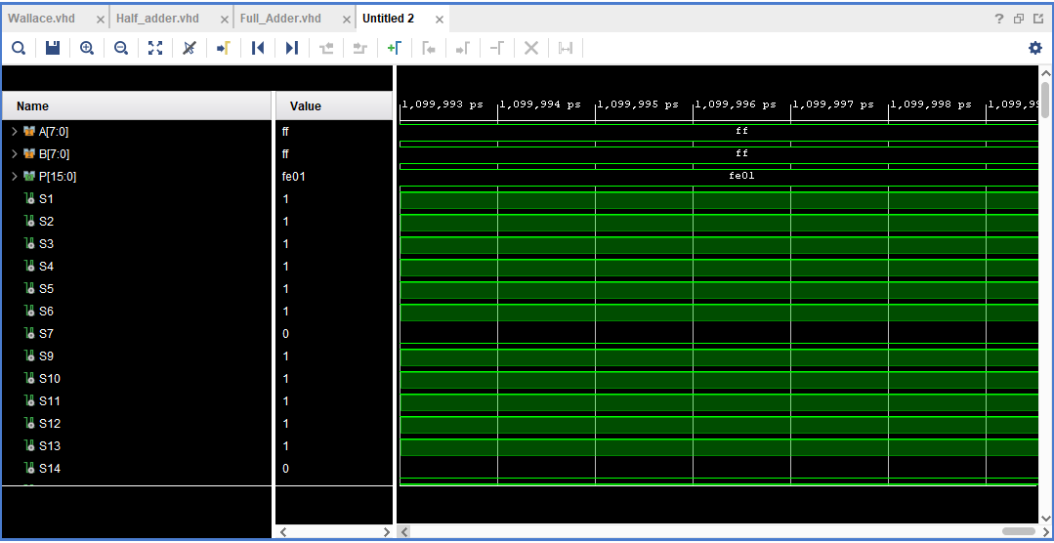
Figure 52 Wallace Simulation of Hex Value 2

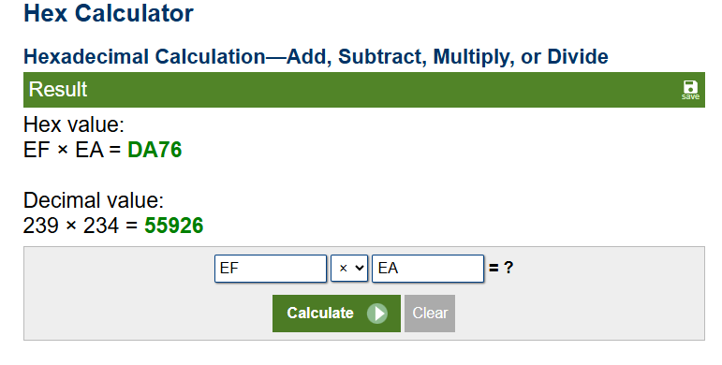
Figure 53 Hex value 3.

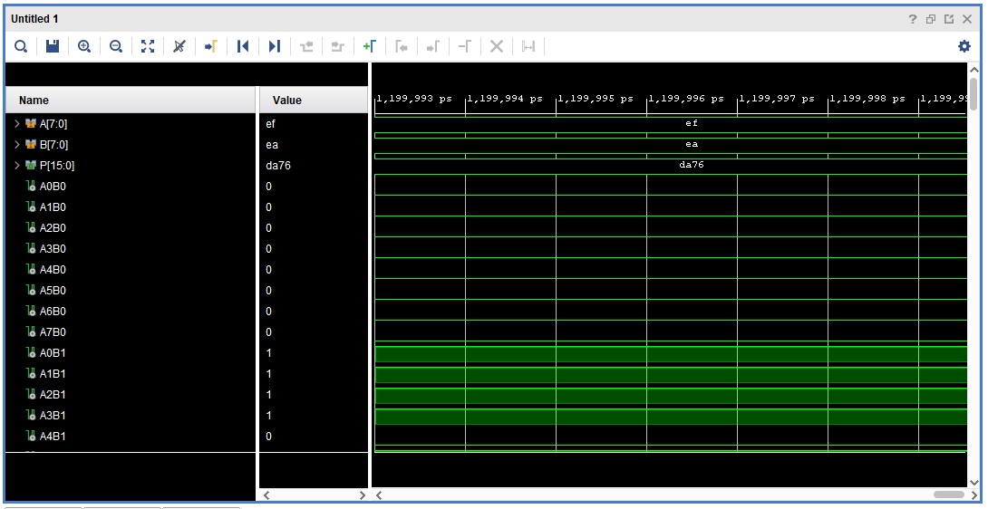
Figure 54 Brauns Simulation of Hex Value 3
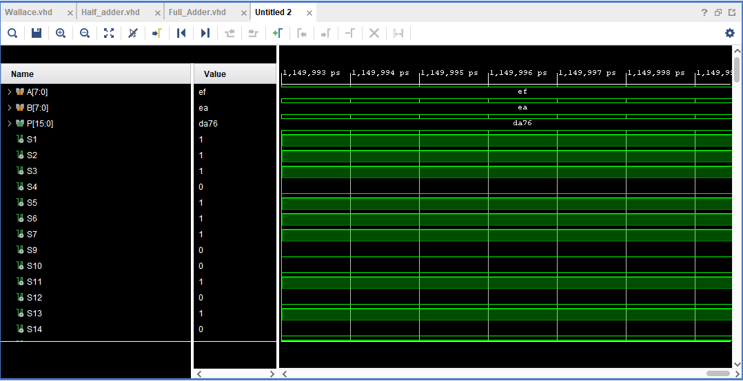
Figure 55 Wallace Simulation of Hex Value 3
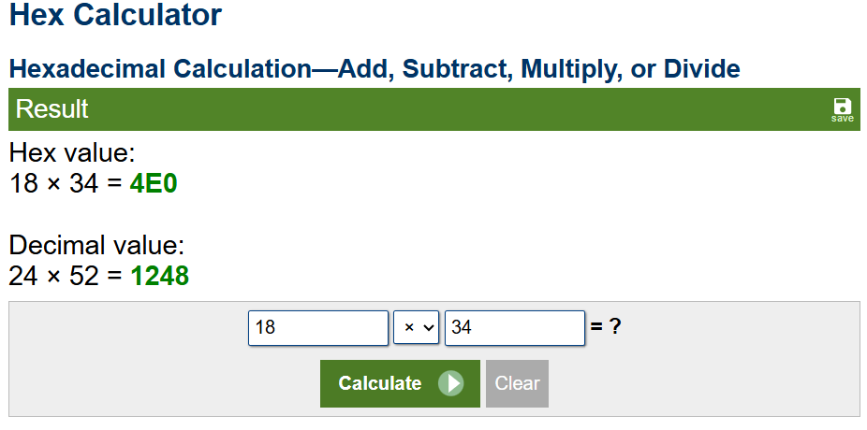
Figure 56 Hex value 4.
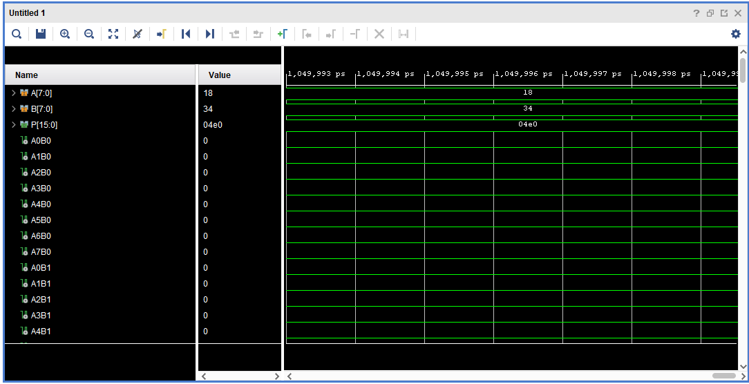
Figure 57 Brauns Simulation of Hex Value 4
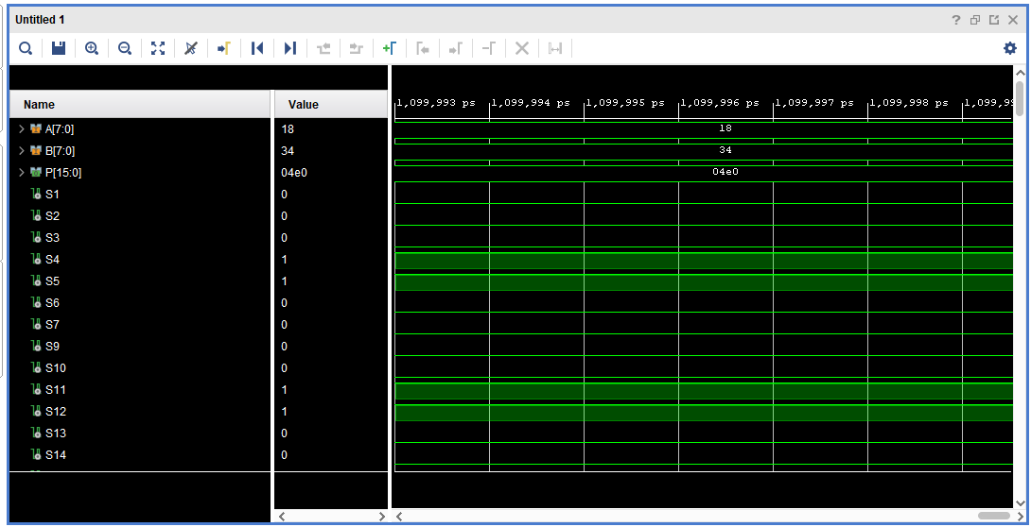
Figure 58 Wallace Simulation of Hex Value 4

Comparison, Analysis/testing details, and interpretation

Whilst the Brauns and Wallace tree multipliers are both quick and efficient. They both have some differences between them both. In comparison to each other regarding the accuracy, the hexadecimal values that have been chosen, the accuracy is the same as they have both produced the same correct hexadecimal values. The Two multipliers are both fast however the Wallace multiplier has a lower input-output time as the highest within the full list of combinational delays is 20.006ns. However, looking at the Brauns multiplier the highest combinational delay is 23.749ns. A second difference between the two multipliers is the Worst Negative Slack [10]. Worst negative slack means the time taken to get through the critical path [10]. Within the Brauns and Wallace multiplier both WNS are positive. As the WNS needs to be positive or equal to 0 [10]. However, in the case of the two multipliers the Wallace multiplier has a better WNS, this is because it is closer to zero in both synthesis (5.721ns) and implementation (13.074ns). Compared to the Brauns multipliers synthesis (14.226ns) and implementation (21.490ns) WNS the Brauns multiplier is slower by ≈8.416ns within synthesis and ≈ 8.505ns within implementation.

Interpretation of Power utilisation and LUTs

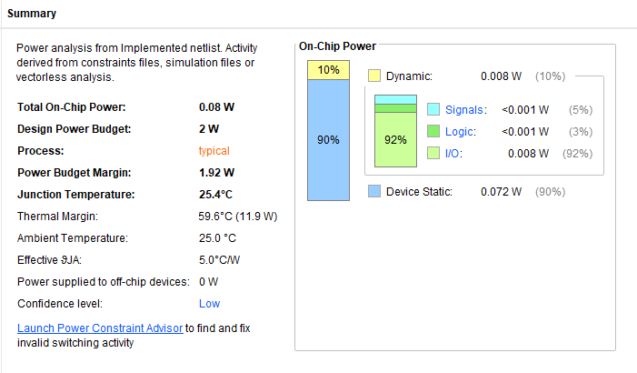
Figure 59 Brauns Multiplier Power Summary
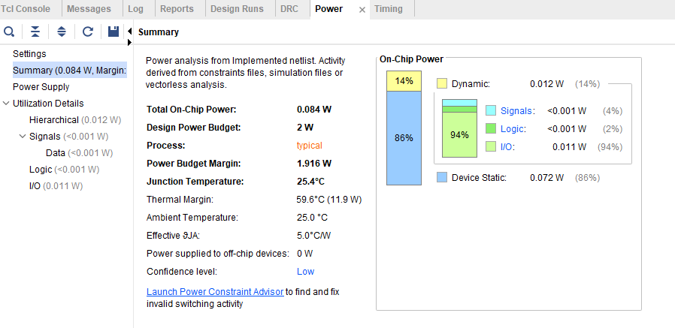
Figure 60 Wallace Multiplier Power Report
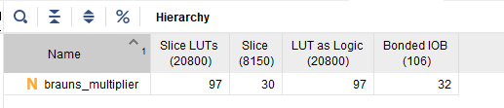
Figure 61 Brauns Multiplier Utilization Hierarchy
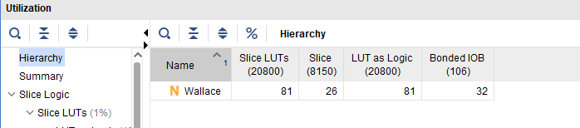
Figure 62 Wallace Multiplier Utilization Hierarchy
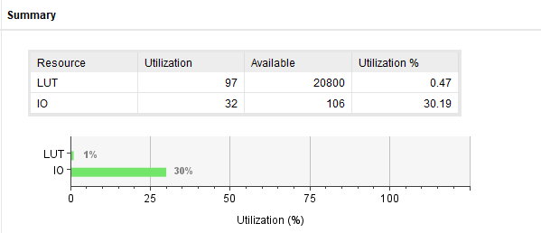Figure 63 Brauns Multiplier Utilization Summary
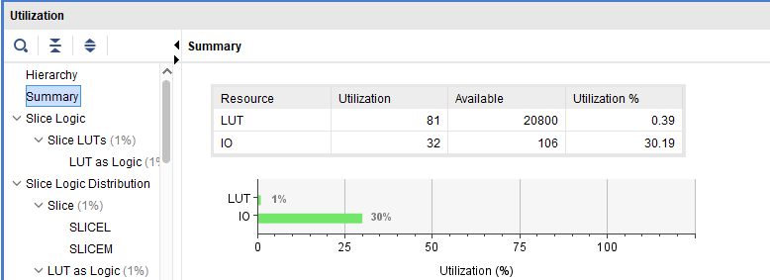
Figure 64 Wallace Multiplier Utilization Summary

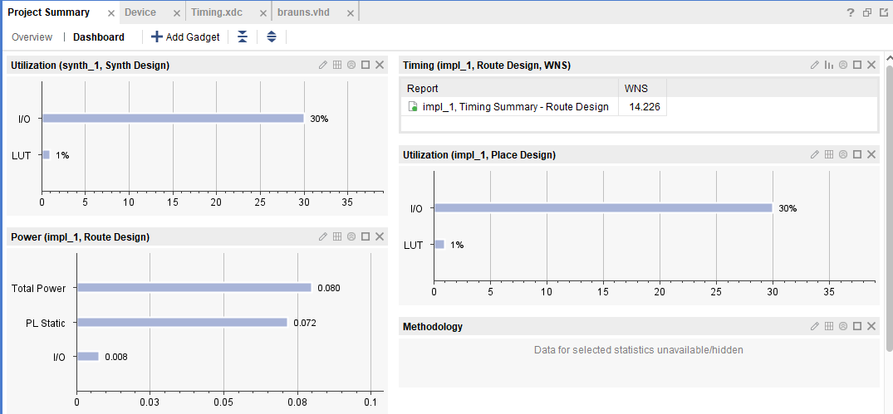
Figure 65 Brauns Multiplier Project Summary
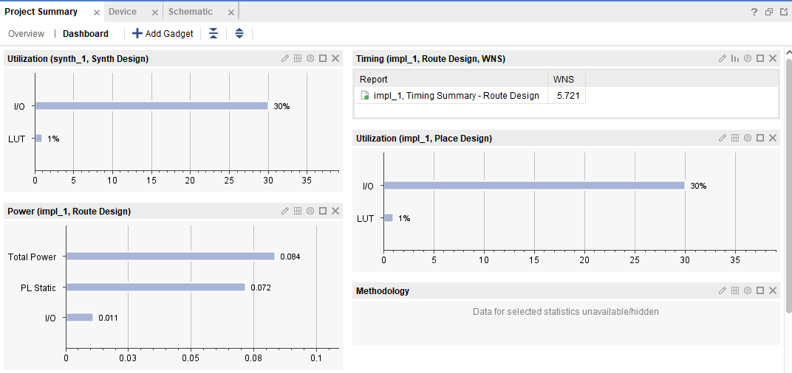
Figure 66 Wallace Multiplier Project Summary

Within the power report with regards to figure 59 and 60 the Brauns multiplier uses slightly less on chip power than the Wallace multiplier, the Brauns multiplier has 10% dynamic on chip power whereas the Wallace multiplier uses 14% of the dynamic on chip power. Other than the power figures the rest of the values within the power report are the same.
The utilization hierarchy also shows the Wallace multiplier utilises less LUTs and Slices than the Brauns multiplier. The Brauns multiplier uses ≈0.47% of the Slice LUTs available. The Wallace multiplier uses ≈0.4% of the available Slice LUTs. The LUT as logic is also the same values as previously stated for the two multipliers. The Brauns multiplier uses more Slice, with ≈0.37% used and the Wallace multiplier with ≈0.32% of the Slice utilised. The final figure within the hierarchy is the Bonded IOB which is the same value for both with ≈30.2% of the IOB utilised. Thirdly the utilisation summary shows the percentage of LUT and percentage of I/O which is both the same for the two multipliers. Finally, the project summary gives an overall of the things previously spoken of.

Details of testing
Once the code had been written to evaluate the VHDL code the first step in the testing process is to run a simulation. This will help to show if there are any problems within the code. For example, if certain lines are producing a value of U, then the code will have some errors within them which need to be addressed. Once the simulation has been completed and the value of the calculator matches the value of the multiplication online then the next step may be conducted.
The second step within testing was to run synthesis. This will compile the code and map it all within FPGA for example. Synthesizing the code will also allow for timing data when the timing constraint has been applied to the code. Third step is to show schematic of the synthesis, this will show the RTL Design. Within synthesis the Pin Allocation can be done for the I/O planning, with use of the Basys 3 diagram the two multipliers were allocated I/O pins.
The fourth step is to start the implementation. The implementation will complete and then you can see the implementation schematic. The timing summary can also be seen within the implementation. These steps will be done for both the Brauns and Wallace multipliers.
Within Testing there will be the timing constraints. With addition to the timing constraint source the timing summary can be found, this will be found in the implementation and the synthesis portions of the software. All the ports will be connected so that the timing of each port is visible, all the Port combinational delays should be a lower value than the one calculated using the diagrams. Additionally, Power Reports can be made within the implementation stage of the software, this can be used to find the usage of ports, wattage and working temperature. Testing on hardware was also completed using the Basys 3. The hardware was able to use the multipliers software to answer the requested multiplier values. Figures seen below.

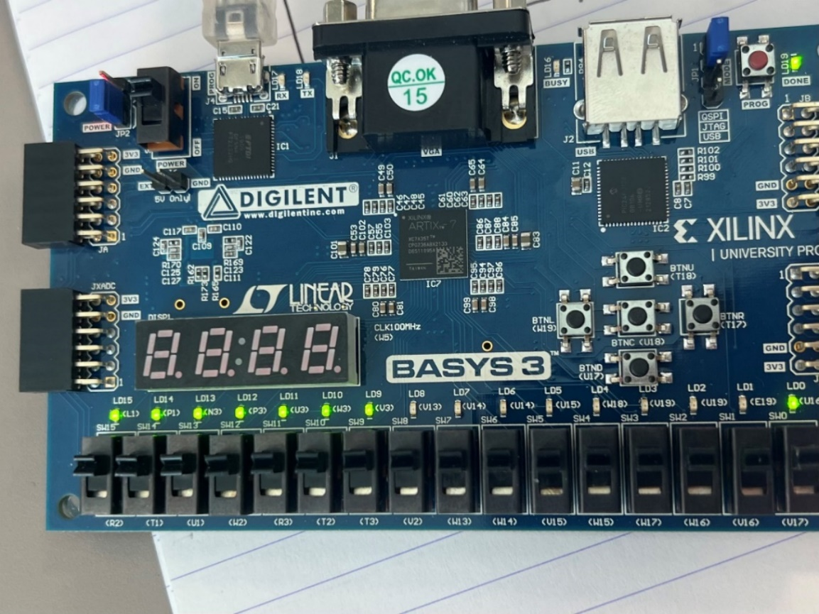
Figure 67 Basys 3 FF x FF.
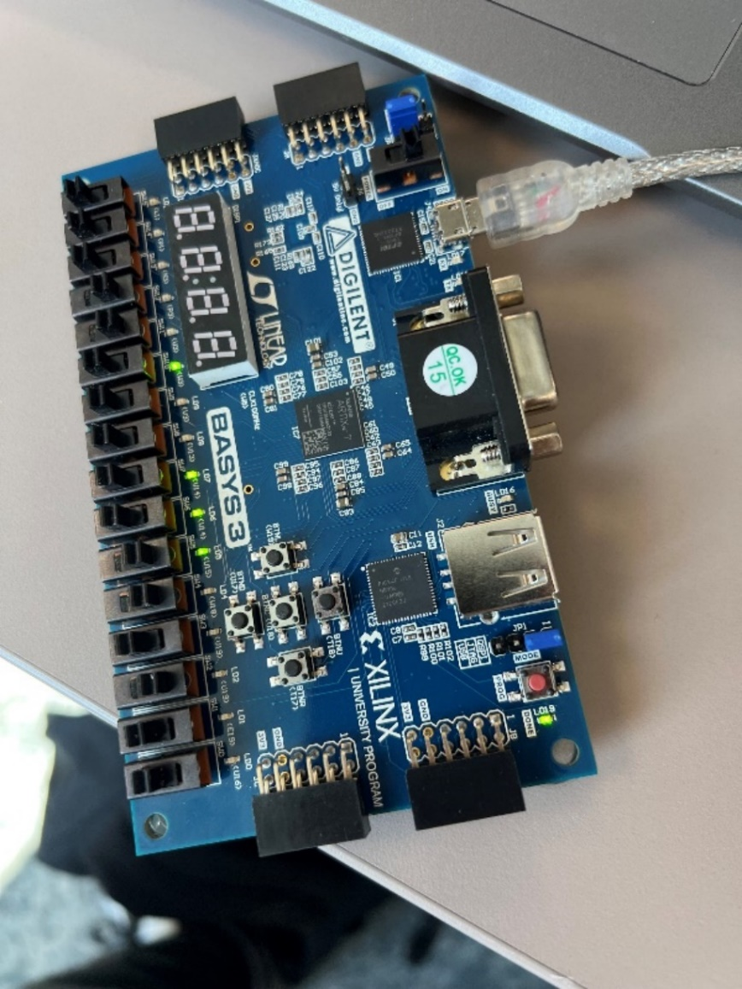
Figure 68 Basys 3 13 x 34.
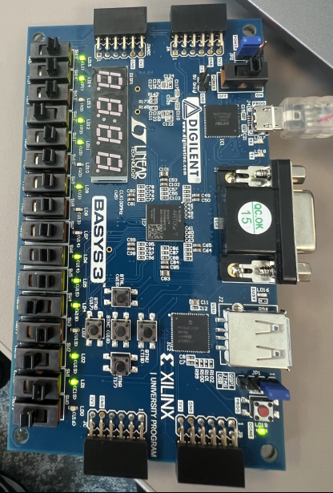
Figure 69 Basys 3 EF x EA.
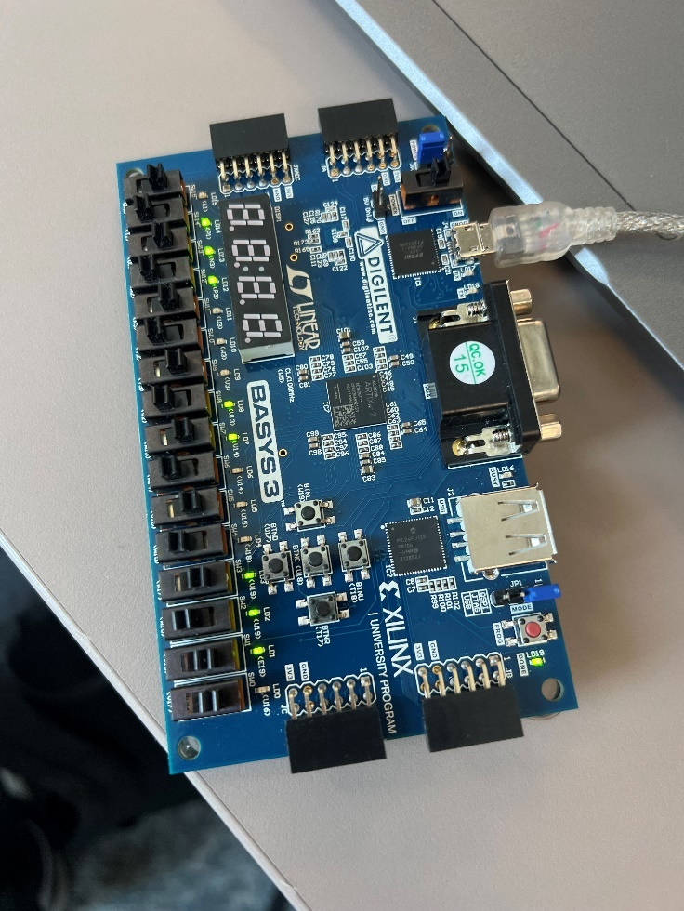
Figure 70 Basys 3 AA x AB

Recommendations

Within the code that has been developed, there are some simplifications that can be done to make the VHDL code much clearer to read, for the Brauns multiplier, tidying up the code within the VHDL where the partial product signals are held, for example C2_1 and p2_1, improved would be C3, C4 etc. similarly with P2_1 this could be changed to S3, S4 etc... This would make it so that the two codes are mostly identical, this will help with readability and the debugging aspects if there were any changes made to the code. From research, to improve the speed of the Brauns multiplier, an adder which is known as Brent kung or B-K adder can be used to improve the speed [11].
Another type of adder can be used to improve the system which is known as a Kogge-Stone adder [11]. This type of adder can reduce the delay of the multiplier and increase the speed of the multiplier, the adders will reduce delay, however when designing the power constraints must be looked at due to the increase in complexity and the amount of LUTs or logic slices used will increase making the multiplier more intricate [11]. With the addition of these types of adders the multiplier can be utilised in low-mid performance applications.
The Wallace multiplier also has a few recommendations for improvements. The Wallace multiplier can be improved from research [13]. The multiplier can use prefix adders along the final stage of the multiplication [13]. The prefix adders allow for less delay and faster multiplication, however there is a trade off when using prefix adders as they will increase the power consumption of the multiplier [13]. Certain adders which can be used are also able to reduce the complexity of the multiplier [13].
With the inclusion of the Prefix adders the Wallace multiplier is more competitive with the other multipliers that are out there for example the Booth multiplier [13]. The improvements with the Prefix adders will also help with real time applications, as when high speed operations are needed the multiplier will be able to complete them on time [13]. Similarly, as the Brauns multiplier the introduction to prefix adders will also increase the power consumption, LUTs and slice logic used which should be looked at when designing to make sure that the multiplier is appropriate for the application [13].

References

[1] D. V. N. Bharathi, V. Nikhil, T. Priya Raghavi, U. A. Manas, and O. Vijay Kumar, Review on Performance and Hardware Complexity of Multipliers, vol. 15, no. 5, pp. 1–3, 2020. doi:10.9790/2834-1505011416
[2] A. Sharma, “Design and implementation of Braun multiplier using Verilog: Research,” Ijraset, https://www.ijraset.com/research-paper/design-and-implementation-of-braun-multiplier-using-verilog-research#:~:text=Braun%20multiplier%20is%20mainly%20used,technology%20and%20digital%20signal%20processing. (accessed Mar. 13, 2025).
[3] S. Ananthakumaran, M. Abdullah, C. Kamalanathan, K. Nehru, and S. Karthick, “Design and analysis of Braun multiplier using CMOS/GDI technique for signal processing,” International Journal of Emerging Trends in Engineering Research, vol. 8, no. 10, pp. 6917–6924, Oct. 2020. doi:10.30534/ijeter/2020/488102020
[4] B. Kasturi, Effective GDI Based Array Multiplier and Braun Multiplier with TSMC 45nm, vol. 7, no. 5, pp. 46–51, 2020.
[5] “Hex Calculator,” Calculator.net, https://www.calculator.net/hex-calculator.html?number1=FA&c2op=x&number2=AC&calctype=op&x=Calculate (accessed Mar. 26, 2025).
[6] A. Oladele, “Top 15 software development methodologies,” Velvetech, https://www.velvetech.com/blog/software-development-methodologies/ (accessed Mar. 28, 2025).
[7] S. N. Leela, B. Manisha, P. Bharath, and E. Praneeth, “Design of Wallace Tree multiplier circuit using high performance and low power full adder,” E3S Web of Conferences, vol. 391, p. 01025, 2023. doi:10.1051/e3sconf/202339101025
[8] K. Rambabu, H. Venkatesh Kumar, and N. Jayalakshmi, “High speed and efficient Wallace tree multiplier for DSP applications,” Journal of VLSI circuits and systems, vol. 2, no. 1, Jan. 2020. doi:10.31838/jvcs/02.01.01
[9] H. Bansal, K. G. Sharma, and T. Sharma , “Wallace Tree Multiplier Designs: A Performance Comparison Review,” Wallace Tree Multiplier Designs: A Performance Comparison Review , vol. 5, no. 5, pp. 60–67, 2014.
[10] “What is the Worst Negative Slack?,” AMD Customer Community, https://adaptivesupport.amd.com/s/question/0D54U00006qTJxwSAG/what-is-the-worst-negative-slack?language=en_US (accessed Apr. 7, 2025).
[11] S. C. Bikkina and Nekkanti. Mouni, “Design and implementation of Braun multiplier using parallel prefix adders,” International Journal of Engineering and Advanced Technology, vol. 9, no. 4, pp. 1251–1254, Apr. 2020. doi:10.35940/ijeat.d8075.049420
[12] M. Bansal, V. Bharti, and V. Chander, “Comparison between conventional fast multipliers and improved fast multipliers using PTL Logic,” IOP Conference Series: Materials Science and Engineering, vol. 1126, no. 1, p. 012041, Mar. 2021. doi:10.1088/1757-899x/1126/1/012041
[13] I. Journal, “Reduced complexity Wallace multiplier using parallel prefix adders.,” International Journal of Engineering Sciences & Research Technology, https://www.academia.edu/5673653/Reduced_Complexity_Wallace_Multiplier_using_Parallel_Prefix_Adders (accessed Apr. 8, 2025).
[14] Rajagiritech, “FAMILIARISATION OF BASYS 3 ARTIX-7 FPGA BOARD,” rajagiritech, https://www.rajagiritech.ac.in/Stud/KTU/RIMS/Brochure/11099.pdf (accessed Apr. 11, 2025).

Appendix
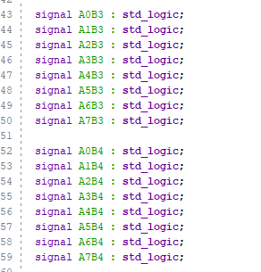
Figure 71 Signal Generation 2
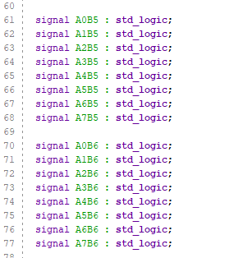
Figure 72 Signal Generation 3

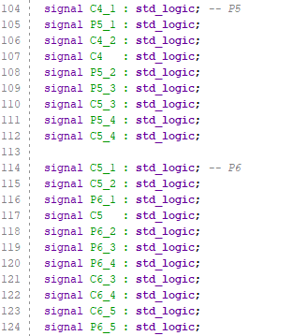
Figure 73 Sum & Carry signals P5 & P6
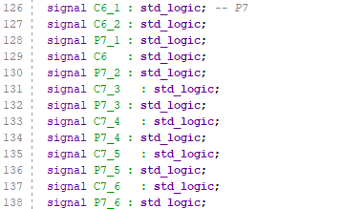
Figure 74 Sum & Carry signals P7.
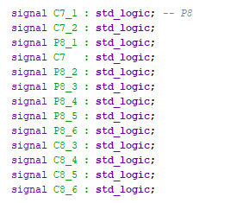
Figure 75 Sum & Carry signals P8.
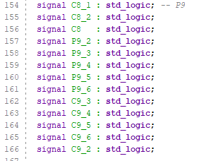
Figure 76 Sum & Carry signals P9.
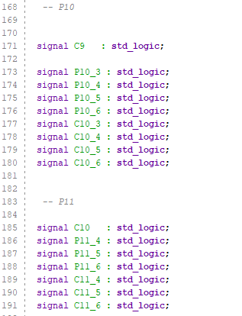
Figure 77 Sum & Carry Signals P10 & P11

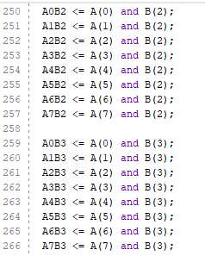
Figure 78 Brauns Multiplier Partial Products 2
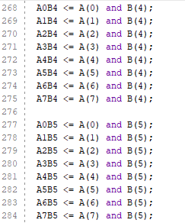
Figure 79 Brauns Multiplier Partial Products 3
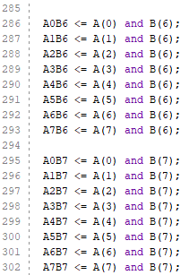
Figure 80 Brauns Multiplier Partial Products 4

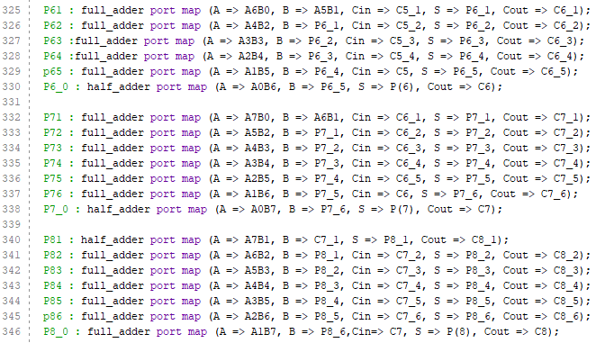
Figure 81 Brauns Multiplier Port Maps 2
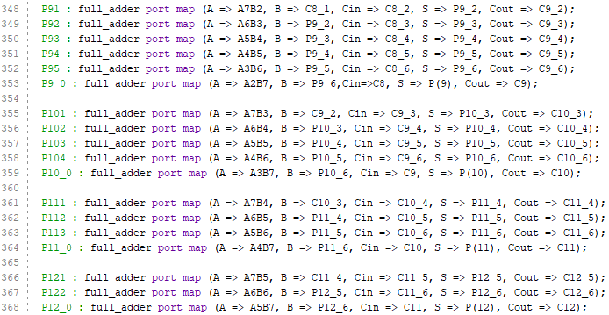
Figure 82 Brauns Multiplier Port Maps 3

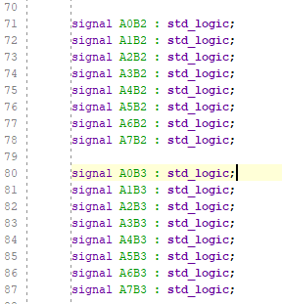
Figure 83 Wallace Multiplier Signal Generation 2
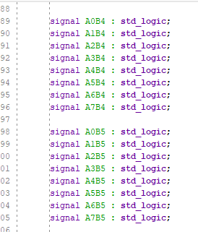
Figure 84 Wallace Multiplier Signal Generation 4
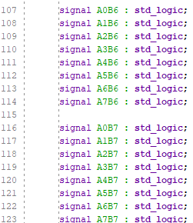
Figure 85 Wallace Multiplier Signal Generation 5

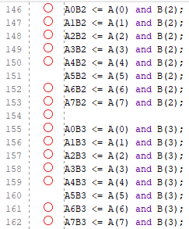
Figure 86 Wallace Multiplier Partial Products 2
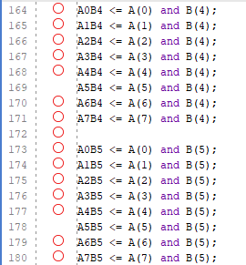
Figure 87 Wallace Multiplier Partial Products 3
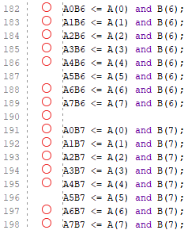
Figure 88 Wallace Multiplier Partial Products 4

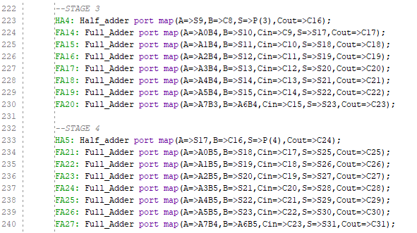
Figure 89 Wallace Multiplier Stage 3 & 4 Reduction
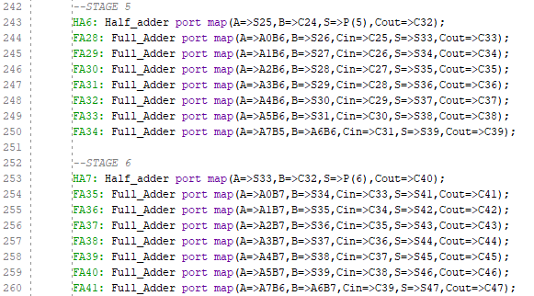
Figure 90 Wallace Multiplier Stage 5 & 6 Reduction
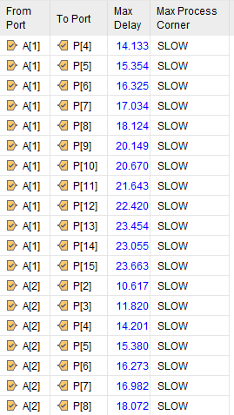
Figure 91 Brauns Multiplier Combinational Delay 2

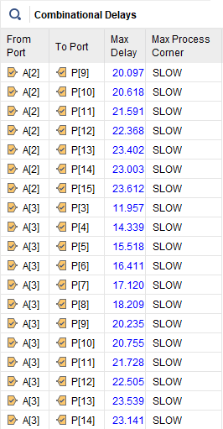

Figure 92 Brauns Multiplier Combinational Delay 3

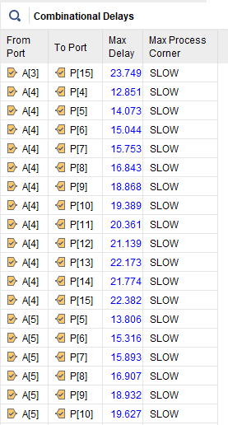
Figure 93 Brauns Multiplier Combinational Delay 4

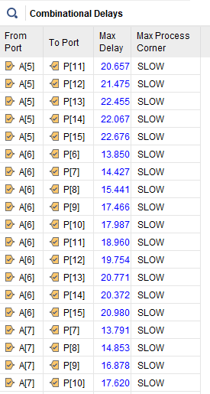

Figure 94 Brauns Multiplier Combinational Delay 5

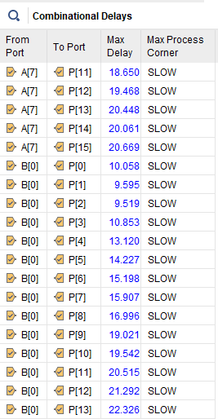
Figure 95 Brauns Multiplier Combinational Delay 6

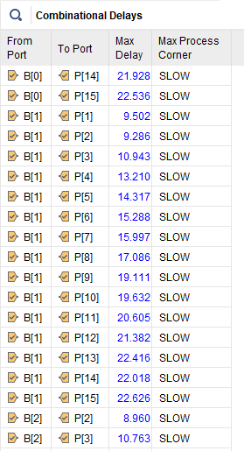

Figure 96 Brauns Multiplier Combinational Delay 7

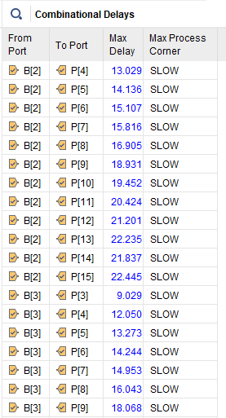

Figure 97 Brauns Multiplier Combinational Delay 8

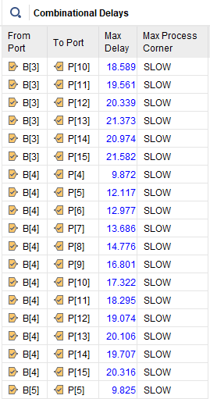

Figure 98 Brauns Multiplier Combinational Delay 9

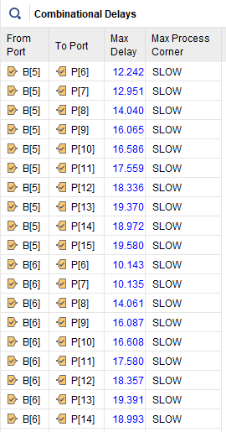

Figure 99 Brauns Multiplier Combinational Delay 10

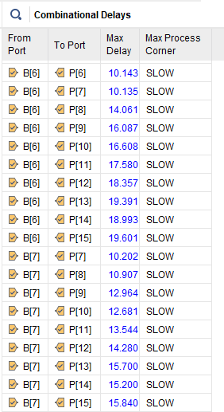

Figure 100 Brauns Multiplier Combinational Max Delay 11
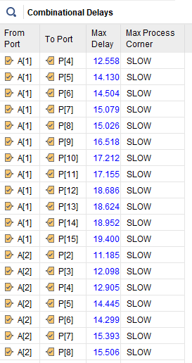
Figure 101 Wallace Multiplier Combinational Delays 2
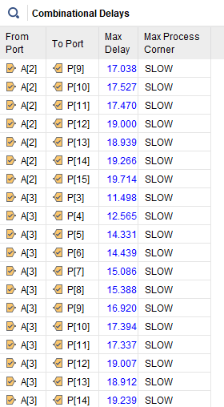
Figure 102 Wallace Multiplier Combinational Delays 3
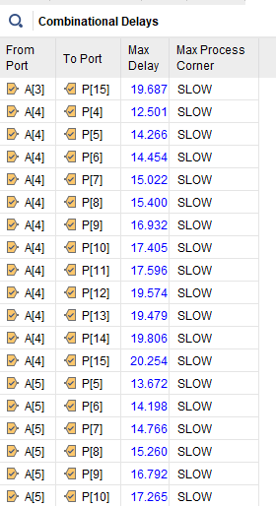
Figure 103 Wallace Multiplier Combinational Delays 4
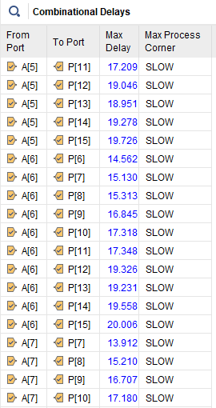
Figure 104 Wallace Multiplier Combinational Delays 5
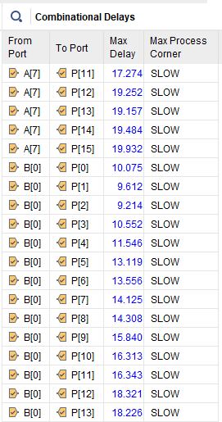
Figure 105 Wallace Multiplier Combinational Delays 6
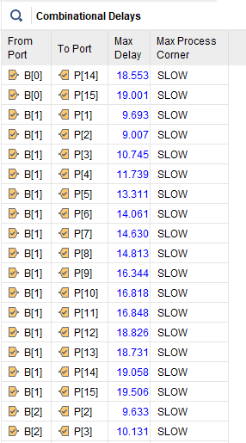
Figure 106 Wallace Multiplier Combinational Delays 7
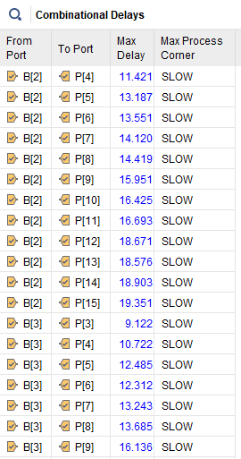
Figure 107 Wallace Multiplier Combinational Delays 8
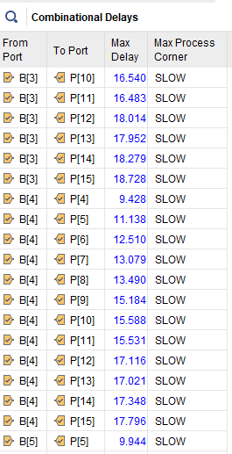
Figure 108 Wallace Multiplier Combinational Delays 9
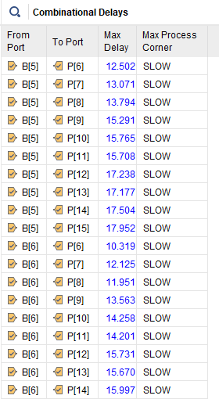
Figure 109 Wallace Multiplier Combinational Delays 10
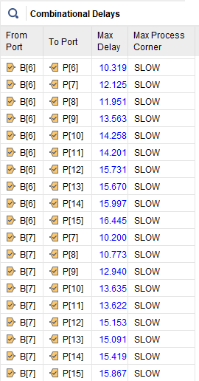
Figure 110 Wallace Multiplier Combinational Delays 11
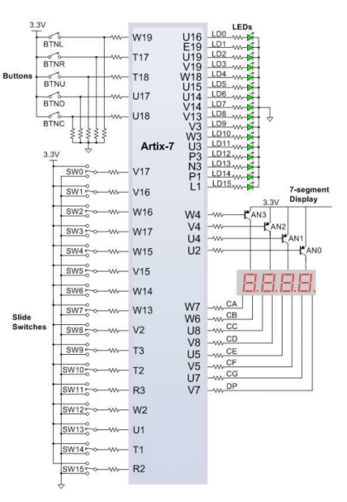
Figure 111 Basys 3 Diagram [14]

