
APPENDIX GA36c

LEVEL 6 ASSESSMENT SPECIFICATION

Student name: | Angharad Locke | Student ID number: | P151197
Programme: | Primary
Module: | Principles of Pedagogy
Module code: | M6X01438/C | Contribution to Overall Module Assessment (%): | 100%
Lecturer: | Siân Brooks | Internal Verifier: | Siân Brooks
Assignment Title: | ‘Describe a learning event which has happened during your recent school experience. Reflect upon what took place, connecting events to theories of learning and teaching. Make recommendations about how you could improve your own practice in the light of this. Produce a poster to illustrate how you would develop the elements of an effective learning environment.’ | Word count (or equivalent): | 5296
Submission deadline: | 17/10/18 (23.59) | Return date of provisional marks & written feedback: | 14/11/18
Submission method: | All written assessments, where practical and possible, must be submitted via Turnitin unless otherwise instructed by the Lecturer. (Please DO NOT put this assessment specification into Turnitin or it will match many similarities with other students’ submissions.)  Alternative submission method (if applicable):  Late submission of the assessment will result in a late penalty mark. Penalties for late submission: Up to one week late, maximum mark of 40%. Over one week late, 0%. Only the Extenuating Circumstances Panel may approve a change to submission dates.
Academic honesty / referencing: | Academic honesty is required. In the main body of your submission you must give credit to authors on whose research and ideas your work is based. Append to your submission a reference list that indicates the books, articles, etc. that you have used, cited or quoted in order to complete this assessment.

Student FEEDBACK FORM

Generic Assessment Criteria | Marks available | Marks  awarded
1. Engagement with Literature Skills
.
2. Knowledge and Understanding Skills

3. Cognitive and Intellectual Skills

4. Practical Application Skills

5. Transferable Skills for Life and Professional Practice

This section details the extent to which the assessment criteria are demonstrated by you, which in turn determines your mark. The marks available for each category of skill are shown. Lecturers will use the space provided to comment on the achievement of the task(s), including those areas in which you have performed well and areas that would benefit from development/improvement.

Assessment Mark (Assessment marks are subject to ratification at the Exam Board. These comments and marks are to give feedback on module work and are for guidance only until they are confirmed. ) | Late Submission Penalties (tick if appropriate) |  | %
 | Up to 1 week late (40% Max) |  | %
 | Over 1 week late (0%) |  | %

There are many different theories about how people learn. The vast amount of research invested into this subject has suggested that there are a variety of factors that influence how people learn and build new understanding. One of the most prominent factors is the importance of talk and social interaction within the classroom (Vygotsky, 1978; Mercer, 1995; Barnes & Todd, 1977). Over the course of this essay I will discuss a learning event that depicts how talk can be a useful tool in teaching and learning, linking it with theories of learning and teaching, and reflecting on how this observation will affect my own teaching practice in the future.

The learning event that I have chosen to write about took place in a large primary school located in South-West Wales. There are currently around 450 pupils on roll in 16 single year classes and in the school’s last Estyn inspection they achieved an overall rating of good for their current performance. The learning event that I witnessed occurred in a Year 2 class consisting of 29 pupils. For the purpose of this essay I have chosen to take ethical considerations and I will be ensuring the anonymity of the school, the teachers and the pupils that I observed, according to the BERA (2018) guidelines.

Observation

The learning event that I witnessed occurred after a session of carpet time that involved the teacher revisiting prior learning on the subject of number bonds and numbers represented by unit blocks, ‘towers of ten’ and hundred blocks. A ‘learning conversation’ (Myhill & Brackley, 2004) transpired between the learners and the teacher, with the teacher making links between what was already known by the children from previous lessons and the new activities that they would be moving onto in that lesson. After recapping the children’s prior knowledge, the teacher sent the children to complete various challenges that had been set up around the classroom, all of which were linked to the current Maths topic. From observing this ‘learning conversation’ I was able to understand that talk was deemed to be an important teaching and learning tool in this Year 2 classroom. This was further highlighted by the learning event that occurred during one of the Maths challenges set up by the teacher.

The event that I have chosen to write about transpired between two pupils who had partnered up to complete a Maths game on the computer. In order to complete the challenge, the children had to look at and discuss the number blocks that were displayed on the screen and pick the correct number from the three options that were given. The talk that the two pupils engaged in was not simply a sharing of thoughts and opinions, but was a social mode of thinking, a tool which they used to construct new knowledge and understanding (Mercer, 1996: 374). This is evident in the transcript below.

I recorded this piece of talk using a written observation method. Other methods of observation, such as the target child method, would not have been suitable for this observation as the learning event occurred spontaneously. The written method allowed me to record what was being said as it was being spoken and did not require me to interrupt the pupils in any way. This observation method has been shown to offer ‘rich evidence of…children’s behaviours or the implementation of activities’ (Palaiologou, 2008: 60) and is known to be accurate and comprehensive. However, the information recorded in a written observation can be taken out of context and can lead to inaccurate interpretations of what was seen and heard, so this needed to be kept in mind when I was observing. If I was to observe another learning event like this, I would use both the written method for its accuracy with the addition of video recorded evidence to ensure objectivity. However, this method was also the most ethical choice I could have made due to the school’s policy on filming and photographing the students. As part of our visit to the school, it was requested that we only took photographs of the displays of work in the classrooms. The method I chose allowed me to respect the school and their policies, as well as the anonymity of the pupils.

Pupil 1: I think it’s 26. There are two tens and 6 units.

Pupil 2: No, it’s 36. If you look, there are 3 towers of ten.

Pupil 1 [recounting]: Oh yeah, you’re right.

Pupil 2 [looking at the new number blocks on screen]: That one is 28

Pupil 1 [interrupting] I just guessed that one.

Pupil 1 [looking at answer chosen by Pupil 2]: How do you know that it’s 15?

Pupil 2: I counted the blocks carefully. Can you see that there is one tower of ten-and five-unit blocks? That means that the answer is 15.

Figure 1. Transcript of talk observed during Maths activity

In his research on dialogue and understanding in the classroom, Mercer (1995) identified three different examples of talk that learners participated in when they were learning. These were: disputational talk, which he characterised as being based on disagreement and individualised decision making; cumulative talk where speakers communicated positively with one another, but did not engage critically with each other’s ideas; and exploratory talk, defined as being a dialogue where partners critically and constructively engaged with what the other had said, which allowed understanding to develop (Mercer, 1995: 105). Mercer based his research on the pioneering studies conducted by Barnes and Todd, who reported that pupils were more likely to engage in open and extended discussion with their peers when they were outside of the control of the teacher (Barnes & Todd, 1977). They suggested that while teachers traditionally do most of the talking in the classroom, it is entirely possible for constructive and useful conversation to take place when the teacher is not present, and pupils are working together in collaboration on a task.

The learning event transcribed above is a prime example of the type of exploratory talk that Mercer defined in his research, and the useful and constructive conversation that Barnes and Todd reported when pupils work together in collaboration. The talk that Pupil 1 and Pupil 2 take part in, as seen in Figure 1, can be positively identified as exploratory talk because of the critical, but constructive way in which Pupil 2 challenged Pupil 1 to rethink the answers they were giving on their Maths activity. Despite the teacher revisiting the pupil’s prior knowledge of the Maths topic, it is clear that Pupil 1 was unsure of how to come up with the correct answer and relied on guessing some of the numbers instead of counting out the blocks on the screen. Unlike some of the disputational talk that occurred when I observed other pairs of pupils working together on the same activity, Pupil 2 chose to question Pupil 1 on their answer and reminded them constructively how to work out the correct number. This happened a number of times throughout the activity and I noted how, at the end of the challenge, Pupil 1 had started to develop their understanding because of the dialogue they were engaged in with Pupil 2. Eventually Pupil 1, without any more prompting from Pupil 2, was able to choose the correct answer for the last three questions. I noticed how the exploratory talk that occurred during this activity had helped to develop Pupil 1’s understanding of the topic, allowing them to more fully engage with the task. Pupil 1 experienced a form of psychological success when they were able to answer the questions correctly, motivating them to put energy and effort into their learning (Johnson & Johnson, 1999: 72). However, the success that they experienced, and the understanding that they developed, only became possible when the two pupils used talk as a social mode of thinking (Mercer, 1996), working together to find the correct answers.

The collaborative learning and talk that Pupil 1 and Pupil 2 share in Figure 1 highlights how the teacher used talk as a teaching and learning tool in the classroom. The talk that developed between these two pupils would not normally have developed naturally. Research and observational studies into the importance of talk between peers in the classroom has found that exploratory talk is very rare, and that learners are more likely to participate in disputational or cumulative talk unless the class teacher has introduced a more constructive form of talk to the learners (Bennett & Cass, 1989; Galton, Hargreaves, Comber, Wall, & Pell, 1999; Blatchford & Kutnick, 2003; Wegerif & Scrimshaw, 1997). This learning event underscored the importance of teachers introducing their pupils to the different ways they can communicate with each other so that they are able work together effectively. Without clear ground rules set up by the teacher, the talk that takes place between peers is likely to be of little use in the construction of new knowledge and understanding.

This learning experience, therefore, highlights the importance of talk in the classroom and the effect that it can have on children’s learning. Figure 1 is an example of how talk can be used as an effective tool to aid children’s development and extend their understanding so that they can go on to complete a task with little to no help needed. The event that I witnessed demonstrates how beneficial it can be when children are allowed to talk and work together. This is not to say that a more guided form of talk does not have its benefits. The talk that occurs through teacher/pupil interaction constructs a knowledge base for the children to work from and helps them to form an understanding of the topic being taught. However, it is important that the learning environment is not completely dominated by teacher-student talk and that learners are presented with opportunities to talk with one another. The best teachers are ones that treat learning as a social, communicative process (Rojas-Drummond & Mercer, 2004) and who do not see learners as passive vessels to fill up with knowledge. It is imperative, therefore, that children are encouraged to become vocal and active participants in their own learning. Cognitive development in children is strengthened and driven forward by social interaction (Vygotsky, 1978; Bruner and Haste, 1987) and so its promotion in our classrooms, in its many forms, is essential. Giving this social interaction the chance to develop underpins many of the theories regarding how people develop and learn.

Learning Theories

One of the key theories that explore how people learn was developed by the creator of social constructivism, Lev Vygotsky. For Vygotsky, dialogue and social interaction are a vital part of constructing new understanding when learning. This can be observed long before a child begins school, when the conversation that spontaneously develops between a child and its parents not only helps the child learn to talk, but through talk, allows them to learn a wide range of other things (Wells, 1987: 53). Vygotsky recognised that language was a useful tool for cognitive development, and that through the dialogue a child engages in, new knowledge and understanding can be developed. This was evident in the learning event that was observed in the Year 2 class in School X, when the talk between Pupil 1 and Pupil 2 became a vehicle for Pupil 1 to develop their understanding of their Maths activity.

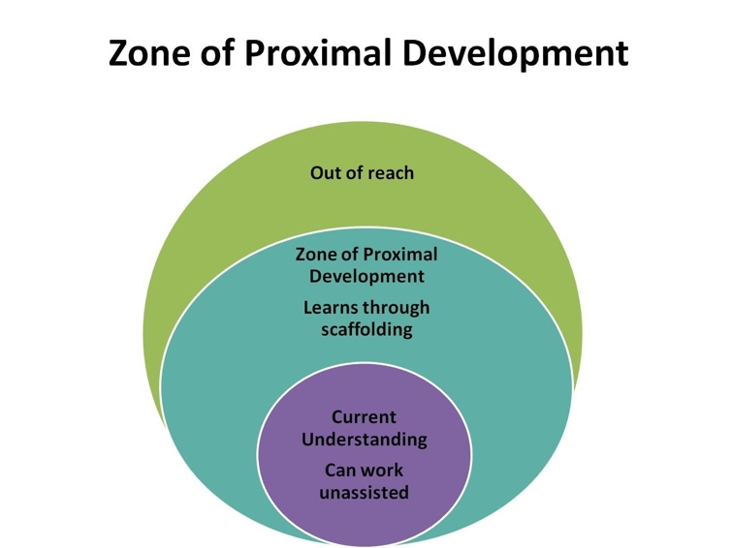

Figure 2. Vygotsky’s Zone of Proximal Development. Image taken from barbarabray.net. Available at: https://barbarabray.net/2017/08/31/7-strategies-for-personal-professional-learning/ (accessed on 12th October 2018)

A central idea to Vygotsky’s theory on cognitive development was that of the Zone of Proximal Development (ZPD). Vygotsky defined the ZPD as:

‘the distance between the actual developmental level as determined by independent problem solving and the level of potential development as determined through problem-solving under adult guidance, or in collaboration with more capable peers’ (Vygotsky, 1978: 86).

In simpler terms, the ZPD is the difference between what a learner cannot do without help and what they can do with help. Vygotsky theorised that through dialogue with a more knowledgeable other (MKO), a learner could eventually move past the need for help and on to completing a task independently because their understanding had been sufficiently developed through the dialogue with the MKO. Vygotsky emphasised that for development and understanding to occur within the ZPD, social interaction and dialogue between the learner and their teacher, or more capable peer, was not only important but necessary.

The support and assistance that Pupil 1 received during the joint Maths activity, through the dialogue that they engaged in with Pupil 2 (the MKO), pushed them past what they could not do without help into a place where Pupil 1 could successfully answer questions correctly in the task without the need for support. Pupil 2 created a scaffold for Pupil 1 through their shared dialogue. This idea was developed by Wood, Bruner and Ross who, similarly to Vygotsky, claimed that learning needed to be social in nature and that other people help children to develop new understanding through this process they called scaffolding. Scaffolding, as defined by Wood et al., involved taking most of the stress off of the learner, so they could focus on the knowledge that they were trying to learn (Bruner, 1978), involving the learner in discussions about what they were learning, and breaking down the number of steps that were required to solve a problem. This, in turn, would motivate the learner and lessen the risk of failure (Fernandez et al., 2015). The dialogue witnessed during the learning event was an example of an MKO scaffolding learning for their peer in practice. The links between Vygotsky’s ZPD and Bruner’s scaffolding led to the terms becoming interchangeable with one another as they both involve helpful and structured interaction between a more capable and knowledgeable other and a learner.

Despite having witnessed the success of Vygotsky’s theory of the ZPD in practice, the theory has garnered some criticism. One such critique originates in Vygotsky’s statement that the development of learning and new understanding can only happen when a learner is engaged in collaboration with a more capable peer or teacher. Vygotsky claimed that there must be an intellectual asymmetry between those engaged in a joint task for new understanding to occur. However, studies have found that it is possible for learning to occur when the students working in collaboration share the same level of understanding and a similar intellectual symmetry (Littleton & Light, 1999; Cowie & van der Aalsvort, 2000). These studies suggested that it is the process of collaborative learning through dialogue that helped to construct new understanding, not the difference in intelligence between those working on a task together. The idea of a shared, communicative space based on collaboration and common aims relates to Mercer (2000) and his theory of the Intermental Development Zone (IDZ) that, much like Vygotsky’s ZPD, focused on the learner and how they progress under guidance in a joint activity. The learning event that was observed in School X can also be seen as an example of the IDZ at work as Pupil 1 and Pupil 2 created a shared space in which to communicate so that they could achieve their common aim of completing the numeracy game, which then led on to Pupil 2 guiding Pupil 1 as they worked on the Maths task.

It should be noted here that merely providing learners with an opportunity to work and talk together is not enough to create productive social interaction (Howe & Mercer, cited in Grigg 2010). The tasks that teachers provide for learners must give them the opportunity to critically, but constructively, engage with one another’s ideas so that effective learning can take place. Grigg (2010) highlighted the importance of ICT and computers contributing towards the promotion of this form of communication in the classroom. He reported how the Spoken Language and New Technology (SLANT) research project discovered that computers and the tasks associated with them in the classroom motivated interaction and talk between learners, but that it was essential that children ‘be set a clear task to promote speaking and listening skills’ (Grigg, 2010: 305). The task that Pupil 1 and 2 were working on together in Figure 1 highlights this point made by Grigg. It was the task itself that allowed a shared communicative space to develop between the two learners, and which allowed Pupil 2 to scaffold the task and act as an MKO for Pupil 1. While talk can be seen as a vital tool for learning, it is only through tasks that promote the ‘right kind’ of talk that cognitive development can occur. Talk must be carefully planned for and clear guidelines must be set out by the teacher so the talk that develops between pupils is useful and constructive.

Talk has been shown to be an important and necessary tool for learning when the right opportunities are given to learners for exploratory talk to develop, however its importance is not solely limited to the tasks like the one that was witnessed in School X. Grigg also suggested that talk can take place during activities such as drama and role play. This type of talk emphasises the well-being of the child and gives learners a space where they are free to express themselves and give voice to their feelings and emotions. The talk that develops in drama can also help children’s moral and social development, providing opportunities for them to improve their behaviour and personal relationships in a safe space (Dickinson & Neelands, cited in Grigg, 2010). This is important for a child’s holistic development, as they are given the time and freedom to discuss what is important to them. Talk designed to increase the well-being of the learner is also discussed by Thomas and Lewis (2016) in their research into the Foundation Phase. They highlight the importance of a teacher listening to their students and giving them the chance to be involved in decision making processes that involve them. In doing so pupil participation becomes more prevalent as the pupils feel that they are being heard and that their ideas are worth listening to. This also increases their self-esteem, their confidence and their independence. While not linked to the learning event that was observed, it was noted during the observation that areas for talk dedicated to the well-being of the child were set up around the classroom, most notably a role play area. These areas helped children to develop their communication skills and enhanced their sense of well-being in the classroom. This seemed to have an effect on their learning when they were engaged with other tasks as they felt able to give a voice to their opinions and thoughts.

From researching theories on the importance of different types of talk in the classroom and how it can be used to develop understanding as well as a sense of well-being in learners, I will use what I have learnt to improve my future teaching practice. I will adopt a dialogic approach to teaching, which involves using talk to promote coherence and continuity in children’s learning and to help students understand that talk is a useful tool for learning (Alexander, 2008). I will use talk in different areas throughout my classroom environment so that learners are able to use talk in a variety of ways that will benefit them holistically. In order for this approach to be successful, I will need to challenge my students to think in different ways, to ask questions and give feedback that can promote discussion and reflection on learning. I will also need to give them opportunities to express themselves and involve them in decisions that affect them and their learning. I aim to make dialogue and social interaction a focal point in all areas of learning and experience and will make it central to my own teaching practice.

Commentary

Figure 3: Ideal Learning Environment Poster
(Figure 9 is available at: https://www.pinterest.co.uk/pin/518547344570416457/?lp=true)
(Figure 10 is available at: : http://designinganewme.blogspot.com/p/classroom-decor.html)
(Figure 11 is available at: https://www.pinterest.co.uk/pin/554505772853433866/?lp=true)

The learning environment can have a powerful influence on a child’s achievement and well-being (Grigg & Lewis, 2016). It should facilitate and enhance the learning and development of children and be a positive space in which they can thrive. There are a number of pedagogical principles included in my learning environment, such as bilingualism, children as active learners (Figure 11. Accessed: 12th October 2018), and learning through play and creativity (Figure 9. Accessed: 12th October 2018). In this section I will focus on four critical aspects of my learning environment that demonstrate the type of collaborative and play based learning that I believe is important for children’s development of new knowledge and understanding.

Outdoor learning will be one of the core components of my ideal learning environment. Learning outside the classroom offers a stimulating and active alternative to the confines of the classroom, which increases the engagement of the learners. (Waite, 2017). Taking learning outside of the walls of the classroom can also improve children’s awareness of cultural and environmental issues and can create concrete links between classroom learning and the new knowledge that has been constructed outdoors. It is important, therefore, to view the indoors and outdoors as two halves of the same whole, and as teachers we must treat both halves equally to create a holistic classroom environment. The outdoor learning environment (OLE) should not be given a lower status than the indoor learning environment and should not be viewed as an add-on (Bilton, 2010: 86). The activities that occur in the outdoors should be treated as a vital and valid part of creating new knowledge and understanding. This is reflected in the Foundation Phase in Wales, where learning in both the indoors and outdoors is emphasised.

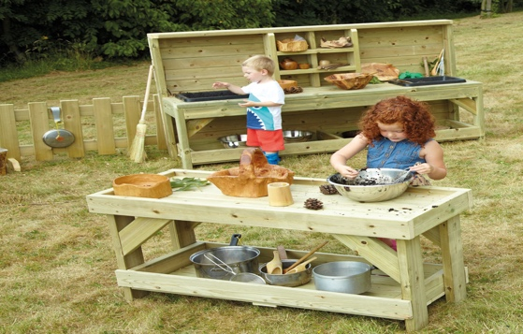

Figure 4: Messy outdoor area with children using natural resources. Image taken from tts-group.co.uk. Available at: https://www.tts-group.co.uk/messy-play-outdoor-wooden-furniture-offer/1006679.html (accessed on 12th October 2018)

I designed my learning environment so that there would be a seamless transition between indoor and outdoor learning. I created a sheltered outdoor area where construction and messy play can take place. This would allow the children in my class to utilise natural resources such as soil, sand, water, leaves and twigs in a creative and imaginative way. I felt that it was important for the learners to experience these resources as they provide an indispensable way for children to interact and play with the things that surround them, helping them to make sense of and develop their understanding of the world. The natural resources available outdoors can be used in a multitude of different ways and offer new play and learning opportunities across the whole curriculum (White, 2014). The inclusion of a construction area would also give learners the chance to explore and experience moments of ‘What happens if I…?’ when experimenting with different tools and resources. Bilton (2010) emphasised that outdoor construction areas also provide a safe space for learners, especially boys, to engage in the type of social, cooperative and more dramatic play that is important for their development, but which they may not be able to experience indoors (Bilton, 2010: 70). Both of these outdoor spaces give learners the chance to experience and learn about the outdoors in an active and imaginative way, making them ideal for continuous provision within my learning environment. They are also ideal for any enhanced provision or focus tasks that link back to the class topic.

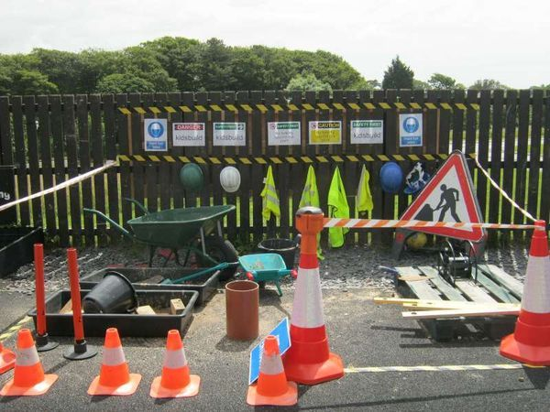

Figure 5: Construction area in an outdoor space. Lots of natural and man-made materials available to use. Image taken from Pinterest. Available at: https://www.pinterest.co.uk/pin/343610646554231948/?lp=true (accessed on 12th October 2018)

Another important aspect of my outdoor learning environment is the inclusion of a nature reserve where the children can take part in welly walks and forest schools. The outdoor areas set up directly outside my classroom are designed to allow the learners to experience and play with the natural resources that I have provided for them; the nature reserve would provide a multi-sensory space for children to experience plants and wildlife in their natural habitat. A notable benefit of forest schools is how it can foster learner’s self-esteem, confidence and well-being (Wilson, 2012). A study conducted by Knight (2009) reported the dramatic effects that being in a natural space can have on individual children. Knight stated that in a natural space normally shy and reserved children began expressing themselves more freely and showed a confidence that had not been witnessed before. This idea of two personalities, the indoor and the outdoor, making themselves known in children has been reported by Bilton (2010), who claimed that the inside persona of a child may be quiet and have little interaction with other children in the class, but once that child is given the freedom to play and explore in an outdoor space another personality can be observed. The child transforms from being an observer of learning to an active participant. This shows how the natural environment can provide a platform for children to express themselves, and how it is important that such areas are provided for learners. Knight (2009) also stated that the setting up of a forest school in a natural space can have the added benefits of marked improvement in concentration, perseverance, cooperation, and motivation in learners. The freedom and space for children to explore and ‘play’ in the nature reserve would have numerous benefits for my learners and that is why I believe that it is an important and necessary component to my ideal learning environment.

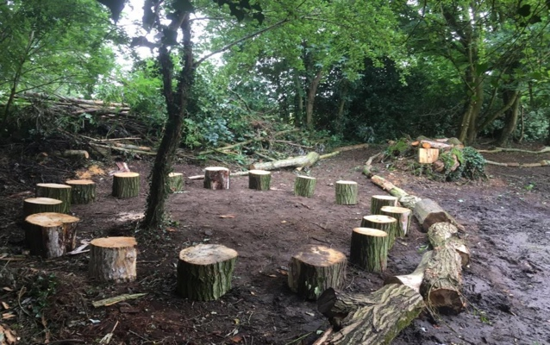

Figure 6: Nature reserve/Forest School area. Image taken from greenscape.services. Available at: http://www.greenscape.services/tree-clearance/forestschools.aspx (accessed on 12th October 2018)

Role play will also be an important part of my ideal learning environment. Role play allows children to explore and be imaginative in a space where anything can happen, and this is imperative for young children’s learning. While it is all too easy to label ‘play’ as frivolous and purposeless, its value and impact on children’s learning cannot be ignored. This is evidenced in the Welsh Assembly Government (WAG) guidance document on the benefits of play for children between 3 and 7 years of age. The document explains how play allows children to be active and engaged participants in their own learning and well-planned play can give children the freedom to explore and make sense of the world around them in a safe space (WAG, 2008). Play has been shown to develop and extend children’s language and communication skills, provides them with the opportunity to explore and rehearse problems (Bryce-Clegg, 2013) and explore their own, and others, emotional well-being. Role play is also the perfect space for children to revisit and expand on their previous learning, firmly embedding the new knowledge and skills that learners have acquired elsewhere in the classroom. Based on this recent consensus and my own observation of play as a tool for learning, I believe it is essential to include a role play area as part of my ideal learning environment. The inclusion of a role play area would also be critical in working towards one of the four purposes of the new curriculum as outlined by Donaldson in the Successful Futures Report. Role play would enable children in my class to develop their creative abilities and by including this in my ideal environment, I will be developing ‘creative contributors’ (Donaldson, 2015), learners who are able to solve and engage with problems creatively, in their learning and work. The role play area would be used as a source of continuous provision, as a space for children to engage in ‘free-play’, however it could also be used as a focus task to be completed with the teacher.

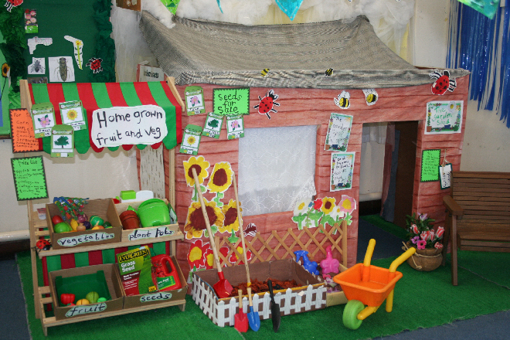

Figure 7: Garden/shop role play area. Image taken from SparkleBox. Available at: http://www.sparklebox.co.uk/gallery/gal766-770/gal769.html#.W8IusFJRfq0 (accessed 12th October 2018)

Another key provision in my ideal classroom will be the use of ICT. While I do not have a dedicated area in my classroom for ICT, I have noted that iPads will be utilised in my learning environment. This is in line with the Digital Competence Framework (DCF) that will be a cross-curricular responsibility for all teachers with the introduction of the new curriculum in Wales. The DCF aims to help children to become more comfortable with and adept at using technology in all its forms, as well as helping children to understand how technology can be a tool used for learning. As with other aspects of my ideal learning environment, play is a central and important theme, and I would encourage the children in my classroom to ‘play’ and experiment with the technology in the classroom. This will enable them to discover what the technology they are using is capable of and will make them more creative and effective in using technology to solve problems (Whitebread & Siraj-Blatchford, 2003: 26). Braithwaite and Siraj-Blatchford also reported that the use of technology has been found to create a collaborative learning environment when children are working on a joint task. This was observed during the learning event at School X where Pupil 1 and Pupil 2 engaged collaboratively on the Maths ICT challenge. The game that they were playing on the computer created a shared communicative space (Mercer, 2000), where Pupil 2 emerged as a more knowledgeable other (Vygotsky, 1978) and helped Pupil 1 to create new understanding about their Maths topic. ICT is a useful and powerful tool in the classroom and it is capable of creating the collaborative work and talk that is vital in the learning environment. The ICT available in my learning environment could be used in a range of ways throughout the classroom, primarily as a means of enhanced provision or as part of a focus task.

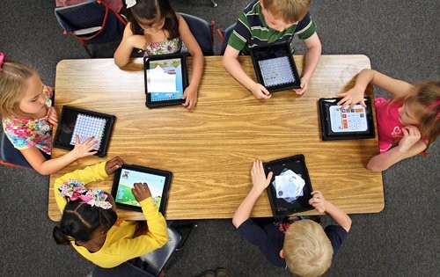

Figure 8: Children using iPads for learning. Image taken from gofundme.com. Available at: https://www.gofundme.com/5xlfho (accessed on 12th October 2018)

The aspects of my learning environment that I have focused on work towards creating a space where learners can explore, play and collaborate together. These aspects would link to other areas in my classroom to ensure that learners experience a rich and varied classroom environment. The learning event that I witnessed demonstrated how this type of open and collaborative classroom, where play is an important part of learning, can gain the best results for learners and this is what I wanted to demonstrate when creating my ideal environment.

Conclusion

To conclude, the learning event that I observed demonstrates how talk and social interaction can be a vehicle for learning within the classroom environment. The exploratory talk that Pupil 1 and Pupil 2 participated in helped to develop new understanding and ability for Pupil 1 and allowed Pupil 2 to revisit their knowledge and embed it more deeply into their long-term memory. They worked critically, but constructively in a shared communicative space that benefitted their learning. This learning event is in line with Vygotsky’s social constructivist approach of the ZPD, which highlighted the importance of dialogue and interaction as a tool to develop and enhance learning. It also aligns with Mercer (2000) who not only defined the different examples of talk that can be found within the classroom environment, but who also developed the idea of the IDZ, a zone of shared communication between those with similar aims, working together on a joint task. Based on these theories and the learning event that I witnessed, I will improve my future teaching practice by becoming a dialogic teacher (Alexander, 2008) who promotes discussion and talk within my classroom. I have also created an ideal learning environment, and through analysis of this in my commentary, I have gained a better understanding of how the learning environment that I develop in my classroom will have a huge impact on the learning of my pupils, which I will use to improve my practice in the future.

Bibliography
Alexander, R.J. (2008). Towards dialogic teaching: rethinking classroom talk. 4th edn. Thirsk, Yorkshire: Dialogos.

Barnes, D. and Todd, F. (1977) Communication and Learning in Small Groups. London: Routledge & Kegan Paul.

Bennett, N. and Cass, A. (1989) ‘The effects of group composition on group interactive processes and pupil understanding’. British Educational Research Journal. Vol. 15, pp. 119-132.

BERA (2018). Ethical Guidelines for Educational Research. Available at: https://www.bera.ac.uk/wp-content/uploads/2018/06/BERA-Ethical-Guidelines-for-Educational-Research_4thEdn_2018.pdf?noredirect=1 (Accessed: 12th October 2018)

Bilton, H. (2010). Outdoor learning in the early years: management and innovation. London: Routledge, pp.70-86.

Blatchford, P., and Kutnick, P. (2003) ‘Developing groupwork in everyday classrooms’. Special issue of the International Journal of Educational Research. Vol. 39, pp. 1-11.

Bruner, J. (1978). ‘The role of dialogue in language acquisition’. In A. Sinclair, R., J. Jarvelle, and W. J.M. Levelt (Eds) The Child's Concept of Language. New York: Springer-Verlag.

Bruner, J., and Haste, H. (1987). Making sense: The Child’s Construction of the world, London: Methuen.

Bryce-Clegg, A. (2013). Creative role play in the early years: how to plan stimulating and exciting role play, inside and out. London: Featherstone Education.

Cowie, H., and van der Aalsvort, G. (Eds.). (2000). Social Interaction in Learning and Instruction. Oxford: Pergamon.

Donaldson, G. (2015). Successful Futures: Independent Review of Curriculum and Assessment Arrangements in Wales. Available at: https://gov.wales/docs/dcells/publications/150225-successful-futures-en.pdf (Accessed: 6 October 2018).

Fernandez et al. (2015). ‘Re-conceptualizing “Scaffolding” and the Zone of Proximal Development in the Context of Symmetrical Collaborative Learning.’ Journal of Classroom Interaction, 50 (1), pp 54-72.

Galton, M., Hargreaves, L., Comber, C., Wall, D. and Pell, A. (1999) Inside the Primary Classroom: 20 years on. London: Routledge.

Grigg, R. (2010) Becoming an outstanding primary school teacher. Harlow: Longman, p. 305.

Grigg, R., and Lewis, H. (2016). A to Z of Learning Outside the Classroom. London: Bloomsbury Publishing.

Johnson, D.W., and Johnson R.T (1999) ‘Making Cooperative Learning Work.’ Theory Into Practice. Vol. 38 (2), pp.67-73.

Knight, S. (2009). Forest School and Outdoor Learning in the Early Years. London: Sage Publications.

Littleton, K., and Light, P. (1999). Learning with Computers: Analysing Productive Interaction. London: Routledge.

Mercer, N. (1995). The Guided Construction of Knowledge. Clevedon: Multilingual Matters, p.105.

Mercer, N. (2000). Words and Minds: How we use language to think together. London: Routledge, p.141.

Mercer, N. and Elsevier, B.V. (1996). ‘The Quality of Talk in Children’s Collaborative Activity in the Classroom’, Learning & Instruction. Vol.6 (4), pp.359-377.

Myhill, D. and Brackley, M. (2004). ‘Making Connections: Teachers’ Use of Children’s Prior Knowledge in Whole Class Discourse’. Vol.52 (3), pp.263-275

Palaiologou, I. (2008). Childhood Observation. Exeter: Learning Matters, p.60.

Rojas-Drummond, S. and Mercer, N. (2004) ‘Scaffolding the development of effective collaboration and learning’, International Journal of Educational Research. Vol. 39, pp. 99-111.

Siraj-Blatchford, J. and Whitebread, D. (2003). Supporting ICT in the early years. Berkshire: Open University Press, p.26.

Thomas, A. and Lewis, A. (2016). An Introduction to the Foundation Phase: Early Years Curriculum in Wales. London: Bloomsbury.

Waite, S. (2017). Children Learning Outside the Classroom: From Birth to Eleven. 2nd edn. London: Sage Publishing.

Wells, C. (1987). The Meaning Makers: Children Learning Language and Using Language to Learn. London: Hodder and Stoughton, p.53.

Wegerif, R. and Scrimshaw, P. (Eds) (1997). Computers and Talk in the Primary Classroom. Clevedon: Multilingual Matters.

Welsh Assembly Government (2008). Play/Active Learning: Overview for 3 to 7-year-olds. Available at: http://learning.gov.wales/docs/learningwales/publications/130215play-activeen.pdf (Accessed: 6 October 2018).

White, J. (2014). Playing and Learning Outdoors: Making provision for high quality experiences in the outdoor environment with children 3-7. 2nd edn. Oxon: Routledge.

Wilson, R. (2012). Nature and Young Children: Encouraging creative play and learning in natural environments. 2nd edn. Oxon: Routledge.

Image References

Figure 2, Visual Representation of Vygotsky’s ZPD. Available at: https://barbarabray.net/2017/08/31/7-strategies-for-personal-professional-learning/ (Accessed: 12th October 2018)

Figure 4, Outdoor Messy Area. Available at: https://www.tts-group.co.uk/messy-play-outdoor-wooden-furniture-offer/1006679.html (Accessed: 12th October 2018)

Figure 5, Outdoor Construction Area. Available at: https://www.pinterest.co.uk/pin/343610646554231948/?lp=true (Accessed: 12th October 2018)

Figure 6, Forest school/nature reserve area. Available at: http://www.greenscape.services/tree-clearance/forestschools.aspx (Accessed: 12th October 2018)

Figure 7, Role Play Area. Available at: http://www.sparklebox.co.uk/gallery/gal766-770/gal769.html#.W8IusFJRfq0 (Accessed: 12th October 2018)

Figure 8, iPads in the classroom. Available at: https://www.gofundme.com/5xlfho (Accessed: 12th October 2018)

Figure 9, Creative area. Available at: https://www.pinterest.co.uk/pin/518547344570416457/?lp=true (Accessed: 12th October 2018)

Figure 10, Reading den. Available at: http://designinganewme.blogspot.com/p/classroom-decor.html (Accessed: 12th October 2018)

Figure 11, Rainbow challenge wall. Available at: https://www.pinterest.co.uk/pin/554505772853433866/?lp=true (Accessed: 12th October 2018)

