

Education and offending: an exploration of links between childhood experiences and offending.

Name: Elisha Phillips
Student ID: 1901362
Degree: Policing and Criminology
Due Date: 6th May 2022
Wordcount: 13131

Acknowledgements –

I would like to thank my supervisor Mike Durke for helping me through this module and his continued support throughout my university experience.
I would also like to thank my parents, grandparents and my boyfriend for their ongoing support and encouragement throughout the past three years of my degree. Their support has allowed me to pursue my degree and to always remain positive. I am forever grateful for the support I have received.

Abstract –
The aim of this dissertation is to discuss the links between education and young offending. It will discuss the importance of education and analyse the statistics surrounding the topic. It will also consider some of the other factors that could lead to a young person committing crime. This includes adverse childhood experiences such as physical abuse, neglect, and drug and alcohol misuse.
An objective for this paper is to also research what preventative measures, if any are in place to help young vulnerable people, this includes early intervention and support within schools.
Research was conducted to obtain primary research to support the discussion. An online questionnaire was formed and posted to social media such as Facebook and Instagram for the public to respond to. It was also sent to the researchers, friends, family, colleagues and lecturers. This was to gather a varied and reliable sample group, which was essential inorder to gather enough responses from a variety of age groups and backgrounds to determine the general public’s opinion on young offending.

Declarations -
This work has not previously been accepted in substance for any degree and is not being concurrently submitted in candidature for any degree.
Statement 1
This dissertation is being submitted in partial fulfilment of the requirements for the degree of BA/BSc.
Statement 2
This dissertation is the result of my own independent work/investigation, except where otherwise stated.
Other sources are acknowledged in the reference section.
Statement 3
I hereby give consent for my dissertation, if accepted, to be available for photocopying and for interlibrary loan, and for the title and summary to be made available outside originations.
Statement 4
I hereby give consent for my dissertation, if accepted, to be available on the university’s IT system to those who have consent to use the system.

Signed: Elisha. J. Phillips Date: 06/05/2022

Table of contents –

Chapter 1 – Introduction…………………………………………………….…………….6
1.1 introduction…………………………………………………………………….……….6
1.2 Background and Rationale……………………………………….………….…….….6
1.3 Aims and Objectives……………………………………………………...……….…..7
Chapter 2 - literature review…………………………………………………...…………8
2.1 Introduction to literature review……………………….…………………..………….8
2.2 The current education system………………………………………………………...8
2.3 Links between education and crime…………………………………………………10
2.4 Adverse childhood experinces………………………………………………….……12
2.5 What is currently in place to help children with ACE’s in the education system..14
2.6 Preventing youth offending through other avenues………………..….….………..15
2.7 Literature review conclusion…………………………………………………………..18
Chapter 3 – Research methods…………………………………………………………..18
3.1 Introduction to research methods……………………………………...……………..18
3.2 The research onion……………………………………………………...……………..19
3.3Research philosophy…………………………………………………….……………..20
3.4 Research approach and strategy…………………………………………..…………21
3.5 Research choices………………………………………………………………………21
3.6 Time horizons…………………………………………………………….…………….21
3.7 Techniques and procedures……………………………………….…………..……..21
3.8 Questions and literature review matrix………………………………….….………..22
3.9 Ethical considerations…………………………………………………...…………….23
3.9.1 Research methods conclusion……………………………………………………..23
Chapter 4 – Findings……………………………………………………………………….24
4.1 Findings introduction…………………………………………………….…………….24
4.2 data analysis……………………………………………………………………………24
4.3 Demographic……………………………………………………………..…………….24
4.4 analysing responses…………………………………..……………………………….25
4.5 Findings conclusion……………………………………………………………………32
Chapter 5 conclusion and recommendations……………………………..……………..33
5.1 Introduction……………………………………………..………………….…….……..33
5.2 Main findings…………………………………………….……………………………..33
5.3 Recommendations…………………………………….…………………………….…33
5.4 Completed aims and objectives………………………………………………………34
5.5 Conclusion………………………………………...……………………………………35
Bibliography……………………………………………..………………………………….36
Ethics form………………………………………………………………………………....40

Chapter 1: Introduction –

Introduction –
This chapter will provide the structure of the research for the paper. It will also provide the rationale and background to young offending in the UK. This chapter will also include the aims and objectives for this dissertation and the research into the publics views on young offending in the UK and its links to education.

Background and rationale –
According to the law in England and Wales a young offender is a person between the ages of 10 and 17 that commits a crime (GOVUK 2022 A). A person aged 18 and above is by law classed as an adult and will be tried as an adult in court, if they have committed a crime. Any person below the age of 10 is currently not considered to be criminally responsible and therefore cannot be charged or sentenced for any crime. There are other forms of punishment for children under 10 who commit crime these include; a child protection order and a local child curfew (GOVUK 2022 B). People classed as young offenders between the ages of 10-17 are dealt with differently after committing a crime. Young offenders are not sent to an adult prison they are tried by youth courts instead of a magistrate’s court or crown court.
When sentencing a child, a court must always take into consideration the effect the sentence will have on the child whether its positive or negative (Sentencing council 2017). The severity of the crime, will always be one of the main factors when it comes to the sentencing process. However, rehabilitation will be the main outcome of sentencing and a young offender will only be sent to a secure youth centre, instead of a prison for the most serious crimes or for repeat offending. Schooling is provided for the young offenders detained in the secure youth centres and all exams and qualifications that the young person would usually take will be taken inside the centre, these include GCSE exams. Teachers inside the secure youth centre will work with the youths to ensure they get the best grades possible and continue to provide education whilst away. According to a government issued 2014 press release, young offenders are contracted to attend at least 12 hours of schooling a week, this is compared to the average of 30 hours a child outside of the secure centre would attend (Ministry of justice et al 2014).
According to the registered charity Shannon’s trust, more than 50% of prisoners in the UK cannot read or at least struggle to (Shannon’s trust 2022). Shannon’s trust was created by Christopher Morgan after he came in contact with a prisoner named Tom Shannon who was serving life. Morgan was shocked to discover that majority of the prison had extremely poor literacy levels and together they both worked to improve the reading and writing of the prisoners. Over 50% of prisoners in the UK have the literacy level of an 11-year-old or cannot read and write at all. The Shannon trusts works with prisons to ensure that inmates are developing literacy skills. They achieve this by providing volunteers into attend prisons to work prisoners. They alos encourage other prisoners who can already read and write to teach others. The trust has worked with prisons across England and Wales and 9 out of 10 of the prisoners who learn to read and write through the Shannon trust then seek further education. The trust prides itself on educating the prisoners through relaxing and enjoyable techniques that do not require formal test or exams. Providing prisoners with this opportunity has also proven to prevent them becoming disruptive by giving them something to focus on.
Shocking statistics like these are far too common and the question is often asked, why wasn’t more done for these people when they were younger. Prime time for education is between the ages of 5-16, reading and writing is taught to a child in key stage 1 between the ages of 5 and 7, so it is brought into question why proper education was not given to these individuals who have ended up in the prison system (GOVUK 2022 C).

Aims and objectives –

Aim –
“Education and offending: an exploration of links between childhood experiences and offending.”

Objectives -
Objective 1 – To critically analyse the importance of education for young offenders
Objective 2 – To critically evaluate the effects for adverse childhood experiences and its links to crime.
Objective 3 – To critically analyse current procedures and what is being done to help children who are at high risk of committing crime.

Chapter 2: Literature review –

2.1 Introduction to literature review -
The aim of this portion of the dissertation is to assess academic literature regarding what events occurring at childhood can potentially lead to a person being more likely to commit crime. This portion of the dissertation will also discuss and answer objectives 1-3, these objectives are;
Objective 1 – To critically analyse the importance of education for young offenders
Objective 2 – To critically evaluate the effects for adverse childhood experiences and its links to crime.
Objective 3 – To critically analyse current procedures and what is being done to help children who are at high risk of committing crime.
This literature review is consisted of academic journals and publications which have been sourced from areas such as google scholar, online publications and the University of wales trinity St David library.

2.2 The current education system -

It is important to understand how the current education system works in the UK. There are currently four main stages to education in England, Wales and Northern Ireland (AEGIS 2019). These four stages include Primary education, secondary education, further education and higher education. By law children must attend primary education and secondary education, begin schooling at age 5 at the latest and finish aged 16 at the earliest. Compulsory education is split into 4 key stages (Study in the UK 2022). Key stage one is for pupils aged 5 to 7 years, this is often the first education experience a child has received so basic lessons will be taught to the pupils. Basic English and mathematics skills will be taught throughout key stage 1 to build a foundation of knowledge to move forward. Key stage 2 is for children aged 7 to 11, this is where their knowledge on subjects will be tested more to establish how well they are learning. Subjects such as English language and literature, mathematic and science will be taught throughout this stage and each teacher should asses their pupils progress in these subjects. Key stage 3 is a very important stage in a child’s education as this is where they would enter secondary education. New subjects such as history, drama and geography will be introduced in the lead up to their GCSE exams. A GCSE is a general certificate for secondary education (Politics 2021). GCSE exams are taken in year 11 in key stage 4. In Wales and Northern Ireland, the grading scheme grades alphabetically where as in England they have adapted a numerical approach to grading. In Wales and Northern Ireland, the highest grade is a A*, this is equivalent to a 9 in England’s grading system. There are compulsory subjects which form part of the curriclum, these are; English language, English literature, Mathematics, science and in Welsh first language schools they must sit welsh language and welsh literature exams. In some schools’ subjects such as religious education may be compulsory however this varies from school to school. Pupils may also choose other subjects such as history, art and drama in order to gain more qualifications. Pupils are expected to achieve a grade C or equivalent to pass their exams comfortably. Many schools now claim that a grade D is a pass however many colleges and six forms may only accept a grade C and above.

2.3 Links between education and crime -

According to the education secretary in 2019 Damian Hinds, if a child has had contact with a social worker any time after year 5 in school which is key stage 2, they are more likely to score an average of “20 grades lower over eight GCSE’s” (Hinds MP 2019). New research conducted by the education endowment foundation also suggests that the recent coronavirus pandemic has had a huge negative effect on disadvantaged children (EEF 2021). Their study suggests that there is concern over the development of disadvantaged children’s learning and that there is an ever-growing gap between disadvantaged pupils and their peers. The education endowment foundation, also known as EEF has explained that due to schools closing due to the pandemic, disadvantaged children have not received the extra help and support from schools that they may need. Thus, allowing more of a gulf to develop. It is important to know exactly what the government and the education system class ad a “disadvantaged child”. According to RT Hon Sajid Javid MP, secretary of state for the department for communities and local government, a disadvantaged child and or family can cover a wide spectrum (Javid MP 2019). Disadvantaged children can include children in the care system, children from low income areas and disadvantaged families. Disadvantaged families can include unemployment, debt, alcohol and substance abuse, mental health problems and abusive or violent households. These circumstances can disadvantage a child in many ways in their education journey through absences, lack of concentration and a lack of support at home. In 2016 Charlie Taylor published his review of the youth justice system, this review was requested by the ministry of justice (Taylor 2016). In this review Taylor explains that the number of minor offences committed by young people is on the rise and as such highlights the importance of education for young people. Taylor explains that to ensure we minimise the number of young offenders from committing further crimes as adults we must treat them as children and not as adults. This means that instead of instantly handing them a custodial sentence or other forms of punishment we must use the health and education systems to improve these children’s lives. In the review he stresses the importance of children remaining in school until they are 18 years of age. Many times, disadvantaged children drop out of school at 16 due to lack of opportunity, interest or because of exclusion. Because of this according to a study in the report, more than half of 15-17-year olds in youth offending institutes have the literacy and numeracy level of a 7-11-year-old. Charlie Taylor’s theory is that if a young person is occupied throughout the day in school, studying or playing sport that they are less likely to commit crime. This review calls out for the health and education system to do more to help disadvantaged children from falling into a life of crime. It suggests that more opportunities should be given by schools to pupils an example of this is teaching children trades so that they develop the skills they need to allow them to get jobs. Also, to provide hobbies for children, so they have things to keep them occupied making them less likely to participate in disruptive or criminal behaviour. The review figures showed a drop of 79% in the amount of young people cautioned or convicted between 2007-2015 (Webster 2016). The review does however state that majority of youths that are cautioned or convicted have “complex needs” or are black Asian or from other ethnic minority groups. Taylor’s review is concluded by explaining that it is essential for the health, social and education systems to work together to help these at-risk youths. Recommendations from the review include; more funding for communities, more mental health support for young people, and for the government to set up secure schools.

2.4 Adverse childhood experiences -
It is also important to understand that there are many factors that may contribute to a child being considered at risk of becoming a young offender. Another one of these factors being adverse childhood experiences also known as “ACE’s”. Adverse childhood experiences are experiences a child might have that are considered “highly stressful and/or traumatic (NHS 2022). Examples of these adverse childhood experiences include the following;
- Physical abuse
- Sexual abuse
- Living with someone who abuses drugs and/or alcohol
- Living with someone who has gone to prison
- Living with someone who has serious mental health problems
- Losing a parent through death, divorce or abandonment
- Exposure to violence
These adverse experiences can lead to a child developing anti-social behaviour, poor mental health which can make it difficult for the child to develop healthy friendships and relationships in the future. ACE’s are extremely common with a 2014 survey suggesting that 47% of the UK had experiences 1 ACE and 9% of the population had experienced 4 or more ACE’s (Bellis et al 2018). The more ACE’s a person has experienced and the greater the length of time they have experienced it for, the more likely it is that they will experience these challenges throughout their lives (Public health Scotland). According to research conducted by the NHS in England and Wales, 1 in 3 cases of diagnosed mental health conditions can be linked back to at least 1 ACE. Self-harm is also common for people who have been exposed to these experiences.
Along with these social and behavioural issues that can stem from ACE’s, studies have also shown that a child who has experienced ACE’s may also suffer physically as these children are significantly more at risk of getting cancer, heart disease and diabetes and are more likely to smoke and drink more alcohol than average (Blair, Boullier 2018). A 2014 Ted talk presented by paediatrician and surgeon Nadine Burke Harris perfectly highlights the serious issues that adverse childhood experience can cause to a person’s health throughout their lifetime (Harris 2014). Harris explains in her presentation that high doses of these experiences effects brain development, the development of a person’s immune system and the hormonal system, each a key element to a person’s development. She explains that high levels of stress caused to a child through these experiences targets certain areas of the brain these include; the nucleus accumbens which is the part of the brain that controls pleasure and reward and the prefrontal cortex which controls impulses. MRI tests have also shown that there are “measurable differences” in the amygdala which is the fear response centre part of the brain. The severe effects this has neurologically, results in lifelong health issues and studies have shown in the United States of America that people who have had these adverse childhood experiences have on average a 20-year difference in life expectancy compared to those without this exposure. Nadine Burke Harris suggests that there are numerous ways of treating people who are experiencing the effects of ACE’s but the number one way to prevent adverse childhood experiences is through educating parents on the effects of this and how detrimental it can be to their child’s life.

2.5 What’s currently in place to help children with ACE’s in the education system -
There have been growing efforts in recent years to tackle young offending and to prevent young people who may be seen by society as “troubled children” from entering the justice system. Schools and the education system play a key role in a young person’s life and children usually spend more time in schools than with any other public service (Gray HMI 2020). This makes teachers one of the only other people that children see as often as their parents or carers, this can be a prime opportunity to spot concerning behaviour as soon as it begins. The Welsh government have implemented several strategies for teachers and school staff to encourage children and promote positive behaviour. This can include after school clubs where young people can develop hobbies and nurturing sessions where young people have the chance to socialise and develop friendships before and after school. Breakfast clubs are also helpful in ensuring children have a balanced breakfast, so as to prevent hunger and promote learning (Graham et al 2020). This also teaches the children social skills and nutritional balance. Quiet rooms are also suggested particularly as older children can sit and relax and possibly escape overwhelming and stressful situations. Creating a safe space for children in school allows for a positive experience and can promote better attendance. Estyn is a section of the Welsh government which is responsible for assessing schools and determining what can be done to improve education and the learning environment. According to their report in 2020, there are multiple things teachers can do to help them identify individuals who may be experiencing adverse childhood experiences allowing them to quickly provide extra support (Estyn 2020). Teachers and school staff are trained to spot risk behaviour which may correlate with ACE’s. When working with a vulnerable or at-risk child the teacher should work with other organisations and always placing that child’s safety and happiness first. Teachers are also encouraged to involve families in school activities such as sports days, school trips and bake sales. Involving a family in their child’s school activity may lead to building better relationships within the family in order to improve the quality of the child’s life at home. An example in the Estyn report shows a school located in Butetown Cardiff. The school is in a high deprivation area and consists of around 500 pupils 94% of which are ethnic minority. Challenges arise at the school as many parents of the pupils are not fluent in English, the school has adapted by trying to employ bilingual staff in order to improve this challenging situation. The school works closely with the pupils and their families to create a strong bond and relationship, they do this by organising coffee trips and days out. Staff at the school are trained to spot ACE’s and by having so much contact with the families this enables them to asses the situation closely.

2.6 Preventing young offending through other avenues –
The education system can provide important assistance when trying to prevent young people from offending and from struggling with the effects of adverse childhood experiences. There are however efforts being made by other public services to spread the responsibility. Following the 2016 Charlie Taylor review, as previously mentioned secure schools were suggested as a possible way to reform young offenders instead of simply punishing them (Ministry of justice 2016). Secure schools would be schools for young people who currently attend youth offending institutes and have been sentenced. These schools would house between 60-70 young people. These secure schools would provide the young people with extra support and education and provide specialised care for those who are having trouble due to circumstances like ACE’s. The UK government have made it clear that these proposed secure schools will not be prisons with more education but more of a “secure children’s home”. Secure schools such as these are thought to be the way forward for helping young vulnerable people to improve their quality of life and get a second chance by providing a stable learning environment. In 2020 the UK’s first secure school was proposed to be opened in Kent by the charity “Oasis Charitable Trust” (Ministry of justice 2019). The government provided the charity with £5million to create the school. Since this proposal the opening day for the new secure school has been pushed back due to legal complications, it is now thought to be opening as late as 2023 (Inside times report 2021). The school is going to be in place of Medway training centre. Medway training centre was the home for young people involved with the justice system between the ages of 12-17 (BBC 2019). The centre was heavily criticised as Ofcom reviews suggested that children were “at risk of harm” and that the centre overall was inadequate. Since the shocking review the centre has shut down and the secure school is set to take its place.
As well as potentially introducing secure schools across the UK and continuing to train teachers and school staff to spot signs of ACE’s, the UK also has early intervention. Early intervention is a programme which aims to tackle problems within a family, these problems can include the adverse childhood experiences (Early intervention foundation 2022). Early intervention can come in many forms such as at home visits by a social worker, school visits and mentoring groups. Early intervention can be brought into a child’s life by a concerned neighbour, teacher, family member or anyone who may feel like a child is vulnerable. Early intervention has been proven to reduce criminal behaviour, violent behaviour, the misuse of drugs and alcohol and even teenage pregnancy (Allen MP 2011). According to a report for the Ministry of Justice in 2011, a study conducted assessed 3-year-old boys who were deemed as being at risk. The study concluded that the boys who were at risk had two and a half times more criminal convictions by the time they were 21 than the boys who were not deemed to be at risk.
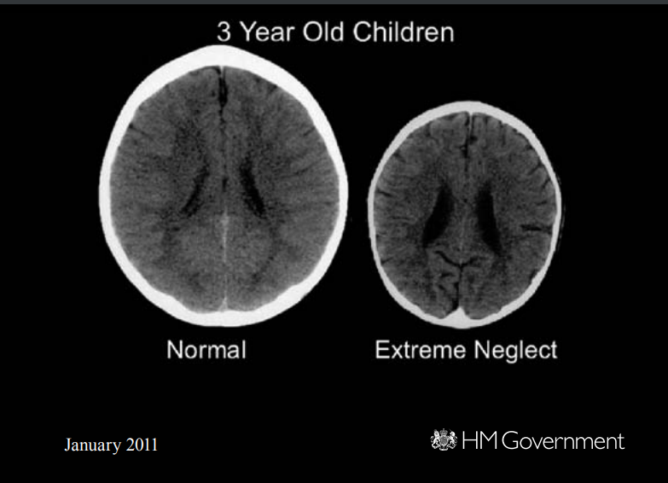
Early intervention in summary is the support given to vulnerable children to try and deter them to committing crime, early intervention aims to tackle the problem before it occurs.

2.7 Literature review conclusion –
To summarise this chapter of the dissertation, there are many contributing factors that could lead to a young person committing crime. Education has a huge role to play in a child’s life and therefore it is essential for schools to have the training required to intervene early enough. Practices and procedures are needed to detect any worrying behaviour or signs. Secure schools have been proposed however, legal issues have risen and the question of whether these schools may adapt very negative traits and practices like the Medway training centre may always be a worry. Early intervention can relieve pressure from other services such as the education system. It has been proven that children need the support as soon as possible therefore if these services take a holistic approach more support can be given to young vulnerable people more efficiently.
The next chapter will discuss the appropriate research methods and methodology for successful research into the topic in question. Research into the topic has been to analyse the publics opinion on youth offending and to reinforce the points made above.

Chapter 3 Research methods –

3.1 Introduction to research methods –
Research is essential to all businesses. There is however no definition in literature to determine what research is exactly (Collis 2013). This is because research is a broad spectrum and means different things to different people. There is an overall agreement on what research means and this is that it is systematic and methodical and that it increases people’s knowledge. The aim of this chapter is to discuss and analyse research conducted to review a sample of the public’s opinion on youth offending. To do this a technique called the Research Onion by Saunders et al 2019 will be used to thoroughly discuss the methods of research used and its effectiveness. The research conducted aims to review the opinions of a sample of the public to answer the following objectives:
Objective 1 – To critically analyse the importance of education for young offenders
Objective 2 – To critically evaluate the effects for adverse childhood experiences and its links to crime.
Objective 3 – To critically analyse current procedures and what is being done to help children who are at high risk of committing crime.

3.2 The research onion –
The research onion was created by Saunders et al 2019. It is most simply described as a holistic approach to methodology (Phair, Warren 2021). The research onion is comprised of size main layers. Each layer holding a specific meaning. A researcher should work through the onion one layer at a time starting from the outer layer. These layers are; Research Philosophy, research approach, research strategy, research choices, time horizons and techniques and procedures. The aim of using this approach to methodology is to gain a better understanding of research and ensure tat the research conducted is reliable, transparent valid. This approach can help a person conducting research to determine what approach they would like to take and to support what methods the researcher decided to choose.
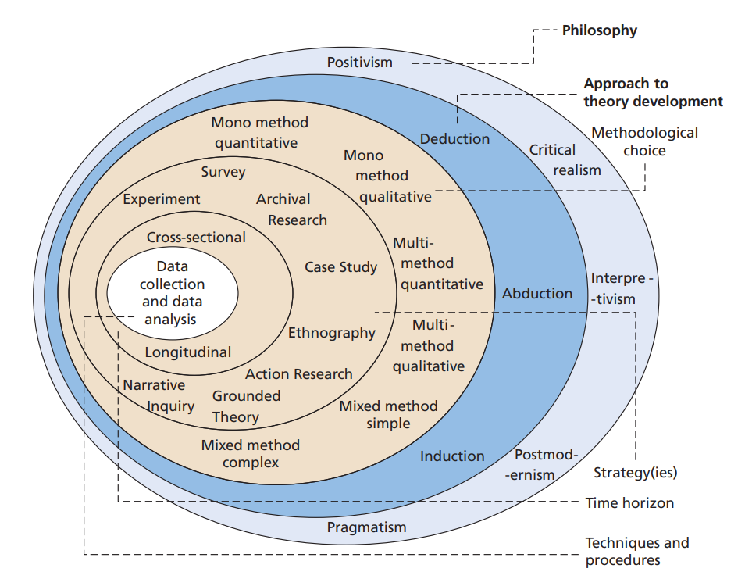

3.3 Research Philosophy –
According to Saunders et al 2015, the research philosophy layer to the research onion refers to beliefs and assumptions made of the topic which is being researched. According to Saunders et al a researcher may subconsciously make pre-made assumptions about the research which may shine through to the research itself. The theory s that structured assumptions should be made to avoid this.
There are two main sections to research philosophy, these are epistemology and ontology.
Epistemology is defined as being what constitutes valid knowledge and how can we obtain it. Epistemology is the assumptions we make about the world. Epistemology tries to make sense of all knowledge (Al-Saadi 2014). Ontology on the other hand is “the study of being”. Ontology is concerned with the nature of reality. Examples of ontology questions would be “what is the nature of existence” where as an example of an epistemology style question would be “what do you know”. There is however another section to research philosophy and this is interpretivism. Interpretivism looks at research from a social perspective and uses qualitive research to dive deeper into a topic (Alamgeer 2022). Interpretivism will say that knowledge is relative. The research in this dissertation will take an interpretivism approach as it will use the public’s perception.

3.4 Research approach and strategy –
To conduct the research in this dissertation a questionnaire has been used to collect the opinions from a sample of the public. A questionnaire is an effective form of research as it is simple for participants to complete resulting in more completions of the questionnaire and it is also easy to track all answers from the survey (Reference 2020). The questionnaire was published onto social media and sent out to family, friends, colleagues and lecturers. A variety of demographics were met as the questionnaire received responses from different age groups, different professions and gained a variety of opinions. Results from the questionnaire will contain a mixture of quantitative and qualitive data as it is comprised of both “yes and no” questions and questions where participants must answer in more depth. It will also take both an inductive and a deductive approach as it will be compared to already existing theories but also look at a broad generalisation (Keiling 2021). This coincides with using a mixture of qualitive and quantitative data.

3.5 Research choices –
This study used a mono method to its research. A mono method approach to research according to Saunders et al 2015 is using 1 approach to gain research. The one approach being the questionnaire. Although the questionnaire will give insight into the publics opinion on the topic and cooperate the points being made in previous chapters, if done again a mixed method or a multi method may be more beneficial. A mixed method and a multi method use more than one approach and more research methods in order to obtain a wider variety of responses and data.

3.6 Time horizons –
Longitudinal study is a study conducted over a long period of time (Thomas 2021). For example, this can be a study conducted once a year over 5 years or even longer. A cross sectional study is the opposite. Cross sectional studies are conducted within a short period of time and usually with a deadline. The questionnaire for this research was needed to be completed as soon as possible due to a deadline for this dissertation. The questionnaire was sent our months in advance and data was collected once all responses were in.

3.7 Techniques and procedures –
The reasoning behind the research conducted is to reinforce the dissertations objectives. To gain a sample of opinions from the public to see how they view youth offending can be very useful in determining what more can be done in communities to prevent young offending. The research will be primary data but can be used to compare against secondary data if needed. The sample for the questionnaire was wide. The questionnaire got 113 responses from a variety of different age groups. The questionnaire also asked for the respondent’s occupation in order to understand what knowledge or expertise the person may have on the topic. The questionnaire was published onto social media and free for anyone to respond meaning there was no bias beforehand and the results are as valid as possible.

3.8 Question and literature review matrix -
Survey questions | Association to chapter 2
Q1. What is your age group? | This is a demographic related question. It has been asked to assess whether the questionnaire has a wide sample and a variety of demographic.
Q2. What is your profession? | This is another demographic question. This question can help assess whether the person may have any expertise on the topic and provides knowledge on the sample.
Q3. At what age do you think someone should be held criminally responsible for crime (Criminal responsibility) | This question was asked to begin to assess the respondent’s opinion on young offenders and whether or not they think young people should be held criminally responsible from a young age or not.
Q4. Do you think a child’s upbringing and environment can have an effect on future behaviour and possible lead to them committing crime? | This question was a tick box question with the answers “yes” “no” and “not sure”. This is a broad and complex question therefore I did not want respondents to get overwhelmed by the questions and instead I asked for an explanation in the form of other questions below. This question gives an overview of whether a sample of the public believe adverse childhood experiences and other factors can lead to offending.
Q5. *Early intervention is help given to a child at the early stages of their lives when they display “risk behaviour” this can include but is not limited to; poor general health, poor school attendance and problems at home such as exposure to violence *  Do you believe that early intervention can be beneficial in a child’s life? Please explain the reasons behind your answer. | This question begins with a brief definition of what early intervention is. The question then asks respondents what their opinion is on early intervention and if they think it can be beneficial to a child’s life. The respondent is given an answer box where they can write as little or as much as they would like. It is beneficial to see what the public think of early intervention to see if people have faith in the system or not.
Q6. What childhood experiences do you think can have the biggest negative impact on a child’s behaviour? | Respondents were again given a writing box where they could write as long of an answer as they would like. The reasoning behind this question was to see what areas the public think should be targeted more upon as they believe it can lead to young offending.
Q7. What do you think can be done in schools to help children that are potentially more at risk of committing crime? | This question can be beneficial for the findings as it can lead to recommendation for what should be done in the education to help young vulnerable people. Getting the opinion of a variety of members of the public can show a pattern in what the consensus is for helping young people.

3.9 Ethical considerations –
According to Saunders et al 2015 ethical considerations are extremely important to ensure that research is reliable, valid and morally correct. Ensuring the anonymity of each participant is key in not only making them feel comfortable but to also ensure the research is honest and reliable. Participants could refuse to complete the online questionnaire and each response is completely anonymous. At the beginning of the questionnaire was a statement informing participants that the data from the questionnaire will be used in this dissertation. They were also re assured that all Reponses were anonymous and no personal details other than what they decide to share on the questionnaire will be used.
An ethics form was created detailing all information regarding the research methods used. This ethics form was then produced to the course supervisor to ensure there were no ethical concerns. The ethics form was signed and dated and sent to the University of Wales Trinity St David. As stated on the ethics form all data was kept on a password protected device and was not shared to anyone other than the researcher, this is to protect the respondent’s privacy and for the research to remain reliable.

3.9.1 Research methods conclusion –
To conclude this chapter the Saunders et al 2019 research onion was used to create an online questionnaire to gather research and answer the 3 main objectives of this dissertation. An ethical approach was also taken ensuring that all participants remained anonymous and the research remains reliable and valid.

Chapter 4 findings –

4.1 Findings introduction –
This chapter of the dissertation will analyse the results of the online questionnaire that was created to determine a sample of the publics opinion on questions relating to the three main objectives. Each question relates to young offending and includes a mixture of tick boxes and questions which require more in-depth answers. There is a total of 113 responses to the online questionnaire meaning there is a generous size of sample to analyse.

4.2 Data analysis -
To analyse the data from the online questionnaire the Microsoft programme excel will be used. This software will be used to gather all of the data and to create graphs showing the results from some of the questions. The questions in which needed a longer more in-depth answer will be screenshot and placed into the dissertation to discuss. A general consensus will be made from the longer responses to determine what the average opinion was.

4.3 Demographic –
As the online questionnaire was posted to social media such as Facebook and Instagram and was also sent through email to family, friends and lecturers, the questionnaire has 113 responses with a variety of age groups. Each participant answered each all 7 questions and the average time it took a participant to complete the survey was between 3 and 4 minutes. The questionnaire was also specifically sent out to friends, collaegues and family members from different lines of work. This was to determine whether people from different professions viewed young offenders differently to others.

4.4 Analysing responses -
Age demographic:
Of 113 respondents all answered the first question which asked their age group
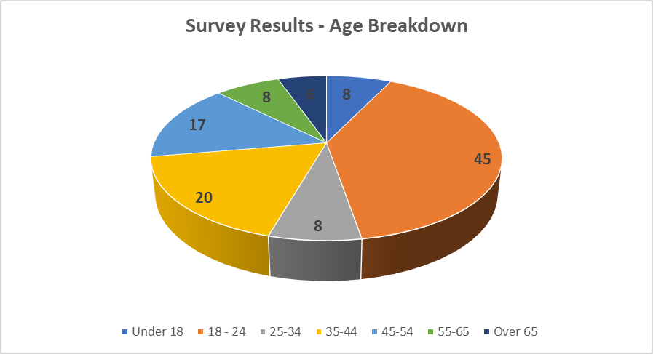
The pie chart above was created on excel and depicts the results from the age group question. Almost 40% of participants answered that they were in the 18-24 age group category. This result is more than likely due to the questionnaire being uploaded to social media pages such as Facebook and Instagram where majority of audience is in that age group. The second largest age group was the 35-44-year-old age group with 20 participants and the lowest being the over 65 age group with only 6 participants.
Professions of respondents:
The second question on the questionnaire was asking the profession of each respondent. Each profession was categorised and there was also an option for “other” if their profession did not fit into one of the other categories.
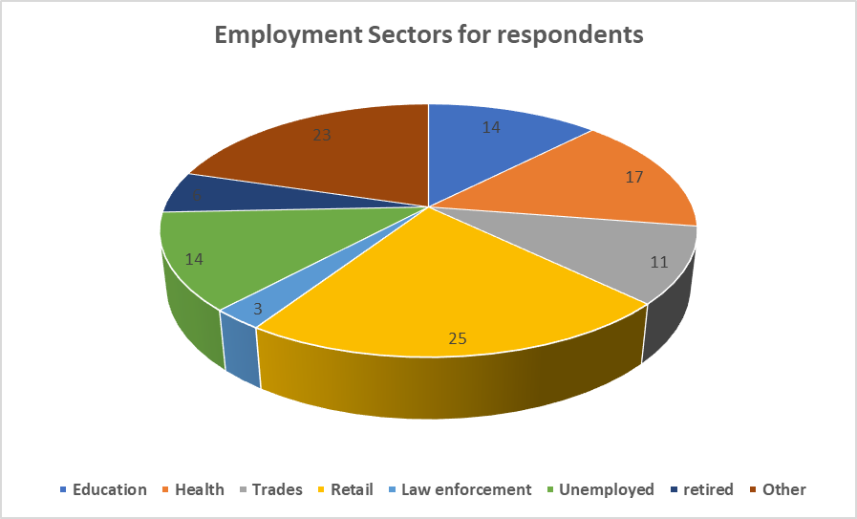
As seen in the pie chart above, there were participants who worked in a variety of the professions listed. The profession which had the most participants was retail with 25 followed closely by the “other” category. In the “other” participants were able to specify what area of work they were in. The answers received from the “other” category included; Students, Factory workers, office clerical, civil servant and others. There were only 3 respondents that worked in law enforcement.

Link between the age demographic and age of criminal responsibility:
Whilst analysing the data a link was discovered between the older participants and what they believe should be the age of criminal responsibility. According to responses of the questionnaire all participants over the age of 65 said that they believe the criminal age of responsibility should be between 10-12. This seems to be a common trend across the research as the younger the respondents are, the higher they believe the criminal age of responsibility should be.
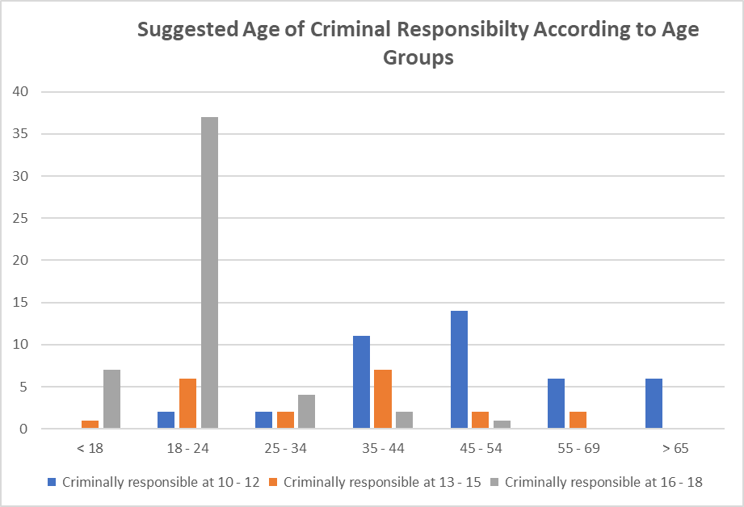
As the graph above shows, all 6 participants over the age of 65 answered between 10-12 compared to the age group 18-24 answering that they think the age should be between 16-18. This trend suggests that the older generations believe that young people are responsible for there actions from a younger age. The current age of responsibility is 10 years old therefore meaning that majority of respondents believe that the age of criminal responsibility should be made higher in the UK. One respondent commented that they were not sure how to answer the question as they believed each case should be determined by the seriousness of the crime, they referenced the James Bulger case as an example which is where a two-year-old little boy was brutally murdered by two ten year old boys Jon Venables and Robert Thompson (Coslett 2014). There was huge public outrage when the two perpetrators were tried as children for such a brutal and devastating crime and that they have continued to receive anonymity to this day.
Can a child’s upbringing and environment lead them to committing crime?
Question 4 asks participants if they think that a child’s upbringing and/or environment can lead to them committing crime in the future. Of all 113 participants each one answered “Yes”
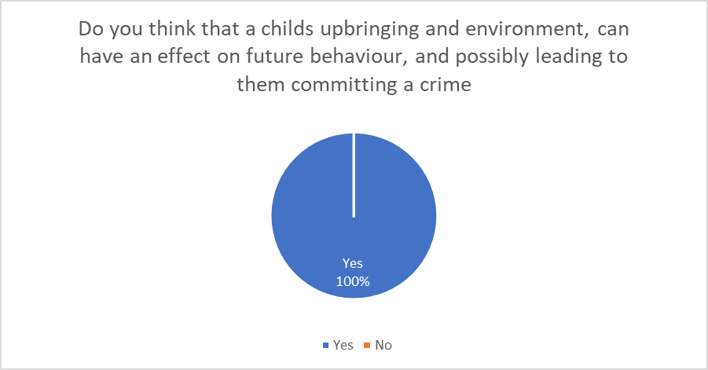
This pie chart proves that there is a general consensus that a child’s upbringing can lead them to committing crime and having anti-social behaviour. This reinforces the importance of early intervention to protect young people from experiencing these harmful situations and confirms that adverse childhood experiences can make a person more susceptible to committing crime.

Can early intervention be beneficial?
Question 5 briefly explained what early intervention is and then asked them to answer whether or not they thought it is beneficial for children. The question asked them to explain the reason behind their answer to understand what exactly about early intervention they thought helps.
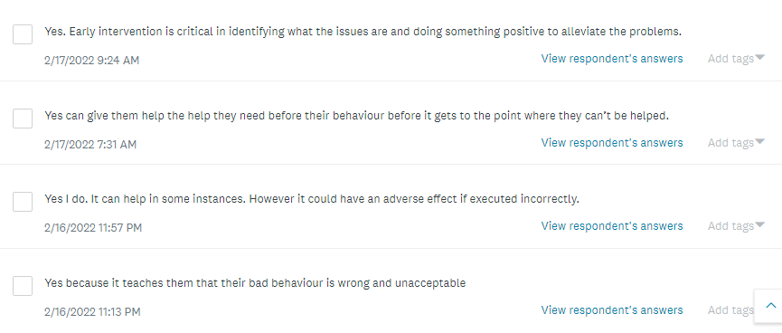
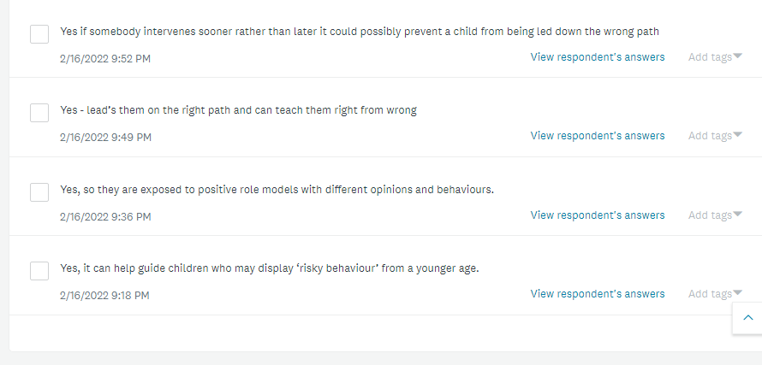
Above are several responses for question 5. The general answer seems to be yes however one respondent says that if executed incorrectly that early intervention could have an adverse effect on the child. Another comment agrees that early intervention is beneficial however they look at it as a form of punishment saying, “yes because it teaches them their bad behaviour is wrong and unacceptable”. Other than these responses the clear majority agreed that early intervention is beneficial but needs to be done as soon as possible before too much damage is done to a child.

What childhood experiences can have the biggest effect on a child behaviour?
Question six asked respondents what childhood experiences they believe can negatively impact a child’s/ person’s behaviour the most. This links back to adverse childhood experiences.
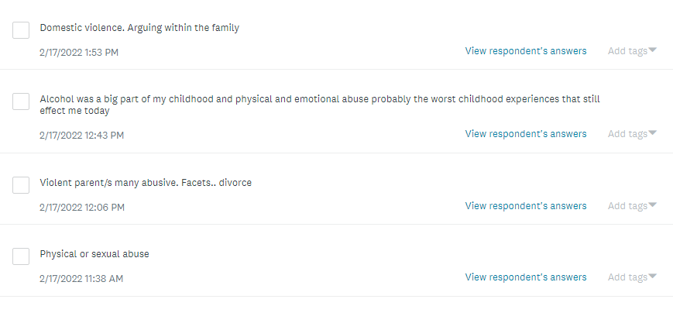
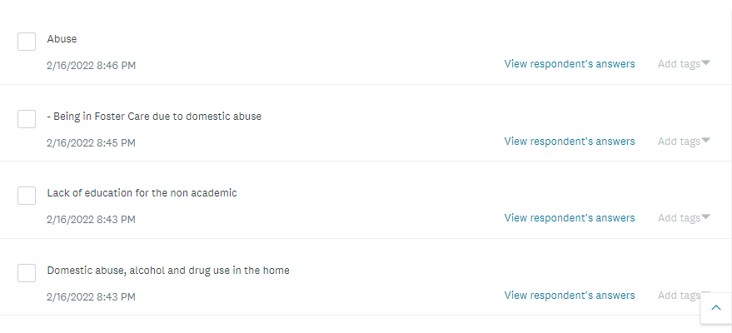
As seen in the responses above, majority of respondents answered similarly by listing, physical/sexual abuse, neglect and exposure to alcohol and drug abuse as the experiences that can negatively impact a child life the most. One respondent also wrote “lack of education” which could coincide with secure schools opening and more one to one sessions with teachers in more deprived areas. Of the sample of the public that answered the online questionnaire most are aware whether that be consciously or subconsciously of adverse childhood experiences and their detrimental effect on children’s lives. According to Nadine Burke Harris in chapter 2, educating the public on the effects of ACE’s is extremely important and from this sample, all respondents seem to be somewhat educated on the topic.

What can be done in schools to help children who are potentially more at risk of committing crime?
The final question asks respondents what they believe can be done in the education system to help vulnerable children. This specific question is where professional knowledge can be seen from the people who listed their profession as being in the education system and law enforcement.

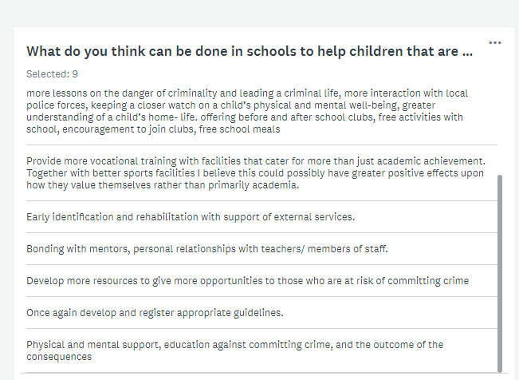

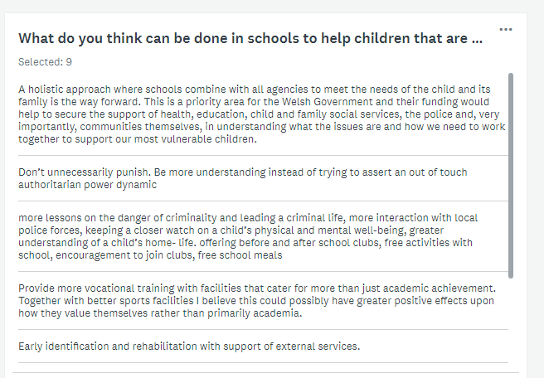

Above are 9 responses to question 7 that have been selected. These questions have been selected as each one was written by either someone with a profession in the education system or within law enforcement. These responses have a similar pattern in that they all agree that rehabilitation is the way forwards, more education and more care and love given to children who may be experiencing ACE’s. One response in particular agrees with a holistic approach where schools work with other agencies to provide the care the children need, this reinforces the ideas put forward in chapter 2 of a combined effort between all services such as the education system, the health service and the justice system.
Other respondent had similar views. The table below shows some of the similar themes throughout the answers and how many people mentioned it;
Themes | Total
“More after school activities” | 8
“child and family services” / “social services” | 7
“more lessons on crime and its effects” | 12
“educating parents” | 4
“bonding with teachers and other pupils” | 5

Analysing responses from a participant:
One participant has answered the online questionnaire from the perspective of a person who experienced adverse childhood experiences. This responder is in the 25-34 age group and works in the construction and trades sector. When asked if they think that early intervention can be beneficial they answered explaining that they had experienced a lot of violence in the family home as a child and that they would have appreciated some sort of early intervention. They continue to explain that they used to go to their grandparents’ home on weekend and it would be relief to escape the environment they were experiencing at home. When asked what experiences they think can have the biggest negative impact on a child behaviour they responded; “Alcohol was a big part of my childhood and physical and emotional abuse probably the worst childhood experiences that still affect me today”. The responses from this particular participant provide first-hand experience of what adverse childhood experiences can do to a person as they explain that even at the age of between 25-34 they are still being affected by what they experienced as a child. They believe that the age of criminal responsibility should be 18 and when asked what more the education system can do to support vulnerable children, they responded “More after school activities, give kids the opportunities to get hobbies too keep them occupied”. The responses from this participant support theories put forward by Nicole burke Harris and reinforce recommendations made by the Charlie Taylor review.

4.5 Findings conclusion –
To conclude this section a clear majority of responses agreed that support within the education system is fundamental in helping a child that is suffering from adverse childhood experiences. All participants agreed that a child’s upbringing can affect their behaviour negatively in the future and possible lead to them committing crime. Responses from a participant who had experienced ACE’s reinforced these theories. There is a connection between the older generation answering that the age of criminal responsibility should be lower compared to younger age groups believing it should be higher. This could be due to the perceived lack of respect towards authority compared to when they were young. Overall data gathered from this research method concludes that focus should be on the education system working with other services to provide help and support for children who may be seen as vulnerable or may be showing any signs of adverse childhood experiences.

Chapter 5 conclusions and recommendations –

5.1 Introduction –
This chapter will conclude the dissertation drawing all points to a close and summarising the points that have been made. It will discuss whether the objective of the paper has been completed. It will also discuss any recommendation and improvements that could be done for further research.

5.2 Main findings –
The main findings in this paper have been that both the government and participants of the online questionnaire agree that adverse childhood experiences can have a huge effect on a child’s life. It has also been determined that education plays a huge role in a young person’s life. This can be through education such as not achieving good grades which can potentially along with other factors lead to a multitude of issues but can also be through socialising as its been proven that children who do not experience the social side of schooling with friends or teachers also tend to suffer more if dealing with adverse experiences at home. There is also agreement between participants and the government as to whether or not we punish young people. The agreement seems to be that young people should be helped before being punished, whether this is by placing young pope in youth clubs, providing them with one to one lessons in school or even sending them to a secure school, overall young vulnerable people should be supported.

5.3 Recommendations –
From the research conducted for this paper, it is clear that more work needs to be done within schools to provide all young people the same opportunities. More works needs to be done in deprived areas of the UK for young people to have hope in the system and not to feel defeated because they have experienced ACE’s. More youth clubs and after school clubs could be opened to give young people actives and hobbies so they are not drawn to gangs and illegal activity such as low level crime and substance misuse. Educating the public about ACE’s is also extremely important. Informing parents of the life long effects their actions can have on children may be the first step in stopping ACE’s.

5.4 Completed aims and objectives –
The title of this paper is;
“Education and offending: an exploration of links between childhood experiences and offending”.
This paper has explored links between childhood experiences, education and offending and have tied them all together with research methods.
There were three main objectives to this paper, these were;
Objective 1 – To critically analyse the importance of education for young offenders
Objective 2 – To critically evaluate the effects for adverse childhood experiences and its links to crime.
Objective 3 – To critically analyse current procedures and what is being done to help children who are at high risk of committing crime.
These objectives have been completed throughout the paper more specifically in chapter 1 with results from the research methods confirming the publics opinion on the matter

5.5 Conclusion –
To conclude this dissertation, there are clear links between education and offending. Young people who experience Adverse Childhood Experiences are more likely to develop negative behaviour, drug and alcohol abuse and violent tendencies, all factors that can lead to a person committing crime. Poor education can also lead a person to committing crime as it is proven that young people who drop out of school at the age of 16 are more likely to become involved in antisocial behaviour, substance misuse and crime. Children and young people from deprived, poorly educated areas should be provided with the care and support they need to break the cycle and live productive lives. Allowing them to have equal opportunities that their peers enjoy. Early intervention is beneficial however more work needs to be done within schools for teachers to notice ACE related behaviour and to contact the relevant authorities. Secure schools may also provide help and support for young people who have found themselves involved with the justice system to provide them with a second chance, so they don’t end up living a life of crime. The researcher is confident that the justice system and other public services understand the importance of education to young people and will work hard to ensure the UK’s young vulnerable people are given the care and support they need.

Bibliography -

- AEGIS (2019). British education system. Available at: https://www.brightworldguardianships.com/en/guardianship/british-education-system/ . Accessed on: 30/03/2022.
- Al- Saadi. H (2014). Demystifying ontology and epistemology in research methods. Available at: https://www.researchgate.net/publication/260244813_Demystifying_Ontology_and_Epistemology_in_Research_Methods . Accessed on: 11/04/2022.
- Alamgeer. Z (2022). What is interpretivism? Available at: https://theinnovidea.com/what-is-interpretivism/#:~:text=Interpretivism%20is%20a%20type%20of%20research%20philosophy.%20Interpretivist,is%20intended%20to%20understand%20and%20interpret%20social%20meanings. . Accessed on: 17/04/2022.
- Allen. G. MP (2011). Early intervention: the next steps. An independent report to her majesty’s government. Available at: https://assets.publishing.service.gov.uk/government/uploads/system/uploads/attachment_data/file/284086/early-intervention-next-steps2.pdf . Accessed on: 08/04/2022.
- BBC (2019). Medway secure training centre: latest damming Ofsted report. Available at: https://www.bbc.co.uk/news/uk-england-kent-50820062 . Accessed on: 08/04/2022.
- Bellis et al (2018). Adverse childhood experiences and sources of childhood resilience. Bangor University PMC Public health. Available at: https://research.bangor.ac.uk/portal/files/21806079/Bellis_et_al_2018_Adverse_childhood_experiences_and_sources_of_childhood_resilience_child_health_and_educational_attendance.pdf . Accessed on: 03/04/2022.
- Blair. M, Boullier. M (2018). Adverse childhood experiences. Volume. 8. Issue 3 pages 132- 137. Available at: https://www.sciencedirect.com/science/article/abs/pii/S1751722217302913 . Accessed on: 03/04/2022.
- Collis. J (2013). Business research: a practical guide for undergraduate and post graduate students. Published 29/11/2013. Fourth edition. Available at: https://r3.vlereader.com/Reader?ean=9781137037480 . Accessed on: 11/04/2022.
- Coslett. P (2014). Murder of James bulger. Available at: https://www.bbc.co.uk/liverpool/content/articles/2006/12/04/local_history_bulger_feature.shtml . Accessed on: 11/04/2022.
- Early intervention foundation (2022). What is early intervention? Available at: https://www.eif.org.uk/why-it-matters/what-is-early-intervention . Accessed on: 08/04/2022.
- EEF (2021). EEF publishes new analysis on impact of COVID-19 on attainment gap. Education endowment foundation. Available at: https://educationendowmentfoundation.org.uk/news/eef-publishes-new-research-on-the-impact-of-covid-19-partial-school-closures . Accessed on: 30/03/2022.
- Estyn (2020). Knowing your children – supporting pupils with adverse childhood experiences (ACES). Available at: https://www.estyn.gov.wales/system/files/2022-01/Knowing%2520your%2520children%2520%2520supporting%2520pupils%2520with%2520adverse%2520childhood%2520experiences_0.pdf . Accessed on: 07/04/2022.
- GOVUK A (2022). Age of criminal responsibility. Available at: https://www.gov.uk/age-of-criminal-responsibility . Accessed on: 12/04/2022.
- GOVUK B (2022). What happens if a child under 10 commits a crime? Available at: https://www.gov.uk/child-under-10-breaks-law . Accessed on: 11/04/2022.
- GOVUK C (2022). The national curriculum. Available at: https://www.gov.uk/national-curriculum/key-stage-1-and-2 . Accessed on: 11/04/2022.
- Gray. D HMI (2020). Adverse childhood experiences (ACE’s) how can schools support children and young people who live in difficult circumstances? Available at: https://www.estyn.gov.wales/blog/adverse-childhood-experiences-aces-how-can-schools-support-children-and-young-people-who-live . Accessed on: 07/04/2022.
- Graham et al (2020). The advantages and disadvantages of breakfast clubs according to parents, children and school staff in the North East of England, UK. Available at: https://www.frontiersin.org/articles/10.3389/fpubh.2015.00156/full . Accessed on: 12/04/2022.
- Harris. B. N (2014). How childhood trauma affects health across a lifetime. Presentation for TED TALK. Available at: https://www.ted.com/talks/nadine_burke_harris_how_childhood_trauma_affects_health_across_a_lifetime. Accessed on: 05/04/2022.
- Hinds. D MP (2019). New measures to support disadvantaged children in schools. Department for education. Available at: https://www.gov.uk/government/news/new-measures-to-support-disadvantaged-children-in-schools . Accessed on: 30/03/2022.
- Inside times report (2021). Delay for Medway secure school. Available at: https://insidetime.org/delay-for-medway-secure-school/ . Accessed on: 08/04/2022.
- Javid. S Hon MP (2019). Supporting disadvantaged families, Troubled families programme 2015-2020: progress so far. Department for communities and local government. Available at: https://assets.publishing.service.gov.uk/government/uploads/system/uploads/attachment_data/file/611991/Supporting_disadvantaged_families.pdf . Accessed on: 30/03/2022.
- Keiling. H (2021). Inductive VS deductive reasoning. Available at: https://www.indeed.com/career-advice/career-development/inductive-vs-deductive-reasoning . Accessed on: 11/04/2022.
- Ministry of justice (2016). Our secure school vision. Available at: https://assets.publishing.service.gov.uk/government/uploads/system/uploads/attachment_data/file/712904/secure-schools-vision.pdf . Accessed on: 08/04/2022.
- Ministry of justice (2019). Global education charity to run UK’s first secure school. Available at: https://www.gov.uk/government/news/global-education-charity-to-run-uk-s-first-secure-school . Accessed on: 08/04/2022.
- Ministry of justice et al (2014). Young criminals must be punished, but education is the cure. Available at: https://www.gov.uk/government/news/young-criminals-must-be-punished-but-education-is-the-cure . Accessed on: 11/04/2022.
- NHS (2022). Adverse childhood experiences (aces) and attachment. Manchester university NHS foundation trust. Available at: https://mft.nhs.uk/rmch/services/camhs/young-people/adverse-childhood-experiences-aces-and-attachment/ . Accessed on: 02/04/2022.
- Phair. D, Warren. K (2021). Saunders research onion: explained simply. Available at: https://gradcoach.com/saunders-research-onion/ . Accessed on: 11/04/2022.
- Politics (2021). GCSE’S. Available at: https://www.studying-in-uk.org/uk-education-system-guide/ . Accessed on: 30/03/2022.
- Public health Scotland (2021). Adverse childhood experiences (ACES). Available at: http://www.healthscotland.scot/population-groups/children/adverse-childhood-experiences-aces/overview-of-aces#:~:text=ACEs%20are%20common.%20The%20original%20study%20found%20almost,impacts%20of%20ACEs%20on%20mental%20and%20physical%20wellbeing. . Accessed on: 05/04/2022.
- Reference (2020). Why should you use questionnaires as a research method? Available at: https://www.reference.com/world-view/should-use-questionnaires-research-method-1a6a5567acb545a4 . Accessed on: 09/04/2022.
- Saunders et al (2015). Research methods for business students. Published: 28/07/2015. Seventh edition. Available at: https://www-vlebooks-com.ezproxy.uwtsd.ac.uk/Product/Index/595218?page=0 . Accessed on: 11/04/2022.
- Saunders et al (2019). Research methods for business students. Published 17/05/2019. Eighth edition. Available at: http://ebookcentral.proquest.com/lib/trinity/reader.action?docID=5774742 . Accessed on: 11/04/2022.
- Sentencing council (2017). Sentencing children and young people. Available at: https://www.sentencingcouncil.org.uk/overarching-guides/magistrates-court/item/sentencing-children-and-young-people/ . Accessed on: 11/04/2022.
- Shannon’s trust (2022). What we do. Available at: https://www.shannontrust.org.uk/ . Accessed on: 11/04/2022.
- Study in the UK (2022). UK education system guide. Available at: https://www.studying-in-uk.org/uk-education-system-guide/ . Accessed on: 30/03/2022.
- Taylor. C (2016). Review of the youth justice system in England and Wales. Published for the ministry of justice. Available at: https://assets.publishing.service.gov.uk/government/uploads/system/uploads/attachment_data/file/577105/youth-justice-review-final-report-print.pdf . Accessed on: 30/03/2022.
- Thomas. L (2021). Cross- sectional study/ definitions, uses & examples. Available at: https://www.scribbr.com/methodology/cross-sectional-study/ . Accessed on: 11/04/2022.
- Webster. R (2016). Charlie Taylor’s review of the youth justice system. Available at: https://www.russellwebster.com/charlie-taylors-review-of-the-youth-justice-system/ . Accessed on: 02/04/2022.

Ethics form -

APPLICATION FOR ETHICAL APPROVAL

In order for research to result in benefit and minimise risk of harm, it must be conducted ethically. A researcher may not be covered by the University’s insurance if ethical approval has not been obtained prior to commencement.

The University follows the OECD Frascati manual definition of research activity: “creative work undertaken on a systematic basis in order to increase the stock of knowledge, including knowledge of man, culture and society, and the use of this stock of knowledge to devise new applications”. As such this covers activities undertaken by members of staff, postgraduate research students, and both taught postgraduate and undergraduate students working on dissertations/projects.

The individual undertaking the research activity is known as the “principal researcher”.

Ethical approval is not required for routine audits, performance reviews, quality assurance studies, testing within normal educational requirements, and literary or artistic criticism.

Please read the notes for guidance before completing ALL sections of the form.

This form must be completed and approved prior to undertaking any research activity. Please see Checklist for details of process for different categories of application.

SECTION A: About You (Principal Researcher)
1 | Full Name: |  | Elisha Phillips
2 | Tick all boxes that apply: |  | Member of staff: | ☐ | Honorary research fellow: | ☐
 | Undergraduate Student | ☒ | Taught Postgraduate Student | ☐ | Postgraduate Research Student | ☐

3 | Institute/Academic Discipline/Centre: | IMH
4 | Campus: | Swansea business campus
5 | E-mail address: | 1901362@student.uwtsd.ac.uk
6 | Contact Telephone Number: | 07570806390
 | For students:
7 | Student Number: | 1901362
8 | Programme of Study: | BA Criminology and policing
9 | Director of Studies/Supervisor: | Mike Durke

SECTION B: Approval for Research Activity
1 | Has the research activity received approval in principle?  (please check the Guidance Notes as to the appropriate approval process for different levels of research by different categories of individual) |  | YES | ☒ | NO | ☐
 |  |  |  |  | Date
2 | If Yes, please indicate source of approval (and date where known): Approval in principle must be obtained from the relevant source prior to seeking ethical approval | Research Degrees Committee |  | ☐
2 |  | Institute Research Committee |  | ☐
2 |  | Other (write in) |  | ☒ | Mike Durke

SECTION C: Internal and External Ethical Guidance Materials
 | Please list the core ethical guidance documents that have been referred to during the completion of this form (including any discipline-specific codes of research ethics, location-specific codes of research ethics, and also any specific ethical guidance relating to the proposed methodology). Please tick to confirm that your research proposal adheres to these codes and guidelines. You may add rows to this table if needed.
1 | UWTSD Research Ethics & Integrity Code of Practice | ☒
2 | UWTSD Research Data Management Policy | ☒
3 | [List any other relevant documents here] | ☐

SECTION D: External Collaborative Research Activity
If there are external collaborators then you should gain consent from the contact persons to share their personal data with the university. If there are no external collaborators then leave this section blank and continue to section E.
1 | Institution
2 | Contact person name
3 | Contact person e-mail address
4 | Is your research externally funded? |  | YES | ☐ | NO |  | ☐
5 | Are you in receipt of a KESS scholarship? |  | YES | ☐ | NO |  | ☐
6 | Are you specifically employed to undertake this research in either a paid or voluntary capacity? | Voluntary | YES | ☐ | NO | ☐
7 |  | Employed | YES | ☐ | NO | ☐
8 | Is the research being undertaken within an existing UWTSD Athrofa Professional Learning Partnership (APLP)? | If YES then the permission question below does not need to be answered. | YES | ☐ | NO |  | ☐
9 | Has permission to undertake the research has been provided by the partner organisation? | (If YES attach copy)  If NO the application cannot continue | YES | ☐ | NO |  | ☐

Where research activity is carried out in collaboration with an external organisation
10 | Does this organisation have its own ethics approval system? | YES | ☐ | NO | ☐
 | If Yes, please attach a copy of any final approval (or interim approval) from the organisation (this may be a copy of an email if appropriate).

SECTION E: Details of Research Activity
1 | Indicative title: | A exploration of links between education and offending
2 | Proposed start date: | 27.9.2021 | Proposed end date: | 6th May 2022
Introduction to the Research (maximum 300 words per section)
Ensure that you write for a Non-Specialist Audience when outlining your response to the points below:
- Purpose of Research Activity
- Proposed Research Question
- Aims of Research Activity
- Objectives of Research Activity
Demonstrate, briefly, how Existing Research has informed the proposed activity and explain
- What the research activity will add to the body of knowledge
- How it addresses an area of importance.
3 | Purpose of Research Activity  To explore the links between education and offending  (this box should expand as you type)
4 | Research Question  What can be done in educational settings to prevent young people from committing crime.  (this box should expand as you type)
5 | Aims of Research Activity  To develop an understanding of what signs to look out for in a child who may be at risk of committing crime and to understand what can be done to prevent this  (this box should expand as you type)
6 | Objectives of Research Activity  To explore what is currently in place in schools to help young people who are exposed to risk factors which may make them more vulnerable to crime. To also research how a link between certain theories such as childhood trauma and adverse childhood experiences can have an effect on crime.  (this box should expand as you type)
Proposed methods (maximum 600 words)
Provide a brief summary of all the methods that may be used in the research activity, making it clear what specific techniques may be used. If methods other than those listed in this section are deemed appropriate later, additional ethical approval for those methods will be needed. You do not need to justify the methods here, but should instead describe how you intend to collect the data necessary for you to complete your project.
7 | I intend to use various methods in my research. I will be using desktop research and conducting a literacy review to ensure cutting edge literature. I will also be using international comparison information to compare statistics from across the globe. A questionnaire is also going to be designed on survey monkey which will be shared to social media in order to achieve a variety of different opinions on the matter.  (this box should expand as you type)
Location of research activity
Identify all locations where research activity will take place.
8 | Swansea  (this box should expand as you type)
Research activity outside of the UK
If research activity will take place overseas, you are responsible for ensuring that local ethical considerations are complied with and that the relevant permissions are sought. Specify any local guidelines (e.g. from local professional associations/learned societies/universities) that exist and whether these involve any ethical stipulations beyond those usual in the UK (provide details of any licenses or permissions required). Also specify whether there are any specific ethical issues raised by the local context in which the research activity is taking place, for example, particular cultural and/or legal sensitivities or vulnerabilities of participants. If you live in the country where you will do the research then please state this.
9 | Not applicable  (this box should expand as you type)

10 | Use of documentation not in the public domain: Are any documents NOT publicly available? | NO | ☒
10 |  | YES | ☐
11 | If Yes, please provide details here of how you will gain access to specific documentation that is not in the public domain and that this is in accordance with the current data protection law of the country in question and that of England and Wales.  (this box should expand as you type)

 | Does your research relate to one or more of the seven aims of the Well-being of Future Generations (Wales) Act 2015? | YES | NO
12 | A prosperous Wales | ☐ | ☒
13 | A resilient Wales | ☐ | ☒
14 | A healthier Wales | ☐ | ☒
15 | A more equal Wales | ☒ | ☐
16 | A Wales of cohesive communities | ☐ | ☒
17 | A Wales of vibrant culture and thriving Welsh language | ☐ | ☒
18 | A globally responsible Wales | ☐ | ☒
19 | If YES to any of the above, please give details:
It will discuss providing children that come from deprived areas or families the same opportunities as those of a different upbringing.

(this box should expand as you type)

SECTION F: Scope of Research Activity
 | Will the research activity include: | YES | NO
1 | Use of a questionnaire or similar research instrument? | ☒ | ☐
2 | Use of interviews? | ☐ | ☒
3 | Use of focus groups? | ☐ | ☒
4 | Use of participant diaries? | ☐ | ☒
5 | Use of video or audio recording? | ☐ | ☒
6 | Use of computer-generated log files? | ☐ | ☒
7 | Participant observation with their knowledge? | ☒ | ☐
8 | Participant observation without their knowledge? | ☐ | ☒
9 | Access to personal or confidential information without the participants’ specific consent? | ☐ | ☒
10 | Administration of any questions, test stimuli, presentation that may be experienced as physically, mentally or emotionally harmful / offensive? | ☐ | ☒
11 | Performance of any acts which may cause embarrassment or affect self-esteem? | ☐ | ☒
12 | Investigation of participants involved in illegal activities? | ☐ | ☒
13 | Use of procedures that involve deception? | ☐ | ☒
14 | Administration of any substance, agent or placebo? | ☐ | ☒
15 | Working with live vertebrate animals? | ☐ | ☒
16 | Procedures that may have a negative impact on the environment? | ☐ | ☒
17 | Other primary data collection methods. Please indicate the type of data collection method(s) below. | ☐ | ☒
 | Details of any other primary data collection method:  (this box should expand as you type) | ☐ | ☒
If NO to every question, then the research activity is (ethically) low risk and may be exempt from some of the following sections (please refer to Guidance Notes).

If YES to any question, then no research activity should be undertaken until full ethical approval has been obtained.

SECTION G: Intended Participants
If there are no participants then do not complete this section, but go directly to section H.

 | Who are the intended participants: | YES | NO
1 | Students or staff at the University? | ☒ | ☐
2 | Adults (over the age of 18 and competent to give consent)? | ☒ | ☐
3 | Vulnerable adults? | ☐ | ☒
4 | Children and Young People under the age of 18? (Consent from Parent, Carer or Guardian will be required) | ☐ | ☒
5 | Prisoners? | ☐ | ☒
6 | Young offenders? | ☐ | ☒
7 | Those who could be considered to have a particularly dependent relationship with the investigator or a gatekeeper? | ☐ | ☒
8 | People engaged in illegal activities? | ☐ | ☒
9 | Others. Please indicate the participants below, and specifically any group who may be unable to give consent. | ☐ | ☒
 | Details of any other participant groups:  (this box should expand as you type) | ☐ | ☒

Participant numbers and source
Provide an estimate of the expected number of participants. How will you identify participants and how will they be recruited?
10 | How many participants are expected? | 100  (this box should expand as you type)
11 | Who will the participants be? | Members of the general public  (this box should expand as you type)
12 | How will you identify the participants? | Mmembers of the general public will interact via social media.  (this box should expand as you type)

 | Information for participants: | YES | NO | N/A
13 | Will you describe the main research procedures to participants in advance, so that they are informed about what to expect? | ☒ | ☐ | ☐
14 | Will you tell participants that their participation is voluntary? | ☒ | ☐ | ☐
15 | Will you obtain written consent for participation? | ☒ | ☐ | ☐
16 | Will you explain to participants that refusal to participate in the research will not affect their treatment or education (if relevant)? | ☐ | ☐ | ☒
17 | If the research is observational, will you ask participants for their consent to being observed? | ☐ | ☐ | ☒
18 | Will you tell participants that they may withdraw from the research at any time and for any reason? | ☐ | ☐ | ☒
19 | With questionnaires, will you give participants the option of omitting questions they do not want to answer? | ☒ | ☐ | ☐
20 | Will you tell participants that their data will be treated with full confidentiality and that, if published, it will not be identifiable as theirs? | ☒ | ☐ | ☐
21 | Will you debrief participants at the end of their participation, in a way appropriate to the type of research undertaken? | ☐ | ☐ | ☒
22 | If NO to any of above questions, please give an explanation
 | (this box should expand as you type)

 | Information for participants: | YES | NO | N/A
24 | Will participants be paid? | ☐ | ☒ | ☐
25 | Is specialist electrical or other equipment to be used with participants? | ☐ | ☒ | ☐
26 | Are there any financial or other interests to the investigator or University arising from this study? | ☐ | ☒ | ☐
27 | Will the research activity involve deliberately misleading participants in any way, or the partial or full concealment of the specific study aims? | ☐ | ☒ | ☐
28 | If YES to any question, please provide full details
 | (this box should expand as you type)

SECTION H: Anticipated Risks

Outline any anticipated risks that may adversely affect any of the participants, the researchers and/or the University, and the steps that will be taken to address them.

If you have completed a full risk assessment (for example as required by a laboratory, or external research collaborator) you may append that to this form.
1 | Full risk assessment completed and appended? |  | Yes | ☐
1 |  |  | No | ☒
2 | Risks to participants  For example: sector-specific health & safety, emotional distress, financial disclosure, physical harm, transfer of personal data, sensitive organisational information
 | Risk to participants:  (this box should expand as you type) | How you will mitigate the risk to participants:  (this box should expand as you type)
3 | If research activity may include sensitive, embarrassing or upsetting topics (e.g. sexual activity, drug use) or issues likely to disclose information requiring further action (e.g. criminal activity), give details of the procedures to deal with these issues, including any support/advice (e.g. helpline numbers) to be offered to participants. Note that where applicable, consent procedures should make it clear that if something potentially or actually illegal is discovered in the course of a project, it may need to be disclosed to the proper authorities
 | (this box should expand as you type)
4 | Risks to the investigator  For example: personal health & safety, physical harm, emotional distress, risk of accusation of harm/impropriety, conflict of interest
 | Risk to the investigator:  (this box should expand as you type) | How you will mitigate the risk to the investigator:  (this box should expand as you type)
5 | University/institutional risks  For example: adverse publicity, financial loss, data protection
 | Risk to the University:  (this box should expand as you type) | How you will mitigate the risk to the University:  (this box should expand as you type)
6 | Environmental risks  For example: accidental spillage of pollutants, damage to local ecosystems
 | Risk to the environment:  (this box should expand as you type) | How you will mitigate the risk to environment:  (this box should expand as you type)

 | Disclosure and Barring Service
 | If the research activity involves children or vulnerable adults, a Disclosure and Barring Service (DBS) certificate must be obtained before any contact with such participants. | YES | NO | N/A
7 | Does your research require you to hold a current DBS Certificate? | ☐ | ☒ | ☐
8 | If YES, please give the certificate number. If the certificate number is not available please write “Pending”; in this case any ethical approval will be subject to providing the appropriate certificate number.

SECTION I: Feedback, Consent and Confidentiality

1 | Feedback  What de-briefing and feedback will be provided to participants, how will this be done and when?
A post of appreciation will be upload to social media for all participants to view.

(this box should expand as you type)
2 | Informed consent  Describe the arrangements to inform potential participants, before providing consent, of what is involved in participating. Describe the arrangements for participants to provide full consent before data collection begins. If gaining consent in this way is inappropriate, explain how consent will be obtained and recorded in accordance with prevailing data protection legislation.
There will be a tick box at the beginning of the questionnaire informing participants that the data will be used in the research.

(this box should expand as you type)
3 | Confidentiality / Anonymity  Set out how anonymity of participants and confidentiality will be ensured in any outputs. If anonymity is not being offered, explain why this is the case.
The questionnaire will be completely anonymous with participants knowing this from the beginning.

(this box should expand as you type)

SECTION J: Data Protection and Storage

 | Does the research activity involve personal data (as defined by the General Data Protection Regulation 2016 “GDPR” and the Data Protection Act 2018 “DPA”)? | YES | NO
1 | “Personal data” means any information relating to an identified or identifiable natural person (‘data subject’). An identifiable natural person is one who can be identified, directly or indirectly, in particular by reference to an identifier such as a name, an identification number, location data, an online identifier or to one or more factors specific to the physical, physiological, genetic, mental, economic, cultural or social identity of that natural person. Any video or audio recordings of participants is considered to be personal data. | ☐ | ☐x
 | If YES, provide a description of the data and explain why this data needs to be collected:
2 | (this box should expand as you type)
 | Does it involve special category data (as defined by the GDPR)? | YES | NO
3 | “Special category data” means sensitive personal data consisting of information as to the data subjects’ –  (a) racial or ethnic origin,  (b) political opinions,  (c ) religious beliefs or other beliefs of a similar nature,  (d) membership of a trade union (within the meaning of the Trade Union and Labour Relations (Consolidation) Act 1992),  (e) physical or mental health or condition,  (f) sexual life,  (g) genetics,  (h) biometric data (as used for ID purposes), | ☐ | ☐x
 | If YES, provide a description of the special category data and explain why this data needs to be collected:
4 | (this box should expand as you type)

 | Will data from the research activity (collected data, drafts of the thesis, or materials for publication) be stored in any of the following ways? | YES | NO
5 | Manual files (i.e. in paper form)? | ☐ | ☒
6 | University computers? | ☐ | ☒
7 | Private company computers? | ☐ | ☒
8 | Home or other personal computers? | ☒ | ☐
9 | Laptop computers/ CDs/ Portable disk-drives/ memory sticks? | ☒ | ☐
10 | “Cloud” storage or websites? | ☒ | ☐
11 | Other – specify: | ☐ | ☒
12 | For all stored data, explain the measures in place to ensure the security of the data collected, data confidentiality, including details of backup procedures, password protection, encryption, anonymisation and pseudonymisation:
All data will be password protected.

(this box should expand as you type)

 | Data Protection
 | Will the research activity involve any of the following activities: | YES | NO
13 | Electronic transfer of data in any form? | ☒ | ☐
14 | Sharing of data with others at the University outside of the immediate research team? | ☐ | ☒
15 | Sharing of data with other organisations? | ☐ | ☒
16 | Export of data outside the UK or importing of data from outside the UK? | ☐ | ☒
17 | Use of personal addresses, postcodes, faxes, emails or telephone numbers? | ☐ | ☒
18 | Publication of data that might allow identification of individuals? | ☐ | ☒
19 | Use of data management system? | ☐ | ☒
20 | Data archiving? | ☐ | ☒
21 | If YES to any question, please provide full details, explaining how this will be conducted in accordance with the GDPR and Data Protection Act (2018) (and any international equivalents, where appropriate):
The research will be uploaded to a turn it in link which will be visible to university officials

(this box should expand as you type)
22 | List all who will have access to the data generated by the research activity:
UWTSD officials

(this box should expand as you type)
23 | List who will have control of, and act as custodian(s) for, data generated by the research activity:
Mike Durke

(this box should expand as you type)
24 | Give details of data storage arrangements, including security measures in place to protect the data, where data will be stored, how long for, and in what form. Will data be archived – if so how and if not why not.
 | (this box should expand as you type)
25 | Please indicate if your data will be stored in the UWTSD Research Data Repository (see https://researchdata.uwtsd.ac.uk/ ). If so please explain. (Most relevant to academic staff)
 | (this box should expand as you type)
26 | Confirm that you have read the UWTSD guidance on data management (see https://www.uwtsd.ac.uk/library/research-data-management/) | YES | ☒
27 | Confirm that you are aware that you need to keep all data until after your research has completed or the end of your funding | YES | ☒

SECTION K: Declaration
The information which I have provided is correct and complete to the best of my knowledge. I have attempted to identify any risks and issues related to the research activity and acknowledge my obligations and the rights of the participants.

In submitting this application I hereby confirm that I undertake to ensure that the above named research activity will meet the University’s Research Ethics and Integrity Code of Practice which is published on the website: https://www.uwtsd.ac.uk/research/research-ethics/
1 | Signature of applicant: | Elisha. J. Phillips | Date:  24/01/2022

For STUDENT Submissions:
2 | Director of Studies/Supervisor: |  | Date:
3 | Signature: |  | Date:

For STAFF Submissions:
4 | Academic Director/ Assistant Dean: |  | Date:
5 | Signature: |  | Date:

Checklist: Please complete the checklist below to ensure that you have completed the form according to the guidelines and attached any required documentation:
☒ | I have read the guidance notes supplied before completing the form.
☒ | I have completed ALL RELEVANT sections of the form in full.
☒ | I confirm that the research activity has received approval in principle
☒ | I have attached a copy of final/interim approval from external organisation (where appropriate)
☒ | I have attached a full risk assessment (where appropriate) ONLY TICK IF YOU HAVE ATTACHED A FULL RISK ASSESSMENT
☒ | I understand that it is my responsibility to ensure that the above named research activity will meet the University’s Research Ethics and Integrity Code of Practice.
☒ | I understand that before commencing data collection all documents aimed at respondents (including information sheets, consent forms, questionnaires, interview schedules etc.) must be confirmed by the DoS/Supervisor, module tutor or Academic Director.

RESEARCH STUDENTS AND STAFF ONLY
All communications relating to this application during its processing must be in writing and emailed to pgresearch@uwtsd.ac.uk , with the title ‘Ethical Approval’ followed by your name.
You will be informed of the outcome of your claim by email; therefore it is important that you check your University and personal email accounts regularly.
STUDENTS ON UNDERGRADUATE OR TAUGHT MASTERS PROGRAMMES should submit this form (and receive the outcome) via systems explained to you by the supervisor/module leader.

This form is available electronically from the Academic Office web pages: https://www.uwtsd.ac.uk/academic-office/appendices-and-forms/

