Setting up mail merge that will take fields from a database table. Version2

Points to note:

You need to make sure that you have your database and you mail merge letter in the same directory.

You can link to the table or query ( this couldl combine fields from two tables ) that will contain your filed names.

You need to set up the document by calling start mail merge under the mailing tab.
Look at the example I have selected fields from a query called appointments.

Because I have spaces in my field names on the database e.g Patient Title, when I add this field to my letter word automatically adds an underscore _. You will need to get rid of this later.

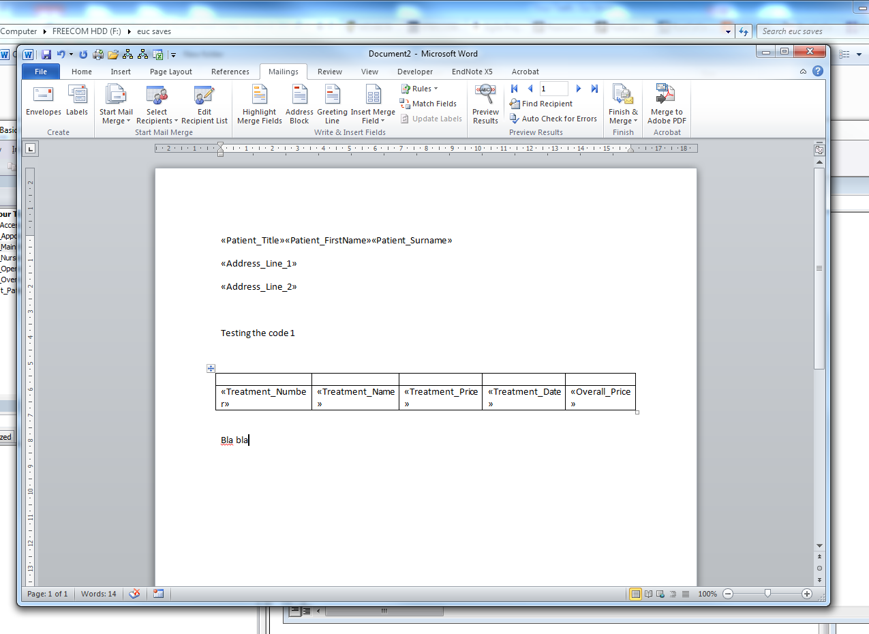

Next I need to press Alt f9

This will show the MERGEDFIELD you need to change this to read DOCVARIABLE also tack out and _ in the files names and replace them with a space and enclose them in “”

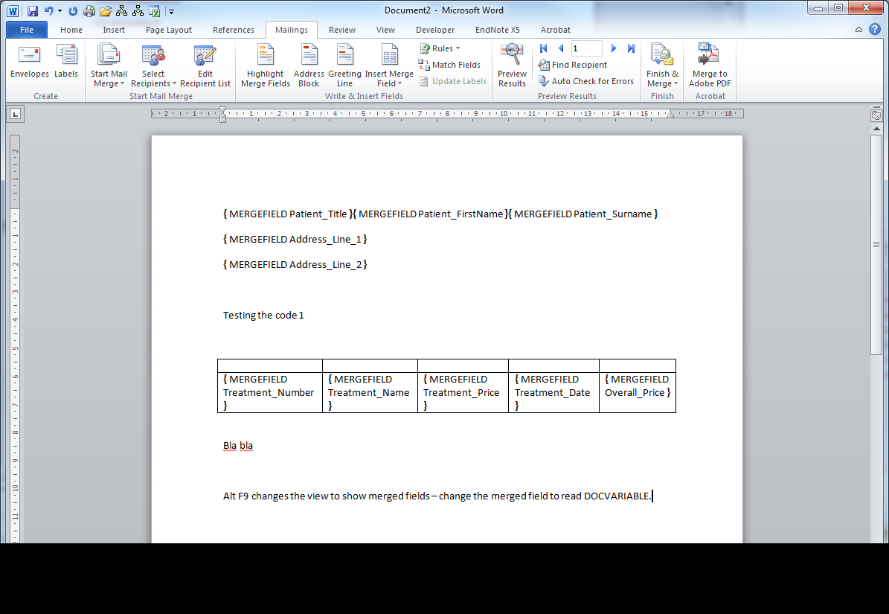

Something like this

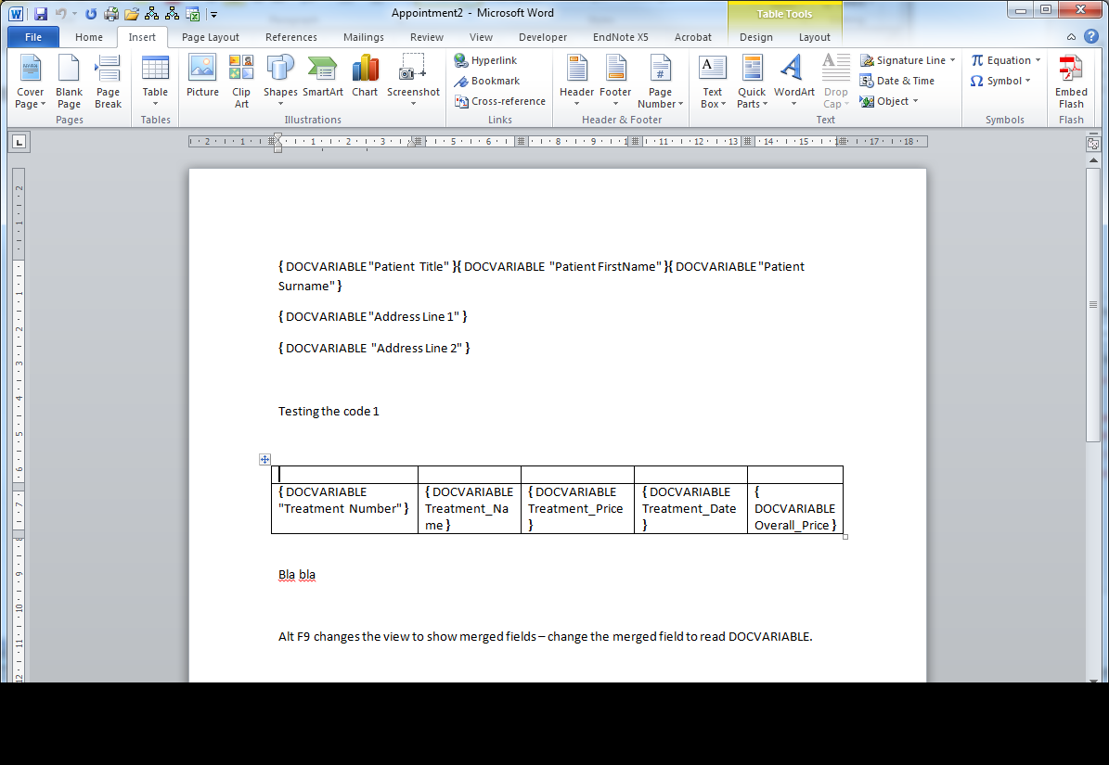

Notice I have included a table also containing some variable from the appointment. It works in the same way but you will need to add what is known as a book mark. Place the cursor in the first cell of the table, under the insert tab you will the bookmark option. Choose this and give the table a name you will refer to this in the code.

One you have set up your letter save it. You will refer to the saved name in the code. I called my letter appointment and the bookmark TreatmentTable you should see them in the code. You could use this for you invoice print out or student time table in your assignement

Private Sub cmd_mm_Click()
Dim oWord As Word.Application
Dim oDoc As Word.Document
Dim oTable As Word.Table
Dim CopyRange As Word.Range
Dim DestinationRange As Word.Range
Dim lPos As Long
Dim cnt As ADODB.Connection
Dim rs1 As ADODB.Recordset
Dim rs2 As ADODB.Recordset
Dim fld As ADODB.Field
Dim sFolder As String

sFolder = CurrentProject.Path
Set cnt = CurrentProject.Connection
Set rs1 = New ADODB.Recordset

Set oWord = New Word.Application
oWord.Visible = True

rs1.Open "Select * FROM [Appmm];", cnt

Do Until rs1.EOF

Set oDoc = oWord.Documents.Add(Template:=sFolder & "\Appointment.docx")

For Each fld In rs1.Fields
oDoc.Variables(fld.Name) = Nz(fld.Value, " ")
Next fld

Set oTable = oDoc.Bookmarks("TreatmentTable").Range.Tables(1)

Set CopyRange = oTable.Rows(2).Range

oDoc.Fields.Update
oDoc.Fields.Unlink

rs1.MoveNext
Loop
End Sub

The code should be attached to a macro button in access.

