BUSINESS SKILLS FOR THE INTERNATIONAL HOTEL INDUSTRY

Module Code: M4X 01917_LON

Iulian-Cristian Iorgulescu
1815071
Lecturer: Dale Clark
Written Assignment Part 1

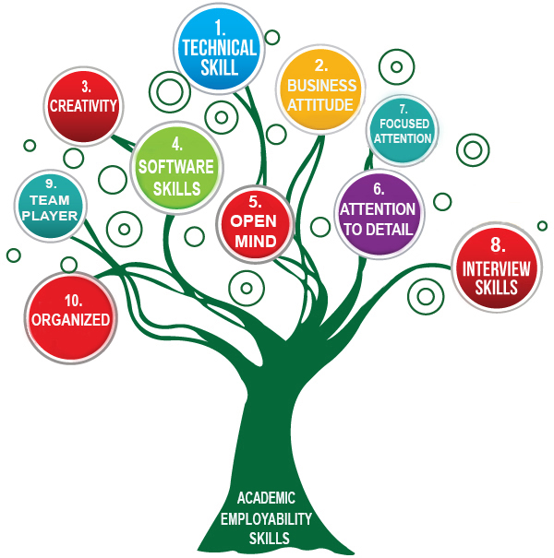

Table of Contents

1. Introduction......................................................................................................Page 3
2. SWOT..............................................................................................................Page 4-5
3. Personal Development Plan............................................................................Page 6-7
4. Conclusions……………………........................................................................Page 7
5. References......................................................................................................Page 8

INTRODUCTION

Self-analysis plays an important role in personal progress. Modern tools are used is nowadays, the SWOT and the Personal Development Plan.

According to Beausaert, S., Segers, M., Fouarge, D., & Gijselaers, W. (2013) “Learning for a profession is only a starting point for learning in the profession”
“An individual SWOT analysis is an important step in finding directions to life and career. Such analysis will guide us. We need to analyze the factors of internal nature as well as a SWOT analysis for external factors and to achieve a PDP. Self-analysis plays an important role in personal progress.”

Beausaert, Segers, Fourage & Gijselaers (2013, p.146) define a PDP as “an assessment tool embedded in a larger assessment cycle of development and performance reviews”.

Locke and Latham (2006) note “that performance is a function of both ability and motivation and a goal will be accomplished so long as a person is committed to it and has the requisite ability to attain it.”

The best tool to improve learning in our profession is the Personal Development Plan (PDP). Personal Development Plan requires to personally analyze and propose methods and ways of personal development through a SWOT analyze (Strengths, Weaknesses, Opportunities, Threats). To maximize our academic and employment potential, a SWOT analyze is mandatory. Beausaert, Segers, Fourage & Gijselaers (2013, p.146) define a PDP as “an assessment tool embedded in a larger assessment cycle of development and performance reviews”.

The report that I will tell in detail, will show how I have succeeded in using SWOT to underline the areas on which I will need ways and methods to plan to achieve my goals.

SWOT

Strengths:

- I am open-minded - I am an open-minded person to everything. I am a person willing to listen to others to learn new things and to understand people.
- I have technical skills - I am a skilful person in the use of technical equipment. The technique is a powerful tool that we have at our disposal, for example, automobiles, computers, video projectors, monitors, etc. They usually help us in professional life.
- I have a business attitude - being able to present myself in a decent, elegant, academic way in front of an audience.
- I am an organized person - I have always avoided chaotic things by understanding that it is much easier to organize my work that I want to accomplish in terms of more precise time, thus avoiding unwanted delays.
- I am a team player - I am a team player and I love the work in a team because is more challenging with each participant coming up with new ideas and a personal contribution to the realization of a professional project.
- I have software skills - Modern society is using technology, especially IT technology. As we know, computers are used through software. I have been continually trying to learn useful software in my professional or academic activity.
- I am a creative person - I am a creative person and that's not because I say it, but because I have always been remarked by those around me to be a person who has come up with new ideas creating valuable new content in the accomplishment of the projects that are being done.
- Attention to detail - I am details oriented. This native feature has helped me to make projects originally, distinguishing myself from other colleagues especially in competitive situations in the realization of a project.
- Focused attention - I can focus attention on the topic in most cases and this quality helps me to don’t lose valuable information that I use in my professional activity or academic study.
- Interview skills - Often in my career, I was interviewed by different managers who had different interview techniques. On these occasions, I was the interviewee but also the one who learned something from these situations. That's how I've improved my personal capabilities and at the moment it's easy for me to interview other people.

Weaknesses:

- Low knowledge in Management - A weak point to work with to gain new theoretical knowledge to achieve a high level of academic knowledge.
- Low knowledge in Marketing - Another weak point to work with to gain new theoretical knowledge to achieve a high standard in a future activity as a manager.
- Not very good in time management - It sometimes happens to think a lot about some aspects and that is why I can lose sight of the fact that time is running out very quickly and can get into the crisis of the time.

Opportunities:

- Plan for the future - to take part in all activities organized by UWTSD while undergoing several courses, I will gain the academic knowledge necessary to plan for future employment in the hotel industry.
- To be connected - I have the opportunity to be in contact with colleagues from different countries and with different cultures and knowledge. Thus broaden my cultural horizon absolutely necessary in the hospitality industry closely related to the hotel industry.
- Getting a degree - being at the UWTSD I have a real chance to acquire the academic degree needed to be a good hotel manager and why not for one of the Marriott hotels with which UWTSD has a close collaboration.

Threats:

- Low finances - To be a student in London, I had to quit the former job because it was not located in London. I am currently working hard to find a job that allows me to study but also to support myself.
- The Brexit - Unfortunately, things are not clear about Brexit, I'm not sure what my status as a European citizen will be in the UK.
- No qualification in management - having no management qualification put me at a disadvantage in front of the competition.
- No experience in academic studies - this disadvantages me in terms of finalizing my coursework and getting good grades.

Personal Development Plan

According to Simon A.J. Beausaert, Maastricht, The Netherlands, (2011):
“The PDP can be defined as a tool that:
- Gives an overview of the competencies the employee worked on in the past and which competencies the employee is planning to work on in the future;
- Is composed by the employee himself (self-direction by the employee)
- Serves for taking different decisions, going from planning an individual training program to whether or not giving someone a promotion.”
By doing a SWOT analysis, I understand that I need to make a Personal Development Plan for improving my academic skills and abilities for a better chance of employment in the future.
Everyone has personal skills for hiring but not everyone has academic skills.

My goals:

- Short-Term Time Frame:
- To submit all my assignment at UWTSD in time.
- To pass the exams successfully.

- Mid-Term Time Frame:
- To get the degree in a maximum of two years from now.
- To start a new career working as a Marriott hotel manager.

- Long-Term Time Frame:
- To engage me myself in a Master Program.
- To become a General Manager in a Marriott hotel.

Skills and Knowledge to be learned:

- Short-Term Time Frame:
- To improve my knowledge about Marketing and Management and any all related matters in Hospitality.
- To improve my computer skills using Microsoft Office Suite.

- Mid-Term Time Frame:
- To achieve all the academic knowledge provided by UWTSD necessary for a job as a manager in a Marriott hotel.
- To practice and improve my skills in a position as a manager in a Marriott hotel.

- Long-Term Time Frame:
- To achieve al the academic knowledge provided by UWTSD for attending in a Master Program.
- To work and put in practice al knowledge achieved in UWTSD to be a General Manager in a Marriot hotel.

How I am going to acquire the skills and knowledge?

- Short-Term Time Frame:
- Taking part in all the courses organized by UWTSD and thus improving my academic level of professional knowledge.

- Mid-Term Time Frame:
- Successful passing all the exams organized by UWTSD and graduating
- Working as a manager in a Marriot hotel.

- Long-Term Time Frame:
- Graduating a Master Program in Hotel Management who can provide me with the best professional and academic standards to be a General Manager in a Marriott hotel.

Conclusions

Bunker and Leggett (2004) argued: “In the context of higher education teaching PDPs can be effective tools for stimulating promotion”.

Taking action and prioritizing will facilitate me to achieve the desired goal as a student or even as a professional.
Thorough personal analysis using the SWOT analysis methodology and generating a Personal Development Plan, I can reach the final goal I desire: to be a general manager in the hotel industry.
Employability and academic skills are that basically makes an individual fit for employment.

References:

- Beausaert, S. Segers, M. Fourage, D & Gijselaers, W. (2013). “Effect of using a personal development plan on learning and development”, Journal of Workplace Learning, Vol. 25 No 3, pp. 145 -158.

- Simon A.J. Beausaert. “The use of Personal Development Plans in the workplace Effects, purposes and supporting conditions” (Maastricht, The Netherlands, 2011) ISBN:9789461590749

- Locke, E. A. & Latham, G. P. (2006). “New Directions in Goal-Setting Theory”, Association for Psychological Science, Vol. 15 No 5, pp. 265 - 268.

- Bunker, A. and Leggett, M. (2004), “Being wise about teaching portfolios: exploring the barriers to their development and maintenance”, available at: www.herdsa.org.au/wpcontent/uploads/conference/2004/PDF/P047-jt.pdf

