

MARKETING MANAGEMENT – ASSESSMENT 2

Student Name: Chandanpreet kaur
Student ID: 2227261
Subject: Marketing Management
Subject Code: LCMB7001
Lecturer name: Dr. Tushara Balendran

Executive Summary
The main purpose of this marketing report is to analyse the concept of marketing management based on the standpoint of an organisation. Thus, it focused on facets faced by Sainsbury, a retail giant in the UK. It used PESTLE factors to analyse the external environment for this company. In addition, it used Porter's 5 Forces as a model to define the impact of each industrial force. It used SWOT factors to analyse the internal environment of Sainsbury along with its business objectives. It related strategies based on STP factors to highlight marketing factors for Sainsbury. The report used 4Ps marketing mix to depict strategies used by Sainsbury. In addition, it developed future market strategies to define recommendations for Sainsbury.

Table of Contents
Question A: Performing an environmental analysis 3
1. Introduction 3
2. PESTLE Factors 4
3. Porter 5 Forces Model 6
4. SWOT Analysis 8
5. STP (Segmentation, Targeting and Positioning) of the selected company 10
6. Describing the marketing mix (4Ps) 11
7. Conclusion 12
Question B: Recommendations 12
1. Developing recommendations for future marketing strategies 12
References 13

Question A: Performing an environmental analysis

1. Introduction
The concept of marketing management involves development and implementation of multiple strategic management programs, procedures, and activities. It is an important factor for organisations due to its ability to generate organisational revenue. The aim of this report is to perform an environmental analysis of a UK retail giant named Sainsbury. In addition, it will incorporate recommendations to frame future marketing strategies for Sainsbury.

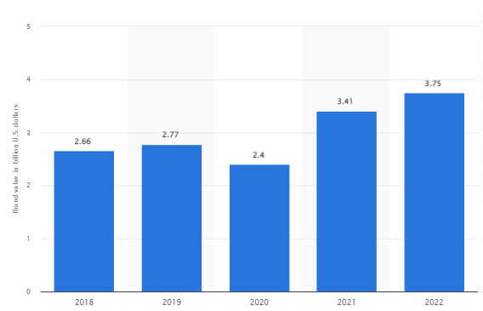
Figure 1: Brand value of Sainsbury’s
(Source: Statista, 2023)

2. PESTLE Factors
Factors | Aspects | Favourability and  Unfavourability of the identified factors
Political | - The living rate of wage for UK individuals is £10.42 (Gov.uk, 2023).  - In terms of PSI (“Political Stability Index”), the UK holds 0.54 points (Sgi-network, 2023).  - As a result of Brexit, the UK government had to increase the rate of expenses to customers by 20% (Deloitte, 2023). | Unfavourable
Economic | - 9.2% is the current rate of CPIH (“Consumer Prices Index including owner occupiers' housing costs”) in the UK (Gov.uk, 2023).  - It is to note, current “GDP per capita” of UK is 41127.44 USD (World bank, 2023).  - £32300 is the current rate of “disposable income” in the UK (Gov.uk, 2023). | Unfavourable
Social | - The UK ranks 19th when it comes to “social progression” (Socialprogress, 2023).  - Currently, the UK manages 99% of literacy to deliver effective results (Org.uk, 2023).  - 66.4 million is the current ratio of population in the UK (Gov.uk, 2023). | Favourable
Technological | - Incorporation of “Advanced AI (Artificial Intelligence) algorithms” can increase revenue of retail organisations by 6% (Intel, 2023).  - Incorporation of RFID (“Radio Frequency Identification”) as a “technological advancement” can unlock up to 5% growth from “inventory control” (Mckinsey, 2023). | Favourable
Legal | - “Consumer Rights Act 2015” has a major impact on retail business practices (Gov.uk, 2023).  - “The General Product Safety Regulations 2005 (GPSR)” helps in managing reasonable business activities (Gov.uk, 2023). | Favourable
Environmental | - Reducing the range of GHG (“greenhouse gas emissions”) is an effective initiative from this industry (Bbc, 2023).  - The UK-based retail industry is focusing on adapting strategies to manage climate change as another initiative (Bbc, 2023). | Favourable
Table 1: PESTLE Analysis
(Source: Self-created)
Changing business environment turned into a major challenge for business activities maintained by Sainsbury. Increasing consumer debts turned into a challenging matter for Sainsbury. A report stated, “General merchandise sales slumped 21.1% in the fourth quarter, after falling 16% in the third” (Reuters, 2023). Economic aspects posed an unfavourable condition to Sainsbury. It affected the employment rate provided by Sainsbury and it had a major effect on this organisation’s inventory stock (Sainsburys, 2023). A report stated, “British consumers are likely to have less disposable income this time next year” (Reuters, 2023). Literacy acts as a favourable aspect for Sainsbury and this organisation focuses on developing reading corners for children (Sainsburys, 2023). AI helped Sainsbury to understand changes in customer preferences (Sainsburys, 2023). On the other hand, RFID helped Sainsbury to extend its checkpoint tags. Legal aspects helped Sainsbury to respect basic human rights (Sainsburys, 2023). Sainsbury’s decided to reduce food waste by 50% by the end of 2030 (Sainsburys, 2023). The organisation focused on using “responsible sourcing roadmaps” to embed its SCs (“supply chains”) by 2025.
Incorporation of an “omnichannel marketing factor” helped in developing multiple marketing outlets for Sainsbury. As an example, innovation in in-store and online shopping options affected Sainsbury’s in a positive manner. Incorporation of a PESTLE analysis helped in developing contextual information from the standpoint of Sainsbury’s. It helped in depicting aspects related to business directions used by Sainsbury. It helped in analysing the impact of external driving factors on this organisation's business practices. On the other hand, incorporation of this analysis depends on assumptions thus, provided datasets can become ineffective afterwards. Potential for data can lead an organisation in the wrong direction, which is a disadvantage.

3. Porter 5 Forces Model
Factors | Aspects | Impact
“Competitive Rivalry” | The UK-based retail industry is very competitive thus, Sainsbury had to face high competition from other supermarkets. | High
“Supplier Power” | Sainsbury can change and buy from in case its current suppliers do not manage compliance. | Low
“Buyer Power” | The customer base of Sainsbury has high power. This indicates that customers can switch to other brands at any moment. | High
“Threat of Substitution” | As a supermarket company, Sainsbury faces intense competition from other brands such as Tesco, Asda, Lidl and Morrisons. These key players provide “food substitutes and non-food products making the company face stiff rivalry”. | Medium
“Threat of New Entry” | The UK-based retail industry has four key players such as Tesco, Sainsbury, Asda and Morrisons. Thus, it is difficult for new entrants to enter this market without a high amount of capital. | Low
Table 2: Porter 5 Forces Analysis
(Source: Self-created)
It is important to note that Tesco, Sainsbury, Asda and Morrisons manage this industry by 70%. This implies that competition from small companies cannot affect business practices managed by the key players. New entrants have to provide high-quality products like Tesco and Sainsbury's to gain effective results. New companies need to have a high market share to give intense compression to Sainsbury. Some of the mentioned retailers need to develop high-quality food products like Sainsbury. It indicates that “Threat of Substitution” as a force provides a moderate effect on Sainsbury's business practices (Sainsburys, 2023). A report stated, “Sainsbury customers have strong power of bargaining within the food and grocery retail sector in the UK” (Sainsburys, 2023). It highlights that Sainsbury allows its customers to control price ranges of products.
Sainsbury can change from one supplier to another one when it does not face any kind of compliance. This acts as an indication due to its ability to influence the bargaining ability of this organisation (Sainsburys, 2023). This aspect will allow Sainsbury to offer a wide range of services and products to its potential customers. A report stated, “Based on intense competition among players, there is a cut of prices among players in this industry hence affecting them negatively within the market share” (Reuters, 2023). It highlights “Competitive Rivalry” acts as a strong force for business practices of Sainsbury.

4. SWOT Analysis
The “SWOT analysis tool” is basically one of the most useful decision-making tools in business. In addition, this particular tool has the advantage of helping easy identification of external and internal factors, which have a direct impact on businesses. However, the disadvantages of this tool are mainly a lack of clarity and a lack of prioritisation.
Strengths | Weaknesses
- “A strong base of customers”  - “Unique Strategies for Promotion”  - Strong existence on social sites (Sainsburys, 2023)  - A listed retail brand | - Reduced profit margins (Sainsburys, 2023)  - Increasing range of prices  - Financial instability  - Switching companies
Opportunities | Threats
- “24*7 Service”  - Global expansion  - A shift in economic factors (Sainsburys, 2023)  - Incorporation of latest trends | - Level of globalisation  - Rules and regulations  - Business related controversies (Sainsburys, 2023)
Table 3: SWOT Analysis
(Source: Inspired by aspects of Sainsbury)
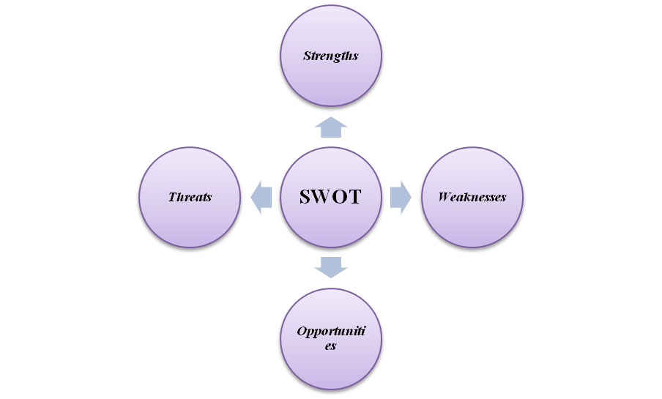
Figure 2: Factors of SWOT Analysis
(Source: Self-developed)

Analysing the SWOT analysis of Sainsbury, it can e understood here that the advantages of this organisation are mainly a strong customer base, unique promotional strategies, and brand popularity. Apart from this, the opportunity for global expansion and incorporation of the latest trends are the other advantages of this organisation. This is mainly because both of these opportunities can be beneficial for Sainsbury in increasing organisational revenue and overall profit margin. On the other hand, the disadvantages of this organisation are mainly increasing product prices, lower profit, and financial instability and switching companies. Apart from this, the threats pf increasing globalisation along with its rules and regulations and the business-related controversies can also be disadvantageous for Sainsbury.
In this context, to highlight strengths, weaknesses, opportunities and threats of Sainsbury it is necessary to discuss its business objectives. It focuses on knowing its customers in a better way. It tends to provide services and products at a reasonable price range (Sainsburys, 2023). “London Stock Exchange” highlighted Sainsbury as a major company. This publication helped in developing a positive brand image for Sainsbury (Sainsburys, 2023). In addition, this company uses various strategies to promote its business activities. “Brand Match” is a promotional strategy used by Sainsbury and it acts as a key strength (Sainsburys, 2023). Additionally, due to a shortage in supplies, this organisation had to increase price ranges of its products and it is another identified weakness. “Strong loyalty programs and promotions” reflected aspects of brand switching.
A report stated, “Sainsbury has been facing huge financial losses for the past 2 years which results in decreasing annual revenue and net profit” (Sainsburys, 2023). On the contrary, “dairy price-fixing”, “VAT avoiding scheme” and ethical issues are major controversies faced by Sainsbury, which acted as a threatening matter. Orientation of a SWOT analysis helps in analysing the internal business environment of an organisation. In this study, SWOT analysis helped in facilitating an understanding of strengths and weaknesses of Sainsbury’s. It is effective in developing strategic thinking procedures for organisations. This analysis will help in enabling focus on strengths to develop opportunities for Sainsbury. In contrast to this, this analysis can oversimplify datasets, which can be a disadvantage. In addition, SWOT analysis incorporates subjective analysis, which acts as a disadvantage.

5. STP (Segmentation, Targeting and Positioning) of the selected company
Segmentation | Targeting | Positioning
- Demographic: Age, “family life cycle”, income, occupation, education, race, nationality and religion  - Psychographic: characteristics and potentiality to purchase offered products  - Geographic: On the basis of the residing location of target customers and existed customers from operating countries | A report stated, “The target audience of Sainsbury is from 15 to 80 years” (Sainsbury, 2023).  The target customers of Sainsbury are mainly from the UK and Ireland. | Usage of a “premium pricing strategy” helped Sainsbury’s to offer proper services and products to the target customers in the UK and Ireland.
Table 4: STP Analysis
(Source: Self-created)
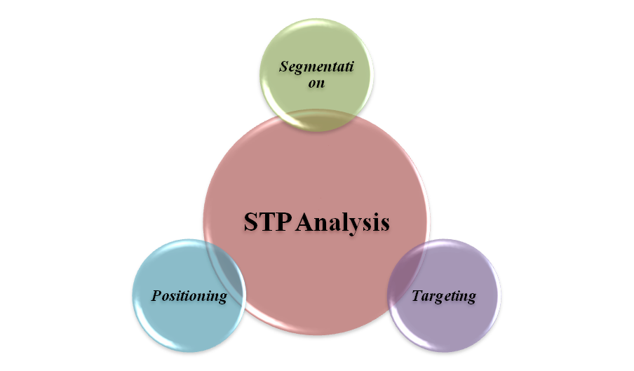
Figure 3: Aspects of STP Analysis
(Source: Self-developed)
Analysis
Segmentation: Sainsbury as a retail organisation focuses on managing segmentation based on multiple demographic factors. In addition, it also focuses on aspects related to “psychographic, demographic and geographic factors” to segment its market.
Targeting: As a supermarket chain, it intends to provide high-quality products to its target market. It will help in developing a better connection with its new and potential customers.
Positioning: Sainsbury positioned itself with the help of a “medium to high-end markets strategy”. It helped this organisation to turn into “second-largest grocery chain” in the UK.

6. Describing the marketing mix (4Ps)
4Ps Marketing mix elements | Strategies
Product | - Sainsbury is a multi-channel retail organisation, which use a “product differentiation strategy” and offers more than 90000 different products (Sainsburys.co.uk, 2023). The main product ranges of this organisation are general merchandise, groceries and clothing products (Sainsburys.co.uk, 2023).
Price | - The pricing strategy used by Sainsbury is “value-based pricing”, which mainly ensures the overall quality of products according to the product price.
Place | - At present times, Sainsbury has more than 700 convenience stores and 500 supermarkets (Sainsburys.co.uk, 2023). In addition, currently, Sainsbury has more than 13 “regional distribution centres” and 2 “national distribution centres” for easily distributing its different categories of products to its customers (Sainsburys.co.uk, 2022).
Promotion | - In order to promote its products and services, Sainsbury mainly uses the strategy of “social media marketing”, especially Twitter and “database marketing and packaging” (Sainsburys.co.uk, 2023).
Table 5: 4Ps Marketing mix strategy of Sainsbury
(Source: Sainsburys.co.uk, 2023)
Selling different varieties of products, such as general merchandise, groceries and clothing products has been significantly beneficial for Sainsbury, one of the popular retail organisations in the UK. In addition, this retail organisation uses the “value-based pricing strategy”, which has assisted this organisation in ensuring that the customer is happy about the pricing they are paying for this company's products. A huge number of supermarkets and convenience stores in Sainsbury has also been greatly useful for this organisation in distributing its products internationally. Moreover, the promotional strategies of “social media marketing” and database packaging have also been fruitful in attracting a huge customer base for this organisation.

7. Conclusion
The study concluded factors related to marketing management based on a perception of Sainsbury. It highlighted aspects faced by Sainsbury by conducting a marketing environmental analysis. It analysed the external environment with the help of PESTLE factors and SWOT helps in analysing the internal atmosphere of Sainsbury. Usage of STP helped in analysing marketing strategies used by this organisation. Hence, it helped in developing future marketing strategies for Sainsbury with 4Ps.

Question B: Recommendations

1. Developing recommendations for future marketing strategies
In the present business world, to get a competitive advantage, Sainsbury is needed to develop its future marketing strategies in a strategic way. Firstly, Sainsbury can implement the “influencer marketing strategy” to promote its products. In the opinion of Campbell and Farrell (2020), this marketing strategy has a high ROI (“Return on Investment”) rate and helps to build brand awareness. Apart from this, the marketing strategy of SEO (“Search Engine Optimization”) can also be quite useful for this renowned UK-based retail organisation in enhancing its future marketing strategies. As per the shared viewpoints of Vrontis et al. (2021), using SEO marketing can be valuable for business organisations in bringing organic traffic to the company website. Sainsbury as an organisation needs to change its current marketing strategy to enhance its branding factors. It is responsible for developing a buyer persona to highlight its branding strategy. Conducting a competitor analysis can be helpful in developing branding aspects for Sainsbury. It needs to audit its recent media campaigns to deliver effective results. It can be stated that by using this recommendation appropriately, the company can enhance its profitability to a greater extent.

References
Bbc (2023). COP26: Supermarkets promise to halve environmental impact by 2030. Available at: https://www.bbc.com/news/uk-59184278 [Accessed on: 15/04/2023]
Bbc (2023). New UK law to curb deforestation in supply chains. Available at: https://www.bbc.com/news/science-environment-53891421 [Accessed on: 15/04/2023]
Campbell, C., and Farrell, J. R. (2020). More than meets the eye: The functional components underlying influencer marketing. Business horizons, 63(4), 469-479.
Deloitte (2023). Brexit Industry Insights Consumer Products and Retail. Available at: https://www2.deloitte.com/content/dam/Deloitte/uk/Documents/international-markets/deloitte-uk-brexit-flyers-brexit-insights-consumer-products-and-retail.pdf [Accessed on: 15/04/2023]
Gov.uk (2023). Average household income, UK: financial year ending 2022. Available at: https://www.ons.gov.uk/peoplepopulationandcommunity/personalandhouseholdfinances/incomeandwealth/bulletins/householddisposableincomeandinequality/financialyearending2022#:~:text=Median%20household%20disposable%20income%20in,(ONS)%20Household%20Finances%20Survey. [Accessed on: 15/04/2023]
Gov.uk (2023). Consumer price inflation, UK: February 2023. Available at: https://www.ons.gov.uk/economy/inflationandpriceindices/bulletins/consumerpriceinflation/february2023#:~:text=The%20CPIH%20inflation%20rate%20is,between%20January%20and%20February%202023. [Accessed on: 15/04/2023]
Gov.uk (2023). Consumer Rights Act 2015. Available at: https://www.legislation.gov.uk/ukpga/2015/15/contents/enacted [Accessed on: 15/04/2023]
Gov.uk (2023). National Minimum Wage and National Living Wage rates. Available at: https://www.gov.uk/national-minimum-wage-rates [Accessed on: 15/04/2023]
Gov.uk (2023). Overview of the UK population: January 2021. Available at: https://www.ons.gov.uk/peoplepopulationandcommunity/populationandmigration/populationestimates/articles/overviewoftheukpopulation/january2021 [Accessed on: 15/04/2023]
Gov.uk (2023). Product safety advice for businesses. Available at: https://www.gov.uk/guidance/product-safety-advice-for-businesses#:~:text=The%20General%20Product%20Safety%20Regulations,this%20obligation%20isn't%20met. [Accessed on: 15/04/2023]
Intel (2023). Artificial Intelligence in Retail. Available at: https://www.intel.co.uk/content/www/uk/en/retail/solutions/ai-in-retail.html [Accessed on: 15/04/2023]
Mckinsey (2023). RFID in retail | McKinsey. Available at: https://www.mckinsey.com/industries/retail/our-insights/rfids-renaissance-in-retail [Accessed on: 15/04/2023]
Org.uk (2023). International Literacy Day - Factsheet | UNA_UK - UNA-UK. Available at: https://una.org.uk/international-literacy-day-factsheet#:~:text=In%20the%20UK%20the%20literacy,struggle%20to%20read%20and%20write. [Accessed on: 15/04/2023]
Reuters (2023). Britain's Sainsbury's warns of lower profit on inflation hit. Available at: https://www.reuters.com/business/retail-consumer/britains-sainsburys-warns-lower-profit-inflation-hits-2022-04-28/#:~:text=%22Sainsbury's%20will%20be%20hit%20on,said%20Bernstein%20analyst%20William%20Woods.&text=General%20merchandise%20sales%20slumped%2021.1,falling%2016%25%20in%20the%20third. [Accessed on: 15/04/2023]
Reuters (2023). Sainsbury's sees UK consumers poorer this time next year. Available at: https://www.reuters.com/article/uk-sainsbury-uk-consumers-idUKBRE9970ES20131008 [Accessed on: 15/04/2023]
Sainsburys (2023). 2022. Available at: https://www.about.sainsburys.co.uk/investors/results-reports-and-presentations/results-reports-and-presentations/2022 [Accessed on: 15/04/2023]
Sainsburys (2023). Getting kids reading – with a little Make Believe. Available at: https://www.about.sainsburys.co.uk/sustainability/plan-for-better/our-stories/2017/getting-kids-reading-with-a-little-make-believe [Accessed on: 15/04/2023]
Sainsburys (2023). Human rights. Available at: https://www.about.sainsburys.co.uk/sustainability/better-for-everyone/human-rights [Accessed on: 15/04/2023]
Sainsburys (2023). Nature - Sainsbury's. Available at: https://www.about.sainsburys.co.uk/sustainability/better-for-the-planet/nature#:~:text=Reduce%20food%20waste%20by%2050,our%20supply%20chains%20by%202025* [Accessed on: 15/04/2023]
Sainsburys (2023). Our business model - Sainsbury's. Available at: https://www.about.sainsburys.co.uk/~/media/Files/S/Sainsburys/documents/reports-and-presentations/2019/ar-docs/sainsburys-ar2019-businessmodel-strategy.pdf [Accessed on: 15/04/2023]
Sainsburys (2023). Sainsbury's. Available at: https://www.sainsburys.co.uk/ [Accessed on: 15/04/2023]
Sainsburys.co.uk, 2023, Sainsbury, Available at: https://www.sainsburys.co.uk/ [Accessed on: 15/04/23]
Sgi-network (2023). 2022 UK Country Report. Available at: https://www.sgi-network.org/docs/2022/country/SGI2022_UK.pdf [Accessed on: 15/04/2023]
Socialprogress (2023). 2022 Social Progress Index. Available at: https://www.socialprogress.org/static/8a62f3f612c8d40b09b3103a70bdacab/2022%20Social%20Progress%20Index%20Executive%20Summary_4.pdf [Accessed on: 15/04/2023]
Statista (2023). Brand value of Sainsbury's worldwide from 2018 to 2022. Available at: https://www.statista.com/statistics/1337783/sainsbury-s-brand-value/#:~:text=In%202022%2C%20Saisbury's%20%2D%20a%20British,from%202.66%20billion%20in%202018. [Accessed on: 15/04/2023]
Vrontis, D., Makrides, A., Christofi, M., and Thrassou, A. (2021). Social media influencer marketing: A systematic review, integrative framework and future research agenda. International Journal of Consumer Studies, 45(4), 617-644.
Worldbank (2023). GDP per capita (current US$) - United Kingdom. Available at: https://data.worldbank.org/indicator/NY.GDP.PCAP.CD?locations=GB [Accessed on: 15/04/2023]

