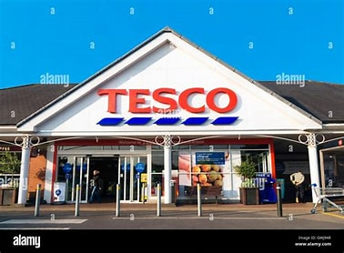  BUILDING CUSTOMER relationship strategies at tesco .  Building a Sustainable Marketing Relationship | University of Wales Trinity Saint David  Anna Misiak-Ali (2311228)  29th November 2024

Executive Summary

This report is looking at relationship marketing at Tesco. Focus is on customer relationship and customer retention. Customer retention is critical for maintaining market position for organisation. This report includes data collection and evaluation, and how it helps to enhance communication with customers. Research suggested that Tesco is providing excellent experience for its customers. During process of segmentation, pricing strategies and differentiation it is observed, and discussed how it influenced customers to become loyal to the company. Report also includes ethics of the organisation and sustainability.
In conclusion, Tesco is pioneering in data collection and analysis, and other competitors can learn a lot from them. Clubcard is one of the best products of Tesco which helps every day draw customers to make shopping with them. There are still areas in which Tesco can improve like segmentation and differentiation. There is a lot to do regardless of ethics and sustainability. Tesco need to push forward because competition does not sleep and are behind close.

Contents
Executive Summary 1
1.0 Introduction 3
2.0 Tesco profile, Current market share and Mission Statement 4
2.1 Tesco History 4
2.2 Tesco Market Share 5
2.3 Mission statement 7
3.0 Data Collection and Evaluation 8
3.1 Data collection 8
3.2 Evaluation 8
4.0. Segmentation, Pricing Strategies and Differentiation 9
4.1 Segmentation 9
4.2 Pricing strategies 10
4.3 Differentiation 10
5.0 Ethics and Sustainability 12
5.1 Ethics 12
5.2 Sustainability 13
6.0 Conclusion 14
7.0 Reference List 16

Introduction
This report was requested by the Marketing Executive Officer of ,,Marketing Focus’’ an online journal produced by Tesco. The report was written to investigate Tesco’s marketing relationship operations and compiled by Anna Misiak-Ali. This report was commissioned by internal study to contribute to Tesco’s magazine journal. To complete this report secondary sources were used that include journals, textbooks, and websites.
In this report focus is on customer relationship and customer retention. Customer retention is critical for maintaining market position for organisation.
The ,,relationship marketing is a mix of marketing tactics companies use to build lasting customer relationships. It involves methods for improving customer experiences and focuses on attaining long-term customer loyalty by getting customers emotionally involved with the business’’ said Mackeviciute (2024).
This report includes history of the company and its current market share. Throughout the report are identified and critically evaluated examples of data collection and its impact on marketing relationship. Discussed are areas of segmentation, pricing strategies, differentiation as well as ethics of the organisation and sustainability.
Provided information put new insight into problems.

2.0 Tesco profile, Current market share and Mission Statement

2.1 Tesco History

In 1919, Jack Cohen founded Tesco. The first stall was opened in London's East End. Having left the Royal Flying Corp at the end of World War I, he used his demob money to buy shares on the first day, with a daily sale of £4 he made a profit of £1. The first Tesco store opened in Burnt Oak, Edgware, North London in 1929, selling dry goods. The first product sold under its own brand was Tesco tea. The name "Tesco" was derived from the initials of T.E. Stockwell, who was a partner in a tea supplier company, and CO from Jack's surname. For further development, Jack Cohen travelled to North America to expand his knowledge, which started with self-service stores in St Albans, Hertfordshire in 1948. Throughout the years Tesco opened more supermarkets, the sale included a counter service selling cheese, butter and meats weighed by sales assistants adding in 1960 meat mincer to their offer (Herbert History, 2010).

2.2 Tesco Market Share

Tesco in 2024 owned 4942 shops, but the numbers were higher in 2012-2019.

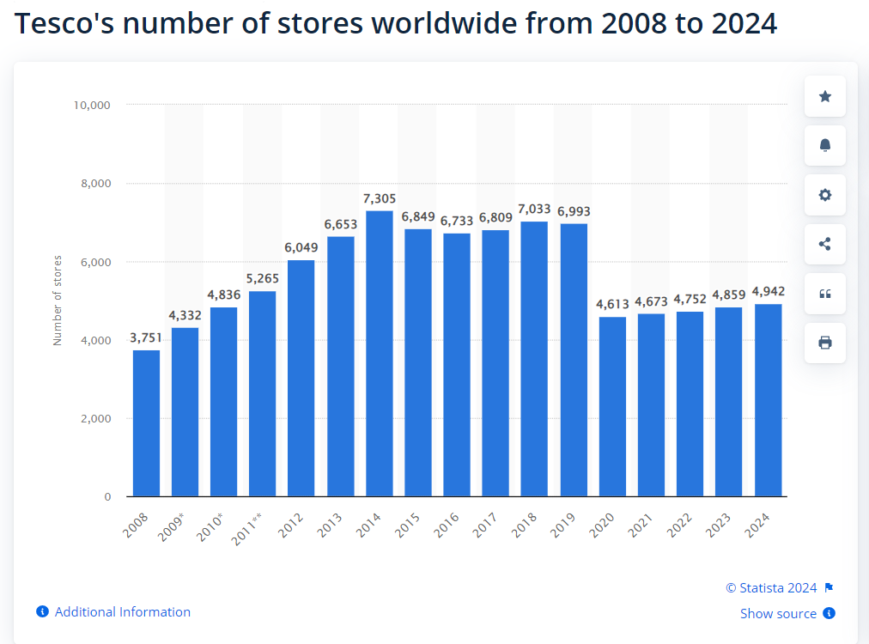
source: Bedford, (2024)

Tesco is one of the oldest supermarkets in the UK. Throughout the years its position on the market strengthened and allowed to keep position number one for many years. Below graph shows how much market Tesco shares with other competitors.
Tesco Market Share
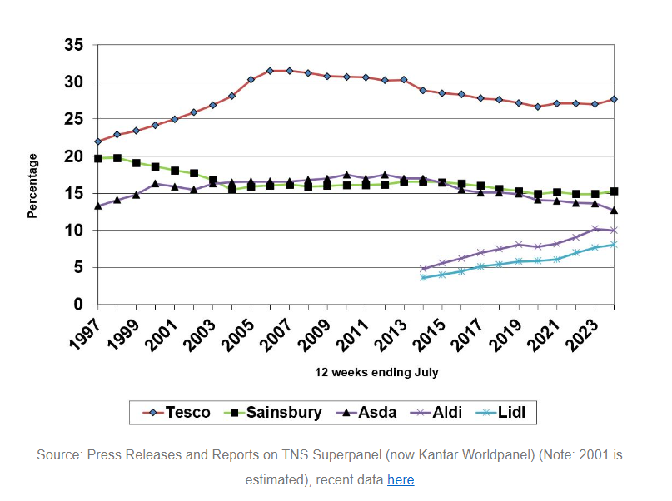
Source: Sparks, (2024)

According to Sparks, L. (2024) Tesco has growth its market share by 0.7% since year 2023. The top three supermarkets with the biggest growth over the year are Tesco, Sainsbury, and Lidl. The biggest loss suffered Co-ops, Aldi, and Asda.

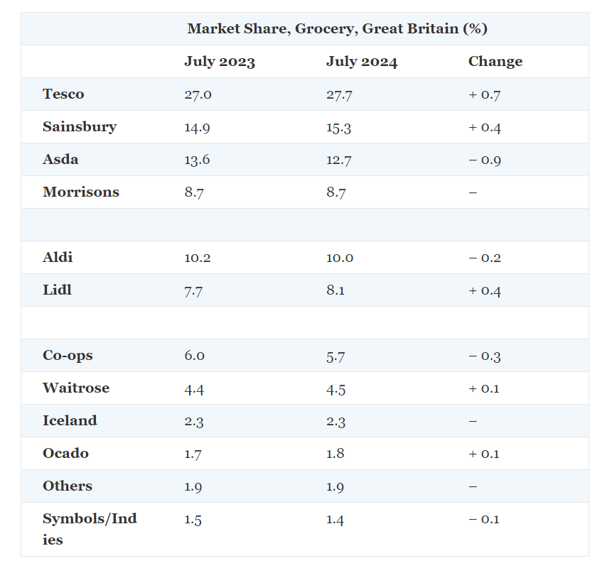
Source: Sparks, (2024)

2.3 Mission statement

Tesco mission statement resolve around customers satisfaction. Tesco as a company with more than one hundred years history wants to be seen as responsible towards customers, employees, and planet. The main core purpose for the organisation is:

,,Serving our customers, communities, and planet a little better every day means we always keep customers at the heart of what we do, while also reflecting our responsibilities to the communities we serve and to society more broadly.‘’
(Tesco, 2024)

3.0 Data Collection and Evaluation

3.1 Data collection

Data collection is a systematic process of monitoring and collecting calculation. The purpose of the research is to collect data that allows to obtain directly knowledge and primary understanding of the research problem (Bhandari, 2023).
First Clubcard was introduced 1995. Since then, Tesco gained over twenty-two million members (Team News, 2024). Tesco as a one of the first supermarket chains used loyalty card system for tracking customer activity (Tyagi, 2021). First data is collected during registration. Tesco acquires the most important information like full name, address, email address and phone number, to enhance communication with customers through emails. While Clubcard is used during shopping instore or online, system collect significant information about shopping behaviour. Using loyalty card also help to build relationship between customer and supermarket. This can help Tesco to sell more goods and preventing stockouts and overstocking. As previously suggested, Tesco also use Clubcard program to supply clients with extra price cut. Tesco while using Clubcard collecting relevant information about its customers and their demands. Hence, it enables them to segment their market and build relevant tactics. It also helps to anticipate demands for specific product.

3.2 Evaluation

Tesco by analysing data can identify patterns and trends in customer behaviour. It helps Tesco to provide offers which can be send by email. Many clients might find this type of communication useful but for many it can be too much intrusive. Companies send hundreds of emails which can spam webmail with unwanted content. Since all the world moved online, many elderly customers may feel left behind. Everything is electronic nowadays; many people struggle with new phones and cannot find information easily. Promotions, coupons, and reward points are available online. Tesco should not forget about customers who grew up with them. Many elderly people are loyal to them, Tesco should make them feel special too, with a little help.

4.0. Segmentation, Pricing Strategies and Differentiation

4.1 Segmentation

Deepak, R. K. A. and Jeyakumar, S. (2019) said that ,,Market Segmentation is the research that determines how your organisation divides its customers (…) into smaller groups based on characteristics such as, age, income, personality traits and advertising to different customers.’’ There are five most common types of market segmentation: geographical, demographic, psychographic, behavioural and lifestyle (Mowar, 2022).
People around the world are different, so their choices will be different too. Since Tesco has stores in many countries around the world, segmentation can be divided on macro segmentation, which includes specific preferences of a nation and their ethnicity, religion, age and family dynamic. Mirco segmentation categories people by their shopping behaviour, preferences, and buying habits.
While subscribing to Clubcard, Tesco does not ask about religion which can be for some people irritating. Offers are sent through emails and unfortunately, many adverts send by email shows that Tesco does not take customers seriously. Great Britain is very diverse country, by sending offers to everyone, Tesco in some ways discriminate customers from different religions that do not celebrate for example Christmas.

4.2 Pricing strategies

Pricing strategies can dictate the value of the price a manufacturer will receive for offering their products or services. Businesses can also set prices that are used for pricing strategies, such as competitive pricing, market pricing, or cost-plus pricing. The price not only affects the level of sales, but also builds the brand's position on the market and determines the perception of the offer by consumers (Bhasin, 2023).
Tesco has its substantial product range, that include clothing, household items, and electronics. The company sets a goal to provide products for everyone, Tesco divided its products into categories. Tesco Finest is the highest quality of products. Position of those products on shelves is in line of sight. Tesco wants customers to first see products more expensive. Much cheaper products are usually positioned on the bottom of shelves. Cheaper options for customers with less money to spend on weekly shopping are labelled as Tesco Everyday Value. Tesco is providing choices in its private labels, such as Tesco Finest, Tesco Everyday Value, and F&F, which have garnered the trust and loyalty of consumers (Sheridan, 2024). Tesco’s promoting to highlight one thing: its low prices. Tesco sets a strategy to boost brand image (Perch, 2023). Tesco use Clubcard to make feel special their customers through offers and promotions. By sending emails not only it helps to specify customers needs but also drove them to buy what Tesco has in offer.

4.3 Differentiation

Differentiated marketing, or segment marketing, is an approach to marketing that targets a niche market or diverse types of customers. A differentiated marketing strategy involves creating different marketing campaigns to optimize brand awareness across different customer bases that belong to your target audience (Sela, 2024).
Tesco has diversified revenue streams, including supermarkets, online grocery delivery, clothing and household goods, insurance, and petrol stations. Tesco also opened its bank (Tutor2u, 2023). This great range of products and services can help to different Tesco from its competitors. One of the services Tesco is trying to gain more clients is Whoosh, a 60-minute delivery. The order is delivered by third-party suppliers. Progress of the delivery can be checked at the Tesco Grocery & Clubcard app or the groceries home page to see delivery updates. Customers are given time frame when book delivery slot based on chosen Whoosh store (Tesco Help, 2023). There are mixed reviews regarding Whoosh, some of them are negative, which can push away customers and decide to choose competition.

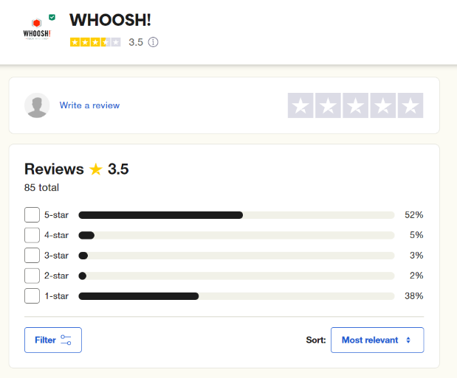
Trustpilot, 2024
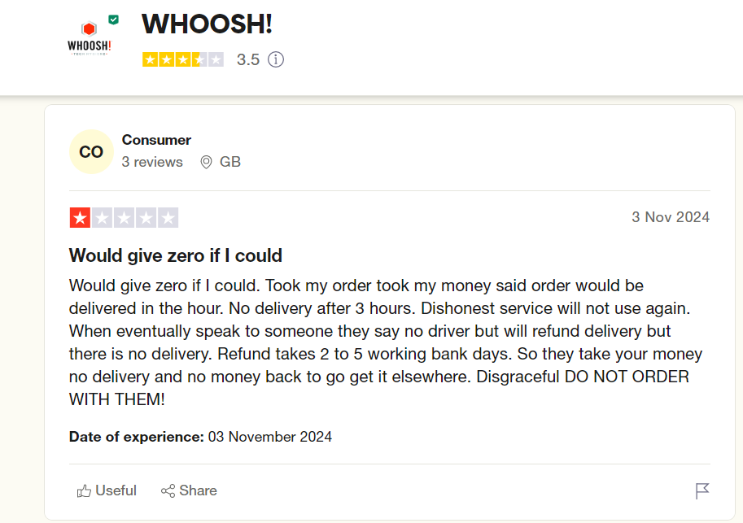
Trustpilot, 2024

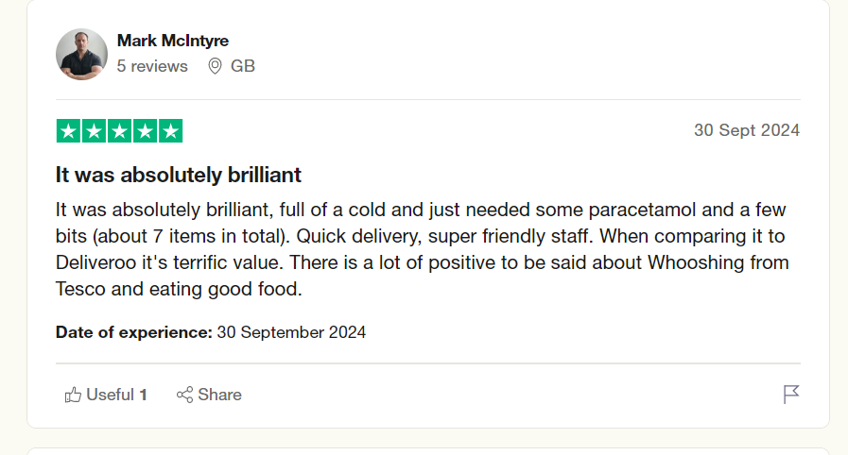
Trustpilot, 2024

Tesco has still a lot of work to do to satisfy customers. As shown above Whoosh has just 52% of positive feedback. Tesco’s Marketing Management must work harder to be able to keep customers loyal.

5.0 Ethics and Sustainability

5.1 Ethics

Business ethics is the relationship between a company and its customers, business partners, employees, and competitors. These relationships must be in accordance with the applicable law and the accepted rules of conduct. Environmental responsibilities and creating long-term value can be achieved by prioritizing the triple bottom line: Profit, People, Planet (Boyles, 2023).
Tesco PLC (2024) is currently focusing on modern slavery strategy and priorities operations within company and supply chains in UK Distribution, Thailand and Malaysia, and manufacture across East and Southeast Asia.

According to United Nations (2022) there are many ways of describing forms of modern slavery. That include slavery by owning a person, forced migrant labour, slavery until debts are paid, child labour, and forced begging, etc. As for Tesco most of those modern slavery forms are not applicable but still needs to make sure that other forms of slavery are controlled. Tesco, a multinational groceries chain enclosed in its annual modern slavery statement has found abuses against migrant workers at its stores and distribution centres in Malaysia and Thailand (Reuters, 2020). In many Asian countries poverty is so great that people are forced to work long hour shift, receiving minimum wage or even below national standards only because there are people who would like to work and have income. The replacement of the employee is easier. Many of them work in terrible conditions and without safety measures.

5.2 Sustainability

Sustainability is the ability to maintain or support a process time after time. In business and policy contexts, sustainability is the ability to find new ways to sustain Earth or look for decrease methods for depletion of natural or physical resources. Sustainability is often divided into three key ideas: economic, environmental, and social (Mollenkamp, 2023).
Tesco is focusing on the Better Baskets initiative, which can help customers choose healthier food for their families and organic, sustainable products for everyday use. Showing ways to reduce food waste and save money (Tesco Annual Report, 2024).
One of the options for caring for the natural environment is sustainable agriculture. Tesco could include buying local products in its plans instead of importing fresh products from Asia or South America. Society should have the opportunity to make healthier choices regarding food and where it was supplied from. Many of the products are harvested half ripped and do not have proper nutrition in it. It can be stored in fridges up to two years before it makes to the store. Reducing import from far away countries can help local farmers as well as customers. Client could purchase fresh product without antifungal or antibacterial injections. People buy so many groceries as the world will soon end, and they do not eat it all, it is thrown away and next shopping are purchased. However, importing products from abroad creates work for people. By reducing import many of the countries would suffer bigger poverty than it is there now, which could contribute to higher criminal activities and further dehumanization of the society. Sustainability should be taken realistically by all countries around the world as there is only one Earth.

6.0 Conclusion

Tesco is one of the biggest supermarkets in the UK. With its history over 100 years, it found place in many customers hearts. People growing up with Tesco has always consider that this retailer is looking after them. In regards of report for ,,Marketing Focus’’, there are positive and negative feedback.
Tesco is performing well during collecting data and analysing its customers preferences. Throughout segmentation process, and pricing strategies Tesco has ability to provide shopping experience for customers allowing them to feel special and understood. Tesco has established a customer relationship management strategy to boost customer retention and loyalty.
Tesco should prioritise sustainability and caring for customers and environment. People became more conscious of practises companies do to reduce expenses. Importing product from overseas can be cheaper but, it leaves carbon prints. Negative information breaching about bad treating its employees can leave negative opinions about company. Tesco also should work better to provide better experience with Whoosh, as it is good idea, but more work needs to be done.

7.0 Reference List

- Bedford, E. (2024). Tesco's number of stores worldwide from 2008 to 2024. [Online]. Statista. Last Updated: 10 June 2024. Available at: https://www.statista.com/statistics/238667/tesco-plc-number-of-outlets-worldwide/#:~:text=In%202024% [Accessed 20 November 2024].
- Bhandari, P. (2023). Data Collection | Definition, Methods & Examples. [Online]. Scribbr. Last Updated: 21 June 2023. Available at: https://www.scribbr.com/methodology/data-collection/ [Accessed 13 November 2024].
- Bhasin, H. (2023). What is Pricing? Definition, Types, Strategies & Examples. [Online]. Marketing91. Last Updated: 24 July 2023. Available at: https://www.marketing91.com/pricing/ [Accessed 19 November 2024].
- Boyles, M. (2023). What Are Business Ethics & Why Are They Important? [Online]. Harvard Business School Online. Last Updated: 27 July 2023. Available at: https://online.hbs.edu/blog/post/business-ethics [Accessed 19 November 2024].
- Deepak, R. K. A. and Jeyakumar, S. (2019). Marketing Management. [Online]. Orangebooks. Available at: https://books.google.co.uk/books?hl=en&lr=&id=_DmvDwAAQBAJ&oi=fnd&pg=PA1&dq=segmentation+definitions+in+marketing&ots=u5 [Accessed 14 November 2024].
- Herbert History. (2010). Tesco. [Online]. Herbert History. Last Updated: 2010. Available at: http://www.herberthistory.co.uk/cgi-bin/sitewise.pl?act=det&pt=&p=756 [Accessed 5 November 2024].
- Mackeviciute, C. (2024). What is Relationship Marketing? Definition, Examples, Strategies. [Online]. Sender. Last Updated: 13 June 2024. Available at: https://www.sender.net/blog/relationship-marketing/ [Accessed 22 November 2024].
- Mollenkamp, D.T. (2023). What is Sustainability? How Sustainabilities Work, Benefits, and Example. [Online]. Investopedia. Last Updated: 13 December 2023. Available at: https://www.investopedia.com/terms/s/sustainability.asp [Accessed 19 November 2024].
- Mowar, A. (2022). Marketing Management. [Online]. BlueRose Publishers. Available at: https://books.google.co.uk/books?hl=pl&lr=&id=lOyZEAAAQBAJ&oi=fnd&pg=PA54&dq=marketing+management&ots=4IogXEtJM_&sig=soO [Accessed 14 November 2024].
- News Team. (2024). Tesco’s Second Attempt at Marketplace A Data-Driven Evaluation. [Online]. Financial News. Last Updated: 06 June 2024. Available at: https://www.financial-news.co.uk/tescos-second-attempt-at-marketplace-a-data-driven-evaluation/ [Accessed 19 November 2024].
- Perch, D. (2023). Market Segmentation of Tesco. [Online]. The Social Grabber. Last Updated: 1 April 2023. Available at: https://thesocialgrabber.com/market-segmentation-of-tesco/ [Accessed 24 November 2024].
- Reuters. (2020). British grocer Tesco's slavery review reports abuses in Malaysia. [Online]. Reuters. Last Updated: 16 May 2020. Available at: https://www.reuters.com/article/business/british-grocer-tescos-slavery-review-reports-abuses-in-mala [Accessed 27 November 2024].
- Sela, R. (2024). Differentiated Marketing: Personalization at Scale. [Online]. RonSela Driving B2B Growth Forward. Last Updated: 17 April 2024. Available at: https://www.ronsela.com/differentiated-marketing/ [Accessed 19 November 2024].
- Sheridan, N. (2024). Tesco Marketing Strategy 2024: A Case Study. [Online]. Latterly.org. Last Updated: 2024. Available at: https://www.latterly.org/tesco-marketing-strategy/?utm_content=cmp-true [Accessed 29 November 2024].
- Sparks, L. (2024). Grocery Market Shares in Great Britain, 1997-2024. [Online]. Stirlingretail. Last Updated: 23 July 2024. Available at: https://stirlingretail.com/2024/07/23/grocery-market-shares-in-great-britain-1997-2024/ [Accessed 20 November 2024].
- Tesco. (2024). Core Purpose and Values. [Online]. Tescoplc. Last Updated: 2024. Available at: https://www.tescoplc.com/about/how-we-do-business/core-purpose-and-values/ [Accessed 05 November 2024].
- Tesco Help. (2024). What to expect when you place an order with Whoosh. [Online]. Tesco. Last Updated: 28 February 2024. Available at: https://www.tesco.com/help/pages/online-grocery-faqs/whoosh/what-to-expect-when-you-place-an-order-w [Accessed 29 November 2024].
- Tesco PLC. (2024). Modern Slavery Statement 2023/24. [Online]. Tesco PLC. Last Updated: 2024. Available at: https://www.tescoplc.com/media/4h2d5o1x/modern-slavery-statement-2023_24_final.pdf [Accessed 25 November 2024].
- Trustpilot. (2024). Whoosh Reviews. [Online]. Trustpilot. Last Updated: 2024. Available at: https://uk.trustpilot.com/review/whoosh.com [Accessed 29 November 2024].
- Tutor2u. (2023). Why is Tesco so profitable?. [Online]. Tutor2u. Last Updated: 19 March 2023. Available at: https://www.tutor2u.net/economics/reference/why-is-tesco-so-profitable [Accessed 29 November 2024].
- Tyagi, N. (2021). Five ways Tesco uses big data Analytics. [Online]. analyticsteps. Last Updated: 14 June 2021. Available at: https://www.analyticssteps.com/blogs/5-ways-tesco-uses-big-data-analytics [Accessed 19 November 2024].
- United Nations. (2022). 50 million people in modern slavery: UN report. [Online]. United Nations. Last Updated: 27 September 2022. Available at: https://www.un.org/en/delegate/50-million-people-modern-slavery-un-report [Accessed 27 November 2024].

