

MODULE CODE: Digital Skills for Personal Development and Business Growth BMSW4008

ASSESSMENT COMPONENT: PORTFOLIO

STUDENT NAME: Ioan Ministru Novac

STUDENT NUMBER: 2109383

LECTURER: Scott James

DATE: 16th March 2026
Contents
Task 1 3
Assessment of Digital Skills 3
References 3
Task 2 4
LinkedIn Learning Certificates for Office365 4
Task 3 5
Essay on Relevance of Excel in professional and personal life. 5
References 5
Task 4 6
7 Minute Reflective Presentation 6
References 6

Task 1

Assessment of Digital Skills
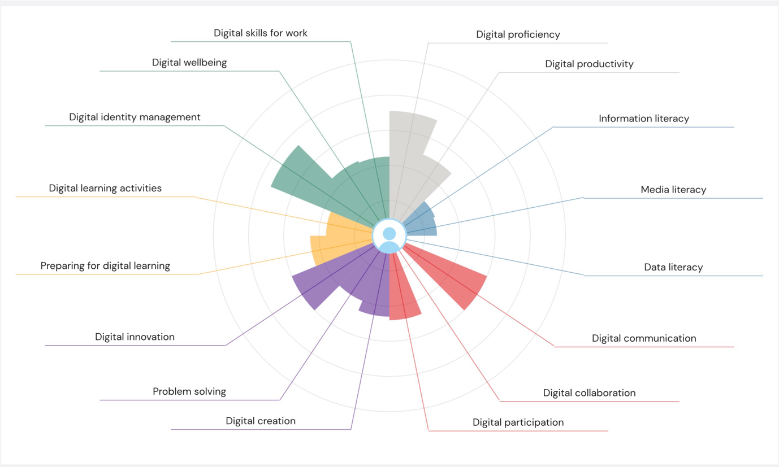

An Assessment of Digital Skills in the AI Era: Challenges and Strategic Recommendations

The global digital landscape has undergone a profound paradigm shift. Digital literacy is no longer defined by the ability to operate basic software but by a sophisticated blend of artificial intelligence (AI) fluency, data interpretation, and cybersecurity resilience. As we progress through 2026, the "digital divide" has evolved from a matter of hardware access to a matter of cognitive application. This assessment explores the current state of digital competencies and provides strategic recommendations for closing the widening capability gap between technological potential and human proficiency.

1. The AI Transition and the "Prompt" Deficit
The integration of generative AI into the professional sphere is the most significant trend of the decade. According to Microsoft (2025), approximately 82% of business leaders now expect AI to expand workforce capacity within their organisations. However, while adoption is high, true proficiency is lagging. Most users treat AI as a sophisticated search engine rather than a reasoning partner. This lack of "algorithmic literacy"—the understanding of how AI models process information and the logic behind their outputs—leads to an over-reliance on automated data without critical verification. Without the skill of "prompt engineering," users fail to extract the full value of these tools, often resulting in generic or inaccurate work products.

2. Data Literacy vs. Data Narratives
Data has become the primary currency of the global economy. The World Economic Forum (2025) identifies "technological literacy" and "big data" as the top-growing skill requirements for the next five years. Yet, a significant "interpretive gap" remains. While technical proficiency in data entry and basic visualisation is common, the ability to synthesise that data into an actionable business strategy is rare. Professionals often struggle with "data storytelling," failing to translate complex datasets into clear narratives that drive high-level decision-making. In many sectors, the abundance of data has led to "analysis paralysis," where the sheer volume of information obscures the path forward rather than illuminating it.

3. The Cybersecurity Paradox
As digital tools become more intuitive and user-friendly, user vigilance has paradoxically declined. The OECD (2024) highlights that while basic digital skills have increased, "security-first" thinking has not kept pace with sophisticated, AI-powered social engineering. Cybersecurity is still widely viewed as a technical issue for the IT department rather than a personal responsibility. With the rise of deepfake technology and hyper-realistic phishing, the human element remains the primary vulnerability in most institutional networks.

II. Strategic Recommendations

To address these challenges, a shift from functional software training to cognitive digital agility is required.

1. Cultivating Human-Centric AI Collaboration
Organisations must move beyond teaching "how to use" specific AI tools and focus on the logic of human-AI interaction.

• Recommendation: Institutions should adopt frameworks similar to the UNESCO (2024) AI Competency Framework, which emphasises the ethical and safe use of AI alongside technical skill. Training should prioritise "human-in-the-loop" workflows, where the human acts as the critical editor and ethical anchor for all AI-generated content.

2. Elevating Data Communication and Interpretation
Technical mastery of software is useless without the ability to communicate findings.

• Recommendation: Shift digital literacy curriculums toward "Data Intuition." This involves teaching employees not just how to calculate figures, but how to identify biases in data and present findings to non-technical stakeholders effectively. Digital skill must be viewed as a communication skill as much as a mathematical one.

3. Decentralising Cybersecurity Responsibility
Security must become a core personal competency for every digital user.

• Action: Implement "Zero Trust" training protocols. Employees should be trained to verify all digital communications, particularly as synthetic media makes scams more convincing. Security should be assessed as a standard performance metric in annual reviews.

4. Prioritising Digital Agility and Lifelong Learning
The shelf-life of technical skills is shrinking rapidly. The most valuable asset is now the ability to "unlearn" and "relearn" as technology shifts.

• Action: Encourage "Micro-learning"—short, frequent bursts of upskilling. By dedicating 15–20 minutes daily to emerging technologies, workers can stay ahead of the "skills obsolescence" curve identified by global economic leaders.

Conclusion

In 2026, digital proficiency is less about technical knowledge and more about a mindset of agility and critical thinking. The transition from a "digital passenger" to a "digital pilot" requires a deep understanding of AI collaboration, data narrative, and personal security. By focusing on these high-order cognitive skills, individuals and organisations can ensure they remain resilient and competitive in an increasingly automated global economy.

References

Microsoft (2025) 2025: The year the frontier firm is born - Work Trend Index Annual Report. [online] Available at: https://news.microsoft.com/source/emea/features/microsofts-2025-work-trend-index-report-reveals-the-rise-of-the-frontier-firm-marking-a-new-era-of-workforce-dynamics/ [Accessed 15 March 2026].

OECD (2024) Education at a Glance 2024: OECD Indicators. Paris: OECD Publishing. doi:10.1787/c00cad36-en.

UNESCO (2024) AI competency framework for teachers. [online] Paris: UNESCO. Available at: https://unesdoc.unesco.org/ark:/48223/pf0000391104 [Accessed 15 March 2026].

World Economic Forum (2025) The Future of Jobs Report 2025. [online] Geneva: World Economic Forum. Available at: https://www.weforum.org/publications/the-future-of-jobs-report-2025/ [Accessed 15 March 2026].

Task 2

LinkedIn Learning Certificates for Office365
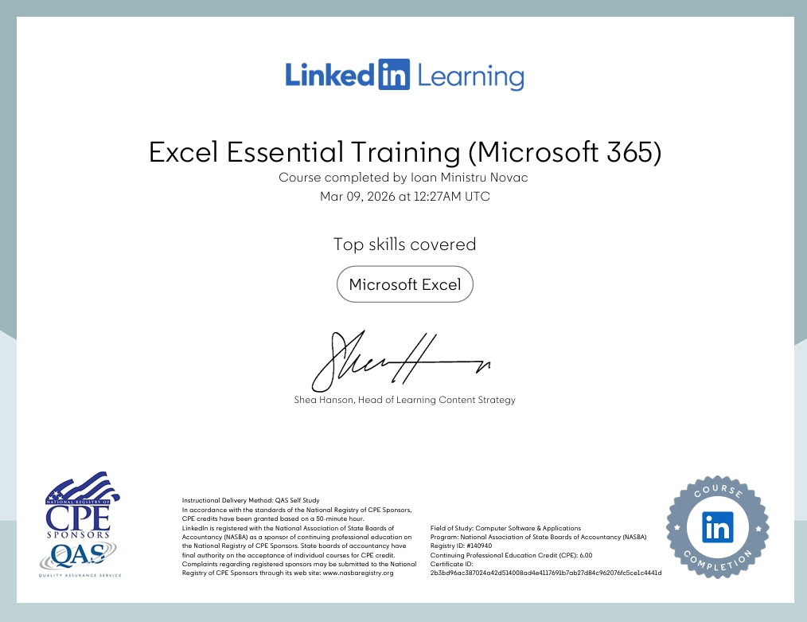

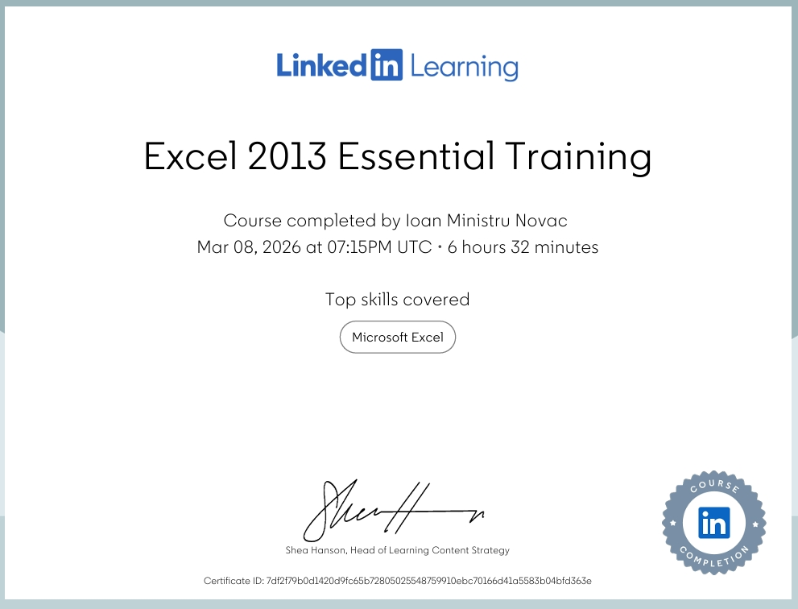

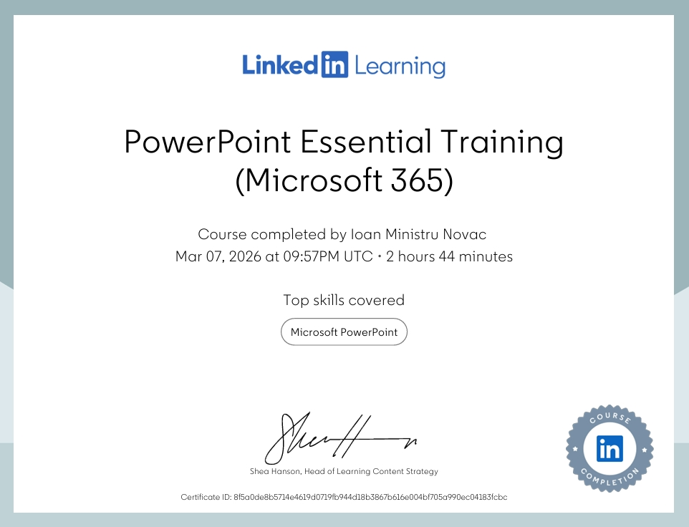

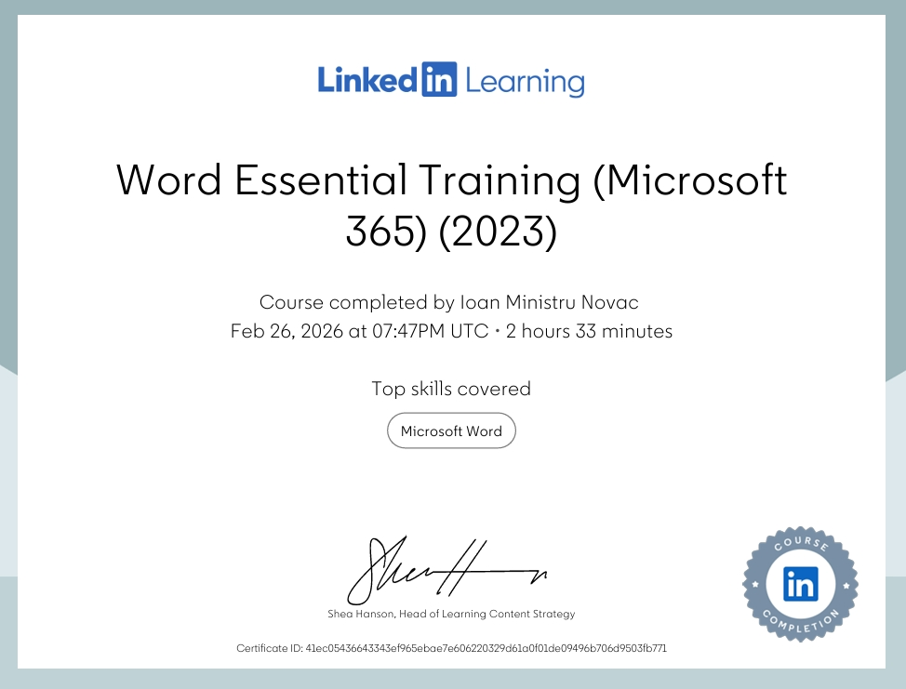

Task 3

Essay on Relevance of Excel in professional and personal life.
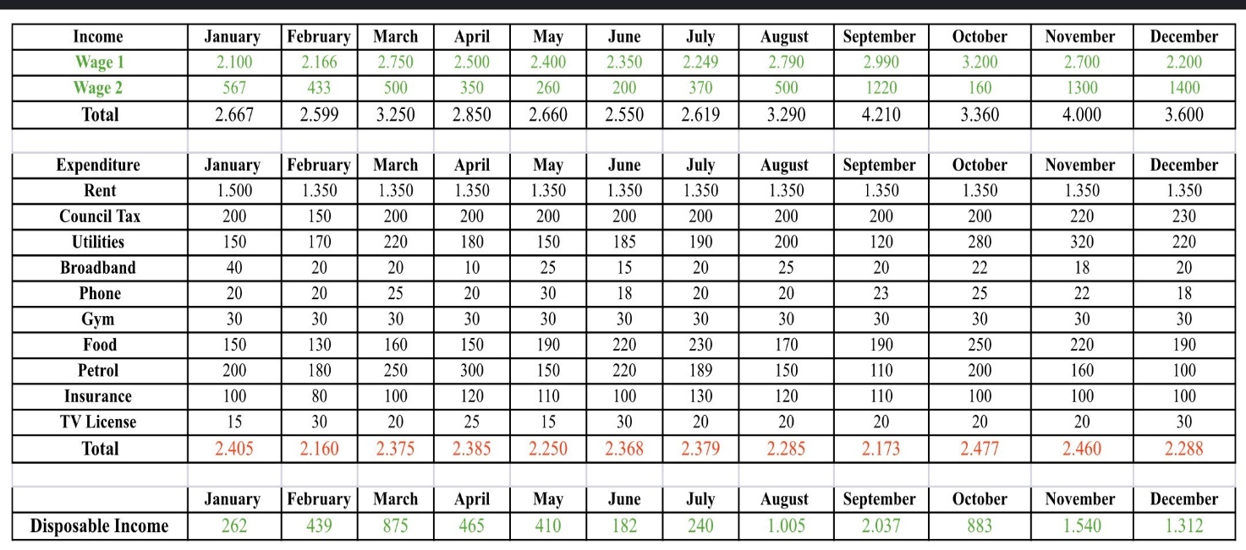
Why Microsoft Excel is Important in 2026: My Assessment

In 2026, many people thought that new AI apps would make Microsoft Excel go away. But actually, Excel is now more popular than ever. It is not just a program for accountants anymore; it is something that everyone needs to know how to use. Whether you are at work or just trying to manage your life at home, Excel helps you organise information so you can make better choices. In this assessment, I will talk about how Excel helps in professional and personal life and give some tips on how to get better at it.

I. Using Excel at Work

In almost every job today, you have to deal with data. Excel is the best tool for this because it is like a "digital toolkit" that can do many different things.

1. Making Sense of Messy Information
Every business has lots of information, like sales, customer lists, and schedules. Usually, this information is very messy. One of the most important skills I have found is using Power Query. This is a tool inside Excel that cleans up data automatically. Instead of fixing every mistake by hand, you can tell Excel how to fix it once, and it will do it forever. This saves a lot of time. According to the World Economic Forum (2025), being able to analyse information is one of the most important skills a worker can have today. Excel is the main way people do this.

2. Working with AI (Copilot)
Now, Excel has AI built-in, called Microsoft Copilot. This is a huge help because you don't have to remember every single formula anymore. You can just ask the AI a question, like "Which month did we sell the most?" and it will show you the answer. But, as Microsoft (2025) says, you still have to be careful. You cannot just trust the AI 100%. You have to check the work to make sure the numbers make sense. This is a new digital skill called "AI auditing."

3. Planning and "What-If" Thinking
Excel is great for planning. For example, if a business wants to see if they can afford to hire a new person, they can put all their costs into a spreadsheet. Then, they can change one number to see what happens. This is called "What-If" analysis. It helps bosses make smart decisions before they spend any money.

II. Using Excel in My Personal Life

I believe Excel is just as useful at home as it is at work. It helps you stay organised and feel in control of your life.

1. Managing My Money
A lot of people use phone apps for their banking, but those apps only show you what you already spent. Excel helps you plan for the future. Many people now make a "Net Worth Tracker" or a "Budget Planner" in Excel. You can track your savings, see how much you owe, and plan for big things like buying a house. This helps people feel less stressed about money. The OECD (2024) says that being good with digital tools like Excel actually helps people manage their personal finances much better.

2. Organising Big Events
If you are planning something big, like a wedding or a trip with friends, Excel is perfect. You can make a list of everyone’s names, how much things cost, and what still needs to be done. You can even use "Conditional Formatting" to turn things red if they are over budget or green if they are finished. It makes a big, scary project feel much easier to handle.

3. Tracking My Health
A lot of us have smartwatches that track our steps and sleep. You can actually move that data into Excel to see how you are doing over a long time. For example, you might notice that you are more tired on Tuesdays because you stayed up late on Monday. Using Excel to track your own habits is a great way to stay healthy.

III. My Recommendations for Getting Better at Excel

If you want to improve your Excel skills in 2026, you don't need to be a computer expert. Here is what I recommend:

• Don't just learn formulas: Focus on Power Query. It is much more useful for fixing data than just learning how to add numbers up.
• Learn to talk to the AI: Practice giving clear instructions to Copilot. If you are specific, the AI gives better answers.
• Keep things simple: Don't make your spreadsheets too complicated. Use clear headings and don't merge cells because it breaks the AI tools.
• Use pictures: A simple bar chart is much easier to understand than a big table of numbers. Always try to turn your data into a picture.

• Keep learning a little bit every day: New features come out all the time. Spend 10 minutes a week looking at a new button in Excel. Being able to learn new things is the most important skill (UNESCO, 2024).

Conclusion

In my opinion, Microsoft Excel is the most useful program you can learn. At work, it makes you look professional and smart because you can handle data. At home, it helps you stay organised and save money. In 2026, if you know how to use Excel, you aren't just a "user"—you are the one in charge of your information. It is a skill that makes everything else in life a little bit easier.
Reference List (Harvard Style)

Microsoft (2025) 2025: The year the frontier firm is born - Work Trend Index Annual Report. [online] Available at: https://news.microsoft.com/source/emea/features/microsofts-2025-work-trend-index-report-reveals-the-rise-of-the-frontier-firm/ [Accessed 15 March 2026].

MoldStud (2025) Maximize Efficiency - Troubleshooting and Optimising Your Excel Workflow. [online] MoldStud Research Team. Available at: https://moldstud.com/articles/p-maximize-efficiency-troubleshooting-and-optimizing-your-excel-workflow [Accessed 15 March 2026].

OECD (2024) Education at a Glance 2024: OECD Indicators. Paris: OECD Publishing. doi:10.1787/c00cad36-en.

UNESCO (2024) AI competency framework for teachers. [online] Paris: UNESCO. Available at: https://unesdoc.unesco.org/ark:/48223/pf0000391104 [Accessed 15 March 2026].

World Economic Forum (2025) The Future of Jobs Report 2025. [online] Geneva: World Economic Forum. Available at: https://www.weforum.org/publications/the-future-of-jobs-report-2025/ [Accessed 15 March 2026].

