

Programme: Master of Business Administration
Module: Marketing Management
Module Code: LCMB7024
Lecturer: Tushara Balendran

Assignment Title: Assessment component 01: Marketing Environmental Analysis

Topic: Marketing Environmental Analysis for Pioneers and Followers

Student Name: Md Rabiul Hassan
Student ID: 2504429
Group: 03
Term: 01

Table of Contents
1. Introduction 3
2. Task 1: Critical Analysis of the Macro Marketing Environment 3
2.1 Overview of the Macro Marketing Environment 3
2.2 Selection of Two External Macro Marketing Actors 5
2.3 Critical Analysis of Each Actor 6
3. Task 2: Strategic Responses of Pioneering and Follower Organisations 7
3.1 Pioneering Organisations’ Strategic Responses 8
3.2 Follower Organisations’ Strategic Responses 9
4. Conclusion 11
5. References 12

1. Introduction
This report is specifically aimed at investigating the manner in which organisations react strategically to the changing macro marketing environment, with specific reference being made to the place of pioneering and follower firms in competitive industries. The macro environment needs to be understood in strategic marketing management since the decisions that are made in organisations are affected by external forces like technological development, changes in policies and sustainability demands and changing consumer tastes. Researching on these forces helps firms to identify opportunities at the right time, predict threats and create marketing strategies that would help them remain viable in the long term. The report thus commences with an elaborate summary of the macro marketing environment through the PESTEL framework to visualize how political, economic, social, technological, environmental and legal forces influence the marketing decision making. Then it picks two macro players such as technological development in artificial intelligence and environmental sustainability considerations to investigate their applicability and impact trends in retail and fashion industries at the moment. Subsequently, the report critically evaluates the impact that these actors have on pioneering and follower organisations in different ways with strategic implications on each group. The following discussions analyze the strategic instruments like the Growth Matrix and the General Strategies proposed by Ansoff and Porter that the innovators and followers use to address the external threat. Altogether, the purpose of the report is to prove the importance of the macro-environmental analysis in the context of successful strategic planning and organisational wellbeing.
2. Task 1: Critical Analysis of the Macro Marketing Environment

2.1 Overview of the Macro Marketing Environment
Overview of the Macro Marketing Environment
Macro marketing environment refers to the broad external elements that influence the organisational decisions but cannot be controlled by the organisation. The forces dictate the behaviour of consumers, competition and the overall condition of the market and hence, it is important in strategic planning. Through the aid of the study of these external factors, organisations stand better chance of predicting their future opportunities and threats, aligning their marketing operations with the new emerging trends, and are able to ensure long-term sustainability in the unsteady business world.
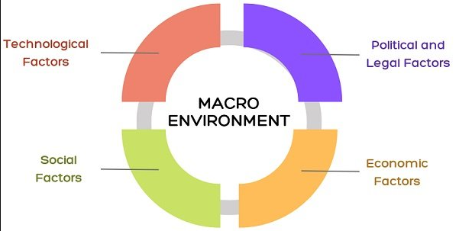
Figure 1: Macro Marketing Environment
(Source: Business Jargons, 2024)
PESTEL Framework as an Analytical Tool
PESTEL framework provides us with a more systematic approach to the macro environment analysis with the help of the six key dimensions; Political, Economic, Social, Technological, Environmental and Legal. The political factors that affect market accessibility relates to the degree of regulatory stability and trade relations. Economic conditions determine buying capacity and consumption behaviour of the consumers. The social trends that define the product development and communication strategies are in the way of demographic changes and cultural changes (Ali et al., 2023). The technology introduces the innovation, digitalisation and marketing channels. The environmental factors increase the pressure on sustainable practices and the rules on the legal practices impact the objectives and ethics. All these elements help the marketers to determine the likelihood of the influence of external forces on the market performance.
Relevance to Marketing Strategy
The macro environment enables the organisations to attract elastic and powerful marketing strategies because they have the knowledge of macro environment. As the PESTEL factors are always observed, companies can alter their value propositions, market positioning policies, and marketing strategies to remain in the pace of the competition (Varadarajan, 2020). This represents a proactive process that would assist in the enhancement of decision-making, be well-matching of customers and being ready to deal with external upheaval in increasingly complex market place.

2.2 Selection of Two External Macro Marketing Actors
Technological Actor – Artificial Intelligence in Retail
A key player in marketing of the retail sector is the technological player in artificial intelligence (AI) and digital analytics that shape the marketing landscape of the retail industry. Recent reports indicate that over 90% of retail marketers are already using AI, 50% of them planning to invest further into it, which confirms its increasing strategic value (Emarsys, 2025). Currently, the retail AI market is USD 11.61 billion in the world and is predicted to reach USD 40.74billion by 2030 signifying a high adoption rate (Grand View Research, 2024). AI assists retailers to develop the ability to personalize the consumer experiences, optimize pricing and real-time inventory supply. With respect to marketing teams, AI stands to benefit much in the the fields of segmentation, targeting and customer-journey mapping. However, the organisations that fail to adopt AI will probably lose efficiency and customer interaction and agility to the other competitors.
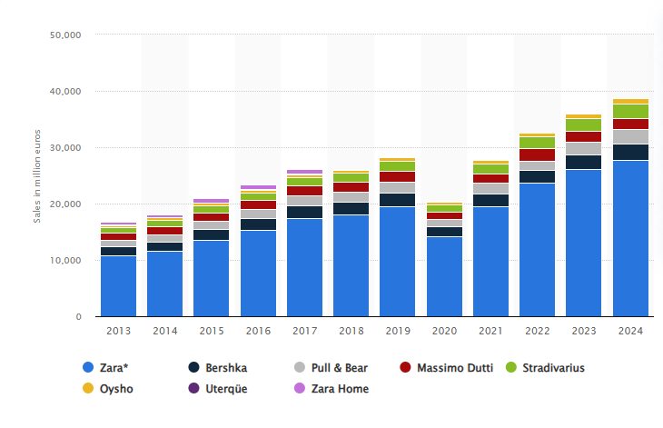
Figure 2: Net Sales of Inditex group from 2013-2024
(Source: Statista, 2025)
Environmental Actor – Sustainability & Regulatory Pressure in Fashion Retail
A major role in the fashion retail subsector is the environmental player particularly green demand and regulatory forces. The industry ranks as one of the leading manufacturers of carbon that emits about one third of all the carbon gases in the world and it also uses a lot of water and this is the cause of concern by regulators and consumers (Earth.Org, 2024). Some regions such as EU and UK are placing model tighter on transparency, extended producer responsibility and eco- labelling (TrusTrace, 2025). This matters to the marketers as they put products on testable sustainability assertions, lifecycle impacts and supply-chain transparency. Failure to consider the expectations of environmental issues may lead to reputational damages, lack of conformity and poor competitiveness in the market.

2.3 Critical Analysis of Each Actor
Critical Analysis of the Technological Actor – Artificial Intelligence in Retail
The artificial intelligence (AI) technological actor has various impacts on the pioneering and follower organisations in the retail industry. The first movers experience advantages of an early survival owing to the high rate of AI retail market growth that could amount to USD 11.61 billion in 2024 and USD 40.74 billion in 2030 (Grand View Research, 2024). This growth, and the results show that more than 60% of retailers intend to invest more in AI allows early adopters to customise more, lower prices, and manage stocks (NVIDIA, 2024). The high data capabilities enable them to make decisions faster, cut down on costs, and improve customer experiences. Conversely, follower organisations are characterized by some of the following difficulties such as inadequate digital infrastructures, lack of expertise, and an increase in the cost of implementation, sluggish AI implementation. It has the effect of building a great competitive divide, as consumers continue to drift towards smooth AI-enhanced experiences (Wood et al., 2021). Nevertheless, AI also offers opportunities like the modular cloud-based tools allow the followers to embrace gradual transformation with minimal initial expenditure. Strategically, pioneers should reinforce data control and ethical application of AI, whereas followers should emphasize adoption of AI on a scale, employee education, and collaborations to evade long-term drawback.
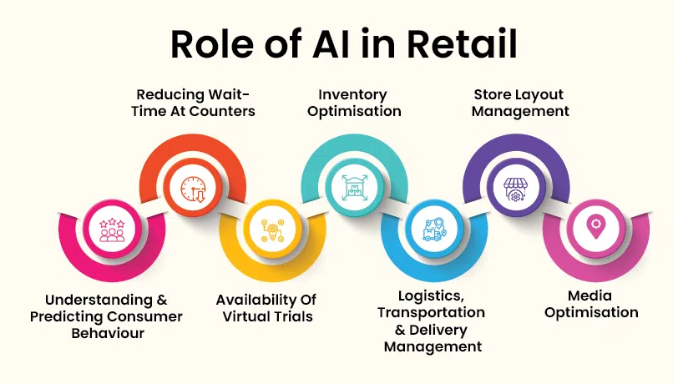
Figure 3: Role of AI in Retail
(Source: GeeksforGeeks, 2025)
Critical Analysis of the Environmental Actor – Sustainability & Regulatory Pressure
In the fashion retail, pioneers and followers are also not influenced equally by environmental pressures especially sustainability demands and changes in regulations. Regulators and consumers are putting the screws on the industry, which contributes approximately 10% of the world carbon emissions and consumes an approximate of 93 billion cubic metres of water each year (MDPI, 2022). First movers investing actively in circular production, supply-chain transparency and eco-labelling enjoy reputational benefits and are likely to be compliant with the increasingly stringent EU and UK regulations ahead of competitors. These companies make sustainability a strategic competitive edge, which appeals to customers with a strong environmental cause. Instead, the growing compliance costs, undermined traceability systems and unsubstantiated accusations of green washing have challenged the followers and could hurt brand credibility (Sharma, 2021). However, sustained shifts also open up growth prospects using second hand markets, rental schemes and recycled products lines. Planning-wise, leaders should further integrate evidence-based sustainability through operations and marketing and followers should invest in traceability systems, precise reporting and realistic sustainability communications to become competitive and compliant.

3. Task 2: Strategic Responses of Pioneering and Follower Organisations

3.1 Pioneering Organisations’ Strategic Responses
Pioneering Organisations’ Strategic Responses Using Ansoff’s Growth Matrix
The pioneering organisations deal with dynamic external issues and opportunities by considering the external issues into proactive growth strategies in terms of the Growth Matrix advanced by Ansoff. They usually invest in product development to follow the pace of competitive advantage especially in the competitive world that is fast-paced and masculine in the technology world. Nevertheless, Amazon, the case in point, builds its opportunities, introducing AI-powered personalisation, the drone delivery service and the sophisticated logistics solutions to improve the quality of working results and customer satisfaction (Purawidjaja et al., 2024). Pioneers also practice diversification to ensure that it does not depend on the core markets, as well as to diversify the risk. The shift toward cloud computing, wearable and driving technologies will be enhanced by Google who can easily show that the diversification assists a leader to survive in the turbulent markets.
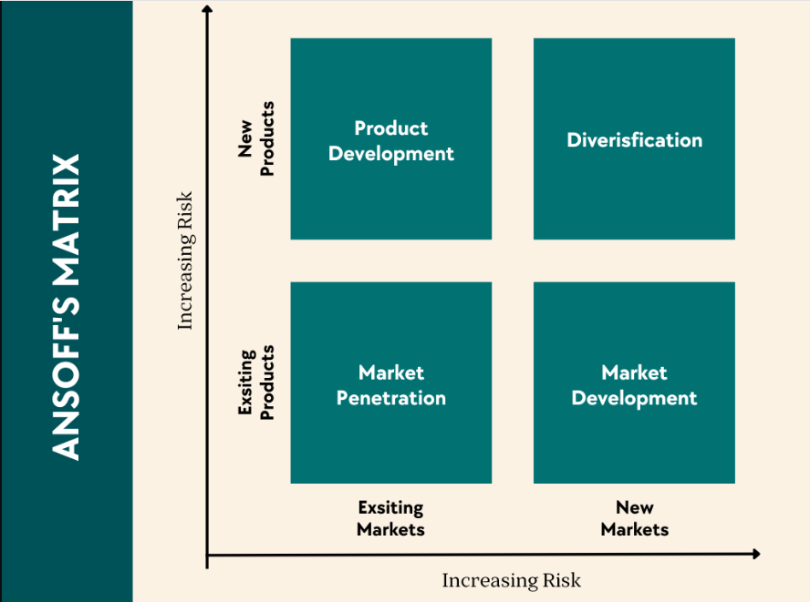
Figure 4: Ansof Matrix
(Source: IdeaScale, 2023)
Strategic Positioning Through Porter’s Generic Strategies
With Porters Generic Strategies, first mover organisations leverage on their strength by applying the strong differentiation strategies that leave a unique value propositions. Apple is one of the examples of this strategy with its combination of high-quality design, ecosystem connectivity, and artificial intelligence to sustain brand differentiation and premium pricing (Acar, 2024). Alternatively, the differentiation and cost leadership is also hybridized such as in the example of Tesla relying on vertical integration, battery as tech and automation as the medium of low-cost production and the supply of technologically advanced electric vehicles. The strategies enable pioneers to have the capability of responding effectively to the rising competitive intensity, technological turbulence and evolving consumer tastes and needs.
Industry Examples of Adaptive Strategic Execution
The second innovation phase is points to pioneering organisations, which bring sustainability and digital transformation into its strategic agenda. Some of the environmental innovations are circular models, which apply environmentally friendly materials and transparent supply chains, which make Patagonia act under regulatory pressure and growing customer demand in ethical products. In the sphere of fast-fashion, Zara has employed real-time analytics and near-shoring, as well as, production cycles, to respond to the changes in consumer trends in the quickest fashion industry. These cases show how innovators have the power to incorporate environmental, technological and market savvy in the development of the capacity to develop flexible strategies, which increases resilience (Pandey et al., 2020). The ability to anticipate the macro-environmental changes and translate them into strategic action plans has made them remain on top of the industry and be instrumental in triggering the competitive processes in the respective industries.

3.2 Follower Organisations’ Strategic Responses
Follower Organisations’ Strategic Responses Using Ansoff’s Growth Matrix
Follower organisations resolve the external threats and opportunities through lower-risk and gradual approach within the Growth Matrix of Ansoff. In contrast to pioneers who ruthlessly seek diversification and product development, followers may tend to focus on market penetration and market development to consolidate their status in well-known markets. Indicatively, the conventional retailers like Marks and Spencer develop the online delivery service, loyalty programs and online partnerships instead of spending a lot of money on disruptive technologies (de Waal-Andrews, and van Vugt, 2020). This calculated way gives followers an opportunity to become more competitive with less financial and operational risk. The selective product development is also applied when the followers mimic successful pioneer innovations.
Follower Organisations’ Positioning Through Porter’s Generic Strategies
By using the Generic Strategies of Porter, the follower organisations normally choose between cost leadership and focused differentiation, instead of direct competition with the level of innovation among pioneers. An example of a cost leadership approach is the use of discount retailers such as Primark, which have supply chains with lean integrations, massive procurement and minimal web communications, which allow them to be able to give low prices in periods of economic turbulence. This business approach attracts revenue-conscious customers and enables followers to remain on the high market share regardless of the low technological innovation (Ndonye, 2022). Other followers pursue a focused differentiation strategy in not competing directly with pioneers and instead focus on specialised segments.
Industry Examples of Adaptive Follower Strategies
Follower organisations also react cautiously to sustainability and digital transformation pressure with step-wise initiatives. In fashion, such brands as Next and H&M first implemented a lack of sustainable product lines and only partial supply-chain disclosure as opposed to entirely sustainable models (Bastardoz, and Adriaensen, 2023). In the retail sector, Tesco and other chains of supermarkets implemented AI tools only after the pioneers claimed apparent efficiency gains. These strategies assist followers to take control of risk, yet they might be surprised by the pressure to adapt according to the regulations, less relevant to the brand, slow adaptation to the change of the market. All in all, follower organisations also rely on the incremental innovation, cost-effectiveness, and strategic emulation, yet their future competitiveness depends on the need to accelerate change due to the challenges faced by them.
Opportunities
Technological innovation, new consumer needs and expanding digital markets offer a great deal of opportunities to pioneering and follower organisations. The first is an opportunity to introduce a new level of development of the product, such as the AI-based personalisation, automation, and entering the new spheres of developmental activity, such as cloud computing and wearable devices (Purawidjaja et al., 2024). These advances in technology allow first movers to increase their differentiation and competitive advantage. Rather, the followers will compete better by adopting evidenced innovations with a lowered risk, such as online delivery enhancements, a loyalty-programme or supply-chain analytics, and can thereby enhance more due to an ongoing improvement initiative and market expansion (de Waal-Andrews and van Vugt, 2020). It is also positive to have the groups that are cost-focused because they will have an opportunity to capture the price-sensitive market segments, particularly when the economies are under strain (NDonye, 2022).
Threats
With these opportunities exist major problems of external threats in both sets. The threat is great due to the high financial and operational expenditure incurred in fast innovation, where the volatile technology and the shifting nature of the consumer preferences render them susceptible, in the second case of innovations to generate the expected returns (Acar, 2024). Moreover, excessive control, especially the sustainability, is the imminent threat to a company which is unable to work rapidly. The threat to the followers is in the overreliance on the existing markets and the slowness of the innovation process that can lead to the gap in strategies that can be used by other more flexible and fast-moving pioneers (Pandey et al., 2020). The risk lies as well in the cost based followers lagging in an ever-growing dynamic markets that will fail to keep pace when the industry leaders have reinvented the concept of quality, sustainability or digital experience to fit their needs.

4. Conclusion
This report has pointed out that there is a necessity of valuing the macro marketing environment and its influence on the organisational strategy. They have been discussed to determine that the impact of outsourcing on the retail and fashion sector is considerable regarding technological innovation as well as safe regulations founded on sustainability. These forces are applied proactively and through innovation by the pioneering organisations through law of diversification and differentiation and in turn through the existence of these forces, the competitive advantage can be maintained and the industry standards can be affected. The follower organisations, on the other hand, are more conservative, more incremental in nature, such as the market penetration, cost leadership as well as selective innovation approaches, which allow them to be more competitive but which make them vulnerable to long term risk unless accelerated. Ansoff Growth Matrix and Porters Generic Strategies were found to be such strategic models to support pioneers and followers to make analysis of the surrounding environment to effectively respond to environmental factors. Overall, the report concludes that the key factor that defines the success of an organisation is continuous scanning of the environment and reactive strategies. By keeping up with the changes in the macro-environment with equal force in marketing, the companies can make themselves more resilient and competitive and undergo sustainable growth in the constantly changing and volatile market environment.

5. References
Acar, S., 2024. A Review of Porter’s Generic Strategies: Strategy Examples in International Firms. International Social Sciences Studies Journal, 10(11), pp.1902-1918.
Ali, O., Osmanaj, V., Kwiatek, P., Chimhundu, R., Alryalat, M. and Dwivedi, Y.K., 2023. The impact of technological innovation on marketing: individuals, organizations and environment: a systematic review. Economic research-Ekonomska istraživanja, 36(3).
Bastardoz, N. and Adriaensen, S., 2023. What does it mean to follow? A critique of the followership literature and a conceptual model of the emergence of downward following. Frontiers in Psychology, 14, p.1072800.
Business Jargons (2024) What is marketing environment? Features and types. Available at: https://businessjargons.com/marketing-environment.html (Accessed: 10 November 2025)
de Waal-Andrews, W. and van Vugt, M., 2020. The triad model of follower needs: Theory and review. Current opinion in psychology, 33, pp.142-147.
Earth.org (2024) Fast Fashion’s Detrimental Effect on the Environment. Available at: https://earth.org/fast-fashions-detrimental-effect-on-the-environment/ (Accessed: 10 November 2025).
Emarsys (2025) 20 AI Retail Marketing Statistics. Available at: https://emarsys.com/learn/blog/20-ai-retail-marketing-statistics/ (Accessed: 10 November 2025).
GeeksforGeeks (2025) Role of AI in Retail. Available at: https://www.geeksforgeeks.org/artificial-intelligence/role-of-ai-in-retail/ (Accessed: 10 November 2025)
Grand View Research (2024) AI in Retail Market Size, Share & Trends Report. Available at: https://www.grandviewresearch.com/industry-analysis/ai-retail-market-report (Accessed: 10 November 2025).
IdeaScale (2023) Analysis and Advantages of Ansoff Matrix. Available at: https://ideascale.com/blog/analysis-and-advantages-of-ansoff-matrix/ (Accessed: 10 November 2025)
MDPI (2022) The environmental impacts of fast fashion on water quality. Available at: https://www.mdpi.com/2073-4441/14/7/1073 (Accessed: 10 November 2025).
Ndonye, D.M., 2022. Followership in leadership process and organizational performance: A review of literature. International Journal of Organizational Leadership.
NVIDIA (2024) State of AI in Retail and CPG: 2024 Trends. Available at: https://images.nvidia.com/aem-dam/Solutions/documents/retail-state-of-ai-report.pdf (Accessed: 10 November 2025)
Pandey, N., Nayal, P. and Rathore, A.S., 2020. Digital marketing for B2B organizations: structured literature review and future research directions. Journal of Business & Industrial Marketing, 35(7), pp.1191-1204.
Purawidjaja, R.A., Chudra, G. and Yohannis, A., 2024. Comprehensive Study of Information Technology Strategy Components in Global ICT Companies Utilizing PESTLE and Ansoff Matrix. Sinkron: jurnal dan penelitian teknik informatika, 8(4), pp.2397-2409.
Sharma, A.P., 2021. Consumers’ purchase behaviour and green marketing: A synthesis, review and agenda. International Journal of Consumer Studies, 45(6), pp.1217-1238.
Statista (2025) Sales of the Inditex Group worldwide by format. Available at: https://www.statista.com/statistics/456505/sales-inditex-group-worldwide-by-format/ (Accessed: 10 November 2025).
TrusTrace (2025) Regulatory Trends 2025: What Fashion Brands and Suppliers Need to Know. Available at: https://trustrace.com/knowledge-hub/regulatory-trends-2025-what-fashion-brands-and-suppliers-need-to-know (Accessed: 10 November 2025).
Varadarajan, R., 2020. Customer information resources advantage, marketing strategy and business performance: A market resources based view. Industrial marketing management, 89, pp.89-97.
Wood, B., Williams, O., Nagarajan, V. and Sacks, G., 2021. Market strategies used by processed food manufacturers to increase and consolidate their power: a systematic review and document analysis. Globalization and health, 17(1), p.17.

