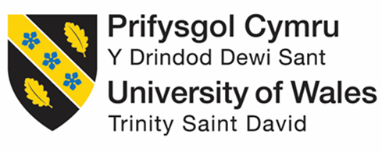
Module Name: Managing Enterprise
Module Code: BMSW4011
Student Name: Daniela Zamfir
Student Number: 2411191
Lecturer: Mel Squire

AI Statement
“I confirm that I have not presented any AI generated materials as my own work.
I confirm that I have copies of my drafts, notes, and other resources I used, which I may be asked to provide in evidence”.

Table of Contents
Task 1 Part 1 - Business plan 3
Business Overview 3
Ownership and Legal Structure 3
Mission, Aims, Objectives, and USP 3
Location and Physical Resources 3
Human Resources 4
Marketing Strategy 4
Market Research 6
Primary research Survey findings 6
Secondary Research Analysis 7
Financial Resources 7
Task 1 Part 2 - Individual reflection 8
References 10
Appendices 12
Primary Data collection (Surveys) 12
Secondary Data Collection (Thematic analysis) 18
SWOT analysis 19
12-Month Cash Flow Forecast 20

Task 1 Part 1 - Business plan

Business Overview
Ecozo Bottles is a London start-up that makes reusable water bottles from sugarcane bioplastic and stainless steel. UV-C self-cleaning lids, hydration trackers and changeable outer shells are included on every bottle. The Ecozo brand is for those who care about the planet, their health and modern styles (Khoyriyah and Purnomo, 2021). Looking at the piles of plastic trash in gyms and parks is what inspired the founder to make an option that helps people stay fit and protect the environment.

Ownership and Legal Structure
Two people will each create a business with their own design and marketing talents. Thanks to this partnership, the partners share duties, assets and choices which works well for a business trying to unite creative and operational capabilities (Fabbrini, 2022). The pros are split finances, access to more expertise and handling a business becomes easier. Yet, the partners in a general partnership are not protected from personal losses by the company and there could be conflicts between them.

Mission
Ecozo Bottles wants to help reduce the use of single-use plastics by providing smart, fashionable and environmentally friendly ways to stay hydrated.
Aims
Within two years, the business wants to be well-known as an eco-lifestyle brand in London, helping people adopt environmentally friendly choices. Also, the company aims to have 5,000 social media followers and secure three brand deals within the first year.
Objectives
Selling 1,000 units in the first six months, introducing the Ecozo mobile app in the third quarter and having a profit margin of at least 30% are some SMART goals (Gupta, 2022).
USP
Its Unique Selling Proposition comes from its unique design: No other UK brand mixes sugarcane bioplastic, UV-C self-cleaning, hydration tracking and custom shells. By doing this, the product comes across as both eco-friendly and advanced which attracts today’s health-conscious people (Chandra et al., 2022).

Location and Physical Resources
Ecozo Bottles has selected a co-working space in Shoreditch, London which is known for supporting start-ups and for being near sustainable suppliers and eco-markets. The business will make use of an environmentally friendly fulfilment centre in Barking for keeping and shipment of stock. It manages overheads and adds flexibility and scalability (Dzulfikar et al., 2022). Essential resources in the office will be Wi-Fi, printing, meeting spaces and a common workshop for prototype projects. Green entrepreneurs also can connect with others at Shoreditch. The warehouse allows efficient logistics for the brand, compatible with its eco-friendly values (Antoniuk et al., 2021).
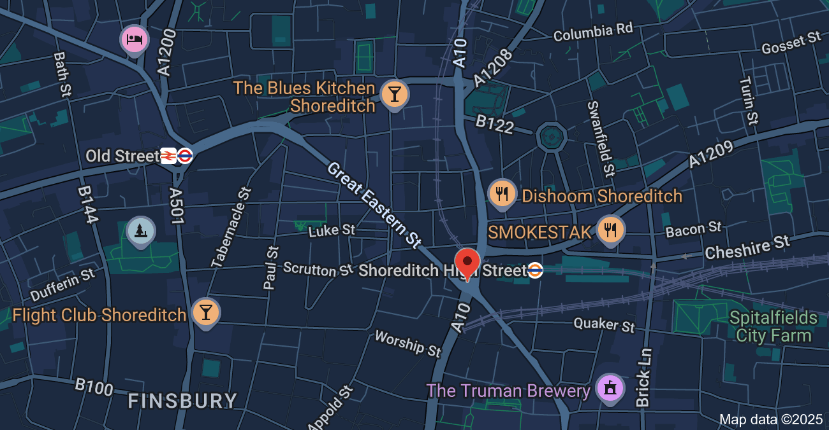
Source: Google map 2025

Human Resources
An initial group of team members will be responsible for major parts of the business. Strategic decisions will be made by the partnership. Further support includes hiring a freelance marketing assistant and product designer plus a part-time operations coordinator. Staff will be found on LinkedIn and through university networks (Gerhart and Feng, 2021). Employees will have to handle brand recognition, developing products, organising shipments and handling customer issues. Because there is just a lean team, operations stay efficient and costs are managed.
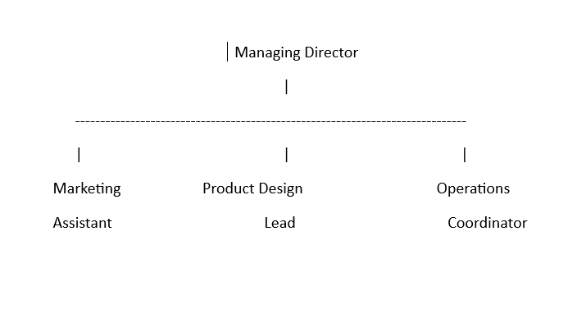
Figure 1: Organisational flow chart
Source: (created by the learner)

Marketing Strategy
Ecozo Bottles will use specific online and offline marketing efforts aimed at people who care about the environment between 18 and 40. To launch the brand, Instagram, TikTok and Facebook will be used with influencers, contests and a hashtag campaign called #SipSmart. At gyms and wellness events, gym users will find branded flyers and every purchase will be accompanied by a green business card (Rosário and Raimundo, 2021). To introduce the product, the company will organise a launch event in London. Bringing together these communication methods means the brand gets noticed and engages with the community.
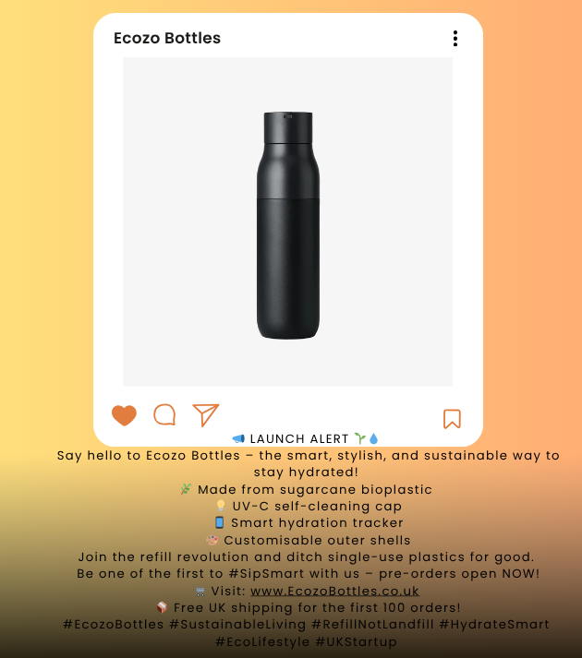
Figure 2: Instagram marketing post
Source: (created by the learner)
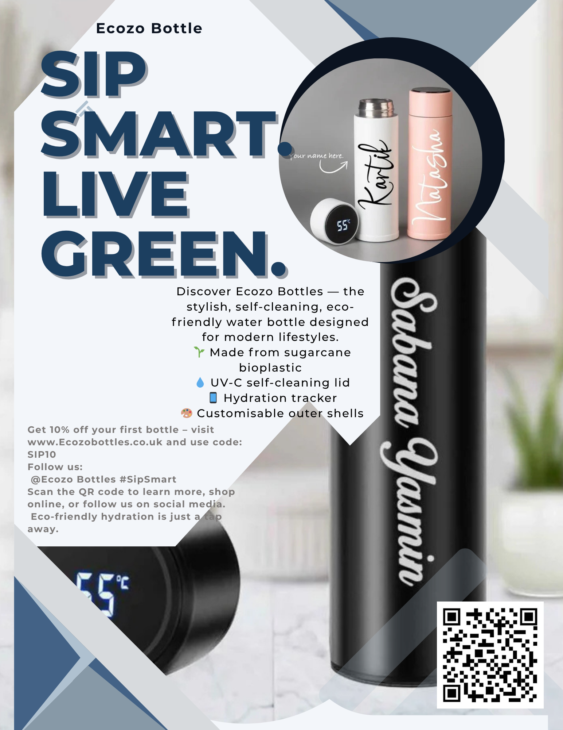
Figure 3: Flyers for the promotion
Source: (created by the learner)

Market Research

Primary research Survey findings
Consumer interest in environmentally friendly hydration was shown in the survey findings. Most respondents say they frequently use reusable bottles, whether daily (8) or a few times a week (6). The choice was to make Sip craft’s parts from stainless steel and bioplastic, in accordance with the Ecozo product design process. The majority (12) said they would like to purchase an environmentally friendly bottle and were prepared to pay up to £30 for it. Fifteen people expressed a willingness to do business with Ecozo based on its online resources. Sustainability was also very important to 12 respondents when choosing their products.

Secondary Research Analysis
Secondary research suggests people are seeking more sustainable bottled water options. Researchers De Marchi, et al. (2020) discovered that consumers are willing to pay more for recyclable and environmentally friendly packaging. Mangal et al. (2023) indicated that bioplastics are considered a good replacement for regular plastics because they degrade quickly and are not harmful to the environment. Environics (2021) located in Borusiak et al. (2021) concluded that being concerned about the environment encourages people to use fewer single-use bottles. In addition, Suryono et al. (2023) confirmed that green marketing and brand image help increase likelihood of purchasing a product.

Financial Resources
It takes £10,500 to get Ecozo Bottles up and running, because the company needs money for product development, inventory, marketing, branding and ongoing operations. There is a need for £3,000 for engineering samples and laboratory costs, £4,500 for the large batch of 500 bottles, £1,500 for making a website, designing a logo and packaging the products, £1,200 for introductory marketing and PR and £300 for business registration, insurance and other expenses. A £5,500 business loan from the Start-Up Loan programme in the UK would be used for the project. Having both equity and debt together is anticipated to provide enough money for the business to get by in its critical early days (Khan et al., 2022).
Starting sales may be easy at first, but they will steadily increase with digital marketing and by guests sharing their positive experiences. The period when break-even is expected is month 7. Because new businesses often generate less cash than they spend at first, having secured financial support helps deal with the downside. According to the findings from surveys realistic monthly sales goals (about 120–160 units) are appropriate by mid-year (Edilia and Larasati, 2023). Keeping the overhead low has been done by using marketing assistant freelancers, online offices and a slim team. The company’s plan should help achieve profitability and allow for reinvestment before the year is over.

Task 1 Part 2 - Individual reflection
Business skills and knowledge
Through developing the business plan for Ecozo Bottles, I have gathered a large amount of new business knowledge and skills. I first gained a better knowledge of market research, covered ways to collect and store both primary and secondary data and used it for creating new products. Surveys and analysing people’s preferences guided me in discovering what the ideal sustainable water bottle looks like to them. I also found out how to set goals using SMART objectives which makes them specific, measurable, attainable, realistic and set by a specific date. Because of this, I was able to set specific targets for improving sales, marketing and the brand. I have also learned how to handle financial planning (Yaacob et al., 2021). I used a cash flow forecast to analyse the impact of income and expenses on the finances of the business. Prior to doing this task, I knew very little about financial documents. I am now able to work out net cash flow, cumulative cash and determine the point when I will break even. It took some practice to get used to it, but now I find it easier to handle and interpret financial data.
I gained more knowledge about marketing strategies and communication with customers. Using marketing on social media, with influence marketing campaigns and offline tools helped me learn how to establish my brand, making it more recognisable and appealing to my target audience. They made sure to use the right social media platforms for different customer groups and mentioned being eco-friendly in their communications (Aydoğmuş and Şentürk, 2023). Thinking about a hashtag campaign, flyers and launch events as marketing ideas was new to me, thanks to the project.
Entrepreneurial trait to develop
Risk management is an entrepreneurial capability I notice I need to build. I realised that I concentrated more on what could go right with my idea but did not adequately plan for possible issues such as problems in the supply chain, rival businesses or costs I hadn’t thought about. I realise that too much optimism without a good risk strategy could be harmful to a start-up. I will work on this by studying how companies handle unexpected situations and come up with solutions. I intend to conduct SWOT and PESTLE cheques from time to time to be ready for any threats inside or outside the organisation.
Investment in the business as an angel investor
As an angel investor, I would put my money into Ecozo Bottles, but only after meeting a few requirements.Innovative and attractive to health-conscious people, the product relies on bioplastics and guaranteed self-cleaning. The company keeps its operations simple, has a sensible sales forecast and spreadsheets for financial planning. But the key difficulty is likely to be limited finance and the company’s speed at which it expands(Yan and Carless, 2022). If I were an investor, I would expect the business to have a detailed plan for growing over the long term and how new funds would help increase production and reach more customers. If we have well-researched and well-planned solutions for those points, I would trust in the business.

References
- Antoniuk, N.A., Plikus, I.Y. and Jammal, M. (2021) Sustainable business development vision under the COVID-19 pandemic.
- Aydoğmuş, M. and Şentürk, C. (2023) ‘An investigation into the predictive power of reflective thinking on learning strategies’, Reflective Practice, 24(2), pp.210–223.
- Benzaghta, M.A., Elwalda, A., Mousa, M.M., Erkan, I. and Rahman, M. (2021) ‘SWOT analysis applications: An integrative literature review’, Journal of Global Business Insights, 6(1), pp.54–72.
- Borusiak, B., Szymkowiak, A., Pierański, B. and Szalonka, K. (2021) ‘The impact of environmental concern on intention to reduce consumption of single-use bottled water’, Energies, 14(7), p.1985.
- Chandra, S., Verma, S., Lim, W.M., Kumar, S. and Donthu, N., (2022). Personalization in personalized marketing: Trends and ways forward. Psychology & Marketing, 39(8), pp.1529-1562.
- De Marchi, E., Pigliafreddo, S., Banterle, A., Parolini, M. and Cavaliere, A. (2020) ‘Plastic packaging goes sustainable: An analysis of consumer preferences for plastic water bottles’, Environmental Science & Policy, 114, pp.305–311.
- Dzulfikar, A., Jahroh, S. and Ali, M.M. (2022) ‘Business development strategy of instant ginger start-up in the COVID-19 pandemic’, Jurnal Manajemen & Agribisnis, 19(2), pp.251–251.
- Edilia, S. and Larasati, N.D. (2023) ‘Innovative approaches in business development strategies through artificial intelligence technology’, IAIC Transactions on Sustainable Digital Innovation (ITSDI), 5(1), pp.84–90.
- Fabbrini, F. (2022) ‘Next Generation EU: Legal structure and constitutional consequences’, Cambridge Yearbook of European Legal Studies, 24, pp.45–66.
- Gerhart, B. and Feng, J. (2021) ‘The resource-based view of the firm, human resources, and human capital: Progress and prospects’, Journal of Management, 47(7), pp.1796–1819.
- Gupta, M. (2022) ‘Business plan’, in Entrepreneurship in India. London: Routledge, pp.57–76.
- Khoyriyah, R.Z. and Purnomo, A. (2021) ‘Business development strategy formulation: Lessons learned from body care startup’, in 4th International Conference on Industrial & Mechanical Engineering and Operations Management (IMEOM 2021).
- Khan, R.U., Arif, H., Sahar, N.E., Ali, A. and Abbasi, M.A. (2022) ‘The role of financial resources in SMEs’ financial and environmental performance; the mediating role of green innovation’, Green Finance, 4(1), p.36.
- Mangal, M., Rao, C.V. and Banerjee, T. (2023) ‘Bioplastic: An eco‐friendly alternative to non‐biodegradable plastic’, Polymer International, 72(11), pp.984–996.
- Rosário, A. and Raimundo, R. (2021) ‘Consumer marketing strategy and e-commerce in the last decade: A literature review’, Journal of Theoretical and Applied Electronic Commerce Research, 16(7), pp.3003–3024.
- Suryono, I.A., Alfan, A. and Sudaryatie, S. (2023) ‘The influence of green product, green marketing, and brand image on consumer purchasing decisions of bottled water’, Journal of Economics and Business UBS, 12(3), pp.1405–1415.
- Yaacob, A., Mohd Asraf, R., Hussain, R.M.R. and Ismail, S.N. (2021) ‘Empowering learners' reflective thinking through collaborative reflective learning’, International Journal of Instruction, 14(1), pp.709–726.
- Yan, Z. and Carless, D. (2022) ‘Self-assessment is about more than self: The enabling role of feedback literacy’, Assessment & Evaluation in Higher Education, 47(7), pp.1116–1128.

Appendices

Primary Data collection (Surveys)

Question | Daily | A few times a week | Rarely | Never
How often do you use a reusable water bottle? | 8 | 6 | 2 | 4
Table 3: Survey question
Source: (Created by the learner)
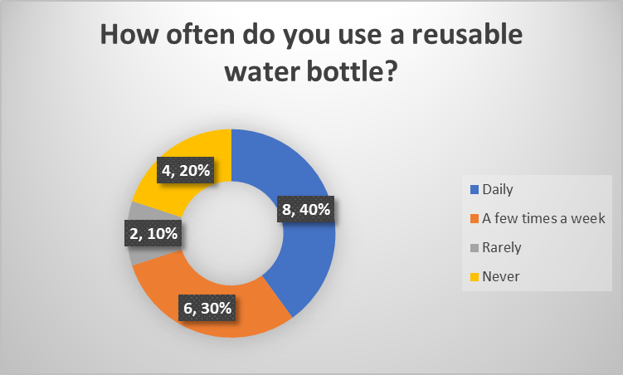
Figure 4: Pie chart
Source: (created by the learner)

Question | Stainless steel | Plastic | Bioplastic (plant-based) | Glass
What materials do you prefer your water bottle to be made from? | 10 | 2 | 6 | 2
Table 4: Survey question
Source: (Created by the learner)
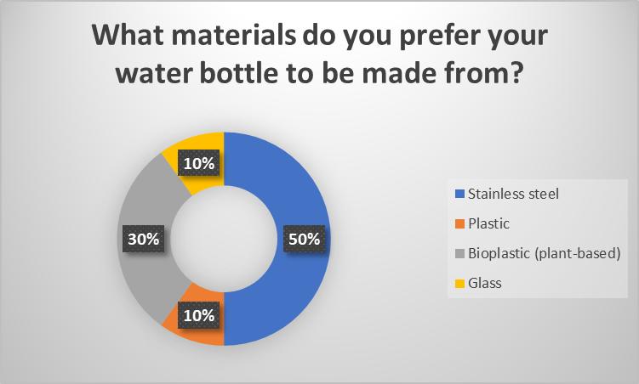
Figure 5: Pie chart
Source: (created by the learner)

Question | Yes | No | Maybe
Would you pay more for a water bottle made from sustainable, plant-based materials? | 12 | 2 | 6
Table 5: Survey question
Source: (Created by the learner)
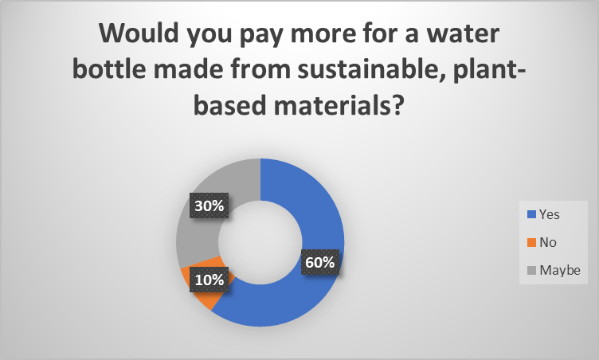
Figure 6: Pie chart
Source: (created by the learner)

Question | Under £10 | £10–£20 | £21–£30 | Over £30
On average, how much are you willing to pay for a high-quality, eco-friendly water bottle? | 5 | 3 | 8 | 4
Table 6: Survey question
Source: (Created by the learner)
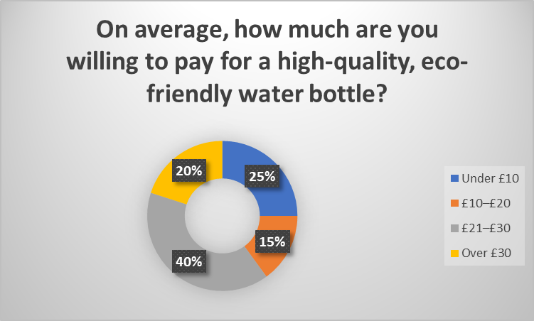
Figure 7: Pie chart
Source: (created by the learner)

Question | Yes | No | Maybe
Would you follow an eco-brand like EcoSip on social media for tips and promotions? | 15 | 2 | 3
Table 7: Survey question
Source: (Created by the learner)
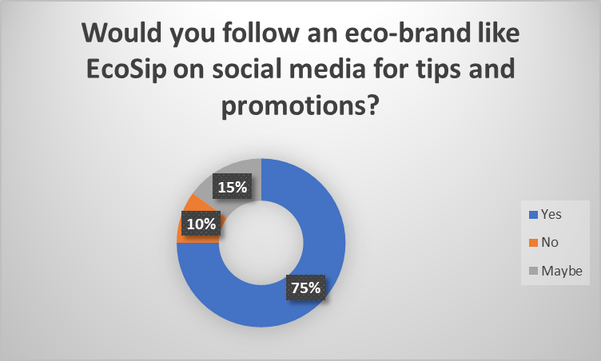
Figure 8: Pie chart
Source: (created by the learner)

Question | Extremely important | Somewhat important | Not very important | Not at all important
How important is sustainability when choosing personal products like water bottles? | 12 | 8 | 0 | 0
Table 8: Survey question
Source: (Created by the learner)
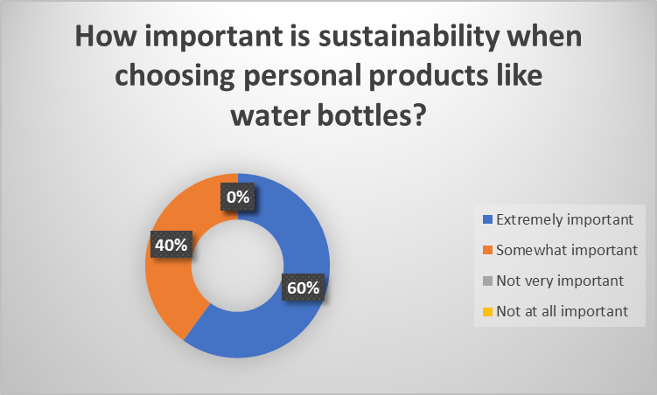
Figure 9: Pie chart
Source: (created by the learner)

Secondary Data Collection (Thematic analysis)
Theme | Authors and Date | Key findings | Summary of the research
Sustainable Packaging Preferences | De Marchi et al. (2020) | People tend to choose plastic bottles that are eco-friendly and recyclable, even if they have to pay a bit more. | The study showed that more Italians are seeking environmentally friendly plastic bottle alternatives.
Bioplastics as an Alternative | Mangal et al. (2023) | Bioplastics break down naturally, help limit carbon emissions and are favoured by people concerned about the environment. | It was examined in this research how bioplastics might be valuable and could potentially replace other types of plastic in consumer products.
Environmental Concern and Behaviour | Borusiak et al. (2021) | Thinking about the environment prompts people to want to limit their use of single-use plastic bottles. | The study found that having environmental concerns positively linked to less use of plastic.
Green Marketing and Brand Perception | Suryono et al. (2023) | Adopting green practices and a sustainable image contributes to customers’ decisions to purchase bottled water. | The report analyses whether branding and environmental marketing change the choices that younger consumers make.
Table 9: Thematic analysis
Source: (Created by the learner)

SWOT analysis
SWOT Analysis | Details
Strengths | Package with sugarcane bioplastic, UV-C cleaning technology and a way to track how much water one drinks. An environmentally friendly brand image and the target customers being those aged 18–40.
Weaknesses | A shortage of budget at the beginning often results in slower product creation, less marketing and a slower increase in business size (Benzaghta et al., 2021).
Opportunities | More people want sustainable items, environmental issues are becoming more recognised, growth on social media is expected and partnerships with influencers.
Threats | Smaller eco-brands must compete with bigger brands using better advertising, as well as face possible problems with getting their products and some customers are not very price sensitive.
Table 2: SWOT analysis
Source: (Created by the learner)
Biggest Weakness: Limited funding for growth and promotion.
Actions to Overcome:
- Apply for eco-business grants and startup competitions.
- Launch a Kickstarter or Indiegogo crowdfunding campaign.
- Introduce pre-order offers to boost early cash flow

12-Month Cash Flow Forecast
Month | Sales Income (£) | Costs (£) | Net Cash Flow (£) | Cumulative Cash (£)
January | 0 | 1800 | -1800 | -1800
February | 500 | 1200 | -700 | -2500
March | 1000 | 1100 | -100 | -2600
April | 1500 | 1200 | 300 | -2300
May | 2000 | 1200 | 800 | -1500
June | 2200 | 1100 | 1100 | -400
July | 2500 | 1200 | 1300 | 900
August | 2800 | 1300 | 1500 | 2400
September | 3000 | 1200 | 1800 | 4200
October | 3200 | 1300 | 1900 | 6100
November | 3500 | 1500 | 2000 | 8100
December | 3800 | 1600 | 2200 | 10300
Table 1: 12-Month Cash Flow Forecast
Source: (Created by the learner)

