Noah John (2502346)
Computer Architecture and Operating Systems
Operating Systems
Cybersecurity and Networking

Contents
Introduction 3
Functions of Modern Operating Systems 3
Memory, Process and Performance Monitoring 3
Device Management: I/O Devices 10
File and Directory Management 11
System Security 12
Commands 13
Windows 13
Process Management 13
File & Directory Management 14
Network Testing/Monitoring 16
User Management 18
Task Scheduling 18
Linux (Bash) 18
Process Management 18
File & Directory Management 20
Network Testing/Monitoring 21
User Management 22
Task Scheduling 22
Scripting 24
Windows (Batch) 25
Script Creation 25
Variables, User Inputs and Printing 26
Goto and If Statements 27
Arrays, For Loops and Functions 28
Linux (Bash) 29
Script Creation 29
Variables, User Inputs, Printing and If Statements 30
Case Statements and Functions 31
Arrays and Loops 33
Conclusion 33
References 34
Appendices 37
What is an Operating System? 37
Top 5 most used Operating Systems today 37
What is the Linux Operating System? 37
How will AI and Quantum computing change the world? 37
Types of Operating Systems: 38
Engagement with 1 Online Certified Course: Cisco OS Basics [12] 39
Appendix References 42

Operating Systems

Introduction
Operating Systems (OSs) are the software bridge that connects computer hardware to the end-user. [1] They ensure that users can interact and execute processes and applications in a simplified form without ever having to engage with the complexity of raw hardware by managing resources such as CPU, memory and storage. An effective operating system provides seamless and convenient user interaction through the means of an intuitive graphical user interface (GUI) or the slightly more technical command line interface (CLI). This paper will discuss how an operating system manages the complexities of a computer system and how the user can customise their environment to tailor to their specific needs concerning multiple operating systems.

Functions of Modern Operating Systems

Memory, Process and Performance Monitoring
While an OS is running, it manages several key areas, including file storage, network connections, CPU time, memory, system security and input/output devices. To do so efficiently, the OS routinely manages system processes and memory using process scheduling and resource allocation. The OS creates, schedules, assigns and terminates processes, allocating CPU time through scheduling algorithms. Users can adjust priority, end tasks and monitor usage, with the help of a variety of process and memory management tools.
Windows:
Task Manager (CTRL-ALT-DEL)
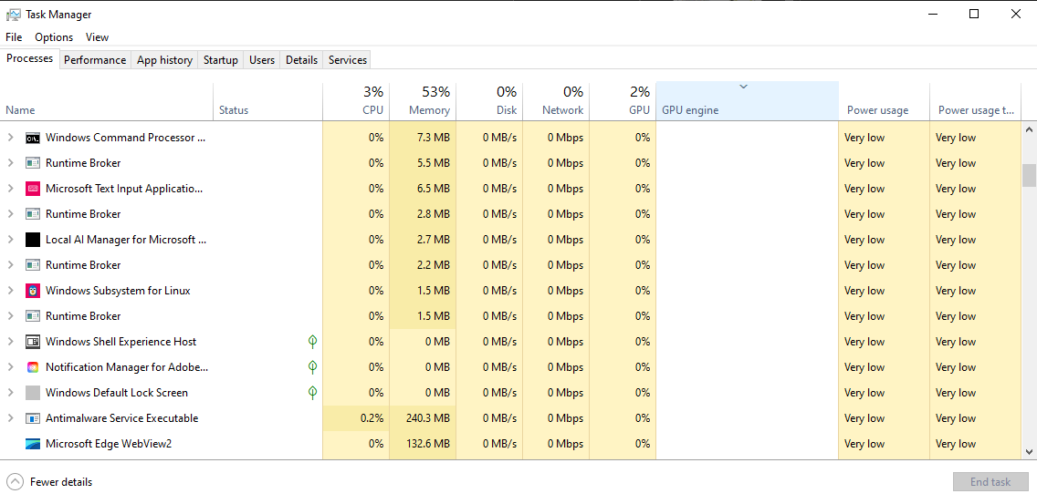
Figure 1: Windows Task Manager displaying active processes.
Task Manager provides a list of all currently running processes within the computer, along with their CPU, Memory, Disk, Network, GPU allocation and power usage levels.

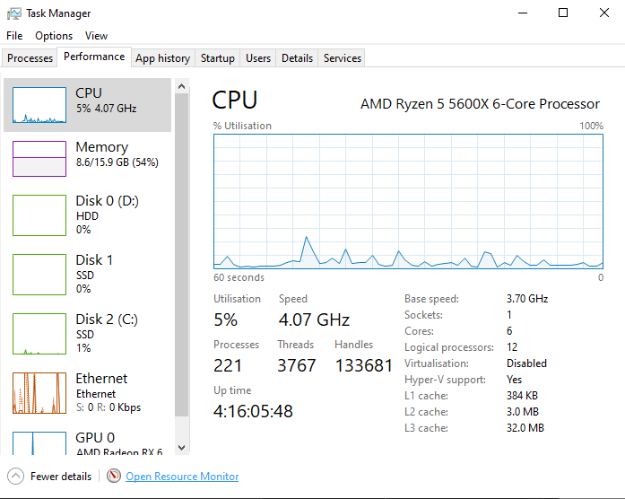
Figure 2: Performance monitoring of a Windows-based host system.
The performance tab provides real time resource usage graphs for each of the previously stated areas.
Resource Monitor
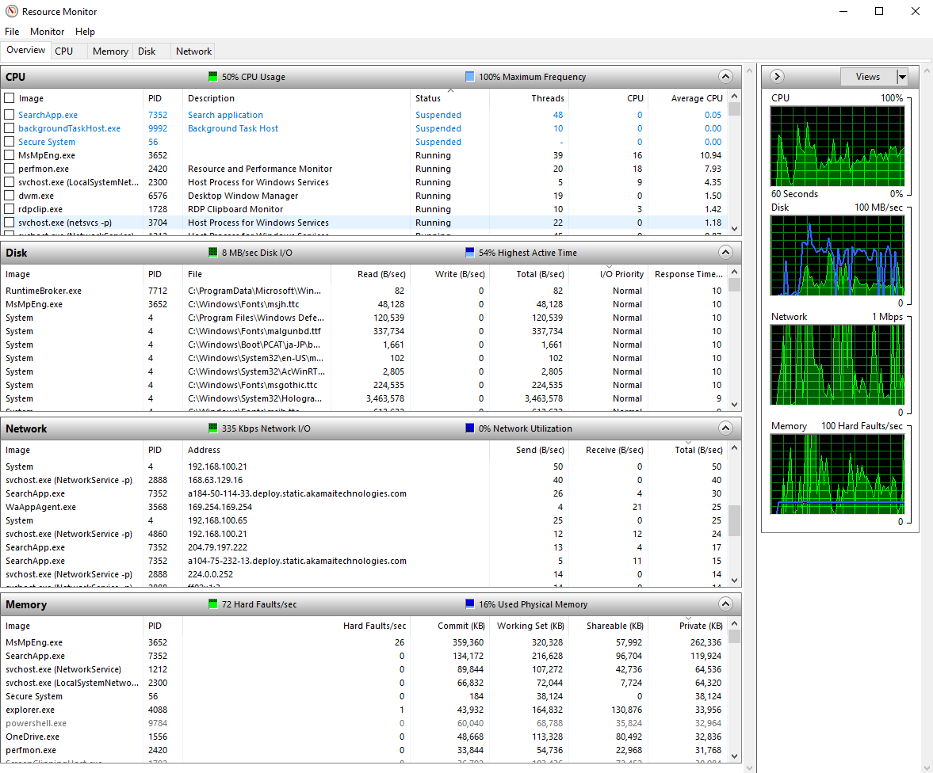
Figure 3: System resource analysis via Windows Resource Monitor.
Resource monitor provides detailed real time monitoring of CPU, memory, disk and network usage per process. This is essential in diagnosing potential performance bottlenecks [2].
Event Viewer
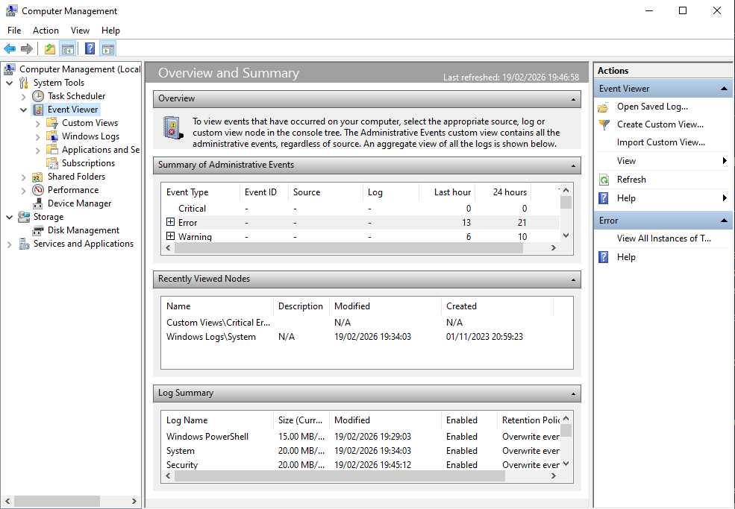
Figure 4: Windows Event Viewer within the Computer Management console.
Event Viewer acts as a detailed log of past events. Logs are categorised as: information (process did what it’s supposed to do), warning (something that didn’t go right), error (a significant problem), critical (failure the system could not recover from) and audits (digital paper trail for user activity).
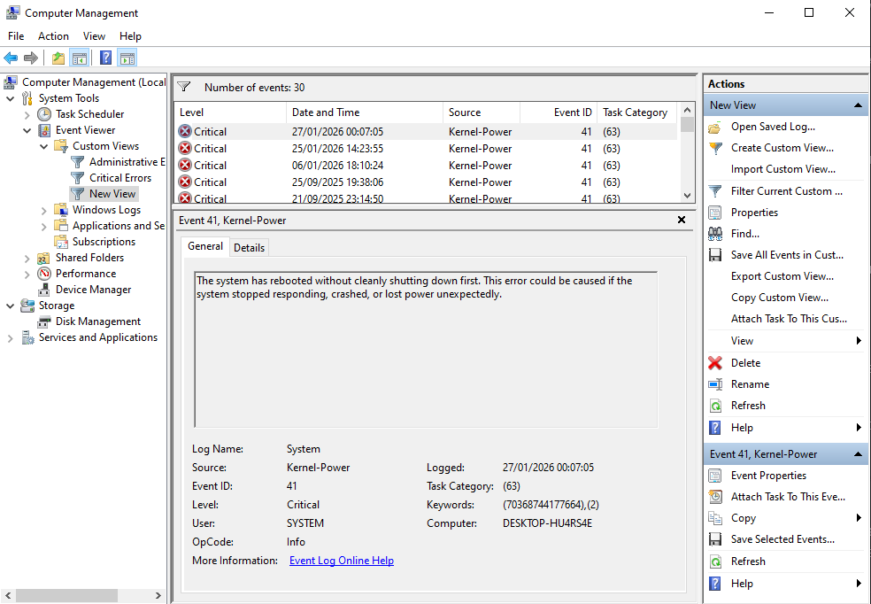
Figure 5: Detailed view of a Critical Kernel-Power event (Event ID 41) within the Computer Management console.
Custom views can be created in event viewer to filter what needs to be seen, figure 5 shows only critical logs.
Reliability Monitor
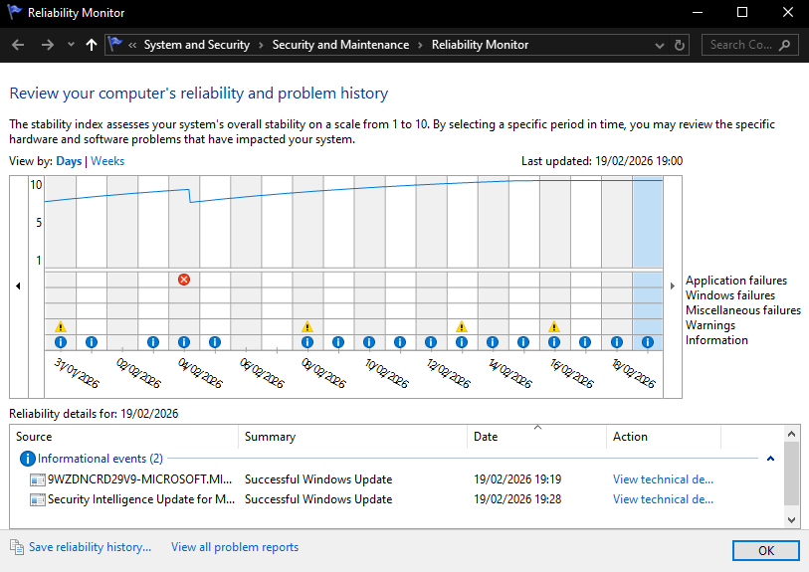
Figure 6: Windows Reliability Monitor displaying system stability over time.
Reliability monitor uses event data to present a simplified timeline of system stability that focuses on crashes, failures and updates [3].
System Diagnostics
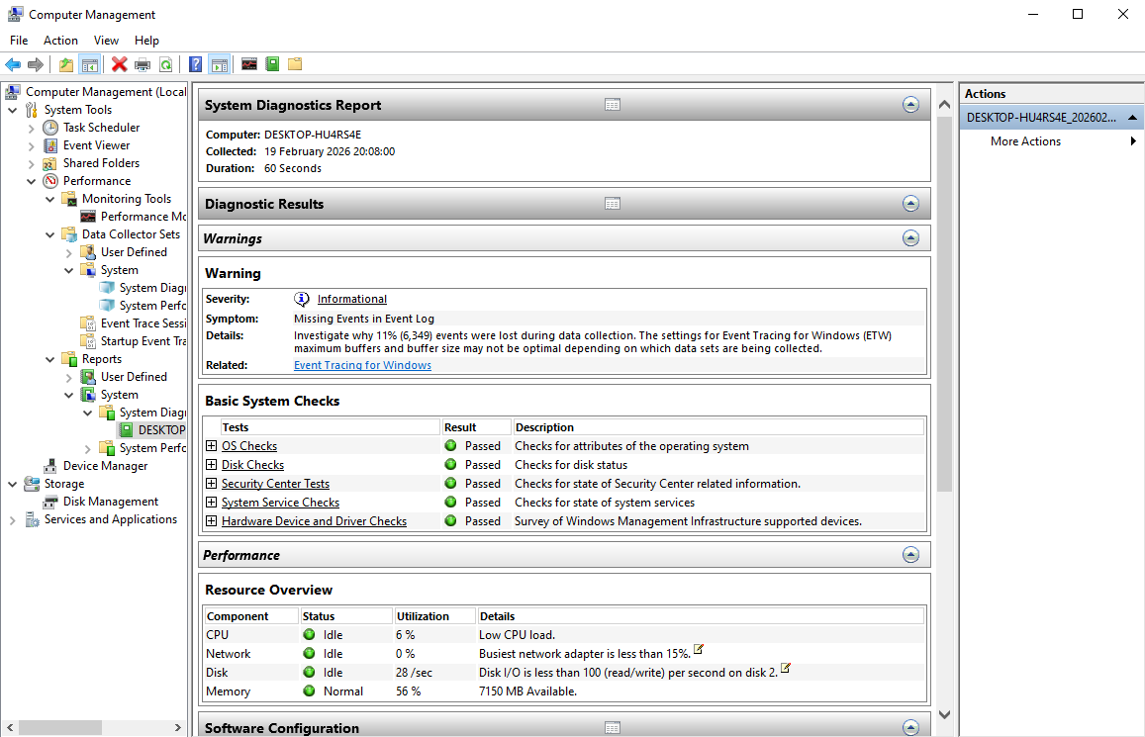
Figure 7: Automated Windows System Diagnostics Report and Basic System Health Checks.
Unlike the previously discussed tools, a system diagnostic run actively tests the system to find the root cause of problems like crashes or delays.
Linux:
Htop (Command)
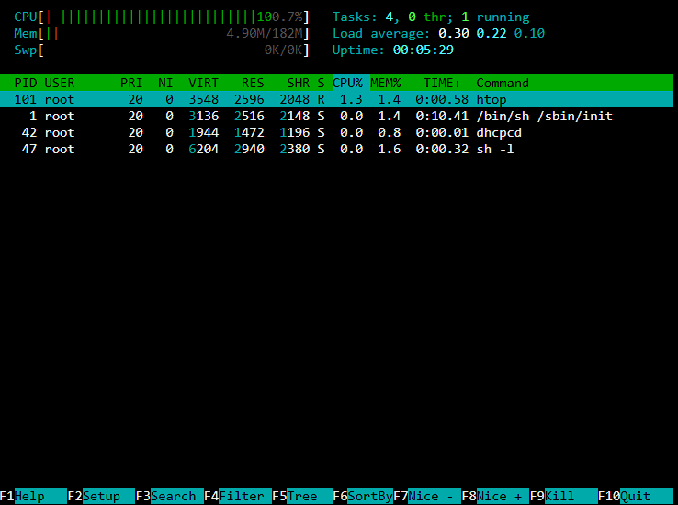
Figure 8: Real-time Linux process monitoring using the htop interactive system monitor.
Like Task Manager, “Htop” gives an overview of processes and system resource allocation [4].

Device Management: I/O Devices
Fundamentally, computers process user inputs to generate specific outputs. To facilitate this, OSs must manage Input/Output (I/O) devices such as mice and monitors. This is done through device drivers, that act as translators between the OS’s generic instructions and the hardware-specific operations. Users can directly monitor and configure these hardware interfaces through dedicated management tools.
Device Manager
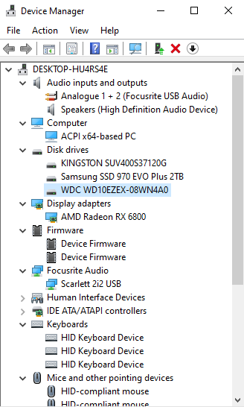
Figure 9: Windows Device Manager displaying the hardware configuration and driver status.
Provides direct control over any hardware components attached to the PC.

File and Directory Management
OSs organise system and application files within directories (folders) in a hierarchical treelike structure acting as a catalogue that provides a roadmap for locating data and managing disk space [5]. Users can directly access these directories using the following tools:
File Explorer
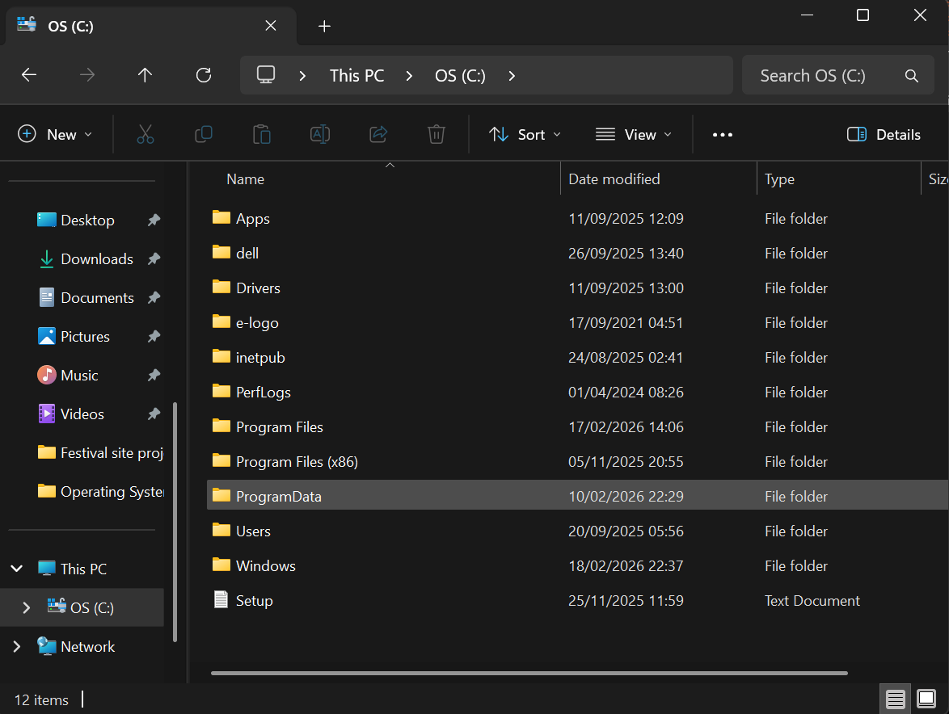
Figure 10: Root directory structure of the Windows (C:) drive and standard system folders.
Allows users to open, copy, move and organise files and directories to manage disk space, security and enhance productivity.

System Security
OSs are a critical line of defence in device security, acting as the primary mediator between hardware and software, protecting against unauthorized access, malware and data breaches [6]. Users can configure and tailor security measures to their data protection needs.
Windows Defender Firewall with Advanced Security
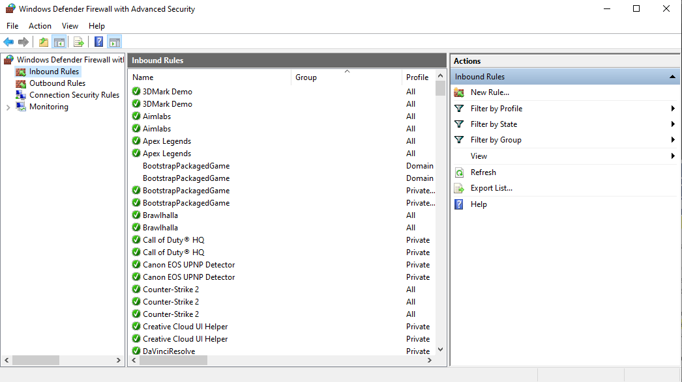
Figure 11: Windows Defender Firewall with Advanced Security showing Inbound Rules and application profiles.
Allows for creation, management and monitoring of inbound/outbound firewall rules, in addition to configuring IPsec settings and monitor network security for domain, private, and public profiles [7]. Particularly useful when administering systems that handle large amounts of network traffic across multiple network profiles.

Commands
Users interact with an OS’s kernel through a Command Line Interface (CLI), by typing specific commands and parameters. This text-based method offers greater customization and control compared to standard Graphical User Interfaces (GUI) that users interact with daily. [8] Shells serve as the critical intermediary layer, translating human-readable commands into system calls for execution. This report focuses on Windows Command Prompt (CMD) and PowerShell, alongside Linux’s Bash. Each language operates through basic commands modified by options or switches (represented as / or -) to accommodate system behaviour to user requirements [9].

Windows

Process Management
Batch – Tasklist /v
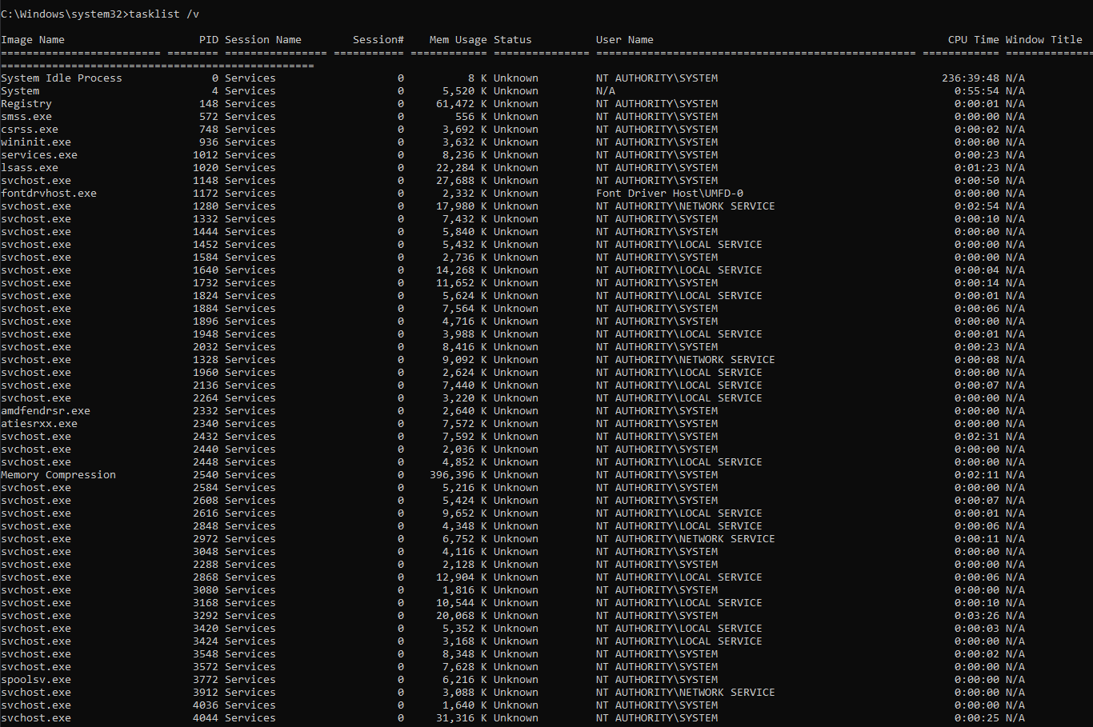
Figure 12: Detailed Windows system process list via the tasklist /v command.
Displays all active OS processes. The “/v” (verbose) switch provides extra details such as the specific User Name running the process and the title of the process in windows.
PowerShell – Get-Process | Sort-Object CPU -Descending | Select-Object -First 10
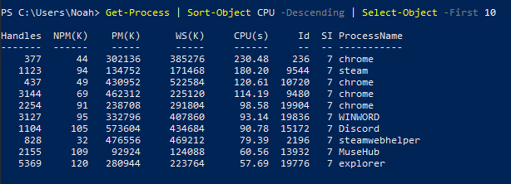
Figure 13: PowerShell pipeline output for identifying the top ten CPU-intensive processes.
“Get-Process” retrieves all running processes, “Sort-Object CPU -Descending” pipes them into a sort function based on CPU usage. Only the top 10 most resource intensive running processes are displayed as specified by “Select-Object -First 10”. This demonstrates PowerShell’s ability to manipulate data as if they’re objects. [10]

File & Directory Management
Batch - dir /s
Figure 14: Recursive directory search within the Windows System32 directory via the dir /s command.
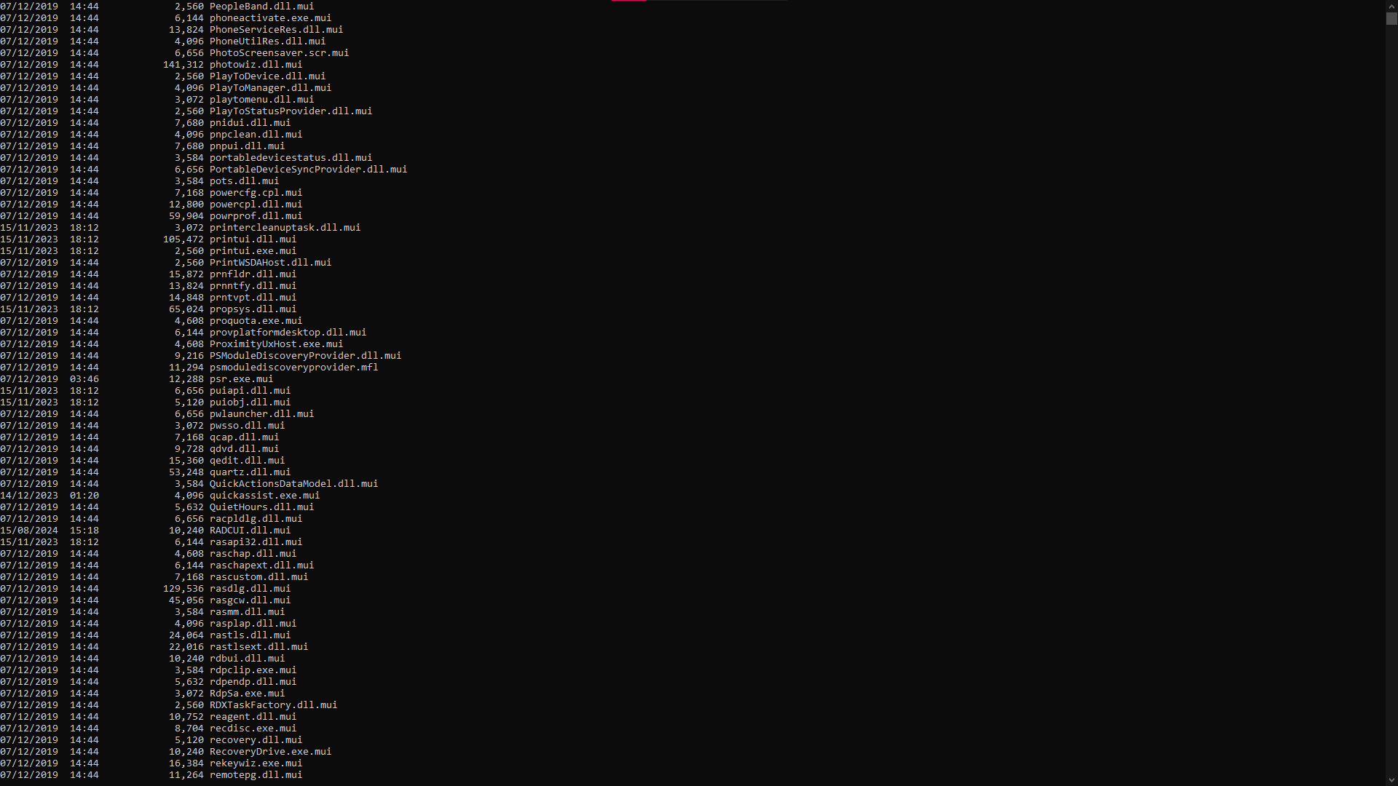
Figure 15: File inventory of the Windows System32 directory listing system binaries and library files.
Displays all files in the current directory in addition to all subdirectories. The “/s” switch is imperative to finding buried files within nested folders. [11]
PowerShell - New-Item -Path "C:\Example\Hello World" -ItemType Directory
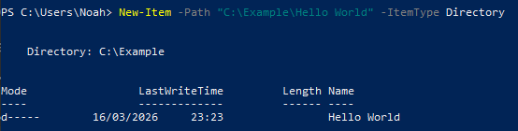
Figure 16: Directory creation within the Windows file system using the New-Item PowerShell cmdlet.
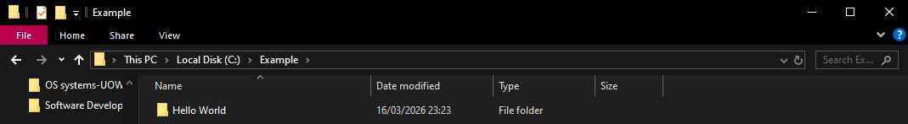
Figure 17: Graphical confirmation of directory creation within the Windows File Explorer.
“New-Item” allows users to manipulate the file system hierarchy using PowerShell. In Figure 16, the “-path” switch is used to specify the destination; in this case, it targets the “Example” folder on the C: drive where “Hello World” is the new directory to be created. The “-ItemType” parameter defines the classification of the item; setting it to “Directory” informs the OS that a folder should be created rather than a standard file.

Network Testing/Monitoring
Batch – Ping -t
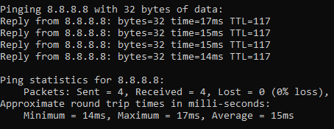
Figure 18: Network latency and packet loss metrics to a public IPv4 address via the ping utility.
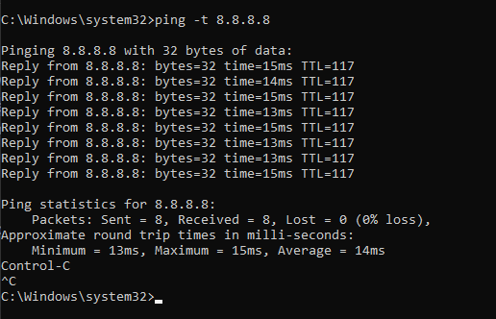
Figure 19: Continuous network latency and packet loss testing via the ping -t utility.
Ping tests end-to-end connectivity by sending ICMP packets to a destination IP. It reports the Round-Trip Time (RTT), the Time to Live (TTL)—a hop limit preventing infinite loops—and packet loss statistics. While Windows defaults to four packets, the “-t” switch enables an indefinite ping (the default behaviour on macOS/Linux), which is stopped using Ctrl+C. This utility shows a statistical summary after finishing, providing a snapshot of network reliability and latency.
Netstat /a
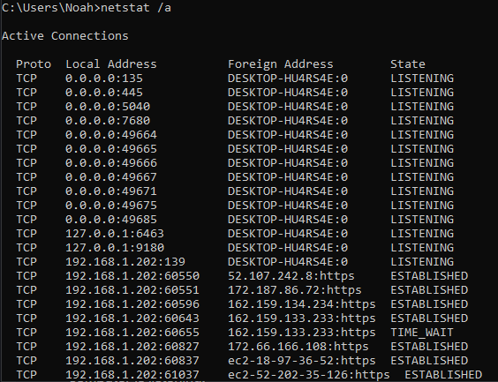
Figure 20: Analysis of active network connections via the netstat /a utility.
Netstat (network statistics) is a foundational utility for monitoring network activity. As shown in figure 20, it displays active connections, listening ports, and protocol statistics. The “/a” (all) parameter extends the by listing all active TCP connections alongside the specific TCP and UDP ports where the system is actively listening for traffic.
PowerShell – Test-NetConnection -ComputerName 8.8.8.8 -TraceRoute
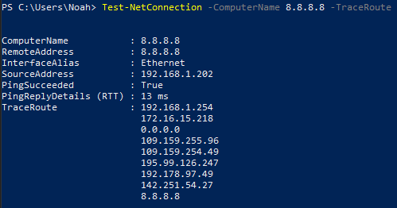
Figure 20: Network path analysis and latency diagnostics via the Test-NetConnection cmdlet.
“Test-NetConnection” is the base PowerShell cmdlet used for network diagnostics. The “-ComputerName 8.8.8.8” perameter targets a specific IP, while “-TraceRoute” identifies each hop the packet travels. Unlike basic connectivity tests such as “ping”, this provides a detailed view of the network path. Figure 20 demonstrates an efficient 9-hop journey with a 13ms latency.

User Management
Batch – net user /add
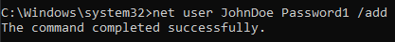
Figure 21: Administrative creation of a new local user account via the net user command.
“Net user” is the legacy command for managing local accounts. As shown in figure 21, the “/add” parameter creates a new user, with the username and password specified between the command and the switch. This command requires administrative privileges, otherwise it will return an “Access is denied” error [13].
PowerShell - Remove-LocalUser -Name "JohnDoe"
Figure 22: Programmatic deletion of a local user account via the Remove-LocalUser PowerShell cmdlet.
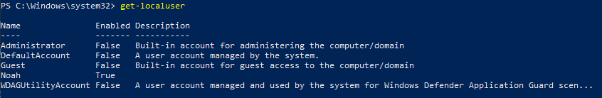
Figure 23: Post-deletion verification of active local accounts via the Get-LocalUser PowerShell cmdlet.
“Remove-LocalUser” deletes a user account from the local device, with the target specified via the “-Name” parameter. Like “net user”, this cmdlet requires administrative privileges to execute. In PowerShell, if the command is successful, it returns no confirmation message, though the account is immediately removed from the system. To verify this, “get-localuser” can be used to display all existing users on the device, as in figure 23.

Task Scheduling
Batch - schtasks /create /tn "TestTask" /tr "notepad.exe" /sc daily /st 12:00
Figure 24: Programmatic creation of a recurring system task via the schtasks /create utility.
“schtasks /create” instructs Windows Task Scheduler to generate a new database entry. “/tn” (task name) assigns an identifier, while “tr” (task run) specifies the executable path. “/sc daily” (schedule) Defines how often the task repeats, and “/st 12:00” (start time) sets the specific start time [14].

Linux (Bash)

Process Management

Top
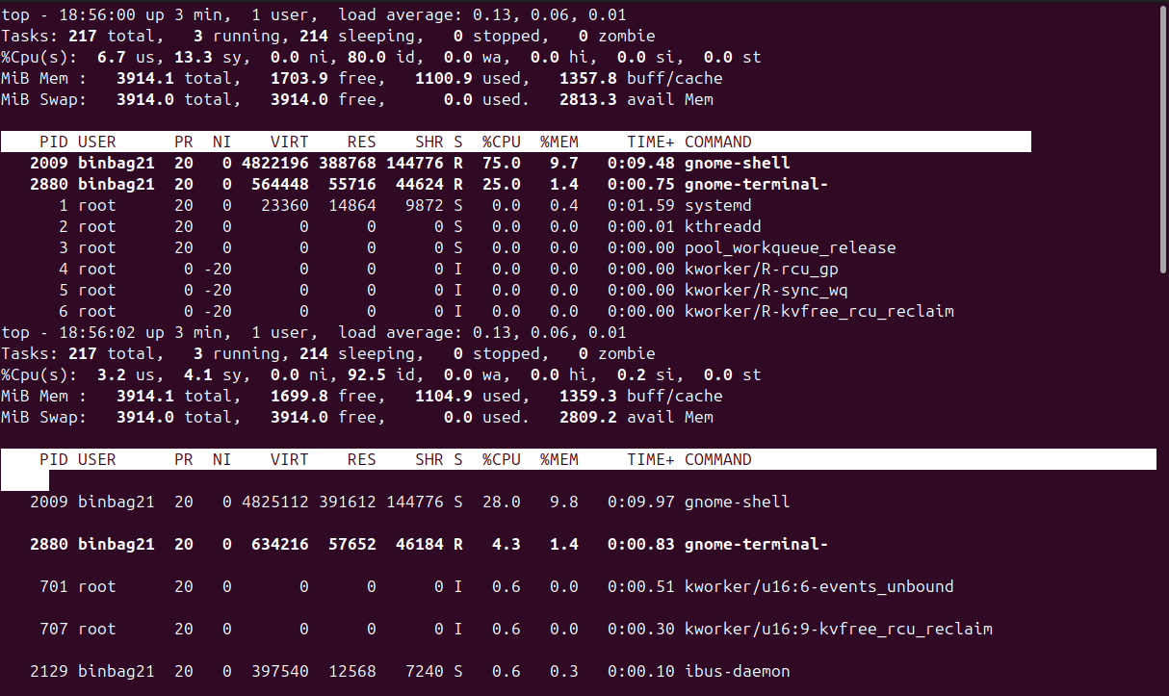
Figure 25: Real-time system resource and process management via the Linux top utility.
ps
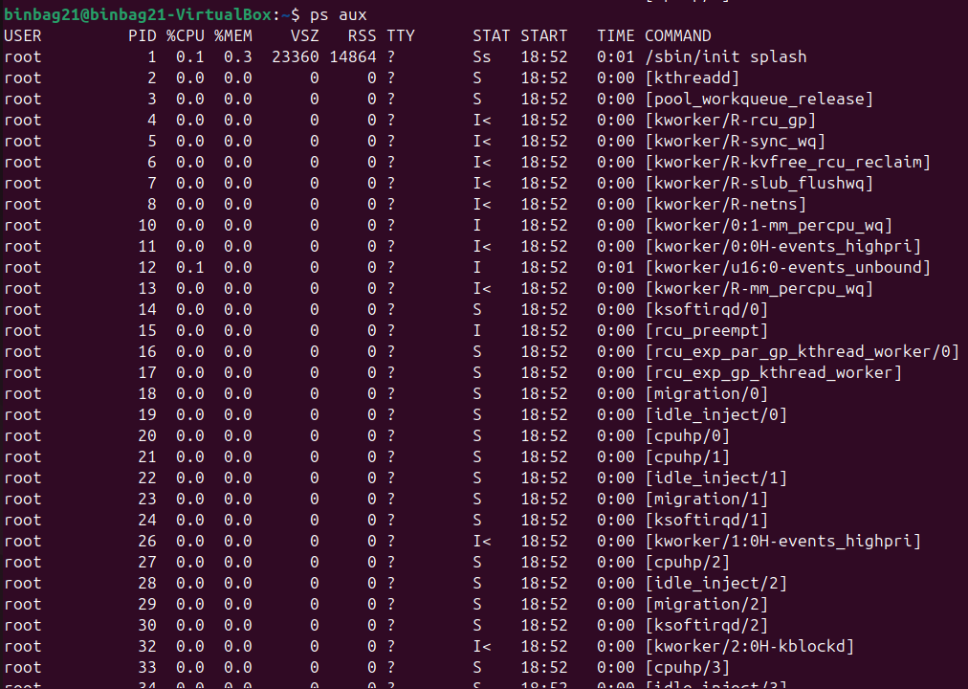
Figure 26: Static process management and system auditing via the Linux ps aux utility.
Kill
Figure 27: Programmatic termination of a system process via the kill utility.
“Top” provides a real-time, interactive system summary and overview of active tasks and their usage, like Window’s task manager as seen in figure 1. “Ps” delivers a non-updating snapshot of all running processes for each user, which includes information such as resource percentages, run time and process ID (PID) [15]. “Kill” is used in conjunction with a PID to terminate a process. Much like PowerShell, when the command is run successfully no verification message will be returned [16].

File & Directory Management
Ls -la
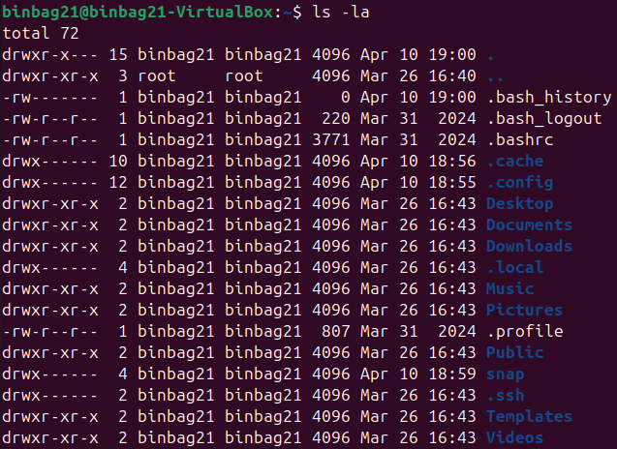
Figure 27: Comprehensive directory auditing and hidden file retrieval via the Linux ls -la command.
Mkdir -p Example/inside/again
Figure 28: Hierarchical directory creation and nested path management utilizing the mkdir -p switch.
e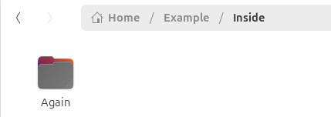
Figure 29: Hierarchical directory tree verification following the execution of the mkdir -p command.
The “ls” command retrieves a list of files and subdirectories within a specific location. The “-l” (long) switch makes the list long-form providing extra details such as the file owner, size and metadata. While the “-a” (all) switch reveals hidden files normally invisible to the user. The “mkdir” (make directory) utility allows users to create directories, the “-p” (parents) switch creates a full directory tree [17]. Figure 29 shows that the command was successful as it created a directory with 2 sub-directories inside.

Network Testing/Monitoring
Ip addr show
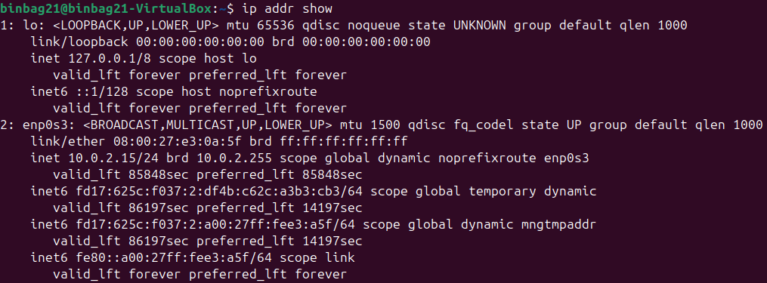
Figure 30: Verification of active network interfaces and local IP configuration using the ip utility.
Ss -tulpin
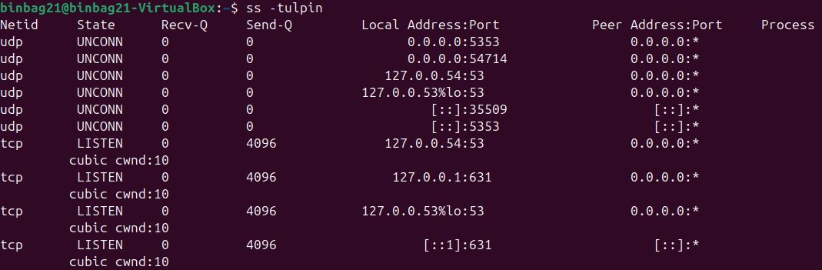
Figure 31: Monitoring active network sockets and local service endpoints via the ss (socket statistics) command.
The “ip addr show” utility identifies layer 2 (MAC) and layer 3 (IPv4/6) addresses for all network interfaces, providing more detail compared to the legacy “ifconfig”. Similarly, “ss” (socket statistics), part of the iproute2 software suite, monitors active TCP/UDP sockets [18]. The “-tulpn” switch filters TCP and UDP protocols, displays only listening sockets and process PIDs while forcing numeric outputs such as the specific port numbers to eliminate DNS delay [19].

User Management
Sudo useradd -m new_user
Figure 32: Creating a new system user and home directory architecture via the useradd -m utility.
Ls /home
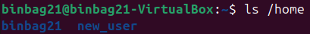
Figure 33: Verification of successful user directory initialization within the /home partition using the ls utility.
Sudo passwd new_user
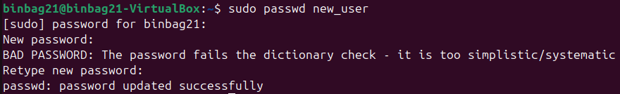
Figure 34: Implementation of authentication credentials and password policy enforcement using the passwd utility.
The “sudo” prefix grants administrative privileges, “useradd” facilitates high-level account provisioning, with the -m switch automating home directory and configuration file generation. The “ls /home” command is used to verify this initialisation, confirming the new user’s directory exists [20]. Finally, “passwd”, when used in conjunction with a username, initialises authentication credentials, while also running dictionary checks to ensure password complexity requirements are met.

Task Scheduling
Crontab -e
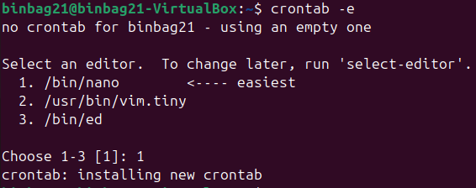
Figure 35: Selection and initialisation of a system-default text editor for task scheduling via the crontab -e utility.
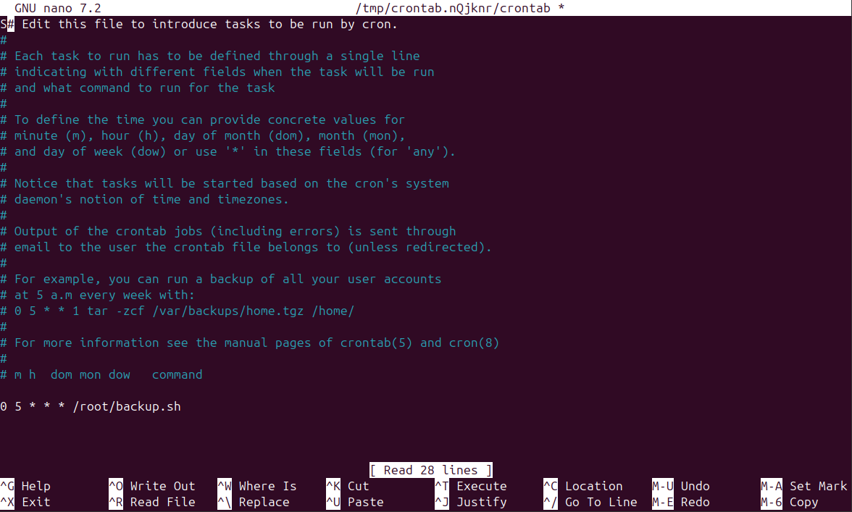
Figure 36: Configuration of a recurring cron job utilizing the GNU nano text editor to automate a daily backup script execution at 05:00.
Crontab -l
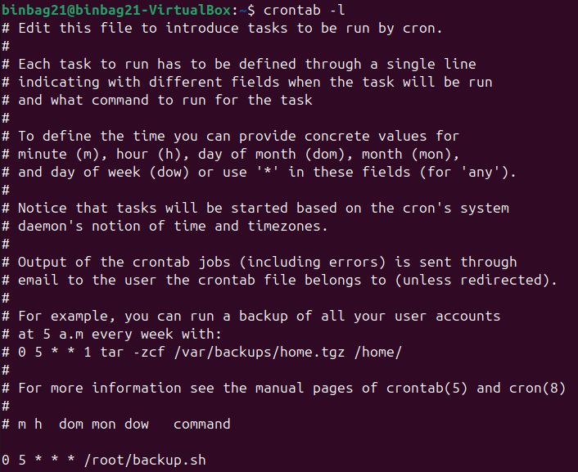
Figure 37: Verification of a recurring system backup task scheduled for 05:00 daily via the crontab -l utility.
“Crontab” is the primary interface for the “cron daemon”, a service that executes commands at specified intervals [21]. The “-e” switch enters an interactive editing sessions, allowing modification of the “cron table” to add or remove automated tasks. As seen in figure 36, the temporal expression “0 5 * * *” was used to specify the task interval, in this case 5am daily, and “/root/backup.sh” specifies the absolute script location. The “-l” switch verifies that the task has been registered by displaying a read-only version of the “cron table” [22].

Scripting
Using the previously discussed command languages (e.g., PowerShell, Batch, and Bash), scripts can be created within text files or directly within the CLI and are interpreted line by line by the shell. Scripts have several important purposes with the most notable being to automate repetitive tasks. This improves efficiency while ensuring repeatability and documentation, which streamlines testing, especially in the context of server configuration [8]. Within scripts, users can use programming logic, such as variables, loops, and if statements to customise the users’ workflow, reduce redundancy, process data efficiently using techniques such as piping, and create a more intuitive product for the end-user using interactive inputs [23]. To demonstrate these concepts, the following section will provide an overview of foundational programming syntax for scripting purposes in Windows using Batch, and for Linux environments using Bash.

Windows (Batch)

Script Creation
To create a script in Batch a simple text editor such as notepad is required.
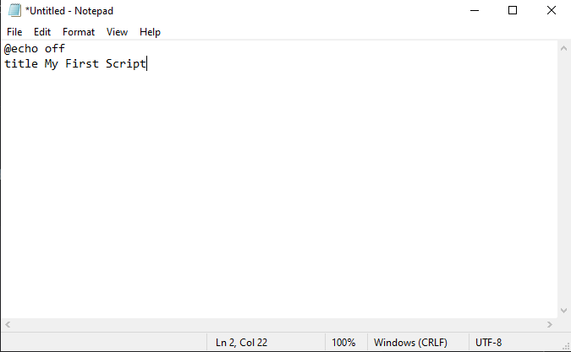
Figure 38: Environment initialization and title configuration for a Windows Batch script using Notepad.
The first two lines of a batch script should always include “@echo off” which prevents the computer from displaying every command before running it, and “title” simply names the script.
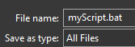
Figure 39: Saving the script with a .bat extension and the "All Files" type selection to ensure executable functionality.
The script must then be saved as a “.bat” file.

Variables, User Inputs and Printing
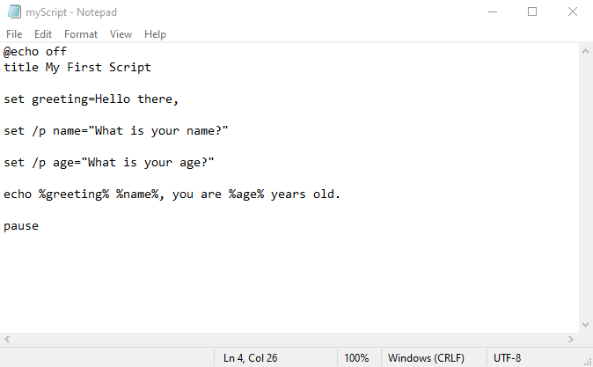
Figure 40: Batch script logic for variable assignment and dynamic string output.
Variables are assigned using “set” followed by the variable name, “=”, and the assigned value. User inputs utilise the “/p” switch, where the text following the “=” is the user prompt, this is wrapped in quotes eliminate trailing spaces. To display a variable, the name is wrapped in percent signs (e.g., %variable%) and preceded by the echo command. Finally, pause is used to suspend script execution, stopping the terminal window from closing until a key is pressed [24].
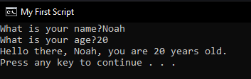
Figure 41: Successful execution of the batch script demonstrating dynamic variable output.

Goto and If Statements
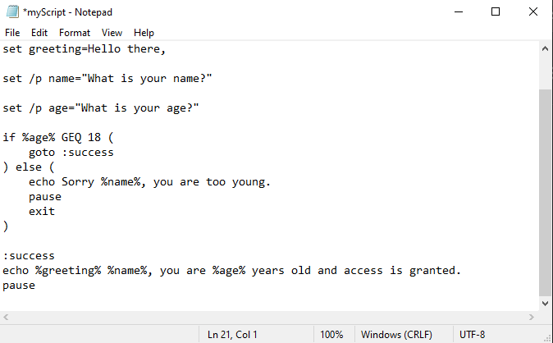
Figure 42: Scripting user-access validation based on integer comparison of the %age% variable.
If statements are used to manage logical flows, in this instance the script checks if the “age” variable is Greater Than or Equal (GTE) to 18. If this condition is met then the “goto” command directs the script to a labelled section, in this case “:success” [24], allowing the script to only execute relevant code blocks.
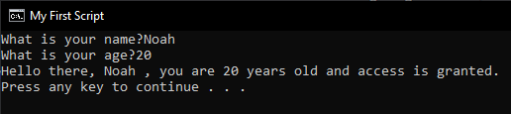
Figure 43: Execution of the batch script showing the "Access Granted" logic path.
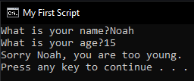
Figure 44: Execution of the alternate script path triggered by a failed integer comparison.

Arrays, For Loops and Functions
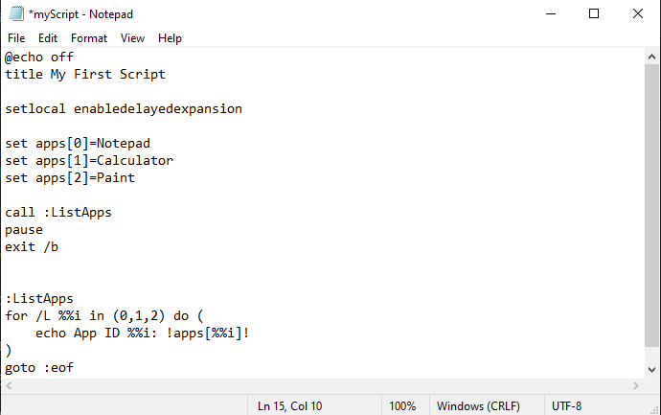
Figure 45: Implementation of a simulated array structure and iterative for /L loop logic to automate application indexing.
Batch simulates arrays using indexed environment variables. The “set” command assigns values (e.g., calculator) to specific indices within the “apps” name. The “call” command manages script flow by triggering the “:ListApps” function, while “exit /b” stops the script without closing the command prompt [25]. The “for /L” loop handles numeric iterations; the syntax (0,1,2), representing (start, step, end), automates the retrieval process while specifying the iterations. By using “%%i” as a counter and “!apps[%%i]!” with delayed expansion, the script prints each application’s ID and name, demonstrating efficiency [26]. Meaning a script can process large datasets through a single loop instead of multiple manual entries. Finally, “goto :eof” ensures a clean return to the main script.
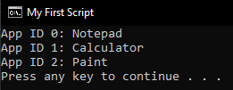
Figure 46: Execution results showing indexed application values retrieved via delayed variable expansion within a batch loop.
This report only covers batch for Windows scripting which is the ideal tool for light-weight legacy automation and simple file administration. However, it needs to be mentioned that PowerShell is the modern standard for advanced system management within enterprise-scale automation such as within cloud management, and it differs greatly from batch as it uses structured objects rather than plaintext.

Linux (Bash)

Script Creation
To create a script in bash a text editor, such as nano, is required.
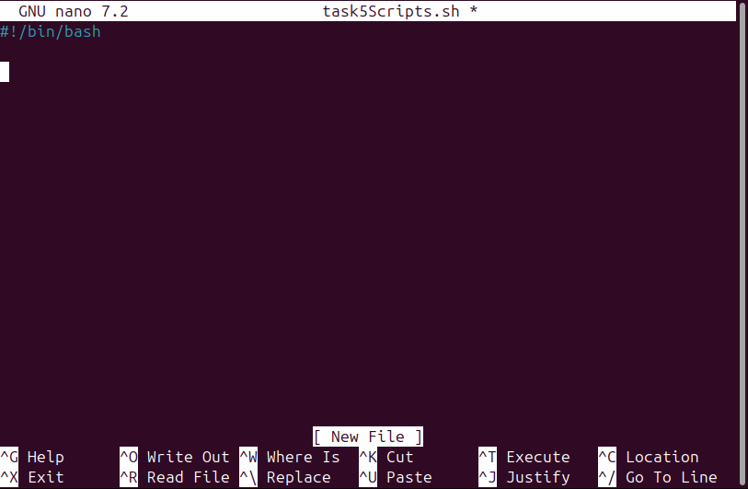
Figure [47]: Environment initialization and shebang configuration for a Linux Bash script using the GNU nano text editor.
The file must be saved as “.sh” (shell) and must begin with the shebang (#!/bin/bash) on the very first line.

Variables, User Inputs, Printing and If Statements
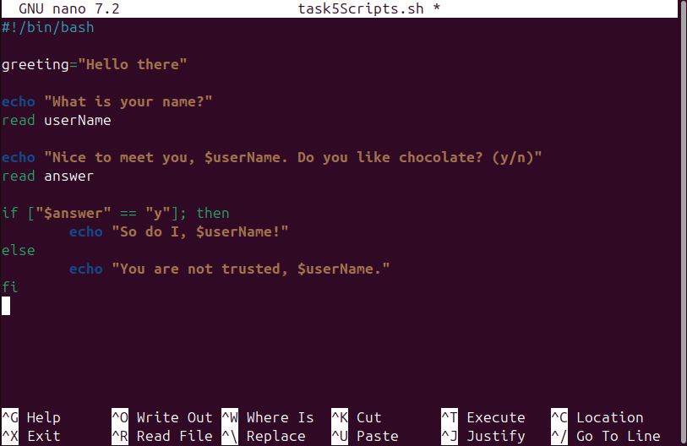
Figure [48]: Scripting interactive user prompts via the read command and evaluating string responses using standard conditional operators.
In Bash, variables are assigned by placing the value directly after the variable name with a “=” in-between. The “echo” command is used to print text and a “$” prefix identifies and allows the printing of a variable [27]. Printed text is wrapped in quotes to ensure correct formatting. User inputs are prompted with a regular echo print, followed by a “read” command that captures typed data and stores it in a specified variable. Conditional logic is handled using if statements, conditions are stored in square brackets, followed by “then” to execute specific code, in this instance an echo command. An “else” block provides the alternative path if the condition is not met, the statement is closed with fi (if backwards) to signify the end of the statement [28].
To run scripts in Linux using nano, the file must first be written out or saved using “ctr-o” then enter. Then run by typing bash followed by the file name in the terminal.
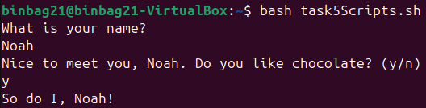

Figure [49]: Terminal output displaying the successful processing of conditional logic based on real-time user string responses.
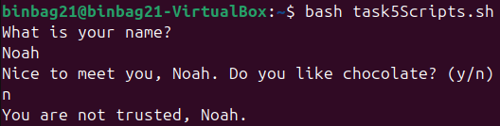
Figure [50]: Terminal output demonstrating the alternative execution path within an if-else statement based on negative user input.

Case Statements and Functions
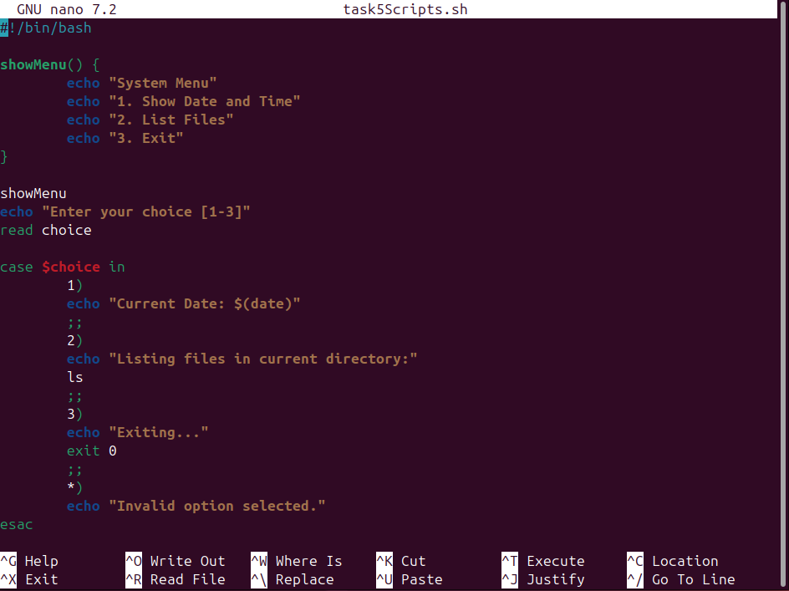
Figure [51]: Implementation of a modular function and a case statement to facilitate a multi-option system menu.
Functions are defined by a name followed by “()”, while “{}” encloses the block. This allows the grouping of multiple commands together, such as multiple echo statements. The function is called by name, and the user is prompted for input [29].
The case statement opens with the “case” keyword, the variable being checked, and the word “in”. It compares the variable against the patterns (1, 2, 3). If a match is found, the corresponding command executes: 1 displays the date using “$(date)”, 2 lists files using “ls”, 3 terminates the statement, and * covers any other invalid inputs. Each option is closed with “;;” to prevent code from entering the next option. The statement is closed using “esac” (case backwards).
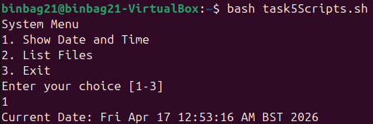
Figure [52]: Terminal output demonstrating the execution of a shell function to display a system menu and the subsequent processing of a case selection.
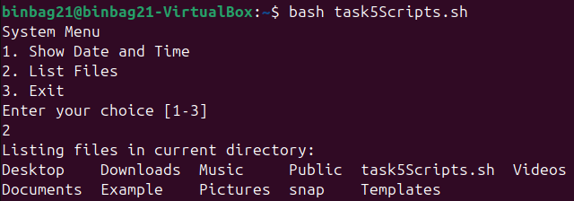
Figure [53]: Terminal output demonstrating the execution of the ls command through a case statement selection.
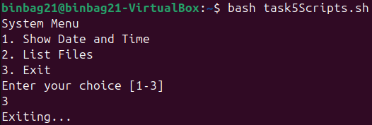
Figure [54]: Successful script termination via a case statement branch utilizing the exit command.
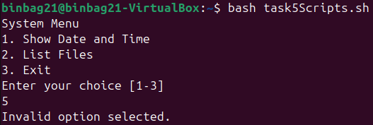
Figure [X]: Demonstration of default error handling within a case statement to manage invalid user inputs.

Arrays and Loops
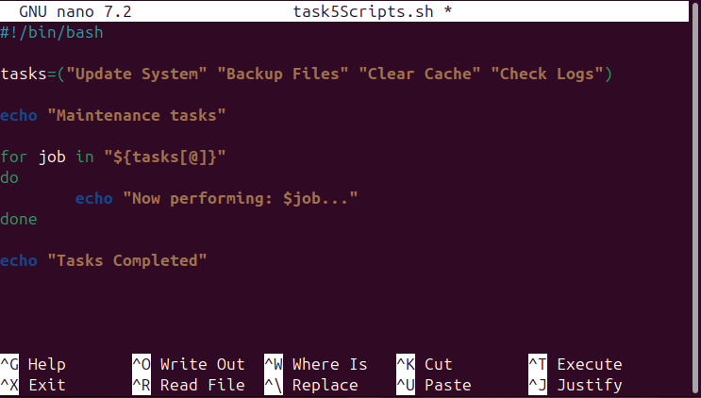
Figure [55]: Utilizing array expansion and for...in loop syntax to systematically iterate through a collection of strings.
Arrays work like variables with one key difference; they act as a container for multiple values opposed to a single string. Array entries are contained in “()” and each element is wrapped in quotes (“”) to ensure that strings with spaces are handled as a single unit.
For loops, begin with “for” followed by a placeholder variable that acts as an iterator. Each cycle the variable updates to hold the value of the current list item being processed. The “in” keyword specifies the data source, the “${tasks[@]}” array. The “@” symbol has a unique purpose here; it tells the bash interpreter to expand the array to every individual element it contains [30]. The “do” and “done” commands signify the entry and the exit point of the loop’s logic.
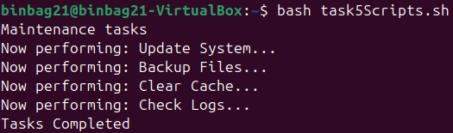
Figure [56]: Validating array expansion logic as the Bash interpreter sequentially processes and prints each stored element within a loop.

Conclusion
OSs are an integral part of the user’s experience with their computer system. Enhanced OS education will improve overall experience and workflow, subsequently influencing their long-term platform preference. This report has covered each of the key functions of OSs, specifically Windows and Linux, and how to directly control each of these functions using GUIs to suit their needs. A layer of additional depth was added by demonstrating how users can interact with lower-level interfaces, such as Windows’s PowerShell and Batch and Linux’s Bash, to gain more direct control over system functions and resources with the use of commands and switches. Expanding on the CLI commands, scripting was then covered to exhibit how users can use programming logic, such as variables, user inputs, loops, functions, arrays and statements to automate large or repetitive tasks using command languages. As computing continues to evolve year over year, with each iteration becoming more complex, a user’s ability to navigate both Linux and Windows OSs through the command line will only become more essential for those in computer-centred roles in addition to the regular user.

References
[1]
GeeksforGeeks, “Introduction to Operating System,” GeeksforGeeks, Jan. 19, 2018. https://www.geeksforgeeks.org/operating-systems/introduction-of-operating-system-set-1/
[2]
Archiveddocs, “Windows System Resource Manager Overview,” learn.microsoft.com. https://learn.microsoft.com/en-us/previous-versions/windows/it-pro/windows-server-2012-r2-and-2012/hh997019(v=ws.11)
[3]
K. Alvi, “Windows has a built-in troubleshooting tool most people never open,” XDA, Feb. 14, 2026. https://www.xda-developers.com/windows-built-in-troubleshooting-tool-most-people-never-open/ (accessed Feb. 19, 2026).
[4]
umer, “htop Explained Visually,” CodeAhoy, Jan. 20, 2017. https://codeahoy.com/2017/01/20/hhtop-explained-visually/
[5]
“AIX,” Ibm.com, Nov. 05, 2024. https://www.ibm.com/docs/bg/aix/7.2.0?topic=systems-directories
[6]
CISA, “Weak security controls and practices routinely exploited for initial access,” Cybersecurity and Infrastructure Security Agency CISA, Dec. 08, 2022. https://www.cisa.gov/news-events/cybersecurity-advisories/aa22-137a
[7]
paolomatarazzo, “Windows Firewall tools - Windows Security,” learn.microsoft.com, Nov. 21, 2023. https://learn.microsoft.com/en-us/windows/security/operating-system-security/network-security/windows-firewall/tools
[8]
Amazon Web Services, “What is a CLI? - Command Line Interface Explained - AWS,” Amazon Web Services, Inc., 2023. https://aws.amazon.com/what-is/cli/
[9]
GeeksforGeeks, “What is Command Line Interface (CLI)?,” GeeksforGeeks, Mar. 17, 2024. https://www.geeksforgeeks.org/operating-systems/what-is-command-line-interface-cli/
[10]
sdwheeler, “Get-Process (Microsoft.PowerShell.Management) - PowerShell,” Microsoft.com, 2022. https://learn.microsoft.com/en-us/powershell/module/microsoft.powershell.management/get-process?view=powershell-7.5
[11]
“MS-DOS and Windows Command Line Dir Command,” www.computerhope.com. https://www.computerhope.com/dirhlp.htm
[12]
T. Amao, “NETSTAT Utility — Explained,” Medium, Jun. 25, 2021. https://amaotaiwo08.medium.com/netstat-utility-explained-589cef76fe42
[13]
R. Mens, “How to use Net User command to Manage User Accounts,” LazyAdmin, Sep. 22, 2022. https://lazyadmin.nl/it/net-user-command/
[14]
Xelu86, “schtasks create,” learn.microsoft.com, Oct. 10, 2023. https://learn.microsoft.com/en-us/windows-server/administration/windows-commands/schtasks-create
[15]
“ps(1) - Linux manual page,” man7.org. https://man7.org/linux/man-pages/man1/ps.1.html
[16]
Chiamaka Iroegbu, “Day 3 of 100 Days of Hands-On Cybersecurity,” LinkedIn, Nov. 14, 2025. https://www.linkedin.com/posts/chiamaka-iroegbu-371462246_day3-100daysofcybersecurity-linuxforcybersecurity-activity-7395067564097175553-gxjS (accessed Apr. 10, 2026).
[17]
“mkdir invocation (GNU Coreutils 9.5),” Gnu.org, 2024. https://www.gnu.org/software/coreutils/manual/html_node/mkdir-invocation.html
[18]
Pankajchougale, “Monitoring Network Usage in Linux: A Complete Guide,” Medium, Aug. 31, 2025. https://medium.com/@pankajchougale1008/monitoring-network-usage-in-linux-a-complete-guide-e1e1c0652d29 (accessed Apr. 10, 2026).
[19]
“20 Essential Linux Network Monitoring and Configuration Commands,” CBT Nuggets. https://www.cbtnuggets.com/blog/technology/programming/20-essential-linux-network-monitoring-and-configuration-commands
[20]
“Linux sysadmin basics: User account management,” Redhat.com, 2019. https://www.redhat.com/en/blog/linux-user-account-management
[21]
“Use the Crontab Utility to Schedule Tasks on Oracle Linux,” Oracle Help Center, 2021. https://docs.oracle.com/en/learn/oracle-linux-crontab/ (accessed Apr. 10, 2026).
[22]
V. Victories, “View Currently Running Cron Jobs in Linux,” eUKhost Knowledge Base, Sep. 08, 2025. https://www.eukhost.com/kb/how-to-view-currently-running-cron-jobs-in-linux/ (accessed Apr. 10, 2026).
[23]
GeeksforGeeks, “Introduction to Linux Shell and Shell Scripting,” GeeksforGeeks, Jun. 02, 2017. https://www.geeksforgeeks.org/linux-unix/introduction-linux-shell-shell-scripting/
[24]
JasonGerend, “Windows commands,” learn.microsoft.com. https://learn.microsoft.com/en-us/windows-server/administration/windows-commands/windows-commands
[25]
JasonGerend, “call,” learn.microsoft.com. https://learn.microsoft.com/en-us/windows-server/administration/windows-commands/call
[26]
robinharwood, “setlocal,” Microsoft.com, Feb. 03, 2023. https://learn.microsoft.com/en-us/windows-server/administration/windows-commands/setlocal
[27]
GeeksforGeeks, “Bash Script Read User Input,” GeeksforGeeks, Nov. 24, 2021. https://www.geeksforgeeks.org/linux-unix/bash-script-read-user-input/
[28]
GeeksforGeeks, “Bash Scripting If Statement,” GeeksforGeeks, Mar. 16, 2022. https://www.geeksforgeeks.org/linux-unix/bash-scripting-if-statement/
[29]
“Bash Functions,” FutureLearn, Oct. 25, 2022. https://www.futurelearn.com/info/courses/linux-for-bioinformatics/0/steps/203002 (accessed Apr. 17, 2026).
[30]
G. Peacock, “A beginner’s guide on expanding Bash arrays and word splitting,” Yahoo Tech, Dec. 24, 2025. https://tech.yahoo.com/computing/articles/beginners-guide-expanding-bash-arrays-130015550.html

Appendices

What is an Operating System?
An Operating System (OS) is the interface between a computer’s hardware and the end user. It bridges this gap by providing abstractions of hardware resources for use by applications [1]. Furthermore, an OS manages a variety of areas to further ensure efficient use of the abstractions provided. Such areas include process and task scheduling, memory management, file system management, hardware management, including Input/Output (I/O) devices, user access control, and security management. OSs allow users to interact with system abstractions/services using a Graphical User Interface (GUI) or a text-based Command Line Interface (CLI) [2].

Top 5 most used Operating Systems today
- Android
- Windows
- iOS
- macOS
- Linux
[3]

What is the Linux Operating System?
Linux is an open-source, Unix-like operating system created by Linus Torvalds in 1991, with community cantered development ongoing to this day. Regarded as one of the most versatile operating systems in the world [4], Linux is responsible for powering 96% of the top 1 million web servers, 70% of global cloud servers, and 80% of the world’s data centres [5]. Furthermore, since Android is built on the Linux kernel, Linux is installed on 76% of mobile phones globally, the largest installed base of any general-purpose OS. Linux powers 100% of the world’s top 500 supercomputers, including specialized units at NASA and major stock exchanges, making it the only choice. The reason for Linux’s versatility is its ability to handle high frequency inputs with minimal latency, in combination with its ability to support all programming languages. Experts unanimously agree that Linux is in a phase of accelerated growth [5], meaning Linux will be implemented more frequently in several different industries throughout the next coming years.

How will AI and Quantum computing change the world?
Artificial intelligence has already changed the world in the few years since it was made readily available to the public in addition to the years previous when corporations were employing its use for several different tasks. The driving force behind its ability to reshape sectors is its ability to process large datasets in quick succession. This in turn provides the framework for AI adaptation for tasks in numerous industries which include the automation of simple repetitive tasks, specifically throughout manufacturing and admin-based roles, enhanced data analytics, commonly used within healthcare, finance and business strategy and less visible applications such as tailored recommendations within ads, shopping and the greater media scope. AI can be seen in both positive and negative lights in its current state. It helps reduce human error while increasing efficiency but is also susceptible to data-based vulnerabilities such as algorithmic bias and data privacy issues. Furthermore, AI introduces uncertainty into labour markets. It will take away jobs due to its handling of repetitive tasks, yet it will create jobs within the data science industry. A subtle positive of these effects is that it frees up time for people usually confined to repetitive jobs to learn more complex skills [7]. However, year after year, it becomes more likely that civilisation will become too reliant on AI.
Unlike AI, quantum computing is still in its infancy and although no major breakthroughs that provide a clear path to scalability have been made, experts within the field remain optimistic in its development. If fully reliable quantum computers are created, we will see the exponential scaling of computational power which will have a knock-on effect on scientific research, specifically within drug discovery, molecular simulation, climate modelling and material science, and optimisation problems within logistics, traffic systems, supply chains and finance. However, areas concerning security such as cryptography will also be affected. This carries the potential to break current encryption methods, rendering them mostly useless. This will show the need for post-quantum cryptography encryption methods [8].
If AI is ever able to be combined with quantum computing, accelerated innovation will be observed. This is due to the higher computational power allowing AI training speed and complexity to scale massively. Ultimately this means all previously covered areas both positive and negative will see rapid development and innovation. However, AI as it is today still lacks true general intelligence and quantum computing is still experimental and very expensive, meaning the combination of the two is not yet practical due to the current technical barriers.

Types of Operating Systems:
Operating Systems (OSs) have undergone significant evolution from their initial designs in the 1950s. Over time they have branched out into multiple specialised types that cater to specific computing needs, supporting everything from personal devices to global computing infrastructure.
- Batch Operating Systems: Emerging in the 1950s, batch OSs are cited as the first generation of OS [9]. Originally made for early large-scale data processing (e.g payrolls, bank records), they pioneered grouped sequential execution of processes and instructions, which required no direct user interaction. However, they came with a long turnaround time and lack of flexibility.
- Time-Sharing Operating Systems (TSOS): Developed in the 1960s, TSOSs such as UNIX were designed to allow multi-user environments (for use in corporations and universities) and early network systems for resource sharing [10]. This iteration of OSs is credited for laying the foundation for modern multi-user systems such as Windows and macOS.
- Real-Time Operating Systems (RTOS): Introduced in the 1970s, RTOSs were tailor-made for critical systems within medical, industrial and aviation sectors to provide precise control over computer resources for specific, time-critical tasks [11]. RTOSs provided immediate processing with guaranteed response times in combination with high reliability and stability. These usually came in 2 types, hard real-time for time sensitive tasks and soft real time for more lenient tasks.
- Distributed Operating Systems: Developed from the 1970s – 1980s, distributed operating systems were created for use within cloud environments, scientific computing and large networks [11]. Distributed OSs allow multiple machines to act as a single coordinated system by sharing resources such as CPU and memory. This is known as clustering, and it involves balancing multiple complex loads at once. These OSs significantly improved performance and fault tolerance compared to older systems.
- Embedded Operating Systems: Developed throughout the 1980s and 1990s embedded OSs were created for specific hardware and tasks within cars, appliances and IoT devices [11]. These are usually designed for systems with lower computational power that need be to run with low resource usage and high efficiency.
- Desktop Operating Systems: Desktop OSs, such as Microsoft Windows and macOS, emerged in the 1980s to support the widespread adoption of personal computers (PC) [9]. Designed to provide seamless user interaction with computer hardware, they feature intuitive Graphical User Interfaces (GUI) and the capability to multitask by running multiple applications at once.
- Mobile Operating Systems: Originating in the 2000s to support the rapid growth of mobile phones, mobile OSs provide the end-user with a touch-based interface and integrated app ecosystems that are optimized for battery life and wireless connectivity [9]. Examples include Android and iOS.

Engagement with 1 Online Certified Course: Cisco OS Basics [12]

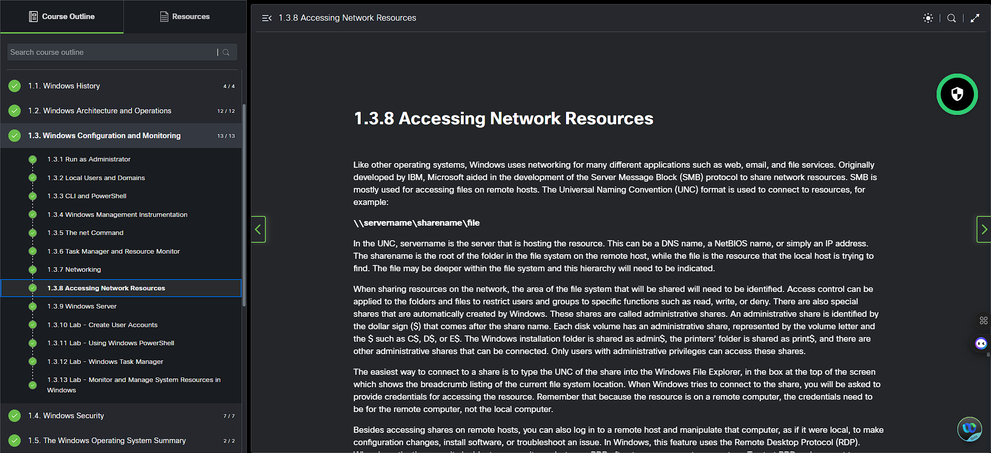
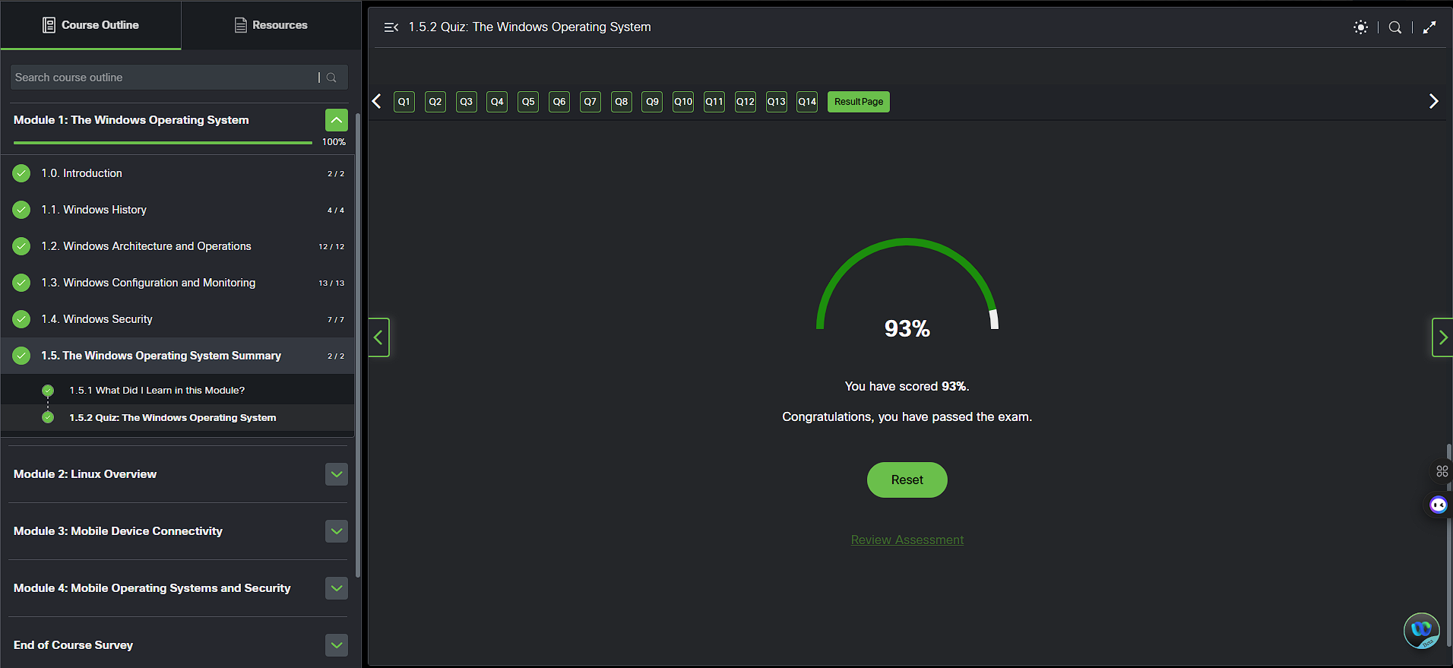
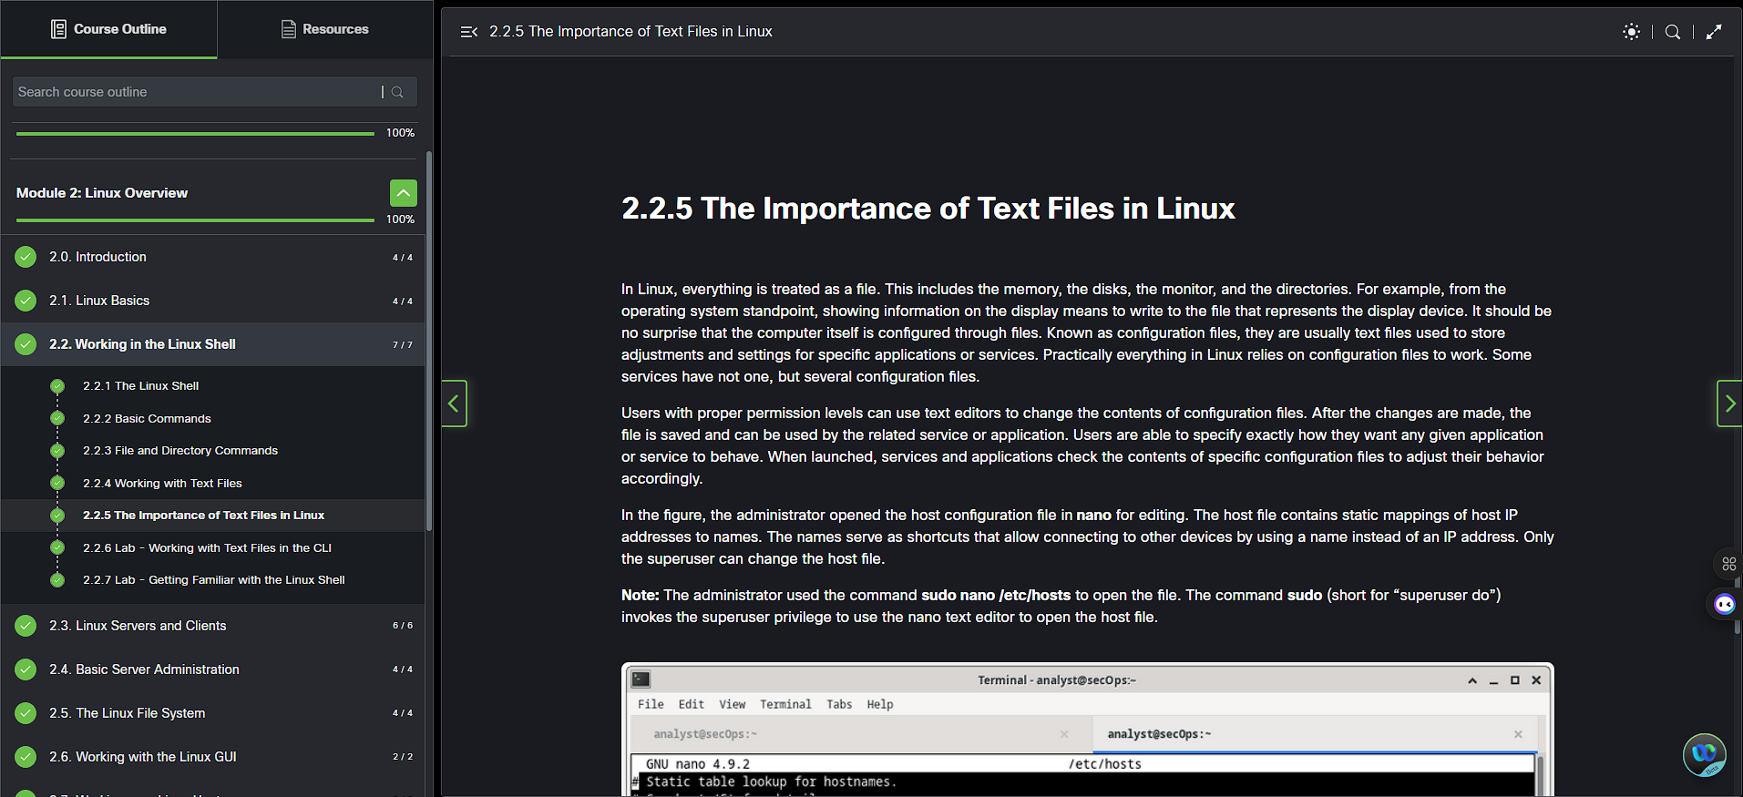
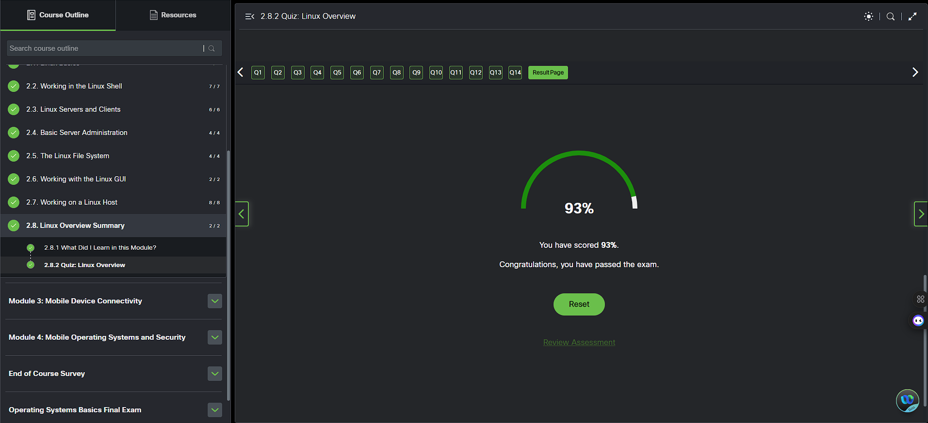

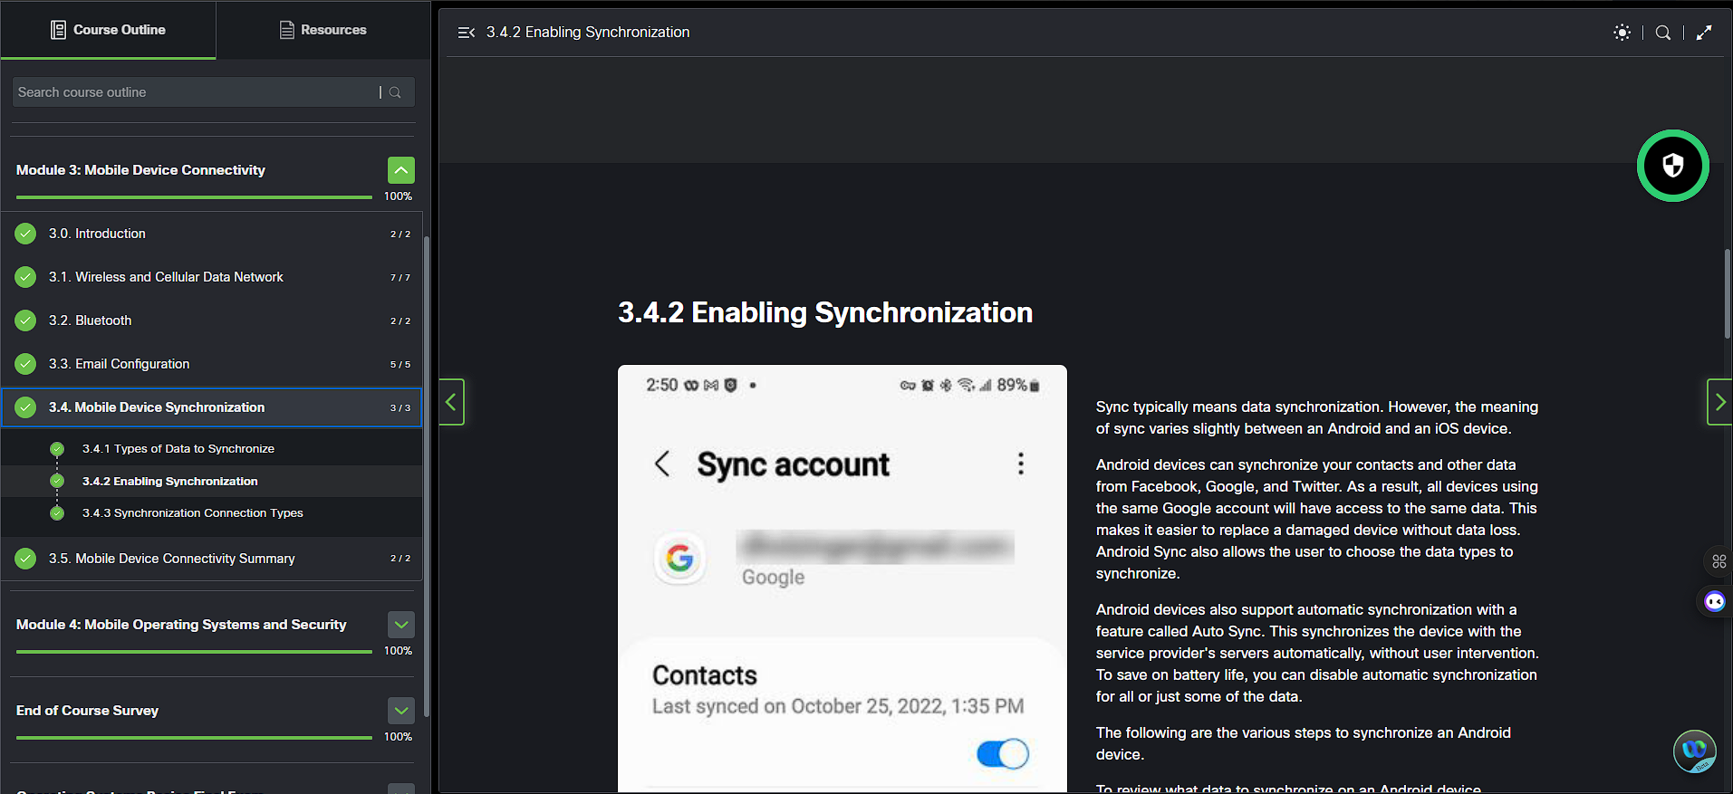
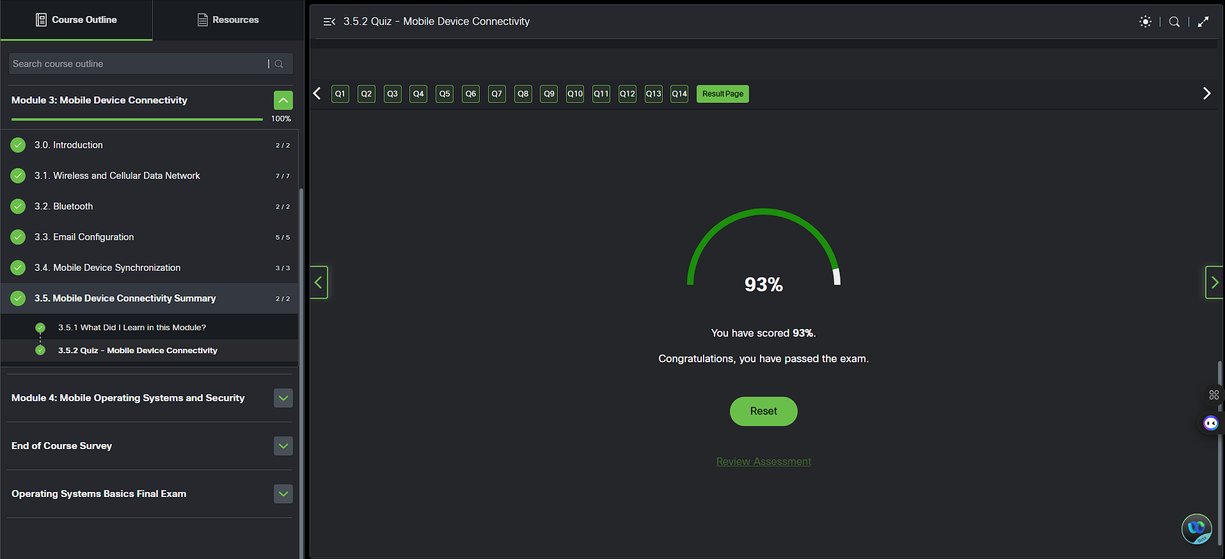
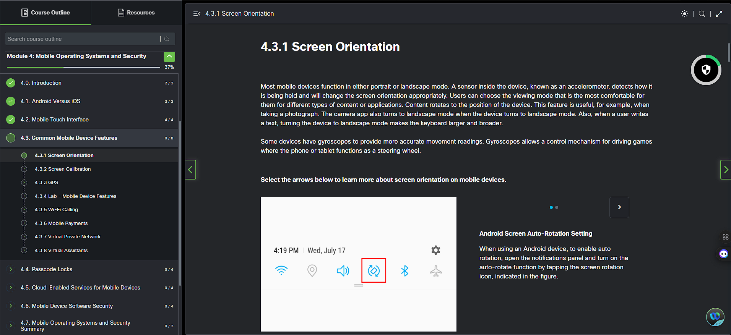
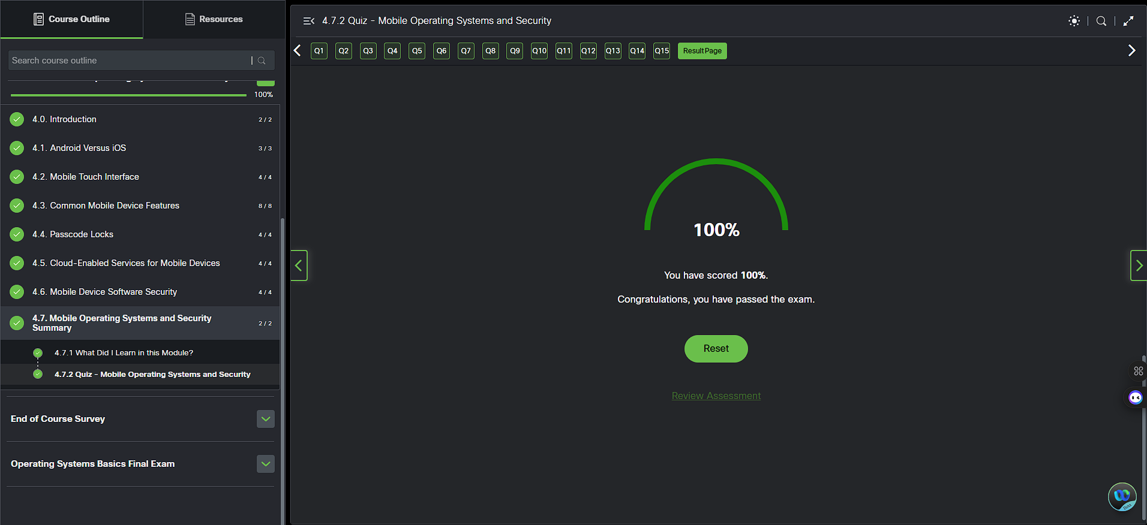
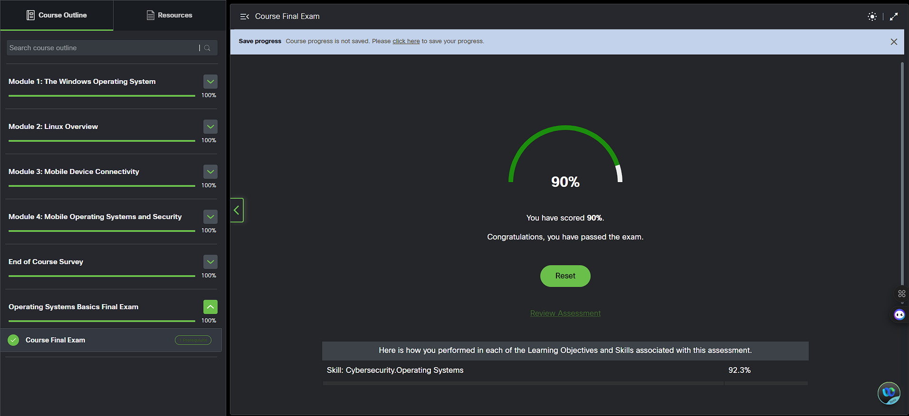

Appendix References
[1]
“Introducing ICT systems,” Introducing ICT systems. https://www.open.edu/openlearn/digital-computing/introducing-ict-systems/content-section-11.6
[2]
Dr. Jean-Claude Franchitti, “6.1 What Is an Operating System? - Introduction to Computer Science | OpenStax,” Openstax.org, 2024. https://openstax.org/books/introduction-computer-science/pages/6-1-what-is-an-operating-system
[3]
M. Rúa, “Most used operating systems today,” RoiLab, Nov. 22, 2024. https://roilab.es/en/blog/most-used-operating-systems/ (accessed Apr. 02, 2026).
[4]
A. Corbo, “What Is Linux? (Definition, Uses, Advantages) | Built In,” builtin.com, Dec. 29, 2022. https://builtin.com/software-engineering-perspectives/linux
[5]
“Usage Statistics and Market Share of Linux for Websites, December 2019,” W3techs.com, 2019. https://w3techs.com/technologies/details/os-linux
[6]
Dev Kundaliya, “Linux’s Desktop Market Share Climbs,” Mescomputing.com, 2024. https://www.mescomputing.com/news/business/linux-s-desktop-market-share-climbs
[7]
World Economic Forum, “The Future of Jobs Report 2023,” World Economic Forum, Apr. 30, 2023. https://www.weforum.org/publications/the-future-of-jobs-report-2023/
[8]
J. Schneider and I. Smalley, “Quantum computing,” IBM, Aug. 05, 2024. https://www.ibm.com/think/topics/quantum-computing
[9]
GeeksforGeeks, “History of Operating System,” GeeksforGeeks, Oct. 30, 2022. https://www.geeksforgeeks.org/operating-systems/evolution-of-operating-system/
[10]
GeeksforGeeks, “Types of Operating Systems,” GeeksforGeeks, Apr. 05, 2018. https://www.geeksforgeeks.org/operating-systems/types-of-operating-systems/?utm_source=chatgpt.com
[11]
Wikipedia Contributors, “Operating system,” Wikipedia, Feb. 23, 2026. https://en.wikipedia.org/wiki/Operating_system#Real-time_operating_systems
[12]
Cisco , “Cisco Networking Academy: Course Launch,” Netacad.com, 2026. https://www.netacad.com/launch?id=4aa8398a-ffea-4851-80b1-edb7326cb10b&tab=curriculum&view=ae31d187-c21c-5d87-920c-8cceee858d6f (accessed Apr. 22, 2026).

