Graduate Project
By
Tristan Francis (2005134)

Introduction
This project is research led based and will take you through what I have learnt and what research I have done. I talked about what camera I was thinking of using talked about the influences that have helped me produce this artefact. In this artefact I also show you what my editing was like and what I was thinking about when doing my photobook.

Concept and ideas

The concept of the photo book is to give people an insight into what fire spinning is and the people who perform the art, I also wanted to do a promotional photo book the reason I want to do a promotional photo book is because I also wanted people reading the book to get to know the subject and gain an insight into the performing art group, Pembrokeshire Fire Spinners (PFS). The initial idea came from me doing a prior event with PFS entertainment and I decided it was a good idea to make this project.
When thinking of a location to do this project I thought of many places. These include places such as doing outside of Yr Egin and down at the beach in Tenby. One that stood out was St Catherine’s Island in Tenby as the fort was a perfect setting for the some of the images I wanted to get. I also decided that it would be a good idea to take pictures before dusk to try and get photos that change over the period from dusk to night. The reason I’ve picked St Catherine’s Island is the feature of the building work really well with the fire and the inside had good opportunity for taking some photos. Though I have used photos from Yr Egin and other photos from the year.

Gank chart

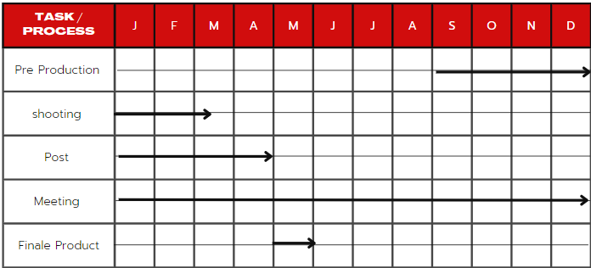

PDP

Goals | Threats and opportunity | Skills and knowledge | Date to achieve this by
To make sure that I have equipment ready for the shoot | Equipment might not come in time.  Opportunity is that a company may send equipment | I will be using my skills in photography which has allowed me to get shot that I want | 25 March 2023
To research information about fire photography and editing them | There might not be many articles and information on them.  The opportunity is that YouTube will allow me to do the research through video | I will be using my research skills and gaining the knowledge to edit m work | 20 February 2023
To be able to find a suitable place to do a photo shoot | Threats are there might not be a suitable place to do a photo shoot.  I will be going to different places to do a small recce | I will be using my skills to do a recce of places that I think are suitable for the project and gaining a knowledge of where the best place to do a photo shoot | 1st March 2023
To be able to gain knowledge for a photo book and be able to research about different cameras. | Threats are the source might not be credible, so I have to be careful where I go.  The opportunity is that I might gain insight and knowledge into a way of making a photo appealing | I will be using my skill to research information about how different cameras work I will also be gaining a knowledge on how to produce a photo book | 30 March 2023

Skill’s Audit

Research

When doing the research for my graduate project, I had a look at a few websites and books that talk about how to take action shots and what setting to use the camera in.
The first person I looked at was a person named Adrian Feliciano, in his website he talks about the technique that he uses for his photo of fire spinning. He states that using the shutter speed will help with the plume or length of the fire trail “shutter speed will control the size of the plume or length of the trail” (Feliciano, 16 May 2018 np) he also states that opening and letting the shutter go for longer makes the fire look larger. “The longer duration your shutter is open then the flame that gets recorded will be larger. “(Feliciano, 16 May 2018, np). Whilst reading this it has allowed me to understand the type of photos, I wanted to get in the photo shoot and gain a knowledge of how to set up my camera to get the best quality photos. Whilst looking on the website he also gives us tips on the setting saying that always have a look at the subject and how the way you frame the shot. Another thing that Adrian Feliciano talks about how ISO can affect the photo as it brightens the image so you have to take in to account your lighting and surrounding and how that might affect you photo “The higher the ISO, the brighter the noise becomes; the lower the ISO, the dimmer the noise gets” (Feliciano, 16 May 2018, np).

Feliciano talks about how distance help affect the composition and exposure saying that we need to think about how dark or light it is and the distance you are away from your subject, he also talks about how it helps to frame your subject “Distance, in particular, affects composition and exposure both by what exactly is visible within the frame” (Feliciano, 16 May 2018, np) this has taught me to be very mindful of the photos I’ve taken and how I used the methods that Feliciano talks about. Whilst taking photos it was always in my mind that I should be careful about the lighting and composition of my shots and framing them.

I feel as if I’ve learnt a lot about how to compose my shots through reading this article because it has made me think about how to compose my shot what setting to use, and to take in my surroundings. It allowed me to be able to make my shot better, it has also allowed me to be able to compare and contrast which camera really suits the shoot. It also has allowed me to understand the cameras better as I know what I need them to do.

Whilst looking at doing a photo book I had to think of the narrative of the story. I really wanted to incorporate the idea of day to night as I think you can really see the change of It, so I looked at a journal by Alfredo Brant (2021) on Alec Soths Niagara’s book he says “Visual narratives have a long history in the context of human cultural artifacts. In any sequence of images” (Brant, 2021). I think this is interesting as he states that images have been a big part of our cultural way of life, so the story needs to represent a start, middle and end, so I need to think about what kind of story I want to tell. Brant then goes on to state that “The importance of narrative as a way of organizing subjective experiences appears to be essential for people” (Brant, 2021, p.153) when reading this it has made me think about the photos I have to use and how it might inform people of story and how they will be informed. When reading this article, it made me think about how to connect my photographs to tell a wider story so when picking out my images I have try to connect them through a timeline, so I have picked photos that have been taken throughout year with fire spinning, fire writing and pyrotechnics this is because I wanted to use a wider range of photos to show off the PFS entertainment work, and the only way I could think of this was to use photos throughout this year.
Whilst getting my photos together I had to think of a narrative, so I went with a story of getting to know your fire spinners and then going into day and night photos with the transitions from day to night. In this way, you see how the fire commands the night and then some fire art with long exposure to make a kind of art. To end the book, I wanted to put some of the pyrotechnics of the book as it shows you that they don’t just do fire they do other thing as well as fire, the last page will be my thanks to the companies that allowed me to this project and being able to use all the equipment I did.
When looking at photo books one I found interesting that called sports and action. The book talks about photography that people have taken in the sports and how they were position . Some of the photos I’ve found interesting are to do with boxing where people are standing and moving. Whilst reading this I’ve used some of the positions outlined in the book. The photos of the boxing were taken by someone called John Gichigi; he was talking about the camera and lenses he uses which is a 35 mm lens and a SLR camera, I find this interesting as he said it was his first camera “it was also the first SLR I had used” (Steel,2008, p26). When I was reading this book, I looked at how he had composed his shots and how they tell a story. Gichigi goes on to talk about how he needs a fast 35mm camera he talks about how he used to use a Nikon D1H and then moved on to use a Canon EOS 1D mk2 “I used a Nikon D1H for much of that time now days I used a Canon EOS 1Ds MK2” (Steel, 2008, p31). When reading this it made me think about what lenses I should use and how far I can be from the target with my chosen lens. He then goes to talk about how he uses a 24-70 mm lens which does everything for his photos, but he talks about how he changes lenses when something about to happen, like a knockout in a boxing match: “if I think someone’s on the verge of a knock out, ill change to a 16-35 mm lens” (Steel, 2008, p31). I find this interesting as it made me think about how I should change lens and when I should do it, for example, if the fire spinners are doing some cool fire blumes then I should change lens to make sure I can catch the type of shot I want whilst looking at the photos. When reading this book I realised that position is key to get good photos so when am taking photos I need to think about my position and how that might affect how the photo looks, I have to also bear in mind that the iso and shutter speed will need to be at the right setting and not blow out the fire, I also need to take the time of day in to account as this will affect how I edit the photos and how they will look in post. Whilst reading this book It has made me think about which lenses to use as this will impact my photos and will make the photos hard to edited. I also look through the book and they have diagrams on where the photographer stood this has allowed me to use these to position myself in the right place to get the best of photos.
I looked at photo books called The wisdom of Wales and a book called The Photo book this was as a guide to how I should set up the narrative of my book. I think I will split the book in to three chapters they will be called getting to know your fire spinners this chapter will have a photo of each fire spinner and a short paragraph and why they love fire spinning , chapter two is called day into night. These will consist of a set of photos where they start of in the day and then turn into night. I really wanted to do this idea as it show how the fire changes when it hit night. Chapter three is called fire spinning into fire art. These will consist of long exposure photos that would turn the fire spinning into fire art. This would then be followed by some pyrotechnics to end the book. When thinking about the end of the book I wanted to add a picture at then that might represent the love for fire spinning so on the last page I put a picture of a heart on fire that they did on a previous event.

When thinking about what camera to use I look at website called camera decision this has allowed me to compare both the OM1 and the Fuji X-H2S. The website compares both camera by showing what each camera has and how it compares to the other camera. When looking at this research I was originally going to go for the OM1 as it the camera I was going to use, but I wanted to have a look at using different cameras to test my skills and see what the quality is like. The website talks about how both cameras are both mirrorless which is a key factor. The website says the Fuji X-H2S is an advance mirrorless camera “Fujifilm X-H2S is an Advanced Mirrorless class camera and OM System OM-1 is a Pro Mirrorless class camera.” (Camera Decision). A mirrorless camera means that it works without a reflective mirror, this means that both cameras are good for what am trying to produce. I think the edge is with the Fuji as it has a bigger sensor and is good for all round use; the bigger sensor allows me to do more with the depth of field and to blur my background where a smaller sensor is good when it has the same focal length and aperture. After doing this research I found that I wanted to use the Fuji camera as I believe that it would allow me to produce a better Photo. I also think that even though the OM1 is good I don’t think it would have suited the high impact of how many photos I wanted to take as it only produces 520 shots on a battery life, where the fuji has 160 more shot on a full battery life at 680. Overall, I decided that the Fuji would be better for the shoot. Another key factor for me using the fuji was the lenses even though the Om1 has morel lenses I felt like the lenses that the Fuji had was a good set for the fire spinning as it had a wider lens and a portrait lens that did a very good job with the lighting that I used that which was using natural light from the fire the photo didn’t get to blowen out.

Sensor Size and Resolution Comparison image of Fujifilm X-H2 and OM System OM-1 Cameras
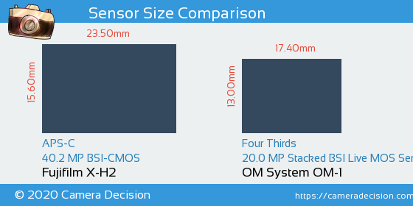

(Camera Decision,2023)

Whilst getting ready to produce the work I had to look at the best way to edit the fire spinning photos as I felt like I could improve my editing skill, so I had a look at a video about editing low light. Anthony Gugliotta (Gugliotta, 2022) says that setting the colour temp before you edit will help you edited the photo, he then goes on to talk about changing the exposure how that will help you when you’re dealing with low light. In the video he goes on to talk about how to use the dehaze make your image either light or darker which the image get darker or lighter when you slide it up and down in lightroom. He also talks about using colours to help the image be vibrance and have key aspect look more visual pleasing. I also must take in the two account if there should be fade in my photo that blends into the black background so there a lot to think about when editing my photos.

The design and process of my photo book

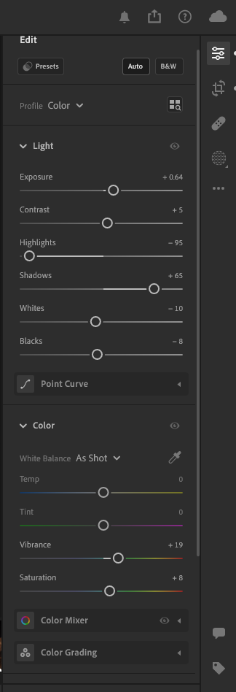
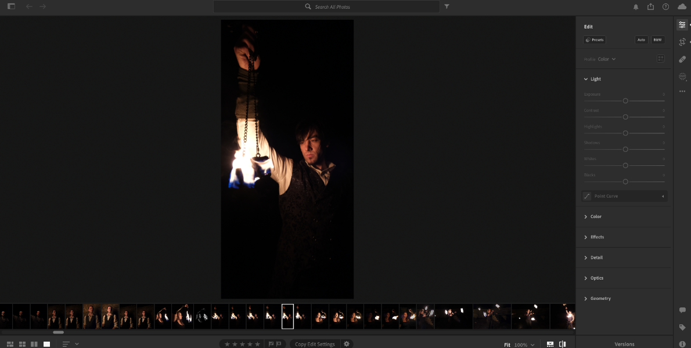
Before the edited (Tj Francis, 2023)
As you can see the photo I have taken is quite well lit as the fire is the source of light it also got a nice dark background that I wanted to keep. Dure in the editing process I had to think about what I wanted to do with the highlights and shadows to sort out the highlights, I brought them straight down to – 95 this is because I didn’t want to make the fire bright and for it to take over the photo as that’s not the plan here. The picture is to also show off the fire spinner themselves. The other thing I change on her was the colour the only thing I’ve change of the colour is the vibrance I’ve done this as I wanted the overlay colour to be a bit more eye catching this included making sure that it was set to the right balance. As you can see the edited one looks really nice I’ve lit the face of the subject in my work and I’ve made sure the fire hasn’t over powered the subject I didn’t want to touch anything else as I think that would ruin the image I did this to a lot of my work as they were dark and most of them had fire in them so it was trying not to blow out the fire .
Setting of the edited photo
(Tj francis, 2023)

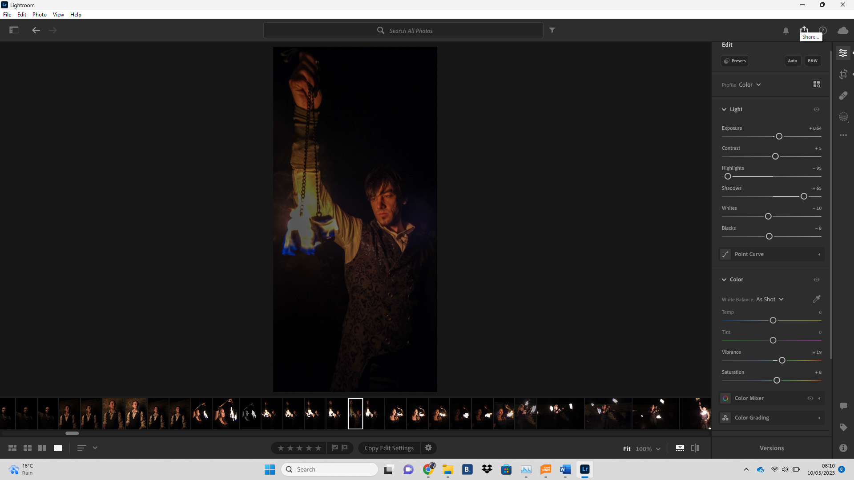
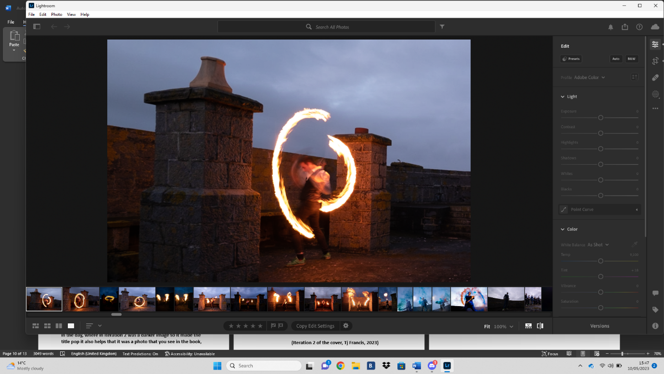
After the edit (Tj Francis, 2023)
Before edit (Tj Francis 2023)

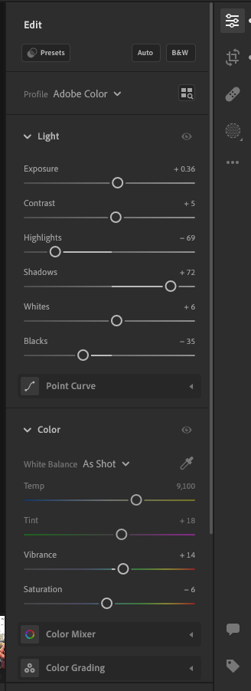
Another edit I did was with the fire art where I had a long exposure. As you can see in the photo above, l I’ve got the long exposure but I as you can see the photo is very exposing so your eyes wonder somewhere else, so I had added some highlights in to the photo and then added some more vibrance as I wanted to add a bit more vibrance so your eyes are instantly drawn to the fire and you can see the technique used. I really like the way this edited as I didn’t need to do much to it and it still a really nice photo.
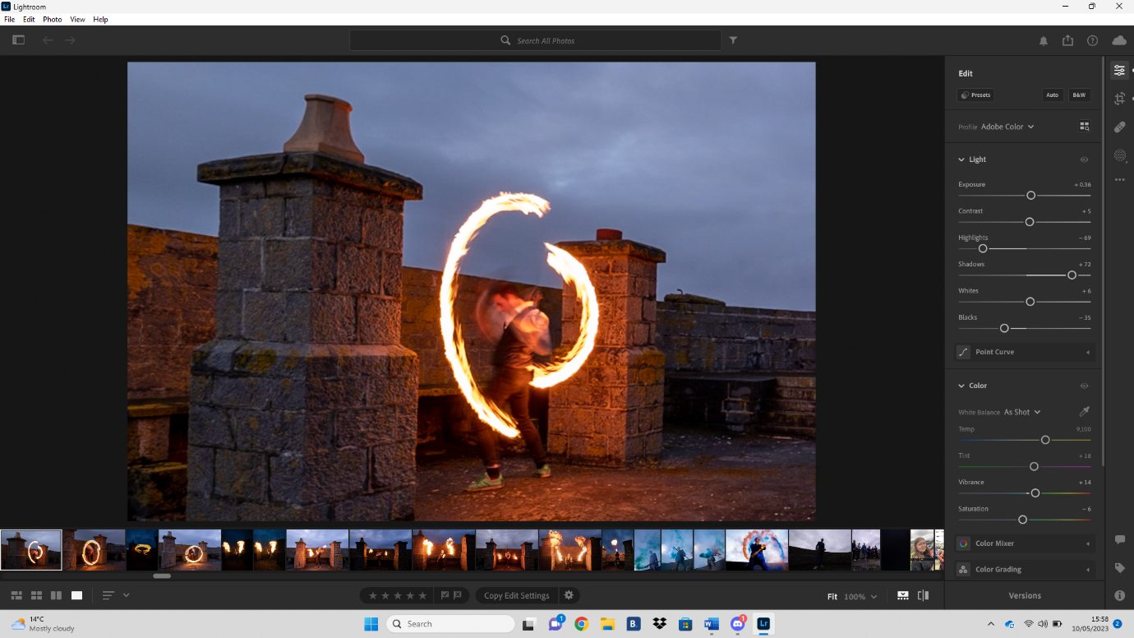
After edit and settings (Tj Francis, 2023)

My photo book cover had gone through two iterations which included have the whole team together before they stared the event I then did it as them actually spitting a fire ball out in to the air as the main cover instead of the back cover when getting some feed back on the cover from my peers they said that it looked like a boy band cover and you’ll need to change it to make sure people knew that it was to do with fire instead of something else so what I did was change the back cover to the front convert and then decided that was a better decision as it meant you was getting a an authentic look at what was in side of the book instead of getting a boy band cover, I think this was really good decision as well as it helped me to set a tone for my book. As you can see in iteration it doesn’t make my title pope due to the lighter image that was taken in the day, where in iteration 2 was a darker image so it made the title pop it also helps that it was a photo that you see in the book, so you have something to think about why it is used as the cover. I wanted to make sure that I had clear out set from cover to cover so I’ve picked photos that are interesting and impactful to me as the photographer and the ones that I think would impact the audience.

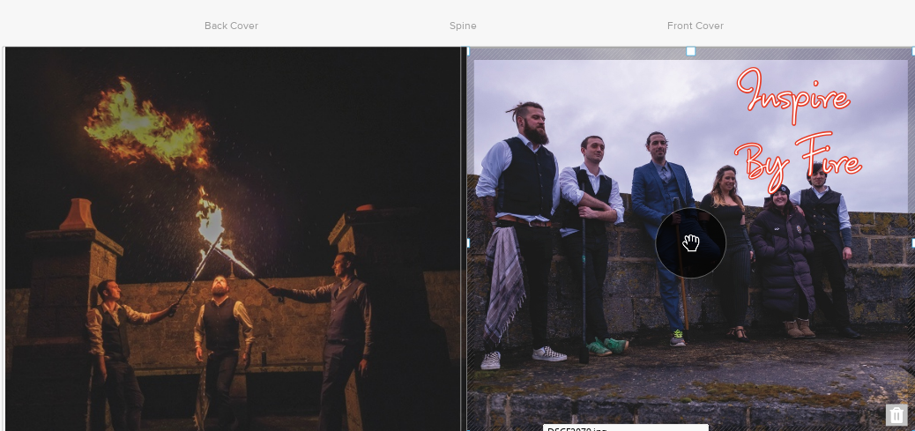
(Iteration 1 of the cover, Tj Francis, 2023)
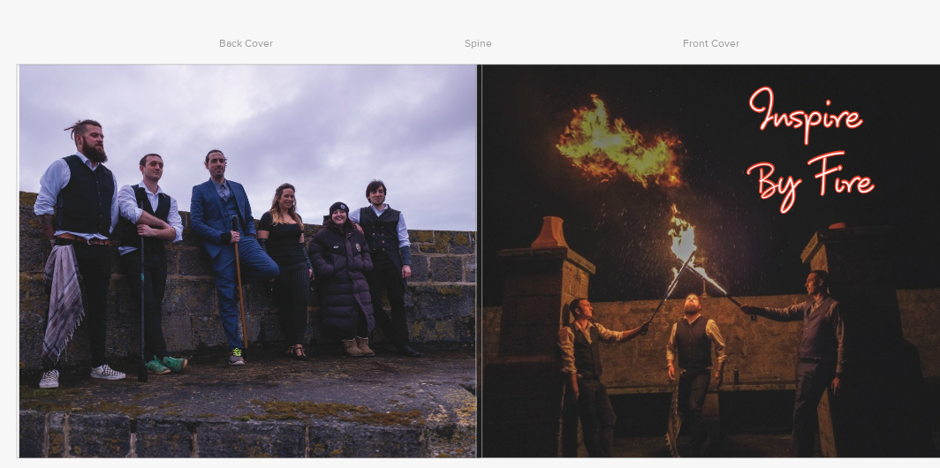

(Iteration 2 of the cover, Tj Francis, 2023)

When I did my second iterations of the book I had added chapter in to the book this was so when people read the book they understood what was going on and why the photo had changed, I used a front called Datangnon as it looks like the fire writing I added a glow on that which was in red and the size of 2, it looked like the fire was doing the writing. I had to spread my chapter on to two pages, so I put the text size up to 120 so it was big enough to fit both pages and not lose the effect I wanted I think this works well as it has made my photo book better as it now has clear sections.

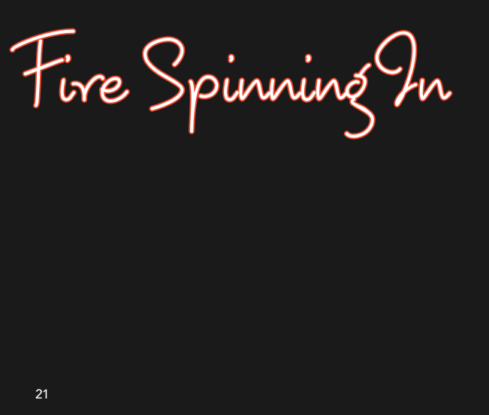
(Setting of the writing in a book, Tj Francis, 2023)
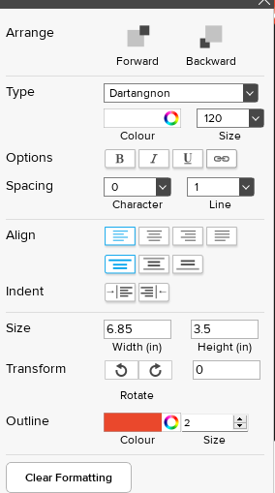

As you can see the red and wite really do work well together as the red does pop well with the red as it looks like someone done the writing in fire am so happy with the choice I made as it has, please me that it works as I wasn’t sure if it would of suited what I wanted to try and make it all about the fire spinners and what they can do. So overall I’ve decided that my chapter are in this kind of writing, I haven’t used it through out as I wanted writing that was eligible for people to read so I decided to go with Avenir as it’s more easy to read I also think it works really well with in the book as it a change to the writing of the chapters I only have writing at the beginning of the book as I wanted you to get to know each fire spinner I felt like the photos talk about them self and they don’t need text to explain what happening in the photos as I think they explain themselves.
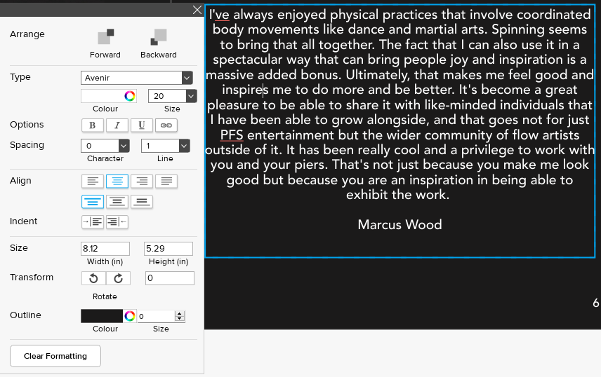
avenir text and writing (Tj Francis, 2023)

when coming up with something to write I decided that I wanted it to come from the fire spinners themselves. I believe that it would give the reader a sense of connection to each performer before seeing the photos. The way I connected to the performers to get their paragraphs were through social media as I have most of the performers on the social media. When contacting them I had giving them a brief summary of what the book was about and what I wanted from them, I told them that I wanted a short paragraph about why they enjoy their art of fire spinning. I message everyone that was at the event that happened on St Catherines Island and at the Yr Egin. The only one that hadn’t replied was one of the performers. Even though they didn’t get back to me I used one of the photos to still represent her, I found this quite hard as I really wanted to let people know how they started but, in the end, I had to improvise and the only way I thought of was to use an portrait picture of them. This went through to iterations of me deciding what to do. I had got this peered review and after a lot of talking to people I had decided that the one photo is better than both as it was brought up that it take away from the one I had chosen.
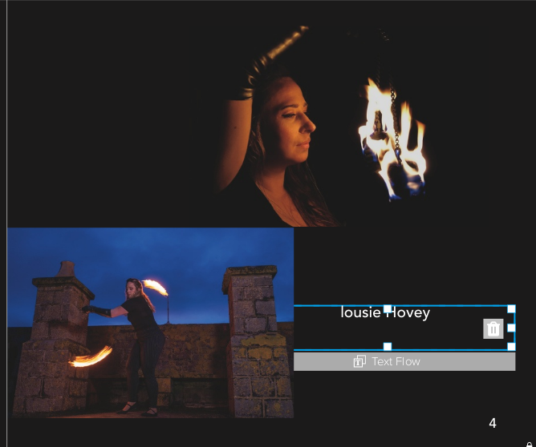
Iteration one (Tj Francis, 2023)

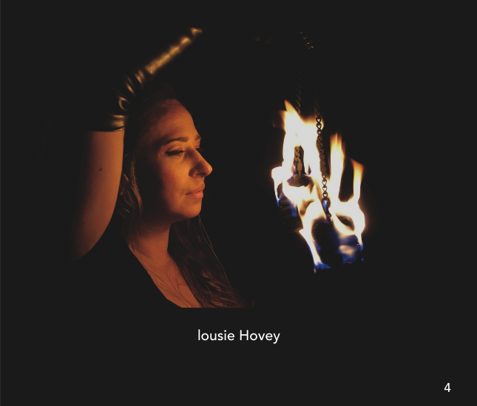
Iteration two (Tj Francis, 2023)

Link to my work
https://acrobat.adobe.com/link/review?uri=urn:aaid:scds:US:0e679cda-2a47-4963-bbe9-f847f87ead6d

Conclusion
In conclusion, I feel as if the photo book has key points that I took when doing my research. I felt that researching about how to take photos of fire really helped as Feliciano talks about composition and settings this really helped as I wasn’t sure how to compose the shot and what setting would help. I also found that reading the sports and action book really opened my mind to where I should position myself, I also found it interesting reading about other photographers and how they take photos. I also found that it has given me an insight to how I can improve my photos. I found that researching about the OM1 and Fuji X-H2 and how they compare to each other was useful. If I was to do this project again, I would do more research into how they are suited to any project I do next. I also think that it was a good comparison for both cameras. It was also a good insight into how one has a bigger sensor and the other have a smaller sensor; that was an insight as I didn’t realise that the bigger sensor is good for low light hence why I picked the Fuji over the OM-1. I found that researching about photo books has also helped me set out the narrative as Brant has said it is about making sure people can understand the story behind the photo book. I also found that making my photo book a promotional one was such fun, even though I have had setbacks. Doing it has opened my eyes into how to approach people and try to get what I need from them at an earlier stage than when I did as I think the project was missing one person’s paragraph so I think I could benefit from having it.
Overall if I was to do this project again, I would like to try and do another photo book about a different subject and to see if I can apply all the things I have learnt to a new subject, like motor sport or skiing. I think I could do something that challenges me as a photographer and my skills. I also feel as if I was to do something like this again I would use a different camera again to allow me to gain knowledge through using different equipment.

Bibliograph

Barrett, Paul. The Wisdom of Wales. Uwic Press, 2001.
Brant, Alfredo. “Visualização de Do Potencial Narrativo Dos Fotolivros: Uma Análise Do Livro Niagara de Alec Soth.” Impactum-Journals.uc.pt, 2022, impactum-journals.uc.pt/matlit/article/view/9582/7671. Accessed 22 Nov. 2022.
Camera Decision . “Fujifilm X-H2 vs OM System OM-1 Detailed Comparison.” Camera Decision, 2023, cameradecision.com/compare/Fujifilm-X-H2-vs-OM-System-OM-1#:~:text=Fujifilm%20X%2DH2. Accessed 8 May 2023.
Feliciano, Adrian. “How Do You Photograph Fire Performers by Thinking?” Adrianfeliciano.com, 16 May 2018, adrianfeliciano.com/how-to-photograph-fire-performers-by-thinking/. Accessed 4 May 2023.
Gugliotta , Anthony . “Lightroom Photo Editing // Moody Night Street Photography.” Www.youtube.com, Anthony Gugliotta , 16 Apr. 2022, www.youtube.com/watch?v=y5HGHa-X6Fw. Accessed 9 May 2023.
Patrizia Di Bello, et al. The Photobook. Routledge, 7 Aug. 2020.
Steel, Andy. Sport & Action. Mies ; Hove, Rotovision Sa, 2008.

