UNIVERSITY OF WALES TRINITY SAINT DAVID
Student: Juditha Henry
Student Number: 1910054
Module Code: BMSW4002_Lon
Assignment Tile: Effective Team Working and Communication
Module Title: Definition of communication
Lecturer: Dr Molly Jack

Table of Content

UNIVERSITY OF WALES TRINITY SAINT DAVID 1
Table of Content 2
Introduction of communication 3
Types of communication 4
Three models of communication ………………………………………………………………….5
Summarize 7
Reference 8
Appendix ………………………………………………………………………………………………9

Introduction of Communication
Effective communication
This is defined as verbal speaking/talking to each other, these are further meaning of communicating. In which information that would get a point across. An example of ‘effective communication’ this is when the person who you are talking to listen actively, engages your point and understand it. (Your Dictionary, 1999 – 2019).

Define teamwork and explain its importance
An organization gradually working on team work to accomplish work tasks. A communication within an organization complies with team working; building a team with effective attitude and a good source of communication. Such as, Speaks to each other in a clear and simple way. Listen to each other and analyzes, what each other are trying to say, be specific on important matter. Develop a clear understanding towards each other. Most of all respect each other. Forming a group of people to create a team, can be very awkward. There can be Absence of commitment, poor communication as to the particular working, that include team work and to process, team work. (wiley online libuary, 1999-2019)
Define communication and explain its important at the workplace
Communication comes with good practice of ‘communication skills.’ For example, an organization the receptionist works at the front desk of the company, their communication skills are essential well-mannered and improved.
The workplace can be improved, by listening to each other; engage into the conversation. Do not multitasks, this can be uncooperative within the workplace. Use open ended questions, and work along with the flow and briefly uptrained your work. A workplace is one of the most importance of an organization to enhance a social measurement in which is currently a strong focus on emphasis. Things can simply go wrong in a workplace for instance, a presentation there can be lost for words.
According to this an organizational perspective is much of important, whereas an organization falls in line with its strategic directions, within the community spirit. An internal communication can be important in encouraging such supportive attitude. There are two ways of temporary support, “both is to creates a sense of commitment within the organization, the other is establish trust in the management”. Both approaches appear to have a positive relationship with good inside communication. The quality of task-related communication is important to create commitment and trust within the workplace. (Wiley online library, 1999-2019)

Name the organization for which you work and give brief explanation of the nature of the organization (what it does)-explain why communication is important
Home carer organization
Home carer is an organization who works, with client directly in their home. The coordinators of the home carer company, have their own team workers. A coordinator creates a rota and sent a text to me or Email me to their team workers are the workers would pick up their Shift/Rota at the office. The Rota would explain the shift of the worker that assigned to, along with the client details. The workers work, along with a weekly basis contract. For example, A single-handed job, one-person work on their own. A double handed job, two person works together on a shift.
Communication, this is very important within my organization, I have to follow instructions such as prompting medication, dieting and the requirements that the client need on a daily basis. Some client or a risks patient, so in order for me to care for the client I have to have a communication skill. Such as, checking the client portfolio and communicating with client in order acknowledge what have been done for the client; from previous shift and what I need to do for the client on my shift. At the end of my shift the workers have to sign the client portfolio as well as the client signing my time sheet, in which the workers would submit their time sheet to the office in whereas I am assigned. A certain day of the week for me to get paid on time. Its takes compassion to work as a home carer.
Home care assistant
A carer is a person who is actively working in an organization. A care assistant works alongside a carer. Has a new care assistant, they have to work with a carer in which called shadowing? As a care assistant you would follow procedures that carries out by your carer on a daily basis.
The care assistant would stand next to the carer to observe and learned to carry out duties. The carer would communicate with the clients on an arrival and during their session. We have to have a form of politeness, greeting the client, talking, arousing, smiling, cheerful etc., this can enable the client mood some may not have anyone one to communicate with. The carers would communicate with clients asking the client, how was their day, did you have a restful night and how would they have liked their meal. Has a Home Carer you would have to consume a good communication skill?

Types of Communication:
This is the resources of a one to one interaction between two or more people, verbally or non-verbally. Sending and receiving information by Telephone, Emails, Memos, Reports and Websites etc.
Verbal communication
A verbal communication is about language both written and spoken.
A sound from the mouth which communicates appropriately amongst people by using speech, expressing yourself, exchanging messages with one another and develop as individuals. Discussion is obtainable as a valued learning for teaching serious, intellectual and educating communication skills. Involved in the conversation are a short-term past of the use of argument as an education policy, the tasks of the tutor also student, once using debate in the teaching space and its various advantages designed for developed capabilities in communication and critical thinking. (Fink et al, 2019)
Non-verbal communication
In modern times, autistic undeveloped individuals are subject to play skills. There is certain behavior indicated such as, shortfalls in their speech which is categorized. Children who received a diagnosis of autism the shortfalls of their development are non-verbal communication. Their nonverbal communication refers to communication that occurs through means other than words, such as body language, gestures, and silence. Verbal and nonverbal communication can be spoken and written. (Wiley online library, 1999-2019)
Written communication
Written communication can also be part of verbal communication in order for individuals to follow information they have to decode someone idea. For e.g. An authors’ reading someone written communication you are decoding their information, such as, Letters, Documents, Reports, Memos and Books etc. (lumen introduction to communication)

 | Spoken communication | Nonverbal communication
Verbal | Oral language | Chuckling, Crying, Coughing etc.
Non-Oral | Written Language/Sign Language | Gestures, Body Language etc.

These are the three models of communication:
Shannon and weaver’s
Belo’s
Schramm’s
Shannon and weaver’s model of communication
The Shannon model as being term as, the mother of all models. In which can be describe as, mathematical model use for technical communication or machine. Such as: Communication like Telegraph and Telephone, within this model there can be success in communication if the channel does not produce element of noise.
The sender would basically come up with a desire message, and the encoder would transmit the message into a signal. Through a channel that convert messages, the message can be interrupt by noise that give feedback/eco sounds which would disturb the message. Then the receiver the decoder on the other end of the line would receive the message whatever message that is and forward it to the destination. (Communication Theory, 2019).

Berlo’s model of communication
The sender in the Berol’s model of communication is the encoder that originated the thoughts and put together the information and send it through a channel/audio whereas, all the information would transfer to the receiver, then the decoder would analyze, the message and send back a response. The sender would send the messages through a channel or an audio and then the receiver would receive the messages. Such as (sender, messages, channel and receiver) as the diagram shown below. There are two different types of communication within the Berlo’s communication Encoderen and Decoderen. This comes with a good communication skills, Attitude, Knowledge, Social System and Culture. Within the sender and the receiver.
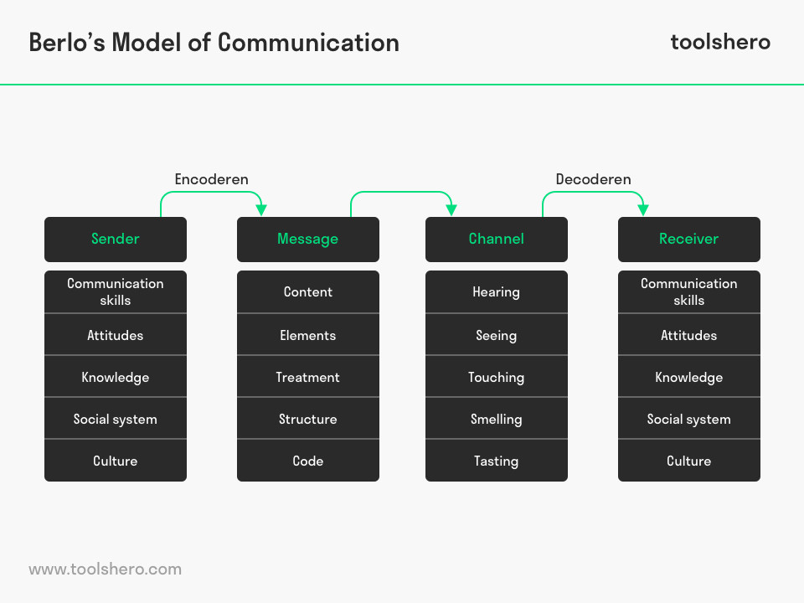
Schramm’s model of communication
The Schramm’s model of communication is originated from the Shannon weaver’s model of communication. The Shannon weaver model is more mathematical and technological, whereas the Schramm’s model of communication is more psychological. Schramm’s is held that the related of individual that who is involved in this communication plays an important role. (Schramm’s model of communication/Businesstopia, 2019).
This model was invented in 1954 and deem as useless the messages of the information is of no use unless the messages has carefully put into words, the thought needed to conveyed into a content. Then when the information reaches the receiver is for him/her to understand what the messages, actually saying or what the speaker intended to convey. (juneja, 2019)
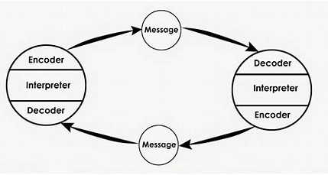

Case study analysis
In the case study I have learned about effective communication, in which individuals would talk in a clear and simple way. Verbal communication such as, Speech improvement, Face to face conversation. Non-verbal communication, Body languages, Face expression, Sign languages etc. The non-verbal messages can also come across negatively or positively.
I have also learned, in my written communication I should be more concise in my writing, make the facts clear, to the point. For e.g. A formal letter, information should be clear from the beginning such as; “this is what I am writing”, I should not address a person by their first name, I should use (Dear, Mr/ Sir/Madam) make a good opening and a good closing of a formal letter. Be more clearly within my speaking voice and improve my tone of voice. Some speaking communication can be disregarded by the way I communicated. (Fast Company, 2019)
Emails
An email is on electronic mail that exchange information sent by a message, allocated by on electronic devices, from one computer user or more as well as a network. This is a main internet operation across supercomputer networks daily. The sort of electronic mail is defined as, the broadcast of the messages over communication networks. Most of the systems included a basic text editor to compasses messages, some of the system allows me to edit my messages, some may provide basic formatting including, Bold, Italics, Front, Color and HTML. The program can be used to send messages to a recipient by requiring the recipient’s address and can also send the same messages to numerous users at once. In which is called distribution. (Electronic mail, 2019)
Business letters
Business letters is a formal document that is useful for many reasons, within a company. Many businesses use business letters, to custom businesses under a professional turf. This is necessary for making sure both businesses and individual have an appropriate written communication document.
In class activities
My in-class exercise 1 activities, I have learned how to write an Email, that went well. I have also learned about encoder and decoder; the sender sends the message. The receiver, receive the message and give back a reply. The sender is the encoder who created the message/think of the message and the decoder is the receiver who accept the message and responds with a feedback. Communication barrier noise, broken headphones etc. Learnt how to improve on our listening skills. (The communication process model captioned, 2013).
Within exercise 2, I myself did not understand the question very well, so this exercise did not go well for me. My other exercise 2 the exercise, ‘writing an e-mail’ were a bit better for me I have receive a good mark on my closing. Within my case 1 exercise I have the need to improve. I should be clearer in my structuring and make my answer simpler.
This in-class exercise is about impact on climate change: Listening that has breakdown in communication, the news politic, election and what the news is about. General listening, conservative from 200 nations converge on Madrid deals are in burning on global and climate change.
Impact on climate change, and to achieve their golds on climate change. Agreeing on rules and acknowledgment it may not be possible. Climate funds, amazon burning. To make a change by 2050 on carbon emissions. Political support, a dead line within 2 weeks, hoping to get political support. The climate change can affect the war. Two country has drop out trilli and brazil
London bridge
My exercise on London bridge suggest that two victims lost their life. Three others were in hospital. The attacks started at fish manga hall way market at 14:03. The police shot dead the suspect.
Election debate
Brexit deal there could be a Brexit talk about independent, talk about people from lower background. For example, food bank party should work together. Poor people making them rich within the population.

Summarize
Shannon and weaver’s model of communication
Shannon and weavers are an interactive communication and it is also called a mathematical theory of communication. This basically designed to develop effective communication between sender and receiver, including factors which affecting communication process called “noise”. For example, information source, Transmitter, Noise, Channel Message, Receiver, Channel, Information destination, Encode and Decode.
This basically explained that a message that being sent from one location to another. The sender would think of a desire message and sent it to the encoder in which the person who receive message would transmit the message into a signal. This message can convert into signals like waves and binary data. (Management study guide, 2019)
According to the theory an ½ a century ago, within 1948 Claude Shannon published his epic paper. A Mathematical Theory of communication. There was a reflective/minor in both of the weaver that involve a slight change, in the Title between 1948-1949 by which include an expository introduction by warren weaver.
There book was published in 1949 by the university of Illinois press. This has been a vast effect on Technological progress. As we know it today.
This book as sold over forty thousand copies, and continues to selling, seven hundred or more copies per year. (The mathematical theory of communication, 1963).

Reference

courses.lumenlearning.com
Fink et al (1996)” Debate: A teaching strategy to improve verbal communication and critical thinking skills: Nurse Educator”, 21 (4) p 37-40. [online] Available from: https://journals.lww.com/nurseeducatoronline/Abstract/1996/07000/Debate__A_Teaching_Strategy_to_Improve_Verbal.15.aspx (Accessed: 26 November 2019).
https://onlinelibrary.wiley.com/doi/abs/10.1111/j.1469-7610.1986.tb00190.x
https://www.managementstudyguide.com/schramm-model-of-communication.htm
Love To know corp (2018) Effective communication [online] Available from: www.yourdictionary.com (Accessed: 05 December 2019)
S. Eduardo, Shawn burke. C, Cannon-Bowers Janis A.(2003)’international journal/management reviews: Teamwork :emerging principle’ 2 (4), pp.339-356[online].Available from:https://onlinelibrary.wiley.com/doi/abs/10.1111/1468-2370.00046 (Accessed: 26 November 2019).

Appendix


