
STUDENT NAME: KRIS BHUDOYE MIExpE
STUDENT ID No: 2214886
PROGRAMME: L4 OME (HNC)
MODULE: SYSTEMS ENGINEERING
MODULE CODE: ACAD4005
DATE: MAY 2024
LEC: DAVE HOLLEY

TITLE: FUNCTIONALITY AND DESIGN IN A HOUSEHOLD OBJECT

TABLE OF CONTENTS

Page 01: COVER

Page 02: TABLE OF CONTENTS

Page 03: SECTION 01 – BRIEFING

Page 04: SECTION 02 – OVERVIEW OF USER REQUIREMENT AND KEY REQUIREMENTS

Page 07: SECTION 03 – PAIR WISE COMPARISON

Pages 08: SECTION 04 – REQUIRED FUNCTIONALITY AND CONCEPT

Page 09: SECTION 05 – QUALITY FUNCTION DEPLOYMENT

Page 10: SECTION 06 – FUNCTIONAL MEANS ANALYSIS

Page 11: SECTION 07 – DESIGN FAILURE MODES

Page 12: SECTION 08 – CONCLUSION AND SUMMARY

Pages 13-16: APPENDICES

Page 17: REFERENCES

Page 18: BIBLIOGRAPHY

SECTION 01 – BRIEFING

Systems Engineering is a logical method of realising, creating, and managing the design of a System. The System can be a combination of Units, or elements that form a function, and this all must be assembled to meet a need. This can be a User need or Requirement; It can encompass all factors that feed into the Requirement. It is a process that highlights the benefits of an element that feeds into a Requirement, and can methodically prioritise and focus in, driving the process of development, with demonstrable benefits to the overall System.

A series of needs or Requirements can dove tail in to create a larger System, with overlapping Requirements. This process can be immensely complicated when overlapping Requirements (System-levels) prove to be detrimental to other Systems, Users, or needs.

Systems Engineering will drive the properties and functions, as well as behaviours and overall performance of the resulting System.

REPORT

The aim of this report is to show the process in identifying the key customer requirements, exploring system functionality, conceptions, and design choices, possible failure modes, through to a conclusion based on the chosen parameters.

The process will be guided by the use of a systems design toolset, and demonstrate a working understanding of system design, and development through system thinking.

For the purpose of the systems design exercise, any household item could be chosen, and this report covers home office storage units.

The user requires a system to store a variety of readily available items, in a home office.

SECTION 02 – OVERVIEW OF USER REQUIREMENT AND KEY REQUIREMENTS

User requirement, initially and most essentially, is to store multiple, and varied items, for use in the home office environment. The list of items is not exhaustive, due to the changing requirement, from project to project, that is carried out in the home office. However, it can be assumed that there will be a number of items that could be included as “typical” items. Appendix 01 shows a collated list of what can be considered as “typical items”.

Tertiary parameters are also dictated by the user, in that there are known certainties:
- The user has a desk, sufficient to support a laptop, a second keyboard, and second monitor, printer, and at one surge protection power strip.

- There is sufficient space for a large storage unit. The space given by the user is 3.0m x 1.0m.

- There is already an area identified to house and locate the storage unit. This area is negotiable, as there is no fixed furniture within the home office. However, to cause the least amount of disruption, the user has expressed the preference that the storage unit is located in the already identified area.

- The user requires that the storage unit be modular. This is essential, as,

  - The user’s home office is located in a top floor premises
  - The user has already identified that the shape of the storage unit will likely have to change over time, for repurposing, and in order to fit around other essential household items, which may be introduced to the home office, or in that case that new items are added, and required to be stored in the storage unit.

- The storage unit must be constructed of lightweight materials, due to 4a) above.

It should be noted that 4) and 5), above are also considerations for overall User Requirements, addressed in the Design Book (Appendix 02).

Some common terminology must also be established for clarity. Each modular shelf, or cube, will be referred to as a “Unit” of storage.
The Units will be assembled together to form the whole storage unit. This will be referred to as the “System” [2].
IDENTIFIED USER REQUIREMENTS
- Each "shelf" / "cube" (hereafter "Unit") to support weight
- The whole System to be low cost
- The whole System to be easily constructed
- Each Unit will be easily constructed
- Each Unit will easily connect to each neighbouring Unit
- Where the System is built up from Units, the final arrangement of Units to form the System can be any configuration, or 3D shape
- Where the System is built up from Units, the final arrangement of Units will be a structurally sound 3D shape
- Each panel is durable, will not degrade or warp
- Each component, and System as a whole, must adhere to CE standard
- The System, once completed, can be easily deconstructed in order to re-order Units to a new configuration

In order to breakdown any requirements, or specified specifics within each, it is important to understand the realistic limits of the requirement. For example, it would be unrealistic to expect the System to support an exceptionally large weight, due to the modular requirement. This is understood by the User, as an accepted realistic limit on requirement.

Therefore some specifics must be aligned to the requirements.

- Each Unit should be capable of supporting weight, no greater than 1.0kg
  - This is a reasonable weight for each of the items that are likely to be supported
  - The list of “typically found” items (Appendix 01) in the home office, not including the items that are required for a functional home office already supported by the existing desk, are unlikely to weight more than this specified 1.0kg
  - If the weight of an item required to be stored is found to be more than 1.0kg, there may be an opportunity for some innovation and negotiation

- The System overall cost should be kept as low as possible. The structure is temporary-to-medium term, and therefore the User is not willing to outlay a large amount of expenditure

- The whole System must be easy to construct. The User has finite resources, time for construction, and User will be constructing each Unit and then assembling the modular System themselves, as a one man job. The User is also known to have finite mental capacity, and limited construction abilities

- Each Unit must be easily constructed. As 3) above

- Each Unit will easily connect to each other Unit. As 3) above

- Where the System is built up from Units, the final arrangement of Units to form the System can be any configuration, or 3D shape. Essentially the modular requirement of the assembled System must fit around existing shapes, and be able to loosely incorporate other supporting items, such as a shoe rack, or storage case, for example

- Following assembly, the modular system, as a whole three dimensional shape, must have the integrity to stand, unsupported, upon a flat surface

- Each panel, with the walls of each Unit, must be robust, and not degrade or warp either individually or once assembled into a Unit. This will support the overall integrity of the finished System

- CE marking is an European Economic Area assurance marking [1]. It indicates that a product meets stringent manufacturing standards. This gives the User the peace of mind that the System is not made of any products that may release noxious fumes in the case of a fire, will not degrade over time and potentially stain or mark surrounding surfaces, is less likely to cause injury or illness during handling and assembly

- The System, once completed, being modular, can easily be deconstructed in order to remove, or simply move Units into a new three dimensional configuration. Due to the short-to-medium term requirement, the System may be required to fit around newer supporting items that enter into the area. The System as a whole may be required to be moved to an entirely new area, or repurposed entirely, within the existing parameters of the User requirements.

SECTION 03 – PAIR WISE COMPARISON

From the Pairwise Comparison analysis tool (Appendix 02), the results are listed as follows, in order of importance:

- System as a final assembly of Units is to form a structurally sound 3D shape
  - Result x13.5

- System as a final assembly of Units is to form any configuration of a 3D shape
  - Result x13

- Each panel will not degrade or warp
  - Result x12

- System can be easily deconstructed to be re-formed into a new shape or configuration
  - Result x10.5

- Each Unit will be easily constructed
  - Result x11

- Each Unit will easily connect to a neighbouring Unit
  - Result x09

- Whole system to be low cost
  - Result x8.7

- Whole System to be easily constructed
  - Result x8.6

- Each component must adhere to CE standard
  - Result x8.6

- Each Unit must support weight
  - Result x5.1

NB. Results are rounded to one decimal place

The above results highlight that Structure and Configuration clearly become the priority for highlighted functionality requirements. Initially this was identified as low cost, but given the QFD results, this moved further down the priorities of requirement.

SECTION 04 – REQUIRED FUNCTIONALITY AND CONCEPT

Given that the Level 01, most basic, requirement of the Modular Organizer Cabinet is to support various lightweight items in a Storage Cabinet System, this should be identified into the steps that the User will have to take in order to create the System.

At Level 01, the User is required to:
- Unpack the component parts
- Be able to easily identify the component parts, and therefore be able to identify where each connects to another
- Piece together one component part to another component part, to begin the structure of a Unit
- Piece together partially constructed Unit parts, to form one of the cubed storage Units
- Assemble together Units, to form the beginnings of a System
- Place this into the identified area, as required, in order to form the base layer, and thus begin to “build up” the System

This is further broken down into Actions, as there are steps to be identified within each Function:

Level 01 Level 02
Unpack components | Remove Packaging
Unpack components | Lay out component parts
Easily identify component use | Visually confirm type of component
Piece together components to form Units | Take one type of component in either hand
Piece together components to form Units | Take another type of component in the other hand
Piece together components to form Units | Piece together components to form a side, or corner of unit
 | Piece Side together with another Side, or Corner together with Corner, to form Unit
Assemble Units together to form System | Take one Unit in one hand
Assemble Units together to form System | Take another Unit and assemble with other Unit
Place Units as Assembled System, into place as required | Place stable, lower Units
Place Units as Assembled System, into place as required | Assemble together with other, lower Units
Place Units as Assembled System, into place as required | Assemble together with other Units, and continue to build up layers, as required

It is a very simple requirement to identify the above steps. A classic example of this is the “Children’s instructions for their father to make a sandwich “, where if the child has written an instruction, the father will follow this to the letter. Correct instructions, and the understanding of the User Actions are very important.
SECTION 05 – QUALITY FUNCTION DEPLOYMENT

The first Quality Function Deployment analysis will weigh each metric for the User Requirements against the User Functions and Actions that are required to create the System. See Appendix 03.
Once again the Requirement for the System to be of lower cost drops down in priority, against the requirements requiring structural integrity. Another Requirement that begins to gain traction against the expected cost implications is ease of construction. It stands to reason that form and function are higher in priority, and it can be argued that ease of construction will either aide or hinder the final structural integrity. Proportionally, a structure that is harder to construct, or “put together” can lead to a greater structural integrity [3]. Simple, overlapping blocks provide a more stable structure than stacking blocks. Conversely, adding in more complex structures adds in greater chances for failure mechanisms.
In fact the Quality Function Deployment analysis has shown that overall cost does not factor in any importance rating against any other metric. Cost could even be introduced as a detractor, if we give the assumption that a lower cost product, components and system would be more prone to detracting from other requirements (from the above list, as rated from Quality Function Deployment analysis).
- The most important metric: System as a final assembly of Units is to form a structurally sound 3D shape
- The second rated metric: Each panel will not degrade or warp

Lower cost materials can detract from structural integrity

Another requirement that, as a product of the Quality Function Deployment analysis, became a lower priority is the requirement for CE standard for components, and utilised materials.

- Each component must adhere to CE standard
  - Result x8.6

It can be reasoned that if the requirements and QFD analysis are driving the requirements for structural integrity and function, then better and more rigid materials for be used for the components, although this should not be taken as a certainty.

It is also uncertain if the inclusion of the CE mark is a legal requirement from the manufacturer or supplier [1], however from the User requirement, it can be reasoned that in the event of the System causing any damage to the User environment, and a third party demanding an explanation, the User can demonstrate best practice and intentions, in the expectation that the damage would be less likely to occur in a “quality” or CE certified System.

SECTION 06 – FUNCTIONAL MEANS ANALYSIS

Although it can be assumed that the process of assembling the System will be conducted by hand, given that this is a reasonable assumption from the manufacturer in creating the components, there are various methods of carrying out other metrics and functions during the assembly of both Units and the System.
In specifying that the System should be modular, this narrows the options for design and function. Materials cannot be of a prohibitive mass. Components cannot be of a prohibitive size or mass. The entire System, in component form, must be able to be transported by hand. Each of these components must be manipulated by hand, and each Unit when constructed must also be manipulated by hand. In fact, it is a norm in modern society to expect to assemble a system of furniture, as this keeps costs for delivery, manufacture, and purchase lower. More effort is required by the User, and less from the manufacturer, or supplier [4]. This also benefits the Requirements for the modular shelving unit.
However, there are other Means to be considered.
Component parts must be identified and manipulated in order to create Unit. Those Units must then be assembled to create the overall System.
Therefore, Visual Confirmation of Component Parts has been broken down into:
- By Eye
- By Identification of Colours, for each Component Type
- Numbered Parts, for each Component Type (a common method championed by Ikea, to the point that it has become a cultural reference point [4]
- Functional Shape, for each Component Type

Further to the above, Functions can then be grouped into Means Methods:
Piece Together Component Parts to Form a Side or Corner of Unit
Piece Side Together With Another Side or Corner With a Corner to Create a Unit
Assembly of Parts of Units Together to Form a Full Unit
Assemble Together Units
Build up Assembly of Units from Base Layer of Units
These Functions have the following Means:
- By Hand
- Snap Together
- Magnetic Connections
- Velcro Connections

SECTION 07 – DESIGN FAILURE MODE, EFFECT ANALYSIS

There are a number of identifiable Failure Modes that can be introduced into the System, in both materials used to create components, and in the User Functions and Actions:

Material Failures:
- As identified in the Pairwise Comparison: Each Panel is Durable, will not Degrade or Warp
  - While this is listed as a Requirement, there are material stress points that can easily be overcome by the User, given enough force is used. It is reasonable to assume that the User is given over a level of trust, and good will, and will not actively seek to destroy the components.
  - The components are required to be manipulated by hand, so this trust must also be assumed by the User
  - Each Unit is required to support the weight of an Office Item (See Appendix 01). There must be a level of rigidity in each Component and each Unit, while maintaining the required level of manipulation

- Component Failures:
  - As above, each Component can be subject to material failure. Two or more Components when assembled together, may not maintain the rigidity or structural integrity required to maintain a solid shape
  - In use of substandard materials in manufacture, it is possible that sharp or rough edges could injure the User

- Unit Failures:
  - As above, each assembled Unit can be subject to material, or structural failure
  - Units when assembled could lack a cohesive bond, and fail to maintain the structure of the System
  - Units when assembled, could fail to support the level of weight required

- System Failure:
  - At the level of System Failure, assembled Units could fail to support the weight required
  - The System as a whole could fail to support the weight required, due to cumulative weight of all items requiring support

SECTION 07 – CONCLUSION

The activity was carried out by the HNC Course individually, with the household item chosen to use Systems Engineering analysis being the choice of the individual.

It must be noted that for the purpose of the Report, an item was chosen that it was assumed would prove to demonstrate a simple process, and highlight a methodical use of the Systems way of thinking. It has shown, in fact, that there are myriad ways to look at the creation of a System, and how important the identification of Requirements and Needs are, in the process.

In carrying forward the process, further, it will be interesting to identify other routes to explore the Systems thinking methodology. In looking for a System that can satisfy the majority, if not even a greater quantity of Requirements, other aspects could be introduced into the analysis. A future report including consideration of materials used in manufacture, would yield exponentially more avenues of consideration.
In Section 02, the question is raised on a Requirement to support the weight of greater than 1kg. In this consideration alone, an exploration of materials would open up, the demonstration of durability against manipulation by hand, transportation, storage and packaging materials, as only one example.
As a part of the process of further Systems Engineering study, these extra elements, requirements and considerations should be included in a future report.
The Report and exercise have clearly demonstrated that the expected outcomes are not guaranteed to be those that were previously expected. For example, it was expected, before carrying out the analysis exercise, that low costs of a system would be a defining factor. In this actual process the predominant Requirement has been proven to be structural integrity [Appendix 04].

APPENDIX 01

1) Collation of “Typical Home Office Items” results.

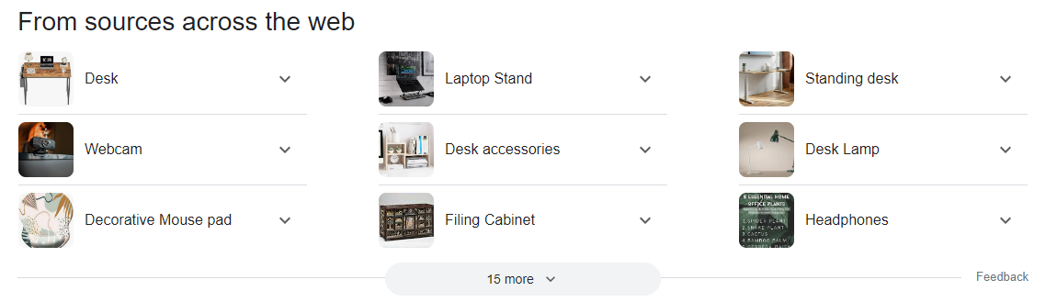
- Above: Collated Google search

- List from various work-related, and recruitment searches:

  - Appropriate Lighting
  - Power Strip / Plug Strip
  - Note pad / paper
  - Writing Utensils
  - Desktop Organiser(s)
  - Calendar / Planner
  - Second Monitor
  - Mouse and Mousepad
  - Phone Stand / Charger
  - Cables, Cable Clips / Tidies
  - Clock
  - Speakers
  - External Hard Drives / USBs
  - Water Bottle holder / Coaster
  - Plants
  - Photo Frames / Motivational Decorations

APPENDIX 02

Pairwise Comparison analysis results.

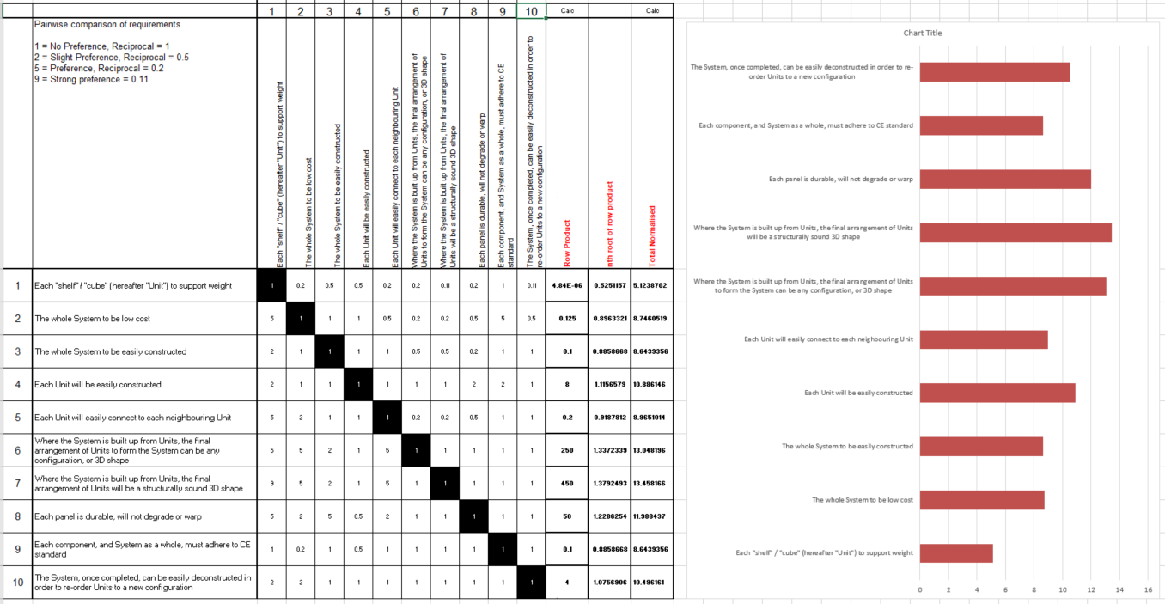

Values in detail:
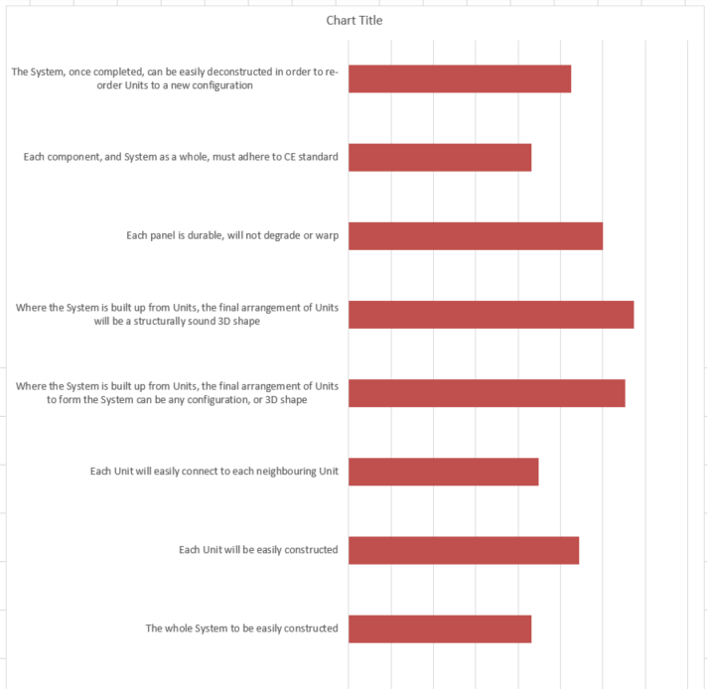
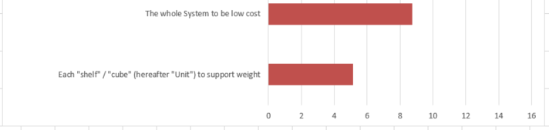

APPENDIX 03

Design QFD1 results.

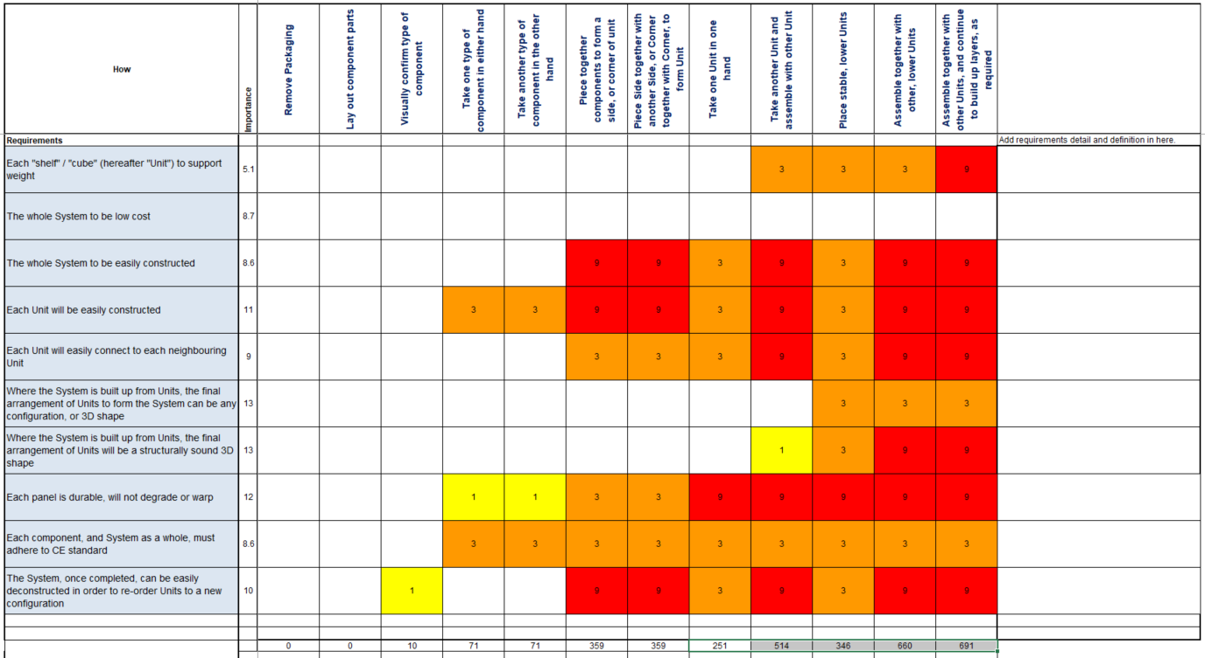

APPENDIX 04

QFD Functional Importance results.

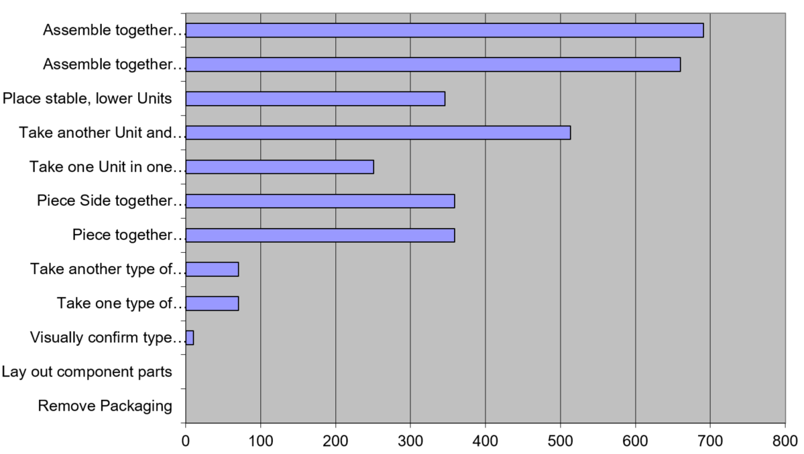

REFERENCES

[1] CE Markings - CE marking - GOV.UK (www.gov.uk)

[2] SHE 2.0 Fundamentals of Systems Engineering - SEH 2.0 Fundamentals of Systems Engineering - NASA

[3] Building Tall - Building Tall | The Franklin Institute (fi.edu)
[4] How Ikea Took Over The World – Readers Digest - How Ikea took over the world - Reader's Digest (readersdigest.co.uk)

BIBLIOGRAPHY

Pugh Charts Jason Forsyth - Pugh Charts (youtube.com)

  - 40 Work-From-Home Office Essentials To Set Up Your Workspace | Indeed.com

  - Instructions Challenge PB&J Classroom Friendly | Josh Darnit - Exact Instructions Challenge PB&J Classroom Friendly | Josh Darnit (youtube.com)

  - Home Office Setup Guide (2023): Webcams, Desks, Chairs, and More | WIRED

  - FMEA (Failure Modes and Effects Analysis) (cam.ac.uk)

