Mock interview

Student name: Ricardo Alexandre
Student number:2025546

Module Code: BMSW4005
Module: Professional Career Development
Assignment Title: Portfolio of work

Lecturer`s name: Dr Charles Nimoh
February 23rd, 2022

Job advertisement
Warehouse Operative (Rotating shifts)
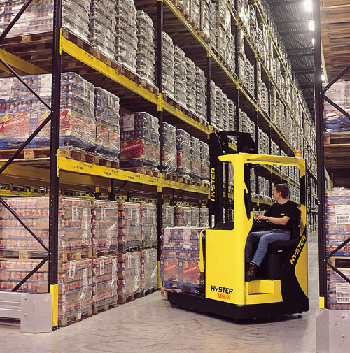
This is the job description for Forklift RT Recruitment:
- Reach truck drivers
- 957 reviews
- Strafford
We have a permanent job opening in Staffordshire for a Warehouse Operative paying between £9.75 and £14.63.
Start immediately - Inductions are held four times a week, so you can get started right away!
- 40 hours of compensation per week (paid break).
Our day shifts rotate
- Every day from 6am to 14pm, and from 14pm to 22pm.
- In the evenings, shifts alternate between 06.00-14.00 and 14.00- 22.00.
- The number of weekends a worker can take for 14 weeks if he works 5 out of 7 days.

Earnings include:
- Hourly pay for regular hours: £9.75.
- Hourly pay for overtime hours: £14.63.
ON TOP OF THE BASE RATE AND OVERTIME RATE, PREMIUMS ARE GUARANTEED.
Benefits:
- Forklift RT's network of agents are aided, and available 24/7,
- You do not need previous experience.
- Training is provided to all employees.
- Weekly pay stubs / Online pay stub portal.
- Free on-site parking and secure bike storage.
The following departments are also included:
- Cages are selected using LLOP and an RDT device when items arrive.
- Stacking pallets and carrying cages occur when products arrive.
- Goods that go into waste management.
- In the main section electronic RDT device, picking manually to trolleys / totes is done.
- Using an electronic RDT device to pick up LLOP from cages.
- Pallets and cages must be unloaded and loaded when goods are received.
- Taking goods in and removing waste
- Using an electronic RDT device is the main department for picking manually to trolleys and totes.
CLICK HERE TO APPLY NOW!
The firm is acting as an employment agency as regards the position at hand.
Recruitment of Forklift or Reach Truck.
Last week
This is the first step.
Post a job opportunity.

Cover letter

Ricardo Alexandre
28 Woodstock Road, Stafford, ST17 0BU (United Kingdom)
+447955210907
2025546@student.uwtsd.ac.uk

Dear Madame/ Sir,

I am writing to apply for the Reach Truck Driver job you have available. I have attached my resume. With over ten years of experience as a truck driver, who has driven a reach truck for stacking and unloading warehouse goods while adhering to regulations and safety rules, I have the education and training to perform this task. During my time working at Reach Truck, I have experience accepting shipments, unloading boxes and cartons, moving things around, and putting things back while collaborating with peers and supervisors to increase productivity.

Considering my previous experiences, I am confident I can adhere to storage criteria and objectives, update inventory, and maintain a clean and safe working environment.

With more than 2 years of experience as a Wincanton Logistic Certified Reach Truck driver, I succeed at moving heavy cargo safely and efficiently with lift trucks, integrating purchases into existing stock, teaching work colleagues inventory management procedures, and logging everyday tasks for evaluation by managers. Communicates effectively, organizes well, and manages time effectively. My leadership and collaborative skills have earned me a solid reputation. With my demonstrated expertise in trucking and warehouse operations, as well as my strong prioritising and issue handling abilities, I would significantly contribute to the success of your company.
Reading this is greatly appreciated by the reader. Hopefully we'll be able to talk soon.

Best regards,
Yours faithfully,

Ricardo Alexandre.

Curriculum vitae
Ricardo Alexandre
- 28 Woodstock Road, Stafford, ST17 0BU (United Kingdom)
+447955210907
ricardoalexandregdv@gmail.com
Sex Male Nationality Portuguese
Profile
I had worked for a large corporation, and I am highly motivated, well-travelled, and creative. Taking on new challenges and trying new things excites me.
Education
September 2017–April 2021
- GCSE Mathematics at TCAT Telford College (United Kingdom).
September 2019–2022
- English level 2 at TCAT Telford college, Telford (United Kingdom)
March 2000–September 2000
- Level 3 - Navy School, Lisbon (Portugal)
- Technical Course Cook Level 2 Group No. 1 is in Lisbon (Portugal).
- Food Hygiene Technology, and Culinary Science.
August 2007–September 2009
- (Portugal), Wall Street Institute, Leiria,
- English Language Upper Waystage 3.
February 2001-June 2006
- Secondary high school students.
- IT programming Level 3
- High school, Lisbon (Portugal).
- Multidisciplinary fields include Information Systems, Programming, Multimedia Systems, Mathematics, English, and Portuguese.
Work Experience
March 2000 until present
- Wincanton Warehouse Logistic in Stafford.
- Team member: Picking.
- Operating MHE including LLOP, vehicles. Picking and packing of customer orders.
- Driver Reach truck.

August 2015–January 2020
- Sous Chef
- Coal Grill & Bar, Telford (United Kingdom).
- Make pizza, salads, and pastas.
- Check stock.
Heathy & Safety certificate level 2
May 1999–November 2008
- Chef.
- Portuguese Air Force base in Lisbon (Portugal).
- Preparation and cooking.
Business or sector Military.
Personal Skills
- Communication skills.
- Worked hard as a team, be honest, be creative, and be helpful.
- Organisational / managerial skills.
- Organisations can work under pressure.
- Digital skills.
- Office 365.
Other skills
- Sports are something I was enjoyed whenever possible, as well as rollerblading on the beach.
- Hobbies are dancing, swimming, and playing football.
Driving Licence
Categories: AM, A1, A, B1, B
References
- Recruitment Department | Wincanton for Screwfix DC1, Prologis Park Shackleton Way Stafford Staffordshire ST16 1GY
Ashley Moore
Ashley.Moore@wincanton.co.uk
- Personnel Assistant HR
Samantha Wright
Screwfix.Stafford.HR@wincanton.co.uk | Contact: 01785 275800

