3/24/2025
E-Portfolio Link: https://learning-in-the-digital-era.my.canva.site/

University of Wales Trinity Saint David
London campus
Module Name: Learning In the Digital Era
Module Code: ACCA 4025

Student Name: Cinthya Vera Mendoza
Student ID: 2528123
Group: 1

Lecturer’s Name: Koushik Modak

LDE Assignment 1
E-Portfolio
Table of Contents
Introduction 2
Main Body 3
Task 1: Essential Academic and Employment Skills for the Future Career Path 3
Task 1 (a): Report on Essential Academic and Employment Skills 3
Task 1 (b): Evaluation of Task 1 (a) based on Similarity report 6
Task 2: Collaborative Mind Map and Individual Poster 7
Mind Map (Collaborative) 7
Task 3: Virtual Collaboration and RefWorks 9
Report on Virtual Collaboration 9
Step-by-step process of using RefWorks with visuals 11
Task 4: E-Portfolio Creation and Evaluation 17
Task 4 (a): E-Portfolio Creation 17
Task 4 (b): Illustrative Review of E-Portfolio Tool Selection 27
Conclusion 28
Task 1 References: 29
Bibliography 29

Introduction

In this module, Learning in the Digital Era we can see how technology has advanced and how it has had an important growth in modern education.
Through technology, we explore distance learning teamwork, the use of digital tools and innovative educational strategies.
In this module we have four tasks. Firstly, in task 1 we use IEEE Refences and work collaboratively in teams. In task 2 one activity is creating a mind map and a poster. Task 3 is about how to use RefWorks for automatic references, and task 4 is about creating an e-portfolio.
The practice of knowledge and learning methods helps the development of different learning styles and the application of skills and knowledge.
Nowadays, we learn in this way in the present era of digitalisation, which is also known as the computer era.
We can see the importance of digital technology and how it is integrated into modern education. How it support students in their academic development as well as in their professional lives.

Main Body

Task 1: Essential Academic and Employment Skills for the Future Career Path

Task 1 (a): Report on Essential Academic and Employment Skills
The essential academic and employment skills is fundamental for students and most for who studying computing in the digital era. Academic skills are the basis for meaningful and lifelong learning [1].

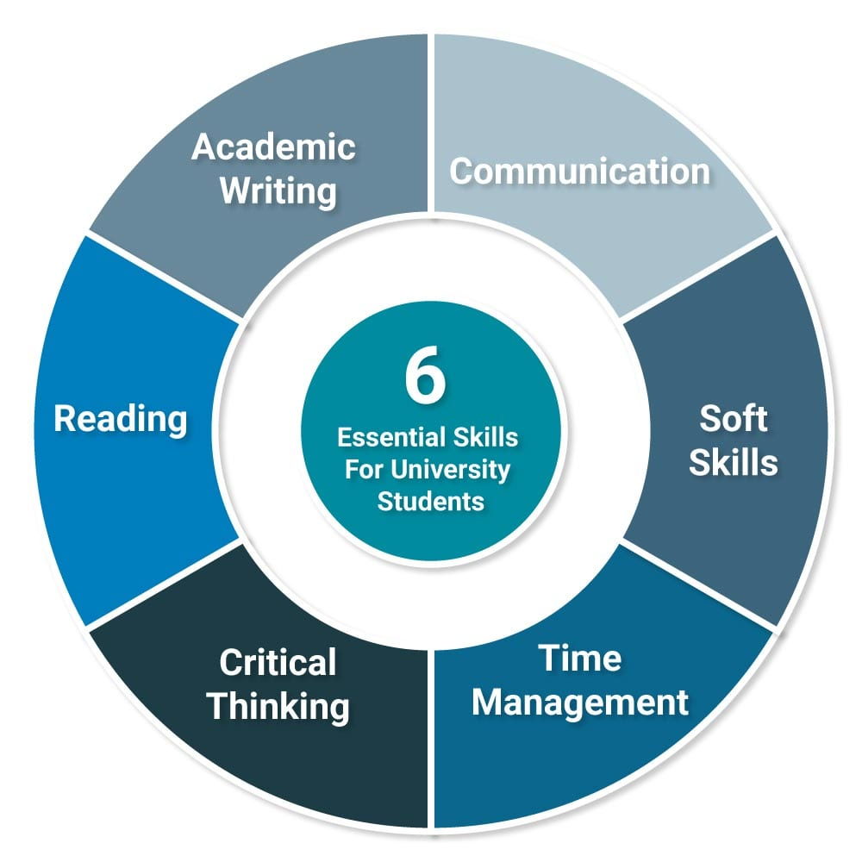
Figure 1 Essential skills [2]

For education and working world, learning is essential in order to developed certain skills. Many years ago, education was abandoned because of different circumstances, and many people could not study. Because of this, over time it became very difficult to find work or get a job [3].

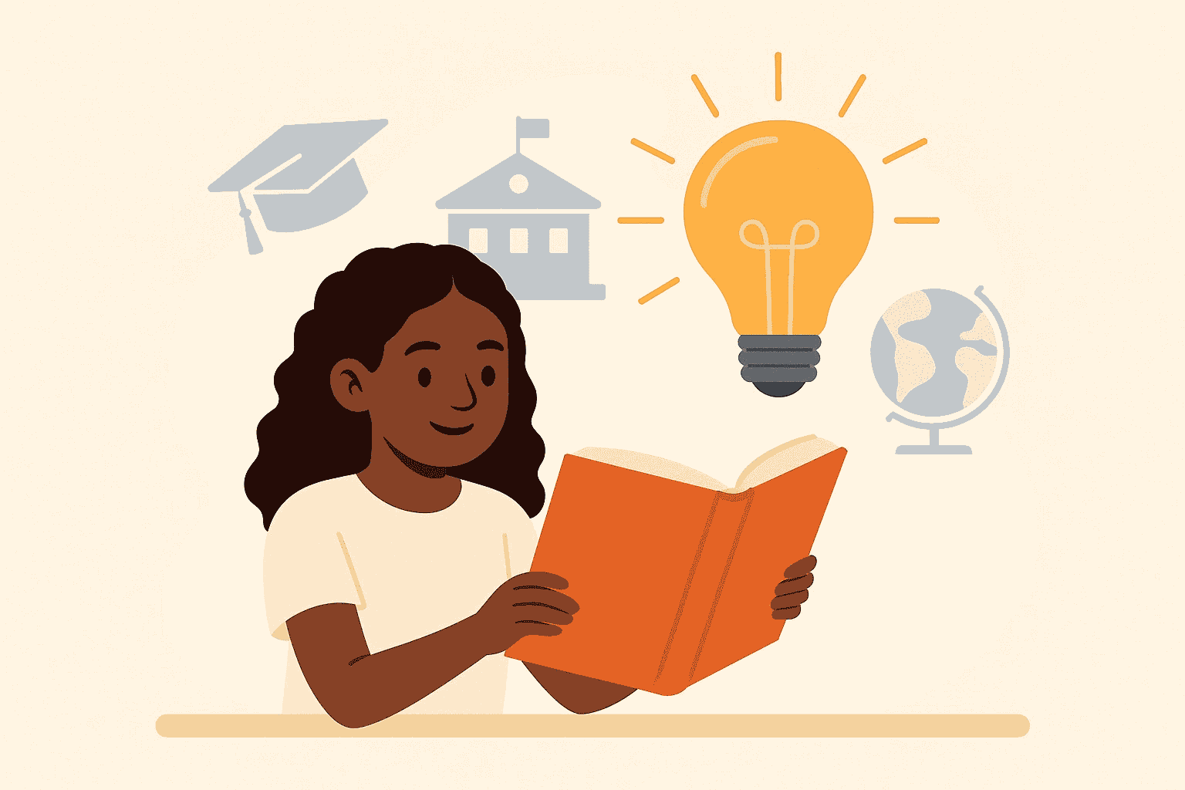
Figure 2 Education [4]

Higher education has changed radically over the last decade and still of process of change. For that reason, nowadays many older people have returned to studying to develop skills and be able to find better jobs [5].
Skills can take many different forms, there are skills are task- based, such reading a map, and others thar are behavioural, like calming someone down. Some are related to coordination, such as typing, while others have to do with thinking [6].
It can be said that there are “hard” and “soft”. Hard skills are technical in nature, and soft skills are for discussion and leadership.

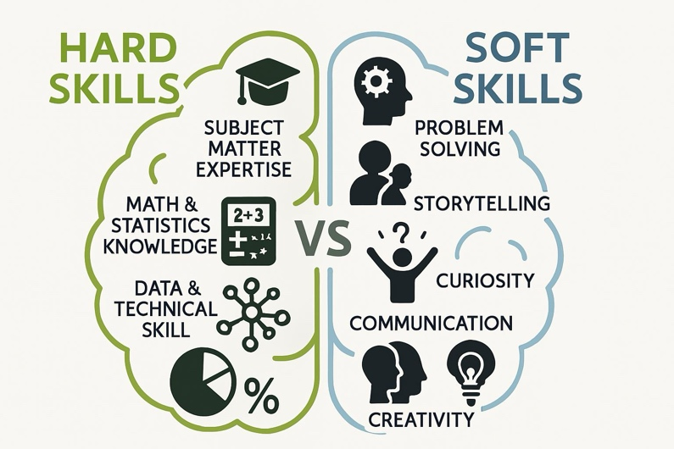
Figure 3 Hard and Soft Skills [7]

Academic skills are the ones we need to study and organise ourselves so we can keep order in our educational tasks, for example: organising ideas, taking notes, understanding texts, and lastly writing our report.

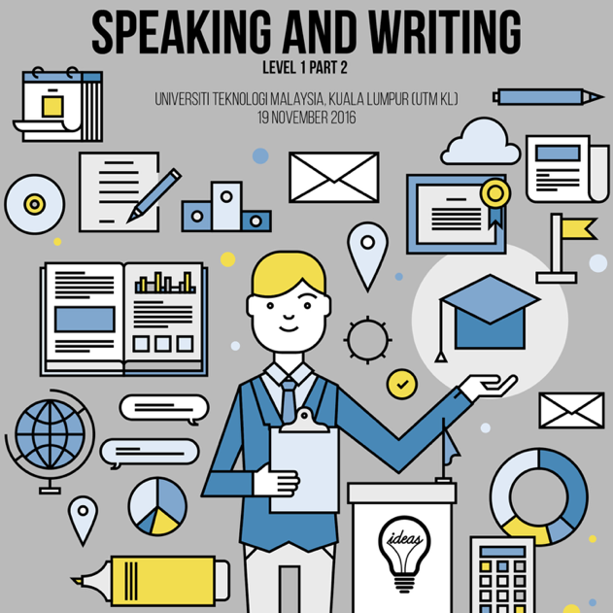
Figure 4 Employability Skills [8]

For the working world it is also very important to develop skills that employers look for any job: knowing how to work in a team, speaking and writing clearly, finding solutions to problems, adapting if there are changes, being responsible, and the most important thing is having good communication with people [9].
Employability skills are those skills necessary for getting, keeping, and doing well on a job [10].
In conclusion, both are important and every person should apply them in their life, both for the student world and working world.

Task 1 (b): Evaluation of Task 1 (a) based on Similarity report

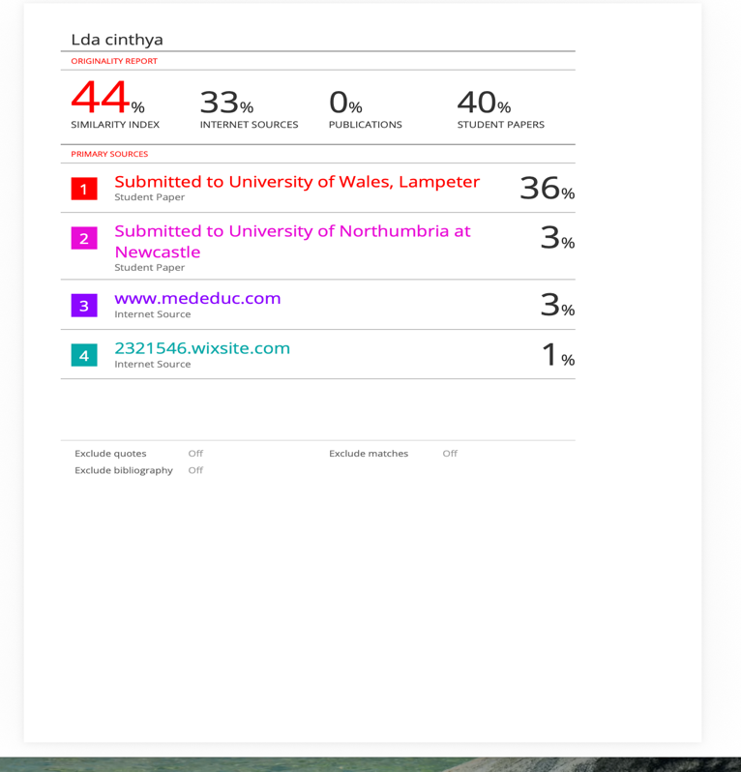
Figure 5 similarity check
I obtained 44% in the similarity check. I copied one sentence exactly as I found it in book because it seemed very coherent to me and I could not find a way to express the same idea in my own words at that moment. I think this happened because I am still learning how to organise my ideas and write more independently.
However, now I understand better how similarity works, and I am learning to structure my work more carefully, for my future assignment, I want to improve my writing, use my own word more and achieve better results.
I would give myself 80 out of 100 marks. Because I believe I have made a good effort and I have completed the task to the best pf my ability at this stage. I am returning of education after many years; I believe that with the time I will improve and be able to develop my ideas better and express myself more confidently in writing. I also I feel happy with that achieved and proud of my progress, but also, I recognise that there is still room for improvement.

Task 2: Collaborative Mind Map and Individual Poster

Mind Map (Collaborative)
Mind Map link: https://mm.tt/map/3952545938?t=fzeTCzFAHg
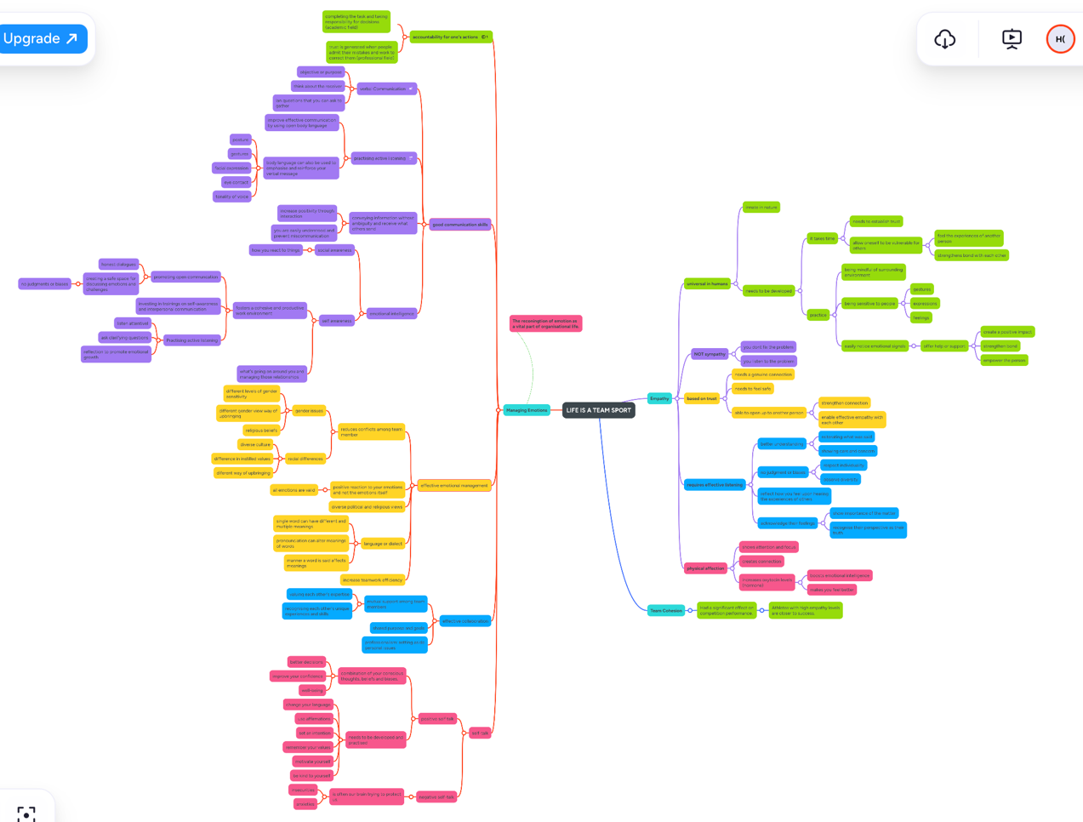

Figure 6 Mind Map

Poster Link: https://www.canva.com/design/DAHDFNmKQt8/FprtfGuW0z8LxwNg7DhV_g/edit?utm_content=DAHDFNmKQt8&utm_campaign=designshare&utm_medium=link2&utm_source=sharebutton
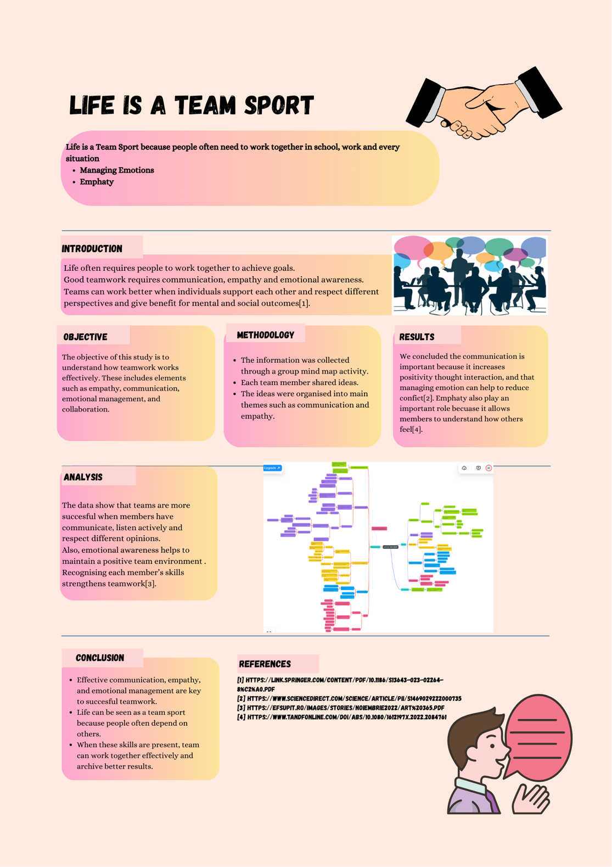
Figure 7 Poster

Task 3: Virtual Collaboration and RefWorks

Report on Virtual Collaboration
Unit 3: Topic 2
Riding the Storm
Technology has transformed digital communication into a central element in virtual teams. Its shows different differences between them such as trust, performance, cultural differences, knowledge management and team management.
Because virtual teams are geographically dispersed, they face additional challenges compared to teams that work face-to-face. Trust is vital to reduce both interpersonal and task conflicts [1].
During the COVID-19 pandemic, digital communication became the main tool for many projects.
When communication and the team processes are carried out correctly or incorrectly, they can create a positive or negative basis for social interaction, which can either facilitate or make future interactions within the group more difficult.
In this type of dynamic, moderators and mediators are often needed to manage conflicts and interactions.
It is also said that virtuality can reduce a virtual team’s ability to manage knowledge, although some positive results have also been identified. This may seem contradictory because knowledge management is a broad concept that includes several subprocesses such as, knowledge creation, acquisition, exchange or sharing, accumulation and expansion of knowledge[2].
These processes can be influenced in different ways by virtuality and team diversity.
The exchange of knowledge can be strengthened through participative leadership. On the contrary, the accumulation of knowledge in a virtual environment can improve depending on how the team functions.
Nowadays it is very common that most office employees occasionally work in virtual teams. We can find different types of intelligence involved in conflicts in virtual teams, such as cultural intelligence and emotional intelligence.
These influence the appearance of conflicts related to task and processes in global virtual teams. It has been shown that process conflict negatively affects team performance.
Understanding the performance and dynamics of this type of team becomes more important than ever, since conflicts within these teams have often been ignored.
Teams task, the work process within the team, and interpersonal relationship can have major consequences, affecting the performance of the team.
However, not all conflicts in teams have negative effect. In some cases, they can even lead to better and more positive performance[3].
Virtual teams are becoming very common in the IT industry. Virtual teams work well when there is good communication, collaboration, trust between team members, effective leadership and clear objectives[4].

Step-by-step process of using RefWorks with visuals

- Firstly, we open on google RefWorks.

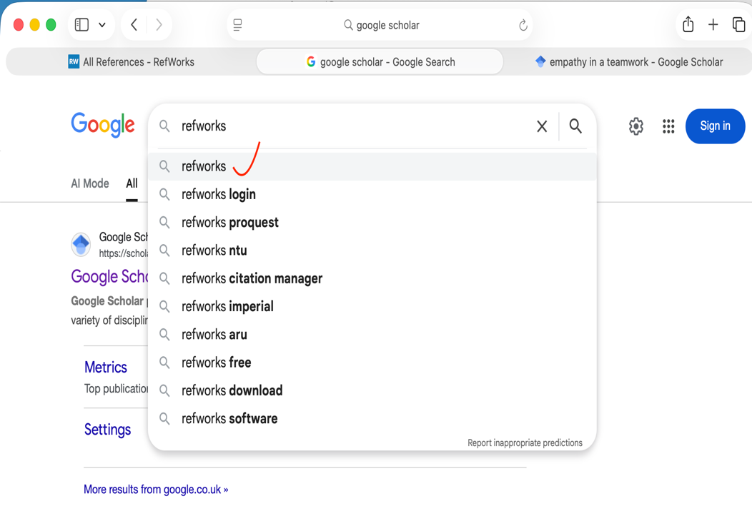
Figure 8

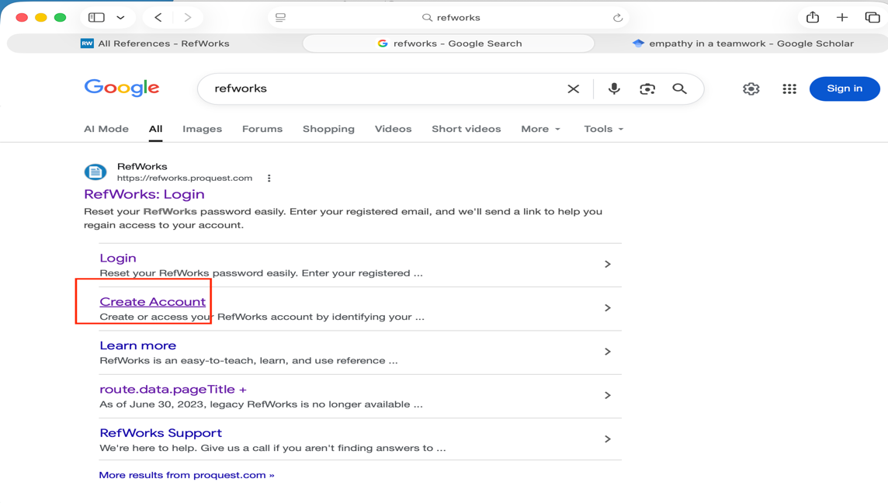
Figure 9

- We create an account in RefWorks using your student email.

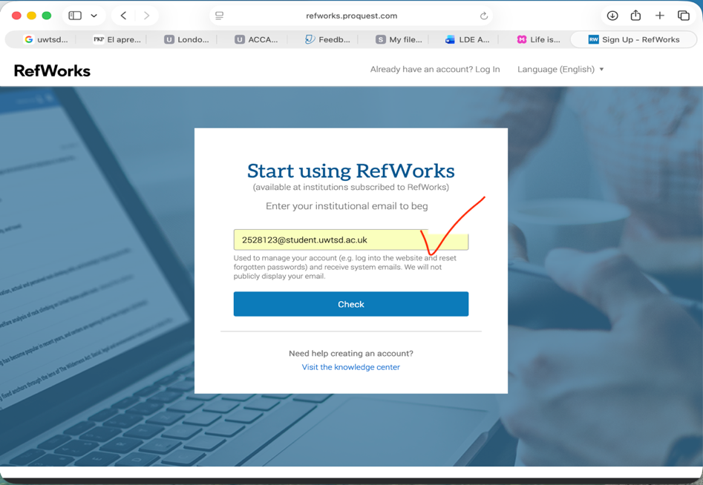
Figure 10

- Created the folder.
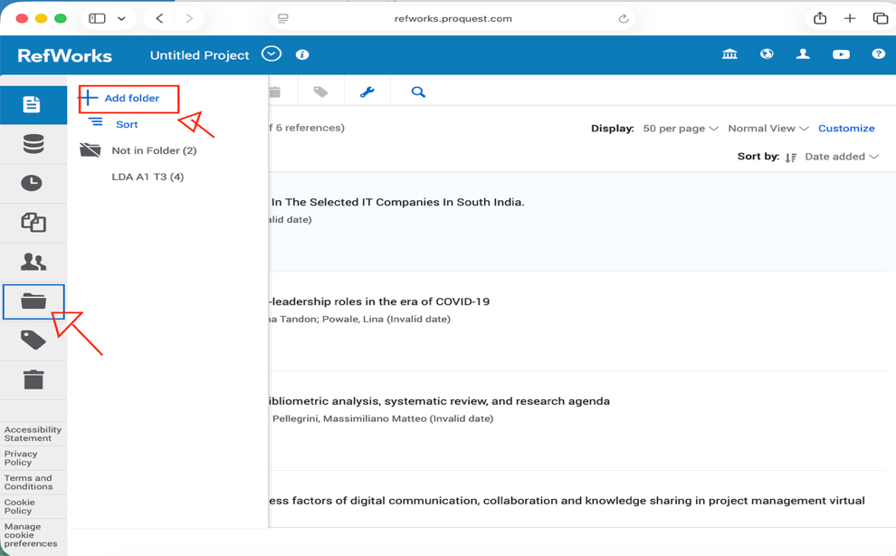
Figure 11

- Then we create a folder and rename it, for example we use LDA A1 T3.

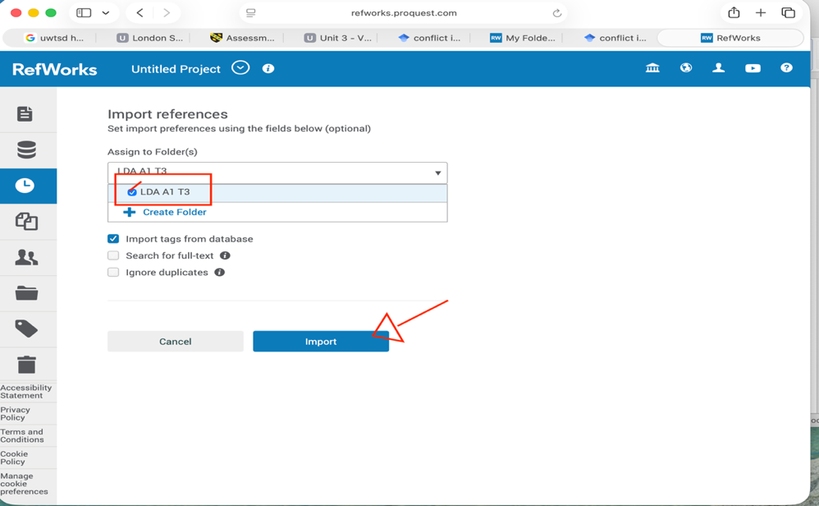
Figure 12

- Next, we open Microsoft Word and connect it with RefWorks.

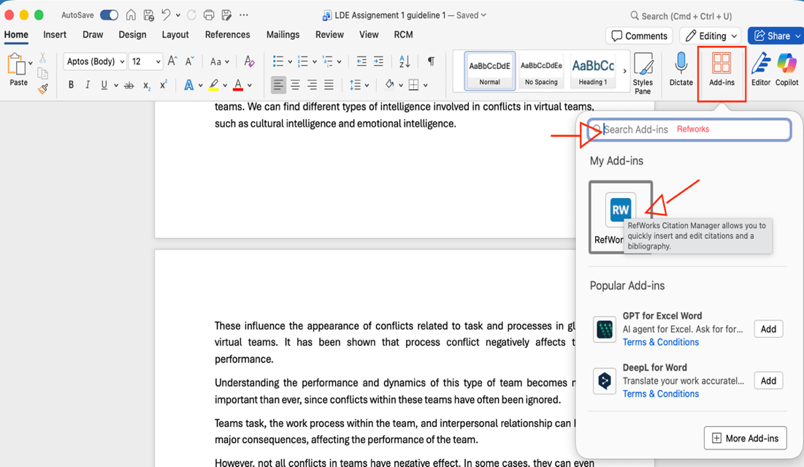
Figure 13

- We selected the citation style IEEE UWTSD. Then, when we inserted the citations into the document and generated the references list automatically.
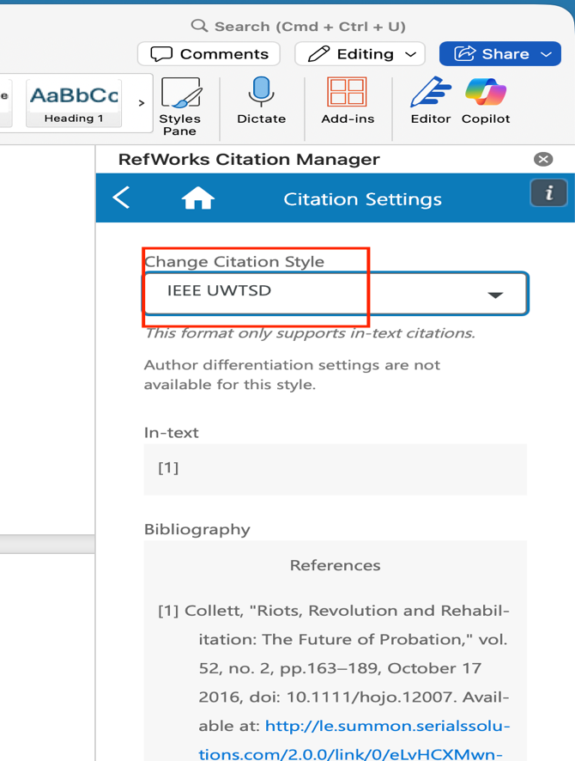
Figure 14
- After that we search on Google Scholar for the topic we want to write about. Then we click on “Cite” and select RefWorks, which take us to the RefWorks page.

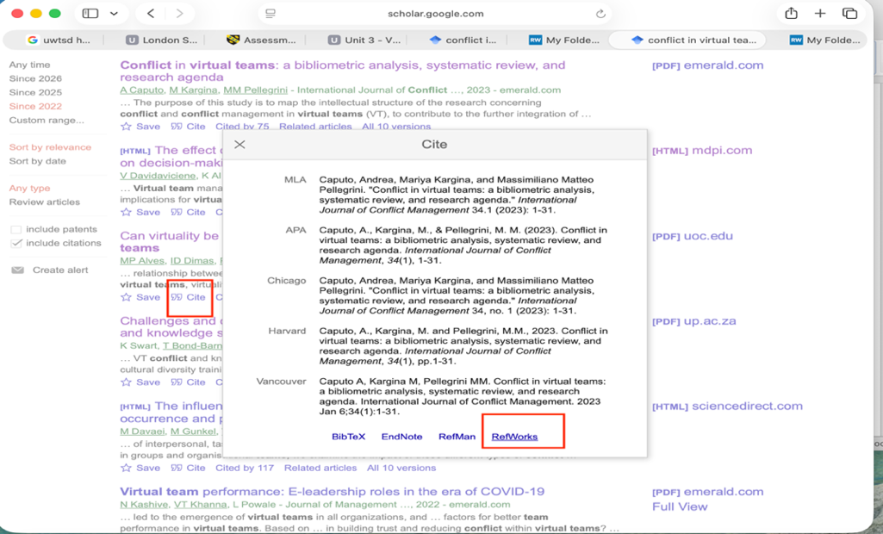
Figure 15

- In RefWorks we assign the reference to the folder we created (for example LDA A1 T3) and click import.

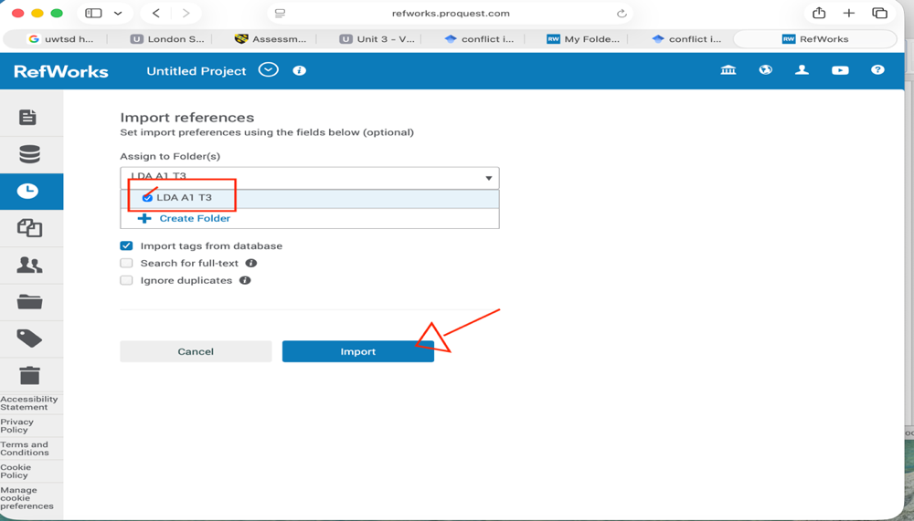
Figure 16

- After that, in Word the references appear automatically. We select the references we want and click Insert Citation. Every time we add a new references we refresh the RefWorks page.

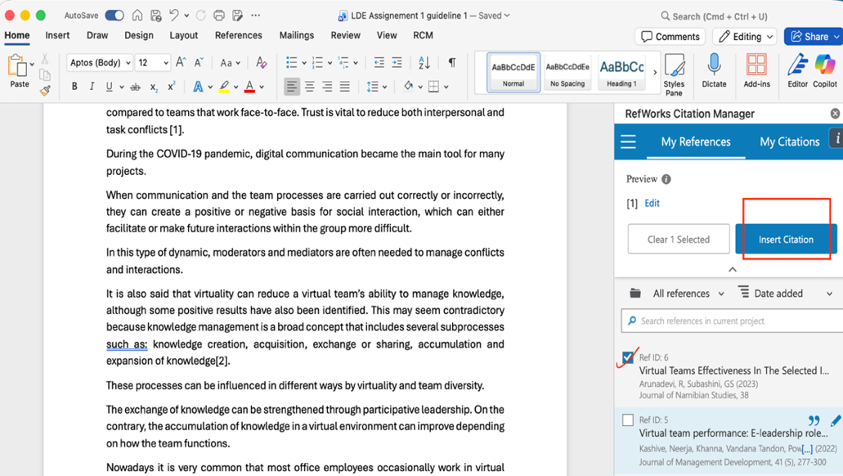
Figure 17

- Finally, to create the bibliography we go to RefWorks, select all the references and click on the quotation mark icon { ’’}then choose Create Bibliography.
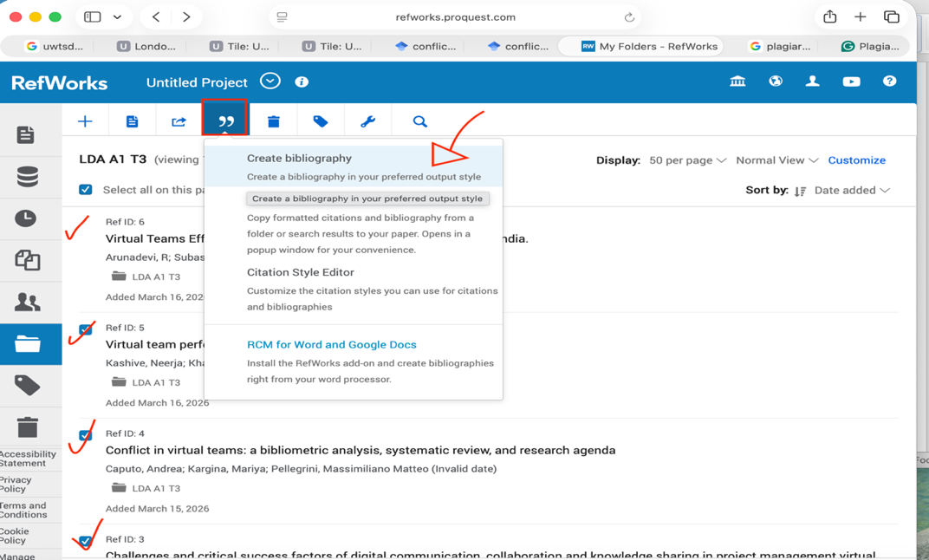
Figure 18

- When the bibliography is created, we simply copy it and paste it into our Word document in the references section and don’t forget select IEEE UWTSD.

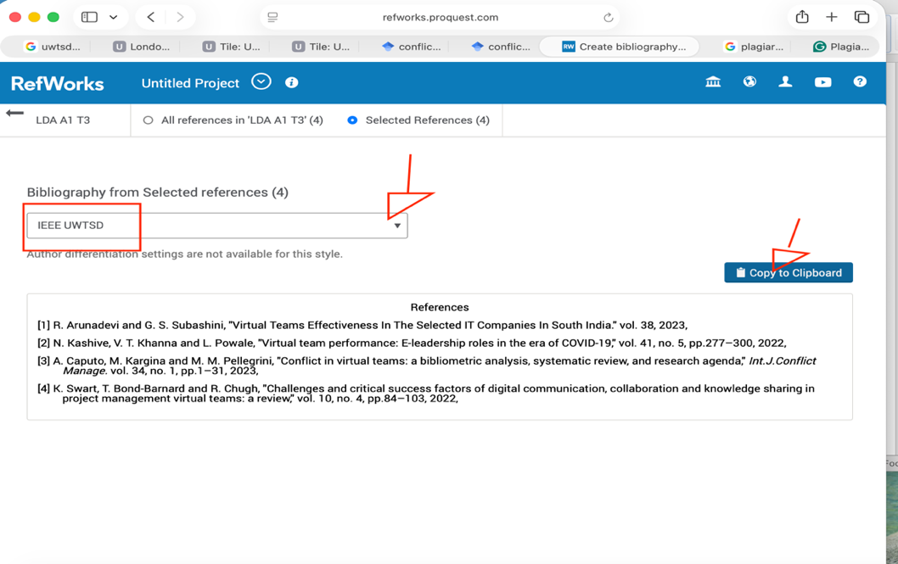
Figure 19

Task 4: E-Portfolio Creation and Evaluation

Task 4 (a): E-Portfolio Creation

In this task I created my e-portfolio using Canva. I designed different pages to present my learning process, including task, reflections, and academic work.
I focused on creating a professional portfolio using warm colours, images, and navigation buttons.

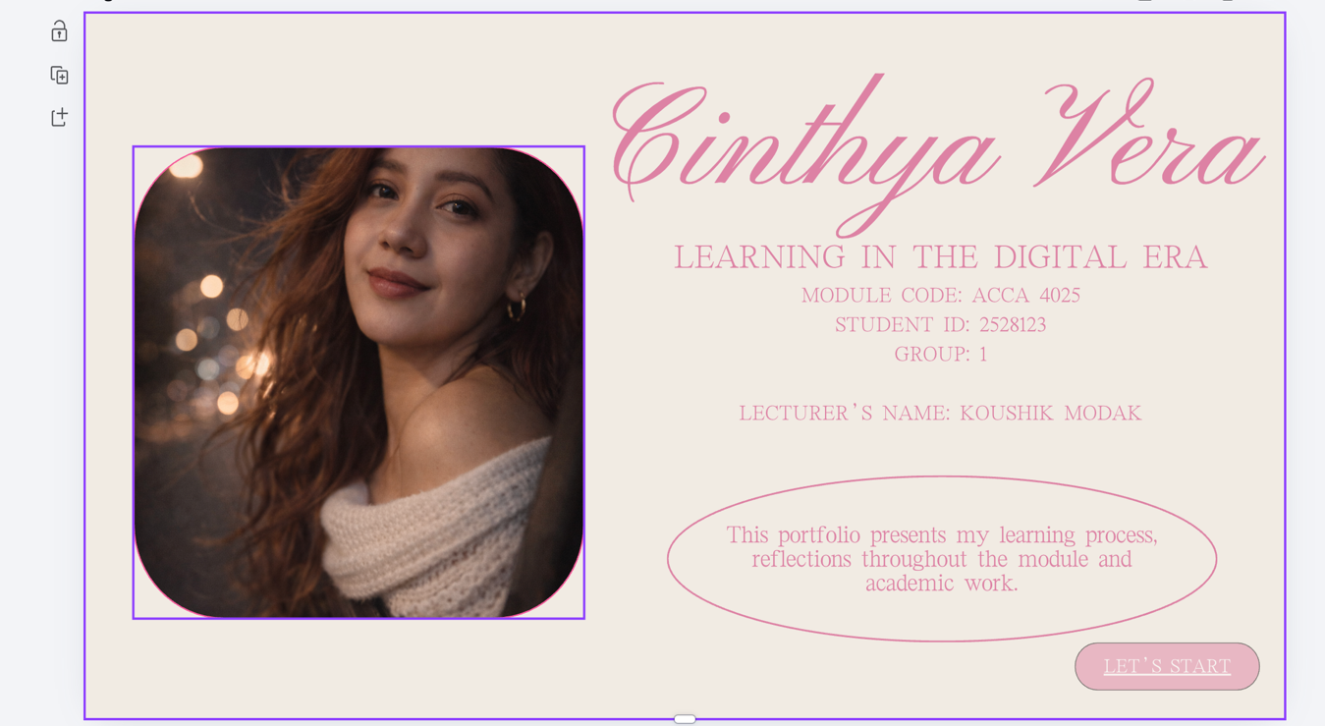

Figure 20
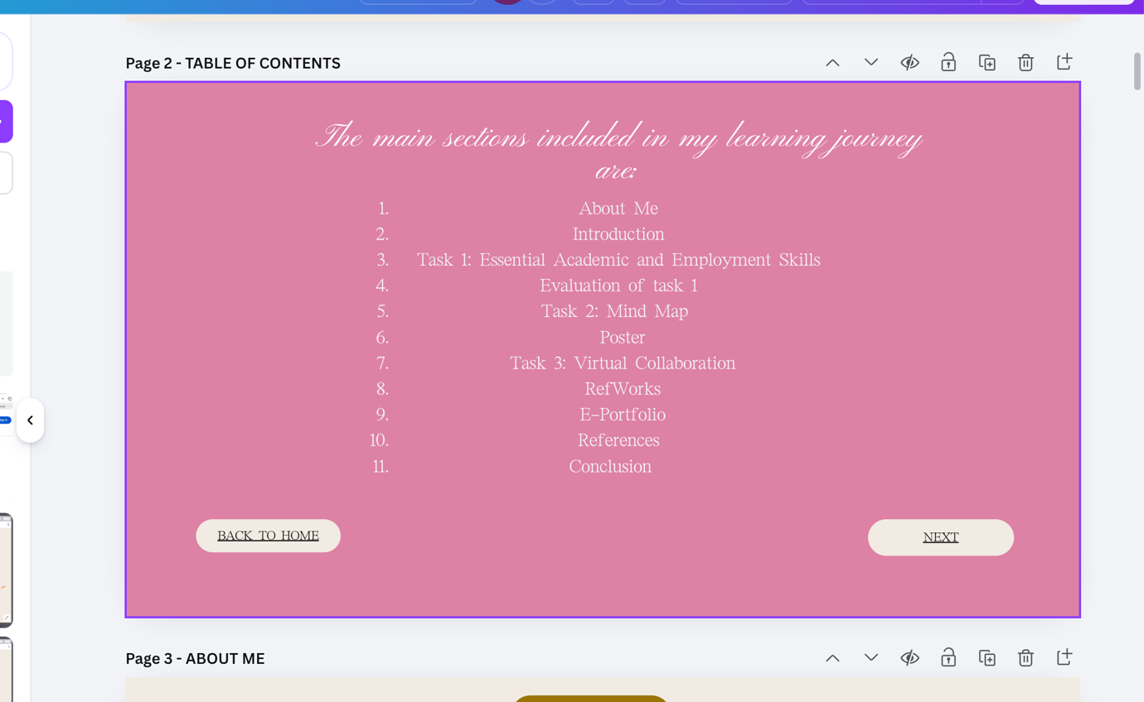
Figure 21

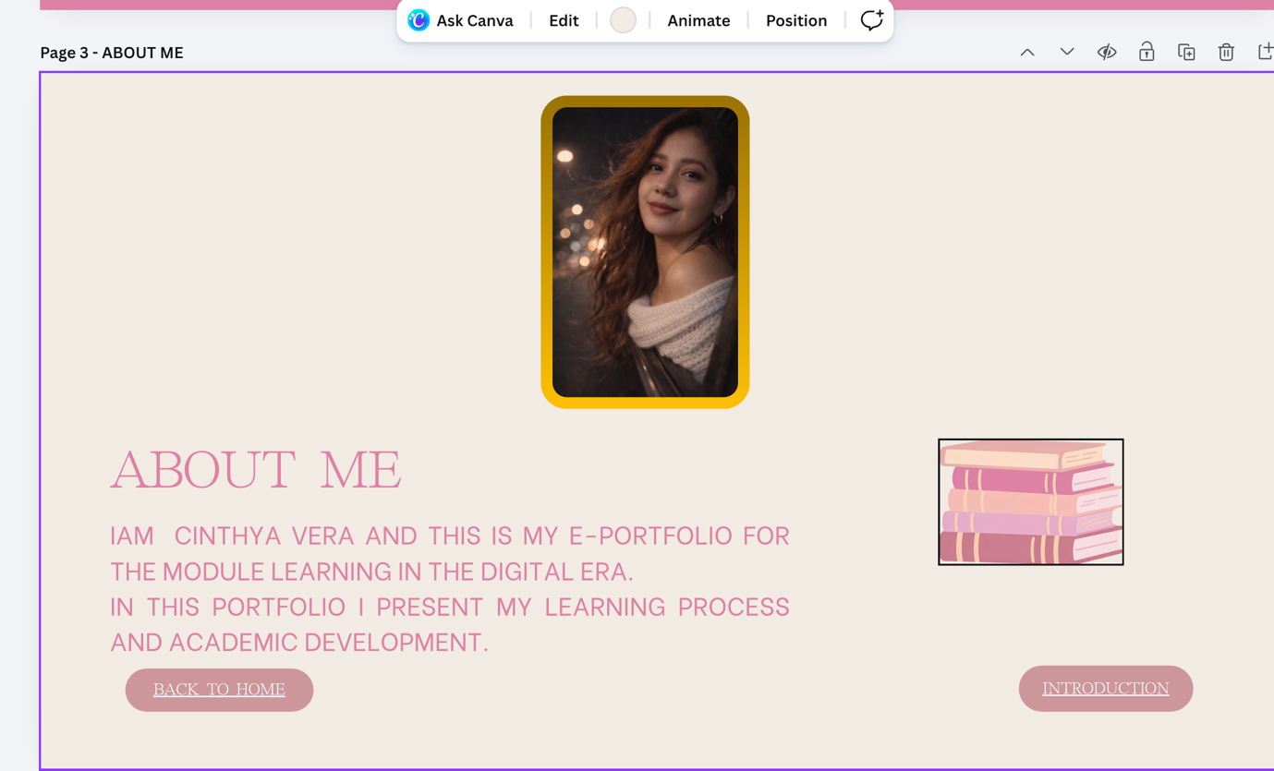
Figure 22

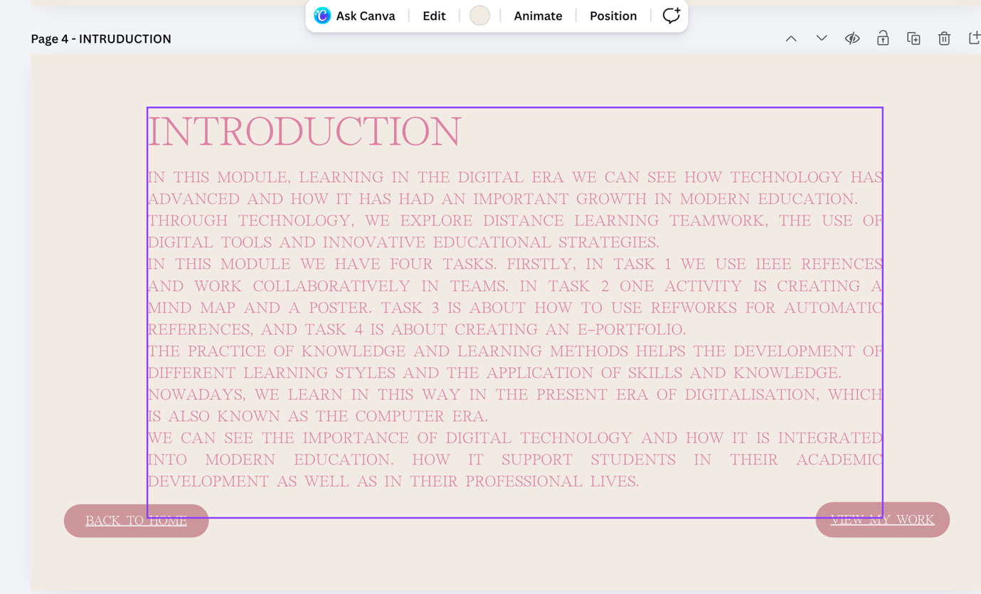
Figure 23

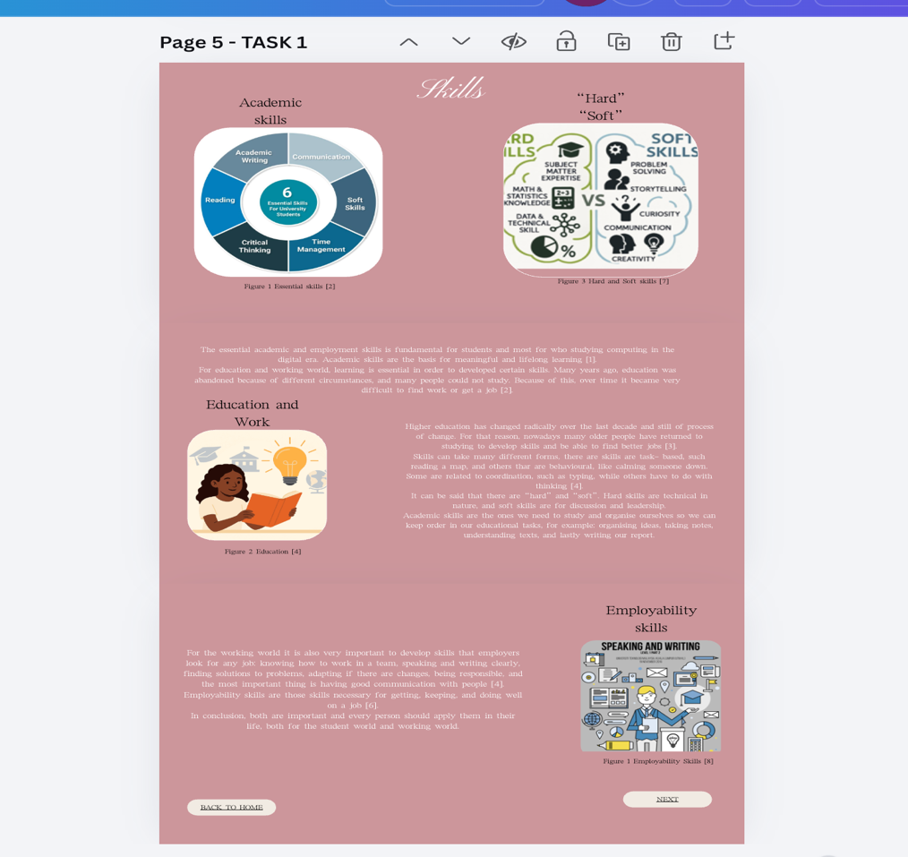
Figure 24
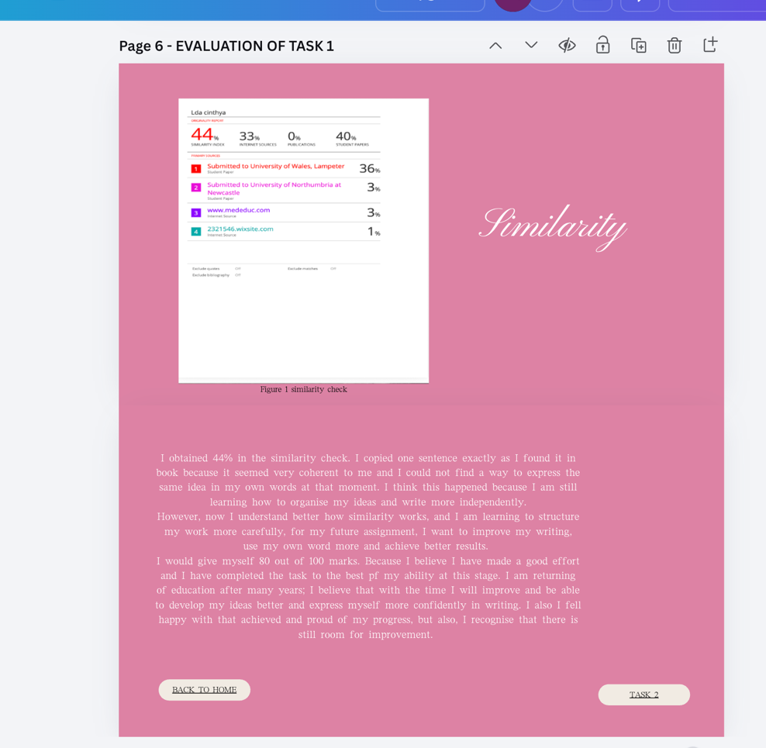
Figure 25
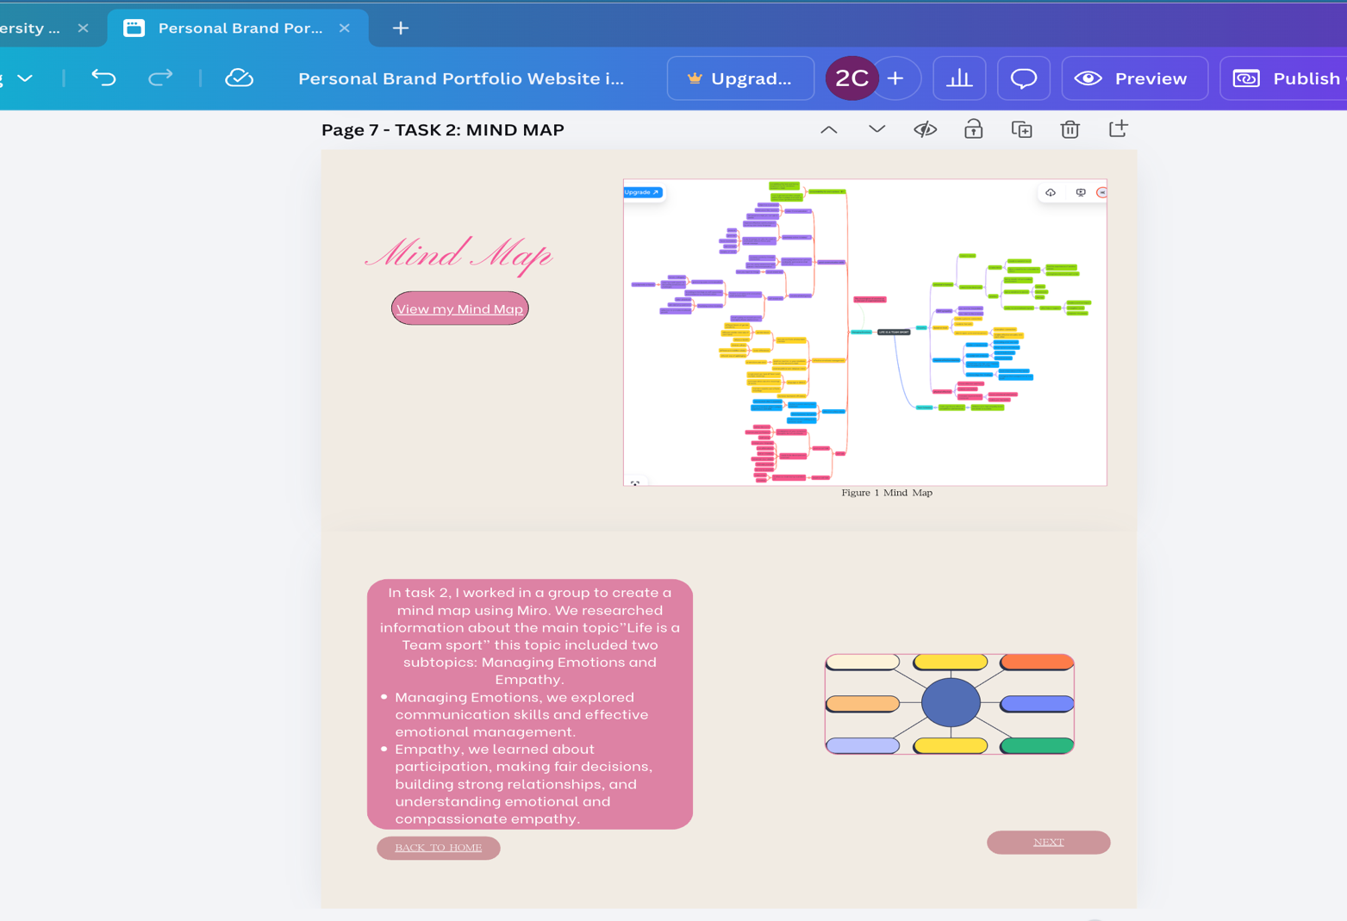
Figure 26

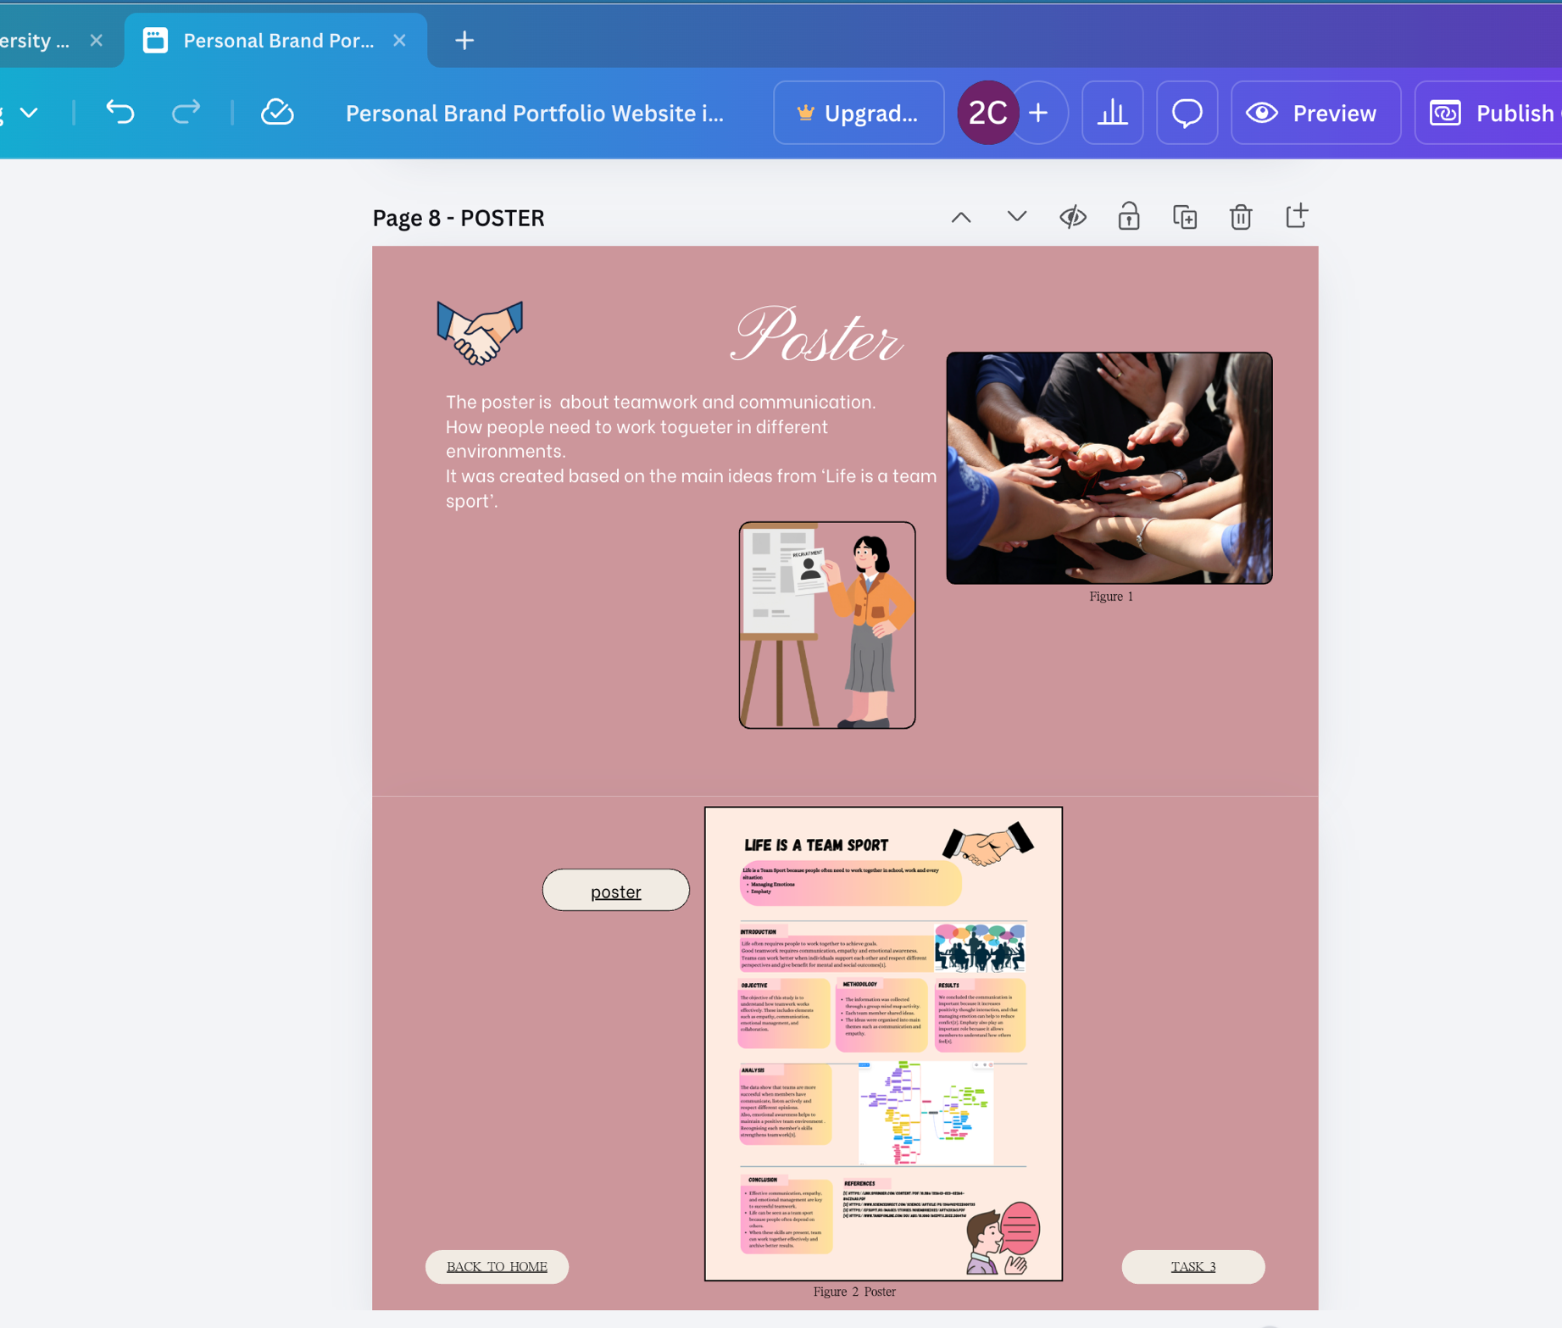
Figure 27

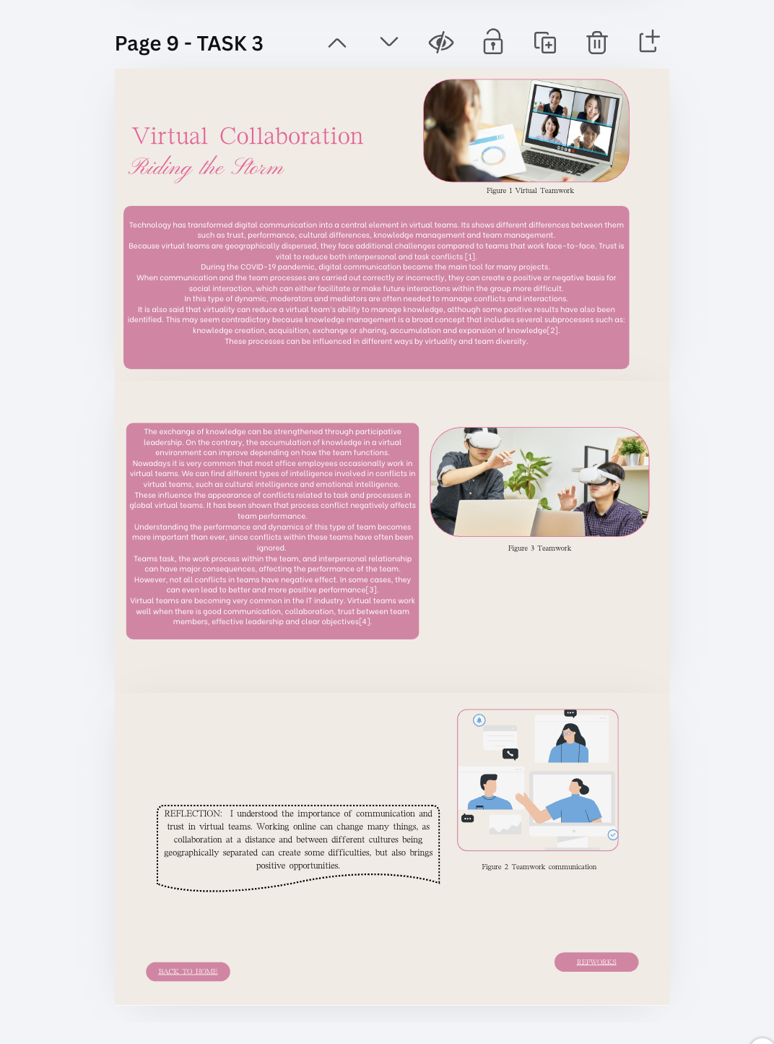
Figure 28

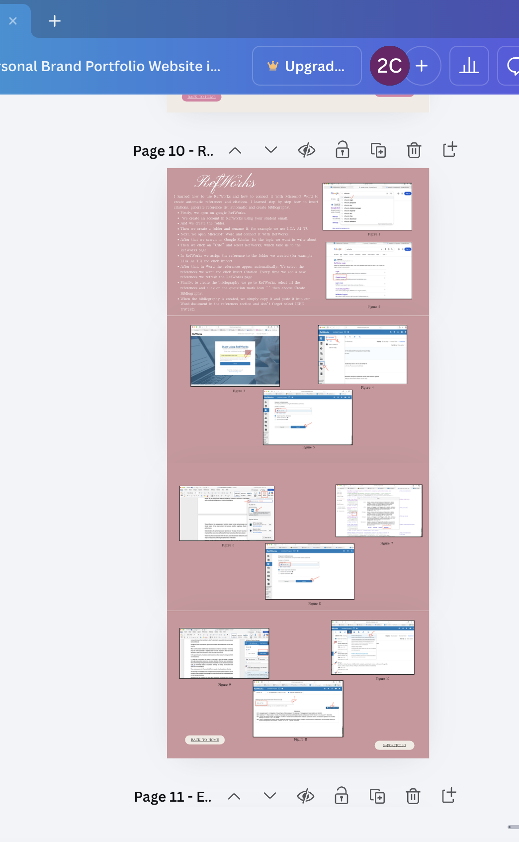
Figure 29

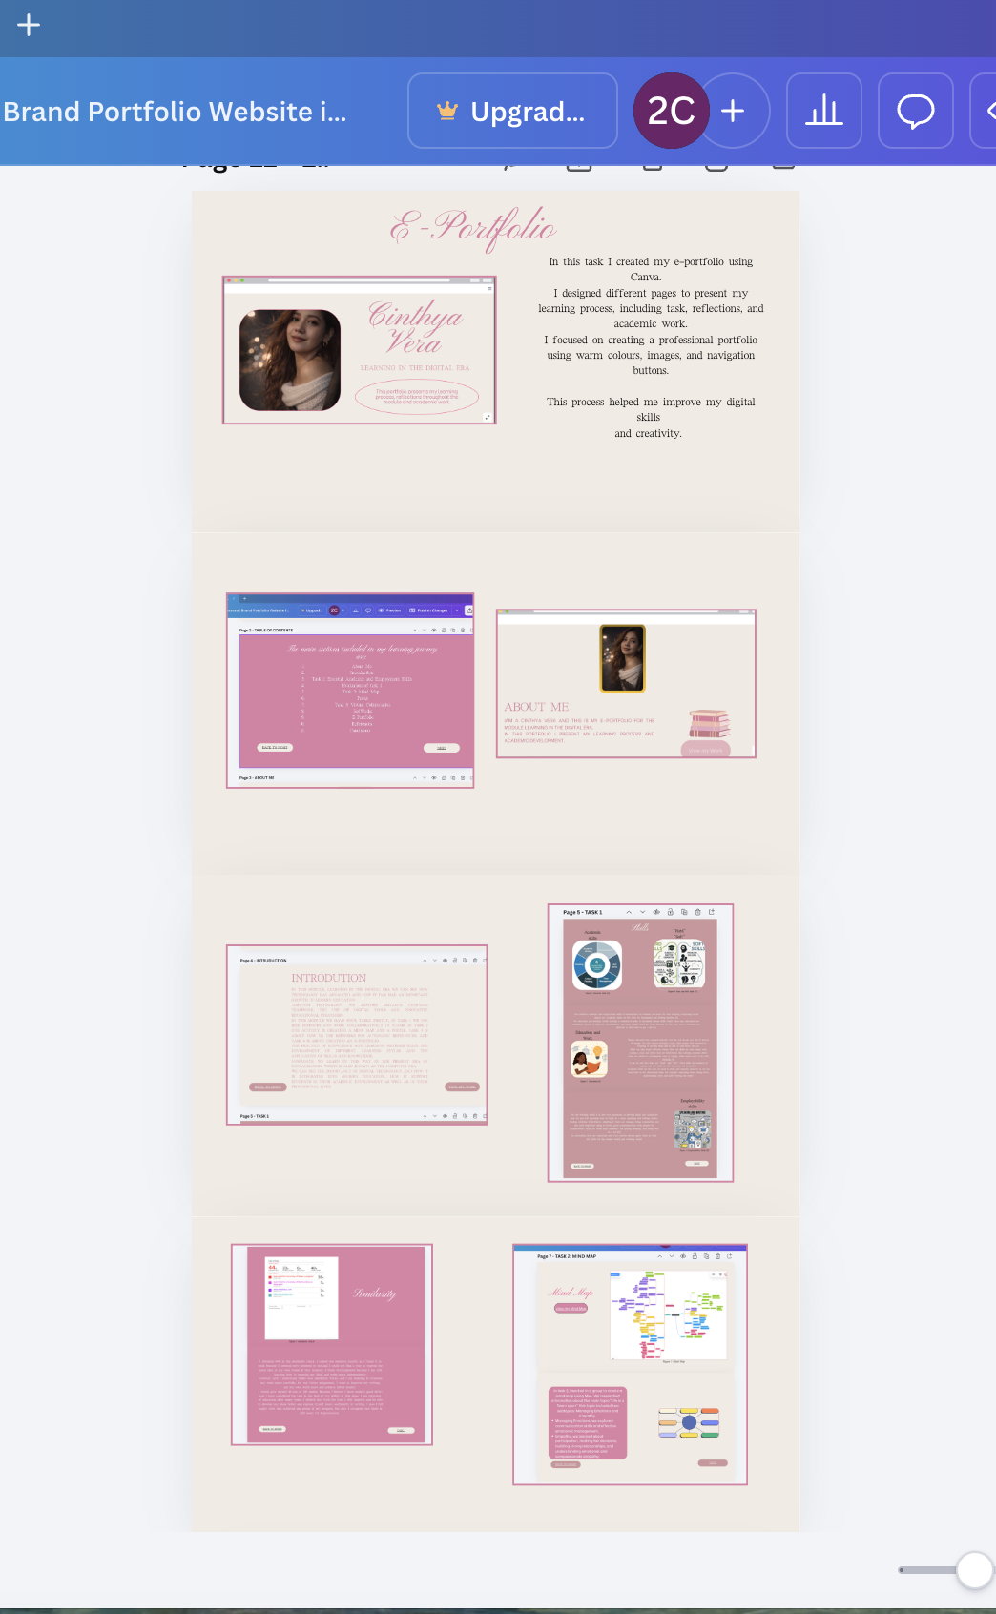
Figure 30

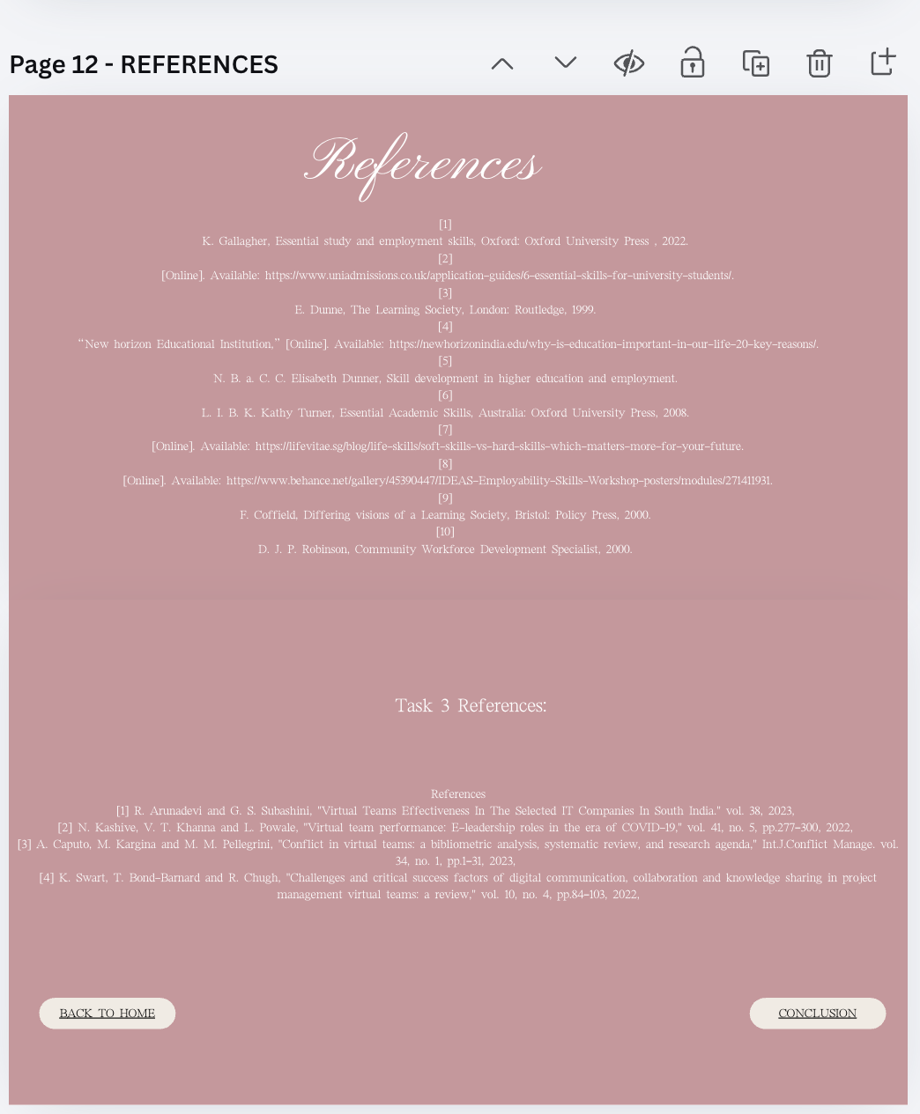
Figure 31

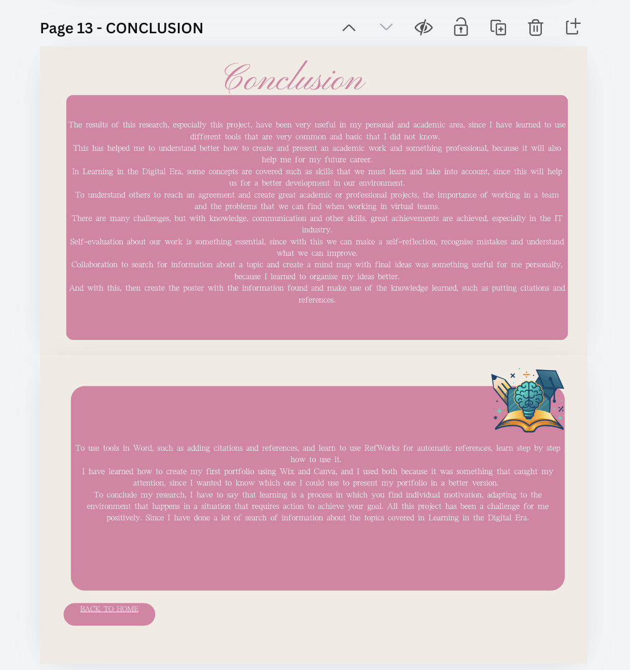
Figure 32

Task 4 (b): Illustrative Review of E-Portfolio Tool Selection
I used Canva because it is a easier to use, and it is a tool that I have used before.
With Canva, I was able to create and design my portfolio quickly. It also allows me to present digital content in an organised and visually attractive way.

Conclusion

The results of this research, especially this project, have been very useful in my personal and academic area, since I have learned to use different tools that are very common and basic that I did not know.
This has helped me to understand better how to create and present an academic work and something professional, because it will also help me for my future career.
In Learning in the Digital Era, some concepts are covered such as skills that we must learn and take into account since this will help us for a better development in our environment.
To understand others to reach an agreement and create great academic or professional projects, the importance of working in a team and the problems that we can find when working in virtual teams.
There are many challenges, but with knowledge, communication and other skills, great achievements are achieved, especially in the IT industry.
Self-evaluation about our work is something essential, since with this we can make a self-reflection, recognise mistakes and understand what we can improve.
Collaboration to search for information about a topic and create a mind map with final ideas was something useful for me personally, because I learned to organise my ideas better.
And with this, then create the poster with the information found and make use of the knowledge learned, such as putting citations and references.
To use tools in Word, such as adding citations and references, and learn to use RefWorks for automatic references, learn step by step how to use it.
I have learned how to create my first portfolio using Wix and Canva, and I used both because it was something that caught my attention, since I wanted to know which one I could use to present my portfolio in a better version.
To conclude my research, I have to say that learning is a process in which you find individual motivation, adapting to the environment that happens in a situation that requires action to achieve your goal. All this project has been a challenge for me positively. Since I have done a lot of search of information about the topics covered in Learning in the Digital Era.

Task 1 References:

Bibliography

[1] | K. Gallagher, Essential study and employment skills, Oxford: Oxford University Press , 2022.
[2] | [Online]. Available: https://www.uniadmissions.co.uk/application-guides/6-essential-skills-for-university-students/.
[3] | E. Dunne, The Learning Society, London: Routledge, 1999.
[4] | “New horizon Educational Institution,” [Online]. Available: https://newhorizonindia.edu/why-is-education-important-in-our-life-20-key-reasons/.
[5] | N. B. a. C. C. Elisabeth Dunner, Skill development in higher education and employment.
[6] | L. I. B. K. Kathy Turner, Essential Academic Skills, Australia: Oxford University Press, 2008.
[7] | [Online]. Available: https://lifevitae.sg/blog/life-skills/soft-skills-vs-hard-skills-which-matters-more-for-your-future.
[8] | [Online]. Available: https://www.behance.net/gallery/45390447/IDEAS-Employability-Skills-Workshop-posters/modules/271411931.
[9] | F. Coffield, Differing visions of a Learning Society, Bristol: Policy Press, 2000.
[10] | D. J. P. Robinson, Community Workforce Development Specialist, 2000.

Task 3 References:
References
[1] R. Arunadevi and G. S. Subashini, "Virtual Teams Effectiveness In The Selected IT Companies In South India." vol. 38, 2023,
[2] N. Kashive, V. T. Khanna and L. Powale, "Virtual team performance: E-leadership roles in the era of COVID-19," vol. 41, no. 5, pp.277–300, 2022,
[3] A. Caputo, M. Kargina and M. M. Pellegrini, "Conflict in virtual teams: a bibliometric analysis, systematic review, and research agenda," Int.J.Conflict Manage. vol. 34, no. 1, pp.1–31, 2023,
[4] K. Swart, T. Bond-Barnard and R. Chugh, "Challenges and critical success factors of digital communication, collaboration and knowledge sharing in project management virtual teams: a review," vol. 10, no. 4, pp.84–103, 2022,

