Lamassu and the Theory of Enchantment
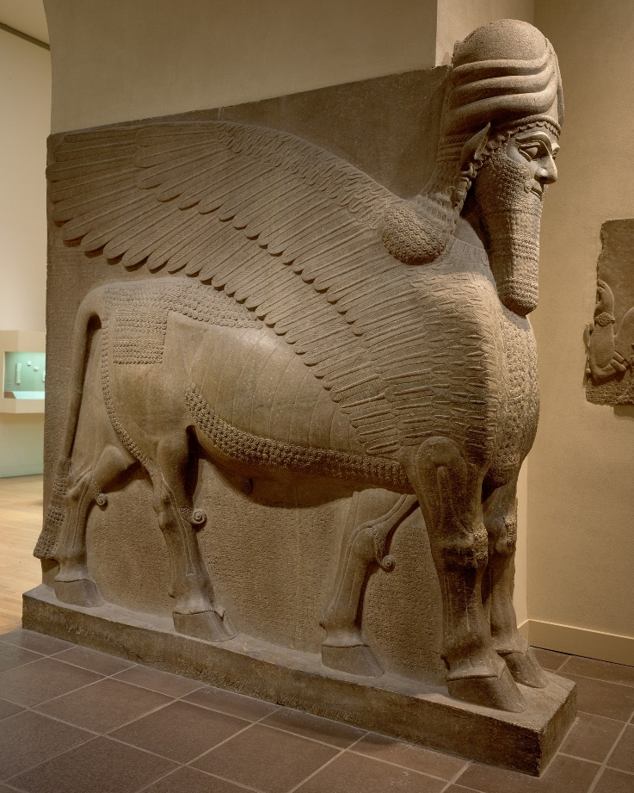
The Lamassu, or winged human headed bulls and lions, of ancient Assyria, are a perfect example of representational art to analyse through the lens of the theory of technologies of enchantment and the enchantment of technology. This is because of their longstanding history within Neo-Assyria art and the implied impact of these images on the minds of the modern man.
Figure 1: Winged Human Headed Bull, Nimrud, 883-859 (metmuseum.org, 2020)
From the stela of the 18th century BC to the colossi of Nineveh in the 7th century BC, the image of the Lamassu was quite prevalent in the Neo-Assyria art. However, in the interests of this analysis we will be focusing solely on the representation of the Lamassu in the form of colossi, such as can be seen in figures one and two.
Focusing on figure one for the moment, this colossi is from Nimrud and was thought to be constructed during the reign of Assurnasirpal II in the 8th century BC, and it, like all other colossi of its type, were placed at the gates of the Palace at Nimrud, with its companion, the winged human headed lion. There is one specific difference between this colossi and the one in figure 2 is that this one has five legs instead of four. This style was also present in the Khorsabad colossi of the 7th century BC, and Danrey (2004) points out that this was possibly “an attempt at realism by the early Assyrian artists” (Danrey, 2004: 134), and this point will become relevant when we begin to analyse these representations later in this article.
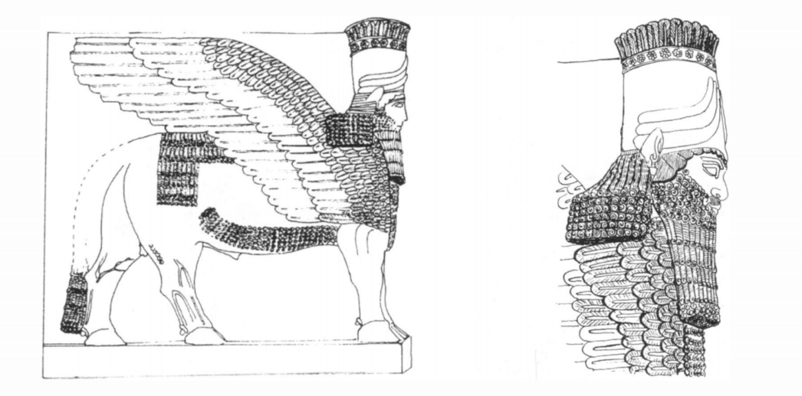
Figure 2: Winged Human Headed Bull, Nineveh 705-681 BC (Danrey, 2004: 135)

As you can see in Figure two, the sculptors of the colossi of Nineveh did not continue this tradition of five legs, and instead decided to put more detail into the design of the wings and hair of the colossi, which was apparently “the expression of a miniaturist tendency in low-relief art from the time of Sennacherib” (Danrey, 2004: 134). However, it could also be said that they chose to forgo the fifth leg in preference of making the colossi appear more lifelike and so became more detailed in their depiction of them.
Before we move on to detailing out the anthropological theory of the technologies of enchantment, which will then be used to analyse the representations of the winged human-headed bulls and lions or Lamassu, we will first briefly explain the term lamassu, which will then lend insight in regards to the analysis of the colossi. The term lamassu and its origins have been debated by scholars, however as Danrey points out all the terms that have been studied all seem to relate “to a notion of protection” (Danrey, 2004: 135) and he goes on to describe how from the Pre-Sargonic period the term lamassu “designated a female protective entity” (Danrey, 2004: 135). This representation of this term is then radically changed during the Assyrian period into the representation that we are focused on, that of the winged human headed bulls, but the term that is connected to it, lamassu, remains unchanged, and thus the meaning behind the term is now connected to this new representational form. This becomes relevant during the analysis of these colossi.
The theory of technologies of enchantment and the enchantment of technology is one such anthropological theory of art that can be used to analyse the lamassu colossi and we will do our best here to briefly explain the purposes of this theory and how best to understand it. The theory was developed by Alfred Gell in his article The Technology of Enchantment and the Enchantment of Technology in 1994. In this article Gell tries to make the argument that we cannot analyse art through the lens of aestheticism because we seem to lend the same amount of importance to aestheticism as we do to religion, and so Gell tries to then explain how we should look at art by using explaining how religion should be studied in regards to anthropological theory. Gell agrees with Peter Berger that a “methodological atheism” (Gell, 1994: 41) is needed in order to fulling analyse religious structures within an anthropological context, so that we can clearly see the cultural structures that are connected to it and why they are connected. As Gell subscribes to this method order to study the anthropology of religion, he also then suggest to employ “methodological philistinism” (Gell, 1994: 42), which means to completely ignore “the aesthetic value of works of art” (Gell, 1994: 42) so as to focus on the cultural and societal role of these works of art. However, even though he suggests this, he does concede that we cannot make a complete break from the aesthetic of the object. This is because, when this is done art is reduced down to an object of communication or of social distinction. What this does is completely ignore the ingenuity of the design and construction of the object itself which Gell believes must be considered, and so the aesthetic of the object cannot be completely ignored. Thus, Gell suggests considering “art as a component of technology” (Gell, 1994: 43), meaning to consider the technical aspects that go into the production of works of art, as well as taking into consideration that “art objects tend to have agency – to captivate their consumers – as ‘a special form of technology’” (Gable, 2002: 126; Gell, 1998: viii).
This is where he brings in the concept of enchantment. There are two forms of enchantment that we must be aware of, that of the technologies of enchantment and the enchantment of technology. The technology of enchantment theorizes that some art is deliberately produced in order to invoke a form of emotional response. This concept is a little vaguer than that of the enchantment of technology, however we will do our best to clarify this theory. In the simplest of terms it does come down in a way to design, but not the technical aspect of its creation, it is more that the object embodies a certain mystical aspect, the concept of what the object is suppose to represent is now embodied within the object, and so evokes a visceral response. The enchantment of technology is the theory that the technical processes associated with the production of art objects can cast a sort of “spell over us so that we see the real world in an enchanted form” (Gell, 1994: 44), meaning that because most of us will not have the technical skill to produce great works of art, great works of art then captivate us because we cannot fully understand how they have come to be. This concept of captivation is one Gell briefly tries to comment on in his book Art and Agency: An Anthropological Theory (1998). It basically takes these two concepts and puts them together. In essence it brings together the aspects of the experience people have when confronted with these works of art, i.e their emotional response, as well as the intellectual response that the objects invoke because of the technical aspects that people try to comprehend about its production.
Moving on now to the analytical portion of this article, in which we analyse the art objects known as the Lamassu, or human-headed bulls or lions, of the Neo-Assyrian era. If we first take a look at the colossi through the lens of the technologies of enchantment, this is where the name of the object and its connotations come into play. The name Lamassu has been hypothesised to mean protector and the design of this representation, as well as its size and where it is placed, at the entrance, certainly invokes this concept. Furthermore, the different designs associated with Nimrud and Khorsabad, as well as Nineveh, in that on the one hand some of these colossi are designed with five legs and the ones from Nineveh are designed with four. The attempt at realism, is also an attempt to embody the concept of the representation, in that it looks as if it could run off from its platform and actually fulfil the duties that it was placed there to do. The attempt at putting more detail into the wings and hair of these representations, in leu of the fifth leg, at Nineveh is also trying to achieve the same purpose. The sheer size of these colossi, as well as their detailed design of the muscles on the legs, would indeed invoke a sense of fear, so as not to cross them or do anything untoward in ‘their’ territory, as well as a sense of ease for those that lived within ‘their’ boundaries, because of the knowledge that they would protect them. In terms of the enchantment of technology, the technical processes that would have gone into the production of these colossi would have been impressive, especially even now as they have survived so well. The lifelike reproduction of the animals legs and basic body structure, as well as the detail of the wings and the human face, are a phenomenal piece of craftsmanship which highlight the level of skill and for thought that went into production of these colossi. Not many people would have had the skill to produce this level of craftmanship and so the awe in which these colossi would have invoked would have been greatly deserved.
This analysis of these colossi can also be brought forward to the present, as the meaning of the colossi is inherently clear. Which makes what happened to the colossi of the Lamassu at Nineveh, or modern-day Mosul in Iraq, all the more culturally scarring, as they were brutely destroyed by the Islamic State (IS). We are told that this is typical of IS behaviour upon capturing a territory, in that they undertake “a systematic iconoclastic programme which saw the razing of countless cultural and religious sites” (Isakhan and Meskell, 2019: 1189). The fact that they have destroyed these pieces means that they can no longer invoke the same feelings of protection and awe that they would have otherwise. However, UNESCO are trying to reconstruct these heritage sites, and so in affect are trying to revive these colossi in order to fulfil their purpose. Once they can safely do this, with the go ahead from the local community, and without of the threat of further destruction, these new colossi will embody the spirit of their originals and hopefully inspire the same emotional and intellectual responses that their predecessors did. Thus, making it possible for the meaning of these representations, which is inherently clear, to once transcend the boundaries of time and cultural milieu.
Although, this article focuses on the analysis of the colossi Lamassu through the lens of the theory of technologies of enchantment and the enchantment of technology, there are other anthropological theories of art that could be used to analyse these colossal representations. One of these theories is the theory of the itinerary of objects, which is a way in which we can understand “how things work both on the intimate scale of human life and on the vast scales of geology, cosmology, and social history” (Joyce and Gillespie, 2015: 37), meaning that by taking a close look at both the history of the colossi, through time periods that is was constructed, all the way to its reception in the modern world and peoples perceptions of it, we can then gain a complete insight of how this representation of art in the form of colossi has been received by the culture it was created in and how subsequent cultures have interacted with it. Another theory is one based on aesthetics, which although rejected by Gell as stated above, and this is relevant because of the fact that although the colossi of the Lamassu are all mostly designed the same, they do have slight differences according to the city in which they are found. These minor differences speak to the specific aesthetic values of the city they are found in, which gives a flair of individual artistic licence layered upon the cultural blueprint for the representation of the Lamassu.
As stated at the beginning of this article the Lamassu are a great example of representation art of the Neo-Assyrian period, because of their longstanding history within the confines of the Neo-Assyrian era as well as their impact on the minds of the people of the time and the people of the modern world. This is witnessed through the history of the representation of the Lamassu, which finally settled into the form of the colossi which is the topic of this analysis as well as its use in three different cities of the Neo-Assyrian period, during the rules of three different kings that spanned hundreds of years. The theory of technologies of enchantment and the enchantment of technologies, explains the reason why they were so prevalent, as the meaning of the Lamassu is to protect, and their design embodies this ideal and invokes the appropriate awe, at the craftmanship, and cautiousness of those entering the city or palace. Furthermore, the reception of these colossi in modern times, i.e their destruction, shows that those that destroyed them understood their meaning as well and destroyed them in order to break the spirit of the local people, in order to assert their dominance. UNESCO’s commitment to restoring the cultural site of Nineveh, however, shows that the spirit of those that admire the craftmanship and the cultural significance of these colossi has not been broken, and that they wish for the people of that region to witness these colossi rebuilt so that the spirit that they represent can one day resume its duties.

Bibliography
Danrey, V., 2004. Winged Human-Headed Bulls of Nineveh: Genesis of an Iconographic Motif. Iraq, 66, pp.133-139.
Gable, E., 2002. Beyond Aesthetics: Art and the Technologies of Enchantment. Visual Anthropology Review, 18(1-2), pp.125-127.
Gell, A., 1994. The Technology of Enchantment and the Enchantment of Technology. In: J. Coote, ed., Anthropology, Art, and Aesthetics. Clarendon Press.
Gell, A., 1998. Art And Agency: An Anthropological Theory. Oxford: Clarendon Press.
Isakhan, B. and Meskell, L., 2019. UNESCO’s project to ‘Revive the Spirit of Mosul’: Iraqi and Syrian opinion on heritage reconstruction after the Islamic State. International Journal of Heritage Studies, 25(11), pp.1189-1204.
Joyce, R. and Gillespie, S., 2015. Things In Motion: Object Itineraries In Anthropological Practice. Sante Fe: School for Advanced Research Press.
Metmuseum.org. 2020. [online] Available at: <https://www.metmuseum.org/art/collection/search/322608> [Accessed 26 November 2020].

