Ways of Perceiving.
Student Name: Nancy Leather
Student Number: 2404204
Program Study: Design Craft
Module: ADDA4022

A Modernists Home
The name of the exhibit is ‘A Modernists Home’. The purpose of this exhibition is for people to interact with the objects on a meaningful level, with the aim to invoke personal relationships between themselves and the art. Also, to have the opportunity to interpret the exhibit with the knowledge they have acquired through their position within society and context. The word context is derived from the Latin ‘con’ meaning together and ‘texere’ meaning to weave (Wan, 2009, p.33). Intertwining personal circumstances and the setting of the exhibition creates a personal meaning and interpretation tailored to the specific individual. Reinforced by John Berger in his book ‘ways of seeing’ (1972) where he explored how each individual perceives art differently depending on their knowledge accumulated from their environment. Modernity happened, bringing changes to the social sphere, the disruption and ugliness that came with it brought about the modernist aesthetic.This is what Gertrude Stein (an American modernist) thought was the duty of art, striving through the ugliness is the way in which truly new art exists (Buchanan, 2010).
In agreement with Richard Sennett, design craft is an area of art that focuses on the quality and technique of mastering a craft as well as our environment. As humans we have a natural drive to create the best possible versions of our craft; whether that be in an art form (ceramics or painting) or in a form of science. Craftsman perfect their craft for both external and internal purposes, to understand themselves but also to understand the world and their environment (2008). Supported through Maurice Marleau- Ponty’s idea of phenomenology and that perception and further supports Sennett’s idea that craftsmanship is a form of an active embodied experience that develops our understandings of our environment.
Using four different pieces of craftsmanship in the form of ceramic, this exhibit will display them in a location of a house (figure 1). In alignment with modernism in art developing from the change in modernity and the disruption of everyday life (Buchanan, 2010) and the relationship between an individuals physical environment and inner world I’m using Gaston Bachelard’s idea of a home space. Bachelard uses a house as symbolism of humans emotional and psychological landscape, exploring the idea of topophilia, a strong emotional connection or our love for a space or environment is the main source of creativity (1969). A home is a personally curated environment specifically for one individual that provides them the most stimulation with no restrictions of social pressure. Throughout the house there will be four examples of modernist ceramists pieces, one displayed in each room. The examples closely relate to feminism, females have a long history linked to the home.
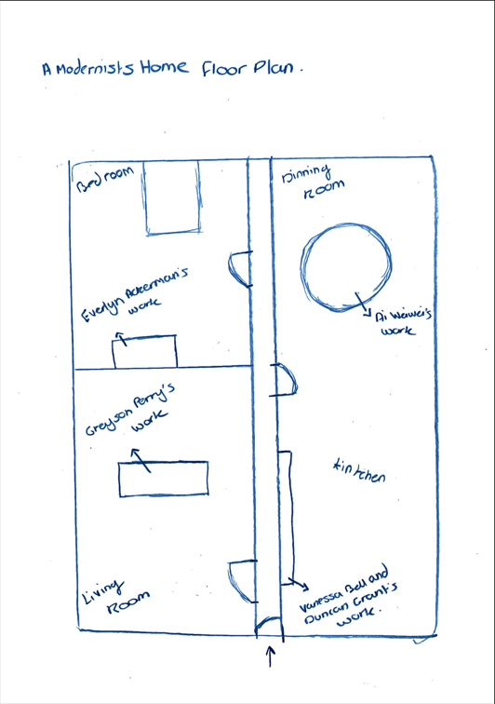
Figure 1, A Modernists Home Floor Plan
In their book, Mihaly Csikszentmhalyi and Eugene Rochberg-Halton in their book The meaning of things Domestic Symbols and the self (1981) explore the ways in which people create meaning from the material world of objects. Interacting with objects creates a world of meaning that is in line with an individuals values and goals. As the main values within this exhibition are modernism and feminism explored through ceramics, within an intimate environment of the home, it will be interesting too see the relationships created through the objects presented and the people interacting with them.
As you walk into the hallway the first door on the left will lead into the living room where, displayed on a coffee table is Greyson Perrys ceramic piece ‘Saint Claire 37 Wanks Across Northern Spain’ (Figure 2). Dissecting the name of the piece there are two words that juxtapose each other ‘Claire’ and ‘Wanks’. Claire, according to the guardian (2014), is the female alter ego of Perry, who takes form in Perry wearing a Little Bo Peep dress and matching bonnet with a clean shaven face. Combining this with ‘wanks’, a word to describe the male form of masturbation creates a sense of gender ambiguity. Putting this in context with the exhibition having gender ambiguity in a modernist home expands the idea of feminism and equality not just within society but in a personal domestic environment.
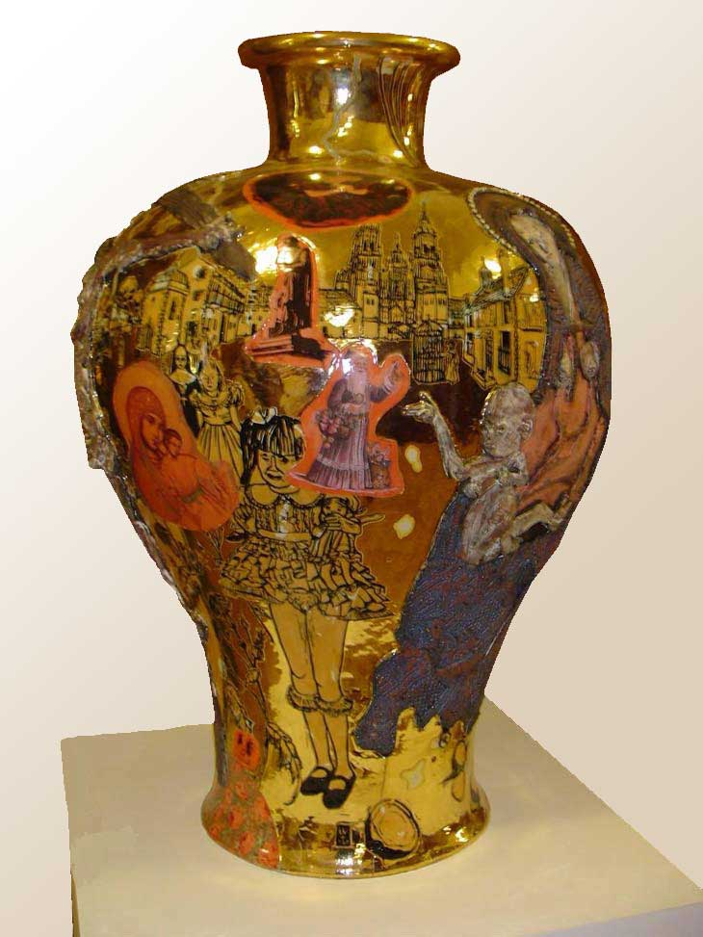
Figure 2, Saint Claire 37 Wanks Across Northern Spain, Grayson Perry, 2003.
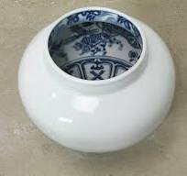
Exiting back into the hallway, the next door that will be on the right will lead into the dinning room with a rounded table in the centre displaying all 96 ceramic vessels of Ai Weiwei’s work called ‘Ghost Gu’(Figure 3). Having a round table is especially important as the absence of the sharp ridged corners creates a shared experience with the other participants at the table and becomes a place of shared experiences, unity and conversation that develops our understanding of what makes a home (Halton and Csikszentmihalyi, 1981). Weiwei work displays the decorative imagery on the inside of his bowl. Put into context with the exhibition and applied to the environment of the home, suggests that the effort and beauty is what takes place inside the home and the effort that gets put into creating that environment only for a selected people to see. Just like how Weiwei decorations being on the inside, in order to see the full interior you have to come close and intimately inspect the object to appreciate the effort that’s gone into the decoration. Using Ferdinand de Saussure ideas on semiotics, the relationship between the signifier and the signified (meaning), we can apply ‘Ghost’ to the concept of this exhibition (1959). On a denotative level ghost is an element or entity that we cannot see but we know is there, ghosts can be known to move objects or change something in an environment, and on the connotative level in relation to this exhibit ghost can mean the women in the house. Food is always on the table and as a society we forget that someone (usually the women) has to create that experience, the food does not just appear.
Figure 3, Ghost Gu’, Ai Weiwei, 2007
At the opposite end of the dining room is the kitchen. The duo Vanessa Bell and Duncan Grants work of 50 hand painted ceramic plates created in 1935, consists of famous women throughout history, the arts and mythology; Cleopatra, Helen of Troy, Pocahontas, Elizabeth I, Lady Murasaki and many more. This series of work is displayed on the left wall, each plate hung up in 10 neat columns with five plates on each row. Both Bell and Grant’s sexuality where unorthodox and they explore there own modernist way on how they view their sexuality. Bell held comparisons between ceramic and sexual joy: “The feeling of clay rising between one’s fingers is like the keenest sexual joy” (Guardian, 2024). Having a display of women in the kitchen acts as a memorial, having them displayed on the wall instead of displayed like they are in use creates a sense of retirement and a change in modernity, change in the social sphere (Buchanan, 2010, p.325).
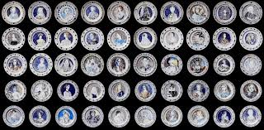
Figure 4, The Famous Women Dinner Service, Vanessa Bell and Duncan Grants, 1935
Carrying on through the corridor the next door will be on the left leading into the bedroom. The layout of the bedroom will have a a bed in the middle of the back wall and directly opposite will be a chest of drawers that will display Evelyn Ackerman’s ceramic vase called “Female Figure Vase” (figure 5). Displaying nude female figures and calling this piece a ‘love story’ evokes questions on the issues within a women’s sexuality from a societal perspective. Depending on the personal experience a women or viewer has can evoke their own meaning on a modern love story. This room will be unbiased, allowing the experience to be completely personal and open to interpretation for the observer. Specifically placing a modernist piece of art completely interpretational in the bedroom because this is the most personal and intermarriage space in a house. John Berger explores this idea within his book ‘ways of seeing’, he examines the way in which we interoperate art. Our perception is shaped through external sources like social, cultural and political changes and historical and a personal role in society is a factor of perception, gender, class, occupation. Berger’s Statement “The way we see things is effect by what we know or what we believe in” reinforces the idea that an individuals specific environment determines there knowledge on the world (1972, p.8).
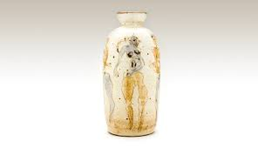
Figure 5, Female Figures Vase, Evelyn Ackerman, 1953

In this exhibition ‘A Modernists Home’ has achieved a modernist outlooks on the home specifically in relation to women. Using beautiful art piece’s that require significant time and effort to symbolise the hardships. Education on inequalities and feminist issues is what this exhibit has achieved.

Bibliography:
Bachelard, G. (1969) The Poetics of Space.1st edn. Boston: Beacon Press
Berger, J. (1972) Ways of Seeing. 1st edn. London: Penguin Books.
Buchan, K. (2024). ‘’A great work of feminist art’: how the Bloomsbury group’s Famous Women Dinner Service got. Place at the table’, The Guardian, 5 October. Available at: https://www.theguardian.com/artanddesign/2024/oct/05/vanessa-bell-duncan-grant-the-famous-women-dinner-service.
Buchanan, I. (2010) Dictionary of Critical Theory. 1st edn. New York: Oxford University Press.
Csikszentmihalyi, M and Rochberg-Halton, E. (1981) The Meaning of Things. Domestic Symbols and the Self. 1st edn. United Kingdom: Cambridge University Press.
De Saussure, F. (1959). Course in General Linguistics. Translated from French by W. Baskin. New York: The Philosophical Library.
Hattenstone, S. (2014) ‘Grayson Perry: ‘Just because you don’t have a dress on doesn’t stop you being a tranny’, The Guardian, 8 October. Available at: https://www.theguardian.com/artanddesign/2014/oct/04/grayson-perry-dress-tranny-art-who-are-you-tv.
Merleau-Ponty, M. (1962). Phenomenology of Perception. Translated from French by C. Smith.London: Routledge & Kegan Paul.
Sennett, R. (2008) The Craftsman. 1st edn. London: Penguin Books.
Wan, K (2009). ‘A Brief History of Context’, International Journal Of Computer Science, (6), pp.33-42.
List of Figures.
Figure 1, Leather, N. (2025) A Modernists Home Floor Plan.
Figure 2, Perry, G. (2003) Saint Clair 37 Wanks Across Northern Spain. Available at: https://www.charlessaatchi.com/artworks/saint-claire-37-wanks-accross-northern-spain/ ( Accessed: 2nd April 2025)
Figure 3, Weiwei, Ai. (2007) Ghost Gu. Avaliable at: https://www.lissongallery.com/artists/ai-weiwei/artworks/ghost-gu?image_id=3767 (Accessed: 2nd April 2025)
Figure 4, Bell, V and Duncan, G. (1932) Famous Women Dinner Service. Available at: https://www.charleston.org.uk/event/famous-women-dinner-service/ (Accessed: 2nd April 2025)
Figure 5, Ackerman, E (1953) Female Figure Vase. Available at: https://ackermanmodern.com/portfolio-items/female-figures/ (Accessed: 2nd April 2025).

