

Student name: Grace Carolina Carrera Echeverria
Student ID:2517020

Module name: Introduction to Health and Social Care
Module code: LCHS4003
Lecturer name: Muhammad Aliyu

Content page

Element 1 …………………………………………………………….. page
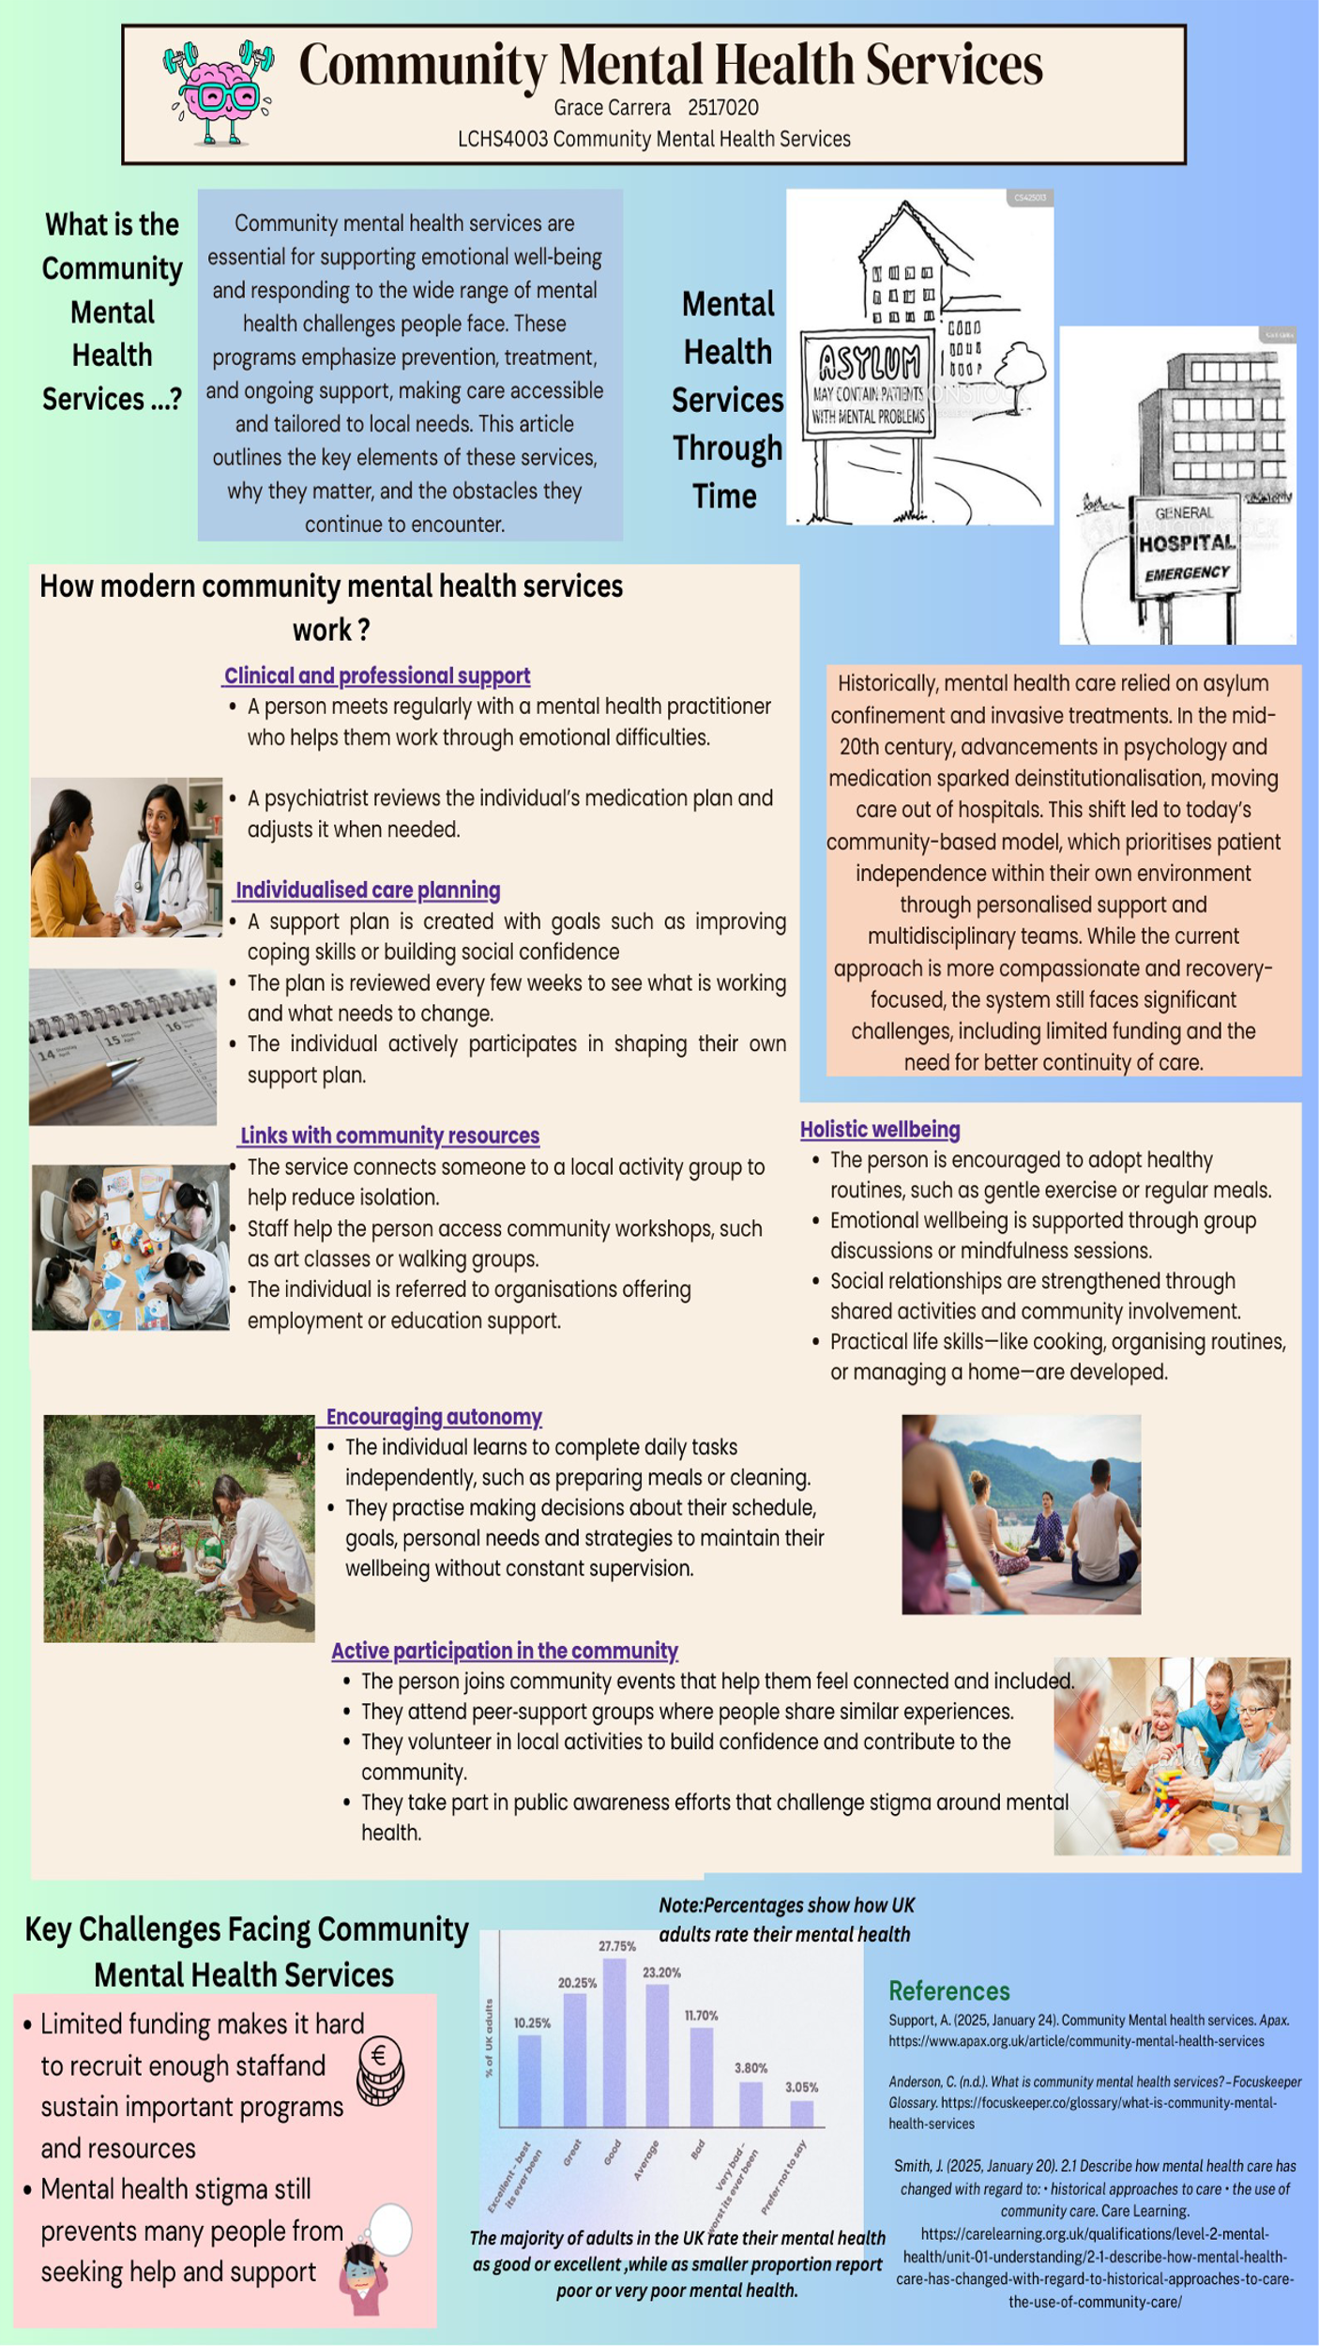

Element 2
Health Care Services
Community antenatal midwifery services
How Antenatal and Midwifery Services Started.
Midwifery is one of the oldest recognised healthcare professions, dating back thousands of years. Pregnancy and delivery occurred in the home for the majority of human history, with traditional midwives providing help based on practical experience and skills passed down through generations. Throughout pregnancy, labour, and birth, these early midwives provided physical aid as well as mental reassurance. Their presence made women feel supported during a period when formal medical care was scarce or unavailable.

During the nineteenth century, medicine began to develop into a more scientific and controlled field. As medical awareness grew, birthing moved from the home to hospitals. Doctors got more involved in maternity care, leading to better management of high-risk pregnancies and complications. However, this transformation diminished the role of community midwives and contributed to a more medicalised approach to childbirth. The previous community-based model of care was replaced by a system that valued clinical processes and professional authority.

Prior to the implementation of a public healthcare system, access to medical treatments in the United Kingdom was unequal. Many women relied on private general practitioners, and while some basic care services were available, they were not free. This meant that only those who could afford it received regular maternal care. As a result, the level of support provided varied widely based on a woman's financial condition, leaving many pregnant women without proper care.

In 1948, the National Health Service (NHS) was established, which marked a watershed moment. Healthcare became free at the point of use and available to the general public. This shift made maternity services more coordinated and uniform. Routine antenatal consultations, organised monitoring, and standardised pregnancy check-ups have improved both continuity and quality of care. Later, in the 1970s, new technologies including ultrasound imaging and foetal monitoring were developed.

These advances improved the safety and accuracy of pregnancy exams, strengthened midwives' professional roles, and allowed for earlier detection of potential difficulties.

Antenatal and Midwifery Care in the Present Day

Antenatal and midwifery services are becoming an important part of modern healthcare systems, particularly in the National Health Services (NHS). These services offer pregnant women regular health checks, practical advice, and emotional support throughout their pregnancy. Midwives play a critical role in making women feel knowledgeable, safe, and prepared for childbirth.

One of the most significant advantages of current maternity care is its emphasis on continuity. This technique ensures that a woman receives care from the same midwife or a small team of midwives throughout her pregnancy and, in certain cases, until birth. This consistency fosters trust, increases communication, and makes women feel more comfortable and secure.
Another advantage is the promotion of informed choice. Women are encouraged to make decisions about their care, such as where they want to give birth and the type of support they choose.

Despite these capabilities, a number of challenges exist. Many maternity services are experiencing staffing shortages and increased demand, which can limit how much time midwives can spend with each mother. Additionally, not all women receive the same level of care. Some populations, such as women from minority ethnic backgrounds, may confront disparities or barriers that reduce the quality of their maternity care. In other cases, care may still be unduly medicalised, diminishing women's sense of control throughout labour and delivery.

Importance of Antenatal and Midwifery Services

Antenatal and midwifery services are critical because they ensure the health of both the mother and the baby during the pregnancy. They enable early detection of probable abnormalities, hence reducing risks during pregnancy and labour. Midwives also offer emotional support, allowing women to feel peaceful, confident, and well-prepared. They provide crucial information on pregnancy, birth, and newborn care, allowing families to feel more safe and less overwhelmed.

These interventions help prevent long-term health complications. Providing high-quality prenatal care can prevent future difficulties for both moms and newborns. Midwives are trained to identify hazards early and refer women to professional care when needed. Furthermore, prenatal and midwifery services serve to eliminate health disparities by ensuring that women from diverse backgrounds receive the same amount of support. In essence, these services provide medical care, emotional support, and education to improve the health of mothers, babies, and families.
References

- England, N. (n.d.). NHS England » Maternity transformation programme. https://www.england.nhs.uk/mat-transformation/

- A brief history of district midwifery | AIMS. (n.d.). https://www.aims.org.uk/journal/item/history-district-midwifery

- Davis, A. (2025, February 25). Choice, policy and practice in maternity care since 1948 - History & Policy. History & Policy. https://historyandpolicy.org/policy-papers/papers/choice-policy-and-practice-in-maternity-care-since-1948/

- Midwives. (2024, May 2). 120 years of the Midwives Act in England and Wales. Royal College of Midwives. https://rcm.org.uk/blog/2022/07/120-years-of-the-midwives-act-in-england-and-wales/

